1. Defining the index and the formulation of the model.

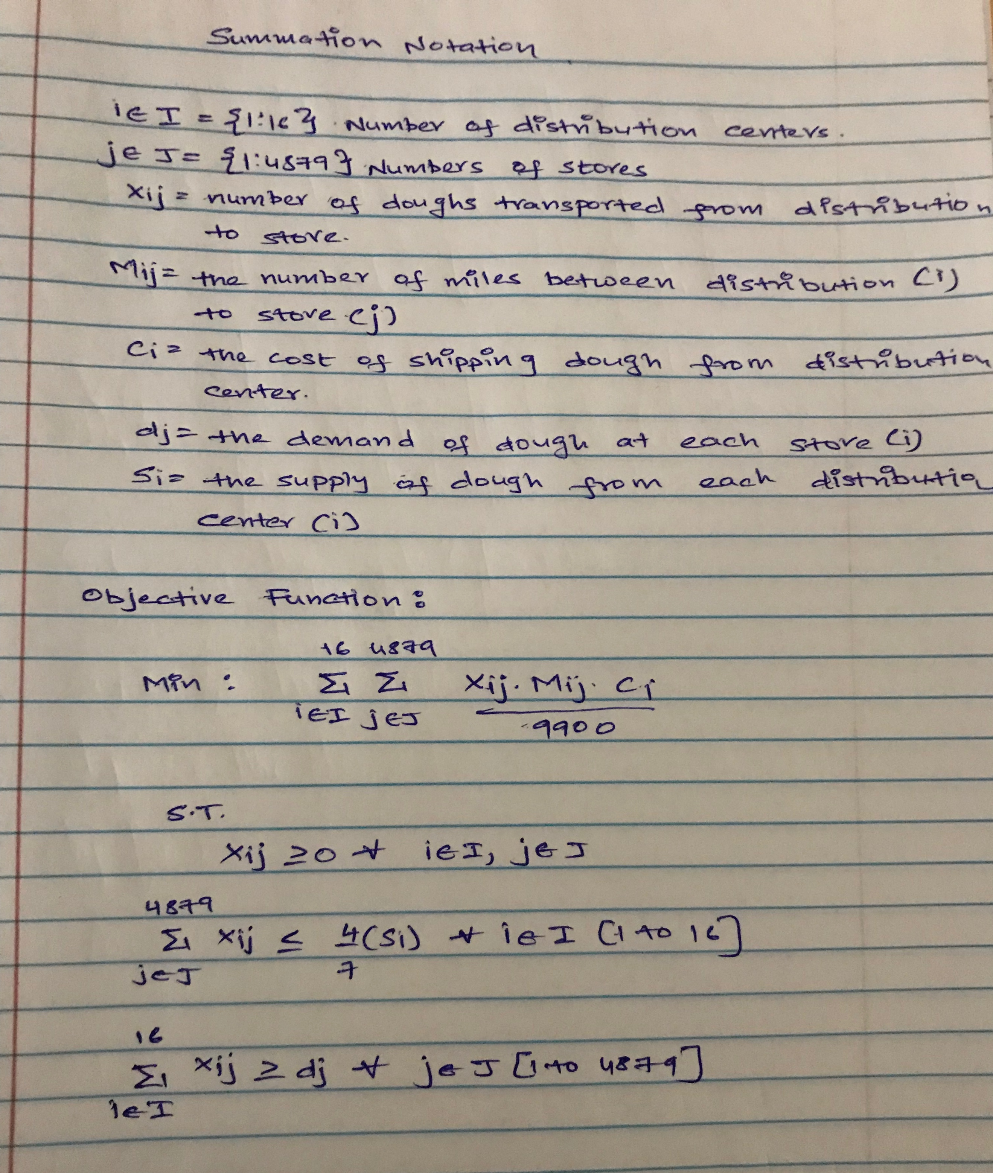

2. –Concept Question:  What would be a good way to present the information (5 points)

We can load the csv file into data visualization tool like tableau and also load the Lat/Long data of the stores and distribution centers. The stores with the distribution center which have a positive decision will be clustered into groups. This representation will give the client a visual representation of our finding. The clients will understand which distribution center will provide to which store [ which distribution center is meeting the demand and also minimizing the cost of transportation]