Booklist

[[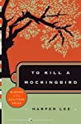](https://www.goodreads.com/list/show/6.Best_Books_of_the_20th_Century)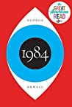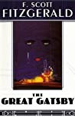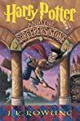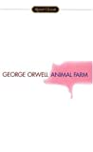](https://www.goodreads.com/list/show/6.Best_Books_of_the_20th_Century)

[**Best Books of the 20th Century**](https://www.goodreads.com/list/show/6.Best_Books_of_the_20th_Century)

7,765 books — 50,344 voters

[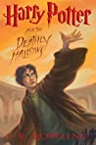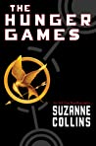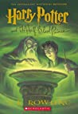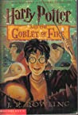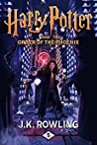](https://www.goodreads.com/list/show/5.Best_Books_of_the_Decade_2000s)

[**Best Books of the Decade: 2000s**](https://www.goodreads.com/list/show/5.Best_Books_of_the_Decade_2000s)

7,035 books — 28,373 voters

[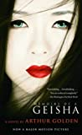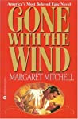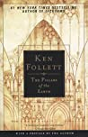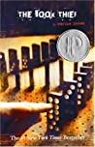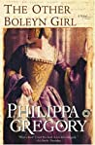](https://www.goodreads.com/list/show/15.Best_Historical_Fiction)

[**Best Historical Fiction**](https://www.goodreads.com/list/show/15.Best_Historical_Fiction)

6,773 books — 26,280 voters

[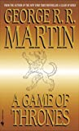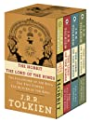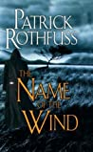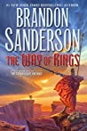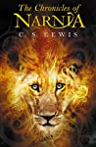](https://www.goodreads.com/list/show/50.The_Best_Epic_Fantasy_fiction_)

[**The Best Epic Fantasy (fiction)**](https://www.goodreads.com/list/show/50.The_Best_Epic_Fantasy_fiction_)

3,613 books — 25,510 voters

[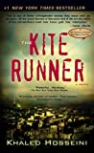](https://www.goodreads.com/list/show/7.Best_Books_of_the_21st_Century)

[**Best Books of the 21st Century**](https://www.goodreads.com/list/show/7.Best_Books_of_the_21st_Century)

9,442 books — 21,590 voters

[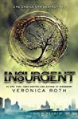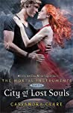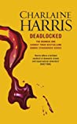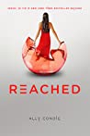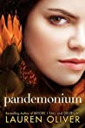](https://www.goodreads.com/list/show/6634.Can_t_Wait_Books_of_2012)

[**Can't Wait Books of 2012**](https://www.goodreads.com/list/show/6634.Can_t_Wait_Books_of_2012)

2,493 books — 15,548 voters

[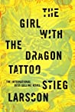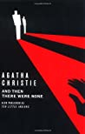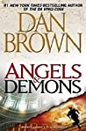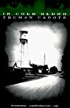](https://www.goodreads.com/list/show/11.Best_Crime_Mystery_Books)

[**Best Crime & Mystery Books**](https://www.goodreads.com/list/show/11.Best_Crime_Mystery_Books)

6,839 books — 14,712 voters

[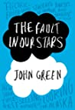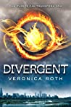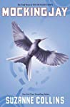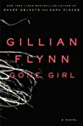](https://www.goodreads.com/list/show/4093.Best_Books_of_the_Decade_2010s)

[**Best Books of the Decade: 2010s**](https://www.goodreads.com/list/show/4093.Best_Books_of_the_Decade_2010s)

7,243 books — 13,355 voters

[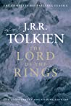](https://www.goodreads.com/list/show/319.Best_Fantasy_Series_Trilogies_and_Duologies)

[**Best Fantasy Series, Trilogies, and Duologies**](https://www.goodreads.com/list/show/319.Best_Fantasy_Series_Trilogies_and_Duologies)

1,933 books — 11,689 voters

[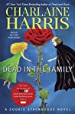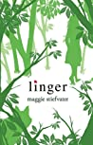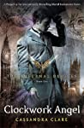](https://www.goodreads.com/list/show/3491.Can_t_Wait_Books_of_2010)

[**Can't Wait Books of 2010**](https://www.goodreads.com/list/show/3491.Can_t_Wait_Books_of_2010)

1,216 books — 10,492 voters

[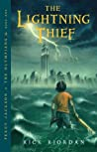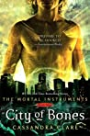](https://www.goodreads.com/list/show/1381.Best_Series)

[**Best Series**](https://www.goodreads.com/list/show/1381.Best_Series)

3,026 books — 10,418 voters

[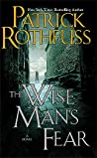](https://www.goodreads.com/list/show/88.Best_Fantasy_Books_of_the_21st_Century)

[**Best Fantasy Books of the 21st Century**](https://www.goodreads.com/list/show/88.Best_Fantasy_Books_of_the_21st_Century)

2,972 books — 9,776 voters

[](https://www.goodreads.com/list/show/15604.Best_Books_of_2012)

[**Best Books of 2012**](https://www.goodreads.com/list/show/15604.Best_Books_of_2012)

3,418 books — 9,473 voters

[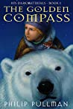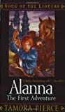](https://www.goodreads.com/list/show/147.Best_Kick_Ass_Female_Characters_From_YA_and_Children_s_Fantasy_and_Science_Fiction)

[**Best Kick-Ass Female Characters From YA and Children's Fantasy and Science Fiction**](https://www.goodreads.com/list/show/147.Best_Kick_Ass_Female_Characters_From_YA_and_Children_s_Fantasy_and_Science_Fiction)

2,814 books — 9,423 voters

[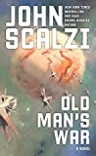](https://www.goodreads.com/list/show/4893.Best_Science_Fiction_of_the_21st_Century)

[**Best Science Fiction of the 21st Century**](https://www.goodreads.com/list/show/4893.Best_Science_Fiction_of_the_21st_Century)

991 books — 8,840 voters

[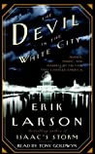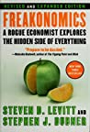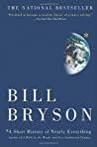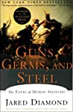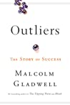](https://www.goodreads.com/list/show/134.Best_Non_Fiction_no_biographies_)

[**Best Non-Fiction (no biographies)**](https://www.goodreads.com/list/show/134.Best_Non_Fiction_no_biographies_)

5,936 books — 8,446 voters

[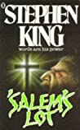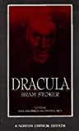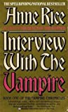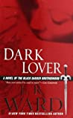](https://www.goodreads.com/list/show/129.Best_Adult_Vampire_Books)

[**Best Adult Vampire Books**](https://www.goodreads.com/list/show/129.Best_Adult_Vampire_Books)

1,656 books — 7,692 voters

[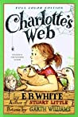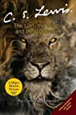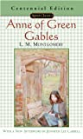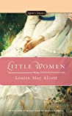](https://www.goodreads.com/list/show/226.Favorite_books_from_my_childhood)

[**Favorite books from my childhood**](https://www.goodreads.com/list/show/226.Favorite_books_from_my_childhood)

4,253 books — 7,288 voters

[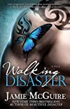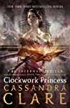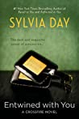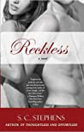](https://www.goodreads.com/list/show/27345.Best_Books_Published_in_2013)

[**Best Books Published in 2013**](https://www.goodreads.com/list/show/27345.Best_Books_Published_in_2013)

3,512 books — 7,180 voters

[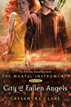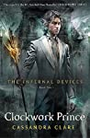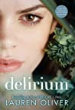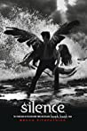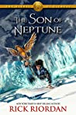](https://www.goodreads.com/list/show/8226.Best_Books_of_2011)

[**Best Books of 2011**](https://www.goodreads.com/list/show/8226.Best_Books_of_2011)

2,593 books — 7,162 voters

[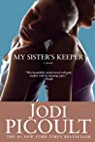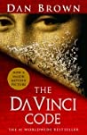](https://www.goodreads.com/list/show/541.Best_Twists)

[**Best Twists**](https://www.goodreads.com/list/show/541.Best_Twists)

5,025 books — 6,975 voters

[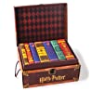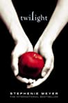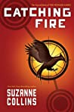](https://www.goodreads.com/list/show/141.Best_Young_Adult_Fiction)

[**Best Young Adult Fiction**](https://www.goodreads.com/list/show/141.Best_Young_Adult_Fiction)

3,420 books — 6,952 voters

[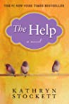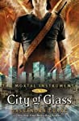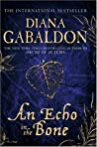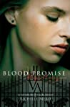](https://www.goodreads.com/list/show/1297.Best_Books_of_2009)

[**Best Books of 2009**](https://www.goodreads.com/list/show/1297.Best_Books_of_2009)

1,701 books — 6,941 voters

[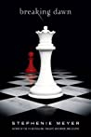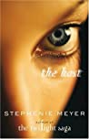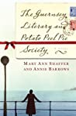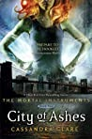](https://www.goodreads.com/list/show/4.Best_Books_of_2008)

[**Best Books of 2008**](https://www.goodreads.com/list/show/4.Best_Books_of_2008)

1,711 books — 6,934 voters

[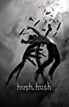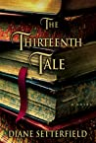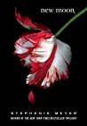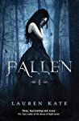](https://www.goodreads.com/list/show/101.Best_Book_Cover_Art)

[**Best Book Cover Art**](https://www.goodreads.com/list/show/101.Best_Book_Cover_Art)

9,286 books — 6,792 voters

[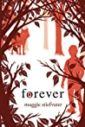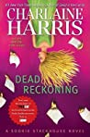](https://www.goodreads.com/list/show/5513.Can_t_Wait_Books_For_2011)

[**Can't Wait Books For 2011**](https://www.goodreads.com/list/show/5513.Can_t_Wait_Books_For_2011)

1,214 books — 6,765 voters

[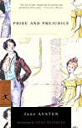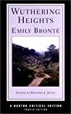](https://www.goodreads.com/list/show/16.Best_Books_of_the_19th_Century)

[**Best Books of the 19th Century**](https://www.goodreads.com/list/show/16.Best_Books_of_the_19th_Century)

1,760 books — 6,599 voters

[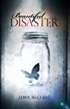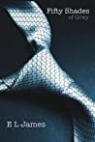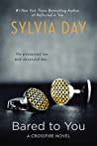](https://www.goodreads.com/list/show/18225.Hottest_Adult_Young_Adult_Romance_Books_)

[**Hottest Adult & Young Adult Romance Books**](https://www.goodreads.com/list/show/18225.Hottest_Adult_Young_Adult_Romance_Books_)

2,794 books — 6,443 voters

« previous *1* [2](https://www.goodreads.com/list/tag/best?page=2) [3](https://www.goodreads.com/list/tag/best?page=3) [4](https://www.goodreads.com/list/tag/best?page=4) [5](https://www.goodreads.com/list/tag/best?page=5) [6](https://www.goodreads.com/list/tag/best?page=6) [7](https://www.goodreads.com/list/tag/best?page=7) [8](https://www.goodreads.com/list/tag/best?page=8) [9](https://www.goodreads.com/list/tag/best?page=9) … [56](https://www.goodreads.com/list/tag/best?page=56) [57](https://www.goodreads.com/list/tag/best?page=57) [next »](https://www.goodreads.com/list/tag/best?page=2)

**search here**

Top of Form

 

Bottom of Form

* [romance](https://www.goodreads.com/list/tag/romance) (7137)
* [fiction](https://www.goodreads.com/list/tag/fiction) (6811)
* [young-adult](https://www.goodreads.com/list/tag/young-adult) (5527)
* [fantasy](https://www.goodreads.com/list/tag/fantasy) (4539)
* [science-fiction](https://www.goodreads.com/list/tag/science-fiction) (3370)
* [non-fiction](https://www.goodreads.com/list/tag/non-fiction) (2764)
* [children](https://www.goodreads.com/list/tag/children) (2244)
* [history](https://www.goodreads.com/list/tag/history) (2087)
* [mystery](https://www.goodreads.com/list/tag/mystery) (2003)
* [covers](https://www.goodreads.com/list/tag/covers) (1996)
* [horror](https://www.goodreads.com/list/tag/horror) (1819)
* [historical-fiction](https://www.goodreads.com/list/tag/historical-fiction) (1730)
* [best](https://www.goodreads.com/list/tag/best) (1702)
* [gay](https://www.goodreads.com/list/tag/gay) (1547)
* [paranormal](https://www.goodreads.com/list/tag/paranormal) (1381)
* [titles](https://www.goodreads.com/list/tag/titles) (1347)
* [love](https://www.goodreads.com/list/tag/love) (1340)
* [middle-grade](https://www.goodreads.com/list/tag/middle-grade) (1264)
* [contemporary](https://www.goodreads.com/list/tag/contemporary) (1234)
* [historical-romance](https://www.goodreads.com/list/tag/historical-romance) (1195)
* [thriller](https://www.goodreads.com/list/tag/thriller) (1192)
* [biography](https://www.goodreads.com/list/tag/biography) (1174)
* [nonfiction](https://www.goodreads.com/list/tag/nonfiction) (1152)
* [women](https://www.goodreads.com/list/tag/women) (1104)
* [series](https://www.goodreads.com/list/tag/series) (1104)
* [lgbt](https://www.goodreads.com/list/tag/lgbt) (1059)
* [classics](https://www.goodreads.com/list/tag/classics) (1050)
* [graphic-novels](https://www.goodreads.com/list/tag/graphic-novels) (1013)
* [queer](https://www.goodreads.com/list/tag/queer) (1005)
* [memoir](https://www.goodreads.com/list/tag/memoir) (1000)

**COMPANY**

* [About us](https://www.goodreads.com/about/us)
* [Careers](https://www.goodreads.com/jobs)
* [Terms](https://www.goodreads.com/about/terms)
* [Privacy](https://www.goodreads.com/about/privacy)
* [Interest Based Ads](https://help.goodreads.com/s/article/Goodreads-Interest-Based-Ads-Notice)