Madan Bhandari Memorial College
New Baneshwor ,Kathmandu Nepal

Lab Report of
Computer Fundamental And Application (CACS 101)

Submitted by Submitted to
Name : Srijana Subedi Department of BCA
Code no :3279616
Faculty :Humanities and Social Science
Semester :First Semester

2. Introduction to MS-Word
Microsoft Word is a word processor developed by Microsoft. It allows us to create, edit, format,save, print, delete, and view a multidirectional text document. By default,documents saved in Word 2010 are saved with the .docx extension.
How to open or run MS-Word
Step 1: Click the button Windows key + R. Then the run
window will pop out in screen.
Step 2: Write winword in Open option in run window.
Step 3: Press OK button and now MS-Word file is open.

Following is the basic window which you get when you start the Word application.

HORIZONTAL RULER
VIEW BUTTONS
STATUS BAR
BLANK DOCUMENT TEMPLATE
INDENT TAB
TAB MENU
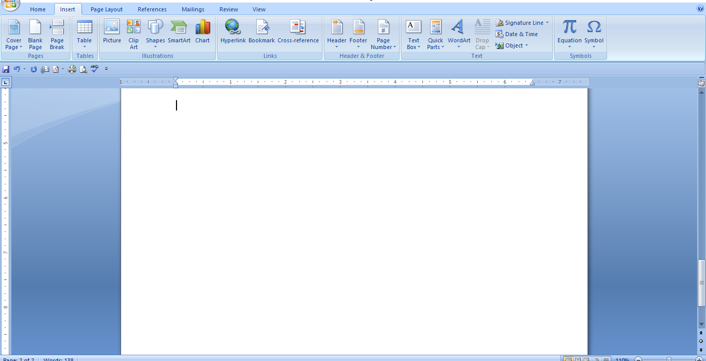
Features
i. Text Formatting
To format a text
a) Select the text you want to format and Click the Home tab.
b) Click the Font Dialog Box Launcher and Select the font, font style, and font size you want.
c) If you want, click the Font Color list arrow, and then click a color.
d) If you want, select the effect you want in your text.
e) If you want, select your underline style.
f) You can see your formatted text in preview
g) Click OK.
ii. Paragraph Formatting
To format a paragraph
a) Select the paragraph you want to format and Click the Home tab.
b) Click the Paragraph Dialog Box Launcher
c) Select the alignment, indentation, and line spacing you want
d) You can see your formatted paragraph in preview
iii. Create a List from Existing Text
Step 1 – Select a list of text which you want to assign bullets or numbers.
Step 2 – Click the Bullet Button triangle icon to display a list of bullets you want to assign to the list.
Step 3 – If you are willing to create a list of bullets you

iv. Table
A table is a structure of vertical columns and horizontal rows with a cell at every intersection.
Creating a table
Step 1 – Click the Insert tab followed by the Table button. This will display a simple grid as shown below. When you move your mouse over the grid cells, it makes a table in the table that appears in the document.
Step 2 – Click the square representing the lower-right corner of your table, which will create
an actual table in your document and word goes in the table design mode.
Step 3 – To select any of the styles, just click the built-in table style and you will see that the
selected style has been appli ed on your table.
Mail Merge in MS-Word
When you use the Word Mail Merge feature, Word merges a main document with a recipient list to
generate a set of output documents:
- The main document contains the basic text that is the same in all of the output documents.
It may contain a letterhead, text, and instructions in merge fields for inserting text (such as
recipient names and addresses) that vary from one output document to another.
- The recipient list is a Microsoft Access database file or an Excel worksheet. This database is typically a list of names, addresses, phone numbers, and other categories of personal information.
- The output documents are the result of the mail merge. The text in an output document can
be the same in all output documents, but you can apply formatting to specific documents.
Step 1 : Set Up the Excel Data File
The first row should contain field names for each column – for example: Title, First Name,
Last Name, Address and Mobile Number and Each field name should be unique.
- Each row should provide information about a particular item.
- Create your Excel data file, and then arrange it by using the fields that you want to use for
your letter, as shown in the following sample data file.
- After you create your Excel data file, save it and then close the data file.

MS-Excel
Introduction to MS-Excel
Microsoft Excel is a spreadsheet program used to record and analyze numerical and statistical data.Microsoft Excel provides multiple features to perform various operations like calculations, pivot tables, graph tools, macro programming etc .
How to open or run MS-Excel in computer
Step 1 – Click the button windows + R at the same time.Then the run option will pop up in screen.
Step 2 – Write excel in open option in run file.
Step 3 – Press OK button and now MS-Excel file is open.
Following is the basic window which you get when you start the Excel application
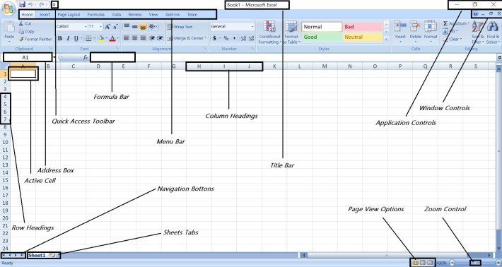.
Features
1. Formulas
Formulas are the Bread and Butter of worksheet. A formula consists of special code, which is entered into a cell. It performs some calculations and returns a result, which is displayed in the cell.
Creating Formula
For creating a formula you need to type in the formula bar. Formula begins with “=” sign.Using the Pointing method to supply the cell addresses for formulas is often easier and more powerful
method of formula building. When you are using built-in functions, you click the cell or drag through the cell range that you want to use when defining the function’s arguments in the Function Arguments dialog box.

2. Function in Formula
These functions enable you to greatly enhance the power of your formulas and perform calculations that are difficult if you use only the operators. You can’t do this complicated calculation by using the mathematical operators alone.
Using Functions
When you type = sign and then type any alphabet you will see the searched functions as below.

PowerPoint
Introduction to MS-Powerpoint
MS-Powerpoint is a presentation software that helps us to create combination of various slides depicting a graphical and visual interpretation of data, to present information in a more creative and interactive manner.
How to open MS-Powerpoint
Step 1 – Click the button windows + R at the same time.
Step 2 – Write powerpnt in open option in run file.
Step 3 – Press OK button and now MS-Powerpoint file is open.
Following is the basic window which you get when you start the Powerpoint application.
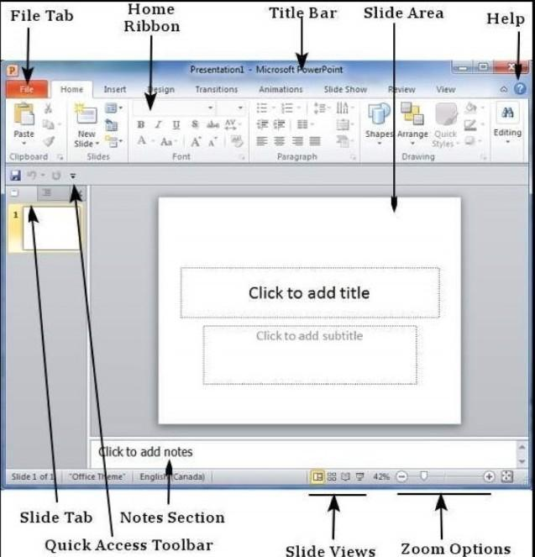

Features of Powerpoint
1. Slide Layout
Multiple options and layouts are available based on which a presentation can be created.
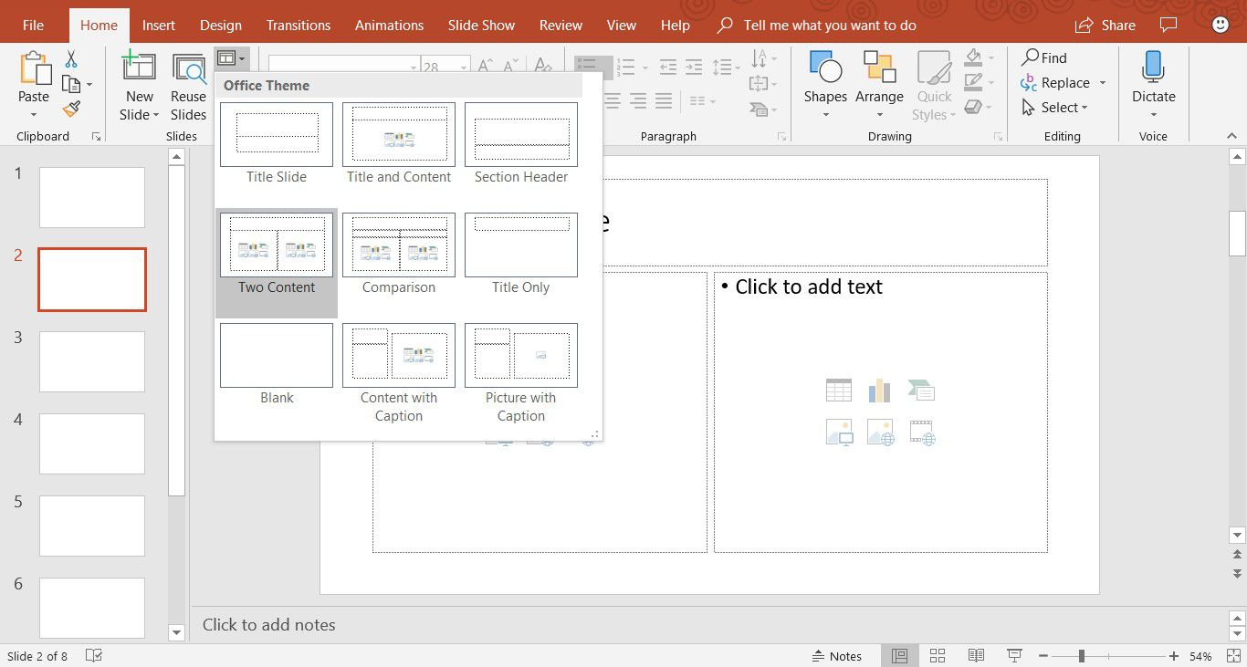
2. Slide Design
MS-Powerpoint has various themes using which background color and designs or textures can be added to a slide.
Given below are the steps to apply theme in PowerPoint:
Step 1: Click the Design ribbon and Select one of the theme that suits your requirements.
Step 2: To edit the theme for a specific slide, right-click on the desired theme and select.
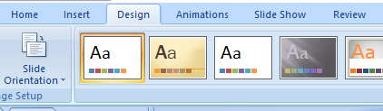
3. Slide Background
As PowerPoint is a design-based program, backgrounds are effective ways of improving the aesthetics and readibility of the slides. The Themes in Powerpoint help to select the background by default, so every time you change the theme.
Given below are the steps to apply backgrounds in PowerPoint.
Step 1 – Click on Design tab
Step 2 – Click on Format Background at the Right Corner of window.
Step 3 – Set the desigred background following the options as shown on above image.
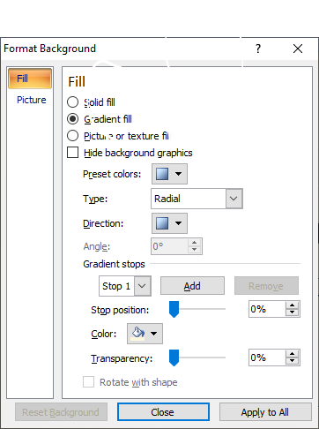
Slide Show in PowerPoint
Most PowerPoint presentations are created to be run as a slideshow. too. Most of these features are really to help you create a good slideshow without having to go through the entire presentation over and over again after every minor change.
Convert PowerPoint Slide to a Video
Step 1 : Click on the file tab to show file options.
Step 2 : Scroll down and select Export and navigate to create a video.
Step 3 : Select your video settings preferences and Click on create a video.
Step 4 : Choose a filename, saving a location and video type.
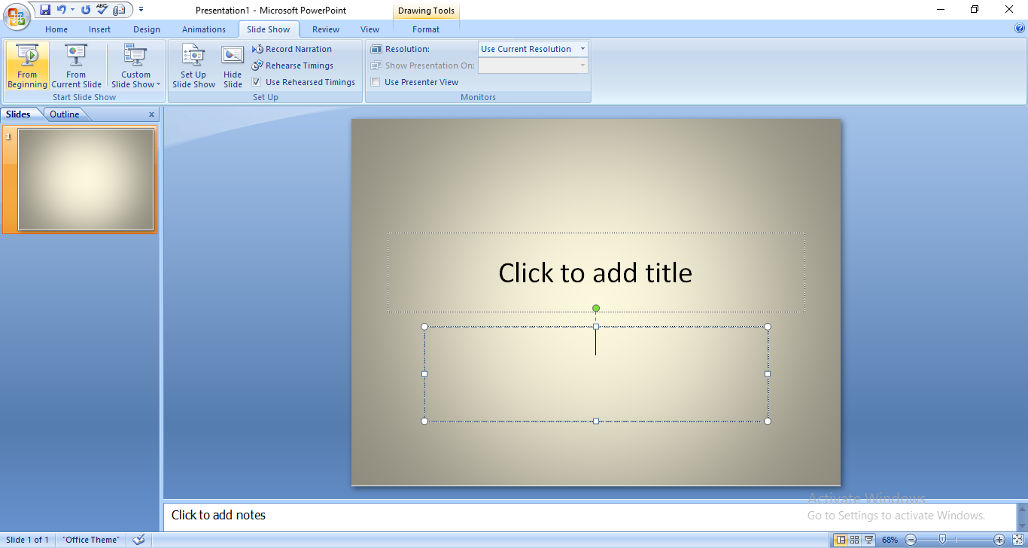
Lab Work

Adobe Photoshop

