**Lab 4 Submission – Srijan Kumar**

**Data Wrangler Script and Screenshot: CMSC**

from wrangler import dw

import sys

if(len(sys.argv) < 3):

sys.exit('Error: Please include an input and output file. Example python script.py input.csv output.csv')

w = dw.DataWrangler()

# Split data repeatedly on newline into rows

w.add(dw.Split(column=["data"],

table=0,

status="active",

drop=True,

result="row",

update=False,

insert_position="right",

row=None,

on="\n",

before=None,

after=None,

ignore_between=None,

which=1,

max=0,

positions=None,

quote_character=None))

# Split data repeatedly on '|'

w.add(dw.Split(column=["data"],

table=0,

status="active",

drop=True,

result="column",

update=False,

insert_position="right",

row=None,

on="\\|",

before=None,

after=None,

ignore_between=None,

which=1,

max=0,

positions=None,

quote_character="\""))

# Cut on '"'

w.add(dw.Cut(column=[],

table=0,

status="active",

drop=False,

result="column",

update=True,

insert_position="right",

row=None,

on="\"",

before=None,

after=None,

ignore_between=None,

which=1,

max=0,

positions=None))

# Drop split

w.add(dw.Drop(column=["split"],

table=0,

status="active",

drop=True))

# Extract from split1 between '[\[' and ' FIFA'

w.add(dw.Extract(column=["split1"],

table=0,

status="active",

drop=False,

result="column",

update=False,

insert_position="right",

row=None,

on=".*",

before=" FIFA",

after="\\[\\[",

ignore_between=None,

which=1,

max=1,

positions=None))

# Drop split1

w.add(dw.Drop(column=["split1"],

table=0,

status="active",

drop=True))

# Extract from split2 between '[\[' and ' FIFA'

w.add(dw.Extract(column=["split2"],

table=0,

status="active",

drop=False,

result="column",

update=False,

insert_position="right",

row=None,

on=".*",

before=" FIFA",

after="\\[\\[",

ignore_between=None,

which=1,

max=1,

positions=None))

# Drop split2

w.add(dw.Drop(column=["split2"],

table=0,

status="active",

drop=True))

# Extract from split3 before '}}'

w.add(dw.Extract(column=["split3"],

table=0,

status="active",

drop=False,

result="column",

update=False,

insert_position="right",

row=None,

on=".*",

before="}}",

after=None,

ignore_between=None,

which=1,

max=1,

positions=None))

# Drop split3

w.add(dw.Drop(column=["split3"],

table=0,

status="active",

drop=True))

# Extract from split4 between '[\[' and ' FIFA'

w.add(dw.Extract(column=["split4"],

table=0,

status="active",

drop=False,

result="column",

update=False,

insert_position="right",

row=None,

on=".*",

before=" FIFA",

after="\\[\\[",

ignore_between=None,

which=1,

max=1,

positions=None))

# Drop split4

w.add(dw.Drop(column=["split4"],

table=0,

status="active",

drop=True))

# Extract from split5 between '[\[' and ' FIFA'

w.add(dw.Extract(column=["split5"],

table=0,

status="active",

drop=False,

result="column",

update=False,

insert_position="right",

row=None,

on=".*",

before=" FIFA",

after="\\[\\[",

ignore_between=None,

which=1,

max=1,

positions=None))

# Drop split5

w.add(dw.Drop(column=["split5"],

table=0,

status="active",

drop=True))

# Extract from split6 between '[\[' and ' FIFA'

w.add(dw.Extract(column=["split6"],

table=0,

status="active",

drop=False,

result="column",

update=False,

insert_position="right",

row=None,

on=".*",

before=" FIFA",

after="\\[\\[",

ignore_between=None,

which=1,

max=1,

positions=None))

# Drop split6

w.add(dw.Drop(column=["split6"],

table=0,

status="active",

drop=True))

# Drop split7

w.add(dw.Drop(column=["split7"],

table=0,

status="active",

drop=True))

# Delete empty rows

w.add(dw.Filter(column=[],

table=0,

status="active",

drop=False,

row=dw.Row(column=[],

table=0,

status="active",

drop=False,

conditions=[dw.Empty(column=[],

table=0,

status="active",

drop=False,

percent_valid=0,

num_valid=0)])))

# Fill extract2 with values from above

w.add(dw.Fill(column=["extract2"],

table=0,

status="active",

drop=False,

direction="down",

method="copy",

row=None))

# Merge extract2, extract, extract1, extract3... with glue ,

w.add(dw.Merge(column=["extract2","extract","extract1","extract3","extract4","extract5"],

table=0,

status="active",

drop=False,

result="column",

update=False,

insert_position="right",

row=None,

glue=","))

# Drop extract, extract1, extract2, extract3...

w.add(dw.Drop(column=["extract","extract1","extract2","extract3","extract4","extract5"],

table=0,

status="active",

drop=True))

# Split merge repeatedly on ','

w.add(dw.Split(column=["merge"],

table=0,

status="active",

drop=True,

result="column",

update=False,

insert_position="right",

row=None,

on=",",

before=None,

after=None,

ignore_between=None,

which=1,

max="0",

positions=None,

quote_character=None))

# Delete rows where split8 is null

w.add(dw.Filter(column=[],

table=0,

status="active",

drop=False,

row=dw.Row(column=[],

table=0,

status="active",

drop=False,

conditions=[dw.IsNull(column=[],

table=0,

status="active",

drop=False,

lcol="split8",

value=None,

op_str="is null")])))

w.apply_to_file(sys.argv[1]).print_csv(sys.argv[2])

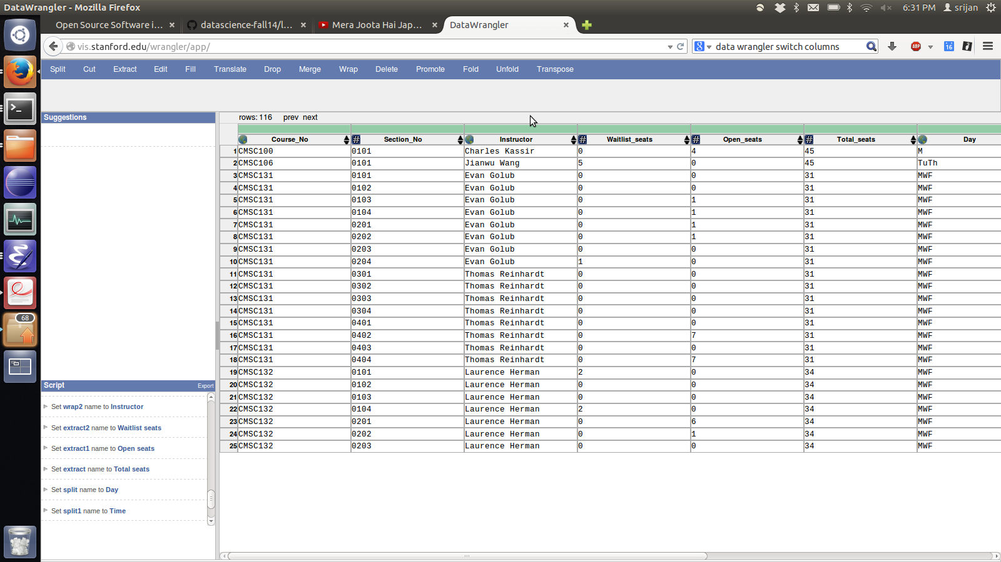

**Data Wrangler Script and Screenshot: World Cup 1**

from wrangler import dw

import sys

if(len(sys.argv) < 3):

sys.exit('Error: Please include an input and output file. Example python script.py input.csv output.csv')

w = dw.DataWrangler()

# Split data repeatedly on newline into rows

w.add(dw.Split(column=["data"],

table=0,

status="active",

drop=True,

result="row",

update=False,

insert_position="right",

row=None,

on="\n",

before=None,

after=None,

ignore_between=None,

which=1,

max=0,

positions=None,

quote_character=None))

# Split data repeatedly on '|'

w.add(dw.Split(column=["data"],

table=0,

status="active",

drop=True,

result="column",

update=False,

insert_position="right",

row=None,

on="\\|",

before=None,

after=None,

ignore_between=None,

which=1,

max=0,

positions=None,

quote_character="\""))

# Cut on '"'

w.add(dw.Cut(column=[],

table=0,

status="active",

drop=False,

result="column",

update=True,

insert_position="right",

row=None,

on="\"",

before=None,

after=None,

ignore_between=None,

which=1,

max=0,

positions=None))

# Drop split

w.add(dw.Drop(column=["split"],

table=0,

status="active",

drop=True))

# Extract from split1 between '[\[' and ' FIFA'

w.add(dw.Extract(column=["split1"],

table=0,

status="active",

drop=False,

result="column",

update=False,

insert_position="right",

row=None,

on=".*",

before=" FIFA",

after="\\[\\[",

ignore_between=None,

which=1,

max=1,

positions=None))

# Drop split1

w.add(dw.Drop(column=["split1"],

table=0,

status="active",

drop=True))

# Extract from split2 between '[\[' and ' FIFA'

w.add(dw.Extract(column=["split2"],

table=0,

status="active",

drop=False,

result="column",

update=False,

insert_position="right",

row=None,

on=".*",

before=" FIFA",

after="\\[\\[",

ignore_between=None,

which=1,

max=1,

positions=None))

# Drop split2

w.add(dw.Drop(column=["split2"],

table=0,

status="active",

drop=True))

# Extract from split3 before '}}'

w.add(dw.Extract(column=["split3"],

table=0,

status="active",

drop=False,

result="column",

update=False,

insert_position="right",

row=None,

on=".*",

before="}}",

after=None,

ignore_between=None,

which=1,

max=1,

positions=None))

# Drop split3

w.add(dw.Drop(column=["split3"],

table=0,

status="active",

drop=True))

# Extract from split4 between '[\[' and ' FIFA'

w.add(dw.Extract(column=["split4"],

table=0,

status="active",

drop=False,

result="column",

update=False,

insert_position="right",

row=None,

on=".*",

before=" FIFA",

after="\\[\\[",

ignore_between=None,

which=1,

max=1,

positions=None))

# Drop split4

w.add(dw.Drop(column=["split4"],

table=0,

status="active",

drop=True))

# Extract from split5 between '[\[' and ' FIFA'

w.add(dw.Extract(column=["split5"],

table=0,

status="active",

drop=False,

result="column",

update=False,

insert_position="right",

row=None,

on=".*",

before=" FIFA",

after="\\[\\[",

ignore_between=None,

which=1,

max=1,

positions=None))

# Drop split5

w.add(dw.Drop(column=["split5"],

table=0,

status="active",

drop=True))

# Extract from split6 between '[\[' and ' FIFA'

w.add(dw.Extract(column=["split6"],

table=0,

status="active",

drop=False,

result="column",

update=False,

insert_position="right",

row=None,

on=".*",

before=" FIFA",

after="\\[\\[",

ignore_between=None,

which=1,

max=1,

positions=None))

# Drop split6

w.add(dw.Drop(column=["split6"],

table=0,

status="active",

drop=True))

# Drop split7

w.add(dw.Drop(column=["split7"],

table=0,

status="active",

drop=True))

# Delete empty rows

w.add(dw.Filter(column=[],

table=0,

status="active",

drop=False,

row=dw.Row(column=[],

table=0,

status="active",

drop=False,

conditions=[dw.Empty(column=[],

table=0,

status="active",

drop=False,

percent_valid=0,

num_valid=0)])))

# Fill extract2 with values from above

w.add(dw.Fill(column=["extract2"],

table=0,

status="active",

drop=False,

direction="down",

method="copy",

row=None))

# Merge extract2, extract, extract1, extract3... with glue ,

w.add(dw.Merge(column=["extract2","extract","extract1","extract3","extract4","extract5"],

table=0,

status="active",

drop=False,

result="column",

update=False,

insert_position="right",

row=None,

glue=","))

# Drop extract, extract1, extract2, extract3...

w.add(dw.Drop(column=["extract","extract1","extract2","extract3","extract4","extract5"],

table=0,

status="active",

drop=True))

# Split merge repeatedly on ','

w.add(dw.Split(column=["merge"],

table=0,

status="active",

drop=True,

result="column",

update=False,

insert_position="right",

row=None,

on=",",

before=None,

after=None,

ignore_between=None,

which=1,

max="0",

positions=None,

quote_character=None))

# Delete rows where split8 is null

w.add(dw.Filter(column=[],

table=0,

status="active",

drop=False,

row=dw.Row(column=[],

table=0,

status="active",

drop=False,

conditions=[dw.IsNull(column=[],

table=0,

status="active",

drop=False,

lcol="split8",

value=None,

op_str="is null")])))

w.apply_to_file(sys.argv[1]).print_csv(sys.argv[2])

A description...

**Data Wrangler Script and Screenshot: World Cup 2**

Too difficult to do

**UNIX Tools Command: CMSC**

cat cmsc.txt | grep -v '^$' | awk -v OFS=',' '/^(CSI|AVW|JMP|ITV|MTH)/ {print $1, $2} !/^(CSI|AVW|JMP|ITV|MTH) / {print $0}' | awk -F')' '/^Seats/ {print $1} !/^Seats/ {print $0}' | awk -F',' '/^Seats/ {print $1, $2, $3} !/^Seats/ {print $0}' | awk -v OFS=',' '/^CMSC/ {course = $1} /^0/ {print course, $0} !/(^CMSC|^0|^Seats)/ {print $0} /^Seats/ {print $3,$5,$7} ' | awk '/^CMSC/ {print combined; combined = $0} !/^CMSC/ {combined = combined", "$0;} END {print combined}'

**UNIX Tools Command: World Cup 1**

cat worldcup.txt | tail +3 | sed 's/|style="background:#fff68f"|//g' | sed 's/{{//g' | sed 's/}}/\ /g' | sed 's/}}/\ /g' | sed 's/(fb\||\|fb\|)//g' | awk '/^(fb|\|fb)/ {num = 0;print $0} !/^(fb|\|fb)/{num = num + 1; if(num < 5) print num," ",$0}' | sed 's/\|fb\|//g' | sed 's/fb\|//g' | awk '/^[A-Z]/ {country = $1} !/^[A-Z]/ {print country, $0}' | grep -v 'sort dash' | grep -v '-' | sed 's/\|[0-9][0-9][0-9][0-9]//g' | sed 's/FIFA\ World\ Cup//g' | sed 's/(\[\[//g' | sed 's/]])//g' | sed 's/\[\[//g' | sed 's/]]*//g' | sed 's/#*//g' | sed 's/\*//g' | sed 's/\,//g' | sed 's/[0-9]\|//g' | awk -v OFS=',' '// { country = $1; medal = $2; for(i = 4; i <= NF; i++) {print country, $i, medal;}}'

**Python Script: CMSC**

import unicodecsv

fw = open("cmsc-python-edited.csv","w")

writer = unicodecsv.writer(fw, encoding="utf8", lineterminator="\n")

writer.writerow(("Course No.","Section No.","Instructor","Seats","Open","Waitlist","Days","Time","Bldg.","Room No."))

f = open("cmsc.txt","r")

l = f.readline().strip()

while l!='':

course = l

l = f.readline().strip()

while l!= '':

section = l

instr = f.readline().strip()

l = f.readline().strip().split(": ")

print l

totalseats = l[1].split(",")[0]

openseats = l[2].split(",")[0]

waitlist = l[3].split(")")[0]

l = f.readline().strip().split()

day = l[0]

time = ' '.join(l[1:])

l = f.readline().strip().split()

bldg = l[0]

room = l[1]

writer.writerow((course, section, instr, totalseats, openseats, waitlist, day, time, bldg, room))

l = f.readline().strip()

l = f.readline().strip()

f.close()

fw.close()

**Python Script: World Cup 1**

import unicodecsv

import re

fw = open("wc1-python-edited.csv","w")

writer = unicodecsv.writer(fw, encoding="utf8", lineterminator="\n")

writer.writerow(("Team","Year","Position"))

f = open("worldcup.txt","r")

f.readline()

l = f.readline().strip()

while l!="|}":

l = f.readline().strip()

country = l.split("{{fb|")[1].split("}}")[0]

for i in range(4):

pos = re.findall("\|\d{4}]]", f.readline().strip())

for pos in pos:

writer.writerow((country, pos[1:-2], i+1))

f.readline()

l = f.readline().strip()

fw.close()

f.close()

**Python Script: World Cup 2**

import unicodecsv

import re

fw = open("wc2-python-edited.csv","w")

writer = unicodecsv.writer(fw, encoding="utf8", lineterminator="\n")

awards = {}

f = open("worldcup.txt","r")

f.readline()

l = f.readline().strip()

while l!="|}":

l = f.readline().strip()

country = l.split("{{fb|")[1].split("}}")[0]

countryawards = awards.get(country, {})

for i in range(4):

pos = re.findall("\|\d{4}]]", f.readline().strip())

for pos in pos:

countryawards[pos[1:-2]] = i+1

awards[country] = countryawards

f.readline()

l = f.readline().strip()

f.close()

writer.writerow([i for i in range(1930,2015,4)])

for k in awards:

x = [k]

print k, awards[k].keys()

for i in range(1930, 2015, 4):

x.append('-' if str(i) not in awards[k].keys() else awards[k][str(i)])

writer.writerow(x)

fw.close()