**#include <bits/stdc++.h>**

**using namespace std;**

**void printMaxActivities(int s[], int f[], int n)**

**{**

**int i, j;**

**cout << "Following activities are selected" << endl;**

**i = 0;**

**cout << i << " ";**

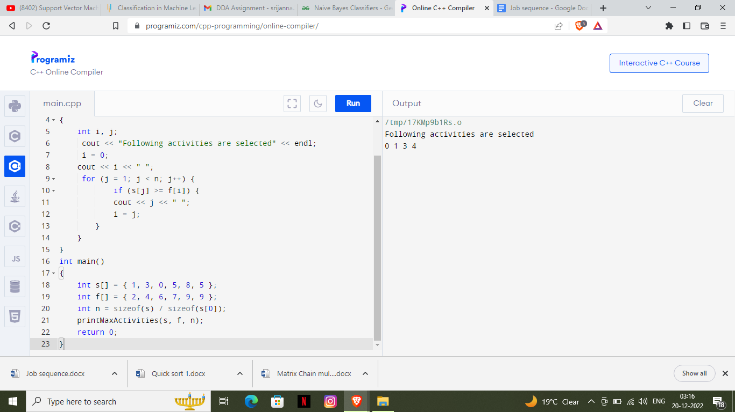 **for (j = 1; j < n; j++) {**

**if (s[j] >= f[i]) {**

**cout << j << " ";**

**i = j;**

**}**

**}**

**}**

**int main()**

**{**

**int s[] = { 1, 3, 0, 5, 8, 5 };**

**int f[] = { 2, 4, 6, 7, 9, 9 };**

**int n = sizeof(s) / sizeof(s[0]);**

**printMaxActivities(s, f, n);**

**return 0;**

**}**