Lab – I
Aim : Introduction to Python for Data Analysis
Introduction to Python for Data Analysis focuses on familiarizing students with Python as an effective tool for handling and analyzing data. In this lab, students learn the basics of Python programming required for data analysis and gain hands-on experience with essential libraries such as NumPy and Pandas. The experiment covers creating and manipulating arrays, generating matrices using zeros and ones, understanding array shape and reshaping, and working with tabular data using Pandas DataFrames. Students also practice reading data from CSV files and performing basic data exploration using functions like head(), tail(), info(), describe(), and dtypes, which helps them understand dataset structure, data types, and statistical properties essential for further machine learning and data science tasks.
Experiment-1 : Write a Python program to Create a NumPy array using a Python list, Display the array and print the shape and data type of the array.
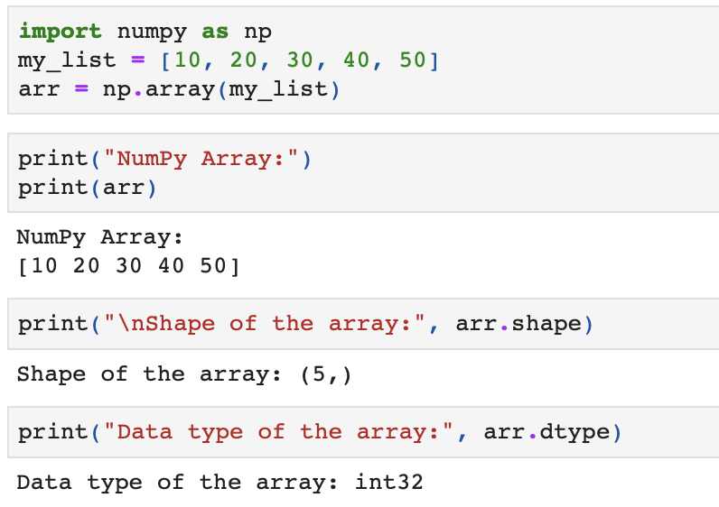
Experiment-2 : Write a program to Create a 3×4 matrix of zeros, create a 2×5 matrix of ones and print both matrices and their shapes.
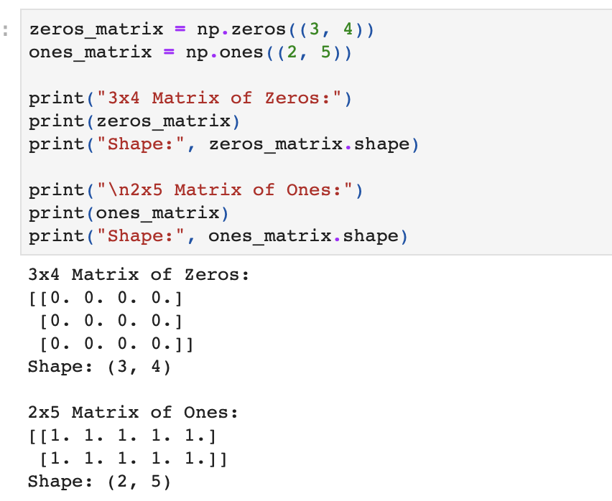
Experiment-3: Write a program to Create a NumPy array of numbers from 1 to 12, Reshape the array into a 3×4 matrix and display the original and reshaped array along with their shapes.
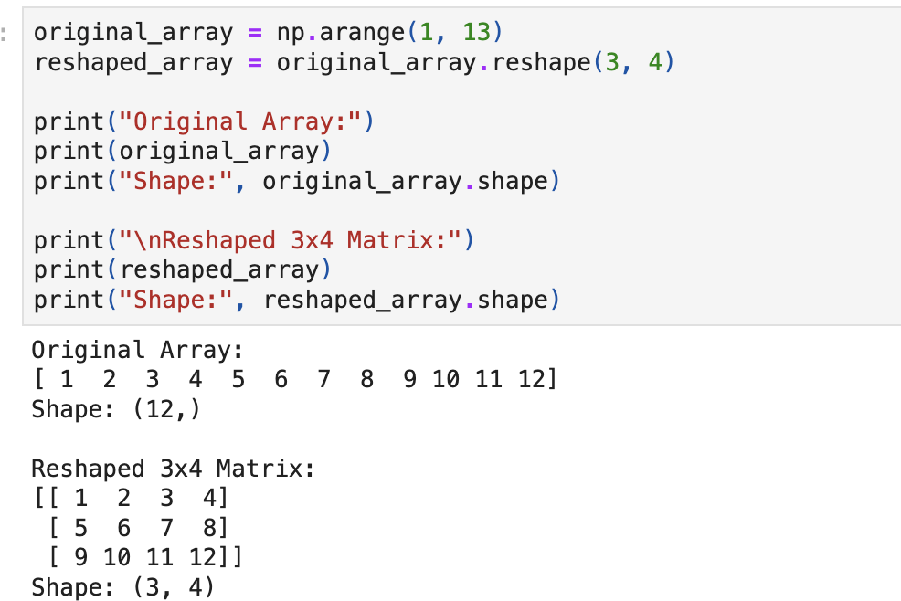
Experiment-4: Write a program to create a NumPy array of 10 random integers, Find the minimum, maximum, mean, and sum of the array.
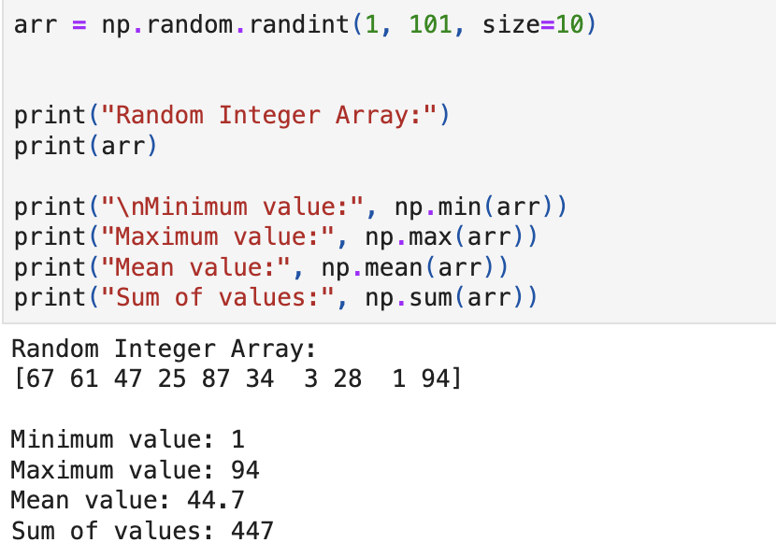
Experiment-5: Write a Python program to create a Pandas DataFrame using a dictionary containing student names and marks. Display the DataFrame and print the data types (dtypes) of each column.
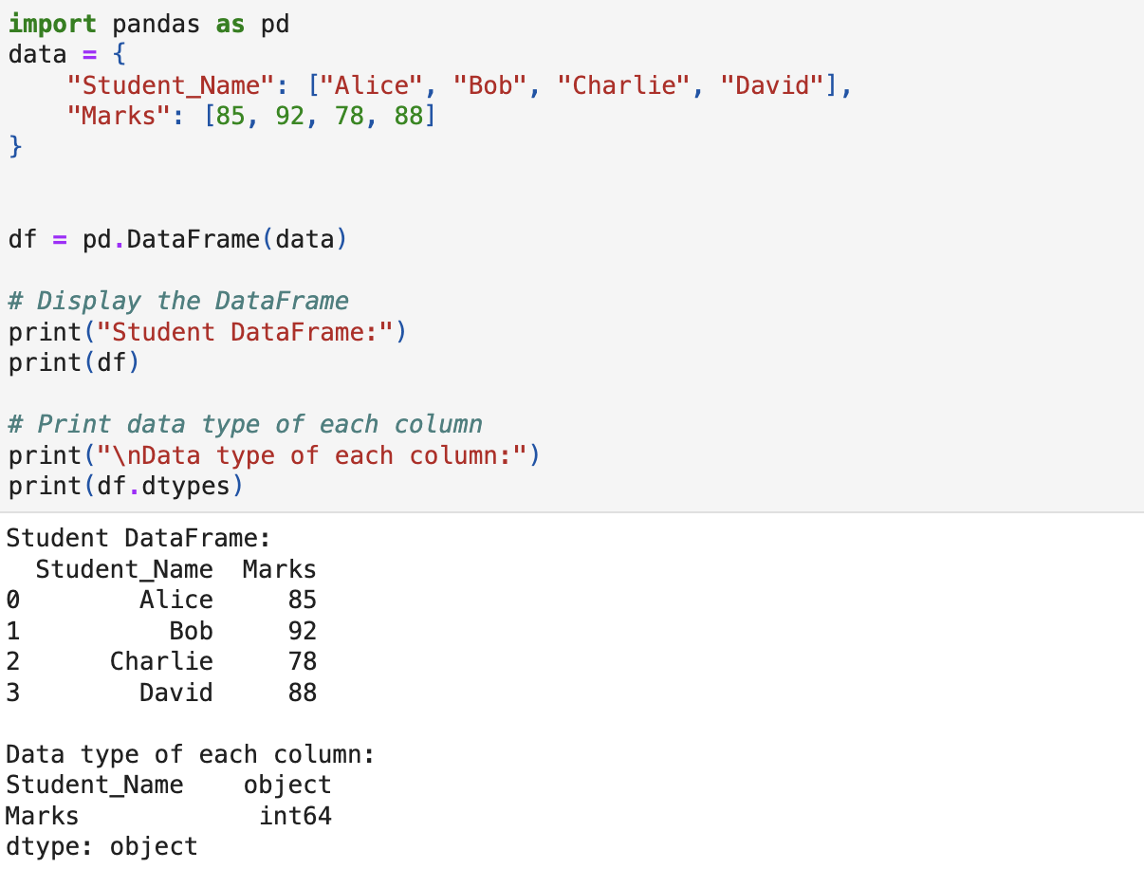
Experiment-6: Write a program to read a CSV file using read_csv(). Display the first 5 records using head() and display the last 5 records using tail() method.
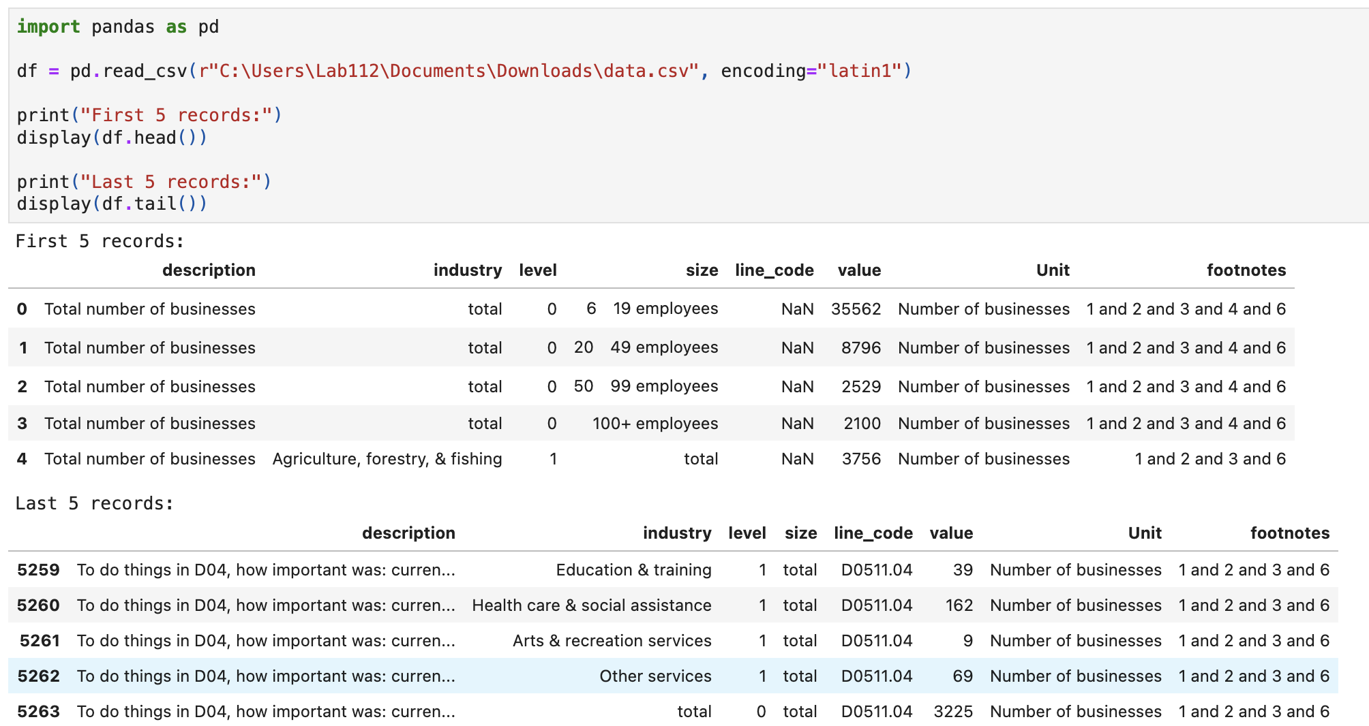

Experiment-7: Write a Python program to Load a dataset using Pandas Display dataset structure using info() and identify the number of rows, columns, and missing values.
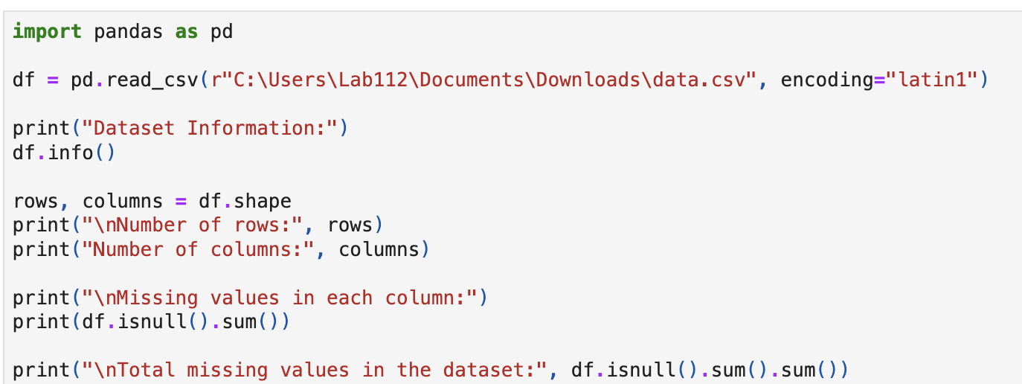
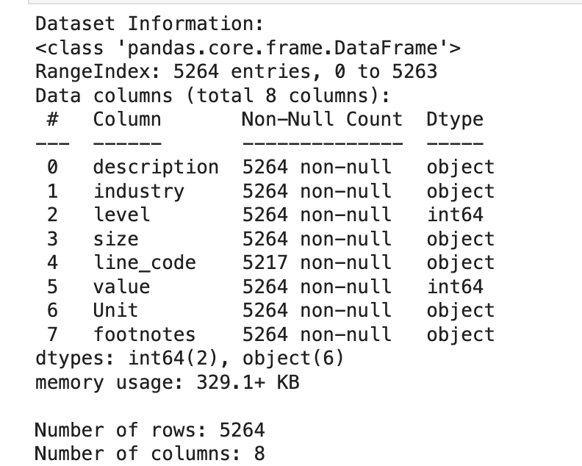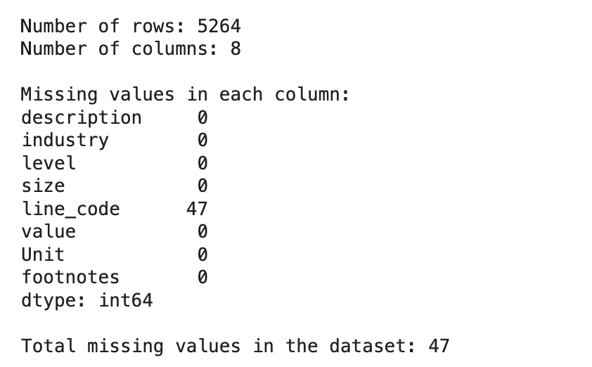
.
Experiment-8: Write a program to Read a CSV file into a DataFrame Display statistical summary using describe() Interpret mean, standard deviation, minimum, and maximum values.
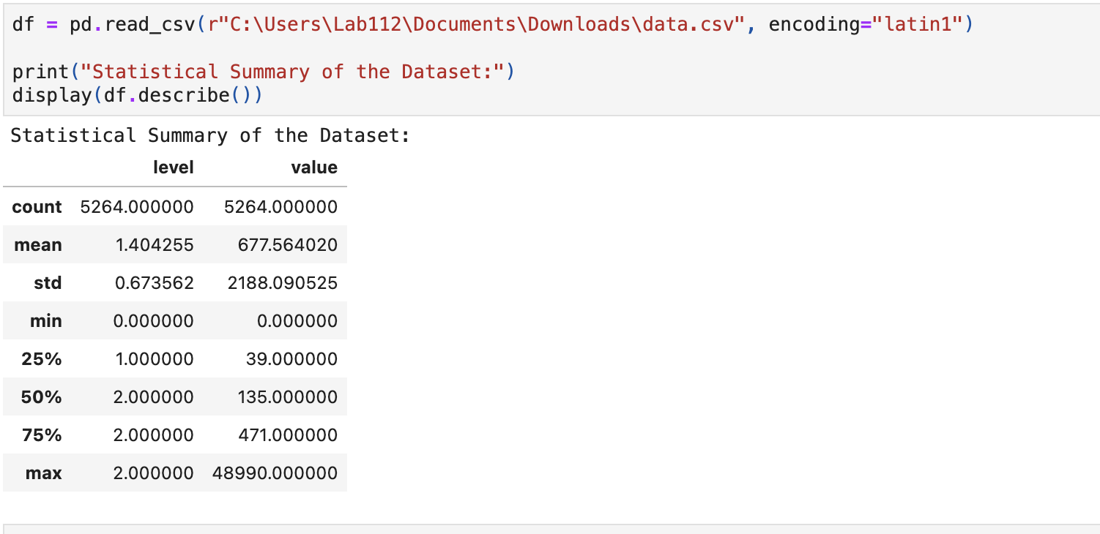

Lab – II
Aim : Data Preprocessing and Visualization
This lab focuses on performing data cleaning, preprocessing, and visualization to prepare datasets for machine learning tasks. Students will explore real-world datasets to identify and handle missing values, remove inconsistencies, and transform data into a suitable format for analysis. The lab also covers basic preprocessing techniques such as encoding categorical variables and scaling numerical features. In addition, students will use data visualization methods to examine data distributions, detect outliers, and understand relationships between
features. These steps help ensure data quality and provide meaningful insights, forming a strong foundation for building accurate and reliable machine learning models.

Experiment 1: Write a Python program to Load a dataset using Pandas Identify missing values using isnull() and notnull(). Display the total count of missing values in each column.

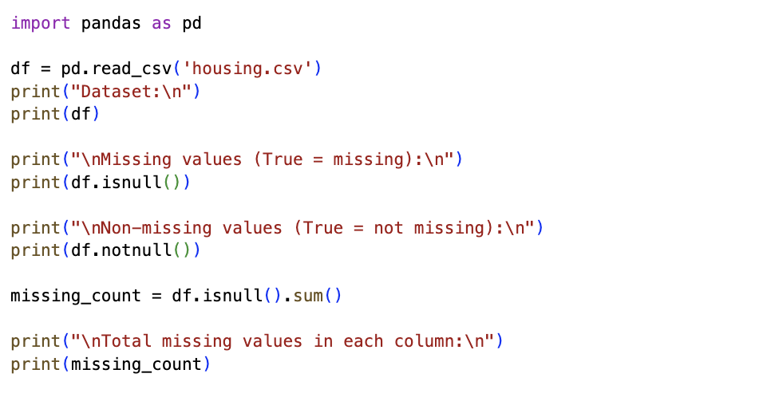

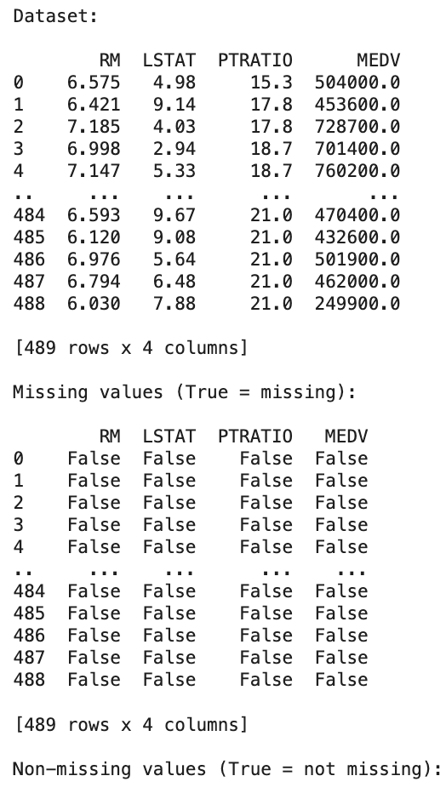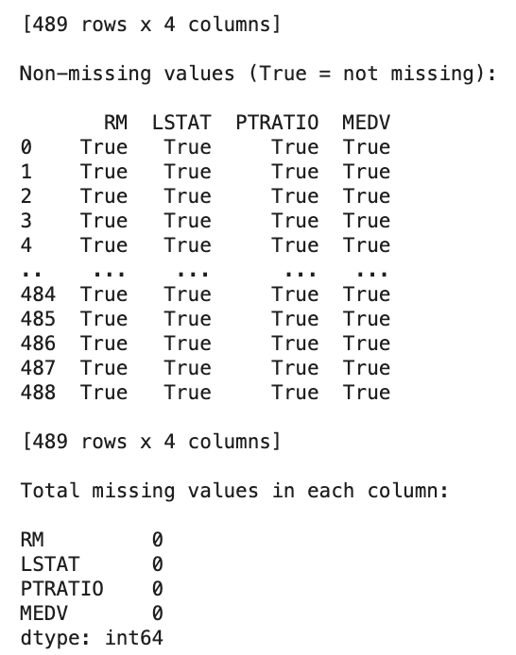

Experiment 2: Write a program to Read a CSV dataset Remove rows containing missing
values. Compare the dataset size before and after cleaning.
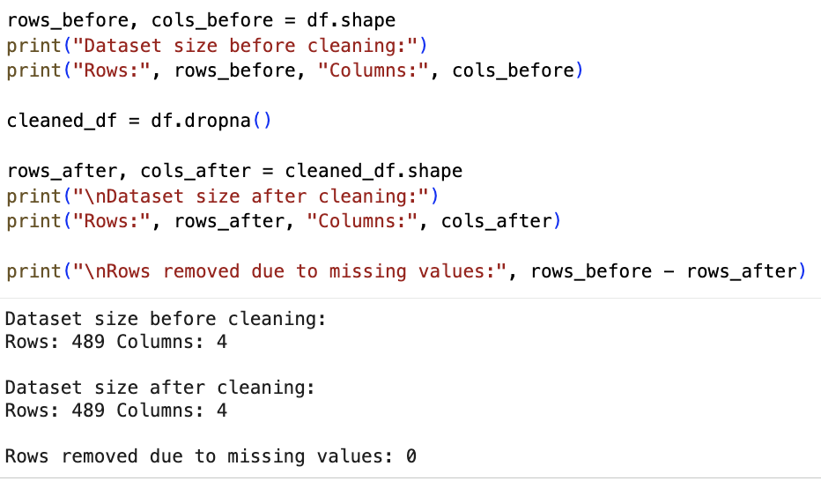
Experiment 3: Write a Python program to load a dataset with missing values Replace missing numerical values using fillna() with mean or median. Replace missing categorical values using appropriate constants.
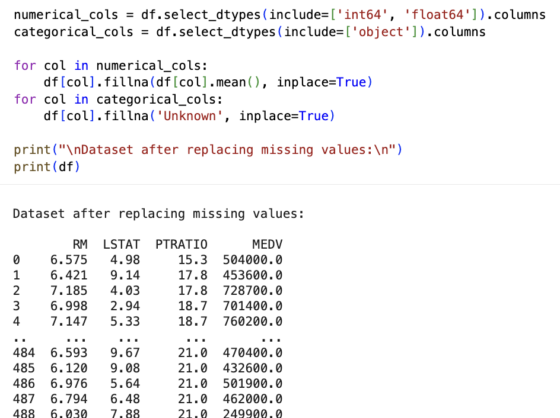
Experiment 4: Write a program to load a dataset, Display column data types, Convert selected columns to appropriate data types using astype(). Verify the changes.
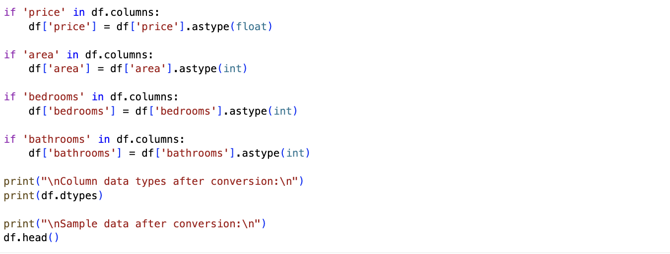

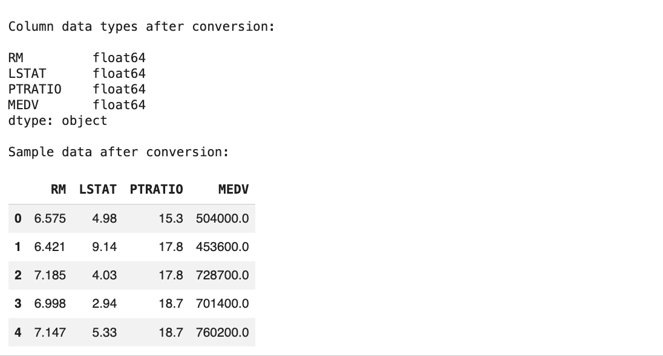

Experiment 5: Write a Python program to load a dataset, rename column names using
rename() for better readability. Display the updated DataFrame.
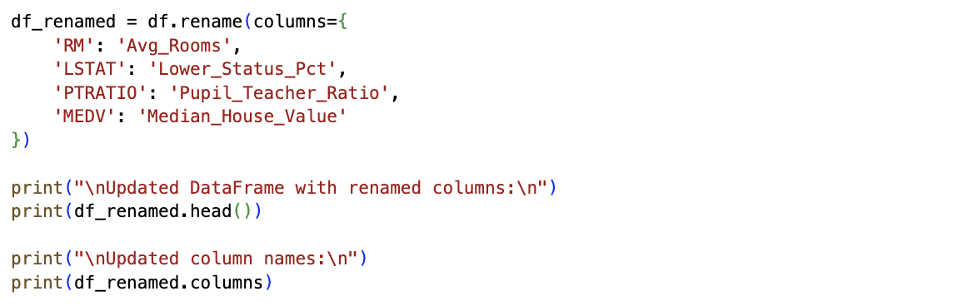
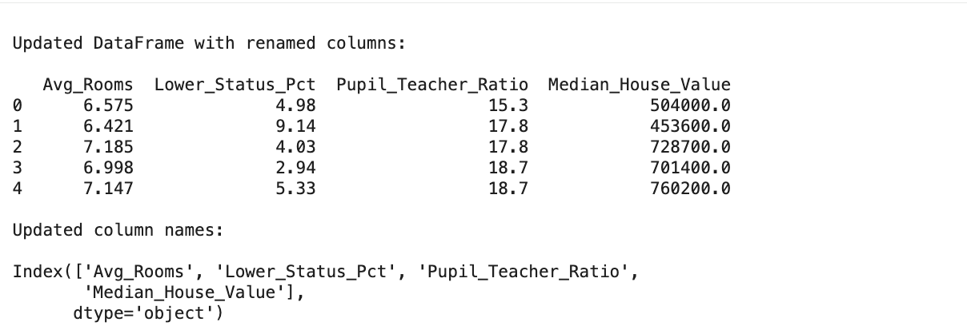
Experiment-6 :Write a program to identify inconsistent or incorrect values in a dataset Replace them using the replace() function Verify the corrected data.
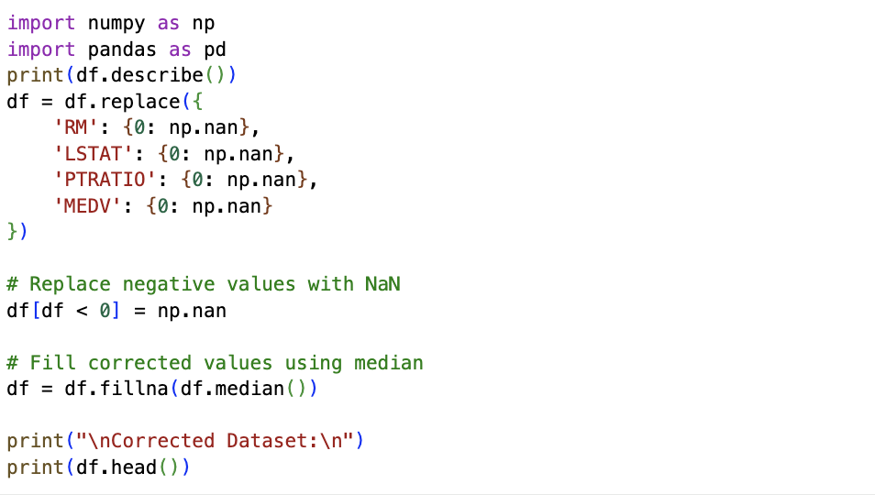
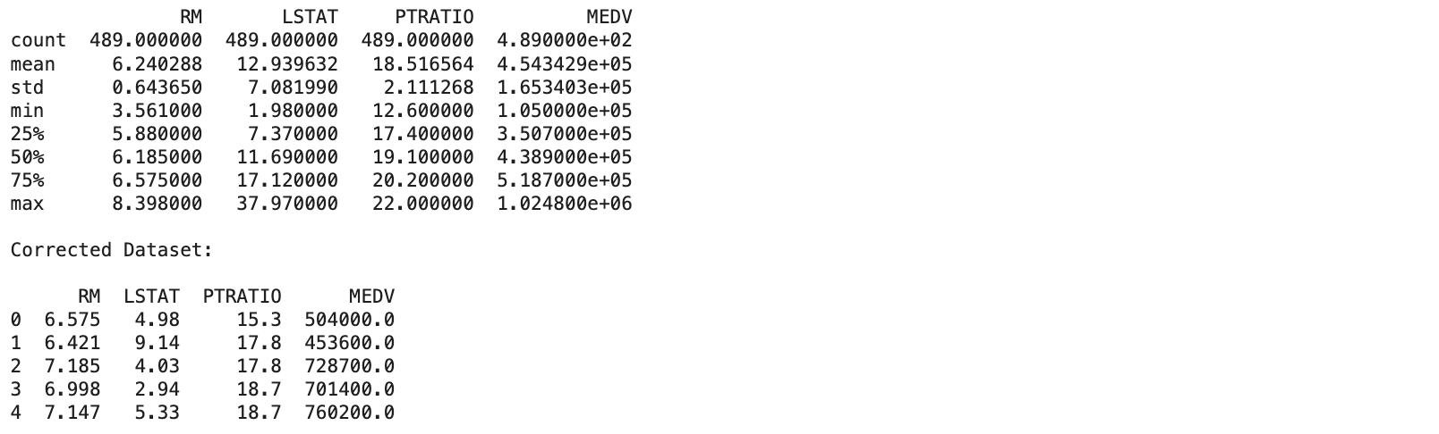
Experiment 7: Write a Python program to load a dataset. Create a line plot to show trends over time. Create a bar plot to compare categorical data.
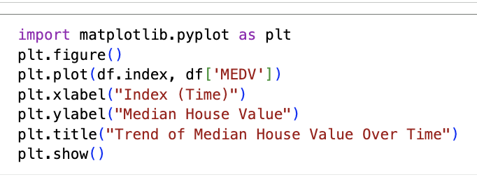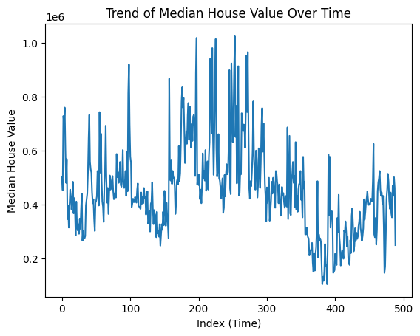

Experiment 8 Create a scatter plot between two numerical features. Interpret the relationship between the features.
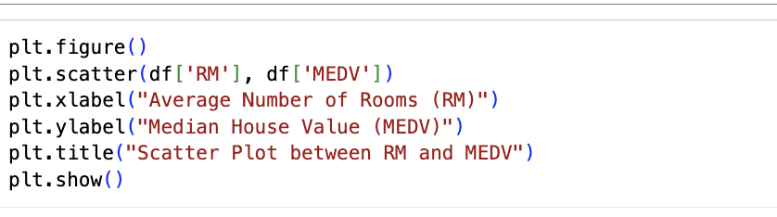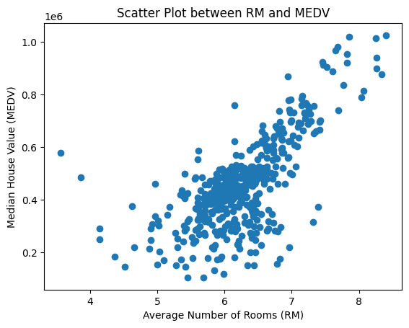

Experiment-9 : Write a Python program to load a dataset. Plot a histogram for a selected
numerical feature. Analyse data distribution and skewness.
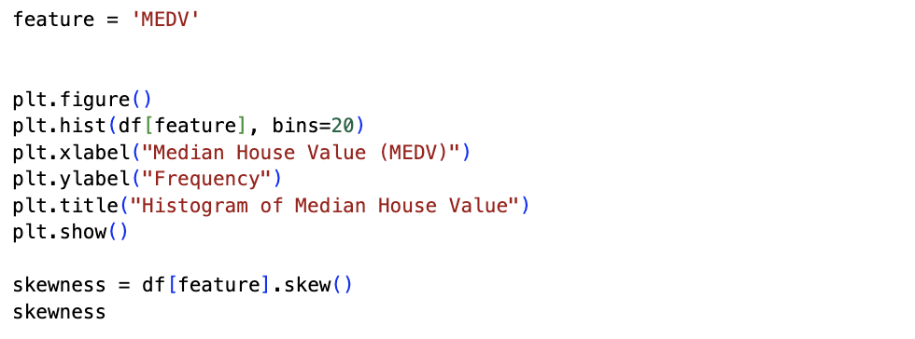
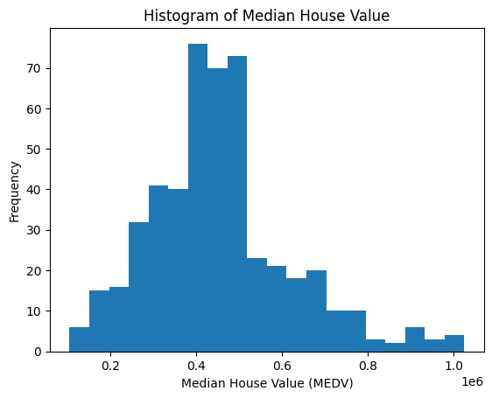

Experiment 10: Write a program to load a dataset. Create a boxplot for numerical attributes. Identify and interpret potential outliers.
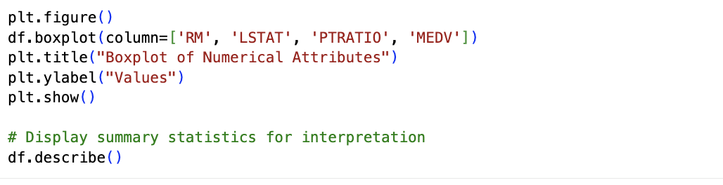
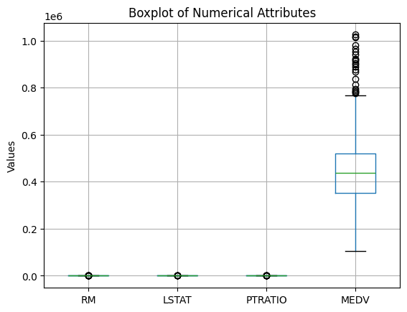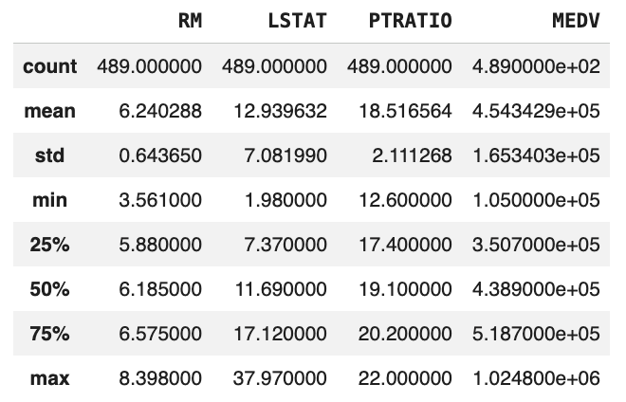

Lab – III
Descriptive Statistical Analysis
Aim : In this lab students focus on applying statistical techniques to summarize, explore, and interpret datasets in a meaningful way before applying machine learning models. Students will work with real-world datasets using Python libraries such as NumPy, SciPy, Pandas, and Matplotlib to compute key descriptive measures. The lab covers measures of central tendency including mean, median, and mode to understand the typical values in the data, and measures of dispersion such as minimum, maximum, sum, variance, and standard deviation to analyse data spread and variability. Students will also compute quartiles and percentiles to understand the distribution and relative position of data points and apply correlation and covariance analysis to study relationships and dependencies between variables.
Dataset: Students Performance Dataset
DatasetLink: https://github.com/rashida048/Datasets/blob/master/StudentsPerformance.csv

Description : The Students Performance Dataset contains information related to students’ academic performance along with basic demographic attributes. It includes categorical features such as gender, parental education level, and test preparation status, as well as numerical features like math score, reading score, and writing score. The presence of multiple numerical attributes makes this dataset suitable for applying descriptive statistical techniques such as measures of central tendency, dispersion, correlation, covariance, quartiles, and percentiles. This dataset is widely used for educational data analysis and is ideal for understanding data distribution and relationships before applying machine learning models.

Experiment-1 : Load the given CSV dataset and display the first few records to understand its structure. Identify numerical and categorical columns and select appropriate features for statistical analysis. Measures of Central Tendency (Compute and interpret mean, median, and mode for selected numerical attributes). Measures of Dispersion (Calculate minimum, maximum, sum, variance, and standard deviation to understand data spread).

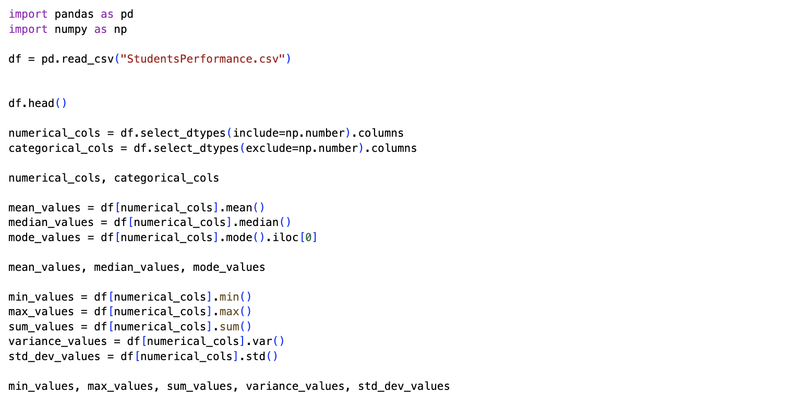

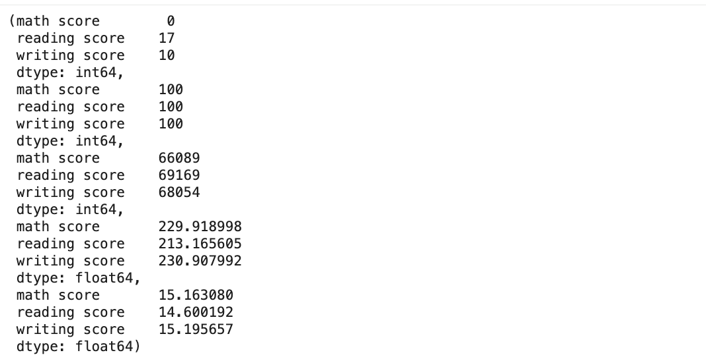

Experiment-2: Compute first quartile (Q1), second quartile (median), and third quartile (Q3) and interpret their significance.
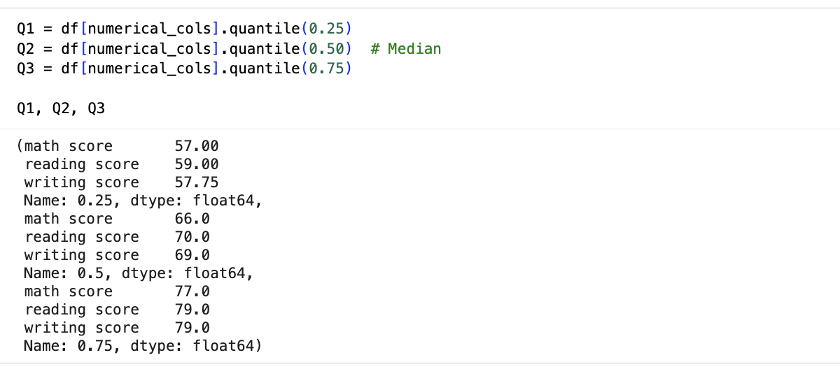

Experiment-3: Compute correlation coefficients between numerical features and interpret the strength and direction of relationships. Calculate covariance between selected variables and explain how it differs from correlation.
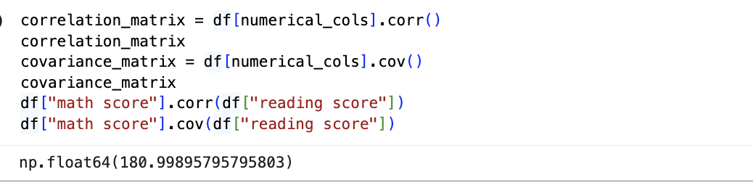

Experiment-4: Plot histograms to analyse data distribution and identify skewness or symmetry. Use boxplots to visualize quartiles, interquartile range, and potential outliers

