Experiment 5

Student Name: Srijan Tripathi UID: 24BAI70081
Branch: CSE - AIML Section/Group: 24AIT_KRG G1
Semester: 4 Date of Performance: 11/3/26
Subject Name: DBMS Subject Code: 24CSH-298

Aim
To understand and apply conditional logic in SQL by using the modulus operator (MOD / %) to analyse numerical data and classify employee salaries as odd or even, thereby improving data analysis and decision-making skills in SQL.

Software Requirements
- Database Management System:
  - Oracle Database Express Edition (Oracle XE)
  - PostgreSQL Database
- Database Administration Tool / Client Tool:
  - Oracle SQL Developer (for Oracle XE)
  - pgAdmin (for PostgreSQL)

Objectives
- To write and execute SQL queries that use the MOD (%) operator to check employee salaries and display odd and even salary values separately from an employee table.

Practical/Experiment Steps
- Schema Architecture: Created the employees table with a structured format, ensuring the emp_id serves as the Primary Key for data integrity.
- Data Ingestion: Populated the table with diverse employee records including names and specific salary figures to provide a sufficient dataset for numerical analysis.
- Mathematical Operation: Leveraged the modulus operator (%) to perform a parity check on the salary column by dividing each value by 2.
- Conditional Classification: Integrated a CASE statement to evaluate the result of the modulus operation and assign a descriptive text label to each record.
- Dynamic Column Generation: Produced a virtual column named salary_type during execution to display the results of the logic without altering the physical table structure.

Procedure
- Initialised the database environment using PostgreSQL or Oracle XE and opened the query editor.
- Executed the CREATE TABLE script to define the employee information schema.
- Used INSERT INTO statements to add multiple rows of sample data, ensuring a mix of odd and even salary values.
- Drafted a SELECT query to retrieve all existing columns while preparing for the conditional logic implementation.
- Applied the % operator within a CASE structure to determine if the emp_sal remained with a zero or non-zero remainder.
- Assigned the labels 'Even Salary' or 'Odd Salary' based on the evaluation of the conditional branch.
- Ran the complete query to verify that numerical values (like 12000 vs. 15675) were accurately classified in the output window.
- Reviewed the resulting data grid to ensure the salary_type column correctly reflected the parity of the corresponding salary.
- Saved the final SQL script and captured screenshots of the results for record maintenance.

Input/Output Analysis
SQL Input Queries
CREATE TABLE employees(
emp_id INT PRIMARY KEY,
emp_name VARCHAR(20),
emp_sal INT
);

INSERT INTO employees VALUES(1, 'Jack', 12000);
INSERT INTO employees VALUES(2, 'Sarah', 15675);
INSERT INTO employees VALUES(3, 'John', 13000);
INSERT INTO employees VALUES(4, 'Sally', 20001);
INSERT INTO employees VALUES(5, 'Charlie', 15000);

SELECT * ,
CASE
WHEN emp_sal%2 = 0 THEN 'Even Salary'
ELSE 'Odd Salary'
END AS salary_type
FROM employees;

Output
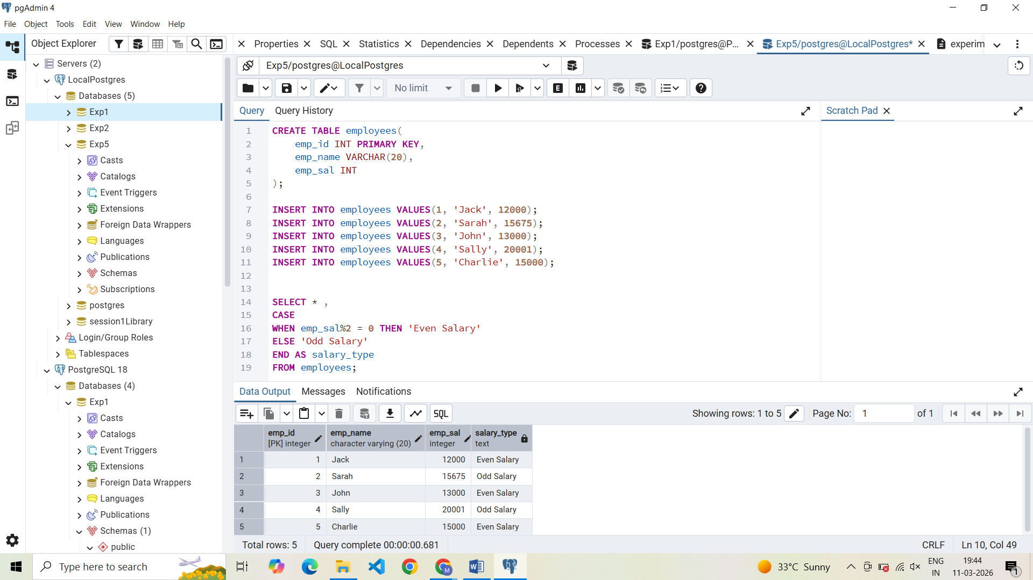

Learning Outcomes
- Gained proficiency in using the modulus operator to identify patterns in numerical data.
- Implemented CASE statements to categorise records based on mathematical results.
- Generated dynamic columns that provide analytical insights during data retrieval.
- Gained skills in transforming raw integers into meaningful descriptive categories for reporting.

