Fake News Detector Using Machine Learning
Student Assignment Report
Project Assignment: Full Stack Web Application with AI/ML Backend
Student Name: Srijata Moitra
University: Brainware University
Submission Date: 23/04/2026

Abstract
Fake news and misinformation have become major challenges in modern digital media ecosystems. Automated systems capable of detecting misleading or fabricated news content are increasingly important for maintaining information integrity.
This project presents a Fake News Detection Web Application that classifies news headlines or article snippets as Real or Fake using machine learning models. The system combines traditional text classification techniques (TF-IDF + Logistic Regression) with a transformer-based deep learning model (DistilBERT) to achieve high classification accuracy.
The trained model is deployed through a FastAPI backend, while a responsive web-based frontend interface allows users to interactively analyze news content and receive predictions with confidence scores.

1. Introduction
The widespread use of social media platforms has accelerated the dissemination of information across the internet. While this enables rapid information sharing, it also facilitates the spread of fake news, misinformation, and disinformation.
Fake news refers to fabricated or misleading information presented as legitimate news, often designed to manipulate public opinion or generate engagement.
Traditional fact-checking methods rely heavily on manual verification, which is slow and difficult to scale. Machine learning techniques provide a promising solution by automatically detecting patterns associated with fake news.
The objective of this project is to build an end-to-end fake news detection system that:
- Trains machine learning models on a real dataset
- Provides predictions through a backend API
- Offers an interactive web interface for users

2. Dataset
This project uses the ISOT Fake News Dataset, which contains a large collection of labeled news articles.
Dataset source: Kaggle – ISOT Fake News Dataset
Dataset Statistics
Category | Number of Articles
Fake News | 23,481
Real News | 21,417
Total | 44,898
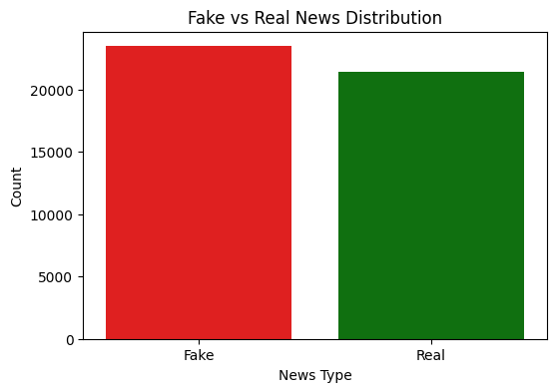
Each dataset entry contains:
- News title
- Article text
- Subject category
- Publication date
For training the model, the title and article text were combined into a single input feature.

3. Data Preprocessing
Before training the machine learning model, the raw text data undergoes several preprocessing steps.
Preprocessing Steps
- Text normalization
  - Convert text to lowercase
- URL removal
  - Remove links from text
- Punctuation removal
  - Remove special characters and punctuation
- Whitespace normalization
  - Replace multiple spaces with a single space
- Text merging
  - Combine title + article text
These preprocessing steps improve model performance by reducing noise in the dataset.

4. Machine Learning Pipeline
The system follows a structured machine learning pipeline.
ML Pipeline Steps
- Load dataset using Pandas
- Merge real and fake datasets
- Assign labels
- Perform text cleaning
- Split the dataset into training and testing sets
- Apply TF-IDF vectorization
- Train classification models
- Evaluate model performance
- Save trained model for deployment

5. Models Used
Two models were implemented in this project.
5.1 TF-IDF + Logistic Regression (Baseline)
TF-IDF converts text into numerical feature vectors representing word importance within the dataset.
Logistic Regression is then used as a classifier to predict whether the news is fake or real.
Advantages:
- Simple and interpretable
- Fast training time
- Strong baseline performance

5.2 DistilBERT Transformer Model
DistilBERT is a lightweight version of the BERT transformer architecture designed for efficient natural language understanding tasks.
It was fine-tuned on the fake news dataset to capture contextual relationships within text.
Advantages:
- Deep contextual language understanding
- Higher accuracy compared to traditional models

6. Model Evaluation
The model performance was evaluated using standard classification metrics.
Evaluation Metrics
- Accuracy
- Precision
- Recall
- F1-Score
- Confusion Matrix
Baseline Model Results
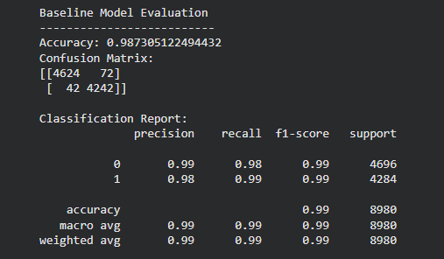
Metric | Score
Accuracy | 98.74%
Precision | 0.99
Recall | 0.98
F1 Score | 0.99
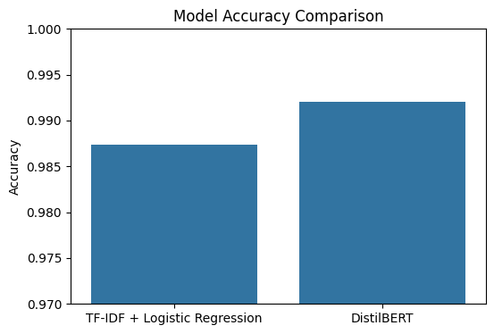
Confusion Matrix
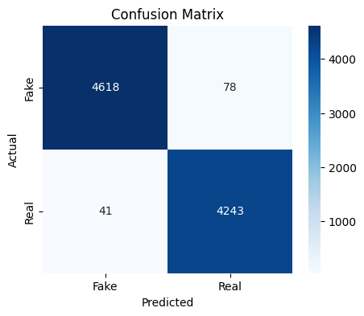
 | Predicted Fake | Predicted Real
Actual Fake | 4618 | 78
Actual Real | 41 | 4243
The DistilBERT model achieved approximately ~99% accuracy, outperforming the baseline classifier.

7. System Architecture
The application follows a three-layer architecture.
Frontend (HTML + CSS + JavaScript)
↓
FastAPI Backend API
↓
Machine Learning Model (DistilBERT)
Components
Frontend
- Text input
- Prediction button
- Result visualization
- History tracking

Backend
- FastAPI server
- /predict REST endpoint
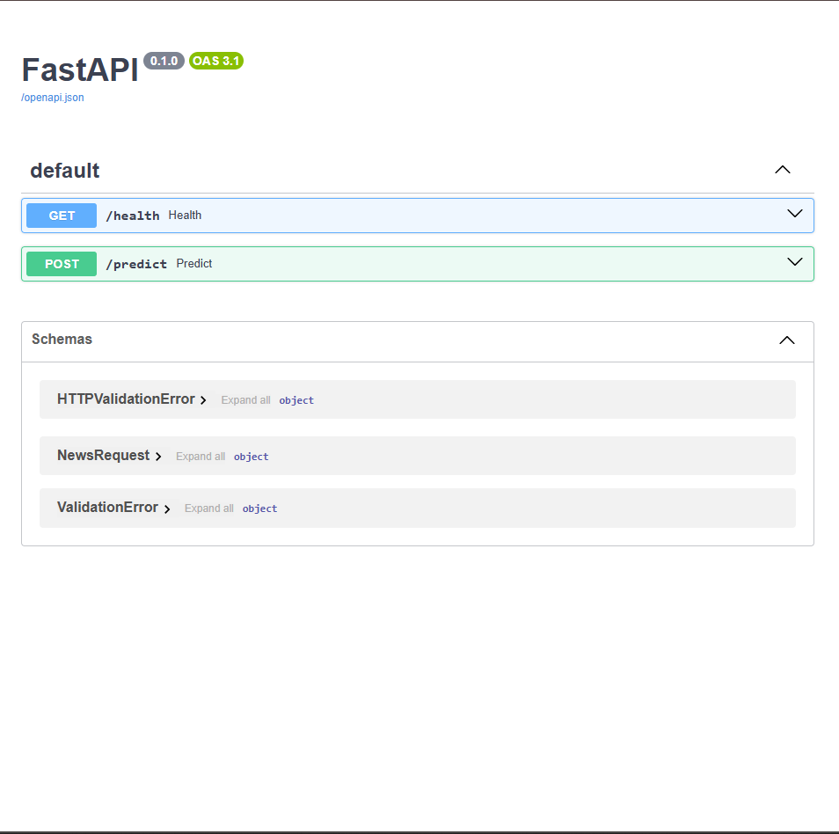
Machine Learning
- DistilBERT model
- TF-IDF vectorizer
- Logistic Regression baseline

8. Web Application Features
The developed web application includes several interactive features.
Implemented Features
- News text input field
- Detect / Analyze button
- Loading spinner while prediction runs
- Real/Fake prediction display
- Confidence percentage
- Color-coded result card
- Dark mode toggle
- Character and word counter
- History panel showing last 5 predictions
- Mobile-responsive layout
These features enhance the usability and accessibility of the system.

9. Backend API
The system exposes a REST API endpoint for predictions.
Endpoint
POST /predict
Request Example
{
"text": "NASA confirms discovery of water on Mars"
}
Response Example
{
"label": "REAL",
"confidence": 100.00
}
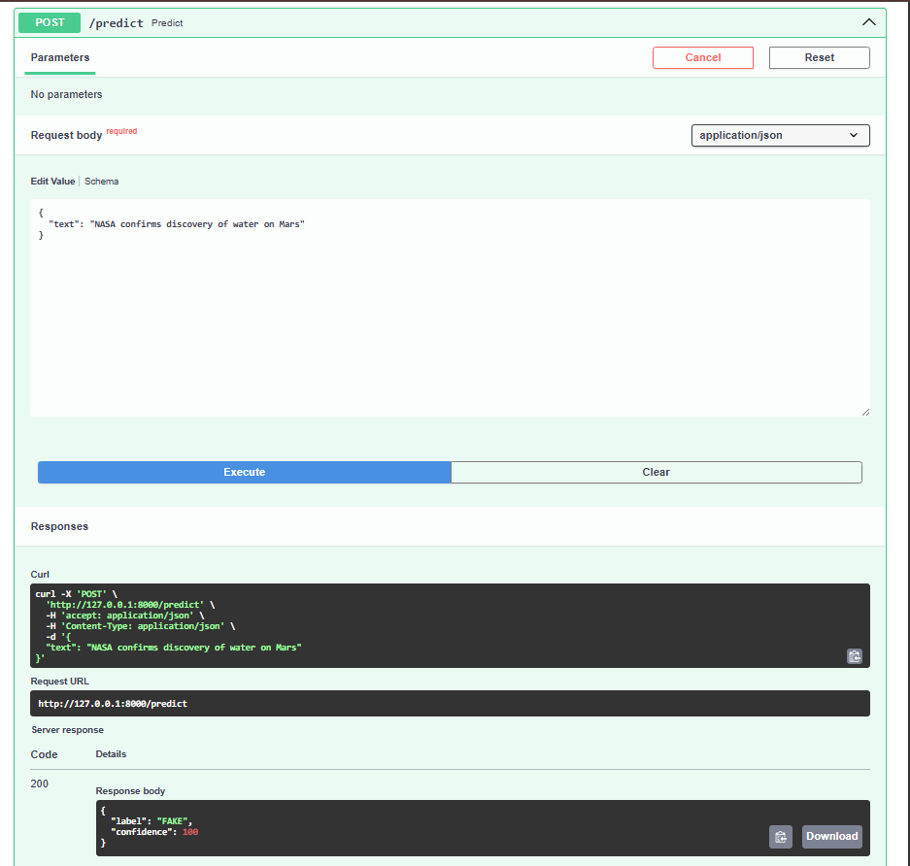

10. Conclusion
This project successfully demonstrates an end-to-end machine learning system for detecting fake news articles.
Key achievements include:
- High-accuracy fake news classification
- Integration of machine learning models with a web API
- Development of an interactive frontend interface
The DistilBERT model proved highly effective at capturing contextual language patterns, achieving near-state-of-the-art performance on the dataset.

11. Future Work
Possible improvements include:
- Training on larger and more diverse datasets
- Multilingual fake news detection
- Integration with real-time news feeds
- URL-based article scraping
- Explainable AI techniques for prediction interpretation

References
- ISOT Fake News Dataset – Kaggle
- HuggingFace Transformers Documentation
- Scikit-learn Machine Learning Library
- Devlin et al., BERT: Pre-training of Deep Bidirectional Transformers for Language Understanding

