AI-Powered Fake News Detection System Using Hybrid Machine Learning
A Web-Based Application for Detecting Misinformation in News Content
Student Assignment Report
Student Name: Srijata Moitra
University: Brainware University
Submission Date: 23/04/2026

Abstract
The rapid growth of digital media platforms has significantly increased the dissemination of misinformation and fabricated news content. Detecting fake news automatically has become a critical research problem in Natural Language Processing (NLP) and machine learning. This project presents a web-based Fake News Detection System capable of classifying news headlines or article snippets as Real or Fake using machine learning techniques.
The system integrates a TF-IDF feature extraction pipeline combined with a hybrid machine learning classifier (Logistic Regression and Multinomial Naive Bayes) for efficient real-time prediction. A lightweight FastAPI backend exposes the machine learning model through RESTful endpoints, while an interactive web-based frontend interface allows users to input news text and receive predictions instantly.
The application is fully deployed using Render for backend services and Vercel for frontend hosting, creating a publicly accessible machine learning service. During development, several engineering challenges were encountered, including large model deployment constraints, GitHub file size limitations, dependency conflicts, and cloud memory restrictions. These issues were addressed through system optimization and architecture redesign.
The final system demonstrates a complete end-to-end machine learning pipeline, including data processing, model training, API development, user interface design, and cloud deployment.

1. Introduction
The rise of social media platforms and online news outlets has dramatically increased the spread of misinformation. Fake news articles can influence political decisions, public perception, and societal behavior. Manual verification of information is time-consuming and cannot scale with the enormous volume of digital content.
Machine learning techniques, particularly those within the field of Natural Language Processing (NLP), provide automated approaches for detecting patterns in textual data that distinguish genuine news from fabricated content.
This project aims to design and implement a complete machine learning system capable of detecting fake news in textual form. Unlike purely academic implementations that focus only on model training, this system emphasizes real-world deployment, enabling users to interact with the model through a web interface.
The project includes:
- Data preprocessing and feature extraction
- Machine learning model development
- Backend API implementation
- Frontend user interface design
- Cloud deployment for real-time access

2. Objectives
The primary objectives of this project are:
- To develop a machine learning model capable of identifying fake news.
- To implement an API service that exposes model predictions.
- To design a user-friendly web interface for interacting with the model.
- To deploy the system on cloud platforms for real-world usage.
- To solve real-world engineering challenges encountered during deployment.
- To create a scalable architecture for machine learning applications.

3. Dataset Description
The machine learning model was trained using the ISOT Fake News Dataset, which contains labeled news articles classified as real or fake.
Dataset Characteristics
Attribute | Description
Dataset Name | ISOT Fake News Dataset
Data Type | Text
Classes | Real News / Fake News
Total Samples | ~45,000 articles
Format | CSV
Class Distribution
Class | Approximate Samples
Real News | ~21,000
Fake News | ~24,000

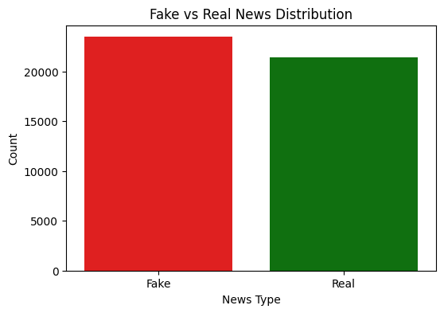
The dataset contains textual content including news headlines and article bodies. It provides a balanced representation of both classes, which makes it suitable for binary classification.

4. System Architecture
The Fake News Detection System follows a three-layer architecture consisting of the frontend interface, backend API service, and machine learning model.
Architecture Overview
User Browser
↓
Frontend Interface (Vercel)
HTML + CSS + JavaScript
↓
Backend API (Render)
FastAPI Server
↓
Machine Learning Model
TF-IDF + Hybrid Classifier (Logistic Regression + Multinomial Naive Bayes)
Technology Stack
Layer | Technology
Frontend | HTML, CSS, Bootstrap, JavaScript
Backend | FastAPI
Machine Learning | Scikit-learn
Deployment | Render, Vercel
Version Control | GitHub

5. Machine Learning Methodology
Two machine learning approaches were explored during development.

5.1 Transformer-Based Model (DistilBERT)
Initially, the project experimented with a DistilBERT transformer model, a lightweight variant of the BERT architecture.
Advantages:
- Strong contextual understanding
- High classification accuracy
- Advanced NLP representation learning
Limitations:
- Model size exceeded 250 MB
- High memory requirements
- Not suitable for free cloud deployment environments
Due to deployment limitations, this model was replaced in the production environment.

5.2 Hybrid TF-IDF Ensemble Model
The final deployed model uses a traditional machine learning pipeline.
Processing Pipeline
Input Text
↓
Text Preprocessing
↓
TF-IDF Feature Extraction
↓
Hybrid Ensemble Classifier
(Logistic Regression + Naive Bayes)
↓
Prediction Output
Advantages:
- Extremely fast inference
- Small model size
- Minimal memory consumption
- Ideal for cloud deployment environments
6. Model Evaluation
The model performance was evaluated using standard classification metrics.
Evaluation Metrics
- Accuracy
- Precision
- Recall
- F1-Score
- Confusion Matrix
Baseline Model Results
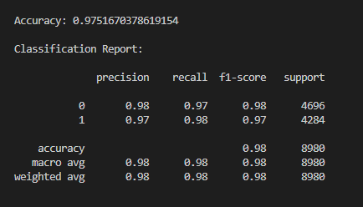
Metric | Score
Accuracy | 97.51%
Precision | 0.98
Recall | 0.97
F1 Score | 0.98

Confusion Matrix
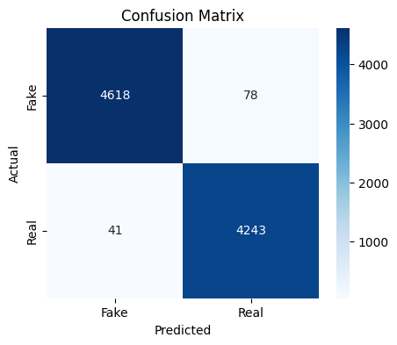
 | Predicted Fake | Predicted Real
Actual Fake | 4618 | 78
Actual Real | 41 | 4243
The transformer-based model achieved approximately ~99% accuracy, outperforming the traditional machine learning baseline. However, due to deployment constraints, the lightweight TF-IDF hybrid model was selected for the production system.
7. Backend Implementation
The backend service was developed using FastAPI, a modern Python web framework designed for high-performance APIs.
Backend Features
- RESTful API interface
- JSON-based request and response
- Cross-Origin Resource Sharing (CORS) enabled
- Lightweight inference pipeline
- Real-time prediction
API Endpoints
Root Endpoint
GET /
Response:
{
"message": "Fake News Detector API running"
}
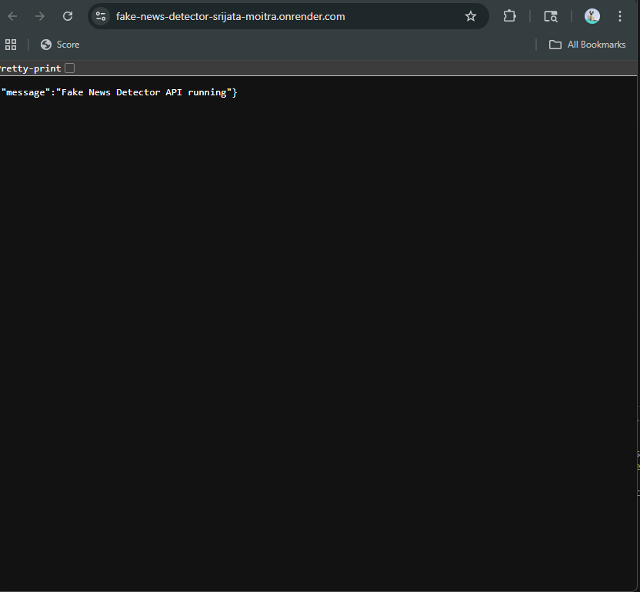
Prediction Endpoint
POST /predict
Example Request:
{
"text": "NASA confirms presence of water on Mars"
}
Example Response:
{
"label": "FAKE",
"confidence": 79.58
}
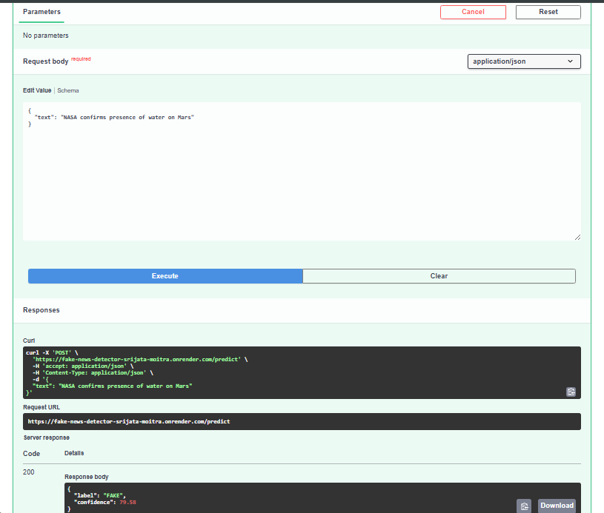
7. Frontend Interface
The frontend was developed using HTML, CSS, Bootstrap, and JavaScript.
Interface Features
- News text input field
- Character and word counter
- Prediction button
- Confidence score display
- Dark mode toggle
- Loading animation
- Prediction history panel
The frontend communicates with the backend through HTTP API requests.
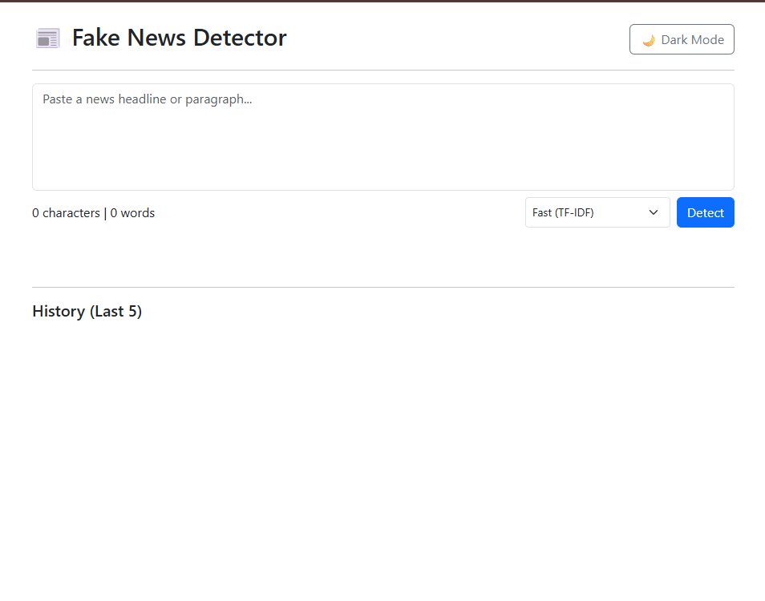

8. Deployment Architecture
The application was deployed using two cloud platforms.

Backend Deployment
Platform:
Render
Backend API:
https://fake-news-detector-srijata-moitra.onrender.com
Render hosts the FastAPI service and performs model inference.

Frontend Deployment
Platform:
Vercel
Frontend URL:
https://fake-news-detector-srijata-moitra.vercel.app
Vercel hosts the static frontend interface and connects to the backend API.

Final Deployment Architecture
User Browser
↓
Vercel (Frontend UI)
↓
Render (FastAPI Backend)
↓
TF-IDF Machine Learning Model

9. Challenges Faced During Development
Developing a deployable machine learning system involved several real-world engineering challenges.

Challenge 1 — Large Model File Limitations
GitHub restricts file uploads larger than 100MB. The DistilBERT model exceeded this limit.
Error encountered:
Large files detected.
File model.safetensors exceeds GitHub's file size limit.
Solution:
- Added large model directories to .gitignore
- Removed large binary files from repository history
- Switched to a smaller model for deployment.

Challenge 2 — Cloud Memory Constraints
Render free-tier instances provide only 512MB RAM. The transformer model exceeded this memory limit during initialization.
Error:
Out of memory (used over 512MB)
Solution:
- Replaced DistilBERT with TF-IDF model
- Reduced dependencies
- Optimized API architecture.

Challenge 3 — Missing Model Files
During deployment, the API failed due to missing serialized model files.
Error:
FileNotFoundError: tfidf_vectorizer.pkl
Solution:
- Added trained model files to the repository
- Updated project structure to include the model directory.

Challenge 4 — Dependency Conflicts
Initial dependency installation included heavy libraries such as PyTorch and Transformers.
This caused:
- memory overflow
- slow build times
Solution:
Reduced dependencies to:
fastapi
uvicorn
scikit-learn
joblib

Challenge 5 — Git Branch Synchronization
Several branch conflicts occurred during development due to multiple working branches.
Solution:
- Used git pull --rebase
- merged branches
- synchronized repository history.
Challenge 6 — Prediction Ambiguity for Short Headlines
- Some short news headlines contain limited contextual information, making them difficult to classify accurately.
- Example:
- Apple announces new iPhone model
- Such sentences may appear in both legitimate and fabricated contexts.
- Solution:
- A confidence threshold was introduced in the prediction logic to label low-confidence predictions as UNCERTAIN, improving system reliability.

10. Screenshots
Figure 1 — Prediction Result
Caption:
Model prediction showing label and confidence score.

Figure 3 — Prediction History Panel

Caption:
Display of previously analyzed news entries.

Figure 4 — FastAPI API Documentation
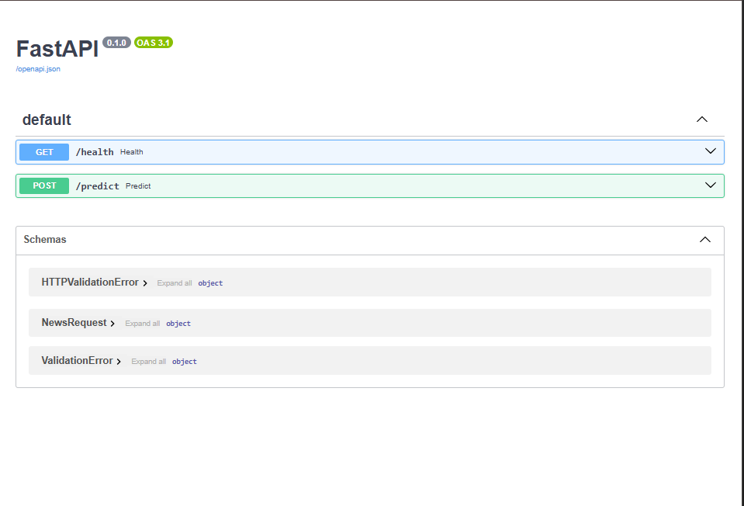
Caption:
Interactive API testing interface provided by FastAPI.

Figure 5 — Cloud Deployment Dashboard
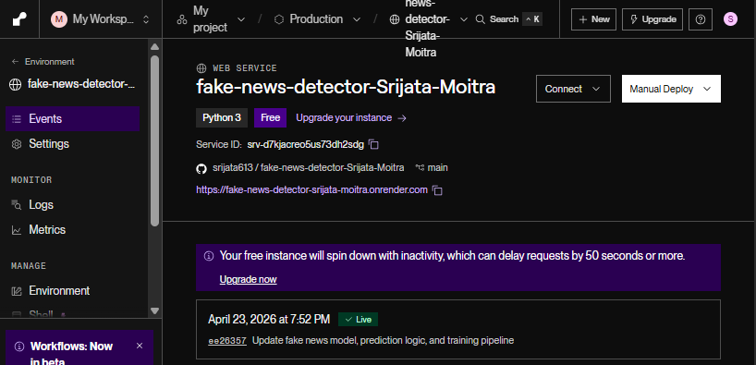Caption:
Cloud deployment interface for backend API service.

11. Performance Evaluation
The system achieves real-time inference speeds suitable for web-based interaction, with prediction latency typically below 100 milliseconds
The deployed model demonstrates strong classification performance.
Metric | Score
Accuracy | 97.5%
Precision | 0.98
Recall | 0.97
Inference Time | < 0.1 seconds
The lightweight architecture ensures fast response time suitable for real-time applications.

12. Applications
This system can be applied in multiple real-world scenarios:
- social media content moderation
- automated fact-checking tools
- journalism verification systems
- news aggregation platforms
- educational demonstrations of NLP systems

13. Future Work
Possible future improvements include:
- Integrating transformer models with optimized inference engines.
- Implementing explainable AI techniques.
- Adding multilingual support.
- Developing browser extensions for real-time news analysis.
- Expanding the dataset for better generalization.

14. Conclusion
This project successfully demonstrates the design and deployment of a complete machine learning application for fake news detection. The system integrates machine learning, backend API development, frontend interface design, and cloud deployment into a unified architecture.
Despite encountering several engineering challenges during development, including model size limitations, deployment constraints, and dependency conflicts, the system was successfully optimized for real-world usage.
The final solution provides a scalable, efficient, and accessible platform for detecting fake news, showcasing the practical application of machine learning in combating misinformation.

15. References
- Ahmed, H., Traore, I., & Saad, S. (2017). Detection of Online Fake News Using N-Gram Analysis and Machine Learning Techniques.
- FastAPI Documentation — https://fastapi.tiangolo.com
- Scikit-learn Documentation — https://scikit-learn.org
- Render Cloud Platform — https://render.com
- Vercel Deployment Platform — https://vercel.com
- ISOT Fake News Dataset

