**HW2**

1) What are semantic elements?

Semantic elements explain the meaning clearly to both the browser and developer.

Ex: instead of <div> and <span>, we can use alternatives as <from>, <table>, <article> and <img>.

2) Why do we need to use semantic elements? Advantages?

* It gives sense to the content which we have written.

* It provides accessibility to other technologies to read and understand the webpage’s design.

* The structure of webpage design can be easily understood by other Programmers.

3) HTML Tags

Article: The article tag specifies a component of a page that consists of a self-contained content in a document, page, and application. An article should make sense on its own and it should be independently distributable from the rest of the site.

Ex: <article>

<h1> Apple </h1>

<p> Apple was founded by Steve Jobs, Steve Wozniak, and Ronald Wayne in April 1976 to develop and sell personal computers. <p>

</article>

Output:

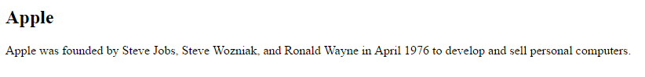

Aside: The aside tag specifies a section of a page that contain content aside from the content in which it is placed.

EX: <aside>

<h2>Apple</h2>

<p>Apple was founded by Steve Jobs, Steve Wozniak, and Ronald Wayne in April 1976 to develop and sell personal computers.</p>

</aside>

Output:

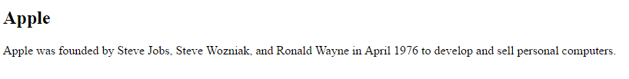

Details: The details tag specifies additional details in the content that the user can view or hide. It creates an interactive widget that the user can open and close. Any information can be kept inside the content and the content is visible only when the open attribute is set.

Ex: <details>

<summary>Apple</summary>

<p>- Apple was founded by Steve Jobs, Steve Wozniak, and Ronald Wayne.</p>

<p>- In April 1976 to develop and sell personal computers.</p>

</details>

<p><b>Note:</b> The details tag is not supported in Internet Explorer.</p>

Output:

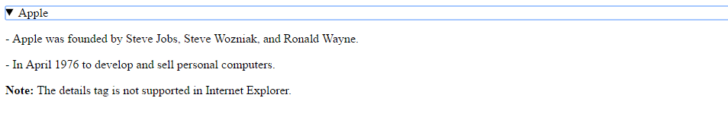

Summary: The Summary tag specifies a visible heading for the details tag. When we click on heading, we can view or hide the details in the cont+ent.

EX: <details>

<summary>Apple</summary>

<p>- Apple was founded by Steve Jobs, Steve Wozniak, and Ronald Wayne.</p>

<p>- In April 1976 to develop and sell personal computers.</p>

</details>

Output:

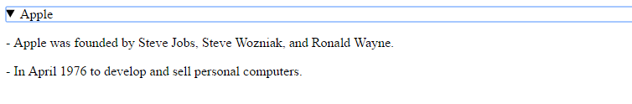

Figcaption: The Figcaption tag specifies a caption for a <figure> element to mark up diagrams, illustrations, photos and code examples. The <figcaption> element can be placed as the first or last child of the <figure> element.

EX: <figure>

<img src="1.jpg" alt="Apple icon" width="100" height="100">

<figcaption>Fig.1 Apple icon</figcaption>

</figure>

Output:

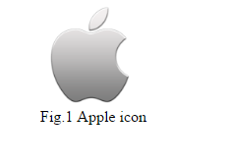

Figure: The Figure tag specifies self-contained content, diagrams, illustrations, photos and code examples. The <figure> element is independent of the main flow, if the figure> element is removed or replaced it does not affect the flow of the content.

EX: <figure>

<img src="1.jpg" alt="Apple icon" width="100" height="100">

<figcaption>Fig.1 Apple icon</figcaption>

</figure>

<p><strong>Note:</strong> The figure tag is not supported in Internet Explorer 8 and earlier versions.</p>

Output:

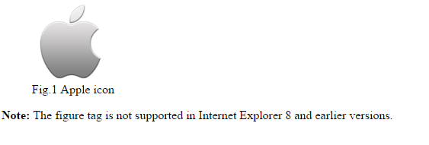

Footer: The Footer tag specifies a footer for a section or document. There can be several <footer> elements in one document. The <footer> element typically contains copyright information, contact information, related documents, sitemap, authorship information, back to top links.

EX: <footer>

<p>Posted by: Srija Reddy Kandimalla</p>

<p>Contact information: <a href="mailto:srija.uidev@gmail.com">srija.uidev@gmail.com</a>.</p>

</footer>

<p><strong>Note:</strong> The footer tag is not supported in Internet Explorer 8 and earlier versions.</p>

Output:

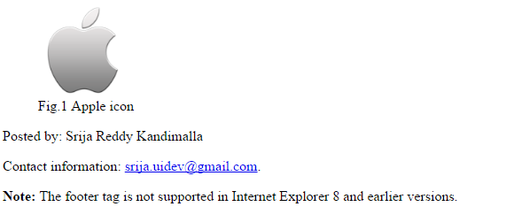

Header: The Header tag specifies an introduction heading of a content or a set of navigational links. A <header> element typically contains logo or icon, one or more heading elements from <h1> to <h6>, authorship information.

EX: <article>

<header>

<h1> Apple </h1>

<p> Apple was founded by Steve Jobs, Steve Wozniak, and Ronald Wayne in April 1976 to develop and sell personal computers. <p>

<header>

</article>

Output:

