**HW3**

1) CSS Selectors

***.class* selector:** Selects all elements with class="intro"

**Code:**

<!DOCTYPE html>

<html>

<head>

<style>

.intro {

background-color: Green;

}

</style>

</head>

<body>

<h1>Welcome to My Homepage</h1>

<p>My name is Srija Reddy K.</p>

<div class="intro">

<p>I am from INDIA</p>

</div>

</body>

</html>

**Output:**

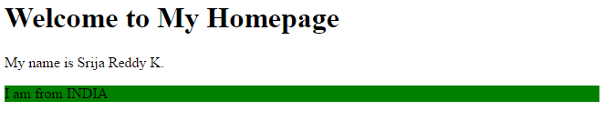

**#*id* selector:** styles the element with the specified id.

**Code:**

<!DOCTYPE html>

<html>

<head>

<style>

#firstname {

background-color: Red;

}

#hometown {

background-color: Green;

}

</style>

</head>

<body>

<h1>Welcome to My Homepage</h1>

<div class="intro">

<p id="firstname">My name is Srija Reddy K. </p>

<p id="hometown">I am from INDIA</p>

</div>

</body>

</html>

**Output:**

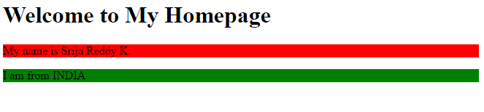

**\* selector:** selects all elements.

**Code:**

<!DOCTYPE html>

<html>

<head>

<style>

* {

background-color: orange;

}

</style>

</head>

<body>

<h1>Welcome to My Homepage</h1>

<div class="intro">

<p>My name is Srija Reddy K. </p>

<p>I am from INDIA</p>

</div>

</body>

</html>

**Output:**

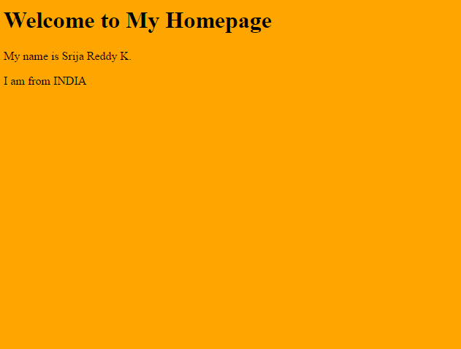

***element,element* Selector:** To style several elements with the same style, separate each element name with a comma.

**Code:**

<!DOCTYPE html>

<html>

<head>

<style>

h1, p {

background-color: orange;

}

</style>

</head>

<body>

<h1>Welcome to My Homepage</h1>

<div>

<p>My name is Srija Reddy K. </p>

<p>I am from INDIA</p>

</div>

</body>

</html>

**Output:**

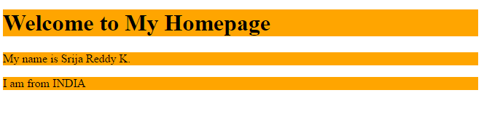

**:active Selector:** The :active selector is used to select and style the active link. A link becomes active when you click on it. The :active selector can be used on all elements, not only links.

# Code:

# <!DOCTYPE html>

# <html>

# <head>

# <style>

# a:active {

# background-color: green;

# }

# </style>

# </head>

# <body>

# <a href="http://www.w3schools.com">w3schools.com</a>

# <a href="http://www.wikipedia.org">wikipedia.org</a>

# </body>

# </html>

**Output:**

# 

# ::before selector: The ::before selector inserts something before the content of each selected elements.

# Code:

<!DOCTYPE html>

<html>

<head>

<style>

p::before {

background-color: green;

content: "Read this -";

}

</style>

</head>

<body>

<p>My name is Srija Reddy K.</p>

<p>I am from INDIA</p>

</body>

</html>

**Output:**

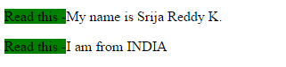

**::after selector:** The ::after selector inserts something after the content of each selected elements.

# Code:

<!DOCTYPE html>

<html>

<head>

<style>

p::after {

content: " - Remember this";

background-color: red;

}

</style>

</head>

<body>

<p>My name is Srija Reddy K.</p>

<p>I am from INDIA</p>

</body>

</html>

**Output:**

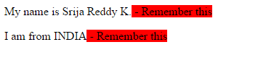

**:focus selector:** The :focus selector is used to select the element that has focus.

# Code:

<!DOCTYPE html>

<html>

<head>

<style>

input:focus {

background-color: orange;

}

</style>

</head>

<body>

<p>Click inside the text fields to see a yellow background:</p>

<form>

First name: <input type="text" name="firstname"><br>

Last name: <input type="text" name="lastname">

</form>

</body>

</html>

**Output:**

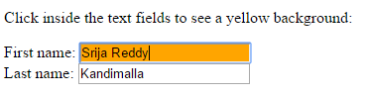

**:empty selector**: The :empty selector matches every element that has no children (including text nodes).

# Code:

<!DOCTYPE html>

<html>

<head>

<style>

p:empty {

width: 200px;

height: 20px;

background: Pink;

}

</style>

</head>

<body>

<p></p>

<p>My name is Srija Reddy K.</p>

<p>I am from INDIA</p>

<p></p>

</body>

</html>

**Output:**

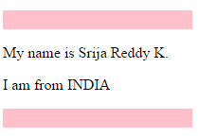

**:checked selector:** The :checked selector matches every checked <input> element (only for radio buttons and checkboxes) and <option> element.

# Code:

<!DOCTYPE html>

<html>

<head>

<style>

input:checked {

height: 20px;

width: 20px;

}

</style>

</head>

<body>

<form action="">

<input type="radio" checked="checked" value="male" name="gender"> Male<br>

<input type="radio" value="female" name="gender"> Female<br>

<input type="checkbox" checked="checked" value="Bike"> I have a bike<br>

<input type="checkbox" value="Car"> I have a car

</form>

</body>

</html>

**Output:**

