**HW6**

**Bootstrap Alerts:**

Predefined alerts are provided to create in bootstrap. They are created with the alert class and are followed by one of the four contextual classes, they are alert-success, alert-info, alert-warning and alert-danger.

**Example:**

<!DOCTYPE html>

<html>

<head>

<title>Bootstrap Example</title>

<link rel="stylesheet" href="https://maxcdn.bootstrapcdn.com/bootstrap/3.3.7/css/bootstrap.min.css">

<script src="https://ajax.googleapis.com/ajax/libs/jquery/3.1.1/jquery.min.js"></script>

<script src="https://maxcdn.bootstrapcdn.com/bootstrap/3.3.7/js/bootstrap.min.js"></script>

</head>

<body>

<div class="container-fluid">

<h1><b>Alerts</b></h2>

<div class="alert alert-success">

<strong>Success!</strong> This alert box could indicate a successful or positive action.

</div>

<div class="alert alert-info">

<strong>Info!</strong> This alert box could indicate a neutral informative change or action.

</div>

<div class="alert alert-warning">

<strong>Warning!</strong> This alert box could indicate a warning that might need attention.

</div>

<div class="alert alert-danger">

<strong>Danger!</strong> This alert box could indicate a dangerous or potentially negative action.

</div>

</div>

</body>

</html>

**Output:**

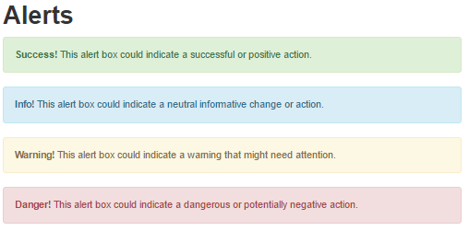

* **Alert Link:** we can even add a link to the alert box to directly take to that link. It is defined by the class alert-link.

**Example:**

<!DOCTYPE html>

<html>

<head>

<title>Bootstrap Example</title>

<link rel="stylesheet" href="https://maxcdn.bootstrapcdn.com/bootstrap/3.3.7/css/bootstrap.min.css">

<script src="https://ajax.googleapis.com/ajax/libs/jquery/3.1.1/jquery.min.js"></script>

<script src="https://maxcdn.bootstrapcdn.com/bootstrap/3.3.7/js/bootstrap.min.js"></script>

</head>

<body>

<div class="container">

<h2>Alert Links</h2>

<p>Add the alert-link class to any links inside the alert box to create "matching colored links".</p>

<div class="alert alert-success">

<strong>Success!</strong> <a href="https://www.google.com/" class="alert-link">You should be directed to google page</a>.

</div>

<div class="alert alert-info">

<strong>Info!</strong> <a href="https://www.google.com/" class="alert-link">You should be directed to google page</a>.

</div>

<div class="alert alert-warning">

<strong>Warning!</strong> <a href="https://www.google.com/" class="alert-link">You should be directed to google page</a>.

</div>

<div class="alert alert-danger">

<strong>Danger!</strong> <a href="https://www.google.com/" class="alert-link">You should be directed to google page</a>.

</div>

</div>

</body>

</html>

**Output:**

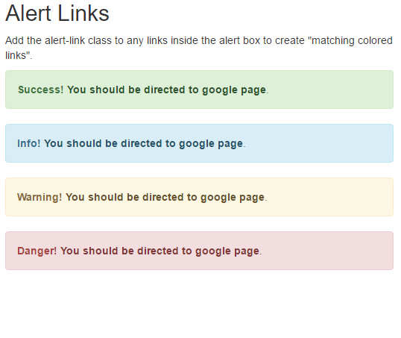

* **Closing Alerts:** An alert can be closed by adding a class alert-dismissible to the alert container and should add class=”close” , data-dismiss=”alert”. For the accessibility of the user we should use aria-label=”close” and the preferred icon for close button in HTML is &times; (x)

**Example:**

<!DOCTYPE html>

<html>

<head>

<title>Bootstrap Example</title>

<link rel="stylesheet" href="https://maxcdn.bootstrapcdn.com/bootstrap/3.3.7/css/bootstrap.min.css">

<script src="https://ajax.googleapis.com/ajax/libs/jquery/3.1.1/jquery.min.js"></script>

<script src="https://maxcdn.bootstrapcdn.com/bootstrap/3.3.7/js/bootstrap.min.js"></script>

</head>

<body>

<div class="container">

<h2><b>Alerts</b></h2>

<div class="alert alert-success">

<strong>Success!</strong><a href="https://www.google.com/" class="alert-link">You should be directed to google page</a>.

<p class="close" data-dismiss="alert" aria-label="close">&times;</p>

</div>

<div class="alert alert-info">

<strong>Info!</strong><a href="https://www.google.com/" class="alert-link">You should be directed to google page</a>.

<p class="close" data-dismiss="alert" aria-label="close">&times;</p>

</div>

<div class="alert alert-warning">

<strong>Warning!</strong><a href="https://www.google.com/" class="alert-link">You should be directed to google page</a>.

<p class="close" data-dismiss="alert" aria-label="close">&times;</p>

</div>

<div class="alert alert-danger">

<strong>Danger!</strong><a href="https://www.google.com/" class="alert-link">You should be directed to google page</a>.

<p class="close" data-dismiss="alert" aria-label="close">&times;</p>

</div>

</div>

</body>

</html>

**Output:**

