**HW6**

**1) What is Bootstrap?**

Bootstrap was developed by Mark Otto and Jacob Thornton at Twitter. Bootstrap is a free front-end framework and is a free collection of tools for creating websites and web applications. It contains HTML and CSS-based design templates for typography, forms, buttons, navigation and other interface components, as well as optional JavaScript extensions. Using bootstrap we can also create responsive designs.

**2) What is grid system in bootstrap?**

Grid systems in bootstrap are used for creating page layouts, through a series of rows and columns which can bring a shape to the content.

* For proper alignment and padding Rows are placed within a **.container** class
* Rows are used to create horizontal groups of columns
* Content is placed within the columns
* Only columns are the immediate children of rows

**3) For 1 row how many columns do we have in bootstrap?**

Bootstrap's grid system allows up to 12 columns for 1 row

**4) What is xs, sm , lg, md ?**

Bootstrap grid systems consist of four classes ,

* xs is for phones
* sm is for tablets
* md is for desktops
* lg is for large desktops

**syntax**- <div class=”col-*-*”>

**Extra Small Grid ( xs):**

Example:

<!DOCTYPE html>

<html>

<head>

<title>Bootstrap Example</title>

<link rel="stylesheet" href="https://maxcdn.bootstrapcdn.com/bootstrap/3.3.7/css/bootstrap.min.css">

<script src="https://ajax.googleapis.com/ajax/libs/jquery/3.1.1/jquery.min.js"></script>

<script src="https://maxcdn.bootstrapcdn.com/bootstrap/3.3.7/js/bootstrap.min.js"></script>

</head>

<body>

<div class="container-fluid">

<h1>Extra Small Grid</h1>

<div class="row">

<div class="col-xs-6" style="background-color:green;">

Srija Reddy

</div>

<div class="col-xs-6" style="background-color:pink;">

Kandimalla

</div>

</div>

</div>

</body>

</html>

**Output:**

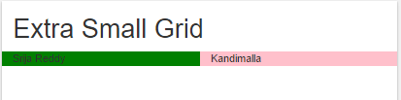

**Small Grid(sm):**

Example:

<!DOCTYPE html>

<html>

<head>

<title>Bootstrap Example</title>

<link rel="stylesheet" href="https://maxcdn.bootstrapcdn.com/bootstrap/3.3.7/css/bootstrap.min.css">

<script src="https://ajax.googleapis.com/ajax/libs/jquery/3.1.1/jquery.min.js"></script>

<script src="https://maxcdn.bootstrapcdn.com/bootstrap/3.3.7/js/bootstrap.min.js"></script>

</head>

<body>

<div class="container-fluid">

<h1>Small Grid</h1>

<div class="row">

<div class="col-sm-6" style="background-color:pink;">

Srija Reddy

</div>

<div class="col-sm-6" style="background-color:yellow;">

Kandimalla

</div>

</div>

</div>

</body>

</html>

**Output:**

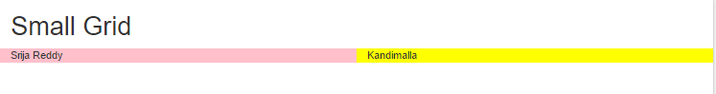

# Medium Grid(md):

Example:

# <!DOCTYPE html>

<html>

# <head>

# <title>Bootstrap Example</title>

# 

# 

# <link rel="stylesheet" href="https://maxcdn.bootstrapcdn.com/bootstrap/3.3.7/css/bootstrap.min.css">

# <script src="https://ajax.googleapis.com/ajax/libs/jquery/3.1.1/jquery.min.js"></script>

# <script src="https://maxcdn.bootstrapcdn.com/bootstrap/3.3.7/js/bootstrap.min.js"></script>

# </head>

# <body>

# <div class="container-fluid">

# <h1>Medium Grid</h1>

# 

# <div class="row">

# <div class="col-md-6" style="background-color:yellow;">

# Kandimalla

# </div>

# <div class="col-md-3" style="background-color:pink;">

# Srija

# </div>

# <div class="col-md-3" style="background-color:orange;">

# Reddy

# </div>

# </div>

# </div>

# 

# </body>

# </html>

**Output:**

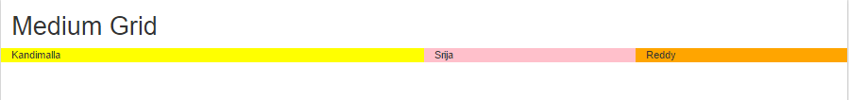

**Large Grid(lg):**

Example:

<!DOCTYPE html>

<html>

<head>

<title>Bootstrap Example</title>

<script src="https://ajax.googleapis.com/ajax/libs/jquery/3.1.1/jquery.min.js"></script>

<script src="https://maxcdn.bootstrapcdn.com/bootstrap/3.3.7/js/bootstrap.min.js"></script>

</head>

<body>

<div class="container-fluid">

<h1>Large Grid</h1>

<div class="row">

<div class=" col-lg-12" style="background-color:orange;">

Srija Reddy Kandimalla

</div>

</div>

</div>

</body>

</html>

**Output:**

