UNEMPLOYMENT ANALYSIS IN INDIA
Internship Project Report

1. Introduction
Unemployment is one of the major economic challenges affecting India. This project analyzes unemployment trends using Python to understand how unemployment changed over time, especially during the COVID-19 pandemic.
The objective of this project is to perform data analysis and visualization to identify patterns, trends, and insights from unemployment data.

2. Dataset Description
The dataset used in this project contains unemployment data in India.
Files used:
- unemployment in india.csv
- unemployment_rate_upto_11_2020.csv
Key columns include:
- Date
- Estimated Unemployment Rate (%)
- Region / Area (if available)

3. Tools & Technologies Used
- Python
- Pandas (Data Analysis)
- NumPy (Numerical operations)
- Matplotlib (Visualization)
- Seaborn (Statistical visualization)
- VS Code (Development environment)

4. Data Preprocessing
The dataset was cleaned by:
- Removing missing values
- Converting date column into datetime format
- Sorting data in chronological order
- Handling inconsistent column names

5. Data Analysis Performed
The following analyses were performed:
1. Trend Analysis
Unemployment rate was analyzed over time to identify fluctuations.
2. Monthly Analysis
Monthly trends were studied to observe seasonal variations.
3. COVID-19 Impact Analysis
Unemployment before and during COVID-19 was compared.
4. Correlation Analysis
Relationships between numerical variables were studied using a heatmap.

6. Visualizations
The following graphs were created: Data visualization plays a key role in understanding unemployment trends clearly. In this project, different graphs were created using Python libraries such as Matplotlib and Seaborn.
Unemployment Trend Analysis
This graph shows how the unemployment rate in India changed over time. It helps identify overall increasing or decreasing patterns in employment conditions.
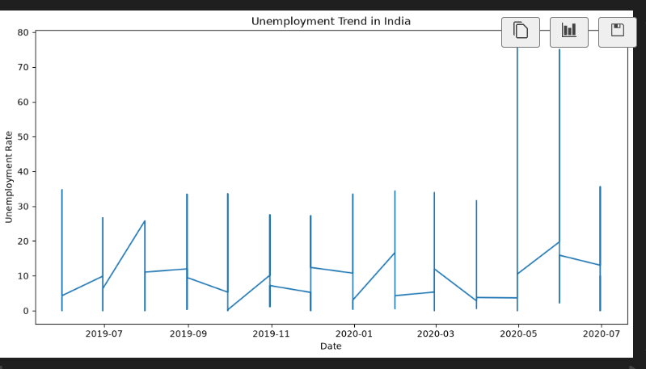

Monthly Unemployment Trend
This visualization represents monthly variations in unemployment rates. It helps in identifying seasonal fluctuations in employment trends.

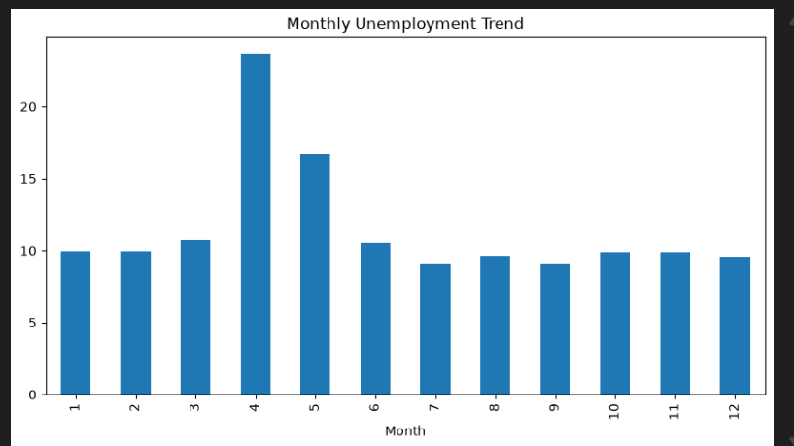

Correlation Heatmap
The heatmap shows the relationship between numerical variables in the dataset. It helps understand how strongly different factors are related to unemployment.

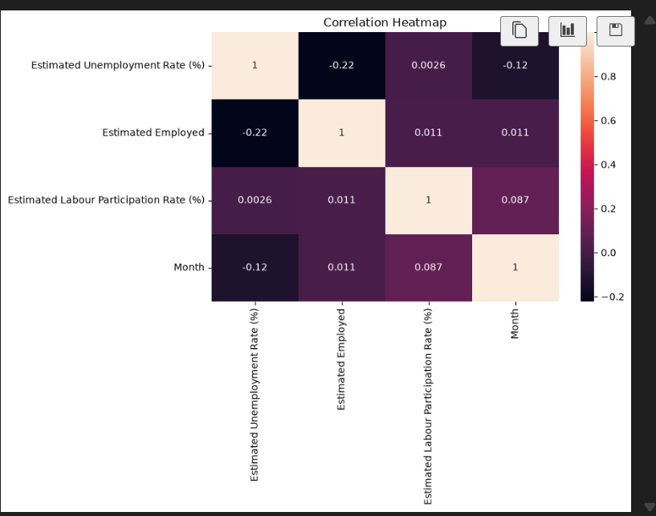

7. Summary of Results
The analysis clearly shows that unemployment in India was significantly affected during the COVID-19 pandemic, with noticeable spikes during lockdown periods and gradual recovery afterward.

8. Screenshots
Overall Insight:
The visualizations collectively indicate that unemployment in India was significantly impacted during the COVID-19 period. A sharp rise in unemployment rates was observed during lockdown phases, followed by a gradual recovery in later periods.

- Trend Graph



- Monthly Graph


- Heatmap Output



9. Key Insights
- The average unemployment rate is 11.78%
- During COVID-19, unemployment increased by 8.26%
- A sharp rise in unemployment was observed during the lockdown period
- Gradual recovery was seen after restrictions were lifted

10. Conclusion
The analysis shows that COVID-19 had a significant impact on employment in India. The unemployment rate increased sharply during the pandemic period, but later showed signs of recovery.
This project helped in understanding real-world economic impact using data analysis techniques.

11. Author
Prepared by: Penagaluru Srija
CodeAlpha Internship Project

