**LIBRARY MANAGEMENT SYSTEM**

**Description:**

This project is all about manages and stores books information electronically according the user needs. It helps both user and also the library manager to keep a constant track of all books that available in the library. It allows both admin and the user to know about the desired book.

The library Management System is developed on C, it mainly focuses on the details of the book like book information, what are the books available, highest price of the book, list of publishers.

**Cost &Feautures:**

**Cost:**

Free of cost.

**Features:** By giving the correct information we will get the required book.

**Requirements:**

**High Level Requirements:**

|  |  |  |
| --- | --- | --- |
| **ID** | **Description** | **Status** |
| HLR1 | User can see book information | Implemented |
| HLR2 | User can see publisher list | Implemented |

**Low Level Requirements:**

|  |  |  |
| --- | --- | --- |
| **ID** | **Description** | **Status** |
| LLR01 | Add book information | Implemented |
| LLR02 | Display all books | Implemented |
| LLR03 | Display highest price book | Implemented |
| LLR04 | Display list of publishers | Implemented |

**SWOT Analysis:**

**Strenghts:**

1. Simple and easy to use.
2. Mobile access, anytime and everywhere.
3. Highly Secure.
4. Saves time.

**Weakness:**

1. Online systems require high speed connectivity.
2. Complicate to first time users.
3. Risk of computer virus.

**Opportunities:**

1. It can be expanded by sharing the information among them.
2. These become a technology hubs.
3. It will plays a major role for every because it was easily access to everyone and also it saves time.

**Threats:**

It needs network security to come across some challenges like privacy of users, unauthorized access etc.

**4W,1H:**

**What:**

It displays book information like name of the author, price of the book, book name, publisher.

**Who:**

It is an application used by all students, staff and the people who are having their Id’s.

**When:**

It is very useful when we have huge number of books with the same book name this application will be useful to check the book with the specific publisher.

**Where:**

Now a days library management system is very useful in the Schools, Colleges, Private libraries, Public libraries and many places and it is very essential for all the people.

**How:**

It is implemented by adding the book information like price, book name and publisher.

**Architecture:**

This will give the brief idea about what the project do. In this architecture we have both behavioural and sequence diagrams. This will help you the what are the low level and high level requirements.

Use case Diagram:

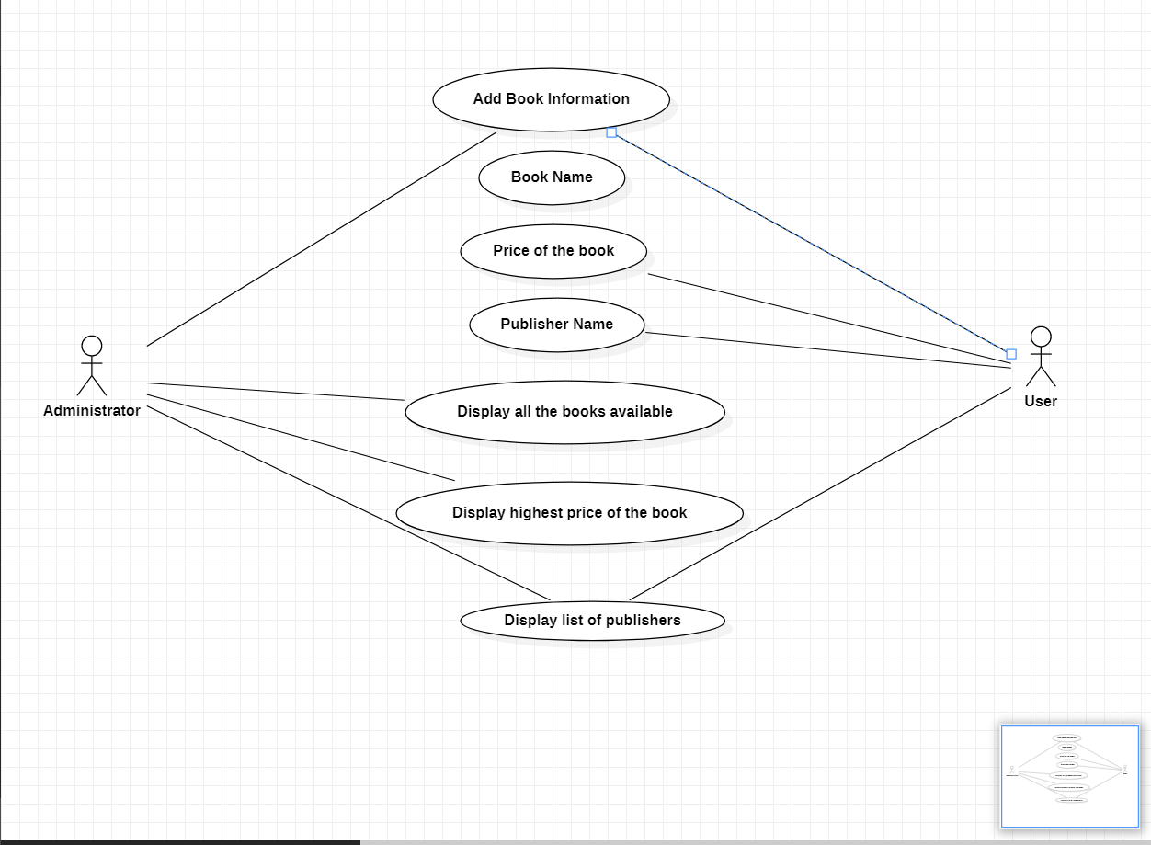

Class Diagram:

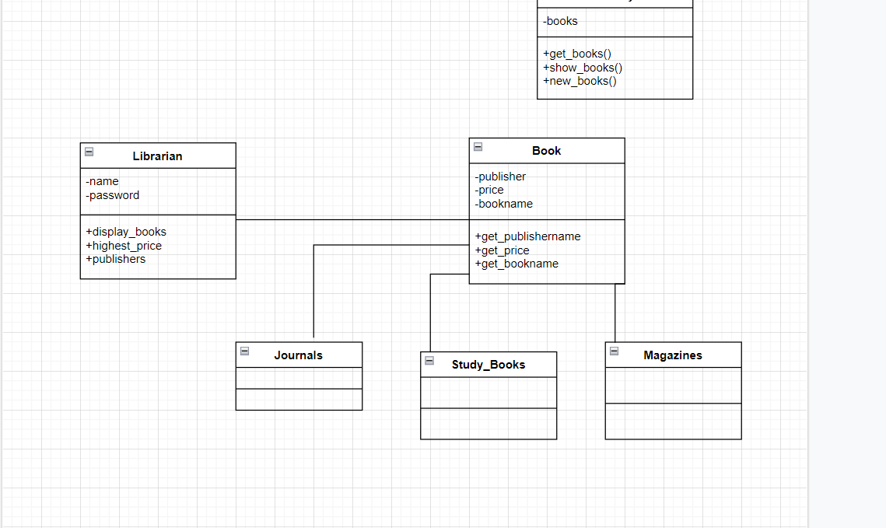

Flow Chart:

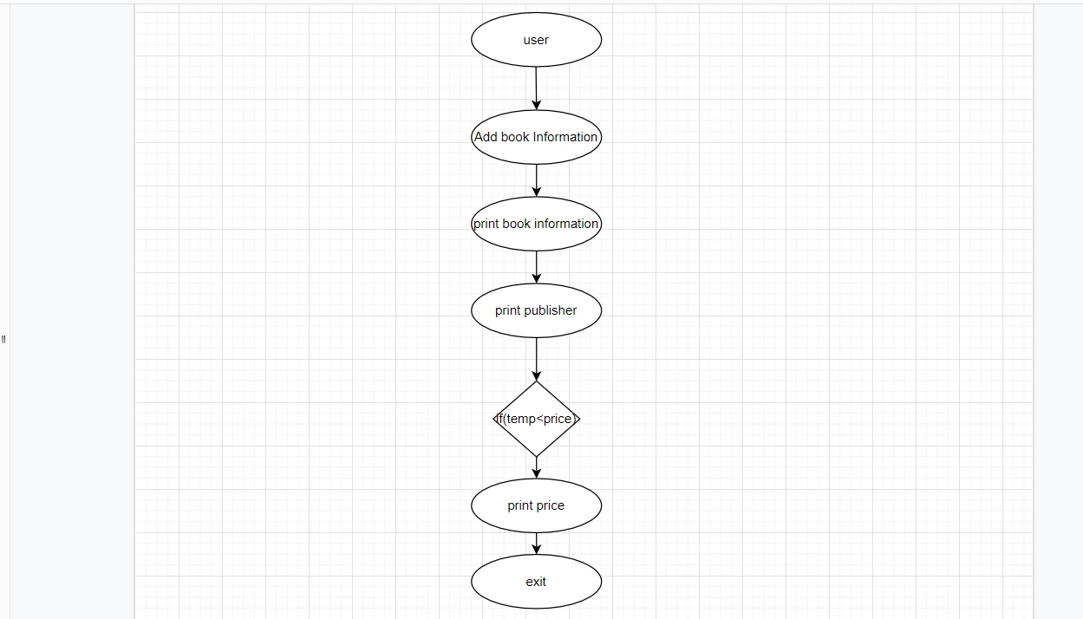

**Implementation:**

The code was done in C programming language. In that I have divided the files into multi file for easy understanding .

**Test plan and output:**

In this I have done low level test plans and high level test plans.

**Images and Videos:**

