FitBuddy
AI Fitness Plan Generator using Gemini Models
Project Documentation

Project Description
FitBuddy is a web-based application that uses AI to generate personalized workout plans and nutrition tips based on a user's fitness goals, such as weight loss, muscle gain, or general wellness. Built with FastAPI and integrated with Google's Gemini AI models, FitBuddy simplifies the process of creating structured and effective fitness routines.
The application takes in user information — such as age, weight, goal, and preferred workout intensity — and generates a customized 7-day fitness plan. Users can also submit feedback to update and refine their plan using AI. A complementary nutrition or recovery tip is also provided based on the selected goal.
With a clean user interface and database support via SQLite, FitBuddy ensures each user's data and generated plan are stored and accessible. It offers both API endpoints and an interactive HTML interface for ease of use.

Scenarios

Scenario 1 — Personalized Workout Plan Generation
A user inputs personal details — name, age, weight, fitness goal (e.g., "weight loss" or "muscle gain"), and preferred workout intensity ("high", "medium", or "low") — to receive a personalized 7-day workout plan. The system generates a day-by-day schedule tailored to the user's fitness objective and experience level, enhancing motivation and adherence through structured, goal-specific routines.

Scenario 2 — Feedback-Based Plan Refinement
A user submits feedback on their existing workout plan — such as "more focus on cardio" or "include more rest days". The system uses this input to regenerate an updated plan, refining it based on the user's evolving needs. This feedback loop keeps users engaged and supports dynamic adjustments as preferences or progress change.

Scenario 3 — Nutrition and Recovery Tips
A user requests a nutrition or recovery tip based on their selected fitness goal. The platform delivers a concise, relevant suggestion (e.g., "include protein in your post-workout meal" for muscle gain) that complements the workout plan and helps align diet and recovery with training.

Scenario 4 — Admin / Coach Dashboard
An admin or coach accesses the platform to view all registered users and their workout plans through a dedicated dashboard. This allows tracking of individual progress, comparison of original and updated plans, and monitoring of user activity — streamlining oversight for trainers managing multiple clients.

Technical Architecture
The diagram below illustrates how the frontend, FastAPI backend, Gemini AI layer, and SQLite database interact.
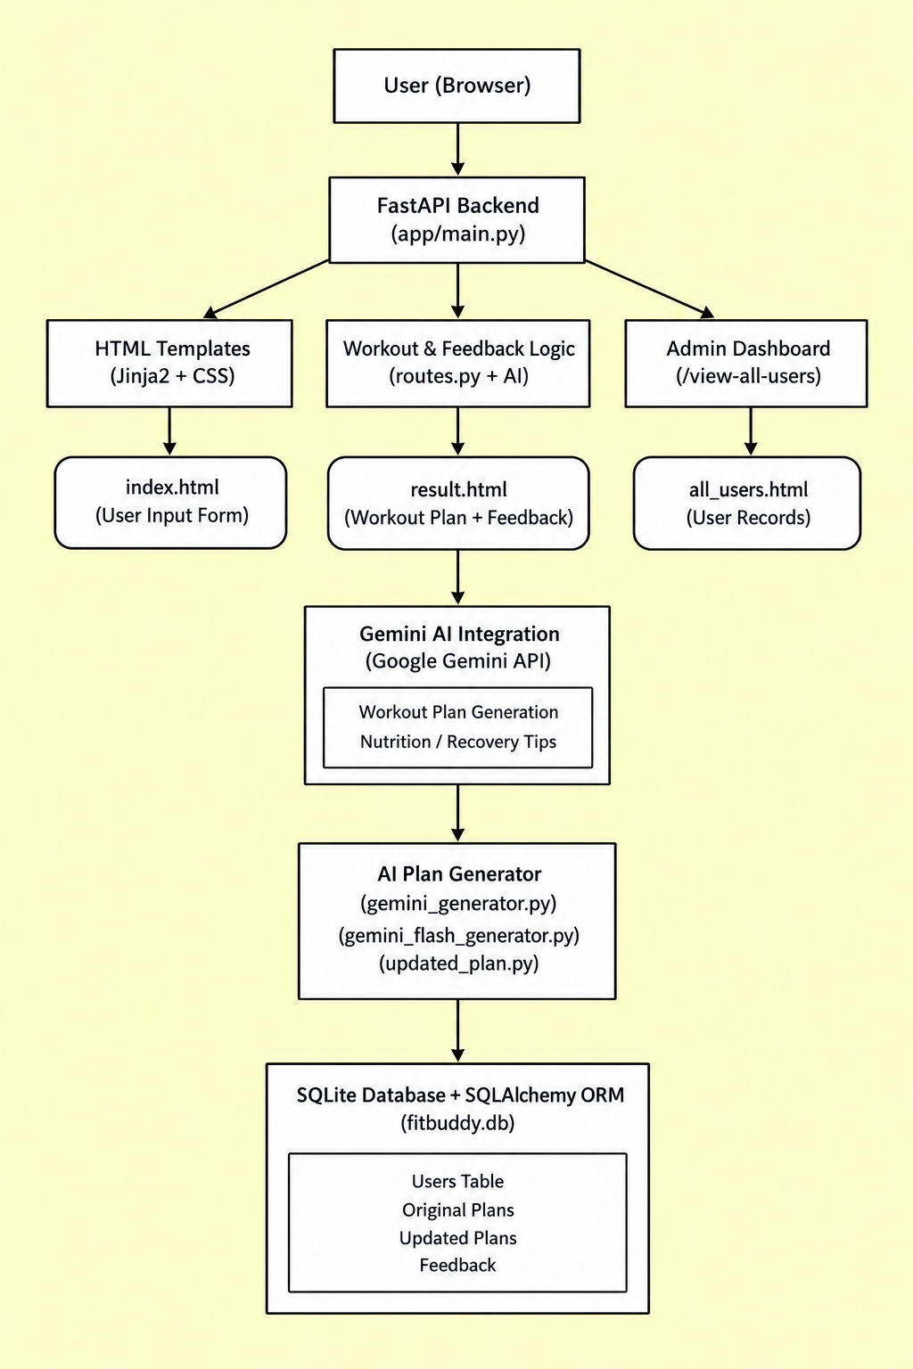

Prerequisites
- FastAPI Framework Knowledge — FastAPI Documentation
- Gemini API Familiarity — Google Generative AI Documentation
- HTML, CSS, and Jinja2 Template Skills — W3Schools HTML/CSS/Jinja2 Tutorials
- Python Programming Proficiency — Python Official Docs
- Version Control with Git — Git Documentation
- SQLAlchemy and SQLite Basics — SQLAlchemy Docs
- Environment Setup (pip, virtualenv, or conda) — Virtualenv Guide
- Uvicorn ASGI Server — Uvicorn Docs

Project Workflow
Milestone 1: Model Selection and Architecture
Activity 1.1 — Research and Select the Appropriate Generative AI Model
Activity 1.2 — Define the Architecture of the Application
Activity 1.3 — Set Up the Development Environment
Milestone 2: Core Functionalities Development
Activity 2.1 — Develop the Core Functionalities
Activity 2.2 — Implement the FastAPI Backend to Manage Routing and User Input Processing
Milestone 3: routes.py Development
Activity 3.1 — Writing the Main Application Logic in routes.py
Milestone 4: Frontend Development
Activity 4.1 — Designing and Developing the User Interface
Activity 4.2 — Creating Dynamic Templates with FastAPI's Jinja2
Milestone 5: Deployment
Activity 5.1 — Preparing the Application for Local Deployment
Activity 5.2 — Testing and Verifying Local Deployment

Milestone 1: Model Selection and Architecture
This milestone focuses on selecting the appropriate generative AI models from Google's Gemini family for FitBuddy, evaluating candidate models against the application's core needs: generating personalized workout plans, updating them based on feedback, and providing tailored nutrition or recovery advice.

Activity 1.1: Research and Select the Appropriate Generative AI Model

Project Requirements
- Generate structured 7-day workout plans
- Provide concise and actionable nutrition tips
- Update workout plans based on user feedback
- Perform well in real-time, web-based interaction

Model Evaluation
Several Hugging Face models were evaluated initially:
- T5 & BART — for text generation (workout/nutrition)
- DistilBERT — for potential intent classification
- Bloom — for general-purpose generation
These models showed promise for basic text generation but required hosting via Hugging Face or a local GPU setup, plus fine-tuning or complex prompting to reliably produce structured plans.

Final Model Selection
After comparative testing, Google Gemini models were selected for production:
- Gemini 1.5 Pro — used for structured 7-day workout generation and plan updating; delivers rich, context-aware, formatted responses reliably.
- Gemini Flash — used for generating fast, practical nutrition tips; lightweight and efficient for quick API calls.
Reasons for choosing Gemini:
- API-based, easy to integrate with FastAPI
- Naturally understands structured formatting (days, sections)
- High accuracy with minimal prompt tuning
- Scalable and fast for feedback-based revisions

Activity 1.2: Define the Architecture of the Application
FitBuddy follows a modular FastAPI-based architecture:
- Frontend: HTML + Jinja2 templates for user input and display
- Backend: FastAPI for route handling and logic
- AI Layer: Google Gemini APIs (Pro & Flash)
- Database: SQLite with SQLAlchemy for persistence

Frontend Responsibilities
- index.html — input form
- result.html — plan, tip, feedback
- all_users.html — admin panel

Backend Responsibilities
- Receives form data
- Calls Gemini models
- Stores user info and plans
- Renders dynamic templates

AI Integration Points
- Workout generation & feedback updates → Gemini Pro
- Nutrition tips → Gemini Flash

Activity 1.3: Set Up the Development Environment
Step 1: Install Python & pip — ensure Python and pip are installed
Step 2: Create a virtual environment: python -m venv fitbuddy-env, then fitbuddy-env\Scripts\activate (Windows)
Step 3: Install required libraries: pip install fastapi uvicorn jinja2 sqlalchemy python-multipart google-generativeai
Step 4: Run the server: uvicorn app.main:app --reload, then visit http://127.0.0.1:8000 (and /docs for API testing)
Step 5: Set up the project structure: create /app (Python files), /templates (HTML), /static/images (assets)
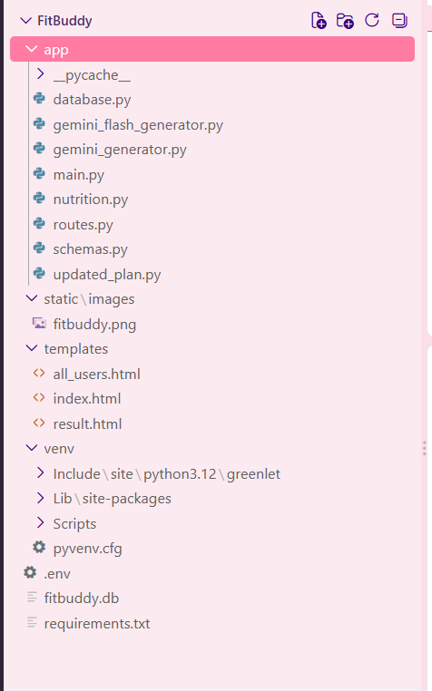

Milestone 2: Core Functionalities Development

Activity 2.1: Develop the Core Functionalities

Workout Plan Generation
Function: generate_workout_gemini()
File: gemini_generator.py
Implements the core logic to generate a personalized 7-day workout plan using user inputs such as goal (e.g., muscle gain, weight loss) and intensity (low, medium, high). The prompt is sent to the Gemini 1.5 Pro model, which returns a structured, day-wise plan including a warm-up (5–10 minutes), the main workout (exercise details, sets, reps), and a cooldown or recovery tip. The output is returned to routes.py and rendered on result.html using <pre> blocks for formatting.

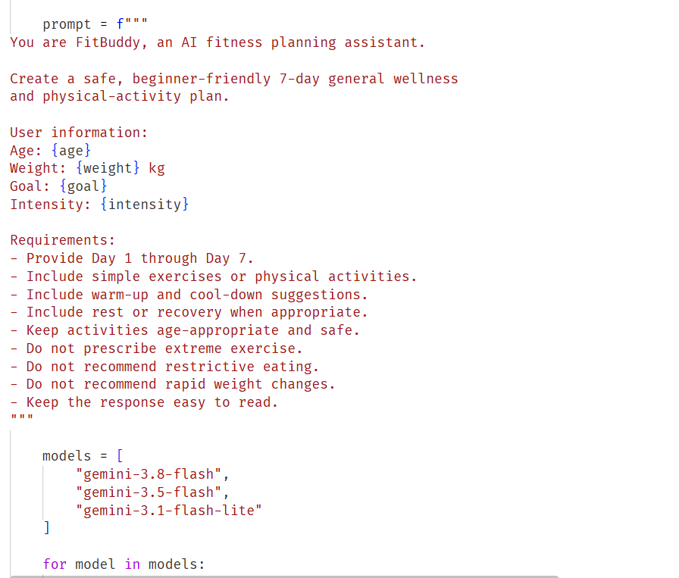

Nutrition Tip Generation
Function: generate_nutrition_tip_with_flash()
File: gemini_flash_generator.py
Generates a concise, practical nutrition or recovery tip tailored to the user's selected goal, using the Gemini Flash model for a fast, helpful response (e.g., hydration advice, protein suggestions, recovery best practices). This tip is displayed beneath the workout plan on result.html.

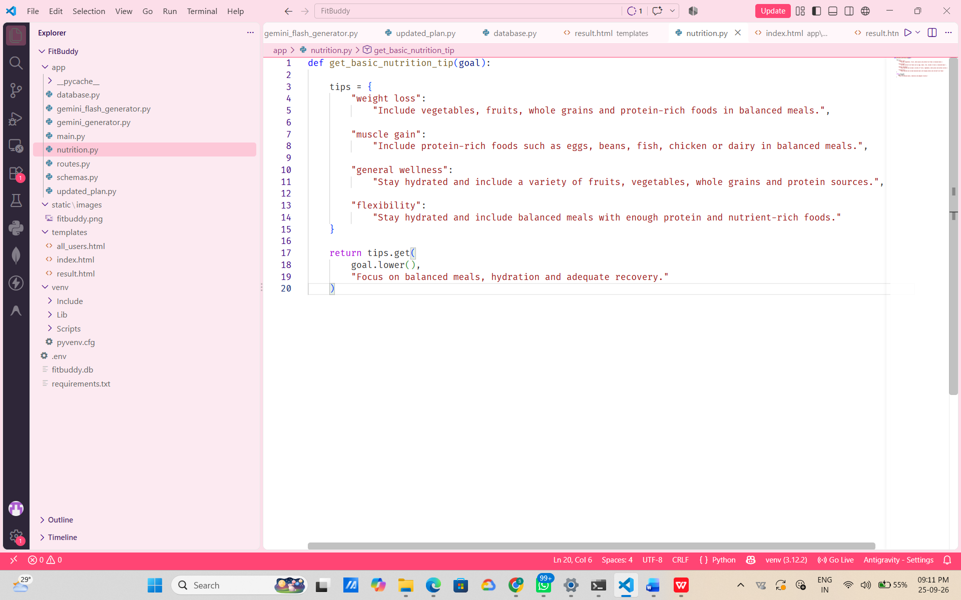

Feedback-Based Plan Updating
Function: update_workout_plan()
File: updated_plan.py
Enables a user to revise their original plan by submitting feedback (e.g., "add yoga", "include more cardio"). The original plan and feedback are passed to Gemini 1.5 Pro, which returns a modified plan. The updated plan is stored and displayed alongside a new nutrition tip.

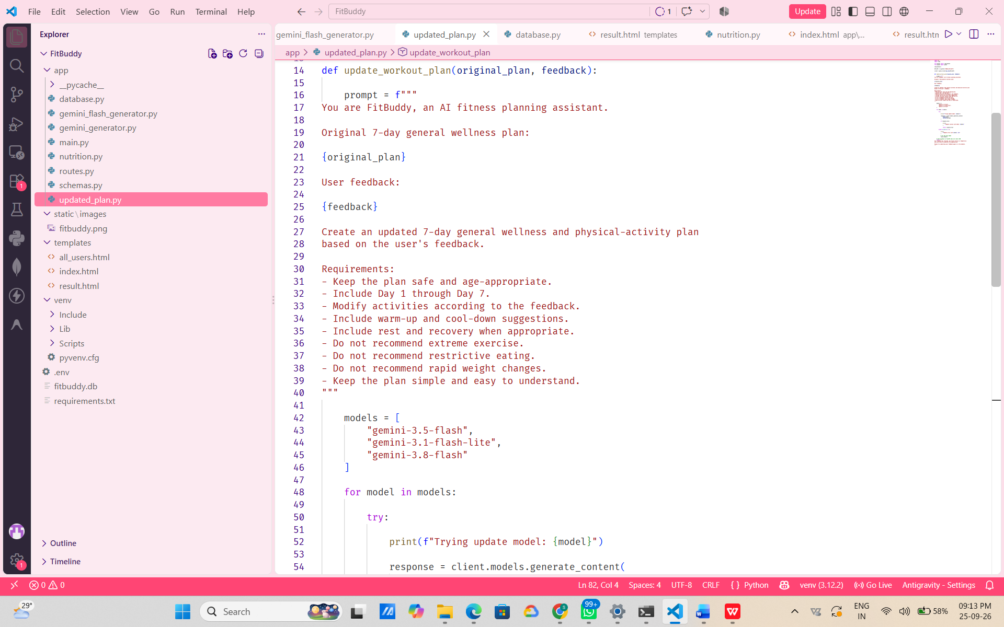

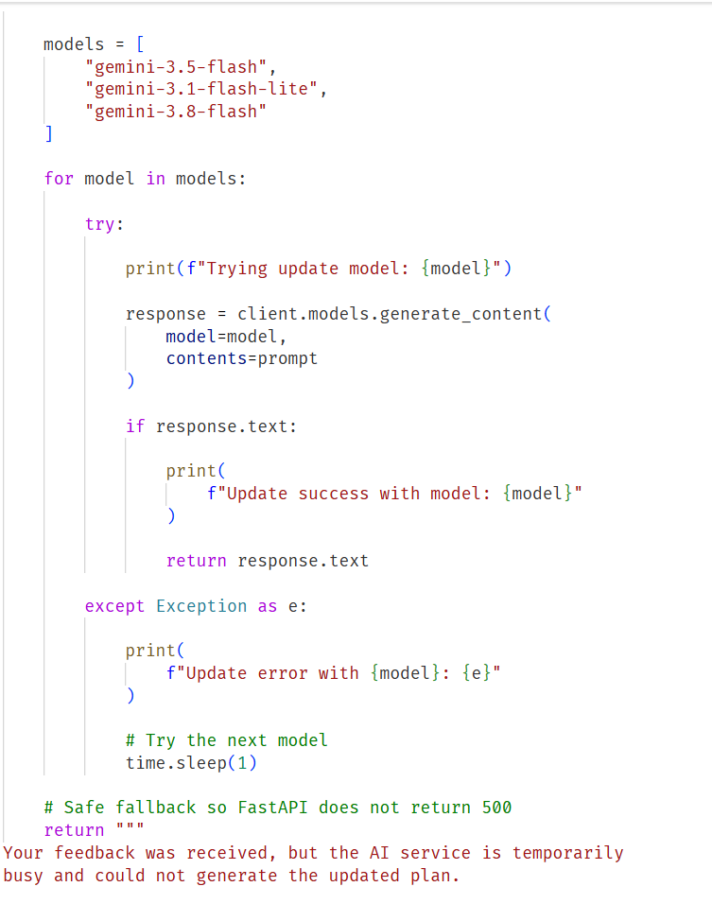

User & Plan Storage
Functions: save_user(), save_plan(), update_plan(), get_original_plan(), get_user()
File: database.py
All user information (ID, name, age, weight, goal, intensity) and AI-generated plans are stored in a SQLite database via SQLAlchemy ORM. Feedback-based updates are saved as a separate field so both the original and updated versions are preserved.

Save-User

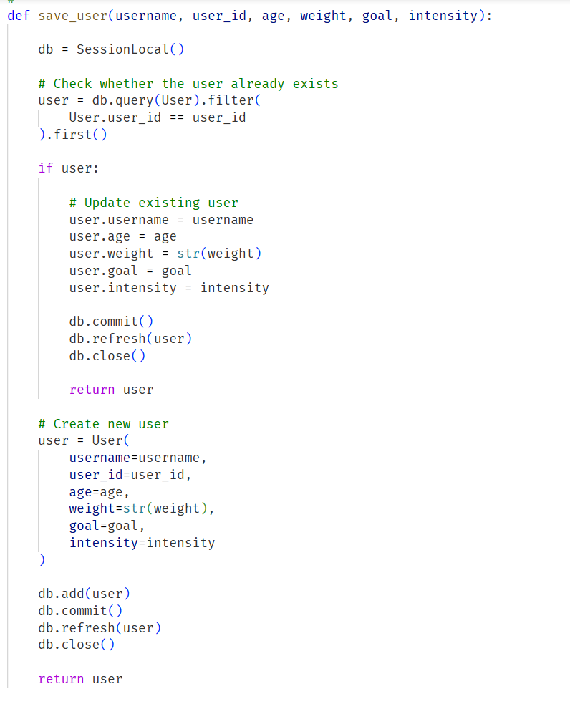

Save-Plan

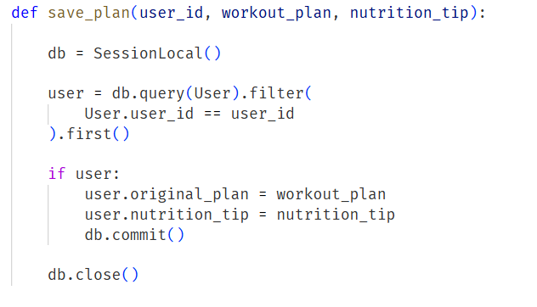

UPDATE WORKOUT PLAN

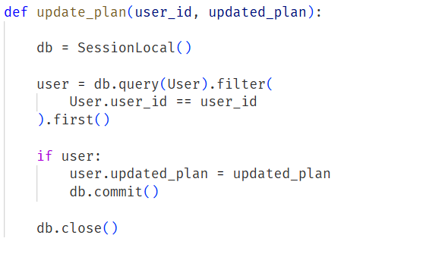

GET ONE USER

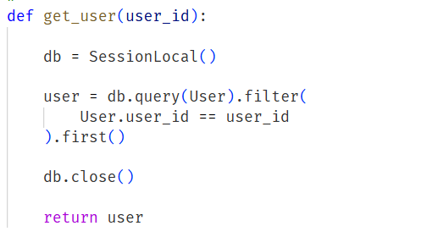

GET ALL USERS

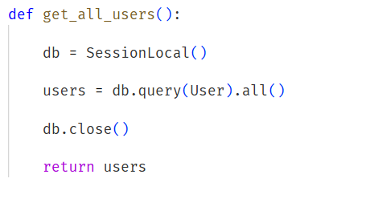

DELETE USER

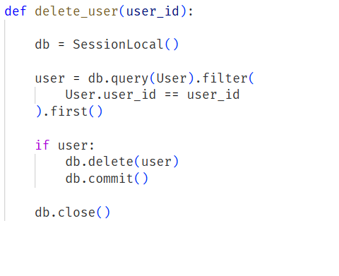

Admin View of All Users
Route: /view-all-users
Template: all_users.html
Displays a list of all users and their respective plans. Rendered with Jinja2 using a {% for user in users %} loop, allowing administrators to see original and updated plans in a structured table.

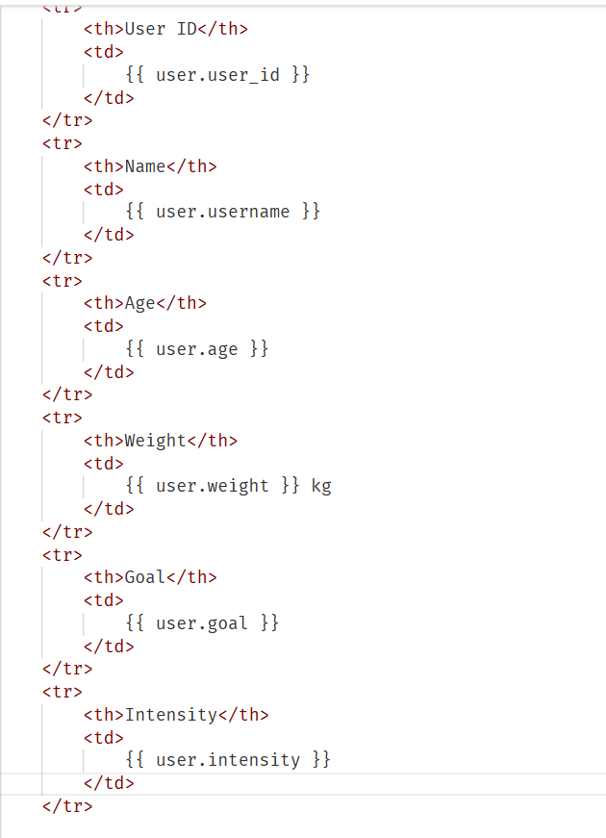

Activity 2.2: Implement the FastAPI Backend to Manage Routing and User Input Processing

Define Routes in FastAPI
All routing logic is handled in routes.py. Each route is linked to the corresponding function developed in Activity 2.1.

Process User Input
- HTML form created in index.html
- Users enter: username, user_id, age, weight, goal, and intensity
- FastAPI captures inputs using Form(...) parameters
- Pydantic schemas (UserInput, FeedbackRequest) validate structure

Integrate Gemini API Calls
- /generate-workout → generate_workout_gemini() for the workout plan, generate_nutrition_tip_with_flash() for the tip
- /submit-feedback → retrieves the plan, sends original + feedback to update_workout_plan()
All AI-generated responses are returned cleanly and injected into the frontend templates for display.

Milestone 3: routes.py Development
This milestone focuses on building the routing logic inside routes.py, the core operational layer that bridges the frontend templates, the AI generation modules (Gemini Pro and Flash), and the SQLite database. Each route defines how user inputs are collected, processed, and responded to.

Activity 3.1: Writing the Main Application Logic in routes.py

Core Routes
- / — displays the user form via index.html
- /generate-workout — processes user input and generates a personalized workout plan
- /submit-feedback — updates the workout plan based on user feedback
- /view-all-users — displays an admin dashboard showing all users and their plans

Route Handlers
/ (Home Route): Returns the homepage (index.html); no form processing logic
/generate-workout (Plan Generator): Receives input via Form(...), builds a UserInput model, calls generate_workout_gemini() and generate_nutrition_tip_with_flash(), stores results with save_user()/save_plan(), and returns result.html
/submit-feedback (Update Plan): Captures feedback and user_id, retrieves the original plan, calls update_workout_plan(), updates the DB via update_plan(), and re-renders result.html
/view-all-users (Admin View): Calls get_all_users() and get_all_plans(), passes them to all_users.html for display

Gemini Integration per Route
All responses are returned to the user through result.html, using <pre> blocks for clear formatting.

GENERATE WORKOUT

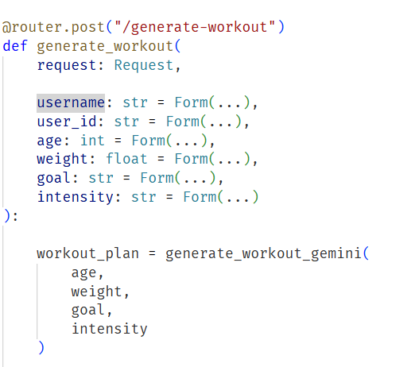

nutrition/recovery tip generation

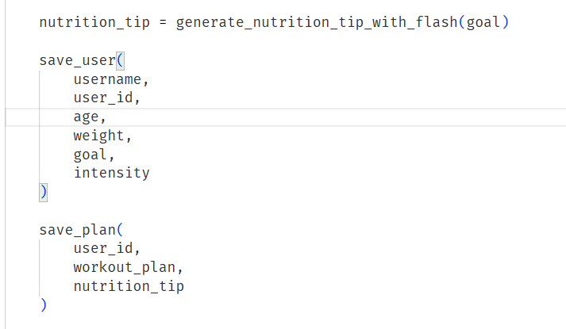

Saving User Info and plan generation route:
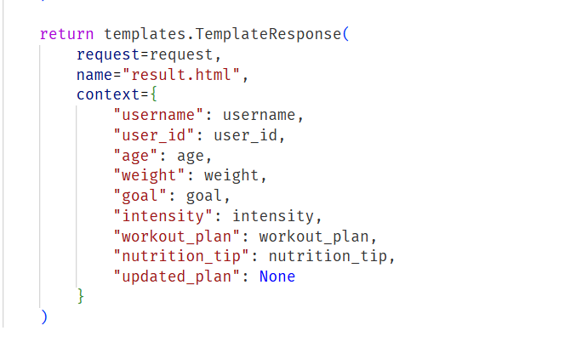

Submit Feedback and Update plan route
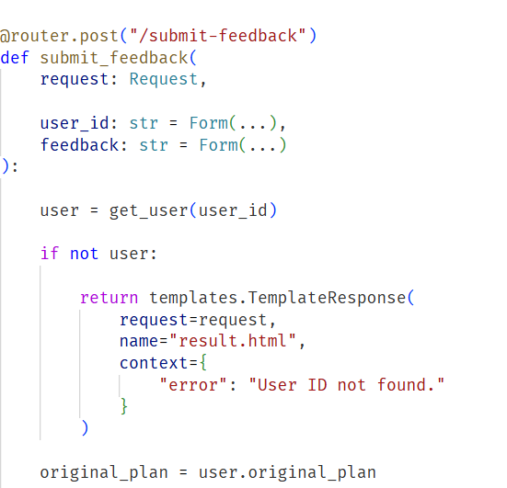

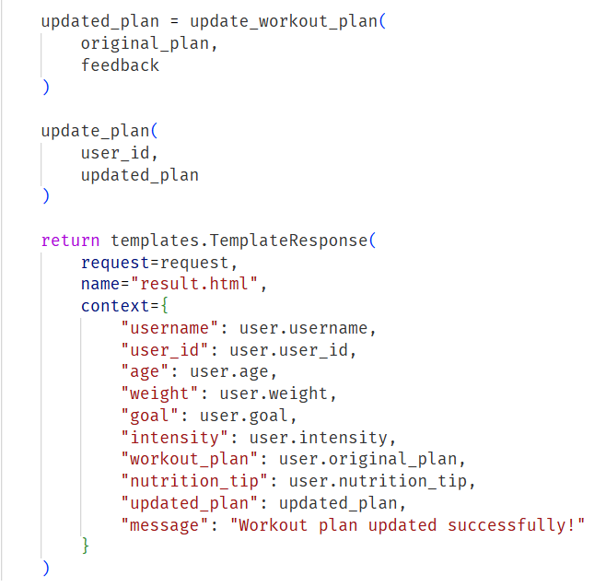

Milestone 4: Frontend Development
This milestone focuses on building a user-friendly, visually structured interface using HTML, CSS, and Jinja2 templating, with each template dynamically rendered through FastAPI.

Activity 4.1: Designing and Developing the User Interface

Base HTML Structure
- index.html is the main entry point for user input
- Form fields: username, user_id, age, weight, goal, and intensity, each labeled and grouped using semantic HTML
- Gym-themed background image, Google Fonts (Roboto), and bold typography create a clean, fitness-oriented interface
- Minimal navigation keeps focus on a clear input-to-output flow

Responsive Layout with CSS
- Embedded CSS styles applied directly in each HTML file
- Flexbox layouts center content vertically and horizontally
- Media queries ensure mobile responsiveness
- Consistent button styling with hover effects
- Padding, shadows, and rounded corners on inputs and result blocks for a modern look
- Color scheme optimized for readability on a dark background

Separate Pages per Functionality
- index.html — user input form (fitness goal, intensity, personal information)
- result.html — displays the 7-day AI-generated workout plan, nutrition tip, and feedback form
- all_users.html — admin panel to view and delete users and review original/updated plans
Templates are modular, and the UI transitions smoothly between steps; forms submit to specific FastAPI endpoints via POST.

Activity 4.2: Creating Dynamic Templates with FastAPI's Jinja2

Jinja2 Templating Setup
from fastapi.templating import Jinja2Templates BASE_DIR = os.path.dirname(os.path.abspath(__file__)) TEMPLATE_DIR = os.path.join(BASE_DIR, "templates") templates = Jinja2Templates(directory=TEMPLATE_DIR)
Each route uses TemplateResponse to render the correct HTML with the passed context, allowing dynamic plan and nutrition tip display after form submission.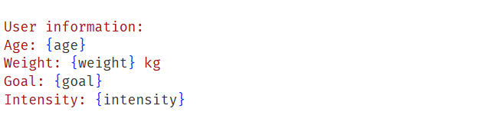 Binding Backend Data to

Templates
index.html: Form elements use name="..." to bind to backend Form(...) parameters; submits to /generate-workout
result.html: Uses {{ username }}, {{ goal }}, {{ intensity }}, {{ workout_plan }}, {{ nutrition_tip }}; includes a feedback form posting to /submit-feedback
all_users.html: Loops over all user records using {% for user in users %}

User.html
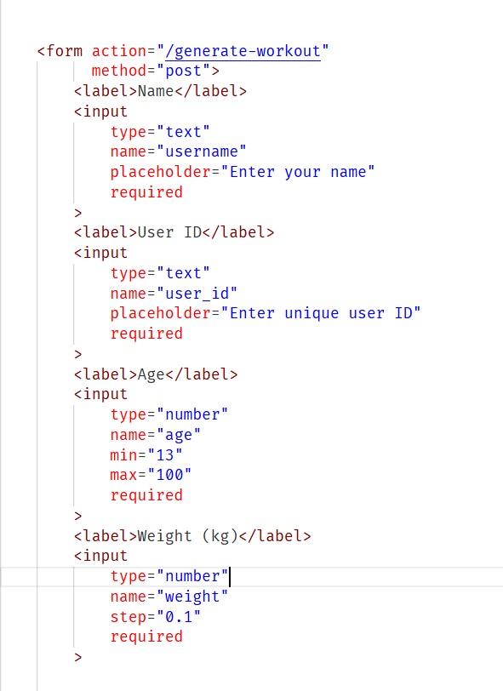

Index.html

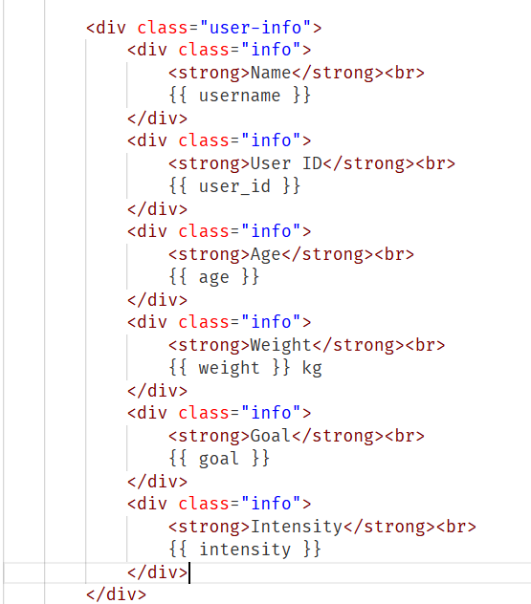

All-user.html

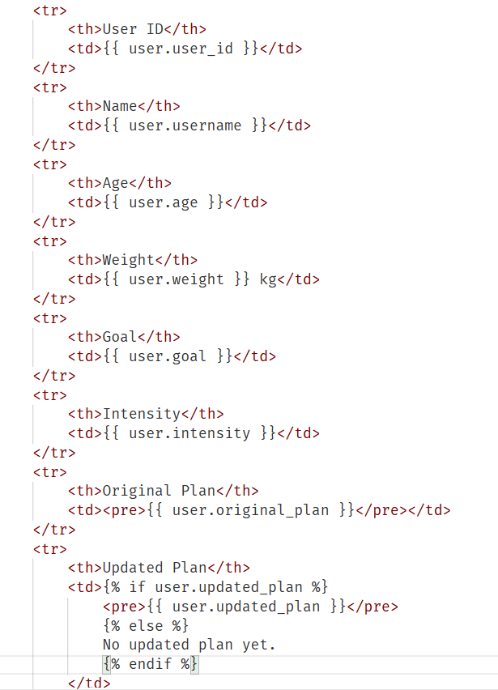

Milestone 5: Deployment
This milestone deploys FitBuddy on a local system using FastAPI and Uvicorn. The app uses HTML templates rendered with Jinja2 alongside AI services powered by Gemini, ensuring all dependencies are installed correctly and the app runs smoothly on a local server.

Activity 5.1: Preparing the Application for Local Deployment

Set Up a Virtual Environment
python -m venv venv source venv/bin/activate # On Windows: venv\Scripts\activate pip install -r requirements.txt

Configure Environment Variables
Sensitive data such as the Gemini API key is stored in environment variables, set in the terminal or in a .env file loaded via python-dotenv:
GOOGLE_API_KEY=your_gemini_api_key_here

Frontend–Backend Rendering via Jinja2
- index.html — collects user inputs
- result.html — displays the generated AI plan
- all_users.html — lists all user records for admin view

Activity 5.2: Testing and Verifying Local Deployment
The FastAPI development server is started with uvicorn main:app --reload. Once running, the app is accessible at http://127.0.0.1:8000, and the interactive API documentation is available at http://127.0.0.1:8000/docs for exploring and testing endpoints.

Home Page
The homepage features a clean, engaging interface for entering personal and fitness details. Submitting the form via "Generate Plan" triggers the AI-powered backend to produce a customized workout and nutrition plan. 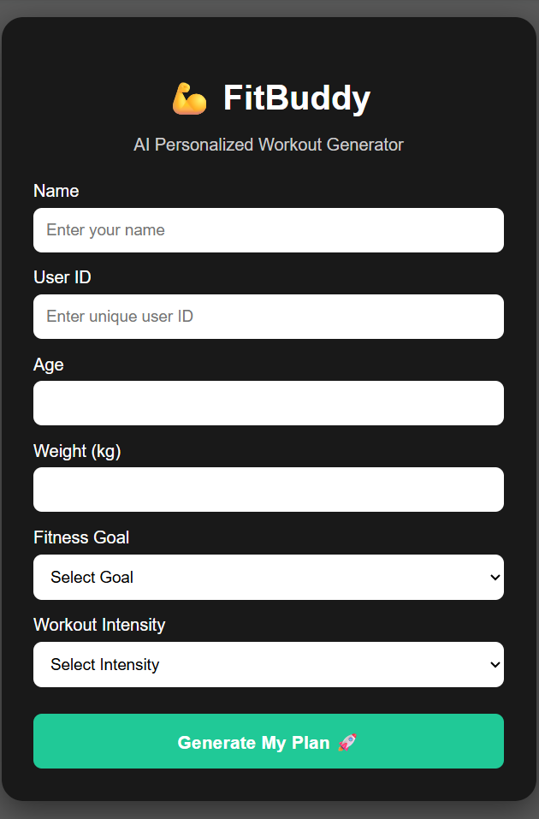

Personalized Workout Generation Page — User Information
After submission, the result page summarizes the user's input, confirming their details before displaying the generated plan. 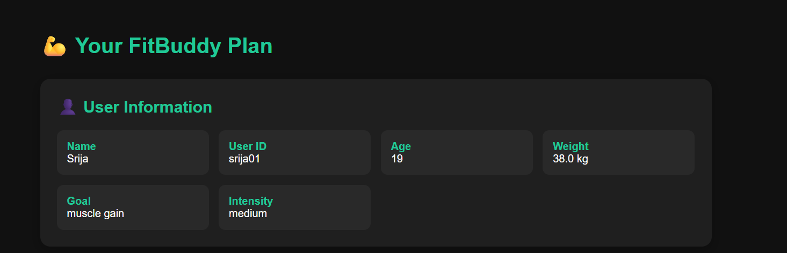

Workout Plan
FitBuddy generates a personalized, day-wise plan with a clear focus per day (full body, upper/lower body, cardio, core, flexibility), listing exercises with sets, reps or duration, and rest intervals, plus warm-up and cooldown guidance.
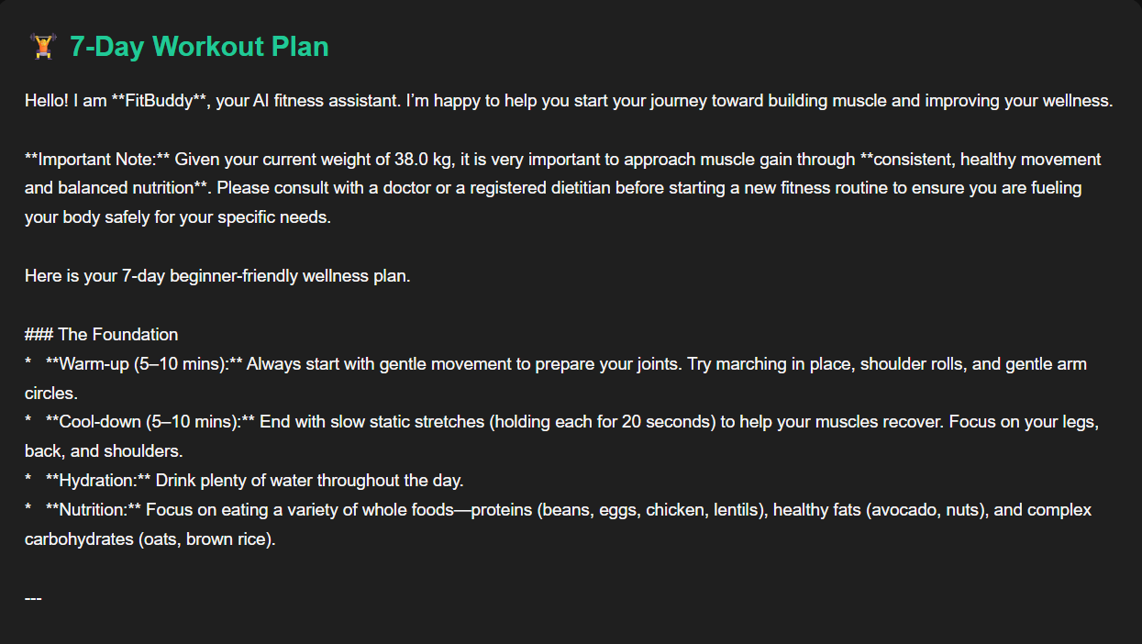

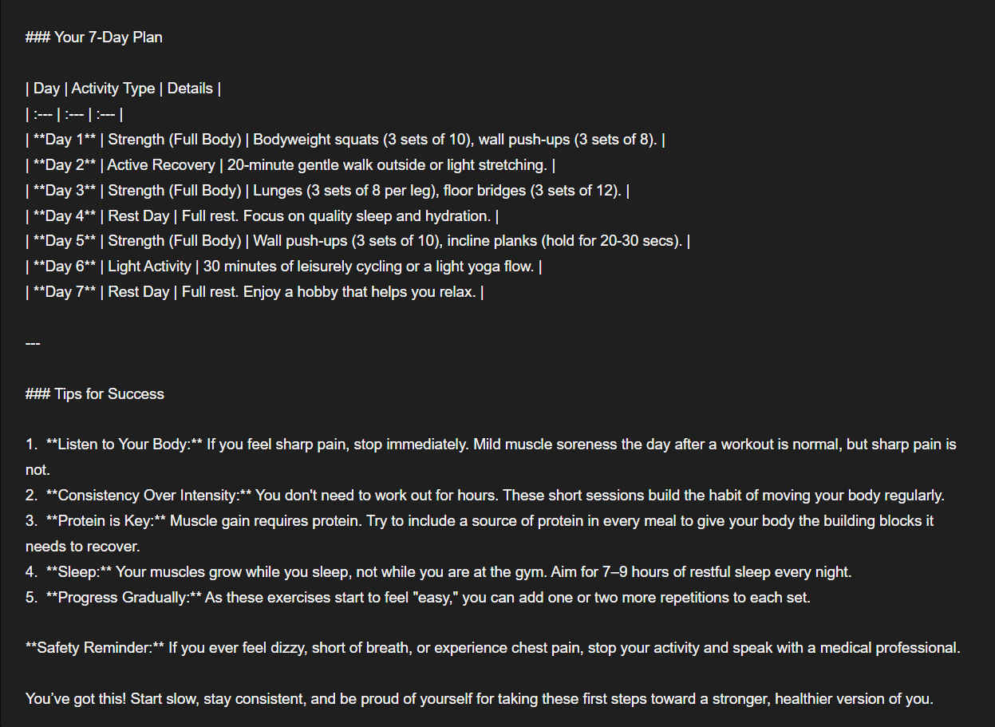

Nutrition Tip
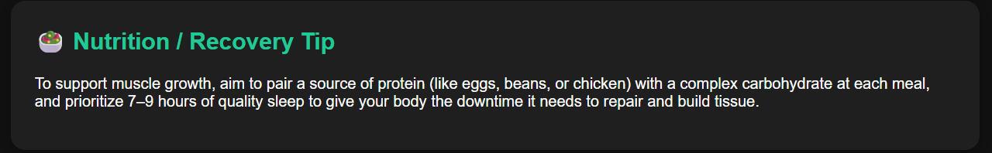 Provides concise, practical dietary advice complementing the workout plan — for example, prioritizing protein from sources like chicken, fish, beans, or Greek yogurt for muscle building, satiety, and metabolic support.

Feedback Page
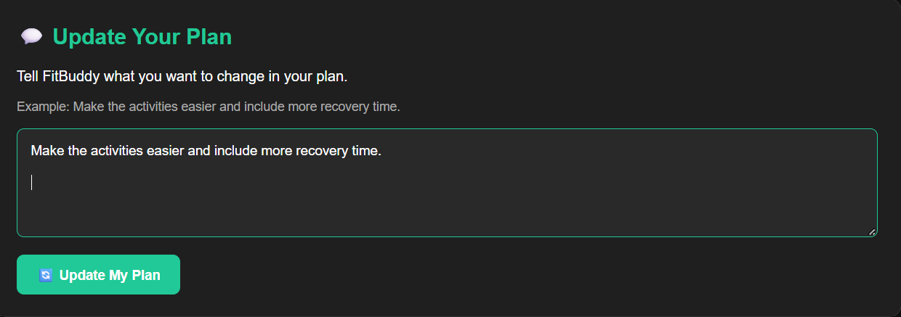 Users submit their User ID and feedback on plan effectiveness, difficulty, or preferences; the system processes this to intelligently update the plan.

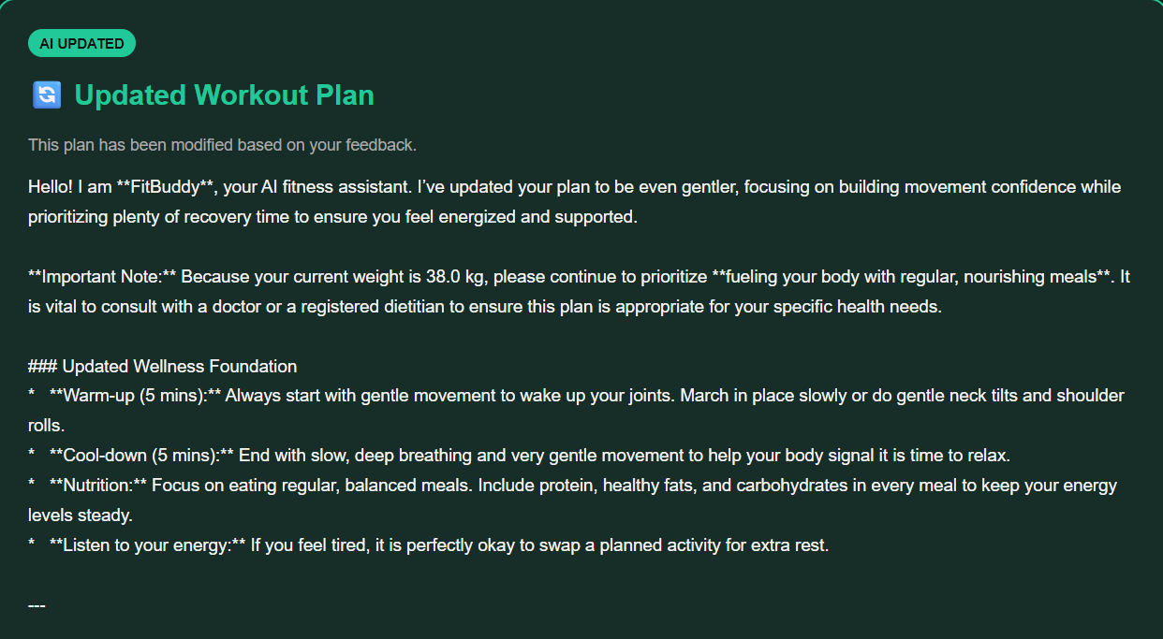

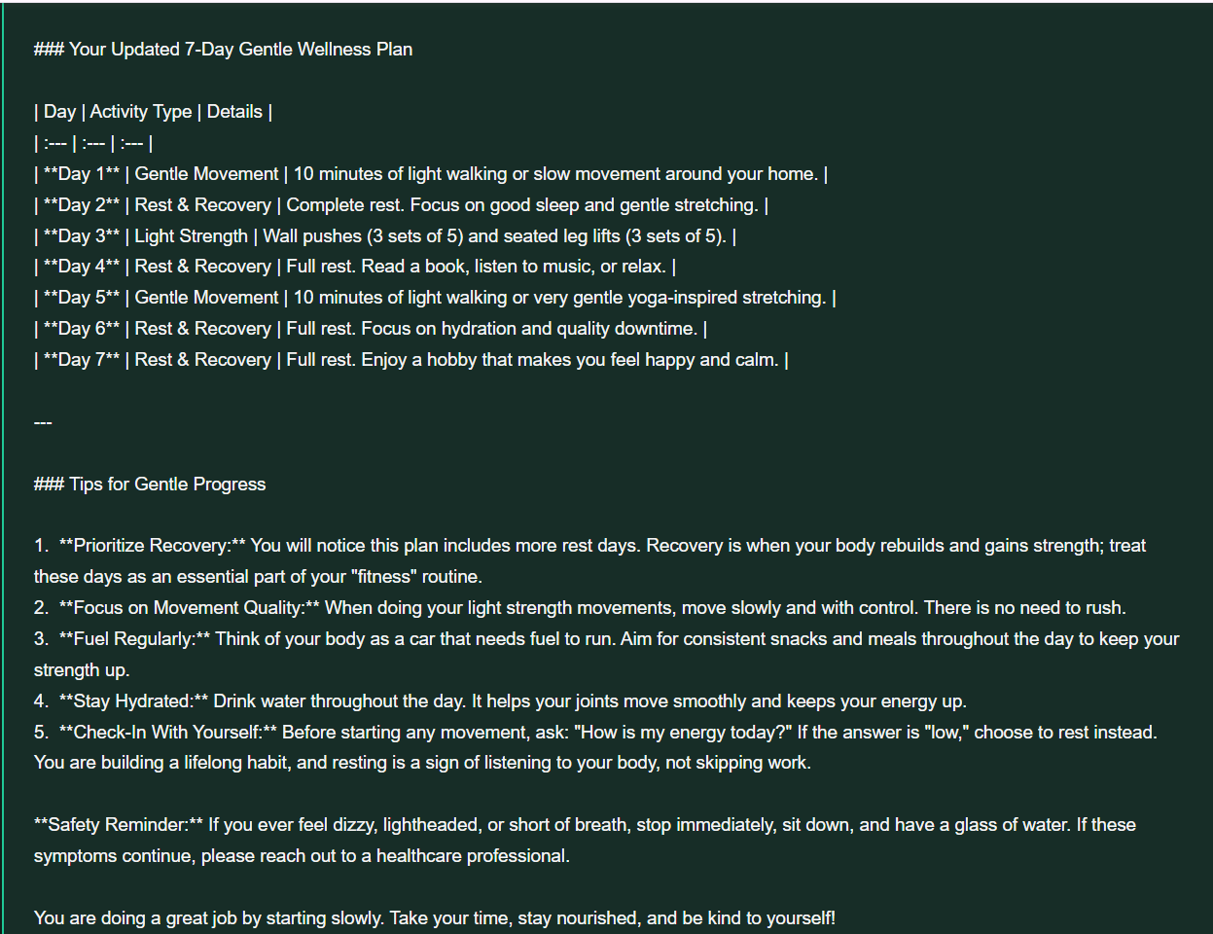

View All Users Page
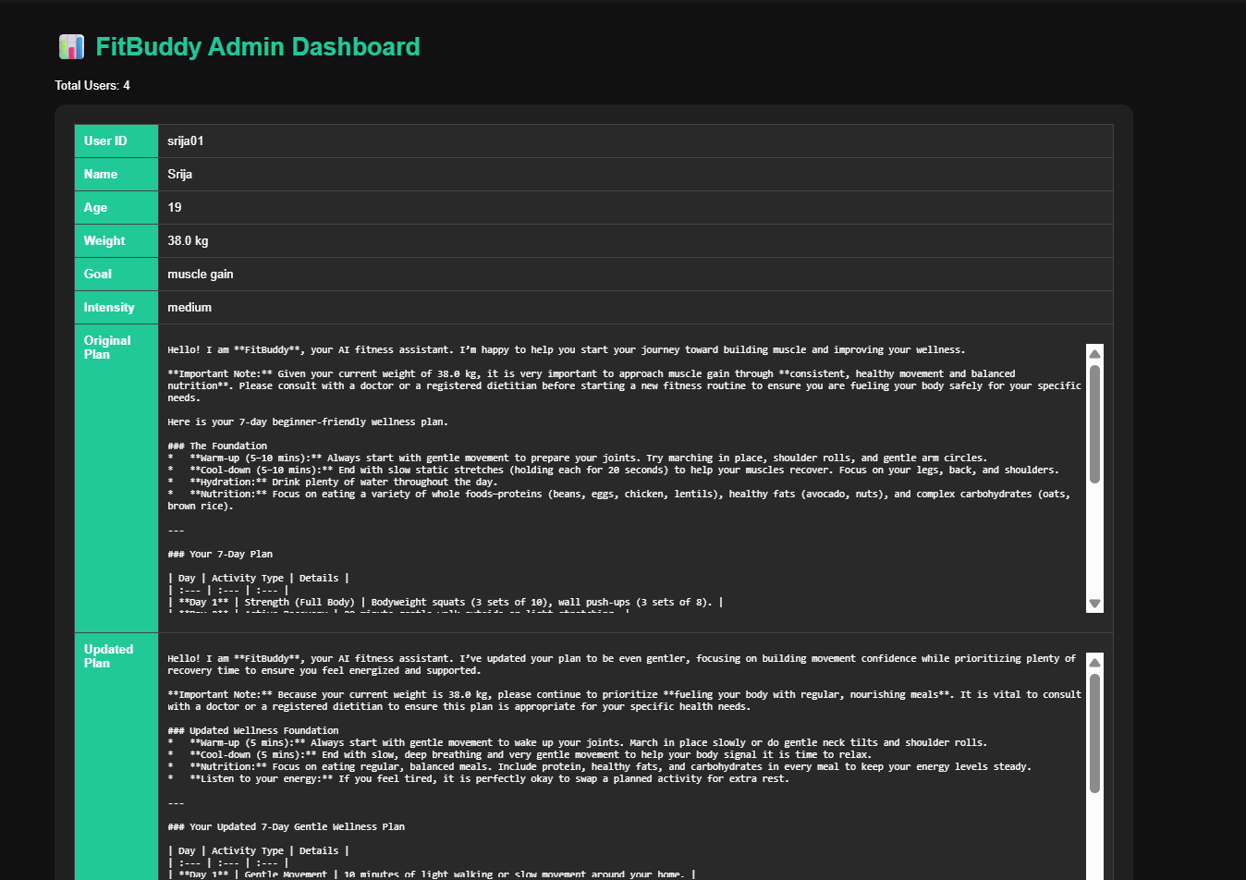 Gives administrators a transparent view of the full user base — personal details, fitness goals, and how each plan evolved from its original version to the feedback-updated version.
Conclusion
FitBuddy — the AI Fitness Plan Generator — is a comprehensive, user-centric web application demonstrating the synergy between artificial intelligence and health-tech. It uses Google's Gemini 1.5 Pro and Gemini Flash models to generate personalized 7-day workout plans and daily nutrition or recovery tips based on user inputs such as age, weight, fitness goal, and preferred workout intensity.
Built with FastAPI for backend logic and API handling, SQLAlchemy with SQLite for persistent storage, and Jinja2 templating for a clean, responsive frontend, the application delivers a tailored plan — including warm-ups, main workouts, cooldowns, and goal-aligned tips — as soon as a user submits their details.
Its dynamic feedback feature allows users to report on plan effectiveness or difficulty, prompting the system to intelligently regenerate the plan via generative AI for ongoing customization. An administrative view further supports transparency and monitoring by displaying all registered users and their original and updated plans, making FitBuddy suitable for individual users as well as coaches or institutions managing multiple fitness profiles.
Overall, FitBuddy is a scalable, adaptable AI-powered solution that personalizes the fitness journey and evolves with each user's progress and preferences — illustrating how generative AI can be woven into everyday wellness routines.

