**WHITE PAPER**

**Intelligent solution for performance analysis: “e-Performer”**

**AREAS COVERED:**

1. **Understanding need of a performance analysis solution**

1. **Why e-Performer: Comparative study with commercial tool option**
2. **Business delivery models**
   1. **As a service model**
   2. **As a Product**
3. **Benefits, Challenges and future state**
   1. **Benefits**
   2. **Challenges**
   3. **Future state**
4. **Understanding need of a performance analysis solution**

Performance analysis have been critical scenario throughout software development lifecycle. Whether it be launching a new application into market space or migrating technology platforms. For any industrial domain applications Non-functional requirements are equally important as functional implementations of any product. In current search for application performance analysis options, primary results listed down will be major commercial solution like Microfocus LoadRunner, Neoload etc and open source tools like Apache JMeter, Gatling, Locust etc.

Major problem statement addressed here is that the Licensed tools in market bring forward a complete solution, covering features like advanced script enhancements, executables management like scripts and dependant files, Load generator management to support virtual user simulation, live monitoring and management of results from test executions, report management and analysis. At the same time when it comes to open source tools, currently there's no solution to fill this gap for any stakeholders.

e-Performer covers most of the features that are unavailable with open source tool, Apache JMeter. For any performance test analysis requirement this could be the solution, we can recommend to market which can be managed by person with least technical expertise. At the same time e-Performer will make it easy to deploy and run with least challenges.

Out of survey on the major open source performance tools in market, published by tricentis. Apache JMeter is considered as the king of performance testing tools. Even though it’s considered as king of performance testing tools, once you compare with commercial licensed tools like Microfocus LoadRunner, it lags a lot of features and capacity.

***Survery on popularity of open source performacne testing tools:***

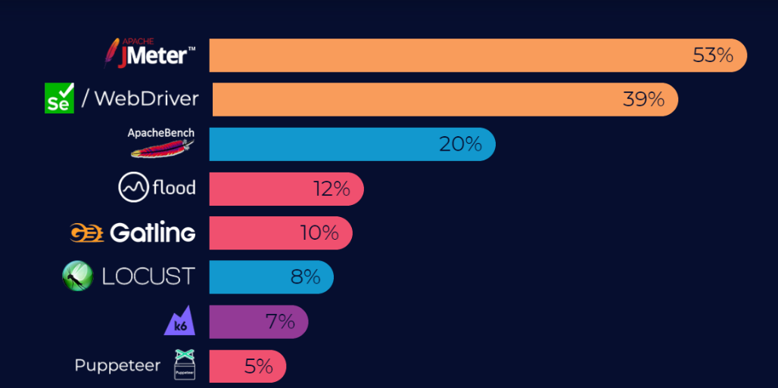

Targeted e-Performer solution will be the absolute package to transform Non-functional business requirements and simulate user population behaviour within the application. Solution also comprises of scope to Automate test lab Infrastructure for Virtual user simulation, live monitoring of the metrics from performance analysis tools and applications, Centralised repository to manage executable credentials and publishing final reports. Beyond these options, e-Performer capacity will be extended to Automate descriptive analytics implementation on result metrics to highlight the performance behaviours using visualization techniques. Also, as an add-on for engagements having any APM tools available can opt to configure application performance management (External APM tool) metrics into existing monitoring dashboards.

1. **Why e-Performer: Comparative study with commercial tool option**

For any Commercial licensed tools like Microfocus LoadRunner, pricing of performance testing tools is proportional to the Virtual user simulation capacity and other add-on features. Whereas the Current solution, web application developed integrating and deploying multiple open source platforms.

Major impediments in performance testing tool implementations for any organizations are listed down;

1. Tool licensed cost
2. Tool complexity in scripting, execution and result analysis
3. Test data management
4. Test lab management for high user simulations
5. Technical support for commercial tools

A detailed feature wise comparison of Microfocus LoadRunner/Performance Center with e-Performer solution;

|  |  |  |
| --- | --- | --- |
| **Comparison chart** | | |
| **Features** | **e-Performer** | **LoadRunner/Performance Center** |
| Application Interface | Web User Interface | Application/Web User Interface |
| Installation & Setup | Easy to install | Complex, an admin role is required to install agents etc |
| Licensing cost | Open source | High cost |
| Infrastructure cost | Depends on user load to simulate and hours of testing | Partially considered along with licensing cost and remaining depends on Virtual user hour utilization |
| Load generation capacity | Load generation capacity depends on the available Infra | Load generation capacity proportional to cost |
| Implementation | Simple | Complex |
| Test lab automation | In scope | Out of scope |
| Script development tool | Apache JMeter | Virtual User Generator |
| Test executables management | SVN repo | ALM repo |
| Technical support | In house support | Support for Golden members |
| Monitoring dashboard | Grafana dashboards | LoadRunner Run time viewer |
| Live real-time results | Grafana dashboards | LoadRunner Run time viewer |
| Usability | Easy to access | Complex setup's, need technical expertise |
| Storage of Results | Yes | Yes |
| Provision for starting and stopping the test | Available | Available |
| Portability | Highly portable | Not so portable |
| Analysis options | Limited | Extensive analysis is possible |
| Result analysis tool | HTML reports | Analysis (in build tool) |
| Provision to add new set of users during the test. | Not possible with current scope | Available |
| Conduct Multiple Test Concurrently | Not possible | Possible |
| Test results comparison dashboard | Can be added in future | Possible with Storm runner |
| SLA settings | Can be added in future | Possible in LR tool |

1. **Business delivery models**

e-Performer have been developed considering it “as-a-product” to be hosted on any engagements that have a Test lab (Multi Load generators) as well as “as-a-service” model, here engagements can opt for

1. **As a service model**
   * **Pay/Use as you go**: To any stakeholders whom want to do performance executions, without getting into challenges of procuring Test lab Infra. “Performance testing as a service” – PTAAS model will provide any stakeholders with ease of continuous test executions and result analysis.
   * **Billing rate:** There can be chargeability based on multiple parameters including hours of test duration and user load/ Load generators required for user simulation. Dedicated Billing model can be generated.
   * **Environment:** EY dedicated environment needs to be running to support any time executions 24/7.
2. **As a Product**
   * Automates test lab setup & configurations and test executions from ePerformer Web Interface, within secure Infra provided by stakeholders. Other than Infra everything remains the same as Pay as you go model.

1. **Benefits, Challenges and future state**

It will be an ongoing development process to make current solution an “Intelligent” one with Analytics and predictive options. With the current solution major benefits listed down;

* 1. **Benefits**
* For Cloud Infrastructure test lab implementation, manage resource optimization.
* Test lab Infrastructure deployment automation on cloud/on premise machines.
* Test execution from Web Interface with defined set of user parameters like load, duration etc.
* Monitor live metrics.
* Stop and break the test, in-case of any issues and restart it.
* Easy to handle test executables and reports via-centralised repo.
* Flexibility to decide set of Load Generators to be utilised based on the load to simulate.
* Non-technical person can execute and analyse results
  1. **Challenges**
* Delivery options -researching to make it as package.
* Scope to take a copy right for the product code.
* Stable Infra to future develop, test and demo this solution.
* Learning curve to implement Kubernetes and descriptive analytics.
* Business requirement to make engagement level implementations.
  1. **Future state**
* Research on the Script automation through an interface in Locust integrated with Python code.
* Scalability with Kubernetes.
* Descriptive Analytics algorithm to identify and recommend root cause.
* Multi performance tools support and implementation.
* Visualization using Python libraries for descriptive analytics for test results.
* Result comparison dashboards from multiple executions.

**e-Performer current/future capabilities:**

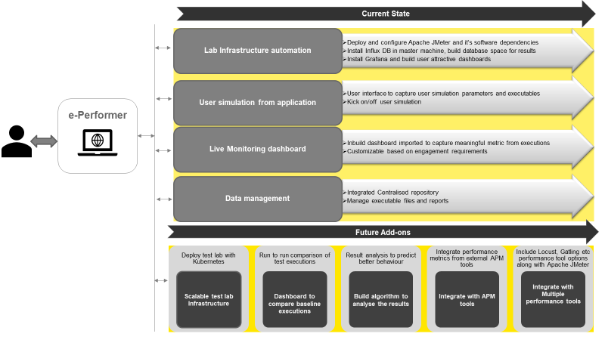

**e-Performer: Technical Architecture(Current state)**

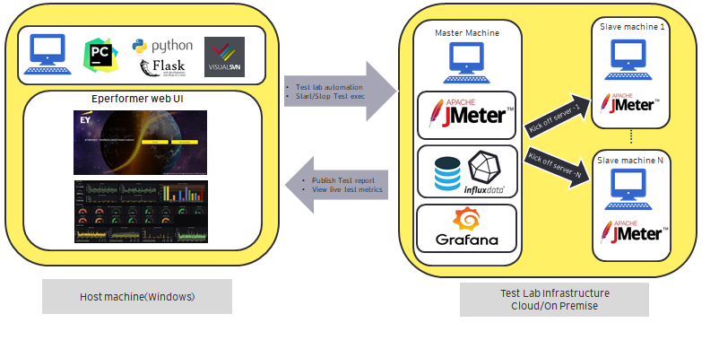

*Pre-requisites:*

*To host e-Performer there are few pre-requisites, which includes a host machine; Windows 10 with internet access. Python IDE to deploy and run solution. Visual SVN manager to manage centralized repository.*

**About Team:** Srijesh Ajay, leads the research and development activities of the solution from the scratch with a dedicated team including Vivek Sreedharan, Abdul Samad and Vishnu Sanisetty. Vivek focused on test lab setup and automation. Abdul focused on web application development and Vishnu contributed with Repository setup. Overall mentored & reviewed by Dinesh Subramaniam.

Referencelink:[*https://www.tricentis.com/state-of-open-source-2020/#:~:text=JMeter%20is%20king%20when%20it,spawn%20browser%20based%20load%20tests*](https://www.tricentis.com/state-of-open-source-2020/#:~:text=JMeter%20is%20king%20when%20it,spawn%20browser%20based%20load%20tests)*.*