Jmeter 4.0 Remote Testing-Challenges and Solutions





Contents

1. Introduction 4

2. Basic Requirements for Distributed Testing 4

3. Challenges and Solutions 4

1. Challenge 1: LAN issues 4
2. Challenge 2: Connection Refused to host 4

**Prepared By**

If you have any questions about this document, please contact the following individual.

|  |  |
| --- | --- |
| **Name** | **Role** |
| Lalithambika N K | Senior Test Lead |
|  |  |
|  |  |
|  |  |
|  |  |

# Introduction

In Apache Jmeter distributed testing we might face some challenges. This document will focus on some of the challenges and solutions while creating a distributed environment using Jmeter version 4.0

# Basic Requirements for Distributed Testing

Basic prerequisites for distributed testing are explained in the following document <https://jmeter.apache.org/usermanual/jmeter_distributed_testing_step_by_step.pdf>

Adding few more points on top of this which is particularly important for Jmeter 4.0 remote testing.

1. Setting up SSL

Create one key/cert pair for all Jmeter Server and Client by running the script located in bin directory (called bin/create-rmi-keystore.bat). Note the following points.

1. Set first and last name as “rmi”
2. Set rmi-keystore password to "changeit"
3. Copy the file bin/rmi_keystore.jks to every Jmeter server and client you want to use for your distributed testing setup
4. Default expiration date of keystore is 7 days. Please ensure to update the keystore if there is failure related to keystore.

Reference: <http://jmeter.apache.org/usermanual/remote-test.html>

1. Make sure the following in all nodes (master and slaves).
   * 1. Same version of Java
     2. Same version of Jmeter
     3. Same version of Jmeter Plugins
     4. Modify Properties files accordingly in master and slaves
     5. Same Data files and folders
     6. Same directory tree

# Challenges and Solutions

## Challenge 1: LAN issues

Not able to download and update Jmeter Plugins from inside office LAN

***Solution***

Run Jmeter behind proxy. Detailed procedure is explained in attached document.



## Challenge 2: Connection Refused to host

Connection refused to host exception on Master (Windows 10, Jmeter 4.0) when using Windows 7 as slave machine.

***Solution***

Tell your java to use IPV4 setting instead of IPV6, in slave machine (Windows 7), as Windows 10 might be using IPv6 addresses by default. This can be achieved in different ways:

1. Add the property to system.properties file (lives under "bin" folder of your JMeter server installation)

java.net.preferIPv4Stack=true

Restart Jmeter server to pick up the change

Repeat the same steps for every remote slave and the master node

1. Next option is to pass the value via -D command-line argument like:

jmeter-server -Djava.net.preferIPv4Stack=true

1. Another option is use the following command from command prompt.

setx _JAVA_OPTIONS -Djava.net.preferIPv4Stack=true

It will set the environment variable. Then start Jmeter server.

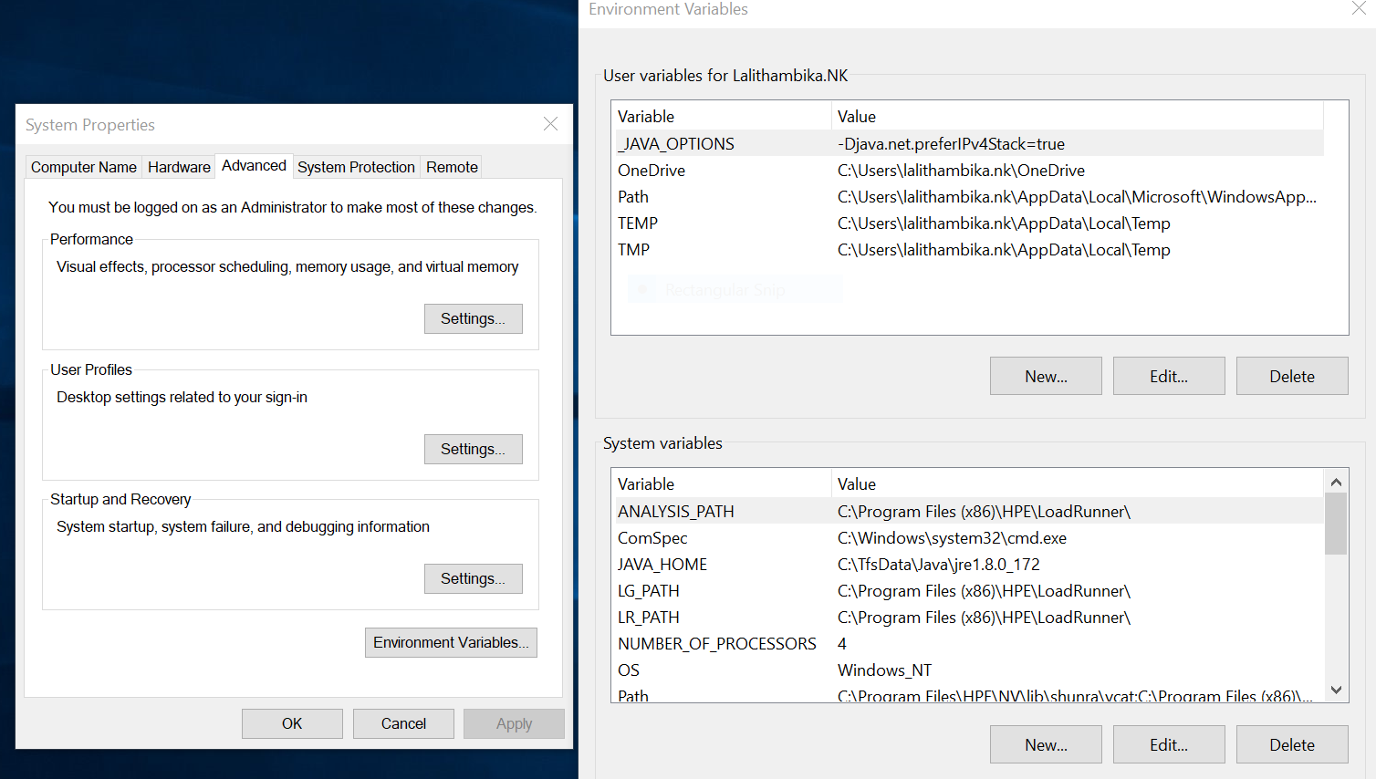

Reference:

[IPv6](https://en.wikipedia.org/wiki/IPv6) is the advanced version of IP, which is the address and identification system for computers and devices on the internet. Currently, most devices on the internet are identified in the network through IPv4. [IPv4](https://en.wikipedia.org/wiki/IPv4) is based on 32 bit addresses, represented by 4 decimal numbers with dots between them (e.g 100.15.1.17). The need to create an advanced version of IP came from the concern that the number of possible IPs would run out, with the growing number of devices on the internet.

As a result, IPv6 was created, and it consists of addresses made of 128 bits, represented by 8 groups of four hexadecimal digits, separated by colons (e.g AB01:C002:0000:9067:DEFA:C79G:H333:BAC1). The length of these addresses can sometimes be shortened.

<https://stackoverflow.com/questions/49147263/jmeter-server4-0-using-ipv6>

<https://knowledgeworldforyou.wordpress.com/tag/jmeter/>