Spring AI

- The Spring AI website is a great place to get general information about the Spring AI project, including Spring AI’s reference documentation at https://spring.io/projects/spring-ai.
- Spring AI is an open-source project. You can find the source code in the GitHub repository at https://github.com/spring-projects/spring-ai.
- The Spring AI team has curated a collection of examples in the Spring AI Examples GitHub repository at https://github.com/spring-projects/spring-ai-examples.
- The author has also made several Spring AI examples available at https://github.com/habuma/spring-ai-examples.
- https://www.youtube.com/watch?v=FzLABAppJfM
_____________________________________________________________________________

1.1 Hello, Spring AI!
AI providers such as OpenAI and MistralAI offer access to their respective collections of LLMs via REST APIs. As long as you have an API key to gain access to those APIs, you can use virtually any HTTP client to submit prompts to the models that will generate responses. While HTTP clients such as Spring’s RestTemplate and RestClient—or even command line tools like curl and HTTPie—are capable of making calls to these LLM-backed APIs, you’ll soon find that once your needs move beyond simple prompts and simple responses, a client abstraction can make the more complex interactions with an LLM easier.
At the risk of oversimplification, Spring AI is, at its core, a client abstraction for working with various AI providers. It makes the easy interactions with LLMs trivial and the more complex uses relatively easy. And it does this while providing an interface that is consistent across all AI providers and their models, making the code you write portable whether your application is backed by models from OpenAI, Anthropic, Meta, MistralAI, or Google Gemini.
As illustrated in figure 1.1, an application built around Spring AI can submit prompts for generation to an LLM at one of several supported AI providers. The generated response is then returned to the application to do with whatever it wishes. Internally, Spring AI handles all of the intricacies of sending the prompt request and handling the response, so that the application doesn’t have to.
Figure 1.1: Spring AI coordinates interaction with AI providers and models.

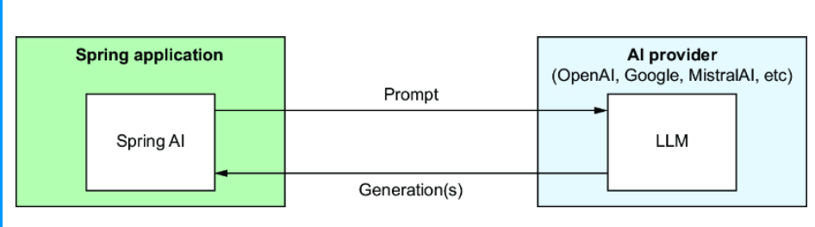

The prompt itself includes text in natural language for which the LLM should generate a response. Common types of prompts include
- A question to be answered
- A message to determine sentiment (e.g., is the message positive or negative?)
- A document to be summarized
- Some content to be moderated
- Some text to be classified (e.g., sentiment analysis)
- A description of an image to be generated
Spring AI can help you achieve incredible generative AI feats, which you’ll do throughout the course of this book. But we have to start somewhere. So, let’s begin your Spring AI journey by writing a very simple REST service that uses the OpenAI service to answer questions.

1.1.1 Initializing the project
Starting a Spring AI application is much the same as starting any other Spring Boot application. Spring AI comes with Spring Boot starter dependencies and autoconfiguration for many of its components, making it easy to go from zero to a working application with minimal effort.
There are many ways to initialize a Spring Boot project, including taking advantage of Spring Boot support in IntelliJ IDEA, Spring Tools (for both Eclipse and VS Code), Netbeans, the Spring Boot CLI, and the Spring CLI. You are welcome to use whichever initialization option you prefer. But they all use the same common service under the hood: the Spring Initializr at https://start.spring.io. If you are using the Initializr directly from the website, you’ll start your first Spring AI project by filling in the blanks and making the choices shown in figure 1.2.
Whether you initialize the project from https://start.spring.io or use one of the other frontends for the Initializr, the choices you make will be the same. For this project, select the following:
- Groovy-based Gradle for the project build.
- Spring Boot version 3.5.5.
- JAR file packaging.
- Java 24 (although Java 17 or higher is fine).
- Spring Web (e.g., Spring MVC) and Spring AI’s OpenAI starter dependencies. (You may also choose the Spring Reactive Web dependency instead of Spring Web.)
You can fill in the Project Metadata fields however you wish. Throughout this book, you’ll use Spring AI to create an application that can answer questions about various tabletop games, so in this screenshot, it’s called Board Game Buddy (and the Artifact, Name, and Package Name fields are set accordingly). But you can call it something else if you’d like. After generating the project and loading it into your IDE, you’ll get a project that includes the build.gradle file.

dependencies
{ implementation 'org.springframework.boot:spring-boot-starter-web'
implementation 'org.springframework.ai:spring-ai-starter-model-openai' test
Implementation 'org.springframework.boot:spring-boot-starter-test'
testRuntimeOnly 'org.junit.platform:junit-platform-launcher'
tasks.named('test') { useJUnitPlatform() }

#1 Spring AI version
#2 Spring AI bill of materials

Although it wasn’t explicitly specified in the Initializr, we’re using Spring AI version 1.0.3. There are many libraries that fall under the Spring AI umbrella, so the build uses a bill of materials (BOM) to manage all of the dependencies we might use for Spring AI.
Now that the project has been initialized, let’s write some code that uses Spring AI to answer questions.

1.1.2 Submitting prompts
The first Spring AI application you write will be a simple REST API that accepts questions and responds with answers to those questions. Internally, it will use Spring AI to submit those questions as prompts to an AI service whose LLM will generate answers.
The core of the application will be handled by a service class that implements this BoardGameService interface:
package com.example.boardgamebuddy; public interface BoardGameService { Answer askQuestion(Question question); }
The askQuestion() method takes a Question object as input and produces an Answer in response. The Question type is a simple Java record that carries the question submitted by the user:
package com.example.boardgamebuddy; public record Question(String question) { }
Similarly, the Answer is a Java record that carries the answer produced by the LLM:
package com.example.boardgamebuddy; public record Answer(String answer) { }
At the moment, each of these contain a single String property, but you’ll add more properties to them both as the project evolves.
The SpringAiBoardGameService class, shown in listing 1.2, implements BoardGameService using Spring AI components to interact with LLMs. This class is where you’ll do much of the work throughout the course of this book.

Listing 1.2 The Spring AI implementation of BoardGameService
package com.example.boardgamebuddy; import org.springframework.ai.chat.client.ChatClient; import org.springframework.ai.chat.prompt.ChatOptions; import org.springframework.stereotype.Service; @Service public class SpringAiBoardGameService implements BoardGameService { private final ChatClient chatClient; public SpringAiBoardGameService(ChatClient.Builder chatClientBuilder) { #1 this.chatClient = chatClientBuilder.build(); #2 } @Override public Answer askQuestion(Question question) { var answerText = chatClient.prompt() .user(question.question()) #3 .call() .content(); return new Answer(answerText); } }

#1 Injects a ChatClient.Builder
#2 Creates a ChatClient
#3 Submits a question

As you can see, SpringAiBoardGameService is injected with a ChatClient.Builder via its constructor, which is then used to create a ChatClient. ChatClient is one of a handful of clients provided by Spring AI for interacting with an AI service. It is useful for the common case of textual generation where you are submitting text to an AI model and are expecting text as a response.
The askQuestion() method is the service’s only method. It takes a Question object and submits it to the LLM using Spring AI’s ChatClient. Using a fluent-style interface, you build up the prompt and then submit it and get the answer.
In the case of the askQuestion() method, the prompt is built with ChatClient's fluent interface with the following steps:
- The prompt() method is called, indicating that you’re defining the prompt.
- The question is specified on behalf of the user by calling the user() method. As you’ll see in the chapter 3, user() is a method that defines a message in the prompt for the “user” role, along with a system() method for defining messages for the “system” role.
- The call() method indicates that you are finished defining the prompt and are ready to submit the prompt to the LLM.
- The content() method submits the prompt and returns the content of the response (e.g., the answer) as a String.
The askQuestion() method wraps up by wrapping the answer text in an Answer object which it then returns to the caller.
Now let’s put SpringAiBoardGameService to work by exposing it in a REST API. The following listing shows AskController, a Spring MVC controller to handle that job.

Listing 1.3 A controller that handles requests working with BoardGameService
package com.example.boardgamebuddy; import org.springframework.web.bind.annotation.PostMapping; import org.springframework.web.bind.annotation.RequestBody; import org.springframework.web.bind.annotation.RestController; @RestController public class AskController { private final BoardGameService boardGameService; public AskController(BoardGameService boardGameService) { #1 this.boardGameService = boardGameService; } @PostMapping(path="/ask", produces="application/json") public Answer ask(@RequestBody Question question) { return boardGameService.askQuestion(question); #2 } }

#1 Injects a BoardGameService
#2 Asks the question

AskController is a relatively straightforward Spring MVC controller. It handles POST requests to “/ask” where the request’s “question” property will be bound to the question property in the Question record. It sends that Question to the injected BoardGameService's askQuestion() and returns the Answer it receives to the client that made the request.
At this point, you’re almost ready to fire up the application and try it out. But there’s one more important thing you need to do first for the application to run.
OpenAI requires that requests include an API key, so you’ll need to obtain your own API key from https://platform.openai.com/api-keys. If you’ve not done so already, you’ll need to create an account and sign in.

PAYING FOR GENERATIVE AI
Generative AI is a special kind of magic and, as the character Mr. Gold (aka Rumplestiltskin) said on the TV show Once Upon a Time, “All magic comes with a price.” Fortunately, the pricing for most LLMs is based on usage and is in fractions of a penny per 1,000 tokens (where a token is a piece of a word; roughly 3/4 of a word). Simple prompts and answers only weigh in at a few hundred tokens, so the bill won’t be adding up very quickly. Even so, keep an eye on your usage so that you aren’t hit with a surprise bill.
Putting this in perspective, the U.S. Declaration of Independence contains 1,695 tokens, while Spring in Action, Sixth Edition contains just over 200K tokens. At the the prices quoted by OpenAI as I’m writing this, sending the entire text of Spring in Action, Sixth Edition as part of a prompt to the GPT-4o-mini model would cost roughly 3 cents. (That said, it would be impossible to do that in a single prompt because the context window only allows 128K tokens.)
Optionally, you can run some models locally using Ollama, which is completely free. You’ll see how to do that a little later in this chapter.
Once you’re signed in, click Create a New Secret Key, give it a name, and then click Create Secret Key. Take note of the key that you’re given because you won’t be able to retrieve it in its complete form from OpenAI later. I suggest saving it in a key store such as LastPass or 1Password so that you can retrieve it later, while still keeping it a secret.
Now that you have your API key, you’ll need to tell Spring AI what it is so that Spring AI can send it in all requests to the API. The most obvious way of doing that is by setting the spring.ai.openai.api-key property in application.properties like this:
spring.ai.openai.api-key=sk-BSMKiIVJM1ck3yM0u53p1K3yZZOINYUiCeC
As straightforward as that might be, it’s not the best idea. When you check your code into source control, you’ll be checking your private API key in along with it. Instead, I suggest that you set your API key to an environment variable named SPRING_AI_OPENAI_API_KEY (which Spring Boot will treat as equivalent to spring.ai.openai.api-key). For example, on macOS or Linux systems, use
export SPRING_AI_OPENAI_API_KEY=sk-BSMKiIVJM1ck3yM0u53p1K3yZZOINYUiCeC
or, if you’re using Windows,
set SPRING_AI_OPENAI_API_KEY=sk-BSMKiIVJM1ck3yM0u53p1K3yZZOINYUiCeC
You’ll need to set the SPRING_AI_OPENAI_API_KEY environment variable on the environments where you’ll be running the application. But the API key won’t be potentially exposed when you check your code into source control.
With the API key specified, you’re almost ready to try it out. But before you get too carried away, let’s take a moment to write a test for SpringAiBoardGameService.

1.1.3 Writing a test
Testing is an important part of any software project. But generative AI presents some challenges with testing that are unlike other types of projects. The responses you get from sending a completion request to an LLM are nondeterministic, making it really hard to write an assertion against the response you get. In short, there is no isEqualTo() when it comes to testing your generative AI code.
Coming up in chapter 2, you’ll learn about evaluators and how to use them to assert that the response you get from an LLM is reasonably equivalent to an expected answer. For now, though, we want to write a test asserting that SpringAiBoardGameServiceWireMockTests does the right thing with whatever response is sent back from the LLM. Since you can’t make the LLM deterministic, you’ll replace the LLM with something that is deterministic.
To accomplish that, you can use WireMock (https://wiremock.org/) to mock the behavior of OpenAI’s API, having it return a known response instead of one generated from an LLM. The first step is to add the following test dependency to the project’s build:
testImplementation 'org.wiremock.integrations:wiremock-spring-boot:3.9.0'
With WireMock in place, you can now write the test itself. The following listing shows the code you’ll write to test the askQuestion() method of SpringAiBoardGameService.

Listing 1.4 Using WireMock to mock the behavior of OpenAI’s API
package com.example.boardgamebuddy; import com.fasterxml.jackson.databind.ObjectMapper; import com.github.tomakehurst.wiremock.client.ResponseDefinitionBuilder; import com.github.tomakehurst.wiremock.client.WireMock; import org.assertj.core.api.Assertions; import org.junit.jupiter.api.BeforeEach; import org.junit.jupiter.api.Test; import org.springframework.ai.chat.client.ChatClient; import org.springframework.beans.factory.annotation.Autowired; import org.springframework.beans.factory.annotation.Value; import org.springframework.boot.test.context.SpringBootTest; import org.springframework.core.io.Resource; import org.wiremock.spring.ConfigureWireMock; import org.wiremock.spring.EnableWireMock; import java.io.IOException; import java.nio.charset.Charset; @EnableWireMock( @ConfigureWireMock(baseUrlProperties = "openai.base.url")) #1 @SpringBootTest( properties = "spring.ai.openai.base-url=${openai.base.url}") #2 public class SpringAiBoardGameServiceWireMockTests { @Value("classpath:/test-openai-response.json") #3 Resource responseResource; @Autowired ChatClient.Builder chatClientBuilder; @BeforeEach public void setup() throws IOException { var cannedResponse = responseResource.getContentAsString(Charset.defaultCharset()); var mapper = new ObjectMapper(); var responseNode = mapper.readTree(cannedResponse); WireMock.stubFor(WireMock.post("/v1/chat/completions") .willReturn(ResponseDefinitionBuilder.okForJson(responseNode))); #4 } @Test public void testAskQuestion() { var boardGameService = new SpringAiBoardGameService(chatClientBuilder); var answer = boardGameService.askQuestion( new Question("What is the capital of France?")); #5 Assertions.assertThat(answer).isNotNull(); Assertions.assertThat(answer.answer()).isEqualTo("Paris"); #6 } }

#1 Enables WireMock
#2 Sets mocked base URL
#3 Injects test response
#4 Stubs completion endpoint
#5 Submits prompt
#6 Asserts response

The @EnableWireMock annotation at the class level not only enables a WireMock test but also establishes a property named openai.base.url that will hold the value of the mock API. This property is then used in the @SpringBootTest annotation to set spring.ai.openai.base-url, the Spring AI configuration property that overrides the default OpenAI base URL.
Next, you’ll notice that a predefined JSON response is injected from that classpath using @Value. That response resource will be used in the test setup() method to stub out the completion endpoint on the mock API. The stub is defined such that if a POST request is made to /v1/chat/completions on the mock API, then the predefined JSON will be returned in the response.
The predefined JSON response is just a typical response you might get from OpenAI’s API:
{ "id": "chatcmpl-BOVzVYyegszUuxVuOwVsCtaslIxs2", "object": "chat.completion", "created": 1745182545, "model": "gpt-4.5-preview-2025-02-27", "choices": [ { "index": 0, "message": { "role": "assistant", "content": "Paris", "refusal": null, "annotations": [] }, "finish_reason": "stop" } ], "usage": { "prompt_tokens": 11, "completion_tokens": 13, "total_tokens": 24, "prompt_tokens_details": { "cached_tokens": 0, "audio_tokens": 0 }, "completion_tokens_details": { "reasoning_tokens": 0, "audio_tokens": 0, "accepted_prediction_tokens": 0, "rejected_prediction_tokens": 0 } }, "service_tier": "default", "system_fingerprint": null }
As you can see, the content property is hard-coded as Paris. The other values are largely irrelevant for our test but are still there for the sake of having a complete response.
Finally, the testAskQuestion() method is where the testing happens. It first creates a new instance of SpringAiBoardGameService from the injected ChatClientBuilder. Then it calls the askQuestion() method to inquire about the capital of France. The two assertions that follow ensure that the Answer object returned will be nonnull and contain Paris in the answer property.
Try running the test. If everything goes well, it should pass with flying colors (or at least the color green).
Now is the time you’ve been waiting for: time to start up the application and give it a try.

1.1.4 Trying it out
Just as there are several ways to initialize a Spring Boot project, there are also several ways to run a Spring Boot application. If you already have a preference, then feel free to use it. If not, then the Spring Boot Gradle plugin makes it as easy as running the following at the command line:
$ ./gradlew bootRun
Once the application starts up, use your favorite HTTP client to send a POST request to http://localhost:8080/ask with JSON in the body that has the question. Here’s how to submit such a request using the well-known curl (https://curl.se/) command:
$ curl localhost:8080/ask \ -H"Content-type: application/json" \ -d'{"question":"Why is the sky blue?"}' {"answer":"The sky appears blue because of the way the Earth's atmosphere scatters sunlight. When sunlight travels through the atmosphere, it collides with molecules and particles in the air. These collisions cause the sunlight to scatter in all directions. Blue light has a shorter wavelength and scatters more easily than other colors, which is why we see the sky as blue during the day."}
Or, if you prefer the HTTPie (https://httpie.io/) command line tool, then the following command will achieve the same results:
$ http :8080/ask question="Why is the sky blue?" -b { "answer": "The sky appears blue during the day because of the way the Earth's atmosphere scatters sunlight. The shorter blue wavelengths of light are scattered in all directions by the gases and particles in the atmosphere. This is known as Rayleigh scattering. This scattering causes the blue light to dominate our view of the sky, making it appear blue to our eyes." }
HTTPie assumes that the hostname is localhost. It also assumes that both the request and response bodies are JSON and maps the “question” parameter into a property named question in a JSON document sent in the request body. The -b flag indicates that you only want the body of the request printed; if you omit it, the request headers will also be displayed.
Aside from showing you two ways to send a POST request to the application, these two command-line examples also show that the responses received were different. But the variation isn’t due to the choice of HTTP client. In fact, you could submit the exact same request multiple times with the same or different clients and get a different response each time.
The reason it varies is that generative AI is nondeterministic. The responses are probabilistic, providing responses that are statistically likely to follow the prompts that are submitted.
Now you have a very simple question-and-answer application that uses Spring AI to generate responses. There’s much more that Spring AI offers, and we’ll explore it all throughout this book. But for now, let’s take a step back and consider the AI services and models that are available with Spring AI and how to choose one for your applications.

1.2 Choosing a model
At the outset of the project you created in this chapter, you chose Spring AI’s OpenAI starter. You’ve been using OpenAI’s REST API under the covers to respond to the questions that were submitted through the application.

OPENAI COMPATIBILITY
Although most AI service providers have their own proprietary APIs, many offer OpenAI-compatible APIs either as their own API or as an alternative to their API. AI service providers such as Groq (https://groq.com/) and Google Gemini, tools such as vLLM (https://docs.vllm.ai/) and LiteLLM (https://www.litellm.ai/), and even Ollama offer APIs that are mostly compatible with OpenAI’s API. You can use Spring AI’s OpenAI starter to integrate with these APIs in the same way you would with OpenAI itself.
What’s more, by default, Spring AI chooses OpenAI’s gpt-4o-mini model, which is one of OpenAI’s most popular models. It’s a very capable model that both understands and can generate responses in natural language and is trained on an enormous set of data, making it capable of answering almost any question you pose to it.
Spring AI offers several other AI services to choose from, including
- Amazon Bedrock—An AI service offered through Amazon’s cloud platform with models such as Claude, Llama, Mistral, and Titan.
- Anthropic—An AI service founded by former members of OpenAI, offering the Claude family of models.
- Azure OpenAI—Essentially the same set of models as OpenAI but offered through Microsoft’s Azure computing platform.
- Google AI—An AI service offered through Google’s cloud platform, including Google’s Gemini models.
- Hugging Face—Offers a repository with over 300,000 models to choose from Spring AI’s integration with Hugging Face works with Hugging Face’s cloud-based API.
- MiniMax—A Chinese AI service offering several models, including multilingual models.
- MistralAI—An AI company founded by former Meta and Google employees that offers several very capable LLMs, including the popular Mistral 7B model.
- Ollama—An option for running several open-source models free and locally on your own hardware, including several popular models offered by some of the cloud-based services.
Those services all provide various models suitable for text-based generation. Some also provide multimodal generation, including images and speech (which we’ll explore in chapter 7). And most also provide an embedding API that can translate text into a mathematical representation that can be used to determine similarity between two or more sets of text, which will become important when we cover retrieval augmented generation (RAG) in chapter 4.
If that list isn’t overwhelming enough, you should know that the generative AI landscape is constantly changing, and more services and models are always becoming available, each one trying to outdo those that came before it. With so many choices, how do you choose which service and model to use? While there really isn’t a definitive way to choose a model, there are a handful of criteria to consider when choosing a provider and model:
- Price—Most of the options, especially the cloud-based options, require payment. While many of them are priced very inexpensively, you’ll want to consider how your choice will impact your budget. But there are also free options, including models served by Ollama.
- Context window—When processing a prompt and providing a response, the prompt and response are broken down into granular pieces called “tokens.” How tokens are created isn’t as important as how many are allowed in the prompt and response. Different models have different context windows, ranging from a few thousand tokens per interaction to millions of tokens per interaction. These limits aren’t of great concern when asking simple questions, but as you add conversational history and document context to your prompts, you’ll want to be sure that your prompts don’t exceed the model’s limits.
- Training—The most significant difference between various models is what data they are trained on. Some models are trained on much larger datasets than others, while some are trained on smaller, but more focused datasets. Moreover, the date that a model is trained up to will have an effect on its ability to provide responses based on more current data.
- Capabilities—Some AI providers and models provide additional capabilities, such as the ability to stream responses and provide content from application-provided tools. Because such features are not standard across all LLMs and providers, you’ll want to be sure to consider whether you’ll need these additional capabilities.
Because new models are frequently being added and the prices, context windows, and capabilities of the models are often changing, I won’t dwell on those specifics in this book. You should refer to each provider’s website for the latest available models and their specifications.
Whatever choice you make, the only significant difference it will make in your application is in what starter dependency you add to your build and how you configure credentials and other options in your application configuration. The code you write that uses ChatClient or most other Spring AI components will be the same.

1.2.1 Configuring OpenAI models
The example we built in this chapter uses Spring AI’s OpenAI integration. So you’ve already seen how to add it to a Spring Boot project. As a reminder, though, here’s the starter dependency to use for integrating with OpenAI:
implementation 'org.springframework.ai:spring-ai-starter-model-openai'
As you’ve seen, this starter comes with autoconfiguration that enables a ChatClient .Builder, making it easy to get started by injecting the builder, using it to create a ChatClient, and then calling the prompt() method to build and submit a request.
By default, Spring AI’s OpenAI module works with the GPT-4o mini model, which is a very capable model. But it’s not the only model you can choose, and you may want to consider using a different one.
OpenAI updates its models and introduces new models every so often. To see what current models are available, visit https://platform.openai.com/docs/models or use the models endpoint:
$ http -A bearer -a $SPRING_AI_OPENAI_API_KEY \ https://api.openai.com/v1/models
Among the models that OpenAI offers are GPT-4.1 mini, GPT-4.1 nano, and GPT-4.1. Spring AI defaults to GPT-4o mini, but you might consider choosing the more capable GPT-4.1 for more complex work. Or perhaps you want to try GPT-4.1 nano to be more cost-effective.
To use GPT-4.1, GPT-4.1 nano, or any of OpenAI’s other models, set the spring.ai.openai.chat.options.model property. For example, here’s how you would override the default to use GPT-4.1 nano:
spring.ai.openai.chat.options.model=gpt-4.1-nano
As an alternative to using OpenAI models directly through OpenAI’s service, you can also access OpenAI models through Microsoft Azure. You’ll need to sign up for Azure access at https://azure.microsoft.com/ and obtain your API key through the Azure portal.
Spring AI has a different starter dependency if you’re using Azure OpenAI:
implementation 'org.springframework.ai:spring-ai-starter-model-azure-openai'
Likewise, specifying your API Key for Azure OpenAI is slightly different in that the property includes the word “azure”:
spring.ai.azure.openai.api-key=sk-BSMKiIVJD0n4ldDuck2p1K3yZZOINYUiCeC
Or you can specify it as an environment variable like this:
export SPRING_AI_AZURE_OPENAI_API_KEY=BSMKiIVJD0n4ldDuck2p1K3yZZOINYUiCeC
It’s also important to note that even though Azure OpenAI serves OpenAI models, it is a separate provider from OpenAI. As such, your OpenAI API key will not work with Azure OpenAI. If you want to use Azure OpenAI, you’ll need to sign up for an account at https://mng.bz/X7e1 and obtain an API key from Microsoft.
To select a non-default model, set the spring.ai.azure.openai.chat.options .deployment-name. The following line in your application’s application.properties file should do the trick:
spring.ai.azure.openai.chat.options.deployment-name=gpt-4
As shown here, the spring.ai.azure.openai.chat.options.deployment-name property is telling Spring AI to send prompts to the GPT-4 model rather than the default GPT-4o-mini model.

1.2.2 Serving models locally with Ollama
One more very compelling option, especially for development purposes, is to use Ollama (https://ollama.com). Ollama is an amazing tool that enables you to run several open-source LLMs locally and for free on your own machine. Some of the most popular LLMs available for Ollama include Meta’s Llama, Google’s Gemma, Alibaba’s Qwen, and MistralAI’s Mistral 7B.
After downloading and installing Ollama on your machine, you’ll need to pull one or more models that you want to use. Pulling models to your local machine is made easy with the ollama command-line tool. For instance, to install the Gemma 2B model locally, you would use the following command-line incantation:
$ ollama pull gemma:2b
Similarly, if you would like to use MistralAI’s Mistral 7B model, you would use this command:
$ ollama pull mistral:7b

LLMS AREN’T ONE-SIZE-FITS-ALL
Be aware that the performance of the models you choose will depend on their size as well as the hardware that is running Ollama. For example, I had no trouble at all running Gemma 2B on my MacBook Pro, which is a few years old, but the Gemma 7B model was significantly slower and consumed a lot more memory while generating responses.
Refer to Ollama’s official list of available models (https://ollama.com/library) for information regarding what models are available. To see a list of the models installed on your machine, use the ollama command line:
$ ollama list
Or, for more details on the models that you have installed, send a GET request to the Ollama API’s /api/tags endpoint:
$ http http://localhost:11434/api/tags -b
Once you have pulled one or more models and Ollama is running on your machine, you can start using them in your project using Spring AI’s Ollama starter dependency:
implementation 'org.springframework.ai:spring-ai-starter-model-ollama'
Unlike the other AI providers supported by Spring AI, you won’t need to obtain or set an API key to use Ollama. That’s because Ollama isn’t a cloud-based AI service like OpenAI. Ollama will be running on your local machine, so no access credentials are required.
Spring AI defaults to the Mistral 7B model when using Ollama. If you’d like to use a different model, you’ll have to specify which one you want to use with the spring.ai.ollama.chat.model property, as shown here:
spring.ai.ollama.chat.model=gemma:2b
This configures Spring AI to use the Gemma 2B model from Ollama running on your local machine.
Spring AI also offers something special for working with Ollama models. Instead of using ollama pull to pull the models you want to use, you can ask Spring AI to pull them for you by setting the spring.ai.ollama.init.pull-model-strategy property. For example, to have Spring AI pull the model if it hasn’t already been installed, you can set spring.ai.ollama.init.pull-model-strategy like this:
spring.ai.ollama.init.pull-model-strategy=when_missing
You may also choose to set it to always to have it pull the model every time that the application starts. The default value is never, which means it will never pull the model automatically.
Although having Spring AI pull Ollama models for you automatically is very convenient, it does add time to the application startup. You will probably want to avoid taking advantage of this in production settings and reserve its use for development and test time.
Although Spring AI supports several AI services and models, we need to make a choice that we’ll stick with for most of the examples. So, unless otherwise stated, the examples in this book will be written to work with OpenAI’s (or Azure OpenAI’s) gpt-4o-mini model as well as Ollama using the Gemma, Llama, or Mistral models. You’re welcome and encouraged to try other models, but be aware that the results and your success may vary.

1.3 Previewing Spring AI’s capabilities
In this chapter, you’ve created a very elementary Spring AI application that sends a basic textual prompt to an LLM and prints out the textual response. It doesn’t get much simpler than that. But if that’s all there was to Spring AI, you wouldn’t bother to read this book (and I wouldn’t have bothered to write it). Spring AI has a lot more to offer than that, as you’ll see in the chapters that follow.
For more advanced cases, the prompts you send will be longer and more involved than one-sentence questions. You’ll want to provide more detailed instructions for how the LLM should respond, as well as data or other context that the LLM can draw upon when generating a response. To make complicated prompts easier to work with, Spring AI offers the option of creating prompt templates that have placeholders that can be filled with parameter values and context.
Many times, working with an LLM is more than a single question and answer. When interactions become a back-and-forth conversation, it’s important that the conversation’s history be kept so that the LLM will remember what was said before. Spring AI makes it easy to maintain chat history and provide that history as context when prompts are sent.
All models are trained on information up to a specific date and know nothing about events that may have happened after that date. Moreover, your project may require asking about confidential documents that the LLMs were not trained on. To fill in the gaps, a technique known as retrieval-augmented generation (RAG) can be applied with Spring AI. With RAG, you’ll be able to ask questions about and converse with your own documents.
While RAG is wonderful when working with unstructured documents, there may be situations where you’ll want to integrate generative AI with functionality provided by your application, such as looking up data from a database or even taking some action (e.g., placing an order). For those cases, Spring AI can work with the tools offered by some of the models from OpenAI, Mistral, and Google. And applying Spring AI’s support for Model Context Protocol (MCP) will let you work with collections of related tools as a module.
Often, your users will need to ask more than a single question and get a single answer. Although LLMs themselves do not remember past interactions, by applying Spring AI’s chat memory, you’ll enable your application’s users to carry on conversations.
Spring AI can do more than just interact with an LLM to answer questions. Using Spring AI, you’ll be able to do more with text, such as analyzing sentiment, moderating content, summarizing documents, and classifying text.
Finally, textual prompts that yield textual responses are only one aspect of generative AI. Spring AI can also help you generate images from text, transcribe audio into text, and many other exciting ways of making your AI-enabled applications shine.
These are the things you’ll use Spring AI to do before the final page of this book. So hang on tight. This is going to be an exciting ride!

Summary
- Spring AI enables generative AI capabilities for applications developed with Spring Boot.
- Spring AI provides a client abstraction with a consistent interface, no matter what AI service provider or LLM you are using.
- Spring AI integrates with several popular AI service providers, including OpenAI, Azure OpenAI, Anthropic, MistralAI, Google, and Amazon Bedrock.
- Spring AI applications can also use locally run LLMs served through Ollama.
_____________________________________________________________________________

Chapter 2: Evaluating Generated Responses

This Chapter Covers
- Getting started with Spring AI evaluators
- Checking for relevancy
- Judging response correctness
- Applying evaluators at runtime
Writing tests against your code is an important practice. Not only can automated tests ensure that nothing is broken in your application, but they can also provide feedback that informs the design and implementation. Tests against the generative AI components in an application are no less important than tests for other parts of the application.
There’s only one problem. If you send the same prompt to an LLM multiple times, you’re likely to get a different answer each time. The nondeterministic nature of generative AI means that there can be no “assert equals” approach to testing.
In chapter 1, you saw how to use WireMock to mock the API’s responses to get a deterministic response in a test. That approach to testing is a good way to test the code around a request to a generative AI API, but it doesn’t test the prompt and how the model responds to it. Fortunately, Spring AI provides another way to decide if the generated response is an acceptable response: Evaluators.
An evaluator takes the user text from the prompt that was submitted to the LLM, along with the content from the response and decides whether the response content passes some criteria. Under the covers, an evaluator can be implemented in any way suitable for the kind of evaluation it performs. But as illustrated in figure 2.1, evaluators typically rely on an LLM (via ChatClient) to judge how fitting the response is to the submitted prompt.
Figure 2.1: Spring AI evaluators send a prompt and a generated response to the LLM to assess the quality of the response.

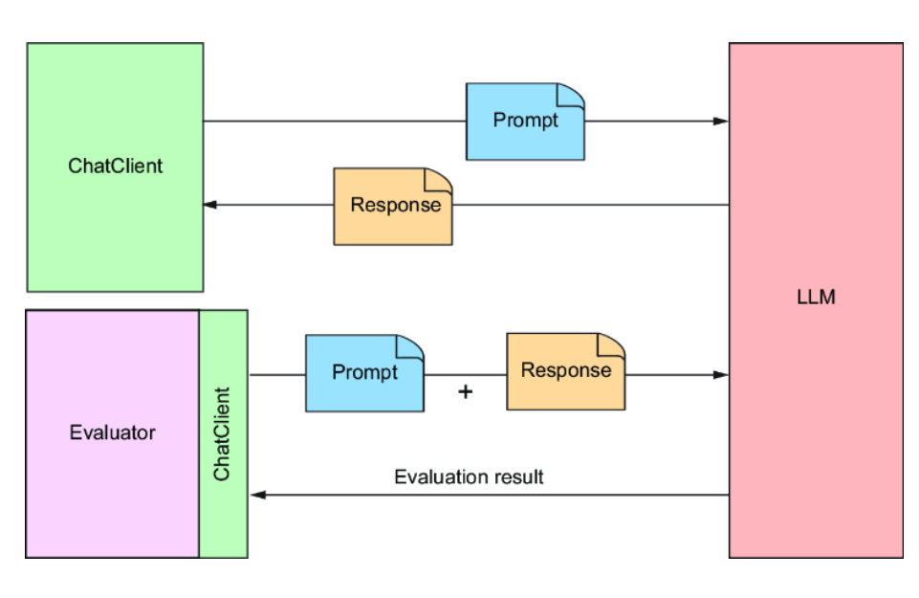

Let’s see how to use an evaluator to write an integration test against BoardGameService, the one component in the Board Game Buddy application that applies generative AI.

2.1 Ensuring relevant answers
The most basic form of evaluation is to determine whether the LLM answered the question posed. That is, was the generated response at least on-topic with regard to the submitted prompt?
For example, if the user asks, “Why is the sky blue?” and the LLM responds with “Because of Rayleigh scattering” (or some such response), then the answer is relevant. On the other hand, suppose the LLM were to respond with “The moon is approximately 239,900 miles from Earth.” Although correct, that answer isn’t relevant to the question regarding the sky’s color.
Determining whether an answer is relevant to the given question is precisely the kind of evaluation that Spring AI’s RelevancyEvaluator does. To see how RelevancyEvaluator works, let’s use it to write a test against BoardGameService. The test class in the following listing is such a test.

Listing 2.1 Testing that the response from an LLM is relevant to the question
package com.example.boardgamebuddy; import org.assertj.core.api.Assertions; import org.junit.jupiter.api.BeforeEach; import org.junit.jupiter.api.Test; import org.springframework.ai.chat.client.ChatClient; import org.springframework.ai.chat.evaluation.RelevancyEvaluator; import org.springframework.ai.evaluation.EvaluationRequest; import org.springframework.ai.evaluation.EvaluationResponse; import org.springframework.beans.factory.annotation.Autowired; import org.springframework.boot.test.context.SpringBootTest; @SpringBootTest public class SpringAiBoardGameServiceTests { @Autowired private BoardGameService boardGameService; #1 @Autowired private ChatClient.Builder chatClientBuilder; #2 private RelevancyEvaluator relevancyEvaluator; @BeforeEach public void setup() { this.relevancyEvaluator = new RelevancyEvaluator(chatClientBuilder); } @Test public void evaluateRelevancy() { String userText = "Why is the sky blue?"; Question question = new Question(userText); Answer answer = boardGameService.askQuestion(question); #3 EvaluationRequest evaluationRequest = new EvaluationRequest( userText, answer.answer()); EvaluationResponse response = relevancyEvaluator .evaluate(evaluationRequest); #4 Assertions.assertThat(response.isPass()) #5 .withFailMessage(""" ======================================== The answer "%s" is not considered relevant to the question "%s". ======================================== """, answer.answer(), userText) .isTrue(); } }

#1 Injects BoardGameService
#2 Injects ChatClient.Builder
#3 Asks the question
#4 Evaluates the response
#5 Asserts relevancy

As you examine SpringAiBoardGameServiceTests, you’ll see that the first several lines of the test perform some setup necessary to run the evaluation. The class is annotated with @SpringBootTest, indicating that this is an integration test so that a Spring application context, including all of the beans from the application, will be created. From that application context, a BoardGameService and a ChatClient.Builder are injected into the test with the help of the @Autowired annotation. The ChatClient.Builder is then used in the setup() method to create a new RelevancyEvaluator that you’ll use in the test method.
The first thing the evaluateRelevancy() test method does is create a Question object and send it to the askQuestion() method on the injected BoardGameService to get back an Answer. Then it creates an EvaluationRequest from the original user text and the answer, and then passes it to the RelevancyEvaluator’s evaluate() method. Internally, the evaluate() method sends a prompt to the LLM asking it to judge the relevancy of the answer to the question.
The evaluate() method returns an EvaluationResponse, from which isPass() is called to find out whether the evaluation passed. If isPass() returns true, the answer has been deemed relevant to the question. Otherwise, isPass() will return false, meaning that the answer was not relevant and the assertion will fail.
With this test in place, you can quickly and automatically check that a question posed through the SpringAiBoardGameService’s askQuestion() method results in a fitting answer. But just because the answer is relevant, that doesn’t mean that it’s correct. Let’s turn our test up a notch by checking that the answer is also correct.

2.2 Testing for factual accuracy
Suppose that when asked why the sky is blue, the LLM were to respond with something like “The sky is blue because there are a gazillion tiny bubbles filled with blueberry jam floating in the atmosphere.” Although that answer appears to be relevant, it is most certainly not correct. It might sneak past the RelevancyEvaluator’s scrutiny, but it might not be the answer you should present to your application’s users.
Spring AI’s FactCheckingEvaluator works similarly to RelevancyEvaluator, except that instead of asking the LLM to judge the relevancy of the answer to the question, it asks the LLM to judge whether the answer correctly answers the question.
Before adding a factual accuracy test to SpringAiBoardGameServiceTests, you’ll need to tweak the setup() method to create a FactCheckingEvaluator and assign it to an instance variable:
private FactCheckingEvaluator factCheckingEvaluator; @BeforeEach public void setup() { this.relevancyEvaluator = new RelevancyEvaluator(chatClientBuilder); this.factCheckingEvaluator = new FactCheckingEvaluator( chatClientBuilder); }
Now let’s write the fact-checking test method:
@Test public void evaluateFactualAccuracy() { var userText = "Why is the sky blue?"; var question = new Question(userText); var answer = boardGameService.askQuestion(question); var evaluationRequest = new EvaluationRequest(userText, answer.answer()); var response = factCheckingEvaluator.evaluate(evaluationRequest); Assertions.assertThat(response.isPass()) .withFailMessage(""" ======================================== The answer "%s" is not considered correct for the question "%s". ======================================== """, answer.answer(), userText) .isTrue(); }
The evaluateFactualAccuracy() method is much like the evaluateRelevancy() created earlier. Just as when testing relevancy, the EvaluationResponse’s isPass() is used in an assertion, which will cause the test to fail if the generated answer is judged to be incorrect.
If isPass() returns false and the assertion fails, the failure message explains why it failed. For instance, suppose that the generated answer was “There are tiny bubbles filled with blueberry jam high in the atmosphere.” In that case, the FactCheckingEvaluator would judge the answer incorrect and the assertion would fail. The resulting failure message might look like this:
======================================== The answer "The sky is blue because there are a gazillion tiny bubbles filled with blueberry jam floating in the atmosphere." is not considered correct for the question "Why is the sky blue?". ========================================
As you work through this book, you’ll make many changes to how the prompt sent to the LLM is formed. By having tests like those in evaluateRelevancy() and evaluateFactualAccuracy(), you can be assured that you’re still getting appropriate and correct answers, no matter what changes you may make.
Even so, what might not be obvious is that you might find it useful to apply evaluators outside of tests to make sure that the answers given at runtime are also relevant and correct. Let’s have a look at how to apply evaluators directly in the application code.

2.3 Applying self-evaluation at runtime
Even if the evaluator-based tests are passing when you build your application, you still could get irrelevant or incorrect responses at runtime. The nondeterministic nature of generative AI allows for the possibility that the tests could get lucky and receive good responses, but then have things go pear-shaped when the application is in production. Applying evaluators at runtime can help prevent bad answers from being returned to your application’s users.
As it turns out, there’s nothing about evaluators that limit their use to integration tests. The following listing shows how to use RelevancyEvaluator along with Spring Retry to avoid returning answers that aren’t relevant to the user’s question.

Listing 2.2 Verifying relevancy in runtime code
package com.example.boardgamebuddy; import org.springframework.ai.chat.client.ChatClient; import org.springframework.ai.chat.evaluation.RelevancyEvaluator; import org.springframework.ai.chat.prompt.ChatOptions; import org.springframework.ai.evaluation.EvaluationRequest; import org.springframework.ai.evaluation.EvaluationResponse; import org.springframework.retry.annotation.Recover; import org.springframework.retry.annotation.Retryable; import java.util.List; @Service public class SelfEvaluatingBoardGameService implements BoardGameService { private final ChatClient chatClient; private final RelevancyEvaluator evaluator; public SelfEvaluatingBoardGameService(ChatClient.Builder chatClientBuilder) { var chatOptions = ChatOptions.builder() .model("gpt-4o-mini") .build(); this.chatClient = chatClientBuilder .defaultOptions(chatOptions) .build(); this.evaluator = new RelevancyEvaluator(chatClientBuilder); #1 } @Override @Retryable(retryFor = AnswerNotRelevantException.class) #2 public Answer askQuestion(Question question) { var answerText = chatClient.prompt() .user(question.question()) .call() .content(); evaluateRelevancy(question, answerText); return new Answer(answerText); } @Recover #3 public Answer recover(AnswerNotRelevantException e) { return new Answer("I'm sorry, I wasn't able to answer the question."); } private void evaluateRelevancy(Question question, String answerText) { var evaluationRequest = new EvaluationRequest(question.question(), answerText); var evaluationResponse = evaluator.evaluate(evaluationRequest); if (!evaluationResponse.isPass()) { throw new AnswerNotRelevantException(question.question(), answerText); #4 } } }

#1 Creates RelevancyEvaluator
#2 Declares method as retryable
#3 Recovery method
#4 Throws an exception if not relevant

SelfEvaluatingBoardGameService is much like SpringAiBoardGameService, except that the askQuestion() method is annotated with @Retryable. This annotation from Spring Retry indicates that if an AnswerNotRelevantException is thrown from the method, the method should be retried.
Within askQuestion(), the evaluateRelevancy() method is called to evaluate relevancy. The evaluateRelevancy() method itself used the RelevancyEvaluator created in the constructor. If isPass() returns false, evaluateRelevancy() will throw an AnswerNotRelevantException, which is then thrown from askQuestion(), triggering a retry.
As for AnswerNotRelevantException, it’s a simple unchecked exception that looks like this:
package com.example.boardgamebuddy; public class AnswerNotRelevantException extends RuntimeException { public AnswerNotRelevantException(String question, String answer) { super("The answer '" + answer + "' is not relevant to the question '" + question + "'."); } }
By default, methods annotated with @Retryable are retried up to three times. You can change that by specifying the maxAttempts attribute. For example, to retry up to five times, use @Retryable like this:
@Retryable(retryFor = AnswerNotRelevantException.class, maxAttempts=5)
Even though you can increase the number of retries by setting maxAttempts, be aware that each retry means sending the prompt to the LLM more times. It also means that the evaluator will send the evaluation prompt to the LLM over and over again. This can add to the cost of submitting the prompt because more tokens could be sent before arriving at a relevant answer. And you might encounter rate limiting if you send the same prompt too many times consecutively. Keeping the maxAttempts value low will avoid such problems.
If after three attempts (or however many attempts specified by maxAttempts), a relevant answer still hasn’t been generated, control is passed to the recover() method. The recover() method is annotated with @Recover, another Spring Retry annotation that acts as the last resort when retries continue to fail. In the case of SelfEvaluatingBoardGameService, the recover() method simply returns an Answer indicating that it was unable to answer the question.
One final thought regarding Spring AI’s evaluators: although RelevancyEvaluator and FactCheckingEvaluator are the only evaluators that come with Spring AI out of the box, they are both based on the following Evaluator interface from Spring AI:
package org.springframework.ai.evaluation; import java.util.List; import java.util.stream.Collectors; import org.springframework.ai.document.Document; import org.springframework.util.StringUtils; @FunctionalInterface public interface Evaluator { EvaluationResponse evaluate(EvaluationRequest evaluationRequest); default String doGetSupportingData(EvaluationRequest evaluationRequest) { List<Document> data = evaluationRequest.getDataList(); return data.stream() .map(Document::getText) .filter(StringUtils::hasText) .collect(Collectors.joining(System.lineSeparator())); } }
If your evaluation needs aren’t met by RelevancyEvaluator or FactCheckingEvaluator, you can create a custom evaluator by implementing the Evaluator interface.

Summary
- The nondeterministic nature of generative AI makes it tricky to test.
- Spring AI provides evaluators that can be used to make assertions against generated responses.
- Evaluators work by submitting prompts to an LLM to assess the relevancy and factual accuracy of a response.
- Evaluators can be applied at runtime so that the prompt can be retried in the event that an unsatisfactory response is returned.

Chapter 3: Submitting Prompts for Generation

This Chapter Covers
- Defining prompt templates
- Providing context
- Formatting response output
- Streaming responses
- Accessing response metadata
In the first chapter, you created a very simple Spring AI application that receives a question in a POST request and submits it directly to an LLM via the injected ChatClient. It worked well, but as your generative AI requirements get more advanced, so will the prompts you send to the LLMs. As your prompts get more sophisticated, a String-based prompt may not do.
Also, there’s more to a generated response than just a basic String response. The result may include useful metadata, including usage data to help you gauge how much each generation affects billing. Responses can also stream back to the client pieces at a time rather than all at once.
In this chapter, you’re going to take your prompt and response handling to the next level. Let’s start by looking at how to define prompt templates.

3.1 Working with prompt templates
Spring AI offers the ability to create prompts from templates. The templates will have one or more placeholders placed among static text. As illustrated in figure 3.1, these templates can have their placeholders filled with model data that will vary from invocation to invocation to generate the prompt sent to the LLM. The model data is filled into placeholders, surrounded by prompt text to guide the LLM in how it should respond.
Figure 3.1: Using prompt templates to create prompts from model data
To demonstrate how prompt templates work, let’s start by building out the example from chapter 1 to answer questions about various tabletop games, such as checkers, Monopoly, or even more modern Euro-style games like Catan and Wingspan.
First, we must capture the title of the game as part of the Question record:
package com.example.boardgamebuddy; import jakarta.validation.constraints.NotBlank; public record Question( @NotBlank(message = "Game title is required") String gameTitle, @NotBlank(message = "Question is required") String question) { }
This new version of Question includes a new gameTitle property to capture the game’s title. This property ensures that there’s enough context to answer questions about a specific game, without requiring that the game be mentioned in the question itself.
You may have also noticed that both properties are annotated with @NotBlank. Although validation isn’t a Spring AI feature, it’s a very important and useful feature of Spring itself. By annotating these properties with @NotBlank, you are stating that both are required and can’t be null or trimmed to an empty String.
The @NotBlank annotations and, in fact, Spring validation support will need to be added to the project’s build with the following starter dependency:
implementation 'org.springframework.boot:spring-boot-starter-validation'
You’ll also need to add a @Valid annotation to the Question parameter in the controller’s ask() method to tell Spring to apply validation when handling requests through that controller:
@PostMapping(path="/ask", produces="application/json") public Answer ask(@RequestBody @Valid Question question) { return boardGameService.askQuestion(question); }
Finally, so that the validation error is returned neatly in a JSON response, the controller advice class in the following listing makes use of Spring’s support for Problem Details (RFC-7807; https://datatracker.ietf.org/doc/html/rfc7807).

Listing 3.1 Applying Problem Details to handle validation errors neatly in the response
package com.example.boardgamebuddy; import org.springframework.context.MessageSourceResolvable; import org.springframework.http.HttpStatus; import org.springframework.http.ProblemDetail; import org.springframework.web.bind.MethodArgumentNotValidException; import org.springframework.web.bind.annotation.ExceptionHandler; import org.springframework.web.bind.annotation.RestControllerAdvice; import java.util.List; @RestControllerAdvice #1 public class ExceptionHandlerAdvice { @ExceptionHandler(MethodArgumentNotValidException.class) #2 public ProblemDetail handleValidationExceptions( MethodArgumentNotValidException ex) { var problemDetail = ProblemDetail .forStatusAndDetail(HttpStatus.BAD_REQUEST, "Validation failed"); var validationMessages = ex.getBindingResult().getAllErrors() .stream() .map(MessageSourceResolvable::getDefaultMessage) .toList(); problemDetail.setProperty("validationErrors", validationMessages); #3 return problemDetail; } }

#1 Applies to all REST controllers
#2 Handles validation exceptions
#3 Adds validation failures

Problem Details, in a nutshell, is a specification for structuring errors from HTTP APIs in a standard way. Spring has had first-class Problem Details support since Spring 6.0. When Problem Details is applied to validation and validation fails (the game title is left unspecified in the request, for instance), the client will get a standard response similar to this:
{ "detail": "Validation failed", "instance": "/ask", "status": 400, "title": "Bad Request", "type": "about:blank", "validationErrors": [ "Game title is required" ] }
Now let’s turn our attention to the response. As with Question, you’ll want to add the title of the game to the Answer record so that the client of the API will have context to know which game the answer pertains to:
package com.example.boardgamebuddy; public record Answer(String gameTitle, String answer) { }
Now that both Question and Answer include the game’s name along with their original payload, you can change the askQuestion() method in SpringAiBoardGameService to simply use a String concatenation like this:
@Override public Answer askQuestion(Question question) { String prompt = "Answer this question about " + question.gameTitle() + ": " + question.question(); String answerText = chatClient.prompt() .user(prompt) .call() .content(); return new Answer(question.gameTitle(), answerText); }
Now you can try it out by asking a question about a game and including the name of the game in the request. For example, using HTTPie, you can ask a question about the classic game of checkers like this:
$ http :8080/ask gameTitle="checkers" \ question="How many pieces are there?" -b { "answer": "In checkers, there are a total of 24 pieces-12 for each player.", "gameTitle": "checkers" }
The underlying LLM was able to answer this question about checkers based on its own training. This method will work for well-known games such as checkers and chess, but it might have trouble answering questions about newer and lesser-known games. We’ll see how to enable the LLM to ask questions beyond its own training in the next chapter.
Although it works, creating prompts with String concatenation is clumsy. Even with a simple prompt like the one used in the askQuestion() method, it makes the code somewhat awkward and not so easy to read.

3.1.1 Defining a prompt template
Instead of using String concatenation, let’s create a prompt template that defines the raw, unrendered prompt with placeholders for the variable data in the prompt. The following listing shows a new SpringAiBoardGameService, modified to use a templated prompt.

Listing 3.2 Using a prompt template to avoid clumsy String concatenation
package com.example.boardgamebuddy; import org.springframework.ai.chat.client.ChatClient; import org.springframework.stereotype.Service; @Service public class SpringAiBoardGameService implements BoardGameService { private final ChatClient chatClient; public SpringAiBoardGameService(ChatClient.Builder chatClientBuilder) { #1 this.chatClient = chatClientBuilder.build(); #2 } private static final String questionPromptTemplate = """ Answer this question about {game}: {question} """; @Override public Answer askQuestion(Question question) { var answerText = chatClient.prompt() .user(userSpec -> userSpec .text(questionPromptTemplate) #2 .param("gameTitle", question.gameTitle()) .param("question", question.question())) #3 .call() .content(); #4 return new Answer(question.gameTitle(), answerText); } }

#1 The template as a String
#2 Sets the prompt template
#3 Injects data into the template
#4 Sends the prompt and gets a response

As you can see, the prompt template named questionPromptTemplate is a String that looks a lot like the prompt that was created via concatenation. But its value is more than just text. It is a StringTemplate (https://www.stringtemplate.org/) with placeholders, {game} and {question}, for each of the prompt’s parameters.
Because of the placeholders, this prompt template can’t be submitted as a simple String value. You must also specify the values to fill those placeholders.
Therefore, within the askQuestion() method, the user() method is called with a lambda rather than just the template itself. More specifically, this lambda implements the Consumer<UserSpec> interface, which allows you to customize the message sent in the request to the LLM.
In this case, the text of the user message (the prompt template in this case) is specified by calling text() on the user specification. The values that will go into the placeholders are set by calling the param() method, called once for each parameter. Before the prompt is sent to the LLM, the placeholders will be filled in with those parameter values to create the complete prompt message. Figure 3.2 illustrates how this works.
Figure 3.2: Prompt templates render model data into prompts to be submitted to the LLM.

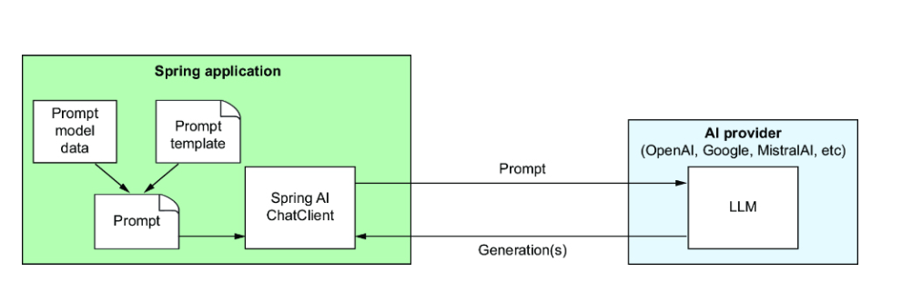
The remaining code in askQuestion() is the same as before. The call() method indicates that the prompt is ready to be sent, and the content() method returns the text of the answer.
If you restart the application and try submitting a request to it now, it should work just as well as it did before, although the answer might vary slightly in wording due to the nondeterministic nature of generative AI. Maybe even try asking questions about other tabletop games to see how it answers.
Now the essence of the prompt is all captured in one place—the static String constant—and it’s easier to read and maintain, even if it added a few extra lines of code to the askQuestion() method. Now that it’s easier to maintain, let’s apply a little bit of prompt engineering to make the prompt a little better. Consider the following change to the template String:
private static final String questionPromptTemplate = """ You are a helpful assistant, answering questions about tabletop games. If you don't know anything about the game or don't know the answer, say "I don't know". The game is {game}. The question is: {question}. """;
This new prompt template sets more context for the LLM as to its role and our expectations by telling it that it is a useful assistant and that it is going to answer questions about tabletop games. It also asks that the LLM admit to not knowing an answer if its training doesn’t know the answer to the question.
Prompt engineering techniques like this can help you get better results from your prompts. For more prompt engineering tips, have a look at the Prompt Engineering Guide (https://www.promptingguide.ai/).

3.1.2 Importing the template as a resource
Extracting the prompt template String into a constant helped tidy up the askQuestion() method and made it easier to read and make adjustments to the prompt. But you can make it even tidier by extracting the template into an external file. This keeps the template separate from the Java source code, while still enabling you to check the template into source code control.
To do that, first create a new directory named “promptTemplates” in the project’s src/main/resources folder. In the newly created directory, create a file named questionPromptTemplate.st with the following contents:
You are a helpful assistant, answering questions about tabletop games. If you don't know anything about the game or don't know the answer, say "I don't know". Answer in complete sentences. The game is {gameTitle}. The question is: {question}.

NOTE
The name of the directory and template file can be anything you want. You’ll just need to reference them correctly when you inject the template into SpringAiBoardGameService.
Despite what GitHub might tell you if you check this code in there, the .st extension indicates that this is a StringTemplate file (not a Smalltalk file). As you can see, this StringTemplate file contains the same text as the static String constant defined before. But now that the template is defined in its own file, the details of the prompt template can be maintained separately from the code that submits the prompt.
With that in mind, now you’ll need to change SpringAiBoardGameService to reference the template file. Remove the static String constant and replace it with the following lines:
@Value("classpath:/promptTemplates/questionPromptTemplate.st") Resource questionPromptTemplate;
The @Value annotation uses the classpath: prefix to reference the template file, essentially injecting it into the Resource property. Notice that the Resource property has the same name as the former String constant. The text() method of the user specification is overloaded to accept either a String or a Resource. So, by naming the Resource as questionPromptTemplate, you won’t need to change the askQuestion() method to use the new template Resource.
Restart the application and try asking questions about games; it still works the same as before. Even though the behavior of the application hasn’t changed, the internal implementation is cleaner, and any adjustment you make to the template can be made separately from the SpringAiBoardGameService code.
If you ask a question about checkers, chess, or any other well-known game, there’s a good chance that the answer you get will be correct. But suppose that you ask a question about a game that the LLM wasn’t trained on. For example, try asking a question about the card game Burger Battle (https://www.burgerbattlegame.com/). Ideally, if it doesn’t know the answer, it would say, “I don’t know”:
$ http :8080/ask gameTitle="Burger Battle" \ question="What is the Grave Digger card?" -b { "answer": "I don't know.", "gameTitle": "Burger Battle" }
Despite the prompt template telling the LLM to say “I don’t know” if it doesn’t know, you’re just as likely to get a bogus answer:
$ http :8080/ask gameTitle="Burger Battle" \ question="What is the Destroy card?" -b { "answer": "In Burger Battle, the Destroy card is a special card that allows players to eliminate one ingredient card from an opponent's burger.", "gameTitle": "Burger Battle" }
If you’ve ever played—or read the rules for—Burger Battle, you would know that answer is incorrect. This is an unfortunate, albeit sometimes humorous, quirk of working with LLMs. When they aren’t trained on a topic well enough to answer a given question, they may make up an answer that is completely false. The tongue-in-cheek term commonly used to describe this behavior is hallucinations.
There are a few ways to avoid hallucinations, including
- Training your own model
- Fine-tuning an existing model
- Providing additional context in the prompt
While training or fine-tuning a model is arguably the best way to avoid hallucinations (not to mention that they allow you to create models based on proprietary information), they are difficult and require skills that are in the domain of data science, not software development. Moreover, training and fine-tuning require an immense amount of data to be done properly. They’re also very time-consuming activities, potentially taking several hours, days, or even weeks. In the tabletop game example we’ve been building, adding a game can’t happen immediately upon the release of a new game.
In contrast, adding some context in a prompt isn’t much different than adding the question itself, which happens just in time when the prompt is being submitted. Therefore, it’s significantly simpler than training and fine-tuning models.
Let’s take a look at how to provide additional context along with the question in a prompt. This will set the stage for retrieval-augmented generation (RAG), a more advanced way to add context in a prompt that we’ll look at in the next chapter.

3.2 Stuffing the prompt with context
Thinking back on your school days, you may have been given an open-book exam. In such a situation, you wouldn’t need to have committed everything to memory to pass the exam. Even if you hadn’t studied, you could flip through the pages of a book to find the answers you need to pass.
In generative AI, a technique commonly called “stuffing the prompt” is analogous to giving the LLM an open-book exam. Along with the question sent to LLM for generation, you also provide some additional text for the LLM to draw from. In this way, the LLM doesn’t need to be pretrained on a subject to be able to answer questions about that subject.
So that Board Game Buddy can answer questions accurately about Burger Battle, a game that the LLM hasn’t been trained on, let’s give it an open-book exam. That is, let’s add the rules of the game as context in the prompt. The most straightforward way to do this is to create a text file containing the rules for the game.
The rules for Burger Battle (https://mng.bz/yNKo) are relatively short but still far too lengthy to list in the pages of this book. But, at the very least, for the LLM to answer questions about the Destroy card or other battle cards in the game, create a file with the following contents:
* Burger Bomb: Blow up another player's Burger by sending their ingredients to the Graveyard. * Burger Force Field: Your Burger is now protected from all Battle Cards * Burgerpocalypse: Obliterate all players' ingredients, including your own, and toss them in the Graveyard. * Destroy!: Destroy any Battle Card of yours or another player's and toss it in the Graveyard. * Gonna Eat That?: Steal another player's ingredient and add it to your Burger. * Grave Digger: Dig through the Graveyard for any needed ingredient and add it to your Burger. * I Got Nothin': Toss your hand in the Graveyard and draw 5 new cards * More Meat!: Make another player's Burger a double-decker by adding an extra Meat to their ingredients list. * Pickle Plague: Rain vengeance down upon another player by adding Pickles to their ingredients list. * Picky Eater: Throw another player's Lettuce, Tomato, or Onion in the Graveyard. * The Old Switcheroo: Trade hands with another player. * Yours Looks Good!: Trade your Burger and all of your ingredients with another player, including added Battle Cards.
Give this file a home by creating a directory named gameRules in the src/main/resources folder and name it burger_battle.txt.
Next, you’ll need to modify the template to have a placeholder for the rules:
You are a helpful assistant, answering questions about tabletop games. If available, use the rules in the RULES section below. If you don't know anything about the game or don't know the answer, say "I don't know". Answer in complete sentences. The game is {gameTitle}. The question is: {question}. RULES: {rules}
Notice that in addition to adding the {rules} placeholder, there’s also an instruction in the text to tell the LLM to use the rules if they are available.
Before you can inject the rules into the prompt, you’ll need to load them into a String. To help with that, create a service class like the one in the following listing.

Listing 3.3 GameRulesService loads game rules into a String
package com.example.boardgamebuddy; import org.slf4j.Logger; import org.slf4j.LoggerFactory; import org.springframework.core.io.DefaultResourceLoader; import org.springframework.stereotype.Service; import java.io.IOException; import java.nio.charset.Charset; @Service public class GameRulesService { private static final Logger LOG = LoggerFactory.getLogger(GameRulesService.class); public String getRulesFor(String gameName) { try { var filename = String.format( "classpath:/gameRules/%s.txt", gameName.toLowerCase().replace(" ", "_")); #1 return new DefaultResourceLoader() .getResource(filename) .getContentAsString(Charset.defaultCharset()); \ } catch (IOException e) { #2 LOG.info("No rules found for game: " + gameName); return ""; #3 } } }

#1 Creates a resource path from the game name
#2 Loads resource into a String
#3 Returns an empty string on exception

In a nutshell, the getRulesFor() object loads the rules for a given game into a String via a Resource. Since the path to the resource will vary depending on the name of the game, it’s not possible to use @Value to define the Resource (as you did with the prompt template) so getRulesFor() relies on a few Spring utility classes to define the Resource.
As it’s creating the path to the game’s rules, getRulesFor() normalizes the game’s title to lowercase and replaces any spaces with underscores. This avoids any mismatches between the game title and the file if the case or spacing choice in the given title doesn’t match the name of the file containing the rules. For example, if Burger battle is the game title submitted in the Question, the game title will be normalized to burger_battle.
Now you’re ready to modify SpringAiBoardGameService to add the rules to the prompt. First, inject GameRulesService into SpringAiBoardGameService:
@Service public class SpringAiBoardGameService implements BoardGameService { private final ChatClient chatClient; private final GameRulesService gameRulesService; public SpringAiBoardGameService( ChatClient.Builder chatClientBuilder, GameRulesService gameRulesService) { this.chatClient = chatClientBuilder.build(); this.gameRulesService = gameRulesService; } // ... }
Then you’ll need to change the askQuestion() method to use the GameRulesService to load the rules and add them as a parameter to the user message specification via another call to the param() method:
@Override public Answer askQuestion(Question question) { var gameRules = gameRulesService.getRulesFor(question.gameTitle()); var answerText = chatClient.prompt() .user(userSpec -> userSpec .text(questionPromptTemplate) .param("gameTitle", question.gameTitle()) .param("question", question.question()) .param("rules", gameRules)) .call() .content(); return new Answer(question.gameTitle(), answerText); }
Now you’re ready to try it out. Restart the application and ask again about Burger Battle’s Destroy card:
$ http :8080/ask gameTitle="Burger Battle" \ question="What is the Destroy card?" -b { "answer": "The Destroy card in Burger Battle allows you to destroy any Battle Card, whether it belongs to you or another player, and then place it in the Graveyard.", "gameTitle": "Burger Battle" }
Huzzah! This time, the answer is correct and was clearly pulled from the context given in the prompt.
Just to be sure that it can still answer questions for other games, try it again. This time, ask a question about chess:
$ http :8080/ask gameTitle="chess" \ question="How are knights allowed to move?" -b { "answer": "In chess, knights move in an L-shape: two squares in one direction, and then one square perpendicular to that. Knights are the only pieces that can jump over other pieces on the board.", "gameTitle": "chess" }
Even though the application is unable to provide rules for chess from a loaded resource, the model is pretrained to know the rules for chess already.
It’s important to understand that more context in the prompt means more input tokens in the prompt. When asking the chess question, where no additional context was given, the prompt had 75 tokens. In contrast, even though the Burger Battle question only included a relatively small snippet of the Burger Battle rules, the number of prompt tokens was 315—over four times more tokens than when no context is given.
At the very least, token count affects the cost of using an LLM. The more tokens in your prompt (as well as in the response), the more you’ll pay. The price per 1,000 tokens for many LLMs, such as GPT-4o, is very small, but it will add up over time.
Moreover, if you send too many tokens in a prompt, there’s a chance of exceeding the token limits. For GPT-4o, the context window allows for 128K tokens, far greater than our simple example needs. While the rules for most board games will fit easily into 128K tokens, it’s easy to imagine other domains where feeding large documents in the context could exceed the token limit.
In the next chapter, you’ll learn how to apply a technique called retrieval- augmented generation (RAG) to provide relevant context in your prompts without exceeding the token limit. Before employing RAG, there are some more things to explore regarding prompting, including working with prompt roles.

3.3 Assigning prompt roles
Many LLMs, including those from OpenAI, MistralAI, and Anthropic, support splitting a prompt into multiple messages, each message belonging to a specific role that should be assumed for the message. The commonly supported roles include
- User—The message contains a question or statement made by (or on behalf of) the user of an application.
- System—The message contains instructions given to the LLM from the application itself.
- Assistant—The message contains a response from the LLM.
- Tool—The message contains instructions for invoking tools to perform some action or fetch additional context information.
We’ll focus on user and system messages for now. Assistant messages come into play when doing a multiturn conversation between the user and LLM. We’ll delve into conversations in chapter 5. Then, in chapter 6, we’ll see how tool messages can make your AI interactions highly dynamic by working with APIs.
NOTE
Not all LLM APIs support the same selection of message roles. When an API doesn’t support the System role, Spring AI simply adds the text of the message intended for the System role to the User message.
Until now, we’ve been specifying our prompts via the user() method, which indicates that they have all been user messages, submitted on behalf of a user. For example, when asking about the number of pieces in checkers with the code up to this point, Spring AI sends the following JSON in the body of the POST request to OpenAI:
{ "messages": [ { "content": "You are a helpful assistant, answering questions about tabletop games.\nIf available, use the rules in the RULES section below.\nIf you don't know anything about the game or don't know the answer,\nsay \"I don't know\".\n\nThe game is checkers.\n\nThe question is: How many pieces are there?.\n\nRULES:\n", "role": "user" } ], "model": "gpt-4o", "stream": false, "temperature": 0.7 }
Notice that there is only one message whose content is the entire prompt with role set to user. It has been proven to work, but it can be better.
INSPECTING SPRING AI REQUESTS AND RESPONSES
If you’d like to see what the raw request and response JSON looks like when submitting prompts with Spring AI, then you’ll want to add Logbook (https://github.com/zalando/logbook) to your project’s build:
implementation 'org.zalando:logbook-spring-boot-starter:3.9.0'
This dependency autoconfigures some components in Spring that you can use to instrument Spring’s HTTP clients to log the requests sent through those components as well as the responses that are returned.
Since Spring AI’s ChatClient uses Spring’s RestClient under the covers, you’ll need to declare a RestClientCustomizer bean to add Logbook’s LogbookClientHttpRequestInterceptor as a request interceptor:
@Bean RestClientCustomizer logbookCustomizer( LogbookClientHttpRequestInterceptor interceptor) { return restClient -> restClient.requestInterceptor(interceptor); }
Logbook logs request and response details at TRACE level, so you’ll need to set the logging level in the application.properties file to emit logging at that level:
logging.level.org.zalando.logbook: TRACE
By default, Logbook logs the requests and responses in a JSON format that can make it difficult to read the requests and responses, so you may optionally set the logbook.format.style property to http to make it easier to read:
logbook.format.style=http
Now, when Spring AI sends requests and receives responses from various AI APIs, they will be logged for easy inspection. Note, however, that Spring AI’s Gemini module uses Google’s own HTTP client library instead of RestClient, so Logbook will not work if you’re using Google Gemini as your LLM of choice.
As illustrated in figure 3.3, the message’s content could be broken into two messages. Most of the text is instructions that are given to the LLM to tell it how it should respond to the user’s question. Therefore, it would be better as a system message. The only part of the prompt that is from the user is the question itself.
Figure 3.3: Splitting the user message into separate system and user messages

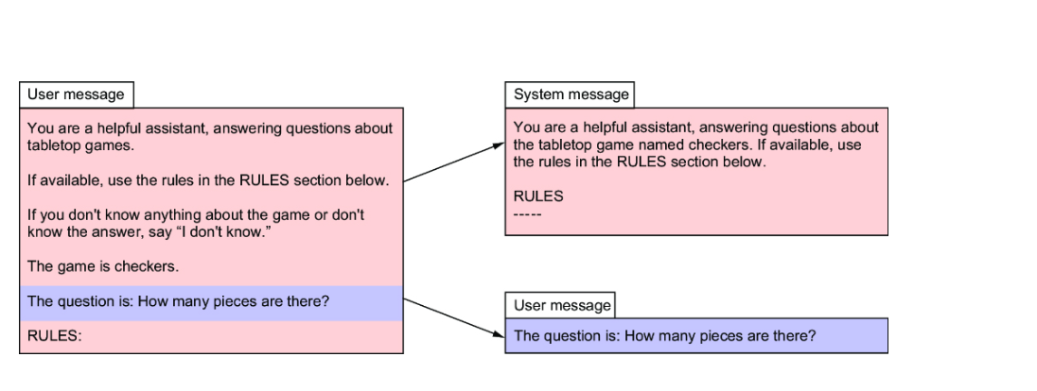
To apply this change to our project, start by creating a new template file named systemPromptTemplate.st that will replace the original questionPromptTemplate.st (which can be deleted because it won’t be used anymore). Here’s the new template to define the system message:
You are a helpful assistant, answering questions about the tabletop game named {gameTitle}. If available, use the rules in the RULES section below. Answer in complete sentences. RULES ----- {rules}
SpringAiBoardGameService will need to be tweaked to use this new template instead of the question template. Replace the existing Resource property in SpringAiBoardGameService with this one:
@Value("classpath:/promptTemplates/systemPromptTemplate.st") Resource promptTemplate;
Finally, there are a few changes that you’ll need to make to the askQuestion() method to use this new template. The following listing shows the new SpringAiBoardGameService.

Listing 3.4 Splitting the prompt into distinct user and system messages
@Override public Answer askQuestion(Question question) { var gameRules = gameRulesService.getRulesFor(question.gameTitle()); var answerText = chatClient.prompt() .system(systemSpec -> systemSpec #1 .text(promptTemplate) .param("gameTitle", question.gameTitle()) .param("rules", gameRules)) .user(question.question()) #2 .call() .content(); return new Answer(question.gameTitle(), answerText); }

#1 Sets the system message
#2 Sets the user message

Specifically, the prompt template was given via the text() method of the system message specification rather than that of the user message specification. The same goes for the parameter values destined to fill in the placeholders of the prompt template. As for the user message, it is once again simply the text of the question itself.
The order in which you specify the user and system messages doesn’t matter. They end up in the request sent to the LLM either way.
With these changes in place, restart the application and give it another try. It should still work as before, but under the covers, the request sent to OpenAI will have two distinct messages—the instructions from the system and the user’s question:
{ "messages": [ { "content": "How many pieces are there?", "role": "user" }, { "content": "You are a helpful assistant, answering questions about the tabletop\ngame named checkers. If available, use the rules in the RULES section below.\n\nRULES\n-----\n", "role": "system" } ], "model": "gpt-4o", "stream": false, "temperature": 0.7 }
Even though our example so far is probably too simple for roles to make much of a difference, generally speaking, roles help the LLM generate better responses. This effect will become more significant as the prompts become more advanced.
So far, we’ve focused on how to create and send a prompt to the LLM for generation. Now, let’s shift our attention to the other side of the conversation and learn to tell the LLM how we would like the generated response to be returned to us.

3.4 Influencing response generation
Spring AI includes a couple of very useful features to influence how the response is returned, including
- Setting generation options can gain some control over how the next token is chosen when a response is generated.
- Output conversion can be used to include instructions in a prompt to tell the LLM how the response should be formatted so that the textual response can be transformed into a Java object.
- By applying streaming, the result will be returned bit by bit rather than waiting for the entire response to be sent all at once.
Let’s take a look at these useful features, starting with binding the response to a Java object.

3.4.1 Specifying chat options
As you work with generative AI, you might find that the responses from an LLM are not always what you expected. The vast amount of training that goes into creating the models, along with the nondeterministic nature of generation, can occasionally produce less-than-ideal responses.
Spring AI offers several properties that let you adjust the knobs on how a prompt is handled by the LLM. You’ve already seen one such option in chapter 1, when you added the following line in application.properties to override the default model to use gpt-4.1-nano:
spring.ai.openai.chat.options.model=gpt-4.1-nano
Similar properties exist for all of Spring AI’s supported APIs to specify the model to use. For example, the following line selects the Llama 3.2 model when using Ollama:
spring.ai.ollama.chat.options.model=llama3.2
The key difference between these two lines (aside from the chosen model) is that one is for OpenAI’s API and the other is for Ollama’s API. When setting chat options in this manner, ensure that you select the property appropriate to the API you’ll be using.
Most of the chat options offered by Spring AI can be set with properties like this in application.properties. You can also set them as default options when creating a ChatClient by calling defaultOptions() on the ChatClient builder. For example, to specify gpt-4.1-nano as the chosen model when creating a ChatClient, you can use the following code:
ChatOptions chatOptions = ChatOptions.builder() .model("gpt-4.1-nano") .build(); ChatClient chatClient = chatClientBuilder .defaultOptions(chatOptions) .build();
The defaultOptions() method accepts a ChatOptions object. You can create a ChatOptions and set a number of options using ChatOptions.builder(). In this example, the model() method is used to specify the model, but in this section, you’ll become acquainted with a few other options.
Any chat options set via defaultOptions() will override the same options set as configuration properties in application.properties. But even options set with defaultOptions() can be overridden by calling options() when creating a prompt. For example, here’s how you could pass in the same ChatOptions object at prompt-creation time:
String answerText = chatClient.prompt() .user(question.question()) .options(chatOptions) .call() .content();
Again, choosing the model is just one of several chat options that you could specify. Not all generative AI APIs support the same set of options, but there are a handful of core options that are common to most APIs. Let’s have a look at a few of these, starting with a set of options that influence how each word (or, more accurately, each token) is chosen when generating a response.

ADJUSTING VARIABILITY
When a response is generated, it is generated one token at a time. The original prompt is considered, and then the API uses the model to choose the next token that should follow the prompt. And then the next token, and then the next, and so on until the entire response has been generated.
The method for selecting the next token is a combination of statistical probability and random selection. Based on the model’s training, a selection of candidate tokens is considered, each with a distinct probability of being the next token to choose. The probability is used as a weighting for each candidate, and a random selection is made. All of the tokens have the potential of being chosen, but those with a higher probability have a higher chance of being randomly chosen.
For example, suppose the prompt submitted is “Finish this sentence: I have a large collection of.” To produce a generated response, the model is consulted to find a selection of tokens to complete the sentence. But since tokens are a little more difficult to think about than words, let’s pretend that we’re selecting the next word and not the next token.
Let’s say that the following five words (and their respective probabilities) are selected as the candidates to complete the sentence:
- “books” - 0.475
- “coins” - 0.236
- “records” - 0.129
- “arts” - 0.096
- “stamps” - 0.064
With this set of words and probabilities, any of those words could be chosen next. By weighting the random selection based on each word’s probability, books is twice as likely to be chosen as coins, and it is over seven times as likely to be chosen as stamps. Consequently, if you submitted the same prompt to the API several times, most of the responses would be completed with books. coins, records, arts, and stamps would appear occasionally and with decreasing frequency as you move down the list.
Using chat options such as temperature, Top-p, and Top-k, you can influence how random the selection is and how likely some tokens are selected over others. Temperature is a chat option with a range of 0 to 2 that applies a scaling factor to calculate probabilities. Without digging into the mathematical details of how temperature works, suffice it to say that higher temperatures produce more random results and lower temperatures produce more deterministic results (figure 3.4). As temperature approaches 2, the probabilities for each token tend to even out. As temperature approaches 0, the probability for the highest probability token approaches 1 while the other probabilities approach zero. When temperature is 1, the probabilities are unchanged.
Figure 3.4: When the temperature is higher, probabilities even out, resulting in more random results; temperatures exaggerate the differences in probabilities, resulting in more deterministic results.

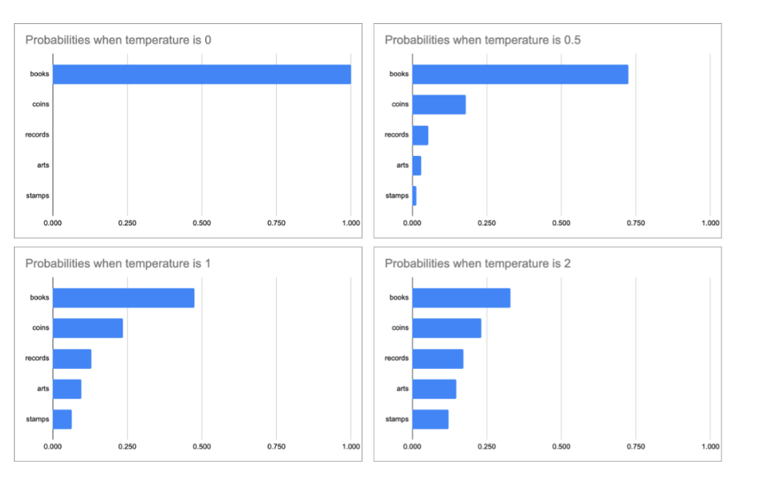
You can specify the temperature globally in application.properties by setting the temperature property appropriate to the API you are using. For example, to set temperature to 0.7 for OpenAI, you can add the following entry in application .properties:
spring.ai.openai.chat.options.temperature=0.7
If you’d prefer to set it programmatically when creating a ChatClient or when creating a prompt, set it in ChatOptions like this:
ChatOptions chatOptions = ChatOptions.builder() .temperature(0.7) .build();
Whereas temperature scales the probabilities for the candidate tokens, Top-P and Top-K can be used to eliminate all but the tokens with the highest probabilities. Top-P has a range of 0 to 1 and is used to limit the set of candidate tokens to the smallest set where the sum of probabilities meets or exceeds the value of top-P.
For example, suppose that Top-P is 0.8. As illustrated in figure 3.5, the sum of probabilities for books, coins, and records is 0.84, making that the smallest set whose sum of probabilities meets or exceeds Top-P. Consequently, arts and stamps are eliminated from candidacy. The probabilities for the remaining tokens are normalized such that they add up to 1, and a weighted random selection is made.
Figure 3.5: Top-P eliminates tokens from the random selection based on the sum of probabilities of the higher-ranked tokens.
You can specify top-P by setting the top-p property appropriate to your chosen API. For OpenAI, set the spring.ai.openai.chat.options.top-p property:
spring.ai.openai.chat.options.top-p=0.8
Or you can set it programmatically in ChatOptions like this:
ChatOptions chatOptions = ChatOptions.builder() .topP(0.8) .build();
It is generally recommended to specify either temperature or Top-P, but not both. That said, it is allowed, and you could achieve some success using both.
Top-K works very similarly to Top-P, except that it applies simple counting rather than sum of probabilities to decide which tokens remain and which are eliminated from candidacy. OpenAI does not support specifying Top-K when submitting a prompt. Therefore, you cannot adjust Top-K when using OpenAI. But Ollama does support Top-K. You can set it in application.properties like this:
spring.ai.ollama.chat.options.top-k=4
Programmatically, Top-K can be set in ChatOptions like this:
ChatOptions chatOptions = ChatOptions.builder() .topK(4) .build();
If you set Top-K in ChatOptions and submit a prompt to OpenAI, you will get an error telling you that OpenAI does not support Top-K.
When applied to the collections example, if top-K was set to 4, the first four items—books, coins, records, and arts—would remain in the running. But stamps would be eliminated. As with Top-P, after Top-K has eliminated all but the top so many tokens, probabilities are normalized, and a random selection is made.
Applying options like temperature, Top-P, and Top-K are helpful in gaining some control over the choices made when the LLM is generating a response. Now, let’s see how to work with output conversion to receive the generation response in a Java object.

3.4.2 Formatting response output
Up to this point, our application has explicitly extracted the textual content from the response returned by the LLM and used it to create an Answer object. Given the simplicity of the Answer record, that’s no big feat. But you can imagine that with more complicated responses, such extract-then-instantiate code could be a bit more unwieldy. Fortunately, Spring AI offers output conversion assistance to handle the task of mapping LLM responses to Java objects.
To demonstrate how output conversion works, let’s first see how to ask the ChatClient to return an Answer object instead of a String response. To do that, you’ll need to modify the askQuestion() method to ask for an entity object.

Listing 3.5 Obtaining an Answer object as the LLM result
package com.example.boardgamebuddy; import org.springframework.ai.chat.client.ChatClient; import org.springframework.beans.factory.annotation.Value; import org.springframework.core.io.Resource; import org.springframework.stereotype.Service; @Service public class SpringAiBoardGameService implements BoardGameService { private final ChatClient chatClient; private final GameRulesService gameRulesService; public SpringAiBoardGameService( ChatClient.Builder chatClientBuilder, GameRulesService gameRulesService) { this.chatClient = chatClientBuilder.build(); this.gameRulesService = gameRulesService; } @Value("classpath:/promptTemplates/systemPromptTemplate.st") Resource promptTemplate; @Override public Answer askQuestion(Question question) { var gameRules = gameRulesService.getRulesFor(question.gameTitle()); return chatClient.prompt() .system(systemSpec -> systemSpec .text(promptTemplate) .param("gameTitle", question.gameTitle()) .param("rules", gameRules)) .user(question.question()) .call() .entity(Answer.class); #1 } }

#1 Asks for an Answer

The askQuestion() method works almost exactly the same as before, except for one almost unnoticeable change. Rather than call the content() method, the entity() method is called, passing in Answer.class to specify what the type of the response should be.
This small change results in two changes to how the prompt is handled:
- Formatting instructions will be sent in the prompt.
- The response will be parsed into an object.
Before the prompt is sent to the LLM, Spring AI will decorate it with formatting instructions to instruct the model as to what form the response should take. The format sent in the prompt is derived from the Answer record and its properties. If you were to intercept the request and look closer, you would see that the formatting instructions look like this:
Your response should be in JSON format. Do not include any explanations, only provide a RFC8259 compliant JSON response following this format without deviation. Do not include markdown code blocks in your response. Here is the JSON Schema instance your output must adhere to: ```{ "$schema" : "https://json-schema.org/draft/2020-12/schema", "type" : "object", "properties" : { "answer" : { "type" : "string" }, "gameTitle" : { "type" : "string" } } }```
Here, the format sent tells the LLM precisely how to format the response into a JSON object, including a JSON schema.
When the response is returned, the JSON object will be converted into the desired type, an Answer in this case.

NOTE
Even if Spring AI’s output conversion does its part to produce formatting instructions, it still may not work. Some LLMs refuse to follow the formatting instructions and will return their answers however they please. OpenAI’s GPT models do a good job of applying the formatting instructions, but other LLMs (such as Mistral 7b) may not. Unfortunately, if you are using one of the LLMs that don’t honor requested formatting, you won’t be able to reliably count on the results to be converted and bound to an object. If that happens, a JsonParseException will be thrown when Spring AI tries to bind the non-JSON response to an object.
That’s it! Now Spring AI’s output conversion will handle the job of creating the Answer object. And it will be able to do that because it first created instructions to tell the LLM how to format the results as a JSON object.

PARSING OUTPUT TO A LIST
Spring AI can also parse the response into a List<String>. This could be fitting when the response is expected to be a list of things, such as the attractions in a theme park, the teams in a sports league, or the top songs on the Billboard Hot 100.
To demonstrate how to get a list response, let’s create a new controller, such as the one in the following listing, which returns the top 10 songs for a given year.

Listing 3.6 Controller that returns the top songs for a year
package com.example.topsongs; import java.util.List; import org.springframework.ai.chat.client.ChatClient; import org.springframework.beans.factory.annotation.Value; import org.springframework.core.ParameterizedTypeReference; import org.springframework.core.io.Resource; import org.springframework.web.bind.annotation.GetMapping; import org.springframework.web.bind.annotation.RequestParam; import org.springframework.web.bind.annotation.RestController; @RestController public class TopSongsController { @Value("classpath:/top-songs-prompt.st") Resource topSongPromptTemplate; #1 private final ChatClient chatClient; public TopSongsController(ChatClient.Builder chatClientBuilder) { this.chatClient = chatClientBuilder.build(); } @GetMapping(path = "/topSongs", produces = "application/json") public List<String> topSongs(@RequestParam("year") String year) { return chatClient.prompt() .user(userSpec -> userSpec .text(topSongPromptTemplate) .param("year", year)) .call() .entity(new ParameterizedTypeReference<List<String>>() {}); #2 } }

#1 Injects the prompt template
#2 Asks for results as a List

To keep things simple, ChatClient is used directly in the controller rather than extracted into a separate service class as you did with SpringAiBoardGameService.
As for the prompt template, it is defined in src/main/resources/top-songs-prompt.st and is injected into the controller as a Resource. The template itself looks like this:
What were the top 10 songs on the Billboard Hot 100 in {year}? Each item should only include the song title.
Much of what this controller does is similar to the code in SpringAiBoardGameService you’ve worked with already. What makes it a little different is that when calling entity(), it passes in a new ParameterizedTypeReference<List<String>>. The desired result is List<String>, but it’s not possible to simply pass in List or List<String> to entity(). ParameterizedTypeReference is a special type of String that provides a means of carrying a type into a method, such as entity(), without losing the generic type due to Java type erasure.
As a consequence of passing in a new ParameterizedTypeReference<List<String>> to entity(), the prompt will be given the following formatting instructions:
FORMAT: Your response should be a list of comma separated values eg: `foo, bar, baz`
After running the application, you can try this out using HTTPie to find the top songs, like this:
$ http :8080/topSongs?year=1981 -b [ "Bette Davis Eyes", "Endless Love", "Lady", "(Just Like) Starting Over", "Jessie's Girl", "Celebration", "Kiss On My List", "I Love A Rainy Night", "9 To 5", "Keep On Loving You" ]
Excellent! A quick Google search should confirm that these were, in fact, the top 10 songs for 1981. Of course, the accuracy of the list depends on how well the LLM you choose was trained—the previous list was provided by OpenAI’s gpt-4o model. Accuracy aside, what’s important is that, thanks to list output conversion, the response was formatted into a list of values.
While formatting the response into a Java object or list can be useful, sometimes a textual response is fine, but you want it returned progressively as it is being created. Let’s see how to use another Spring AI chat client that streams the results back to the caller.

3.4.3 Streaming the response
If you’ve ever used any of the AI chat clients, such as OpenAI’s ChatGPT or Microsoft’s Copilot, you’ve interacted with an LLM in a user-friendly chat-style interface. You may have also noticed that the response from the LLM stream into the chat as if the LLM is typing its answer a word at a time.
The key benefit of streaming the response is that it improves the user experience in a chat application. While simple responses may come back quickly, more complicated responses may take a while for the LLM to produce. If the response can be emitted in the user interface as it is being created, it gives the user assurance that the application is actually doing something and isn’t stuck.
Spring AI supports this streaming style of response when working with ChatClient. The following listing shows that you only need to make a few minor modifications to the askQuestion() method to get the results back as a stream.

Listing 3.7 A board game service that streams the response
@Override public Flux<String> askQuestion(Question question) { #1 var gameRules = gameRulesService.getRulesFor(question.gameTitle()); return chatClient.prompt() .system(systemSpec -> systemSpec .text(promptTemplate) .param("gameTitle", question.gameTitle()) .param("rules", gameRules)) .user(question.question()) .stream() #2 .content(); }

#1 Returns Flux&lt;String&gt;
#2 Asks for results as a stream

As you can see, the key differences from the former implementations of askQuestion() is that this method returns Flux<String> and instead of invoking the call() method, it calls the stream() method. But wait! What’s a Flux?
The Flux type comes from Project Reactor (https://projectreactor.io/), the library that underlies the reactive programming capabilities across the entire Spring portfolio of projects. To learn more about Project Reactor, you should have a look at Spring in Action (https://www.manning.com/books/spring-in-action-sixth-edition) which has had a chapter dedicated to Project Reactor and working with Flux and Mono (Reactor’s other reactive type) since the fifth edition.
For now, it’s sufficient to understand that Flux is a reactive type that streams zero-to-many pieces of data as they become available. In the case of a response from an LLM generation, the Flux will contain brief pieces of the generated response, typically one word at a time.
You’ll also need to change the AskController to return the Flux returned from the askQuestion() method. The following listing shows the necessary changes.

Listing 3.8 A streaming AskController
package com.example.boardgamebuddy; import org.springframework.web.bind.annotation.PostMapping; import org.springframework.web.bind.annotation.RequestBody; import org.springframework.web.bind.annotation.RestController; import reactor.core.publisher.Flux; @RestController public class AskController { private final BoardGameService boardGameService; public AskController(BoardGameService boardGameService) { this.boardGameService = boardGameService; } @PostMapping(path="/ask", produces="application/json") public Flux<String> ask(@RequestBody Question question) { return boardGameService.askQuestion(question); } }

There is one other small change to the ask() method. The @PostMapping annotation on the ask() method specifies that it produces a streamed response with the text/event-stream MIME type. This MIME type is important because if it was application/json as before, the result would come back all at once, rather than streamed.
You can try this change out using HTTPie as before. Because the streaming response tends to come back very quickly, you might not notice it unless the answer is lengthy. One question that you can ask with a sufficiently long answer is regarding the battle cards in Burger Battle. For example,
$ http :8080/ask gameTitle="Burger Battle" \ question="What battle cards are there?" -b data: data:Here data: is data: a data: list data: of data: the data: Battle data: Cards ...
To avoid several pages with one word per line, the response shown here only shows the first few entries. But clearly, it is streaming a single word at a time rather than returning the entire answer at once. Although it may not be obvious from the output, there’s a small delay between each word, as if the LLM is typing the response.
The unfortunate side effect of the text/event-stream MIME type is that each word is prefixed with data:, which demands that a client of this API be able to handle the response appropriately to extract the actual word from each entry without the prefix.
To avoid special handling for each word, you can change the @PostMapping annotation on the ask() method to produce application/ndjson(aka newline-delimited JSON) like this:
@PostMapping(path = "/ask", produces = "application/ndjson")
In this case, the LLM will still stream back a word at a time. But the word will not be prefixed with data:.
If you were to try this MIME type change with HTTPie, you might think that streaming is broken. Although HTTPie assumes streaming when the response’s MIME type is text/event-stream, it doesn’t make any such assumption for application/ndjson. To turn on streaming in that case, you can specify the --stream switch:
$ http :8080/ask gameTitle="Burger Battle" \ question="What battle cards are there?" -b --stream --pretty none #1 In Burger Battle there are several Battle Cards that players can use. Here is a list of the standard Battle Cards: 1. **Burger Bomb**: Blow up another player's Burger by sending their ingredients to the Graveyard. 2. **Burger Force Field**: Your Burger is now protected from all Battle Cards. 3. **Burgerpocalypse**: Obliterate all players' ingredients, including your own, and toss them in the Graveyard. 4. **Destroy!**: Destroy any Battle Card of yours or another player's and toss it in the Graveyard. 5. **Gonna Eat That?**: Steal another player's ingredient and add it to your Burger. ...

#1 The --pretty none switch disables color formatting, which doesn’t look good when the response is plain text.

Again, the response shown here is truncated to save space. Although a statically printed book page doesn’t make it clear, the response is streamed back with a small delay when using HTTPie. However, even though the response is still streamed back one word at a time, HTTPie will buffer the words until an entire line is gathered.
You might be wondering if it is possible to use streaming responses along with the output conversion you used earlier. While the streaming client can stream back JSON-formatted text just as well as it can stream plain text, the JSON it streams back will be broken apart one word or JSON symbol at a time, and you won’t have a complete and well-formed JSON document to parse until you have received the entire response from the LLM.
Therefore, you’d need to collect the streamed response into a complete JSON string before asking output conversion to do its job, defeating the purpose of using streaming. In short, it’s best if you don’t try to mix streaming with output conversion.
In this chapter, you’ve seen how to use Spring AI to submit prompts to an LLM for generation, use prompt templates for fill-in-the-blanks creation of prompts, stuff the prompt with context, work with prompt roles, and influence how the response is generated for a prompt. Before wrapping up, let’s take a look at how to inspect response metadata that may be sent back from a model.

3.5 Working with response metadata
In addition to getting back the generation response, ChatClient can also provide useful metadata regarding the interaction with the LLM. The most useful of this metadata is usage statistics. Each prompt and each generated response is ultimately broken down into several tokens. Among other things, these tokens are used to calculate the cost you’ll pay to the AI service. Therefore, knowing how many tokens are spent for each request is helpful in determining the cost of the interaction with the LLM.
What you do with the token usage information is up to you. A very basic thing you might want to do is simply log the information to the application’s logs. In chapter 9, you’ll see how to expose token usage and other metrics using Spring AI’s observability features.

Listing 3.9 Logging token usage
package com.example.boardgamebuddy; import org.slf4j.Logger; import org.slf4j.LoggerFactory; import org.springframework.ai.chat.client.ChatClient; import org.springframework.ai.chat.client.ResponseEntity; import org.springframework.ai.chat.metadata.ChatResponseMetadata; import org.springframework.ai.chat.metadata.Usage; import org.springframework.ai.chat.model.ChatResponse; import org.springframework.beans.factory.annotation.Value; import org.springframework.core.io.Resource; import org.springframework.stereotype.Service; @Service public class SpringAiBoardGameService implements BoardGameService { private static final Logger log = LoggerFactory.getLogger(SpringAiBoardGameService.class); #1 private final ChatClient chatClient; private final GameRulesService gameRulesService; public SpringAiBoardGameService( ChatClient.Builder chatClientBuilder, GameRulesService gameRulesService) { this.chatClient = chatClientBuilder.build(); this.gameRulesService = gameRulesService; } @Value("classpath:/promptTemplates/systemPromptTemplate.st") Resource promptTemplate; @Override public Answer askQuestion(Question question) { var gameRules = gameRulesService.getRulesFor(question.gameTitle()); var responseEntity = chatClient.prompt() .system(systemSpec -> systemSpec .text(promptTemplate) .param("gameTitle", question.gameTitle()) .param("rules", gameRules)) .user(question.question()) .call() .responseEntity(Answer.class); #2 var response = responseEntity.response(); #3 var metadata = response.getMetadata(); logUsage(metadata.getUsage()); #4 return responseEntity.entity(); } private void logUsage(Usage usage) { log.info("Token usage: prompt={}, generation={}, total={}", usage.getPromptTokens(), usage.getCompletionTokens(), usage.getTotalTokens()); } }

#1 Declares a logger
#2 Gets a ResponseEntity
#3 Gets a ChatResponse
#4 Logs usage data

The askQuestion() method looks a little different than before. The key difference is that instead of calling content() or entity() to get the response, it calls responseEntity(). This method is similar to entity() in that it binds the response to an object of the specified type (Answer in this case). But instead of returning an Answer object alone, it returns a ResponseEntity<ChatResponse, Answer> that carries a ChatResponse object along with the Answer.
The ChatResponse object is where to find the metadata. Calling the getMetadata() method pulls the usage metadata from the ChatResponse. From there, the ask() method sends it to the logUsage() method for logging. Then, askQuestion() finishes up by returning the Answer carried in the ResponseEntity.
With these changes, fire up the application and make a request to the /ask endpoint as before. You should notice an entry in the logs that looks something like this:
Token usage: prompt=1618, generation=35, total=1653
In the interest of focusing on the outcome, the log entry shown here has been stripped of all but the log message itself. And the actual token count will vary depending on what question was posed and the answer given. But as you can see, the log entry provides useful insight into how many tokens were used (which can then be used to calculate the cost of the prompt).
Be aware that not all AI services will report usage metrics. For instance, any prompts sent to an LLM running locally in Ollama will not provide usage data. Mistral AI is another service that doesn’t seem to respond with usage data. But you can count on getting usage data from OpenAI, Anthropic, and Google (and possibly others).

Summary
- Prompt templates enable you to define and externalize a generic prompt that is filled in with specifics before it is submitted for generation.
- Templates also enable providing additional context to the prompt so that generation is more focused and accurate.
- Context can include instructions to guide how the response should be formatted, including JSON for binding to Java objects.
- Output conversion can parse generated responses from an LLM into Java objects and lists.
- Responses can be streamed back to a client to mimic thinking and typing as if the LLM is a human typing their response in a chat.
- Useful response metadata, including token usage metrics, may be available in generation responses.

Chapter 4: Talking With Your Documents

This Chapter Covers
- Retrieval-augmented generation (RAG)
- Enabling a vector store
- Creating a document loading pipeline
Thinking back on your school days, do you recall ever being told that the exam you’d be taking would be an open-book exam? No matter how much you learned or how hard you could cram for a test, knowing that you’d have the source material at your fingertips to help you answer the questions on the exam gave you greater confidence that you’d be able to answer the questions correctly.
Now imagine that instead of just being told you could use your book to look up the answers, you were told which specific pages the answers could be found. Being equipped with the knowledge of exactly where to look in the book would all but guarantee success.
LLMs are trained with an immense amount of information, but there are often questions that their training will not have prepared them for. Being able to pair a question with a document that includes the answer—or better yet, a small chunk of a document with the required information—not only can help the LLM answer questions more accurately but also virtually eliminate the hallucinations that come about when it tries to answer questions that exceed the limits of its training.
In this chapter, you’ll look at retrieval-augmented generation (RAG), a way to provide relevant information to the LLM on the fly as you are asking questions. Let’s start by getting to know how RAG works.

4.1 Understanding RAG
In the previous chapter, you were able to “stuff the prompt” with the rules for the game Burger Battle. By doing so, you provided context—an open-book—in which the LLM could find answers to your questions about the game.
The rulebook for Burger Battle is relatively small (just over 1,000 tokens), so it fits easily into a prompt without eating up too much of the prompt’s token window. But some games have more in-depth rules that will take up more of the context window. And you’ll want to be able to answer questions about more games other than Burger Battle. It would be impractical to fit every rulebook for several games into a prompt’s context, especially when the answer for any question is probably found in such a small fraction of those documents.
RAG is a technique that addresses the problem of simple prompt stuffing by breaking documents into smaller chunks and ensuring that only document chunks that are similar to the question being posed make it into the prompt. Figure 4.1 illustrates how this works.
As you can see, there are three key pieces of a typical RAG system:
- The document loader is responsible for loading documents into a vector store.
- The vector store is where documents are stored and can be later looked up.
- The RAG-enabled application submits queries to the vector store to find documents that are similar (and presumably relevant) to a question.
Using the numbered cue balls in figure 4.1 as signposts, here’s what happens in such a RAG system:
- Documents of any size are loaded and split into smaller documents. The splitting strategy employed is up to you, but a common approach is to ensure that no document chunk exceeds a certain number of tokens.
- The contents of each chunk are assigned a set of coordinates in multidimensional space based on attributes of the content. These coordinates are called embeddings.
- The individual document chunks are written to a vector store. A vector store is a kind of database that enables you to search for document chunks based on their embeddings.
- When a question is asked, embeddings are calculated for the question itself and the question’s embeddings are sent as query parameters to the vector store to locate only the document chunks that are closest to the question in multidimensional space.
- The top handful of document chunks that are returned from the vector store will go into the prompt as context.
Figure 4.1: RAG involves finding documents relevant to the question and adding them as context in the prompt.
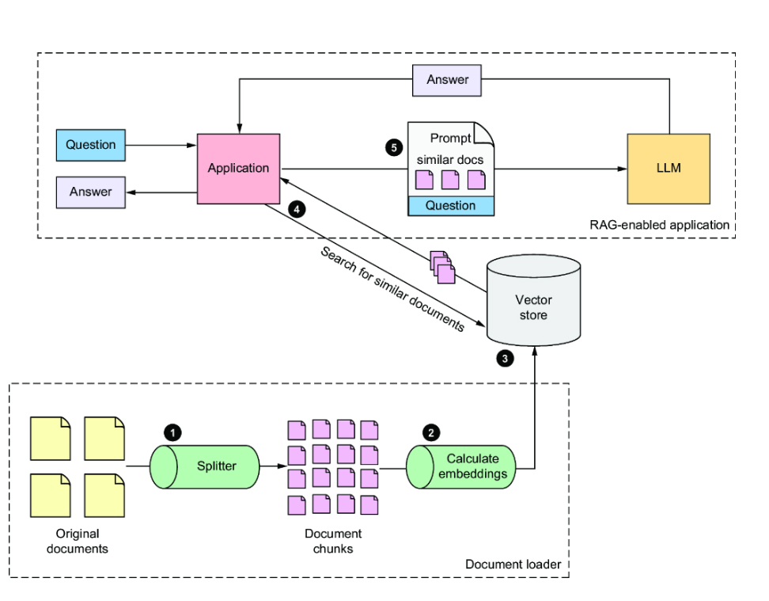
If that all sounds complicated to you, that’s because it is. But the good news is that you don’t need to worry yourself with how embeddings are calculated or how the distance between a question and a document in multidimensional space is determined. Those things are all handled by AI provider embedding models and vector stores. Spring AI further abstracts how you work with embedding models and vector stores, making RAG completely pain-free.
You’re going to add RAG capabilities to the Board Game Buddy application, enabling it to answer questions about any game whose rules have been loaded into the vector store. But before you can do that, you’ll need a vector store to write those rules into.

4.2 Setting up a vector store
Vector search is a way to search for content similar to a query from a data store by comparing the multidimensional vector coordinates of a query with those of the content itself. Commonly, a measurement called cosine similarity (https://en.wikipedia.org/wiki/Cosine_similarity) is applied to determine the cosine between the vectors for the query and the document and then subtracted from 1 to determine the cosine distance (a value from 0 to 2). Put simply, the smaller the angle between the vectors for the query and the document, the more similar they are.
Although cosine similarity is interesting from a mathematical point of view, it’s not important to fully understand it to take advantage of it when using a vector store. The vectors for queries and documents are calculated by APIs or libraries, and the math involved in calculating cosine distance is handled within the vector store itself. All you need is a vector store handy and use it.
Spring AI comes with support for several popular vector stores, including
- Azure AI Search
- Apache Cassandra
- Chroma
- Elasticsearch
- GemFire
- SAP Hana
- Milvus
- MongoDB
- Neo4j
- Pinecone
- PostgreSQL with pgvector extension
- Qdrant
- Redis with RediSearch module
- Weaviate
Ultimately, which vector store you choose for your project will be weighed according to its capabilities, performance, and price. Your choice will have little effect on how you develop your Spring AI-enabled application.
Although many of these vector store options are available as cloud-hosted services, for the purposes of our example, you’re going to use a vector store that can be run using Docker Compose. Several of the vector stores supported by Spring AI fit that requirement, but you must pick one. So, let’s go with Qdrant.
Before you can run Qdrant with Docker Compose, you’ll need to be sure that Docker is installed on your machine. See Docker’s documentation at https://docs.docker.com/engine/install for installation instructions relevant to your operating system.
Once Docker is installed, you’ll need to create a Docker Compose file to start up Qdrant in Docker. Create a file named compose.yaml, in the root of the Board Game Buddy project, with the following contents:
services: qdrant: image: 'qdrant/qdrant:latest' ports: - '6334:6334' - '6333:6333'
This YAML tells Docker Compose to start a Qdrant service. The most relevant bit of information for working with it is the ports entry, which sets up port-forwarding such that the service will be exposed through port 6334 on the machine it is running on. That’s perfect because later, when we use the Qdrant vector store client in Spring AI, it will default to assume that Qdrant is listening for requests on localhost, port 6334.
It also exposes port 6333. This is optional, but very handy for debugging purposes. This port exposes a REST API through which you can interact with Qdrant using HTTP clients such as curl or HTTPie.
There are two ways to start Qdrant with Docker Compose:
- Manually with the docker compose command
- Using Spring Boot’s Docker Compose support
To start the Qdrant database with docker compose, issue this command at the command line:
$ docker compose --file compose.yaml up
But the easier way to start Qdrant is to let Spring Boot start it for you when the application starts up. To do that, add the following dependencies to the project’s build:
implementation 'org.springframework.boot:spring-boot-docker-compose' implementation 'org.springframework.ai:spring-ai-spring-boot-docker-compose'
The first dependency adds Spring Boot’s support for automatically starting containers in Docker based on the contents of the compose.yaml file. Spring Boot will stop the Qdrant container when the application shuts down. The second dependency enables a service connection so that Spring AI will be properly configured to connect to the Qdrant database. That same dependency will also create service connections for the following containers, if available:
- AWS OpenSearch
- Chroma
- MongoDB
- Ollama
- OpenSearch
- TypeSense
- Weaviate
Spring Boot also provides service connection support for additional containers, including those listed in the Spring Boot documentation at https://mng.bz/eBNG.
Whether you choose to start Qdrant with the docker compose command or by using Spring Boot’s Docker Compose support, the Qdrant database is now ready to handle all of your document storage and vector search needs. Now that you have a vector store up and running, it’s ready to be put to work to support RAG interactions in the Board Game Buddy application. Before the application can answer any questions about game rules, though, you will need to be able to load those rules into the vector store. Let’s see how to create a document-loading pipeline to fill the vector store with game rules.

4.3 Loading documents
At its core, adding documents into a vector store is very simple. You just need to read the files, split them into smaller chunks, and then save the chunks to the vector store. This process involves three essential components provided by Spring AI: a document reader, a text splitter, and the vector store client. The following code snippet shows the most basic way of loading a document into a vector store:
@Value("file://${HOME}/documents/my-document.txt") private Resource documentResource; public void loadDocument(VectorStore vectorStore) { DocumentReader reader = new TextReader(documentResource); TextSplitter splitter = TokenTextSplitter.builder().build(); vectorStore.accept(splitter.apply(reader.get())); }
In this simple case, a TextReader reads the my-document.txt file into a single-entry List<Document> which is then passed into a TokenTextSplitter, which breaks the Document down into one or more Documents, each carrying a chunk of the original document. That list of subdocuments is then given to the given VectorStore to be saved.
For simple RAG applications where there’s only ever one document that you’ll be asking questions about, that’s fine. But in the Board Game Buddy application, you could be asking questions about any number of games. And you could be adding new game rules documents to the vector store as your game library grows. Declaring a single document in a Resource that’s loaded when the application starts isn’t going to be suitable.
Instead, you’ll create a document-loading pipeline that can load multiple documents into the vector store and enable us to add new documents at any time without restarting the application. The flow of this pipeline is illustrated in figure 4.2.
Figure 4.2: A pipeline to load documents into a vector store
Larger View

4.3.1 Initializing the loader project
To build this pipeline, you’ll use a special mix of Spring libraries, including:
- Spring AI OpenAI—This will be used primarily to access OpenAI’s embedding API. You can optionally use a different AI service instead of OpenAI. If you do, then it’s important to understand that different embedding models aren’t cross-compatible. As such, you’ll want to be sure that you use the same or a compatible embedding API in the game rules application.
- Spring MVC—You’ll need Spring MVC because Spring AI requires it.
- Spring AI Qdrant—This is the client library for the vector store that the loader will be writing documents to.
- Spring AI Tika Document Reader—This is a Spring AI document reader based on Apache Tika and is capable of reading many different types of files.
- Spring Function Catalog—Specifically, you’ll use the fileSupplier function from the Spring Function Catalog (https://mng.bz/pZaR) to watch a directory for new files and send them to a custom consumer that writes them to the vector store. The file supplier is shown in the leftmost box in figure 4.2. The other box is a custom component you’ll build in this section.
- Spring Cloud Function—Spring Cloud Function (https://spring.io/projects/spring-cloud-function) will be used to coordinate the interaction between the file supplier and the custom consumer.
The choice of Spring Cloud Function and Spring Function Catalog makes it easy to define a pipeline such as the one in figure 4.2, but this is not the only way, nor is it a necessary choice when working with Spring AI. Another option is to use Spring Batch (https://spring.io/projects/spring-batch).
To get started, you’ll need to create a new Spring Boot project. If you’re using the Spring Boot Initializr at https://start.spring.io, create the project by filling out the form and choosing the dependencies shown in figure 4.3.
Figure 4.3: Initializing the Vector Store Loader project
Larger View
You’ll also need another dependency that isn’t a starter dependency and thus aren’t available from the Initializr. Specifically, you’ll need to add the Spring Function Catalog file supplier dependency. After creating the project, edit the build.gradle file and add the following dependency entry in the dependencies block:
implementation 'org.springframework.cloud.fn:spring-file-supplier'
The file supplier dependency is part of the larger Spring Functions Catalog project and requires that you add the bill of materials (BOM; https://mng.bz/Ownj) for Spring Functions Catalog to the build so that it can be resolved. To add the BOM, add this entry to the dependencyManagement block alongside the Spring AI and Spring Cloud BOM entries:
mavenBom "org.springframework.cloud.fn:" + "spring-functions-catalog-bom:" + "$springFunctionsCatalogVersion"
And, lastly, define the springFunctionsCatalogVersion to set the version of Spring Functions Catalog you’ll be using
springFunctionsCatalogVersion = '5.1.0'
When you’re done, the resulting build.gradle should look a little something like this:
plugins { id 'java' id 'org.springframework.boot' version '3.5.5' id 'io.spring.dependency-management' version '1.1.7' } group = 'com.example' version = '0.0.1-SNAPSHOT' java { sourceCompatibility = '24' } repositories { mavenCentral() } ext { springCloudVersion = '2025.0.0' springFunctionsCatalogVersion = '5.1.0' springAiVersion = "1.0.3" } dependencyManagement { imports { mavenBom "org.springframework.cloud:" + "spring-cloud-dependencies:" + "$springCloudVersion" mavenBom "org.springframework.cloud.fn:" + "spring-functions-catalog-bom:" + "$springFunctionsCatalogVersion" mavenBom "org.springframework.ai:" + "spring-ai-bom:" + "$springAiVersion" } } dependencies { implementation 'org.springframework.boot:spring-boot-starter-web' implementation 'org.springframework.cloud:spring-cloud-function-context' implementation 'org.springframework.cloud.fn:spring-file-supplier' implementation 'org.springframework.ai:spring-ai-tika-document-reader' implementation 'org.springframework.ai:spring-ai-starter-model-openai' implementation( 'org.springframework.ai:spring-ai-starter-vector-store-qdrant') implementation 'org.springframework.ai:spring-ai-advisors-vector-store' testImplementation 'org.springframework.boot:spring-boot-starter-test' } tasks.named('test') { useJUnitPlatform() }
Next, you’ll need to set a few essential properties in src/main/resources/application .properties. Specifically, since the application has Spring MVC in play for the OpenAI client to work, you’ll want to make sure that it doesn’t start on port 8080 and present a port conflict with the game rules application. Since this application doesn’t expose an API itself, setting it to 0 will ensure that it starts on some available high-number port:
server.port=0
By default, Spring AI expects that a collection will have already been created in Qdrant and will not try to create one for you. But for the sake of convenience while developing the application, setting the spring.ai.vectorstore.qdrant.initialize-schema property to true will ensure that a Qdrant collection will be created and ready to receive documents:
spring.ai.vectorstore.qdrant.initialize-schema=true
The collection’s name will default to SpringAiCollection, but if you want, you can specify a custom collection name by setting the spring.ai.vectorstore.qdrant .collection-name property:
spring.ai.vectorstore.qdrant.collection-name=GameRules
Setting the collection name is completely optional. But if you decide to set a custom collection name in the loader application, be sure to set the same property in Board Game Buddy so that both applications will be working with the same collection of documents.

Also, you’ll be using OpenAI’s embedding API to calculate the embeddings for documents as they are loaded into the vector store, so you’ll need to provide your OpenAI API key in the spring.ai.openai.api-key property:
spring.ai.openai.api-key="${OPENAI_API_KEY}"
Just as you did in the Board Game Buddy application, the API key is specified with a reference to an environment variable named OPENAI_API_KEY, which holds the actual key.
With the stage set, now you’re ready to declare the high-level definition.

4.3.2 Defining the loader pipeline
Spring Cloud Function lets you define a function that is composed of one or more other functions by setting the spring.cloud.function.definition with a pipe-delimiter separating the individual functions that make up the composed function. For the vector store loader, the following property defined in src/main/resources/application .properties does the trick:
spring.cloud.function.definition=\ fileSupplier|\ documentReader|\ splitter|\ titleDeterminer|\ vectorStoreConsumer
In this case, the composed function begins with a fileSupplier, an implementation of java.util.function.Function provided by Spring Function Catalog. The file supplier’s job is to watch a directory for files to be written, pick those files up, and then send them on to the next function in line. The directory that the fileSupplier bean watches is specified in application.properties via the file.supplier.directory property:
file.supplier.directory="/var/dropoff"
In this case, it’s watching the /var/dropoff directory for any file to appear. But you can configure it to be more discerning about what files it reads by setting the file .supplier.filename-regex to select only the files you’re interested in:
file.supplier.filename-regex=.*\.(pdf|docx|txt)
Here, file.supplier.filename-regex is set with a regular expression that tells the file supplier to only load PDF, Microsoft Word, or plain-text files and to ignore anything else.
The next function in line is documentReader, which is an implementation of Spring AI’s DocumentReader interface that takes the file it is given and reads it into a Document object. The Document object then hands off to the next function in the composed function.
The splitter function is an implementation of Spring AI’s TextSplitter. It receives the Document and splits it into smaller chunks, returned as a list of Document objects.
That list of Documents is then received by the vectorStoreConsumer function, which writes the document chunks into the vector store via Spring AI’s VectorStore interface. The spring.cloud.function.definition property clearly and succinctly defines the document loading pipeline. But how are each of the functions defined?
The names of the functions correspond to beans that should be in the Spring application context. As mentioned, the fileSupplier bean is provided by Spring Function Catalog and autoconfigured for you. But you’ll need to define the other beans. Let’s see how to do that.

4.3.3 Creating the pipeline components
Each of the components in the document-loading pipeline is a Function from the java.util.function package, with the exception of the vectorStoreConsumer, which is a Consumer from that same package. They all take some kind of input and all of the Function components produce some output that is then sent to the next component in line.
As functions, they can be implemented as lambdas and defined in a @Bean method whose name matches the name of the component in the composite function definition. To get started, let’s define the documentReader function as a @Bean method.

READING DOCUMENTS
Spring AI comes with a handful of document readers to choose from, all based on the DocumentReader interface. The document readers that come out of the box in Spring AI are
- TextReader—The simplest reader that is capable of reading plain text files
- JsonReader—A reader that is suitable for reading documents in JSON files
You get these document readers as part of Spring AI’s commons module. But you’ll be loading the rules for board games, and since the rulebooks for most board games don’t come in plain text or JSON format, you’ll need to consider one of Spring AI’s other choices.
Board game rulebooks are typically available from the publisher’s website or from sites like Board Game Geek (https://boardgamegeek.com/) in PDF format. Therefore, it might seem logical to use one of Spring AI’s PDF document readers:
- PagePdfDocumentReader—A reader that reads PDF files, splitting them into multiple documents on page breaks
- ParagraphPdfDocumentReader—A reader that reads PDF files, splitting them into multiple documents per paragraph (where a paragraph is loosely defined as a section in the document’s table of contents)
Neither of these comes in the Spring AI’s commons module, but if you want to use them, you can add them to the project’s build with the following dependency entry:
implementation 'org.springframework.ai:spring-ai-pdf-document-reader'
Both of these document readers read documents and split them into smaller document chunks. As its name suggests, PagePdfDocumentReader splits on page breaks. But the way that ParagraphPdfDocumentReader works is not as obvious. It relies on table of contents metadata being provided in the PDF and splits the document on sections in the PDF (which may or may not be paragraph-sized).
Aside from its peculiar understanding of what a paragraph is, ParagraphPdfDocumentReader may not be suitable for all PDF documents. If the PDF doesn’t include the table of contents metadata (and many board game rulebooks do not), it will throw an exception and will be unable to load the PDF.
You might be thinking that PagePdfDocumentReader should be the go-to choice for Board Game Buddy’s document loader. But before you decide on that, consider that, in some cases, the rules for a game may be provided to you in some form other than PDF, such as in a plain text file or as a Microsoft Word document. And, of course, if you’re trying to apply Spring AI to load documents from your organization, those could come in many forms, including PDF, plain text, Microsoft Word, Microsoft Excel, Microsoft PowerPoint, and any other formats that can’t be read by PagePdfDocumentReader.
For those times when you need flexibility in what type of document you’re loading, consider Spring AI’s TikaDocumentReader. This reader is based on Apache Tika (https://tika.apache.org/) and is capable of reading a wide selection of document types, including those previously mentioned and many more.
Because of its flexibility, we’ll use TikaDocumentReader in the rules loader for Board Game Buddy. To ensure that TikaDocumentReader is available in the classpath, add the following dependency to the project build (instead of the PDF document reader dependency from before):
implementation 'org.springframework.ai:spring-ai-tika-document-reader'
Now you can define the documentReader function by creating the following @Bean method:
@Bean Function<Flux<byte[]>, Flux<Document>> documentReader() { return resourceFlux -> resourceFlux .map(fileBytes -> new TikaDocumentReader( new ByteArrayResource(fileBytes)) .get() .getFirst()).subscribeOn(Schedulers.boundedElastic()); }
This function is defined to accept a Flux<byte[]> as input and to produce a Flux<List<Document>>> as output. It is necessary to accept Flux<byte[]>> as input because the fileSupplier component provided by Spring Function Catalog produces a Flux<byte[]> as its output.
You’ll recall from section 3.4.3 that a Flux is a reactive type from Project Reactor. It represents a stream of data that is delivered as it becomes available. In this case, the fileSupplier produces the bytes from a file it has read and drops them into the Flux stream to be sent along to the next function in line. Later, when another file is read, its bytes will be sent along in the same Flux.
Because the flow of the pipeline represents a long-running stream of data, it’s important that we accept the input as a Flux and continue that stream throughout the entire document-loading pipeline. That’s why the function also returns a Flux, albeit a different one that carries a List<Document>.
Within the documentReader function, the incoming Flux<byte[]> is mapped to the new Flux<Document> by calling the map() method on the original Flux. The lambda given to the map() contains the file’s bytes as a byte array, which are used to construct a ByteArrayResource that is given to TikaDocumentReader. From there, a call to the document reader’s get() method returns a List<Document>, but since there should only ever be a single Document in that list, the first document is extracted from the list and returned and passed along to the next function in line in the Flux<Document>.

SPLITTING DOCUMENTS
Because a document could be quite large, it’s usually important to split it into smaller chunks so that you’re not sending the entire document as context in a prompt. Spring AI’s PDF document readers already split documents, but since we’re using TikaDocumentReader and since it doesn’t already split documents, you’ll need a document splitter defined in the rules loader pipeline. The splitter function is defined with the following @Bean method:
@Bean Function<Flux<Document>, Flux<List<Document>>> splitter() { var splitter = new TokenTextSplitter(); return documentFlux -> documentFlux .map(incoming -> splitter .apply(List.of(incoming))) .subscribeOn(Schedulers.boundedElastic()); }
As with the documentReader function, splitter is defined as a lambda. It uses Spring AI’s TokenTextSplitter to split the incoming Document, resulting in a List<Document> that contains split apart chunks of the original document.
TokenTextSplitter splits the text into chunks that are no larger than a specific number of tokens (800 by default). The chunk might be smaller than the target number of tokens, as it ensures that the split doesn’t take place mid-sentence. You can adjust how TokenTextSplitter works by setting various properties when building the splitter. Table 4.1 lists the methods that TokenTextSplitter’s builder offers for fine-tuning the splitter.

Table 4.1: Builder methods to fine-tune how a TokenTextSplitter behaves
Method | Description | Default value
withChunkSize() | The target size of each text chunk in tokens | 800
withKeepSeparator() | Whether to keep line separators in the chunks | true
withMaxNumChunks | The maximum number of chunks to generate from a text | 10000
withMinChunkLengthToEmbed() | Discards chunks shorter than this value | 5
withMinChunkSizeChars() | The minimum size of each text chunk in characters | 350
For example, suppose that you want the splitter to create chunks that are 500 tokens at most. You also want it to discard any chunks that are smaller than 10 chunks and remove line separators from the chunks. For such a text splitter, you would use TokenTextSplitter’s builder like this:
TextSplitter splitter = TokenTextSplitter.builder() .withChunkSize(500) .withKeepSeparator(false) .withMinChunkLengthToEmbed(10) .build();
No matter how you configure the text splitter, after it has done its work, the List <Document> is then passed along on the outgoing Flux<List<Document>>> for the next function to handle.

DETERMINING THE GAME’S TITLE
Before the document chunks can be written to the vector store, it’s important to set the title of the game as metadata on them, so when the Board Game Buddy application does a similarity search, it can search for rules for a specific game. Otherwise, a similarity search could return rules that seem similar to the question being asked but for the wrong game.
One way to determine the name of the game is to require that the documents follow a naming convention such that the game title can be derived from the document name. But that requirement puts a little too much faith in the ability and willingness of those providing the documents to adhere to the naming convention.
Here’s a crazy idea: What if instead of relying on a naming convention to determine the title of a game, we use generative AI to figure it out based on the content of the document itself? That’s what the titleDeterminer function does.

Listing 4.1 Using generative AI to determine the title of a game from the game rules
private static final Logger LOGGER = LoggerFactory.getLogger(GameRulesLoaderApplication.class); @Value("classpath:/promptTemplates/nameOfTheGame.st") Resource nameOfTheGameTemplateResource; @Bean Function<Flux<List<Document>>, Flux<List<Document>>> titleDeterminer(ChatClient.Builder chatClientBuilder) { var chatClient = chatClientBuilder.build(); return documentListFlux -> documentListFlux .map(documents -> { if (!documents.isEmpty()) { var firstDocument = documents.getFirst(); #1 var gameTitle = chatClient.prompt() .user(userSpec -> userSpec .text(nameOfTheGameTemplateResource) .param("document", firstDocument.getText())) #2 .call() .entity(GameTitle.class); if (Objects.requireNonNull(gameTitle).title().equals("UNKNOWN")) { LOGGER.warn("Unable to determine the name of a game; " + "not adding to vector store."); documents = Collections.emptyList(); return documents; } LOGGER.info("Determined game title to be {}", gameTitle.title()); documents = documents.stream().peek(document -> { document.getMetadata() .put("gameTitle", gameTitle.getNormalizedTitle()); #3 }).toList(); } return documents; }); }

#1 Pulls first document chunk
#2 Adds chunk to prompt
#3 Sets title as metadata

As you can see, titleDeterminer is a bit more interesting than the pipeline functions up to this point. Upon receiving the document chunks from the splitter function, it sends the first chunk in a prompt asking the LLM to figure out the game’s title. The prompt template for determining the game title looks like this:
Your job is to determine the name of a game based on the rules given in the document (in the DOCUMENT section). The document will be a short excerpt from the rules of the game. The title of the game may or may not be explicitly stated in the document. If the title is not explicitly stated, set the title to "UNKNOWN". If the title is explicitly stated in the rules, then it should be given in title case. DOCUMENT: {document}
The prompt gives clear instructions to figure out the name of the game from the document chunk that is passed in as context. If, for some reason, it can’t determine the name of the game, it’s a good practice to provide a fallback. In this case, the fallback plan is to respond with UNKNOWN. Otherwise, the title of the game will be returned in a GameTitle object and used to set the game name as metadata on all of the document chunks in the list. A Flux carrying the modified list is then returned for processing in the next step in the pipeline.
GameTitle is a simple Java record that carries the title of the game and includes a getNormalizedTitle() method to normalize the title to lowercase with underscores for spaces:
package com.example.gamerulesloader; public record GameTitle(String title) { public String getNormalizedTitle() { return title.toLowerCase().replace(" ", "_"); } }
Normalizing the title will make it easier to search for documents relevant to a specific game later when retrieving the document chunks from the vector store.

WRITING DOCUMENTS TO THE VECTOR STORE
Now that the document has been read and split up into chunks, and the title of the game has been set as metadata on those chunks, the pipeline’s final task is to write the document chunks to the vector store. The vectorStoreConsumer component is the end of the pipeline and is defined in the following @Bean method:
@Bean Consumer<Flux<List<Document>>> vectorStoreConsumer(VectorStore vectorStore) { return documentFlux -> documentFlux .doOnNext(documents -> { if (!documents.isEmpty()) { var docCount = documents.size(); LOGGER.info("Writing {} documents to vector store.", docCount); vectorStore.accept(documents); LOGGER.info( "{} documents have been written to vector store.", docCount); } }) .subscribe(); }
As you can see, vectorStoreConsumer is an implementation of Consumer, which means it has no output. But it does accept input in the form of a Flux<List<Document>>>. Because the VectorStore’s accept() method doesn’t accept a Flux, at this point, you must extract the List<Document> out of the Flux that is carrying it before passing it to the accept() method. That’s what the doOnNext() method is for. As a List<Document> arrives in the Flux, it acts on it by logging how many documents it is about to write to the vector store. It then passes them to the accept() method before logging that they have been written to the vector store.
The final thing that happens in the vectorStoreConsumer definition is that subscribe() is called on the Flux. This is important because unless the Flux is subscribed to, the stream of data will not flow, and nothing will happen. Think of the entire Flux pipeline as a garden hose, and the subscribe() method is turning on the spigot.
The pipeline has been defined and all of the components implemented. Now let’s run it and see what happens.

4.3.4 Running the pipeline
The pipeline, as defined by the spring.cloud.function.definition property in application.properties, is itself a function that is composed from the various components you’ve created. Before any data can flow through the pipeline, you’ll need to run that composed function.
The go() method shown here defines an ApplicationRunner bean that kicks off the pipeline by calling run() on the composed function:
@Bean ApplicationRunner go(FunctionCatalog catalog) { Runnable composedFunction = catalog.lookup(null); return args -> { composedFunction.run(); }; }
The ApplicationRunner bean is injected with a FunctionCatalog from which functions can be looked up. But since our application only has one composed function, passing null to the lookup() function will return the pipeline function. With that function in hand, the pipeline is kicked off by calling the run() method on the function.
Now you’re ready to fire up the application to put it all in motion. From within the vector store loader project’s folder, run the following command:
$ ./gradlew bootRun
After the application starts up, try copying the PDF rules for a board game into the /tmp/dropoff directory. If you don’t happen to have any PDF rulebooks handy, you can usually find them for many games at game publisher websites or at Board Game Geek.
After copying one or more game rules documents to the dropoff directory, you should see evidence in the logs that the document was picked up, run through the pipeline, and written to the vector store. Larger documents take more time to load, so be patient if loading game rules with many pages.
For example, if you had copied the rules for Burger Battle into the /tmp/dropoff directory, you might see the following in the logs (modified to fit the margins of the printed page):
TextSplitter : Splitting up document into 2 chunks. GameRulesLoaderApplication : Determined game title to be Burger Battle GameRulesLoaderApplication : Writing 2 documents to vector store. GameRulesLoaderApplication : 2 documents have been written to vector store.
You can verify that the document chunks have been written to Qdrant using HTTPie. First, using the /collections endpoint provided by Qdrant, ask for a list of document collections so that you will know the collection ID:
$ http :6333/collections -b { "result": { "collections": [ { "name": "board-game-buddy" } ] }, "status": "ok", "time": 2.1375e-05 }
The response to this request includes a list of collections in the Qdrant vector store. In this case, the only collection is board-game-buddy. That’s a good clue that the collection exists. But now let’s make another request to the API to get a count of document chunks in that collection.
In Qdrant terminology, document chunks are called points (meaning that each chunk resides at some point in multidimensional space). To get a count of points, you can submit a POST request to the API:
$ http POST :6333/collections/board-game-buddy/points/count exact:=true -b { "result": { "count": 2 }, "status": "ok", "time": 0.000239875 }
This endpoint, which includes the collection name in its path, responds to a POST request whose body contains properties to refine and filter the results. In this case, the exact property is set to true to get an exact count of points in the collection. Alternatively, you can have it give an estimated count, with a potentially quicker response, by setting exact to false. But with so few entries in the collection, it’s fast enough to get an exact count. Speaking of that count, it is shown that after adding the Burger Battle rules, there are two entries in Qdrant, the same number as the logs said there would be.
You can also use Qdrant’s API to query for similar documents if you’d like. But that gets tedious, requiring that you calculate a set of embeddings before posting the query request. If you’re interested in trying that, you can find Qdrant’s API documentation at https://api.qdrant.tech/api-reference.
It’s more fun and useful, however, to make such queries with Spring AI by implementing RAG in the Board Game Buddy API. So, let’s add RAG to the Board Game Buddy application next.

4.4 Implementing RAG
Adding RAG to any application involves first querying the vector store for documents that are similar to the question being asked and then providing those documents in the prompt as context. The first thing you’ll need to do is to add the vector store starter dependency to the Board Game Buddy application. Since you used Qdrant in the vector store loader, you’ll want to add the same Qdrant dependency to the build:
implementation 'org.springframework.ai:spring-ai-starter-vector-store-qdrant'
Next, you’ll need to implement the RAG functionality to search for documents similar to the question being asked.

4.4.1 Searching for similar documents
Although GameRulesService doesn’t yet implement RAG, it is responsible for loading the rules for a game into the prompt. Currently, it loads the game rules from a fixed location. But if Board Game Buddy is to be able to answer questions about many different games, many of which may have lengthy (e.g., token-heavy) rulebooks, then GameRulesService will need to change to query the game rules as document chunks from the vector store that are similar to the posed question.
The following listing shows how GameRulesService needs to be changed to employ RAG search.

Listing 4.2 Implementing RAG in GameRulesService
package com.example.boardgamebuddy; import org.springframework.ai.document.Document; import org.springframework.ai.vectorstore.SearchRequest; import org.springframework.ai.vectorstore.VectorStore; import org.springframework.ai.vectorstore.filter.FilterExpressionBuilder; import org.springframework.stereotype.Service; import java.util.List; import java.util.stream.Collectors; @Service public class GameRulesService { private final VectorStore vectorStore; public GameRulesService(VectorStore vectorStore) { this.vectorStore = vectorStore; } public String getRulesFor(String gameName, String question) { var searchRequest = SearchRequest .builder() .query(question) .filterExpression( new FilterExpressionBuilder() .eq("gameTitle", normalizeGameTitle(gameName)).build()) .build(); #1 System.err.println("Search request: " + searchRequest); var similarDocs = vectorStore.similaritySearch(searchRequest); #2 if (similarDocs.isEmpty()) { return "The rules for " + gameName + " are not available."; } return similarDocs.stream() .map(Document::getText) .collect(Collectors.joining(System.lineSeparator())); #3 } private String normalizeGameTitle(String gameTitle) { #4 return gameTitle.toLowerCase().replace(" ", "_"); } }

#1 Creates a SearchRequest
#2 Searches for similar documents
#3 Maps documents to a String
#4 Normalizes game title

This new version of GameRulesService is injected with a VectorStore (in this case, QdrantVectorStore) through its constructor. It will use the VectorStore in the getRulesFor() method to search for documents that are similar to the question.
First, however, the getRulesFor() method creates the SearchRequest that defines the parameters of the search. The query itself is the question posed by the user. If that’s all you care to search for, you could have stopped right there, and the SearchRequest would be defined like this:
var searchRequest = SearchRequest.builder().query(question).build();
But since there could be rules documents for many different games in the vector store, getRulesFor() defines the SearchRequest such that it filters based on metadata where the gameTitle entry has a value equal to the normalized game title (where normalized means snakecase).
The filter is defined using a FilterExpressionBuilder, which makes easy work of building a filter through a fluent interface. But you can also specify the filter as a String. For example, the same expression could have been expressed like this:
.filterExpression("gameTitle == '" + normalizeGameTitle(gameName) + "'");
By default, the similarity search will return up to four documents that are the most similar to the question. But you can refine the number of documents by setting the Top-K value on the request. Top-K specifies how many of the most similar documents to return. For example, the following code uses the withTopK() method to set the Top-K value:
var searchRequest = SearchRequest.builder() .query(question) .topK(6) .filterExpression( new FilterExpressionBuilder() .eq("gameTitle", normalizeGameTitle(gameName)).build()) .build();
As a consequence, the search will return, at most, six similar documents.
Bear in mind that the more document chunks added to the prompt context, the more tokens you’ll use. This not only increases the cost of the request but could also potentially exceed the token limit. On the other hand, if you were to tune Top-K to a lower value, you might not receive enough documents for the LLM to find a correct answer.
While we’re on the subject of fine-tuning the search request, you might find it helpful to specify a threshold for how similar the documents are. Similarity has a range of 0.0 to 1.0. By default, the search request’s threshold is 0.0, meaning that any document, even if it is remotely similar, will be returned. If you find that the similarity search is returning results that are not similar enough to be useful as context for answering the questions, you can tune the similarity threshold by calling withSimilarityThreshold(). Here’s an example of setting the similarity threshold to 0.5:
SearchRequest searchRequest = SearchRequest.builder() .query(question) .topK(6) .similarityThreshold(0.5) .filterExpression( new FilterExpressionBuilder() .eq("gameTitle", normalizeGameTitle(gameName)).build()) .build();
Although the similarity threshold can be useful in weeding out some results that don’t seem all that relevant, take caution against setting it too high. The higher it is set, the greater the possibility that you will get fewer (or possibly zero) results back, and the LLM will not have enough context to be able to respond to the question.
With the SearchRequest prepared, the vector store is then queried for similar documents by calling the similaritySearch on the VectorStore. If the search returns no similar documents, a String is returned stating that there are no rules for the specified game. But if rules for the game are found, the list of similar documents is converted into a String by extracting the content and joining them together, separated by a line break.
In the end, the String returned from getRulesFor() will contain the text from all of the similar documents. It will be used by SpringAiBoardGameService to populate the {rules} placeholder in the system prompt template. But for it to be effective, a few small changes are required for SpringAiBoardGameService and the system prompt template.

4.4.2 Updating the service
For the most part, SpringAiBoardGameService doesn’t need to change much to support RAG interactions. That’s because the bulk of the RAG technique is implemented in the GameRulesService class. But because GameRulesService’s getRulesFor() now takes both the game name and the question as parameters, you will need to change how getRulesFor() is called from the SpringAiBoardGameService’s askQuestion() method:
@Override public Answer askQuestion(Question question) { var gameRules = gameRulesService.getRulesFor( question.gameTitle(), question.question()); var answer = chatClient.prompt() .system(systemSpec -> systemSpec .text(promptTemplate) .param("gameTitle", question.gameTitle()) .param("rules", gameRules)) .user(question.question()) .call() .content(); return new Answer(question.gameTitle(), answer); }
Nothing else needs to change in SpringAiBoardGameService because it was already injecting the String returned from getRulesFor() into the {rules} placeholder of the prompt.
The prompt (systemPromptTemplate.st) does require a little work. In its past form, it was very lenient, allowing the question to be answered from the LLM’s own training if the answer could not be found in the rules text. But that leaves open a lot of opportunity for wrong answers (aka hallucinations) to be returned. This new version of systemPromptTemplate.st is stricter:
You are a helpful assistant, answering questions about a tabletop game named {gameTitle}. Given the context in the DOCUMENTS section and no prior knowledge, answer the user's question about the game. If the answer is not in the DOCUMENTS section, then reply with "I don't know". DOCUMENTS: ---------- {rules} ----------
Per the instructions given to the LLM in this prompt template, if the LLM can’t find the answer to the user’s question in the given rules, it should respond with I don’t know.
Now let’s try it out. Make sure that the vector store is still running and has been populated with a few game rules. Then start the application and ask some questions via the /ask endpoint. For example, if you have loaded the rules for Burger Battle, you could ask about the Grave Digger card using HTTPie:
$ http :8080/ask question="What is the Grave Digger card?" \ gameTitle="Burger Battle" -b { "answer": "The Grave Digger card allows a player to dig through the Graveyard for any needed ingredient and add it to their Burger in the game Burger Battle.", "gameTitle": "Burger Battle" }
On the other hand, suppose that you were to ask a question about Carcassonne but had not loaded the rules for that game into the vector store. Then you would get this result:
$ http :8080/ask question="How do you score a monastery?" \ gameTitle="Carcassonne" -b { "answer": "I don't know.", "gameTitle": "Carcassonne" }
If later you were to load the rules for Carcassonne and try again, you might get the following answer:
$ http :8080/ask question="How do you score a monastery?" \ gameTitle="Carcassonne" -b { "answer": "To score a monastery in Carcassonne, it must be completed when it is surrounded by tiles. Each of the monastery’s tiles (including the one with the monastery itself and the 8 surrounding tiles) is worth 1 point.", "gameTitle": "Carcassonne" }
The results may vary depending on which model you are using. Most models will reply with I don’t know as instructed by the prompt. Sometimes, you might get a lengthier answer that essentially means “I don’t know.” And some models will completely disregard the instructions and attempt to answer the question from their own training.
Implementing RAG in GameRulesService was fairly straightforward and makes it clear how the similarity search fits into the question-and-answer flow. But Spring AI offers another way to apply RAG that cuts down on some of the code involved. Let’s see how to apply RAG using an advisor, a Spring AI component that provides much of the common functionality of RAG for you.

4.5 Implementing RAG with an advisor
As you’ve seen, much of the work of RAG takes place before the actual prompt is sent to the LLM. In fact, the way you implemented RAG in the previous section, the bulk of the RAG work is handled in the GameRulesService, and the getRulesFor() method is called as the very first thing that the service’s askQuestion() method does. The only other RAG-related thing that the askQuestion() method does is to ensure that the {rules} parameter is set as the prompt is set.
It doesn’t take much imagination to think that perhaps the RAG work could be extracted in some kind of interceptor that wraps the call to the LLM. Such an interceptor could start by doing a similarity search to find the documents that are similar to the question and then inject the documents into the prompt template before the prompt is sent.
That’s precisely what Spring AI’s QuestionAnswerAdvisor is for. Spring AI advisors are called before and after interactions with the ChatClient and can add context to a prompt, as well as extract information from the response for later use. The main thing that QuestionAnswerAdvisor does is to append some text to the user prompt template and search the vector store for documents to add as context.
NOTE
QuestionAnswerAdvisor is only one of a handful of advisors offered by Spring AI. There are a few other advisors that come in handy when handling chat memory, including RetrievalAugmentationAdvisor, which we’ll look at later in this chapter. We’ll see how to use those as we add conversational memory in chapter 5.
To see how QuestionAnswerAdvisor works, consider the following implementation of the askQuestion() method:
@Override public Answer askQuestion(Question question) { String gameNameMatch = String.format("gameTitle == '%s'", question.gameTitle()); return chatClient.prompt() .system(systemSpec -> systemSpec .text(promptTemplate) .param("gameTitle", question.gameTitle())) .user(question.question()) .advisors( QuestionAnswerAdvisor.builder(vectorStore).build()) .call() .entity(Answer.class); }
In this version of askQuestion(), notice that although the system prompt is still specified, it is no longer used to provide the document chunks retrieved from the vector store. Consequently, the system prompt template can be simplified:
You are a helpful assistant, answering questions about the tabletop game named {gameTitle}.
Instead of providing game rules through this template, the advisors() method is called so that QuestionAnswerAdvisor will be used to search for documents similar to the question. It will even append text to the system prompt that includes the similar documents and instructions to the LLM to use those documents. Essentially, almost everything you had to do yourself in the previous section is handled under the covers by QuestionAnswerAdvisor.
By default, the text that QuestionAnswerAdvisor appends to the prompt is as follows:
Context information is below. --------------------- {question_answer_context} --------------------- Given the context and provided history information and no prior knowledge, reply to the user comment. If the answer is not in the context, inform the user that you can't answer the question.
The {question_answer_context} will be replaced by the documents found when doing the similarity search.
Before ChatClient submits the request, it will call on QuestionAnswerAdvisor to handle the RAG work. QuestionAnswerAdvisor is created with a reference to the VectorStore so that it can do the similarity search. It’s also created with a default SearchRequest that it will build upon with the question as the search criteria.
But all of that happens internally to ChatClient and QuestionAnswerAdvisor, so you won’t need to implement it in your code. You won’t need GameRulesService or anything like it when using QuestionAnswerAdvisor.
As used in the askQuestion() method, there’s nothing about QuestionAnswerAdvisor that’s specific to a given request. Consequently, you could extract it out of the askQuestion() method and instead set it as a default advisor on the ChatClient so that it will be used for all ChatClient requests. What you’d need to do is explicitly declare a ChatClient bean and set the advisor by calling defaultAdvisors(). The configuration class in the following listing shows how to do that.

Listing 4.3 Configuring a ChatClient bean with a default advisor
package com.example.boardgamebuddy; import org.springframework.ai.chat.client.ChatClient; import org.springframework.ai.chat.client.advisor.vectorstore .QuestionAnswerAdvisor; import org.springframework.ai.vectorstore.VectorStore; import org.springframework.context.annotation.Bean; import org.springframework.context.annotation.Configuration; @Configuration public class AiConfig { @Bean ChatClient chatClient( ChatClient.Builder chatClientBuilder, VectorStore vectorStore) { return chatClientBuilder .defaultAdvisors( QuestionAnswerAdvisor.builder(vectorStore).build()) .build(); } }

That’s a good start, and now you won’t need to provide QuestionAnswerAdvisor in askQuestion() when handling a request. But there’s still something missing. The next listing shows the new implementation of SpringAiBoardGameService that creates the QuestionAnswerAdvisor with a SearchRequest that includes the game title filter.

Listing 4.4 Specifying a filter in the SearchRequest to create QuestionAnswerAdvisor
import static org.springframework.ai.chat.client.advisor .vectorstore.QuestionAnswerAdvisor.FILTER_EXPRESSION; @Override public Answer askQuestion(Question question) { var gameNameMatch = String.format( "gameTitle == '%s'", normalizeGameTitle(question.gameTitle())); #1 return chatClient.prompt() .system(systemSpec -> systemSpec .text(promptTemplate) .param("gameTitle", question.gameTitle())) .user(question.question()) .advisors(advisorSpec -> advisorSpec.param(FILTER_EXPRESSION, gameNameMatch)) #2 .call() .entity(Answer.class); }

#1 Creates filter expression
#2 Sets advisor parameter

The askQuestion() method no longer creates a QuestionAnswerAdvisor because that’s now specified when the ChatClient bean is created. But since the game title wasn’t known at bean creation time, the askQuestion() method is responsible for providing that detail.
First, askQuestion() uses the given game title to form an expression for filtering documents from the vector store based on the game title. When it calls advisors(), it specifies the expression as a parameter whose key is provided by the FILTER_EXPRESSION constant. As a consequence of this change, the QuestionAnswerAdvisor specified when the ChatClient bean was created now has everything it needs to filter its results and focus on a specific game.
Although using QuestionAnswerAdvisor is much simpler than implementing RAG yourself, it isn’t very flexible in how it does its job. But Spring AI offers another advisor that gives you more control of the RAG flow, while remaining relatively easy to work with. Let’s take a look at RetrievalAugmentationAdvisor, Spring AI’s modular RAG advisor.

4.6 Applying modular RAG
Let’s say you want to ensure that the question being asked is in the same language as the documents being queried from the vector store. Perhaps you want to increase the accuracy of the documents found when querying the vector store by focusing the user’s query. Or maybe you want to find relevant documents from some location other than a vector store.
While QuestionAnswerAdvisor can’t help you with any of these things, Spring AI’s RetrievalAugmentationAdvisor is ready to assist. RetrievalAugmentationAdvisor is a modular RAG advisor that lets you customize its behavior by plugging in supporting components to handle various tasks.
To see how RetrievalAugmentationAdvisor works, let’s start by approximating the RAG flow that QuestionAnswerAdvisor provides. Then we’ll see how to change its behavior by plugging in components that alter the advisor’s behavior.
First, you’ll need to add Spring AI’s RAG dependency to the build to make RetrievalAugmentationAdvisor available in the application:
implementation 'org.springframework.ai:spring-ai-rag'
Next, you’ll create a new instance of RetrievalAugmentationAdvisor and use it with ChatClient, similar to how you used QuestionAnswerAdvisor in the previous section. The following listing shows the updated chatClient() bean method to use RetrievalAugmentationAdvisor.

Listing 4.5 Configuring a default RetrievalAugmentationAdvisor
package com.example.boardgamebuddy; import org.springframework.ai.chat.client.ChatClient; import org.springframework.ai.rag.advisor.RetrievalAugmentationAdvisor; import org.springframework.ai.rag.preretrieval.query.expansion .MultiQueryExpander; import org.springframework.ai.rag.preretrieval.query.transformation .RewriteQueryTransformer; import org.springframework.ai.rag.preretrieval.query.transformation .TranslationQueryTransformer; import org.springframework.ai.rag.retrieval.search. VectorStoreDocumentRetriever; import org.springframework.ai.vectorstore.VectorStore; import org.springframework.context.annotation.Bean; import org.springframework.context.annotation.Configuration; @Configuration public class AiConfig { @Bean ChatClient chatClient( ChatClient.Builder chatClientBuilder, VectorStore vectorStore) { var advisor = RetrievalAugmentationAdvisor.builder() #1 .documentRetriever( VectorStoreDocumentRetriever.builder() #2 .vectorStore(vectorStore) .build()) .build(); return chatClientBuilder .defaultAdvisors(advisor) #3 .build(); } }

#1 Creates advisor
#2 Sets retriever
#3 Sets advisor

Here, the advisor is specified as a default advisor when creating the ChatClient bean, but you could also set it at prompt time by calling the advisors() method when building up the prompt.
The first thing you might notice is that creating a RetrievalAugmentationAdvisor is a few more lines of code than when creating a QuestionAnswerAdvisor. But that’s because you must specify a document retriever by calling documentRetriever(). Whereas QuestionAnswerAdvisor assumes that you want to query a vector store, RetrievalAugmentationAdvisor makes no such assumption. You could plug in any implementation of Spring AI’s DocumentRetriever interface, perhaps offering it a document retriever that fetches documents from a knowledge base service. But here, the document retriever chosen is VectorStoreDocumentRetriever, which retrieves documents from a vector store.

ONLY ONE DOCUMENTRETRIEVER?
RetrievalAugmentationAdvisor's document retriever is pluggable and can work with any implementation of the DocumentRetriever implementation you want. However, in Spring AI 1.0.0, VectorStoreDocumentRetriever is the only implementation available.
That said, you are welcome to create a custom implementation if you’d like. The DocumentRetriever is simple and only requires that you implement one method:
public interface DocumentRetriever extends Function<Query, List<Document>> { List<Document> retrieve(Query query); default List<Document> apply(Query query) { return retrieve(query); } }
By setting RetrievalAugmentationAdvisor as the default advisor, you will still need to specify any filters at prompt time, just like you did in listing 4.4 to filter based on the game title. An important difference is that the FILTER_EXPRESSION constant is not the same one from QuestionAnswerAdvisor. Instead, you’ll need to statically import the FILTER_EXPRESSION from VectorStoreDocumentRetriever:
import static org.springframework.ai.rag.retrieval.search .VectorStoreDocumentRetriever.FILTER_EXPRESSION;
Then you can set the filter expression via the advisors() method when building up the prompt:
return chatClient.prompt() // ... .advisors(advisorSpec -> advisorSpec.param(FILTER_EXPRESSION, gameNameMatch)) .call() .entity(Answer.class);
Aside from the FILTER_EXPRESSION import, this snippet is exactly the same as in listing 4.4 for QuestionAnswerAdvisor.
RetrievalAugmentationAdvisor’s flexibility doesn’t end with where the documents are retrieved from. Let’s have a look at how to plug in a component that rewrites the user’s query to produce more focused results.

4.6.1 Rewriting the user’s query
The character Kevin Malone, from the U.S. version of The Office once said, “Why waste time say lot word when few word do trick?” Although Kevin’s minimal word choice is humorous and silly, he might have a point. Saying fewer words when asking a question might provide more focus and help produce better results.
Suppose that the user asked, “What is the Burger Force Field and how can I play it in the game Burger Battle?” Although the wording of that question isn’t overly verbose, it could perhaps be shortened to get to the point more effectively. And a shorter question might yield a more relevant selection of documents when querying the vector store.
Spring AI offers a query transformer called RewriteQueryTransformer that will rewrite the user’s query to be more concise and clear-cut. It works its magic by using an LLM via a ChatClient.
To use RewriteQueryTransformer, you need to create an instance of it and then set it when creating RetrievalAugmentationAdvisor:
var advisor = RetrievalAugmentationAdvisor.builder() .documentRetriever( VectorStoreDocumentRetriever.builder() .vectorStore(vectorStore) .build()) .queryTransformers( RewriteQueryTransformer.builder() .chatClientBuilder(chatClientBuilder) .build()) .build();
As with many Spring AI components, RewriteQueryTransformer is created with a builder. You must specify a ChatClient.Builder via the chatClientBuilder() method. RewriteQueryTransformer will use that to create a ChatClient that it will use to ask the LLM to rewrite the user’s query. After building the RewriteQueryTransformer, it is given to the RetrievalAugmentationAdvisor’s builder through the queryTransformers() method.
With RewriteQueryTransformer in play, wordy questions will be rewritten to be more focused. The hypothetical question about the Burger Force Field card from Burger Battle might be rewritten as “What is the Burger Force Field in Burger Battle?” before using it to query the vector store.
Now, let’s examine another query transformer that ensures the query is submitted in a language that matches the documents in the vector store.

4.6.2 Translating user queries
Thus far, we’ve been assuming that the rules loaded into Board Game Buddy’s vector store are in English and that users will submit their queries in English. But board game enthusiasts are found all over the world and will likely want to submit questions in their native language. It would be inconsiderate to ask users to always use English when interacting with Board Game Geek. What’s more, it would be impractical to load multiple translations of game rules into the vector store.
If the user asks questions in a language other than the language of the documents stored in the vector store, they may get lucky and get some reasonable results. But it’s easy to imagine that you may get better results if the query is in the same language as the documents. That’s not a problem if you’re using TranslationQueryTransformer.
As its name suggests, TranslationQueryTransformer is another query transformer that translates the user’s query to a target language, ideally matching the language of the documents. Consequently, the vector search is more likely to return more relevant results, even if the user’s language is different from the document’s language.
To see how to use TranslationQueryTransformer, let’s assume that all of the rules stored in Board Game Buddy’s vector store are in English. In that case, you want the user’s question, no matter what language it is posed in, to be submitted to the vector store in English. Here’s how you can ensure that happens by providing a TranslationQueryTransformer when creating RetrievalAugmentationAdvisor:
var advisor = RetrievalAugmentationAdvisor.builder() .documentRetriever( VectorStoreDocumentRetriever.builder() .vectorStore(vectorStore) .build()) .queryTransformers( TranslationQueryTransformer.builder() .chatClientBuilder(chatClientBuilder) .targetLanguage("English") .build(), RewriteQueryTransformer.builder() .chatClientBuilder(chatClientBuilder) .build()) .build();
As you can see, the queryTransformers() method can accept more than one query transformer. Here, both RewriteQueryTransformer and TranslationQueryTransformer are made available to the RetrievalAugmentationAdvisor.
Just like RewriteQueryTransformer, TranslationQueryTransformer relies on a ChatClient to ask an LLM to perform the translation. Therefore, it is given a ChatClient .Builder via the chatClientBuilder() method. But it also needs to know what the target language is, so English is passed into the targetLanguage() method before building the transformer.
With this transformer in place, you can guarantee that the question is in English when used to query the vector store. If a German user were to ask, “Was ist das Burger Force Field und wie kann ich es im Spiel Burger Battle spielen?” the question will first be translated to “What is the Burger Force Field and how can I play it in the game Burger Battle?” by TranslationQueryTransformer. Then that will be given to RewriteQueryTransformer and be rewritten to something more focused, such as “What is the Burger Force Field in Burger Battle?”
Query transformers are only one way to get better results from a vector search. Expanding the user’s query into multiple queries may also produce good results. Let’s see how to plug a query expander into RetrievalAugmentationAdvisor.

4.6.3 Expanding user queries
Whereas RewriteQueryTransformer aims to make a user’s question more focused before submitting it to a vector store, MultiQueryExpander takes an opposite approach. Instead of simplifying the query, MultiQueryExpander expands it by creating multiple queries, each a different way of saying the original.
For example, if the user asked, “Does Burger Force Field protect against Burgerpocalypse?” then MultiQueryExpander might produce the following additional queries:
- “Is the Burger Force Field effective in preventing Burgerpocalypse?”
- “How does the Burger Force Field mitigate the effects of a Burgerpocalypse?”
- “What measures does the Burger Force Field implement to safeguard against a Burgerpocalypse?”
The idea here is that by asking the same question in multiple different ways, the vector search might identify relevant documents that it wouldn’t have matched based on the original wording.
Using MultiQueryExpander isn’t much different than using one of the query transformers. As you build an instance of it, you are required to give it a ChatClient.Builder so that it can ask an LLM to produce the expanded list of queries. But instead of passing it into queryTransformers() when building RetrievalAugmentationAdvisor, you pass it to queryExpander() like this:
var advisor = RetrievalAugmentationAdvisor.builder() .documentRetriever( VectorStoreDocumentRetriever.builder() .vectorStore(vectorStore) .build()) .queryExpander( MultiQueryExpander.builder() .chatClientBuilder(chatClientBuilder) .build()) .build();
By default, MultiQueryExpander produces a list of four queries, three new queries plus the original query. But you can have it produce as many as you want by calling numberOfQueries(). For example,
var advisor = RetrievalAugmentationAdvisor.builder() .documentRetriever( VectorStoreDocumentRetriever.builder() .vectorStore(vectorStore) .build()) .queryExpander( MultiQueryExpander.builder() .chatClientBuilder(chatClientBuilder) .numberOfQueries(5) .build()) .build();
By passing 5 to numberOfQueries(), MultiQueryExpander will produce a list of six queries (five new queries, plus the original). If you don’t want the original to be included, you can exclude it by passing false to includeOriginal:
var advisor = RetrievalAugmentationAdvisor.builder() .documentRetriever( VectorStoreDocumentRetriever.builder() .vectorStore(vectorStore) .build()) .queryExpander( MultiQueryExpander.builder() .chatClientBuilder(chatClientBuilder) .numberOfQueries(5) .includeOriginal(false) .build()) .build();
This will result in a list of five queries, all of which are new queries created from the original query.
Whether you explicitly implement RAG as in the case of GameRulesService or let QuestionAnswerAdvisor or RetrievalAugmentationAdvisor perform the RAG magic for you is largely a matter of how much control you wish to maintain or delegate to the framework. Although using either QuestionAnswerAdvisor or RetrievalAugmentationAdvisor can simplify your code, explicitly implementing RAG gives you more opportunity to customize the RAG flow to suit your needs.
Coming up in the next chapter, we’ll look at a few more advisors that Spring AI has to offer for managing memory in the application, enabling conversational interactions with LLMs.

Summary
- Retrieval-augmented generation (RAG) enables applications to submit prompts that ask about information that the LLM isn’t trained on.
- RAG can also greatly reduce the so-called hallucinations that occur when the model isn’t trained on a topic or is over-trained and can’t discern the context.
- RAG works by focusing the prompt context to a handful of documents that are similar to the question being asked.
- Spring AI includes integration with over a dozen vector stores for storing and querying for documents that are similar to the question being asked.
- Using Spring AI’s ChatClient, you can implement RAG explicitly or take advantage of QuestionAnswerAdvisor to handle the RAG specifics for you.

Chapter 5: Enabling Conversational Memory

This Chapter Covers
- Maintaining conversational state
- In-memory chat history
- Retaining long-term memory
Have you seen the movie 50 First Dates? In it, Drew Barrymore’s character, Lucy, lives with a brain injury sustained in a car accident that gives her a type of short-term memory loss. In the movie, her memory resets to the time just before her accident every day when she wakes up. She retains no memory of anything that has happened since the accident after she goes to sleep at night.
In the same movie, there’s another character called “10-Second Tom.” Tom has a similar injury (from a hunting accident) in which his memory is reset every 10 seconds. Whereas Lucy’s slightly longer memory drives the plot of the movie, Tom’s condition is more comical, with him reintroducing himself by saying, “Hi, I’m Tom,” every 10 seconds.
Even though LLMs seem to be incredibly smart and able to answer almost any question, they have memory problems not unlike those experienced by Lucy and 10-Second Tom. In fact, Lucy’s and Tom’s memories are vastly superior to an LLM’s memory: the LLM doesn’t retain any memory past the completion of a prompt. In short, LLMs are stateless services.
This extreme case of short-term memory loss makes it challenging to conduct a conversation with an LLM. If you asked, “Why is the sky blue?” and follow that question with “Is it ever orange?”, the LLM would have no idea what “it” refers to in the second question, because it has forgotten that you ever asked a question about the sky before.
Fortunately, Spring AI has a solution to the LLM’s extr emely short-term memory problems. And, as it turns out, that solution involves using advisors much like how Spring AI implements RAG using QuestionAnswerAdvisor. Let’s see how it works.

5.1 Making memories in AI
If you were having trouble remembering something, what might you do to help you remember? Tie a string around your finger? Employ a mnemonic device? Or simply write it down in a note to your future self to read?
You can’t tie a string around an LLM’s finger (chiefly because they don’t have fingers), and mnemonic devices are typically based on human whimsy, which is something LLMs are decidedly lacking in. But jotting down something in a note can be useful for both humans and LLMs. So that’s the trick Spring AI employs to help an LLM remember a conversation.
When the user asks a question to the LLM in the course of a conversation, the user message carrying the question is stored in some form of memory (defined in Spring AI by the ChatMemory interface). Then, when the answer comes back, the LLM’s response message (called an “assistant” message) is also stored away for future reference.
The next time the user asks a question, the same thing happens again, but first, the user and assistant messages from past exchanges in the same conversation are pulled from memory and written into the prompt as context, similar to how documents are pulled from a vector store and written in the prompt context in RAG. Figure 5.1 illustrates this exchange and how user and assistant messages are stored in memory and the chat history, which are retrieved and used as context in prompts to the LLM.
As a result, the conversation is stored as a dialog between the user and the assistant and played back to the LLM on every request. The LLM is reminded of everything that has been said before, which enables it to continue the conversation and stay on topic.
Spring AI implements management of conversational memory as advisors. More specifically, Spring AI provides three different advisors, each with its own strategy for managing the history of the chat:
- MessageChatMemoryAdvisor
- PromptChatMemoryAdvisor
- VectorStoreChatMemoryAdvisor
Both MessageChatMemoryAdvisor and PromptChatMemoryAdvisor store the chat history via some implementation of ChatMemory, but they differ in how the prompt is populated with chat history. MessageChatMemoryAdvisor adds the chat history to the prompt as distinct messages for the user and assistant roles. But not all models support role-based messages. For those models, PromptChatMemoryAdvisor will inject the chat history into the prompt as one big string injected into a system message template.
Figure 5.1: Chat memory keeps a record of user and LLM interactions as a reminder for future prompts.
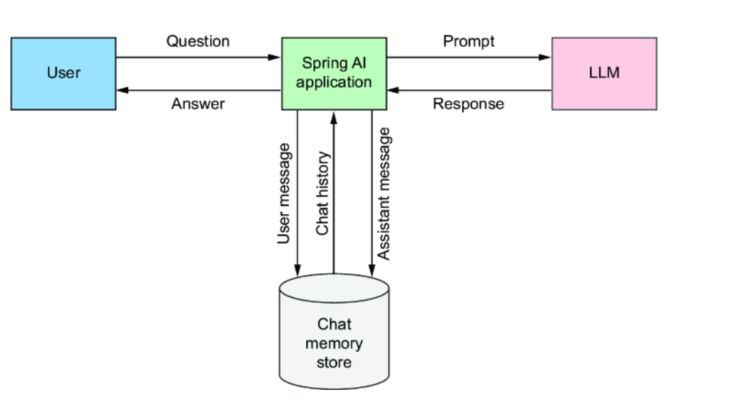
VectorStoreChatMemoryAdvisor takes a completely different approach to storing chat history by storing it in a vector store. By doing this, it can query the vector store, the same way it would query for document chunks in RAG, finding the pieces of chat history that are most similar to the question being asked. Then it places the similar snippets of chat history into the prompt as a string injected into a system message template, the same as PromptChatMemoryAdvisor.
To see how each of these advisors works, let’s start with a simple example that shows how you can use Spring AI’s chat memory advisors to add conversational memory to the Board Game Buddy application.

5.2 Adding conversational memory
When someone is asking questions about the rules of a game, it wouldn’t be uncommon for them to ask one question and then ask one or more follow-up questions. For example, when asking about Burger Battle, you might ask a question about one of the battle cards, followed by a bit of clarification on how it can be used. For example, consider these two questions:
- “What is the Burger Force Field card?”
- “Does it protect against Burgerpocalypse?”
Even though this exchange is brief, it still demonstrates the importance of maintaining a memory of the conversation. The first question is very specific about the subject (the Burger Force Field card), while the second question refers to the subject with a pronoun (“it”). Without the context established in the first question, the second question doesn’t make much sense.
Spring AI’s MessageChatMemoryAdvisor and PromptChatMemoryAdvisor are both quite capable of handling this kind of discussion by storing every question asked by the user, along with every answer provided by the LLM, and then replaying the script to the LLM along with the next question being asked.
Let’s see how these advisors are used by adding them as a default advisor when creating the ChatClient.

5.2.1 Enabling an in-memory chat advisor
If you’re looking forward to writing a lot of code to enable chat memory in the application, you are going to be disappointed. On the other hand, if you like it when a small change yields big results, you’re going to really enjoy what happens next.
As it turns out, adding chat memory is a simple matter of adding one more default advisor when creating the ChatClient. The following listing shows what’s needed to make it work.

Listing 5.1 Adding message-oriented chat memory as a default advisor
@Bean ChatClient chatClient( ChatClient.Builder chatClientBuilder, VectorStore vectorStore, ChatMemory chatMemory) { return chatClientBuilder .defaultAdvisors( MessageChatMemoryAdvisor.builder(chatMemory).build(), #1 QuestionAnswerAdvisor.builder(vectorStore) .searchRequest(SearchRequest.builder().build()).build()) .build(); }

#1 Adds the default MessageChatMemoryAdvisor

Although there’s a lot that goes on behind the scenes regarding chat memory management, the addition of a MessageChatMemoryAdvisor to defaultAdvisors() is all that’s needed to enable simple chat memory. The MessageChatMemoryAdvisor is created, given the ChatMemory passed into the chatClient() method (which is autoconfigured as an instance of MessageWindowChatMemory), and adds the advisor to the list of default advisors alongside the QuestionAnswerAdvisor you added in the previous chapter. By default, MessageWindowChatMemory uses an in-memory implementation to store conversation history.
Alternatively, you could choose to specify a PromptChatMemoryAdvisor in a very similar manner:
@Bean ChatClient chatClient( ChatClient.Builder chatClientBuilder, VectorStore vectorStore, ChatMemory chatMemory) { return chatClientBuilder .defaultAdvisors( PromptChatMemoryAdvisor.builder(chatMemory).build(), QuestionAnswerAdvisor.builder(vectorStore) .searchRequest(SearchRequest.builder().build()).build()) .build(); }
In either case, the main thing to take note of is when the advisor is created, it is given an instance of MessageWindowChatMemory. This implementation of Spring AI’s ChatMemory interface relies on a ChatMemoryRepository for stowing chat messages. By default, the implementation of ChatMemoryRepository stores the conversation history in memory in a simple Map. Because the chat history is maintained in a Map and not written to a database or otherwise stored outside of the application, it will not survive an application restart. But for many use cases, including just-getting-started situations, it is a fine choice.
Now that you have given the Board Game Buddy application the ability to remember the conversation, let’s try it out. Fire up the application and try asking about the Burger Force Field card from Burger Battle (assuming that you have loaded the Burger Battle rules into the vector store):
$ http :8080/ask gameTitle="Burger Battle" \ question="What is the Burger Force Field card?" -b { "answer": "The Burger Force Field card is a Battle Card that protects your Burger from all other Battle Cards.", "gameTitle": "Burger Battle" }
Great! Now let’s ask a follow-up question that requires some past context from the chat history:
$ http :8080/ask gameTitle="Burger Battle" \ question="Does it protect against Burgerpocalypse?" -b { "answer": "The Burger Force Field card does not protect against Burgerpocalypse.", "gameTitle": "Burger Battle" }
Even though the follow-up question doesn’t mention the Burger Force Field card, it’s clear that the answer refers to that card. Chat memory works, and it only took one additional advisor to make it happen!
Let’s take a peek under the hood to see how the chat memory was communicated to the LLM in each request.

5.2.2 Inspecting the prompt for chat memory
Up to this point, you’ve used user messages to carry questions and text from the user and system messages to carry instructions that come from the application itself. When using one of the chat memory advisors, you’re also using assistant messages that represent the response from the LLM. Chat history is a collection of user and assistant messages where the user message is a question that was asked and the assistant message is the answer.
With both MessageChatMemoryAdvisor and PromptChatMemoryAdvisor, the user and assistant messages are stored in chat memory the same way. The key difference between the two advisors is in how those messages from chat memory are sent to the LLM in a prompt.

EXAMINING THE MESSAGECHATMEMORYADVISOR PROMPT
In the case of MessageChatMemoryAdvisor, the user and assistant messages are sent as-is in the prompt. For example, if the conversation has just started, there are no messages in chat memory. So, if the user asks about the Burger Force Field card, the prompt JSON sent looks like this (for OpenAI’s GPT-4o):
{ "messages" : [ { "content" : [ { "type" : "text", "text" : "What is the Burger Force Field?\nContext information is below.\n---------------------\n HOW TO PLAY\n\nBURGER BATTLE\n\n2-6 plavers ... " } ], "role" : "user" } ], "model" : "gpt-4o", "stream" : false, "temperature" : 0.7 }
Look closely at the “messages” property, and you can see that there is only one message. It is a user message that carries both the current question and the RAG context (truncated here to save space).
After the first question has been asked and answered, the user message with the question and the assistant message that contains the answer are stored in chat memory. Then, when the follow-up question is asked, the prompt JSON looks like this:
{ "messages" : [ { "content" : [ { "type" : "text", "text" : "What is the Burger Force Field?" } ], "role" : "user" }, { "content" : [ { "type" : "text", "text" : "{\n \"answer\": \"The Burger Force Field is a Battle Card that protects your Burger from all other Battle Cards. \",\n \"gameTitle\": \"Burger Battle\"\n}" } ], "role" : "assistant" }, { "content" : [ { "type" : "text", "text" : "Does it protect against Burgerpocalypse?\nContext information is below.\n---------------------\n HOW TO PLAY\n\nBURGER BATTLE\n\n2-6 plavers ... " } ], "role" : "user" } ], "model" : "gpt-4o", "stream" : false, "temperature" : 0.7 }
The “messages” property has now grown to three entries: A user message with the original question, an assistant message with the answer, and another user message with the new question and RAG context. For every question asked during the conversation, the “messages” property would grow by two more entries: an assistant message with the answer for the most recently asked question and a user message with the newly posed question.

EXAMINING THE PROMPTCHATMEMORYADVISOR PROMPT
As for PromptChatMemoryAdvisor, rather than add user and assistant messages to the prompt for each turn in the conversation, the entire conversation is captured as a String and injected into a system prompt as context.
To see how this works, let’s say that the conversation has just begun and chat memory is empty. After asking the first question, the prompt looks like this:
{ "messages" : [ { "content" : [ { "type" : "text", "text" : "\nUse the conversation memory from the MEMORY section to provide accurate answers.\n\n---------------------\nMEMORY:\n ---------------------\n\n" } ], "role" : "system" }, { "content" : [ { "type" : "text", "text" : "What is the Burger Force Field?\nContext information is below.\n---------------------\nHOW TO PLAY\n\nBURGER ..." } ], "role" : "user" } ], "model" : "gpt-4o", "stream" : false, "temperature" : 0.7 }
Here, you see that there are two messages: A system message that tells the LLM to use conversation memory and a user message that asks the question (along with RAG context). Because the conversation has just begun, there is no conversation memory to provide in the system message.
When the follow-up question is asked, there will now be some conversation memory. The prompt will look like this:
{ "messages" : [ { "content" : [ { "type" : "text", "text" : "\nUse the conversation memory from the MEMORY section to provide accurate answers.\n\n---------------------\nMEMORY:\n USER:What is the Burger Force Field?\n ASSISTANT:{\n \"answer\": \"The Burger Force Field is a Battle Card that protects your Burger from all other Battle Cards.\",\n \"gameTitle\": \"Burger Battle\"\n}\n---------------------\n\n" } ], "role" : "system" }, { "content" : [ { "type" : "text", "text" : "Does it protect against Burgerpocalypse?\nContext information is below.\n---------------------\nHOW TO PLAY\n\nBURGER BATTLE..." } ], "role" : "user" } ], "model" : "gpt-4o", "stream" : false, "temperature" : 0.7 }
There are still only two messages, as before. But the system message now includes the text from the original user question and the answer from the assistant. The LLM will use this to answer the new question in the user message.
As was the case with MessageChatMemoryAdvisor, the conversation memory will grow as the conversation proceeds. But instead of adding multiple messages to the prompt, the text of the system message will grow to include the dialogue of the conversation that has passed.
When only asking a handful of questions, there’s not much concern about the conversation history getting too big. But as the conversation carries on, the chat memory grows in length. And when sending that chat memory as context in the prompt, it counts against the usage tokens. That means that as the conversation goes on, the token cost goes up. And, of course, there’s a risk that the prompt could eventually exceed the context window limit if the conversation goes on for a very long time. To avoid the problem of an ever-growing chat history, let’s see how to gain some control over how much of the history is sent in the prompt.

5.2.3 Configuring chat memory size
Without you doing anything at all, Spring AI already has you covered when it comes to limiting chat history sent in a prompt. By default, only the most recent 20 messages are sent from the chat memory. After 50 exchanges between the user and the assistant, old messages will drop off when new messages are added, ensuring that the chat memory sent in the prompt will not exceed 20 messages.
You may, however, wish to adjust that limit, either setting it higher for greater conversational context or setting it lower to avoid greater token usage. Regardless of your reason for adjusting it, setting the limit involves overriding the autoconfigured ChatMemory bean to set custom configuration for the MessageWindowChatMemory that is created.
For example, suppose that you decide to limit the number of messages in chat memory to 50. You can set the chat history limit when creating the ChatMemory bean by explicitly defining a @Bean method that creates a ChatMemory. In that method, create a MessageWindowChatMemory instance using its builder and calling maxMessages(). Here’s what that @Bean method would look like:
@Bean ChatMemory chatMemory(ChatMemoryRepository chatMemoryRepository) { return MessageWindowChatMemory.builder() .chatMemoryRepository(chatMemoryRepository) .maxMessages(50) .build(); }
Proving that the chat history limit works can be somewhat tedious. You’d need to carry on a lengthy conversation and inspect the prompt to confirm that it works. But if you were to ask 25 questions and get 25 answers, then the 26th question would not be able to use context from the first question, as it would be dropped. Older conversation entries will be forgotten as new entries are added. Even so, it’s reasonable to think that more recent conversation entries include enough information to infer what’s needed.
Next, let’s have a look at how to set a conversation ID to manage multiple distinct conversations.

5.3 Specifying the conversation ID
Each conversation has an ID associated with it. If you don’t specify otherwise, the conversation ID will be default. That’s fine if your application only has one user. But chances are you have many users, and you’ll want to keep their conversations distinct from each other. To do that, you’ll need to assign a unique conversation ID.
The conversation ID can be any String value that suits you for keeping conversations separate. It could be a user’s username, the session ID, or perhaps the value of a request header, leaving it up to the client to specify. The following listing shows a modification to the controller’s ask() method that extracts the conversation ID from a custom request header whose name is X_AI_CONVERSATION_ID.

Listing 5.2 Pulling the conversation ID from a request header
@PostMapping(path = "/ask", produces = "application/json") public Answer ask( @RequestHeader(name="X_AI_CONVERSATION_ID", defaultValue = "default") String conversationId, #1 @RequestBody @Valid Question question) { return boardGameService.askQuestion(question, conversationId); #2 }

#1 Injects conversation ID header
#2 Passes conversation ID to service

Note that X_AI_CONVERSATION_ID is a custom header defined for the purposes of this application. It is not something specific to Spring AI, and you are welcome to name it anything you want.
After receiving the conversation ID from the request header, it passes it along with the question to SpringAiBoardGameService’s askQuestion() method. That means that SpringAiBoardGameService needs to change to accept the conversation ID and use provide it to keep track of the conversation. First, the BoardGameService will need to change to accept the conversation ID as a parameter:
package com.example.boardgamebuddy; public interface BoardGameService { Answer askQuestion(Question question, String conversationId); }
Then you’ll need to make the appropriate changes to SpringAiBoardGameService. The following listing shows what is needed to add conversational capabilities.

Listing 5.3 Providing the conversation ID to the advisor
import static org.springframework.ai.chat.memory .ChatMemory.CONVERSATION_ID; // ... @Override public Answer askQuestion(Question question, String conversationId) { var gameNameMatch = String.format( "gameTitle == '%s'", normalizeGameTitle(question.gameTitle())); return chatClient.prompt() .system(systemSpec -> systemSpec .text(promptTemplate) .param("gameTitle", question.gameTitle())) .user(question.question()) .advisors(advisorSpec -> advisorSpec .param(FILTER_EXPRESSION, gameNameMatch) .param(CONVERSATION_ID, conversationId)) #1 .call() .entity(Answer.class); }

#1 Sets conversation ID

In the previous version of askQuestion(), the advisors() method was called to specify that QuestionAnswerAdvisor is to be used for performing RAG on the request. That’s still here in this version of askQuestion(), but now another advisors() method is also called that accepts a Consumer<AdvisorSpec>. In this case, the provided AdvisorSpec is used to set the conversation ID as a parameter to the advisors. The CONVERSATION_ID constant provides the key that is shared with the internal chat memory advisor implementations, so that you don’t have to remember to make sure that the key matches what they expect.
As for the conversation ID value, the ask() method accepts it as a parameter annotated with @RequestHeader to extract it from the request’s X_AI_CONVERSATION_ID header. If the header doesn’t exist, it will set the conversation ID to default. The ask() method then passes the conversation ID as a parameter when it calls askValue() on the service.
Now, restart the application and try it out. To ensure that the conversation ID is set, specify the X_AI_CONVERSATION_ID header in the request. When using HTTPie, request headers are specified by giving their name and value, separated by a colon. Here’s how you can submit that initial question within the context of a conversation whose ID is conversation_1:
$ http :8080/ask gameTitle="Burger Battle" \ question="What is the Burger Force Field card?" \ X_AI_CONVERSATION_ID:conversation_1 -b { "answer": "The Burger Force Field card is a Battle Card in the Burger card game that allows a player's Burger to be protected from all other Battle Cards.", "gameTitle": "Burger Battle" }
So far, so good. Now, ask a follow-up question:
$ http :8080/ask gameTitle="Burger Battle" \ question="Does it protect against Burgerpocalypse?" \ X_AI_CONVERSATION_ID:conversation_1 -b { "answer": "The Burger Force Field card does not protect against Burgerpocalypse as it specifically states that all players' ingredients are destroyed, regardless of protection.", "gameTitle": "Burger Battle" }
As before, it’s clear that the LLM was able to infer that “it” means “Burger Force Field card” from the conversation history. As such, it was able to answer the question without having the Burger Force Field card be explicitly mentioned.
Now, let’s trip it up by switching conversations to conversation_2 but leaving the subject unclear as “it”:
$ http :8080/ask gameTitle="Burger Battle" \ question="How do you remove it?" \ X_AI_CONVERSATION_ID:conversation_2 -b { "answer": "To remove ingredients from your Burger, you can play Battle Cards such as Burger Bomb or Picky Eater, which send ingredients to the Graveyard.", "gameTitle": "Burger Battle"
While it did provide an answer, that answer was just as out of context as the question itself, talking about how ingredients can be removed from a burger. Since this request involved a brand-new conversation, there was no history to inform it that you’re asking about the Burger Force Field card. It did its best but had to infer (incorrectly) what the question was referring to.
As you’ve seen, adding chat memory to a Spring AI application with either MessageChatMemoryAdvisor or PromptChatMemoryAdvisor is incredibly easy. They are a great start for enabling conversational history in a Spring AI application. But are they ready for production use?
The biggest problem with how you’ve used them so far is that they rely on MessageWindowChatMemory, whose default ChatMemoryRepository is an in-memory implementation and won’t survive application restarts or shared across multiple application instances. Because the chat history is written to memory, it will continue to eat up application memory over time until the application is restarted.
As such, using either of those chat memory advisors with MessageWindowChatMemory’s default behavior is not recommended for use in a production setting. Instead, let’s see how to add persistent chat memory to a Spring AI application that can survive application restarts, be shared across application instances, and not endlessly consume memory.

5.4 Enabling persistent chat memory
Adding a chat memory advisor to the Board Game Buddy application didn’t give the LLM itself memory. But with the application’s help, the LLM is now capable of engaging in conversation, recalling past exchanges, and using them to inform its next response. It has virtually broken free from 10-Second Tom’s forgetfulness.
Although it’s no longer like 10-Second Tom, it is still somewhat like Lucy from 50 First Dates. Lucy was able to maintain memory throughout the day, but once she went to sleep at night, all memory of that day was lost, and she’d start over the next day with no recollection of the previous day. Similarly, when using MessageWindowChatMemory as you have so far, the application loses its memory when it stops and restarts with a blank slate.
Spring AI offers a couple of options to prevent chat memory from being like the memory of forgetful Lucy:
- Using one of Spring AI’s persistent implementations of ChatMemoryRepository
- VectorStoreChatMemoryAdvisor
Let’s start by taking a look at how to use Spring AI’s persistent ChatMemoryRepository implementations.

5.4.1 Persisting chat memory to a database
As mentioned already, the default implementation of ChatMemoryRepository used by MessageWindowChatMemory is one that stores chat entries in memory. If you could plug in a different implementation of ChatMemoryRepository that persists chat entries to a more durable data store, the conversation history could endure past application restarts. While you could write your own, Spring AI comes with three such implementations for you to choose from:
- CassandraChatMemoryRepository
- JdbcChatMemoryRepository
- Neo4jChatMemoryRepository
Furthermore, thanks to autoconfiguration, it’s extremely easy to add them to your project. We’ll start by looking at how to add Cassandra-based chat memory to your Spring AI application.

CASSANDRA
Apache Cassandra is a popular high-volume NoSQL database; it is highly scalable and designed to handle data across multiple nodes. Its data structure is a hybrid between tabular data and key-value stores. Cassandra can be queried with Cassandra Query Language (CQL), which is quite similar to SQL used to query traditional relational databases.
Spring AI’s CassandraChatMemoryRepository is built to store chat history in a Cassandra cluster. Even if you don’t know much about Cassandra, you can still use CassandraChatMemoryRepository, thanks to autoconfiguration that hides the nitty-gritty of working with Cassandra.
The first step to using Cassandra for chat memory is to add the following starter dependency to your project’s build:
implementation 'org.springframework.ai:spring-ai-starter-model-chat-memory-repository-cassandra'
You can also add this dependency by choosing the Cassandra Chat Memory Repository option from the Spring Initializr.
Next, you’ll need to change the ChatMemory bean you defined earlier to build the MessageWindowChatMemory instance with a reference to an injected ChatMemoryRepository bean:
@Bean ChatMemory chatMemory(ChatMemoryRepository chatMemoryRepository) { return MessageWindowChatMemory.builder() .chatMemoryRepository(chatMemoryRepository) .build(); }
You won’t need to define the ChatMemoryRepository bean, however. Spring AI autoconfiguration will create one for you, and it will be available for injection into the chatMemory() bean method when the application context is being created.
That’s all that’s required to use Cassandra for persistent chat memory. But you’ll need to arrange for a Cassandra cluster to be available. For the purposes of Board Game Buddy, we’re already running our vector store from Docker Compose, so it’ll be easy to add Cassandra to the mix. Just add the following service entry in the Docker Compose file:
services: cassandra: image: 'cassandra:latest' environment: - 'CASSANDRA_DC=dc1' - 'CASSANDRA_ENDPOINT_SNITCH=GossipingPropertyFileSnitch' ports: - '9042:9042'
When you start up the application, chat history will be persisted to tables in the Cassandra cluster. By default, chat history is written to a table named ai_chat_memory in a column named messages. The table will be in the Cassandra namespace springframework. You can customize these details by setting configuration properties like this:
spring.ai.chat.memory.repository.cassandra.keyspace=boardgamebuddy spring.ai.chat.memory.repository.cassandra.messages-column=chat_messages spring.ai.chat.memory.repository.cassandra.table=chat_memory
In this example configuration, the table will be named chat_memory, the message column will be named chat_messages, and the namespace will be boardgamebuddy. This schema will be created for you automatically, so there’s no need for you to worry about creating it yourself. But in a production setting, you may wish to manage the schema yourself. If so, you can disable schema initialization like this:
spring.ai.chat.memory.repository.cassandra.initialize-schema=false
While Cassandra is a solid choice for persistent chat memory, you might also consider storing chat history in the Neo4j graph database. Let’s see how to do that.

NEO4J
Neo4j is a popular and powerful graph database. Data is stored in Neo4j in terms of entity nodes and the relationships between those entities. As you’ll soon see, entities can be visualized as circles with lines connecting them that represent their relationships.
Using Neo4j for persistent chat history is much the same as using Cassandra, with only a few small changes. The main change involves using the Neo4j chat memory starter dependency instead of the Cassandra chat memory starter dependency:
implementation 'org.springframework.ai:spring-ai-starter-model-chat-memory-repository-neo4j'
You can also add this starter to your project by selecting the Neo4j Chat Memory Repository dependency from the Initializr.
The ChatMemory bean you defined for Cassandra will work equally well for Neo4j without any changes. However, the ChatMemoryRepository injected into the chatMemory() bean method will be a Neo4jChatMemoryRepository.
If you’re relying on Docker Compose to start the Neo4j database, you’ll need to edit compose.yaml to add the following Neo4j service:
services: neo4j: image: 'neo4j:latest' environment: - 'NEO4J_AUTH=neo4j/notverysecret' ports: - '7687:7687' - '7474:7474'
On the other hand, if you’ll be using a Neo4j database defined elsewhere, you’ll need to configure the Neo4j connection details in application.properties like this:
spring.neo4j.uri=bolt://some-neo4j-host:7687 spring.neo4j.authentication.username=neo4j spring.neo4j.authentication.password=l3tM31n
Nothing else needs to change. When you run the application and start interacting with the Board Game Buddy application, chat history will be written as a set of entities and relationships to the Neo4j database. If you were to use the Neo4j Browser (https://mng.bz/Nwov) to explore the database, you might see a graph similar to figure 5.2.
Figure 5.2: Viewing chat history in the Neo4j Browser
Figure 5.2 is zoomed in on the top-right quadrant of the visualization such that the default session (aka the default conversation) is in the bottom-left corner. Branching out from that entity node, you can see several user and assistant messages. One of the assistant messages is selected, and its properties are displayed to the right, including the text content that shows the answer to a question about the Burger Force Field card’s limitations. Each of the user and assistant messages themselves is related to a metadata node, which carries additional meta-properties about each message.
The session/conversation entity is the core of a chat history. If you zoom out to see more of the graph, as in figure 5.3, you can see that in this database, three conversations are in play.
Figure 5.3: Multiple conversations visualized in Neo4j
Storing conversation history as a graph in Neo4j is an intriguing option, to be sure. But traditional relational databases have long been the workhorses of application persistence. Let’s see how to use Spring AI’s JDBC-backed chat memory repository to store chat history in a relational database.

JDBC
Spring AI’s JDBC-based implementation of ChatMemoryRepository enables persistence of conversations to a relational database, including any of these databases:
- HSQLDB
- MySQL
- PostgreSQL
- SQL Server
It’s up to you which of these databases you want to use for chat history; for the most part, there’s not much difference in how you configure them. To illustrate how JdbcChatMemoryRepository works, let’s pick PostgreSQL.
First, you’ll need to use the PostgreSQL chat memory repository starter in your build instead of the Cassandra or Neo4j starters:
services: postgres: image: 'postgres:latest' environment: - 'POSTGRES_DB=mydatabase' - 'POSTGRES_PASSWORD=secret' - 'POSTGRES_USER=myuser' ports: - '5432:5432'
You’ll also need the PostgreSQL JDBC driver:
runtimeOnly 'org.postgresql:postgresql'
Next, you’ll need to explicitly configure a ChatMemoryRepository bean. Unlike Cassandra and Neo4j chat memory autoconfiguration, JDBC doesn’t autoconfigure a ChatMemoryRepository bean. It needs to be created with details specific to the kind of database you are using, including a dialect that provides the SQL that works with the specific database. The following chatMemoryRepository() bean method shows how to define the bean for a PostgreSQL database:
@Bean ChatMemoryRepository chatMemoryRepository(DataSource dataSource) { return JdbcChatMemoryRepository.builder() .dialect(new PostgresChatMemoryRepositoryDialect()) .dataSource(dataSource) .build(); }
Here, a new instance of PostgresChatMemoryRepositoryDialect is given to the dialect() method of the builder. The builder is also given a DataSource to issue queries to the database.
By default, the schema will not be initialized with a table to hold the chat history. So, unless you are working with a pre-initialized database, you’ll want to enable the schema initialization like this:
spring.ai.chat.memory.repository.jdbc.initialize-schema=always
Here, the spring.ai.chat.memory.repository.jdbc.initialize-schema property is set to always to indicate that the schema should always be initialized. If you’re using an embedded database such as HSQLDB for tests or demo purposes, you may also choose to set the property to embedded to indicate that the schema should only be initialized when using the embedded database.
Aside from those small changes, everything else is the same as with Cassandra and Neo4j. Regardless of whether you chose to use Cassandra, Neo4j, or JDBC, you’re now ready to try it out.

TRYING IT OUT
Fire up the application and try it out, just as you did when using the in-memory chat memory earlier:
$ http :8080/ask gameTitle="Burger Battle" \ question="What is the Burger Force Field card?" \ X_AI_CONVERSATION_ID:conversation_1 -b { "answer": "The Burger Force Field card is a Battle Card in the Burger card game that allows a player's Burger to be protected from all other Battle Cards.", "gameTitle": "Burger Battle" } $ http :8080/ask gameTitle="Burger Battle" \ question="Does it protect against Burgerpocalypse?" \ X_AI_CONVERSATION_ID:conversation_1 -b { "answer": "The Burger Force Field card does not protect against Burgerpocalypse as it specifically states that all players' ingredients are destroyed, regardless of protection.", "gameTitle": "Burger Battle" }
As you can see, it worked! Regardless of which database you choose to back chat memory, the results are the same. Conversation history is stored persistently and used to give context as the conversation progresses. As long as the database isn’t destroyed (say, by destroying the volume used by the Docker container), the application can stop and start without losing the conversation.
Chat memory can also be stored in a vector store such as Qdrant. In fact, Spring AI comes with a chat memory advisor implementation that does exactly that without needing to write a custom ChatMemoryRepository. To wrap up this chapter, let’s see how it works and what makes it different from the other chat memory advisors.

5.4.2 Storing chat memory in a vector store
Spring AI’s VectorStoreChatMemoryAdvisor is very similar to PromptChatMemoryAdvisor in how it supplies chat memory as context to the LLM in a system prompt. But with regard to how it persists chat memory, it’s quite different than either of the other advisors.
The most obvious difference is that it saves the chat memory to a vector store. But what might not be obvious is that because it writes to a vector store, embeddings are calculated for the chat memory so that they can be queried upon with a similarity search. Put simply, VectorStoreChatMemoryAdvisor applies the RAG pattern to chat memory. But instead of storing document chunks like the RAG you saw in chapter 4, VectorStoreChatMemoryAdvisor stores messages from the chat history.
Consequently, the chat memory fed to the LLM in the system prompt is more focused and relevant than if it were just the most recent so many messages. Rather than simply return the most recent several prompt messages, VectorStoreChatMemoryAdvisor only returns the messages in chat memory that are similar to the question being asked.
Despite its more advanced approach to chat memory, VectorStoreChatMemoryAdvisor is just as easy to use as either of the other two chat memory advisors.

Listing 5.4 Storing long-term memory in a vector store
@Bean ChatClient chatClient(ChatClient.Builder chatClientBuilder, VectorStore vectorStore) { return chatClientBuilder .defaultAdvisors( VectorStoreChatMemoryAdvisor.builder(vectorStore).build(), #1 QuestionAnswerAdvisor.builder(vectorStore) .searchRequest(SearchRequest.builder().build()).build()) .build(); }

#1 Adds VectorStoreChatMemoryAdvisor

As was the case with MessageChatMemoryAdvisor and PromptChatMemoryAdvisor, VectorStoreChatMemoryAdvisor can be specified to the ChatClient in a single line of code. But instead of creating the advisor with an instance of some ChatMemory implementation, MessageChatMemoryAdvisor is created with a reference to the VectorStore, which you already have handy in the ChatClient bean’s definition because you also needed it when you created QuestionAnswerAdvisor in chapter 4.
That’s the only change you’ll need to make to use VectorStoreChatMemoryAdvisor. But you can still set the conversation ID with the CONVERSATION_ID key to specify the conversation ID and chat memory size.

Summary
- LLMs have zero short-term memory and are unable on their own to carry on multiturn conversations.
- Applications can help the LLMs “remember” a conversation by taking note of every line of dialogue between a user and the assistant LLM and reminding the LLM of the chat history on each prompt.
- Spring AI provides three chat memory advisors, each with different strategies for supporting management of conversational memory.
- Long-term memory that outlasts a session can be achieved with VectorStoreChatMemoryAdvisor or by creating a custom implementation of ChatMemory.
- When coupled with QuestionAnswerAdvisor, Spring AI’s chat memory advisors enable conversations with documents.

Chapter 6: Activating Tool-Driven Generation

This Chapter Covers
- Augmenting generation with tools
- Declaratively defining tools
- Using methods and functions as tools
- Providing tool context
When was the last time you visited your doctor? When you were there, did you think about the types of information that the doctor was working with to assess your health?
Doctors undergo extensive training to obtain a license to practice medicine. During that training, they learn the essentials of medicine and physiology. But new discoveries are made frequently, and patients present unusual conditions that require doctors to consult the latest research and, with other medical professionals, to be able to best care for their patients. Even so, no amount of training or medical research can tell the doctor how you feel or what your vital signs are. To better understand your specific situation, the doctor has to measure your vital signs in real-time using tools like thermometers, blood pressure cuffs, and stethoscopes.
If you think about it, that’s kind of how integration with LLMs works. The LLMs are trained with vast amounts of information and can answer many questions from that training. But to bring an LLM up-to-speed with information that they weren’t trained on, you can apply RAG as we did in chapter 4. But at some point, there are things that an LLM just can’t know without using a set of tools to ask. Current weather conditions, stock prices, sports scores, and the wait times for theme park attractions are things that an LLM can’t be trained on and won’t be able to learn from RAG. That’s where tools come into play.
In this chapter, you’re going to see how to use tools to provide an LLM with real-time information and potentially enable the LLM to take some action in response to a prompt.
To understand how to apply tools, you’ll start off by creating a very simple example, based on OpenAI’s GPT-4o that demonstrates not only how Spring AI supports tools but also how tools can overcome some limitations of LLMs. Then, you’ll take what you learned and apply it to provide on-the-fly information to the LLM when asking questions in Board Game Buddy.

6.1 Getting started with AI tools
Much like RAG, tools are a way to enable an LLM to answer questions about data that it was never trained on. Whereas RAG provides information via documents for the LLM, tools provide data via application logic. What’s more, tools can perform tasks, such as updating some data or invoking an API, in addition to providing data. This effectively enables an LLM to take some action and not just respond with answers.
Not all LLMs support tools, but Spring AI makes it easy to enable tools interactions with those that do. Many of the models and AI providers supported by Spring AI support tool calling, including
- Amazon Bedrock Converse
- Anthropic (Claude)
- Azure OpenAI
- Google Gemini
- Groq
- Mistral
- MiniMax
- Moonshot
- NVIDIA (OpenAI-Proxy)
- Ollama (various models)
- OpenAI
- ZhiPu
Even though each of these AI providers supports tools differently in their respective APIs, Spring AI provides a consistent means of applying tools when submitting a prompt. Let’s see how to create a tools-driven Spring AI application.

6.1.1 Developing a tools-enabled application
Specifically, you’re going to create a brand-new Spring AI application that can answer questions about the current time in any city around the world. Start by using the Spring Initializr (either via https://start.spring.io/ or through your IDE) that includes the “web” starter and the Spring AI OpenAI starter, as you did in chapter 1 when you started the Board Game Buddy application. You can name this project anything you like, but the following instructions assume that you named it simple-tools.
Once the project has been created and loaded in your IDE, be sure to specify the OpenAI API key in src/main/resources/application.yml:
spring.ai.openai.api-key=${OPENAI_API_KEY}
Next, create a relatively simple controller that asks the LLM for the current time in a given city. The following listing is a good start.

Listing 6.1 Asking an LLM for the current time in a given city
package com.example.simpletools; import org.springframework.ai.chat.client.ChatClient; import org.springframework.web.bind.annotation.GetMapping; import org.springframework.web.bind.annotation.RequestParam; import org.springframework.web.bind.annotation.RestController; @RestController public class GetTimeController { private static final String CURRENT_TIME_TEMPLATE = "What is the current time in {city}?"; #1 private final ChatClient chatClient; public GetTimeController(ChatClient.Builder chatClientBuilder) { this.chatClient = chatClientBuilder.build(); } @GetMapping(path="/time", params = "city") public String getTime(@RequestParam("city") String city) { return chatClient.prompt() .user(userSpec -> { userSpec .text(CURRENT_TIME_TEMPLATE) .param("city", city); #2 }) .call() .content(); } }

#1 Current time prompt template
#2 Injects city into the prompt

Nothing in this controller should be new to you if you’ve worked through the examples in the previous chapters. The getTime() method handles GET requests to /time, accepting a city parameter. It uses that city as a parameter to the CURRENT_TIME_ TEMPLATE specified as the text of the user message that is sent to the LLM. The last thing that getTime() does is return whatever the response content was from sending that request to the model.
Now you can build it and try it out. Once the application starts up, submit a request to it, asking for the time for any city you’d like. For example, here’s how you might ask for the current time in a small town in southeast New Mexico:
$ http :8080/time?city=Jal+New+Mexico -b I'm unable to provide real-time information, including the current time, as my data is not live. However, you can easily check the current time in Jal, New Mexico, by using a search engine or checking the time on a world clock website or app. Jal, New Mexico, is in the Mountain Time Zone (MT), so you can also convert the time from your local time zone if you know the difference.
Clearly, the LLM understood the question and provided a useful, albeit incomplete answer. As the response indicates, the LLM is incapable of answering any questions about real-time information. The best it could do is respond with instructions for how you might figure out the current time for yourself.
Working with real-time information is just the kind of problem that tools can help with. You’ll just need to define a tool that can determine the current time and provide it to the LLM when submitting the question. To do that, you’ll create a new class with a method that calculates the current time for a given time zone and then configure the ChatClient to let the LLM use it. The following listing shows the new TimeTools class.

Listing 6.2 Defining a tool as a Java lambda
package com.example.simpletools; import org.slf4j.Logger; import org.slf4j.LoggerFactory; import org.springframework.ai.tool.annotation.Tool; import org.springframework.stereotype.Component; import java.time.LocalDateTime; import java.time.ZoneId; @Component public class TimeTools { private static final Logger LOGGER = LoggerFactory.getLogger(TimeTools.class); @Tool(name = "getCurrentTime", description = "Get the current time in the specified time zone.") #1 public String getCurrentTime(String timeZone) { LOGGER.info("Getting the current time in {}", timeZone); var now = LocalDateTime.now(ZoneId.of(timeZone)); return now.toString(); } }

#1 Declares the tool method

TimeTools and its getCurrentTime() method are simple enough, relying on LocalDataTime to do most of the heavy lifting. The method accepts the time zone as a String parameter and passes it as a parameter to LocalDateTime.now() to get the current time in that time zone. The resulting time is then converted to a String and returned to the caller.
The key to making the getCurrentTime() method a tool is that it is annotated with @Tool. In this case, @Tool is used to declare that the getCurrentTime() method is available as a tool for the LLM to use. And it specifies its name (getCurrentTime) and a description to help the LLM understand what it does.
You can have as many @Tool-annotated methods as you like in a class, and all of them will be made available to the LLM. The only restriction is that each tool method must have a distinct name, as specified by the name attribute of @Tool. If the name attribute isn’t specified, the tool’s name will default to be the method’s name.
As it’s doing its work, getCurrentTime() logs that it is getting the current time for a specific time zone at INFO level. This comes in handy as proof that the tool is being called. You’ll also notice that TimeTools is annotated with @Component to ensure that Spring will automatically create an instance of it in the Spring application context.
Now you have a tool that can retrieve the current time in a given time zone. All that’s left is to tell Spring AI to include that tool in any request that it sends. To do that, inject TimeTools into the controller and, from there, pass it to the defaultTools() method when building the ChatClient. The following listing shows the new controller that applies TimeTools when making a request to the LLM.

Listing 6.3 Applying tools when sending a prompt
package com.example.simpletools; import org.springframework.ai.chat.client.ChatClient; import org.springframework.web.bind.annotation.GetMapping; import org.springframework.web.bind.annotation.RequestParam; import org.springframework.web.bind.annotation.RestController; @RestController public class GetTimeController { private static final String CURRENT_TIME_TEMPLATE = "What is the current time in {city}?"; private final ChatClient chatClient; public GetTimeController(ChatClient.Builder chatClientBuilder, TimeTools timeTools) { #1 this.chatClient = chatClientBuilder .defaultTools(timeTools) #2 .build(); } @GetMapping(path="/time", params = "city") public String getTime(@RequestParam("city") String city) { return chatClient.prompt() .user(userSpec -> { userSpec .text(CURRENT_TIME_TEMPLATE) .param("city", city); }) .call() .content(); } }

#1 Injects TimeTools
#2 Includes TimeTools in the prompt

When a prompt is sent to the LLM, the details of the tools will be included in the prompt, giving the LLM an opportunity to make use of it. So, with these changes in place, restart the application and try it again:
$ http :8080/time?city=Jal+New+Mexico -b The current time in Jal, New Mexico is 9:19 PM on February 19, 2025.
This time, the LLM was able to tell you precisely the current time for the specified city. It worked!
But how did the LLM invoke code in your application? Let’s take a look under the hood to see what’s really happening.

6.1.2 Digging deeper
You might be wondering if somehow Spring AI took the tool you defined and exposed it via an endpoint for OpenAI to invoke. While it certainly does appear that the LLM was able to invoke your tool directly, that’s not exactly what is going on.
Instead, there’s a bit of a conversation that takes place between your application and the model when you ask a question that involves tools. Figure 6.1 illustrates each turn taken in this conversation.
Figure 6.1: Tool invocation involves a multipart conversation between the application and the LLM.
The conversation starts with a user message with an initial question, much like any prompt sent to the LLM. The JSON sent in the request to OpenAI’s GPT-4o model looks something like this:
{ "messages": [ { "content": "What is the current time in Jal New Mexico?", "role": "user" } ], "model": "gpt-4o-mini", "stream": false, "temperature": 0.7, "tools": [ { "type": "function", "function": { "description": "Get the current time in the specified time zone.", "name": "getCurrentTime", "parameters": { "$schema": "https://json-schema.org/draft/2020-12/schema", "additionalProperties": false, "type": "object", "properties": { "timeZone": { "type": "string" } }, "required": [ "timeZone" ] } } } ] }
This request is structured to send to OpenAI’s API. If you are using a different AI provider API, the request structure will vary. Even so, the steps in the interaction between the application and any AI API when working with tools is pretty much the same regardless of which model is used.
In this initial request, you can see that there is one user message that carries the question being asked. But also, the tools property specifies an array of tools that are available to the LLM to use when answering questions. In this case, there’s only one tool: the getCurrentTime tool. The tool is described in the description property, which tells the LLM what the tool is capable of. And its parameters property provides a JSON schema to tell the LLM what the tool expects as input.
In response to this initial request, the LLM will reply with the following:
{ "id": "chatcmpl-B2sJlOCkIK1PDnJolKLdri3TtVAzo", "object": "chat.completion", "created": 1740025153, "model": "gpt-4o-mini-2024-07-18", "choices": [ { "index": 0, "message": { "role": "assistant", "content": null, "tool_calls": [ { "id": "call_n64P6pcemoLpheNqMaXRNve8", "type": "function", "function": { "name": "getCurrentTime", "arguments": "{\"timeZone\":\"America/Denver\"}" } } ], "refusal": null }, "logprobs": null, "finish_reason": "tool_calls" } ], "usage": { "prompt_tokens": 59, "completion_tokens": 19, "total_tokens": 78, "prompt_tokens_details": { "cached_tokens": 0, "audio_tokens": 0 }, "completion_tokens_details": { "reasoning_tokens": 0, "audio_tokens": 0, "accepted_prediction_tokens": 0, "rejected_prediction_tokens": 0 } }, "service_tier": "default", "system_fingerprint": "fp_13eed4fce1" }
The first thing to notice is that the response isn’t carrying an answer to the question. The LLM was unable to answer the question without some help. Instead, the response includes a message from the “assistant” (e.g., from the model) asking for the getCurrentTime tool to be called. Although the LLM is unable to determine the time in Jal, New Mexico, it does know that the getCurrentTime tool can and that it needs a time zone. It also knows that Jal is in the America/Denver time zone, so that’s the time zone it asks to be sent to the getCurrentTime tool.
Note that the finish_reason property is set to tool_calls. Usually, this property is set to stop, indicating that the model was able to provide an answer, and the interaction is finished. But when finish_reason is tool_calls, it is saying that the discussion isn’t over and that it needs the application to invoke the tool on its behalf.
The good news is that although the LLM is asking the application to call the tool, you won’t have to explicitly write that code yourself. Spring AI has you covered. Under the hood, it will invoke the getCurrentTime tool and construct a new request with the result it gets. It will then send that new request to the LLM for consideration:
{ "messages": [ { "content": "What is the current time in Jal New Mexico?", "role": "user" }, { "role": "assistant", "tool_calls": [ { "id": "call_n64P6pcemoLpheNqMaXRNve8", "type": "function", "function": { "name": "getCurrentTime", "arguments": "{\"timeZone\":\"America/Denver\"}" } } ] }, { "content": "\"2025-02-19T21:19:13.963458\"", "role": "tool", "name": "getCurrentTime", "tool_call_id": "call_n64P6pcemoLpheNqMaXRNve8" } ], "model": "gpt-4o-mini", "stream": false, "temperature": 0.7, "tools": [ { "type": "function", "function": { "description": "Get the current time in the specified time zone.", "name": "getCurrentTime", "parameters": { "$schema": "https://json-schema.org/draft/2020-12/schema", "additionalProperties": false, "type": "object", "properties": { "timeZone": { "type": "string" } }, "required": [ "timeZone" ] } } } ] }
This new request looks quite similar to the initial request in that it includes the question in the user message and the tool definition in the tools property. But it also includes the assistant message from the original response, as well as a message with a tool role that provides the current time in its content. These three messages form the conversation that has taken place so far, with the most recent message—the tools message—providing the LLM with everything it needs to be able to answer the original question.
Now that the question has been asked again, this time with the current time in the prompt as context, all that’s left is for the LLM to produce the answer in a final response:
{ "id": "chatcmpl-B2sJmwWTsSANYtQfdhitIc1P8L2Rv", "object": "chat.completion", "created": 1740025154, "model": "gpt-4o-mini-2024-07-18", "choices": [ { "index": 0, "message": { "role": "assistant", "content": "The current time in Jal, New Mexico is 9:19 PM on February 19, 2025.", "refusal": null }, "logprobs": null, "finish_reason": "stop" } ], "usage": { "prompt_tokens": 103, "completion_tokens": 25, "total_tokens": 128, "prompt_tokens_details": { "cached_tokens": 0, "audio_tokens": 0 }, "completion_tokens_details": { "reasoning_tokens": 0, "audio_tokens": 0, "accepted_prediction_tokens": 0, "rejected_prediction_tokens": 0 } }, "service_tier": "default", "system_fingerprint": "fp_13eed4fce1" }
And there it is! In this final response, the assistant message includes the answer to the original question. Notice that the finish_reason is now “stop”, indicating that there’s nothing else that needs to be done.
Those are the essentials of working with tools in Spring AI. Now let’s apply what you’ve learned to the Board Game Buddy application as you explore other ways of using tools in Spring AI.

6.2 Implementing tools
For the Board Game Buddy application, suppose that in addition to answering questions about the rules of various games, the API also enables users to provide feedback regarding the complexity level of a game. A game’s complexity could be ranked 1 to 5, graduated along the following lines:
- 1—Easy
- 2—Moderately easy
- 3—Moderate
- 4—Moderately difficult
- 5—Difficult
Presumably, each game’s complexity ranking is supplied by Board Game Buddy users but is ultimately held in a database. As such, it’s just the kind of data that can be provided to an LLM via a tool.
Having established the notion of a game’s complexity, let’s see how to build it into the Board Game Buddy application and ultimately be able to answer questions regarding the difficulty of a game. But before you can define the tool that feeds into the generative AI interaction, you’ll need to build the foundational code that reads the complexity information from a database.

6.2.1 Writing the tool’s foundations
The game data, such as the game’s complexity, is going to be kept in a relational database. There’s no easier way to work with relational data in Spring than to use Spring Data. More specifically, you can use Spring Data JDBC by adding the following dependency to the build:
implementation 'org.springframework.boot:spring-boot-starter-data-jdbc'
You’ll also need to set up a database and add the database’s driver dependency to the build. Almost any relational database will work, but for now, let’s use the H2 in-memory database by adding the following dependency to the build:
runtimeOnly 'com.h2database:h2'
This dependency not only triggers Spring Boot autoconfiguration to create a DataSource bean needed by Spring Data JDBC, but it also causes autoconfiguration to create the H2 database itself. You’ll just need to define the schema by defining it in a schema.sql file under src/main/resources:
create table Game ( id identity, title varchar(255) not null, slug varchar(255) not null, complexity float not null );
The Game table is relatively simple for now, focusing on the essential data needed to keep the complexity of a game. The columns defined are
- id—A database-specific identifier that serves as the primary key.
- title—The game’s title.
- slug—A normalized version of the game title in all lowercase and snake case. This is the same slug we used in chapter 4 to associate document chunks with a game.
- complexity—The game’s complexity level, a real number value from 1 to 5.
Presumably, this table will be loaded by some other component of the Board Game Buddy application as users report their assessment of game complexity. But for now, rather than build that portion of the application, you can just initialize the database with some test data by using SQL insert to add a handful of games to the Game table. Create the following file named data.sql in the project’s src/main/resources directory:
insert into Game (title, slug, complexity) values ('Burger Battle', 'burger_battle', 1.33); insert into Game (title, slug, complexity) values ('Azul', 'azul', 1.76); insert into Game (title, slug, complexity) values ('Carcassonne', 'carcassonne', 1.89); insert into Game (title, slug, complexity) values ('Catan', 'catan', 2.29); insert into Game (title, slug, complexity) values ('Scythe', 'scythe', 3.44); insert into Game (title, slug, complexity) values ('Puerto Rico', 'puerto_rico', 3.27); insert into Game (title, slug, complexity) values ('7 Wonders', '7_wonders', 2.32);
Now let’s turn our attention to the Java code that our tool will use to read that game data. To start, we need a Java object that will hold the data for a game. This Game record type should do the trick:
package com.example.boardgamebuddy.gamedata; import org.springframework.data.annotation.Id; public record Game( @Id Long id, String slug, String title, float complexity) { public GameComplexity complexityEnum() { int rounded = Math.round(complexity); return GameComplexity.values()[rounded]; } }
Aside from the properties that map one to one with the columns in the Game table, the Game record also includes a complexityEnum() method that converts the numerical complexity value into a specific value of a GameComplexity enum. The GameComplexity enum is defined like this:
package com.example.boardgamebuddy.gamedata; public enum GameComplexity { UNKNOWN(0), EASY(1), MODERATELY_EASY(2), MODERATE(3), MODERATELY_DIFFICULT(4), DIFFICULT(5); private final int value; GameComplexity(int value) { this.value = value; } public int getValue() { return value; } }
Next up, you’ll need a repository that can read the game data from the database. This GameRepository interface specifies that the repository will provide a findBySlug() method to look up game data given its slug:
package com.example.boardgamebuddy.gamedata; import org.springframework.data.repository.CrudRepository; import java.util.Optional; public interface GameRepository extends CrudRepository<Game, Long> { Optional<Game> findBySlug(String slug); }
The GameRepository interface also extends Spring Data’s CrudRepository interface, which provides several other methods for reading and writing game data. Most importantly, extending CrudRepository triggers Spring Data’s ability to automatically create an implementation for GameRepository at run time. You won’t need to write the implementation yourself. You only need to create the interface, and Spring Data will take care of the rest. You now have all of the underpinnings necessary to create the tool that will enable the AskController to handle questions about game complexity.

6.2.2 Defining the tool
In listing 6.2, you defined the getCurrentTime() tool in a component class as a @Tool-annotated method. The following listing shows how you can apply the same technique for the game complexity tool by creating a new GameTools component.

Listing 6.4 Declaring a game complexity tool
@Bean package com.example.boardgamebuddy; import com.example.boardgamebuddy.gamedata.*; import org.slf4j.Logger; import org.slf4j.LoggerFactory; import org.springframework.ai.tool.annotation.Tool; import org.springframework.ai.tool.annotation.ToolParam; import org.springframework.stereotype.Component; import java.util.Optional; @Component public class GameTools { private final GameRepository gameRepository; public GameTools(GameRepository gameRepository) { #1 this.gameRepository = gameRepository; } private static final Logger LOGGER = LoggerFactory.getLogger(GameTools.class); @Tool(name = "getGameComplexity", description = "Returns a game's complexity/difficulty " + "given the game's title/name.") public GameComplexityResponse getGameComplexity( @ToolParam(description="The title of the game") #2 String gameTitle) { var gameSlug = gameTitle #3 .toLowerCase() .replace(" ", "_"); LOGGER.info("Getting complexity for {} ({})", gameTitle, gameSlug); var gameOpt = gameRepository.findBySlug(gameSlug); #4 var game = gameOpt.orElseGet(() -> { #5 LOGGER.warn("Game not found: {}", gameSlug); return new Game( null, gameSlug, gameTitle, GameComplexity.UNKNOWN.getValue()); }); return new GameComplexityResponse( #6 game.title(), game.complexityEnum()); } }

#1 Injects GameRepository
#2 Describe parameter
#3 Calculates slug
#4 Fetches game data
#5 Extracts game data from optional
#6 Creates response

Here, the getGameComplexity() method is annotated with @Tool much like how you did with the getCurrentTime() method before. The description attribute provides a description that the LLM uses to decide whether it can be used to answer a question. The method uses the injected GameRepository to look up the game data. If the game can’t be found, a placeholder Game is created to communicate that the complexity is unknown.
The tool method accepts its input in the form of a String that is the game’s title. Notice that the gameTitle parameter is annotated with @ToolParam. This annotation provides a description to help the LLM understand the purpose of the parameter so that it knows what needs to be passed in when it requests that the tool be invoked.
After looking up the game’s complexity from the GameRepository, the tool responds with GameComplexityResponse, a Java record that carries the game title and a GameComplexity value:
package com.example.boardgamebuddy.gamedata; public record GameComplexityResponse( String title, GameComplexity complexity) { }
All that’s left is to put the tool to work by including it in the prompt sent to the LLM. Let’s do that now.

6.2.3 Putting the tool to work
There are a couple of options for providing the tool to ChatClient. One way is to inject GameTools into AiConfig’s chatClient() method and pass it to defaultTools() when creating the ChatClient:
@Bean ChatClient chatClient(ChatClient.Builder chatClientBuilder, VectorStore vectorStore, GameTools gameTools) { return chatClientBuilder .defaultAdvisors( QuestionAnswerAdvisor.builder(vectorStore) .searchRequest(SearchRequest.builder().build()).build(), MessageChatMemoryAdvisor.builder( MessageWindowChatMemory.builder().build()).build()) .defaultTools(gameTools) .build(); }
By providing it to ChatClient at build time, you are guaranteeing that any @Tool-annotated methods in GameTools will be available in all prompts sent to the LLM from that ChatClient. But you could just as easily choose to provide the tools at prompt time by passing GameTools to the tools() method when creating and sending the prompt. In that case, you would inject it into AskController and set it in the prompt in the controller’s askQuestion() method:
@Service public class SpringAiBoardGameService implements BoardGameService { private final ChatClient chatClient; private final GameTools gameTools; public SpringAiBoardGameService(ChatClient chatClient, GameTools gameTools) { this.chatClient = chatClient; this.gameTools = gameTools; } // ... @Override public Answer askQuestion(Question question, String conversationId) { // ... return chatClient.prompt() .user(question.question()) .tools(gameTools) // ... .call() .entity(Answer.class); } }
Whether you choose to specify the game complexity tool at prompt creation time in the service’s askQuestion() method or at ChatClient creation time, you are now ready to try it out. Fire up the application and give it a shot, asking about the complexity of a few of the games in the sample data. Here are a few examples of what you might see:
$ http :8080/ask question="What is the complexity?" \ gameTitle="Puerto Rico" -b { "answer": "The complexity of the game is moderate.", "game": "Puerto Rico" } $ http :8080/ask question="How complex is the game?" \ gameTitle="Burger Battle" -b { "answer": "The complexity of the game is easy.", "game": "Burger Battle" } $ http :8080/ask question="What is the difficulty?" gameTitle="Azul" -b { "answer": "The complexity of the game is moderately easy.", "game": "Azul" }
What’s more, because you placed a call to the logger’s info() method in the tool, you can look at the logs and verify that the tool was called and that the LLM didn’t just make up the complexity answer.
The Board Game Buddy application is now equipped to answer rules questions about games as well as questions about how difficult they are. But before wrapping up this chapter, let’s look at another option for providing tools in the context of a prompt.

6.3 Enables functions as tools
Early milestone versions of Spring AI referred to “tools” as “functions,” but later changed to “tools” to align with the terminology used by many AI APIs. Despite the name change, it turns out that functions are a good way to think of how tools work. Just like Java’s Function interface, tools typically accept input, perform some work, and produce a return value. They can also align with Java’s Supplier and Consumer interfaces as well when inputs or return values aren’t required.
As an alternative to annotated bean methods, Spring AI also offers the opportunity to define tools as implementations of Function, Supplier, or Consumer. The following shows how you might reimplement the GameTools class and its getGameComplexity() method as an implementation of Java’s Function interface.

Listing 6.5 Defining the tool as a Java Function implementation
package com.example.boardgamebuddy.gamedata; import org.slf4j.Logger; import org.slf4j.LoggerFactory; import org.springframework.context.annotation.Description; import org.springframework.stereotype.Component; import java.util.Optional; import java.util.function.Function; @Component @Description("Fetches the complexity of a game.") #1 public class GameTools implements Function<GameComplexityRequest, GameComplexityResponse> { #2 public static final Logger LOGGER = LoggerFactory.getLogger(GameTools.class); private final GameRepository gameRepository; public GameTools(GameRepository gameRepository) { this.gameRepository = gameRepository; } @Override public GameComplexityResponse apply( #3 GameComplexityRequest gameDataRequest) { String gameSlug = gameDataRequest.title() .toLowerCase() .replace(" ", "_"); LOGGER.info("Getting complexity for {} ({})", gameDataRequest.title(), gameSlug); Optional<Game> gameOpt = gameRepository.findBySlug(gameSlug); Game game = gameOpt.orElseGet(() -> { LOGGER.warn("Game not found: {}", gameSlug); return new Game( null, gameSlug, gameDataRequest.title(), GameComplexity.UNKNOWN.getValue()); }); return new GameComplexityResponse( game.title(), game.complexityEnum()); } }

#1 Describes the function
#2 Implements Function
#3 Applies method

The bulk of this version of GameTools is largely the same as the one you created in listing 6.4. However, GameTools now implements Function and the core logic of looking up game complexity is in the apply() method (the one method required by Function). The class is annotated with @Description to provide a description of what the tool does and @Component to ensure that it is discovered and an instance created as a bean in the Spring application context.
Just like the getGameComplexity() method from before, the apply() method returns GameComplexityResponse. But instead of accepting a simple String with the game title, the apply() method takes a GameComplexityRequest object. That’s because Function-based tools cannot accept Strings or native Java types. Therefore, the game’s title had to be wrapped in a custom type. GameComplexityRequest is defined as a Java record like this:
package com.example.boardgamebuddy.gamedata; import org.springframework.context.annotation.Description; @Description("Request data about a game, given the game title.") public record GameComplexityRequest(String title) { }
Here, the GameComplexityRequest itself is annotated with @Description to provide a description of the type. This description serves the same purpose as @ToolParam's description attribute in listing 6.4.
All that’s left to do is register the tool with the ChatClient. But rather than pass an instance of the Function-based GameTools to defaultTools() or tools(), you simply pass the name of the Spring bean to defaultToolNames() or toolNames(). Since GameTools is annotated with @Component and its class name is GameTools, the bean name should be gameTools—that is, the class name with the first letter in lowercase. Knowing this, you can register the tool by calling defaultToolNames() when creating the ChatClient like this:
@Bean ChatClient chatClient(ChatClient.Builder chatClientBuilder, VectorStore vectorStore) { return chatClientBuilder .defaultAdvisors( QuestionAnswerAdvisor.builder(vectorStore) .searchRequest(SearchRequest.builder().build()).build(), MessageChatMemoryAdvisor.builder( MessageWindowChatMemory.builder().build()).build()) .defaultToolNames("gameTools") .build(); }
If you prefer or need to specify the tool at prompt time, you can pass it to toolNames() like this:
@Override public Answer askQuestion(Question question, String conversationId) { return chatClient.prompt() ... .toolNames("gameTools") .call() .entity(Answer.class); }
Either way, you should be able to fire up the application and ask questions about game complexity using this new Function-based tool.

Summary
- By applying tools, LLMs can answer questions about data that is provided in real time.
- Spring AI includes details about available tools when sending prompts to an LLM.
- LLMs do not invoke tools directly but, instead, respond to a prompt by asking the application to call one or more tools and then send a follow-up prompt that provides the tool results as additional context.
- Spring AI provides a consistent programming model for working with tools regardless of the model and API being used.
- Tools can be defined as @Tool-annotated methods or as implementations of Java’s Function, Supplier, and Consumer interfaces.

Chapter 7: Applying Model Context Protocol

This Chapter Covers
- Using tools from a predefined MCP Server
- Creating a custom MCP Server
- Enabling MCP’s STDIO and HTTP+SSE transports
- Exposing tools, prompts, and resources
In the movie Wreck-It Ralph, the character Fix-It Felix Jr. carries an incredibly powerful hammer. With this one tool, Fix-It Felix Jr. is able to repair anything that’s broken by just hitting it once. Got a cracked wall? Hit it with a hammer. Bent streetlights? Hit it with a hammer. Broken window? Defying all logic and everything you know about glass and hammers, hit it with a hammer, and it will be fixed. Fix-It Felix Jr.’s hammer is rivaled only by Thor’s Mjolnir as the most amazing hammer that has ever been wielded.
But in the real world, hammers can’t be used to fix everything. A hammer is the perfect tool for driving nails, but I don’t recommend using it to fix a window. In the real world, there are many tools, each with its own best use case. And while Fix-It Felix Jr. always had his hammer at the ready in his hand, it’s more convenient to keep a set of many tools in a toolbox that you can carry around to where they’re needed.
In the previous chapter, you saw how to employ tools in a Spring AI application, coding them as part of the application itself. In this chapter, we’ll see how to apply Model Context Protocol (MCP), a way to collect sets of associated tools so that they can be shared and used in any AI application that may make use of them.

7.1 Introducing Model Context Protocol
MCP is a specification introduced by Anthropic (the makers of the Claude family of models) in late 2024. Although it was defined by Anthropic, it can be used with any LLM and API that supports tools, including the OpenAI models we’ve been using so far.
The two core components of MCP are MCP Servers and MCP Clients. An MCP Server has access to some resource, such as a database, filesystem, or API, and exposes access to that resource via one or more tools. Meanwhile, an MCP Client running within an application communicates with the MCP Server, fetching a list of its tools, making those tools available in a prompt’s context, and invoking those tools on behalf of the LLM. Figure 7.1 illustrates the relationship between MCP Servers and MCP Clients, as defined in the specification.
Figure 7.1: Interactions between MCP Servers and MCP Clients

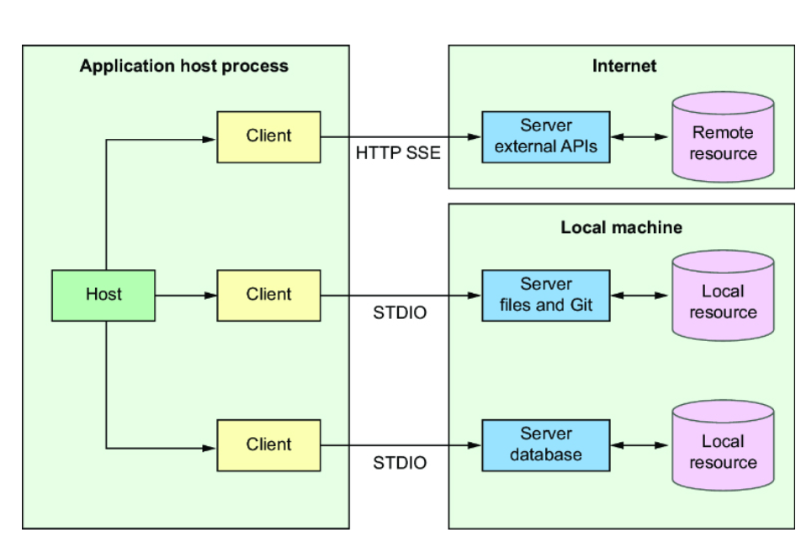

MCP Servers can make their tools available via three transport protocols: Standard Input Output (STDIO), HTTP with Server-Sent Events (HTTP+SSE), and Streamable HTTP. Per the MCP specification, an MCP Server should provide the STDIO transport if possible, but may choose whether to implement the HTTP+SSE transport or Streamable HTTP transport.
NOTE
Spring AI 1.0.0 was released with support for MCP’s STDIO and HTTP+SSE transports. It does not, however, support the Streamable HTTP transport. Therefore, Streamable HTTP will not be covered in this chapter. However, Spring AI 1.1.0 (which is only in early milestone release at the time this was written) will include support for the Streamable HTTP transport.
Even though MCP is a relatively new specification in the world of generative AI, it is already having a significant effect. Upon releasing MCP into open source, Anthropic provided 19 reference MCP Server implementations (https://github.com/modelcontextprotocol/servers/), including MCP Servers that enable integration with services like PostgreSQL, GitHub, and Google Maps. Since then, several hundred more MCP Servers have been created by the community, covering a broad range of tools. You can find an ever-growing registry of MCP Servers at https://www.pulsemcp.com/.
Many of the available MCP Servers include instructions for configuring them in the Claude Desktop (https://claude.ai/download) application. If you have Claude Desktop installed, you can edit the application configuration to add MCP Server configuration. Open Settings in the application and choose the Developer tab and then Edit Config to open the configuration in an editor. Paste in the MCP Server’s configuration and restart the application to try it out.
Let’s say that you want to try out the Google Maps MCP Server (https://mng.bz/Dw0A). The README file shows instructions for running it with either Docker or NPX. If you paste in either of the configurations (and add your Google Maps API key), you should be able to ask location-specific questions after restarting Claude Desktop.
For example, suppose that you’re curious about how many convenience stores there are in the tiny town of Jal, New Mexico. Figure 7.2 shows the results you might get if you ask this burning question in Claude Desktop.
Figure 7.2: Using the Google Maps MCP Server in Claude Desktop

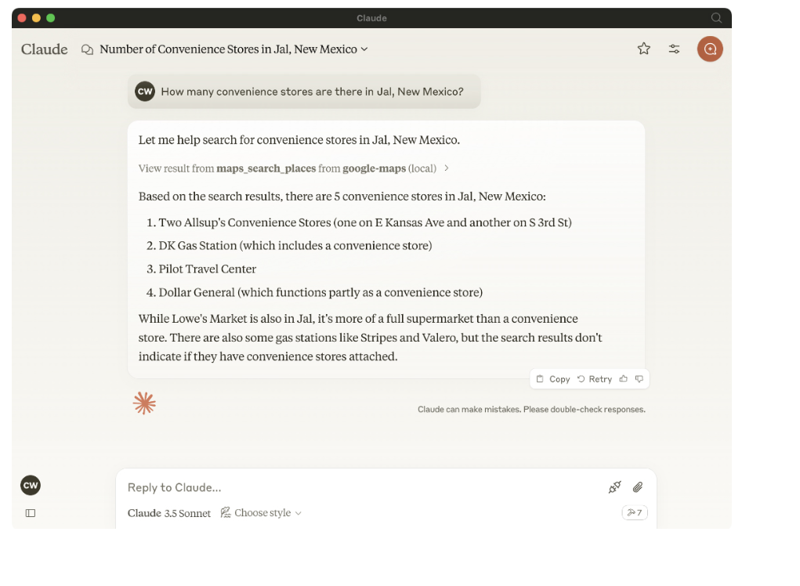

Extending Claude Desktop’s abilities with MCP is fun and useful. But the real power of MCP comes when you mix it into your own applications. To enable that, Spring AI provides support for working with existing MCP Servers as well as creating your own. Let’s see how to use MCP Clients to integrate external tools made available by MCP Servers.

7.2 Working with MCP Clients
As you begin exploring how MCP works with Spring AI, it’s easiest to start by integrating functionality from an existing MCP Server by defining an MCP Client that is configured to connect to that server. One of the easiest MCP Servers to get started with is the Filesystem MCP Server, one of the 19 reference MCP Servers from Anthropic (https://mng.bz/lZQd). Although it is a relatively simple MCP Server, it shows off the potential of what MCP can be used for.
Let’s put the Filesystem MCP Server to work by creating a new Spring Boot project. Just as you began with the Board Game Buddy application, this new project will depend on the Spring Web and OpenAI dependencies. It will also require the MCP Client dependency. Figure 7.3 shows how you might initialize the project with the Spring Initializr.
Figure 7.3: Initializing a new project for working with MCP in Spring

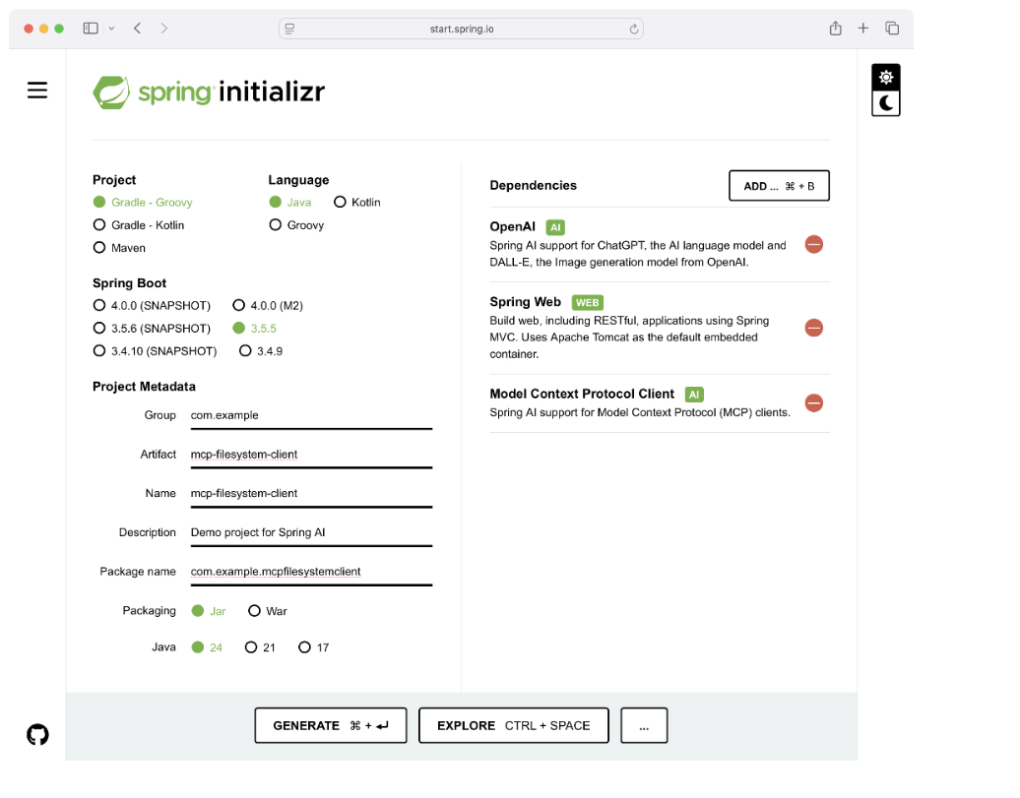

With the project initialized, you are now ready to configure the MCP Client to reference the Filesystem MCP Server. There are two options for configuring MCP Servers in an MCP Client:
- In a Spring configuration (e.g., application.properties or application.yml)
- In a Claude Desktop–compatible JSON configuration
The choice you make is largely a matter of personal preference. Many of the available MCP Servers offer Claude Desktop configuration JSON in their README files, making that option a simple matter of copy and paste to bring those servers into a Spring AI application. On the other hand, Spring-style configuration is no different than how you might configure any configuration property in a Spring Boot application, so it may feel more natural if you’ve worked with Spring Boot for a while. A little later in section 7.4, when you work with MCP’s HTTP+SSE transport, you’ll find that Claude Desktop configuration is not an option, and you can only use Spring-style configuration.
Let’s first see how to configure the MCP Client with Spring Boot configuration properties. You can choose to configure them in either application.properties or application.yml, but MCP Client configuration is easiest to read in YAML. The following listing shows what the configuration for the Filesystem MCP server looks like in the application.yml file.

Listing 7.1 Configuring an MCP Server reference in a client’s application.yml
spring: ai: mcp: client: stdio: connections: filesystem: #1 command: 'npx' #2 args: #3 - '-y' - '@modelcontextprotocol/server-filesystem' - '/Users/habuma/mcp-playground' toolcallback: enabled: true

#1 MCP Client name
#2 MCP Server command
#3 Arguments

The entire MCP Client configuration is rooted in the spring.ai.mcp.client base property. After that comes the stdio property, which indicates that you’ll be configuring the MCP Client to communicate with the server using the STDIO transport. Under stdio, you can configure one or more MCP Clients.
In this case, you’re configuring one MCP Client, whose name is filesystem. The command to run the server is specified in the command subproperty, followed by the args subproperty, which provides command-line arguments to the MCP Server command. When the application starts up, Spring AI will start the MCP Server by running the given command and its arguments; it will communicate with the server via standard input and output.
The configuration in listing 7.1 was derived from the configuration described in the README for the Filesystem MCP Server under the Usage with Claude Desktop heading. Although the actual path given to it is different, it should be clear how to map the configuration intended for the Claude Desktop to Spring configuration properties. But it could be even easier if Spring AI supported Claude Desktop–style configuration. Fortunately, it does!
If you’d rather use JSON configuration in the format for Claude Desktop, you can replace what’s shown in listing 7.1 with a single property that references a JSON configuration file:
spring: ai: mcp: client: stdio: servers-configuration: classpath:mcp-servers.json
The spring.ai.mcp.client.stdio.servers-configuration property is given a URI to a Claude Desktop configuration file. In this case, it’s a classpath: URI indicating that the configuration is at the root of the application’s classpath in a file named mcp-servers.json. That JSON file closely resembles the JSON configuration in the Filesystem MCP Server’s README (with a different filesystem path):
{ "mcpServers": { "filesystem": { "command": "npx", "args": [ "-y", "@modelcontextprotocol/server-filesystem", "/Users/habuma/mcp-playground" ] } } }
Another option to consider is that if you have already configured one or more MCP Servers in Claude Desktop, you could point your Spring AI application at the Claude Desktop configuration to use those MCP Servers. For example, here’s how you would reference Claude Desktop’s configuration on a Mac:
spring: ai: mcp: client: stdio: servers-configuration: "file://${HOME}/Library/Application ↪Support/Claude/claude_desktop_config.json"
No matter which style you choose to configure MCP Clients, Spring AI will automatically start up the referenced server(s) when the application starts. You only need to enable the ChatClient to use the tools that the server(s) make available. You can do so by calling defaultToolCallbacks() when creating the ChatClient or by calling tools() when submitting a prompt.
To see how to do this, you’ll now create the main controller class of this new project. It’ll be a controller much like Board Game Buddy’s AskController that uses a ChatClient to answer questions. But to keep it distinct from Board Game Buddy’s AskController and avoid confusion, let’s name it McpAskController. This new controller is shown in the following listing.

Listing 7.2 An MCP-enabled controller for answering questions
package com.example.mcpfilesystemclient; import org.springframework.ai.chat.client.ChatClient; import org.springframework.ai.tool.ToolCallbackProvider; import org.springframework.web.bind.annotation.PostMapping; import org.springframework.web.bind.annotation.RequestBody; import org.springframework.web.bind.annotation.RestController; @RestController public class McpAskController { private final ChatClient chatClient; public McpAskController(ChatClient.Builder chatClientBuilder, ToolCallbackProvider tools) { #1 this.chatClient = chatClientBuilder .defaultToolCallbacks(tools) #2 .build(); } @PostMapping("/ask") public Answer ask(@RequestBody Question question) { return chatClient.prompt() .user(question.question()) .call() .entity(Answer.class); } public record Question(String question) { } public record Answer(String answer) { } }

#1 Injects MCP tool callback the provider
#2 Configures default tools

McpAskController isn’t much different than the AskController you created in chapter 1. It works directly with ChatClient (instead of an injected BoardGameService) and the Question and Answer records are defined as inner types. But the most significant difference is in the constructor, where the ChatClient is being built. The constructor is injected with an instance of ToolCallbackProvider, which is passed to the ChatClient builder’s defaultToolCallbacks() method to inform the ChatClient of all of the tools made available by the MCP Server. Consequently, any of those tools could be used by the LLM—no different from the gameComplexityFunction you created earlier—to answer questions from the user.
That’s all there is to configuring an MCP Client. Let’s try it out to see what happens.
Start up the application and maybe create a few files in the working directory that you specified to the MCP transport. Then, using HTTPie, ask it to list the files in that directory. For example,
$ http :8080/ask question="List all files" -b { "answer": "[FILE] testfile.txt\n[FILE] someOtherFile.txt" }
Awesome! It was able to see two files in that directory (prefixed with [FILE]). And while that’s pretty cool, what’s even more amazing is that it’s not just capable of read-only operations against the working directory. You can also write to it. For example,
$ http :8080/ask question="Create a file named penguins.txt and write \ a joke about penguins as its content" -b { "answer": "File penguins.txt created with a joke about penguins." }
It says that it wrote the file. You can verify this by opening the file using the file reader of your choice. Or, just ask the application to read it to you:
$ http :8080/ask question="Read the file named penguins.txt" -b { "answer": "Why don't you ever see penguins in the UK?\n\nBecause they're afraid of Wales!" }
The Filesystem MCP Server effectively demonstrates how to utilize an MCP Server with Spring AI to integrate external functionality into your AI applications. But it is just one of 19 MCP Servers made available by Anthropic and one of several hundred that are available from other MCP developers. There’s a treasure trove of functionality provided by those MCP Servers just waiting for you to integrate it into your Spring AI applications.
But you may be wondering if you can create your own MCP Server. If so, then you’re in luck! Spring AI also enables you to create your own MCP Server in Java. Let’s see how to create an MCP Server that provides some custom functionality.

7.3 Creating your own MCP Server
Although several MCP Servers are available that provide tools for integrating with common APIs and functionality, there’s always room for more. Spring AI’s MCP Server support makes it possible to create and share tools that can do virtually anything you can imagine and that Java code can perform. To see how to build an MCP Server with Spring AI, let’s build an MCP Server that provides tools that can help when answering questions about board games.
The RAG techniques you applied in chapter 4 were great for asking questions about a specific game based on the game’s rulebook. But they aren’t so great about answering basic questions that cut across a full collection of games. For example, suppose that the user asked, “What game would you suggest for 10 players?” or “Can you suggest a game that can be played in less than 30 minutes.” At best, RAG would find a few document chunks that seem to match the question and try to answer from that. But these are questions that would be easier answered by querying a database or API.
Imagine a database populated with basic information about several board games. The database might have a table that includes
- The title of the game
- A brief description of the game
- The minimum and maximum number of players that can play the game
- The estimated duration that it takes to play the game
If you were building an MCP Server that exposes tools that return this data, a client application will be able to answer questions about which games are best for a given number of players or that take a certain amount of time to play. Let’s build that MCP Server.

7.3.1 Building the server
To create a custom MCP Server, you’ll start by creating a brand-new Spring Boot application. As you’re choosing dependencies in the Initializr, you’ll need to select Model Context Protocol Server dependency. And because the server will be working with a database, you will also need a few other dependencies. Specifically, you’ll need to select the following dependencies:
- Spring Data JDBC—You’ll use this to create a repository to query the database.
- PostgreSQL Driver—This is to enable connectivity to a PostgreSQL database.
- Docker Compose Support—This will be used to start PostgreSQL automatically in Docker when the application starts.
You won’t need OpenAI or any other LLM-specific dependency, as this server won’t be interacting with an LLM. Figure 7.4 shows how you might initialize the application.
Figure 7.4: Initializing a project to create a custom MCP Server

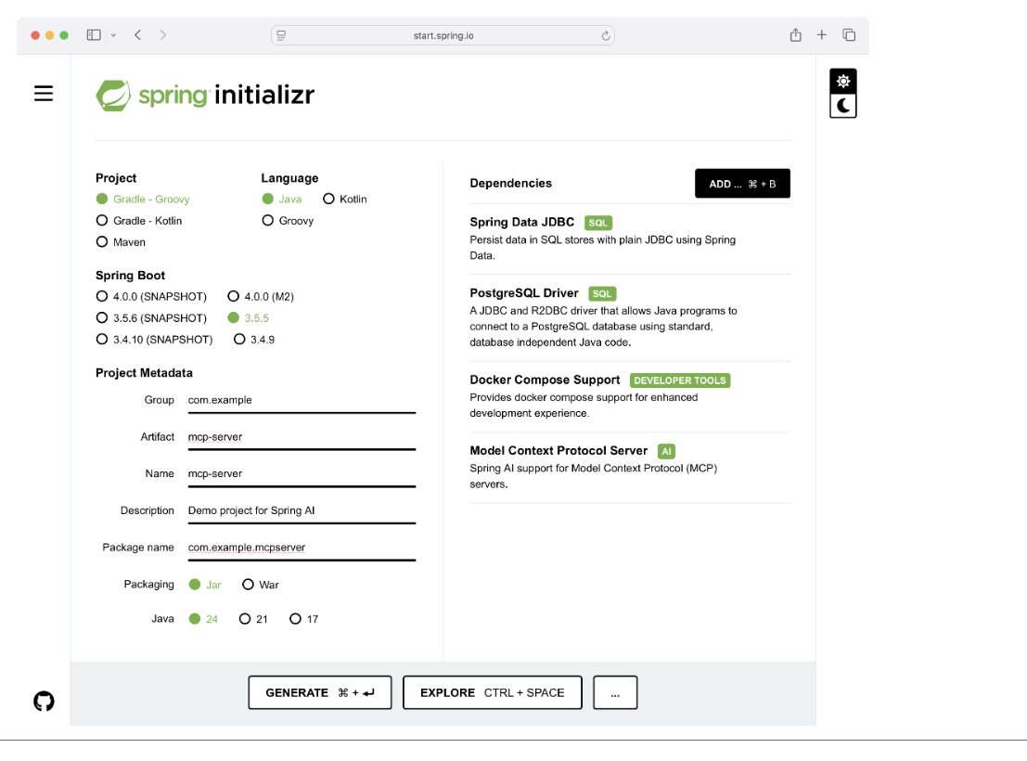

With the project initialized, you can begin creating the MCP Server by creating a JDBC repository and setting up the database with a schema and some game data.

7.3.2 Setting up the database
To keep things simple—and to not require that you have a database setup separately from the MCP Server project—you’ll use Spring Boot’s Docker Compose support to start a PostgreSQL database when the application starts. The Spring Boot Initializr should have given you a compose.yaml file at the root of the project that is already setup with a PostgreSQL service. But if not, create the file and ensure that it looks like this:
services: postgres: image: 'postgres:latest' environment: - 'POSTGRES_DB=boardgamedb' - 'POSTGRES_PASSWORD=secret' - 'POSTGRES_USER=myuser' ports: - '5432:5432'
Next, you’ll need to make sure that the database is properly initialized with a schema and test data. The following schema.sql file (placed in the src/main/resources directory) will ensure that the database will be initialized with a Game table:
drop table if exists game cascade; create table game ( id bigserial not null primary key, title varchar(255) not null, description varchar(1024), min_players int not null, max_players int not null, min_playing_time int not null, max_playing_time int not null );
To fill the database with some game data, you’ll rely on this data.sql file to add information about several games:
insert into game (title, description, min_players, max_players, min_playing_time, max_playing_time) values ('Sagrada', 'A dice-drafting game where players create beautiful ' || 'stained glass windows using colored dice.', 1, 4, 30, 45), ('Catan', 'A strategy board game where players collect resources and ' || 'build settlements.', 3, 4, 60, 120), ('Ticket to Ride', 'A railway-themed board game where players collect ' || 'cards to claim railway routes.', 2, 5, 30, 120), ('Carcassonne', 'A tile-placement game where players build cities, roads, ' || 'and fields.', 2, 5, 35, 45), ('7 Wonders', 'A card drafting game where players develop civilizations ' || 'through three ages.', 3, 7, 30, 45), ('Azul', 'A tile-laying game where players decorate a palace with ' || 'beautiful tiles.', 2, 4, 30, 45), ('Splendor', 'A card-based game where players collect gems and develop a ' || 'trading empire.', 2, 4, 30, 45), ('Azul Duel', 'A two-player version of Azul where players compete to ' || 'create the most beautiful tile mosaic.', 2, 2, 30, 45), ('Wingspan', 'A card-driven engine-building game where players attract ' || 'birds to their wildlife preserves.', 1, 5, 40, 70), ('Flip 7', 'A fast-paced card game where players try to flip cards to ' || 'get the highest score, but avoiding flipping a duplicate card', 3, 13, 15, 30);
If you were using an embedded database, the schema.sql file and data.sql file will be automatically applied by Spring Boot after the application starts. But a PostgreSQL database running in Docker isn’t considered an embedded database. Therefore, you’ll need to configure the spring.sql.init.mode property in application.properties so that Spring Boot always initializes the database:
spring.sql.init.mode=always
Now you’ll need a way for the MCP Server to query the database. Using Spring Data JDBC, you can define an interface that will be implemented by Spring when the application runs. The following GameRepository interface provides the methods needed for your MCP Server:
package com.example.mcpserver; import org.springframework.data.jdbc.repository.query.Query; import org.springframework.data.repository.CrudRepository; import java.util.List; public interface GameRepository extends CrudRepository<Game, Long> { @Query(""" SELECT id, title, description, min_players, max_players, min_playing_time, max_playing_time FROM game WHERE min_players <= :numPlayers AND max_players >= :numPlayers """) List<Game> findGamesForPlayerCount(int numPlayers); @Query(""" SELECT id, title, description, min_players, max_players, min_playing_time, max_playing_time FROM game WHERE min_playing_time <= :minutes AND max_playing_time >= :minutes """) List<Game> findGamesForPlayingTime(int minutes); }
By extending CrudRepository, GameRepository comes with several predefined methods, including a count() method that can be used to answer questions about the number of games in the database. But GameRepository also defines two methods, one for finding games for a given number of players and another for finding games that can be played within a given number of minutes. These methods are annotated with @Query to specify the queries that should be executed to fetch the data.
Additionally, both methods return a list of Game objects. Game is a Java record with properties that carry the information pulled from the database. It looks like this:
package com.example.mcpserver; import org.springframework.data.annotation.Id; public record Game( @Id Long id, String title, String description, Integer minPlayers, Integer maxPlayers, Integer minPlayingTime, Integer maxPlayingTime) {}
The only special thing to note in Game is that the id property is annotated with @Id. This is needed to inform Spring Data JDBC which property is considered the ID of the object.
Now that the database underpinnings have been established, let’s see how to use the GameRepository in tools exposed by the MCP Server.

7.3.3 Creating the MCP Server tools
Just as you learned in the previous chapter, the @Tool annotation is the trick to expose a method in a class as a tool. The methods in listing 7.3 are annotated with @Tool and use the repository to query the games database. Those methods will be the underpinnings of the tools exposed in our MCP Server.

Listing 7.3 The Tools class provides methods to query game data
package com.example.mcpserver; import org.springframework.ai.tool.annotation.Tool; import org.springframework.ai.tool.annotation.ToolParam; import org.springframework.stereotype.Service; import java.util.List; @Service public class GameTools { private final GameRepository gameRepository; public GameTools(GameRepository gameRepository) { #1 this.gameRepository = gameRepository; } @Tool(name = "gameCount", description = "Returns the count of games in the repository.") public long gameCount() { return gameRepository.count(); } @Tool(name = "findGamesForPlayerCount", description = "Finds a games suitable for the specified number of players.") public List<Game> findGamesForPlayerCount( @ToolParam(description = "The number of players to find games for.") int numPlayers) { return gameRepository.findGamesForPlayerCount(numPlayers); #2 } @Tool(name = "findGamesForPlayingTime", description = "Finds games suitable for the specified playing time.") public List<Game> findGamesForPlayingTime( @ToolParam(description = "The time for playing the game.") int time) { return gameRepository.findGamesForPlayingTime(time); #3 } }

#1 Injects repository
#2 Fetches data
#3 Fetches data

The GameTools constructor accepts a GameRepository as a parameter. The GameRepository is used by the gameCount(), findGamesForPlayerCount(), and findGamesForPlayingTime() methods to fetch game data from the database.
So far, this use of @Tool isn’t much different from chapter 6. But to expose these tools in an MCP Server, you’ll need to configure a single bean in the Spring application context that turns these tools into MCP tools. The next listing shows how to configure an MCP Server to offer GameTools’s methods as tools.

Listing 7.4 Configuring an MCP Server to expose methods from GameTools as tools
package com.example.mcpserver; import org.springframework.ai.tool.ToolCallbackProvider; import org.springframework.ai.tool.method.MethodToolCallbackProvider; import org.springframework.context.annotation.Bean; import org.springframework.context.annotation.Configuration; @Configuration public class McpConfig { @Bean ToolCallbackProvider toolCallbackProvider(GameTools tools) { return MethodToolCallbackProvider.builder() .toolObjects(tools) .build(); #1 } }

#1 Creates tool callbacks

The toolCallbackProvider() method creates a bean of type ToolCallbackProvider. Spring AI auto-configuration takes it from there and creates all other components to make the MCP Server work. As such, your MCP Server is almost ready to be built and tested. But there are a couple of small details to be sorted out first.

DISABLING NON-MCP OUTPUT
When an MCP Server communicates with a client over the STDIO transport, it does so via standard input and output. If anything is written to standard output, it will be considered communication from the server to the client. Any logging or other output that isn’t part of the MCP protocol will confuse the client and cause the MCP communication to break down. Therefore, you’ll need to disable logging to standard output as well as Spring Boot’s ASCII art banner:
spring.main.banner-mode=off logging.level.root=ERROR
This particular configuration takes a rather heavy hand by disabling all logging. Alternatively, you can also choose to ensure that all logging is directed to log files or some other log sink. But for now, disabling all logging will be sufficient.
Your MCP server is now ready! Let’s build it with Gradle at the command line:
$ ./gradlew build
If everything goes well, there should be an executable JAR file named mcp-server.jar in the build/libs directory. But you won’t run this JAR yourself. Instead, it will be run by the MCP Client in your Spring AI application. You’ll develop that application in section 7.3.5. But first, let’s kick the tires on the server using the MCP Inspector.

7.3.4 Inspecting the MCP Server
The MCP Inspector (https://mng.bz/V9aN) is a useful tool for testing an MCP Server without setting up a full MCP Client. It’s an easy way to verify, at a surface level, that an MCP Server is exposing the tools you think it should expose.
Assuming that you have npx installed on your machine, you can start the MCP Inspector with the following command line:
$ npx @modelcontextprotocol/inspector
As the inspector starts, it should open a URL in your default browser. If for some reason it doesn’t, it will emit a URL to the console that includes an MCP_PROXY_AUTH_TOKEN parameter. Open this URL (including the MCP_PROXY_AUTH_TOKEN parameter) in your favorite web browser, and you should see something like what’s shown in figure 7.5.
Figure 7.5: Launching the MCP Inspector
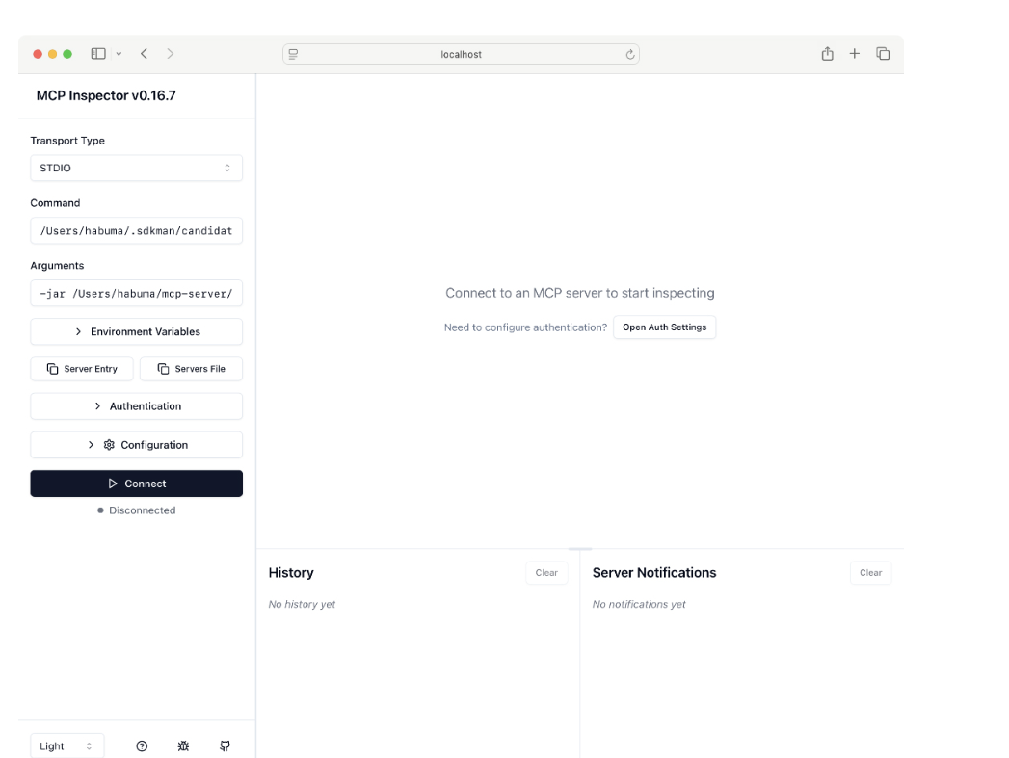

To test the MCP Server, you’ll enter java in the Command field since it is the java command that will be used to run the MCP Server’s executable JAR. Then in the Arguments field, enter -jar, followed by a space and then the absolute path to the executable JAR file. For example, if you’re on a Mac and your username is habuma, it might be something like /Users/habuma/mcp-server/build/libs/mcp-server-0.0.1-SNAPSHOT.jar. Adjust accordingly to match the path on your machine.
Before you press the Connect button to connect the inspector to your MCP Server, there’s one more thing to take care of. Since the MCP Server is using Spring Boot’s support for Docker Compose and the compose.yaml file isn’t packaged in the application’s JAR file at build time, you’ll need to tell Spring where to find it. To do that, expand the Environment Variables button in the inspector and then click the Add Environment Variable button. Add a new environment variable named SPRING_DOCKER_ COMPOSE_FILE and set its value to the path to the compose.yaml file in your project. For example, suppose that your project’s home directory is at /Users/habuma/mcp-server. In that case, set the environment variable’s value to /Users/habuma/mcp-server/ compose.yaml.
Now you’re ready to connect the MCP Inspector to your MCP Server. When you press the Connect button, the right side of the screen should change to show details of your MCP Server. Initially, it should land on the Tools tab because your MCP server doesn’t provide any resources or templates. Click on the List Tools button to see the tools offered by the MCP Server. You should see something like what’s shown in figure 7.6.
Figure 7.6: Viewing MCP Server tools in MCP Inspector

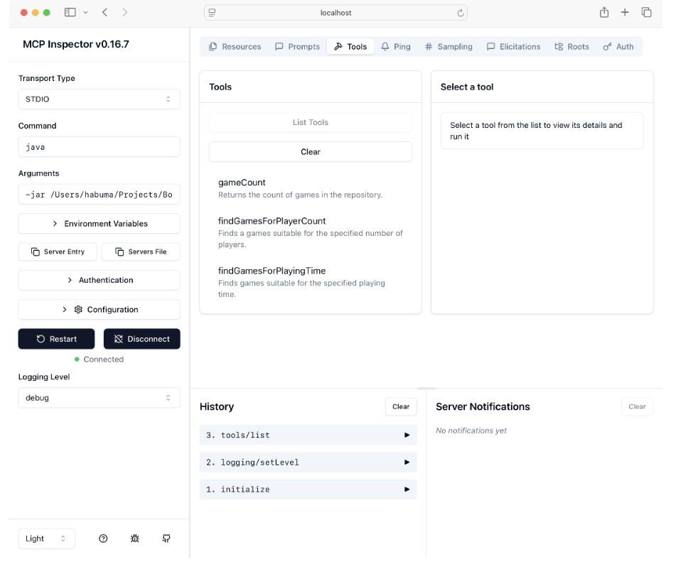

As you can see, the MCP Server offers three tools, one for each of the methods in GameTools (you may need to scroll the list to see them all). If you click on one of the tools, enter any of the required parameters in the form that will appear on the far right, and then click Run Tool, you should see the response from that tool.
Poking at the MCP Server with the inspector is a great way to ensure that the server exposes the tools as you expect. But ultimately, MCP Servers are intended to be invoked by applications at the request of an LLM. Let’s put the MCP Server to work in the context of an AI application, as it is meant to be.

7.3.5 Using the server in a client application
Earlier in this chapter you created a Spring AI application that configured an MCP Client to exercise the Filesystem MCP Server. For purposes of working with the Board Game DB MCP Server, you can either create a new Spring AI application in much the same way, or if you prefer, you can use the original project and just make a few modifications.
The first change you’ll make is to the MCP Client configuration. If you’re using Spring configuration property configuration, your application.yaml file should look something like this:
spring: ai: mcp: client: stdio: connections: boardgamedb: command: ${JAVA_HOME}/bin/java args: - '-jar' - '${MCP_SERVER_PATH}/build/libs/mcp-server-0.0.1-SNAPSHOT.jar'
Note that this snippet assumes that you have JAVA_HOME and MCP_SERVER_PATH environment variables set to point to the installation of Java on your machine and the location of the MCP Server project. Otherwise, you’ll need to provide the complete absolute paths for those things.
Optionally, if you’re using the Claude Desktop configuration to configure the MCP Client, you can use the following JSON:
{ "mcpServers": { "filesystem": { "command": "/Users/habuma/.sdkman/candidates/java/current/bin/java", "args": [ "-jar", "/Users/habuma/Projects/BookProjects/walls10/code/ch07/ ↪boardgamedb-mcp-stdio/mcp-server/build/libs/ ↪mcp-server-0.0.1-SNAPSHOT.jar" ] } } }
In the case of Claude Desktop configuration, you won’t be able to reference environment variables and will have to provide the entire path. Adjust the paths shown here to fit your machine’s setup.
With the server configuration in place, fire up the app and try asking some questions. For example, you might want to find a good game for five players. Here’s what you might get when you ask via the /ask endpoint:
$ http -b :8080/ask \ question="I'm having 4 friends over to play games. What should we play?" { "answer": "You should consider playing 'Ticket to Ride', which is a railway-themed board game where players collect cards to claim railway routes; or 'Carcassonne', a tile-placement game where players build cities, roads, and fields; or '7 Wonders', a card drafting game where players develop civilizations through three ages; or 'Wingspan', a card-driven engine-building game where players attract birds to their wildlife preserves; or 'Flip 7', a fast-paced card game where players try to flip cards to get the highest score while avoiding flipping a duplicate card." }
Or maybe find a game that doesn’t take too long:
$ http -b :8080/ask \ question="We only have about 30 minutes to play a game. What would \ you suggest?" { "answer": "I suggest playing 'Sagrada', which is a dice-drafting game where players create beautiful stained glass windows using colored dice, suitable for 1 to 4 players and has a playing time of around 30 to 45 minutes." }
Outstanding! Not only does your custom MCP Server work, but you also have an application that can suggest games for you based on the number of players and the amount of time it takes to play the game.
Because the MCP Server implements the STDIO transport, the client is responsible for running it, and the communication takes place over standard input and standard output (not unlike the Common Gateway Interface [CGI] from the early days of the internet). In the case of the Filesystem MCP Server you tinkered with in listing 7.2, it was necessary for the MCP Server to run locally with respect to the client so that it could access the filesystem of the client machine. But this isn’t necessary for the Board Game DB MCP Server, and it might be nice to have it running independently of the client. Let’s see how to take advantage of the HTTP+SSE transport in our MCP Server.

7.4 Working with the HTTP+SSE transport
The STDIO transport is a commonly used way to integrate an MCP Server into an application. It’s relatively simple in that it doesn’t require a separate deployable application. The client application starts the MCP Server as a sort of sidecar application, and communication is performed over standard input and output, as if the client is typing its requests to the server.
However, when the STDIO transport is used, the client and the server are essentially coupled at deployment time. Although they may be running adjacent to each other in separate processes, the client is still responsible for starting the server. As you’ve seen, because all communication takes place over standard input and output, it limits how logging can be done in the server. What’s more, debugging the server as it is invoked by the client is incredibly difficult.
In contrast, when the HTTP+SSE transport is used, a more conventional client and server arrangement is employed. The client and server can be deployed, managed, and scaled independently of each other. Communication is conducted over HTTP, so the server can be running anywhere that is reachable from the client, even on a separate host machine. And the server can emit logging messages in whatever way is best, without concern for messing up MCP communication.

STREAMABLE HTTP VS. HTTP+SSE
The HTTP+SSE transport was defined in the November 2024 version of the MCP specification. Since then, it has been deprecated and all but removed from the versions of the specification that have followed. In its place is a new Streamable HTTP transport.
At the time of this writing, neither Spring AI nor the Java MCP SDK has released a version that supports the Streamable HTTP specification. Therefore, due to the lack of support for Streamable HTTP in the current version of Spring AI, this section will cover HTTP+SSE and will not discuss Streamable HTTP further.
The first milestone release of Spring AI 1.1.0 includes support for Streamable HTTP. It appears that enabling the Streamable HTTP transport in an MCP Server is a simple matter of setting a configuration property. The code that implements the server is the same whether its Streamable HTTP or HTTP+SSE.
Using the HTTP+SSE protocol in Spring AI isn’t much different from using the STDIO transport. In fact, you won’t need to change any code other than setting a few properties and swapping out a build dependency. Let’s see how to do that, starting with enabling HTTP+SSE in our MCP Server.

7.4.1 Configuring an HTTP+SSE in the MCP Server
Choosing to deploy your MCP Server using the HTTP+SSE transport is a simple matter of using a different starter dependency. As a reminder, when you chose the Model Context Protocol Server starter from the Initializr when creating the original MCP Server, the build ended up with the following dependency:
implementation 'org.springframework.ai:spring-ai-autoconfigure-mcp-server'
To turn the MCP Server into one that communicates over HTTP+SSE, you’ll replace that starter dependency with one of two separate dependencies. If you’d prefer a nonreactive implementation (or don’t care either way), you can add the HTTP+SSE transport dependency that’s based on Spring MVC:
implementation 'org.springframework.ai:spring-ai-starter-mcp-server-webmvc'
This implementation will serve requests over an embedded Tomcat server and is implemented with Spring’s tried-and-true MVC web framework.
You can also add these starters from the Spring Intiializr by selecting the Model Context Protocol Server dependency. The Initializr will decide which one to add to the build based on whether you have also chosen the Spring Web or Spring Reactive Web starter.
If you’d prefer that the MCP Server’s tools be served on a reactive foundation, you can add the Spring WebFlux implementation to the build:
implementation 'org.springframework.ai:spring-ai-starter-mcp-server-webflux'
If you choose the WebFlux HTTP+SSE transport dependency, the MCP Server’s requests will be served on a Netty server. The key benefit here is a more efficient use of a few request-handling threads, as compared to pulling request threads from a pool.
With the new starter dependency in place, the underlying autoconfiguration will take care of everything needed to make this MCP Server communicate over HTTP+SSE transport. There’s not much else required.
However, there is one small thing you must do before you can put the MCP Server into service. When the MCP Server used the STDIO transport, you disabled the Spring Boot banner and turned off logging. With HTTP+SSE you should turn all of that back on by removing those properties from application.properties. And, although it’s completely optional, you can choose to set server.port to 3001 by adding this line:
server.port=3001
The choice of port 3001 is convenient because it’s the port that the MCP Inspector defaults to when working with HTTP+SSE servers.
Now let’s fire up the MCP Server and try it out with MCP Inspector.

7.4.2 Inspecting the MCP Server
The client application is no longer responsible for starting the MCP Server for you; you’ll need to run it yourself. Using Gradle, you can do this with the Spring Boot build plugin:
$ ./gradle bootRun
After a few moments, the application should start up and be listening for HTTP requests on port 3001. If you turned logging back on, you’ll be able to confirm this in the logs.
At this point, the MCP Server is ready to be used by any client configured with an HTTP+SSE client transport that points to it. In a moment, you’ll see how to modify the client application to do this. First, let’s use the MCP Inspector to verify that the server is operational.
Assuming the MCP Inspector is still running from earlier, open it in your web browser by navigating to http://localhost:5173. On the left side of the MCP Inspector, select SSE as the transport. You’ll notice that the URL is already set to http://localhost:3001/sse. If you chose port 3001 when configuring the HTTP+SSE transport in the previous section, this is precisely the URL you need. Before you click the Connect button, compare what you see with figure 7.7 to make sure you’ve made the right selections.
Figure 7.7: Setting up the MCP Inspector to inspect the HTTP+SSE-enabled MCP Server

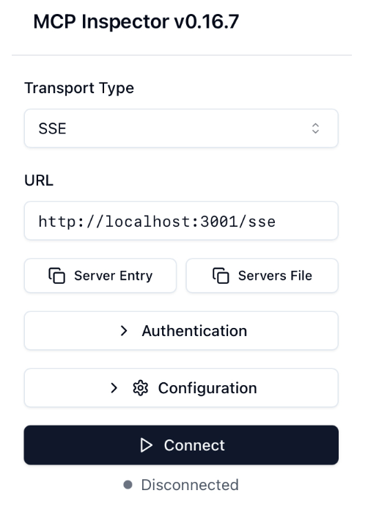

If everything is right, when you click Connect, the right side of the inspector will be enabled. Click the List Tools button to see all of the tools exposed by the MCP Server. Then, you can select any of the tools, provide the necessary parameters, and click Run Tool to invoke the tool. Figure 7.8 shows what you might see if you choose to invoke the findGamesForPlayerCount tool with 5 as the number of players.
Figure 7.8: Invoking the findGamesForPlayerCount tool

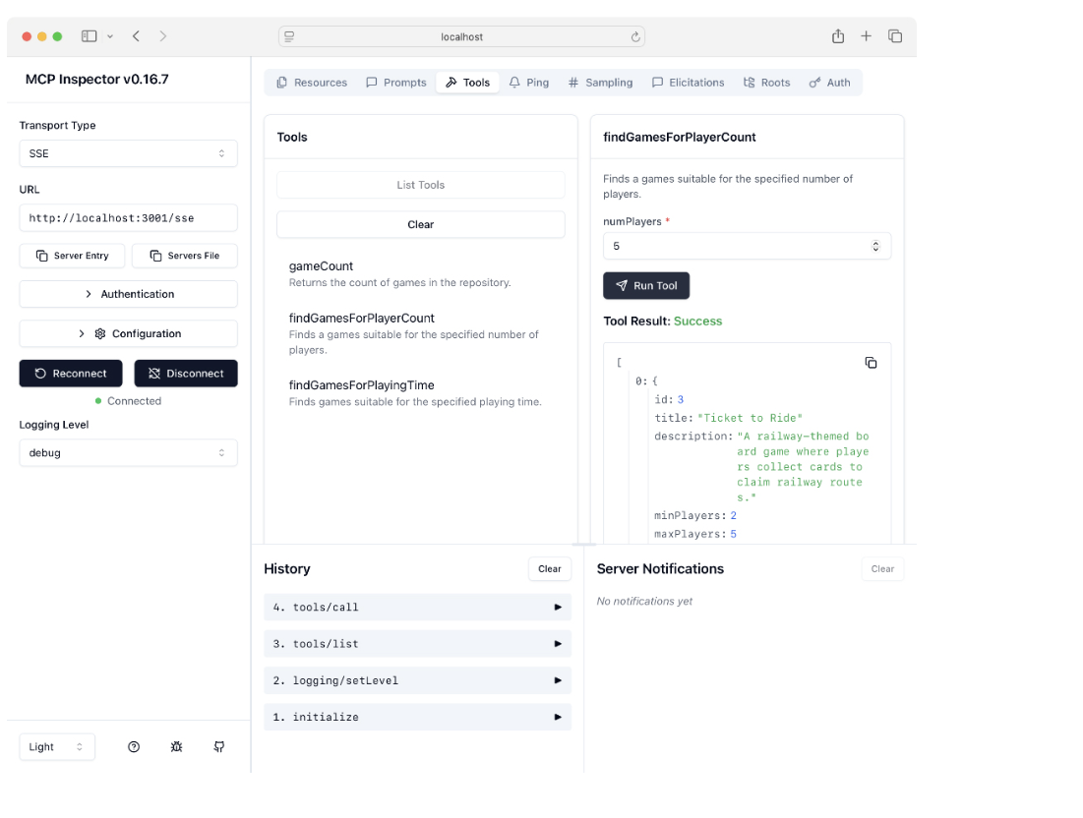
So far, so good. The MCP Inspector had no trouble connecting to the MCP Server and invoking a tool. Now, let’s put the MCP Server to work from the client application.

7.4.3 Configuring the client to use an HTTP+SSE server
Configuring an MCP Client to use HTTP+SSE is almost as easy as it was to convert the MCP Server from STDIO to HTTP+SSE. In fact, you don’t even need to change the MCP Client starter dependency in the build if you’re fine with using the standard client. But if you want to use a reactive client, you can optionally replace the MCP Client starter dependency with the following starter:
implementation 'org.springframework.ai:spring-ai-starter-mcp-server-webflux'
Either way, you’ll need to edit the MCP Client configuration. Unlike the STDIO transport, you can’t configure the client using Claude Desktop configuration; instead, you must configure it using Spring configuration properties. But with HTTP+SSE, the configuration is much simpler, only requiring a URL to the MCP Server.
For example, if your MCP Server is running on localhost and listening on port 3001, the following entry in your application.yml file will configure the MCP Client to connect to the server:
spring: ai: mcp: client: sse: connections: boardgamedb: url: http://localhost:3001
Here, the root configuration property is spring.ai.mcp.client.sse.connections. Under that, the name boardgamedb is the name of the MCP Client connection (and can be anything you want it to be). Finally, the url property specifies the URL to the MCP Server.
Now you’re ready to start up the client application and try out the newly configured HTTP+SSE transport. Make sure that the server is running and then start the client. Once it starts up, you can ask it a question, such as what might be a good game for 10 players:
$ http :8080/ask \ question="What would be a good game for 10 players?" -b { "answer": "A good game for 10 players is Flip 7. It is a fast-paced card game where players try to flip cards to get the highest score while avoiding flipping a duplicate card. The game accommodates between 3 to 13 players and has a playing time of 15 to 30 minutes." }
Awesome! Everything seems to work, and you are now able to ask questions about what games are good for a given number of players. But more importantly, you’re able to develop, evolve, deploy, and manage the MCP Server independently from the client.
Although tools are the most talked-about feature of MCP, it’s not all that MCP has to offer. Let’s see how to expose prompts and resources from an MCP Server.

7.5 Exposing prompts and resources
In the Board Game Buddy API, the user is able to specify the bulk of a prompt in free-form text. Being able to type and ask whatever you want, however you want to ask it, is fundamental to the chat experience. But imagine that you’re defining a more traditional user interface with lists, buttons, checkboxes, and other widgets, which, under the covers, creates a prompt to send to an LLM for processing. Such a UI would set very defined ways for the user to interact with an application while still wielding the awesome power of generative AI.
That’s what prompts and resources exposed by an MCP Server are good for. Rather than encode the prompt creation in the application itself, the MCP Server can provide one or more predefined prompts, which the application can fill in with details from the UI before sending the prompt to the LLM. And resources can provide the application with textual and/or binary data related to the domain of the MCP Server.
Spring AI’s MCP module enables you to declare prompts and resources in Spring configuration in @Bean-annotated methods. Let’s see how to declare such beans to add prompts and resources to your MCP Server.

7.5.1 Declaring prompt and resource-exposing beans
The key to exposing prompts in a Spring AI-based MCP Server is to define a bean that is a list of prompt specifications. More specifically, this bean will either be one of the two following types:
- List<McpServerFeatures.SyncPromptSpecification>
- List<McpServerFeatures.AsyncPromptSpecification>
The choice is up to you. If you’re working with reactive types from Project Reactor, you’ll want to choose the latter. Otherwise, it’s just as good to choose the former. The following listing shows how to add two prompts to your MCP Server.

Listing 7.5 Exposing prompts using Spring configuration
@Bean public List<McpServerFeatures.SyncPromptSpecification> gamePrompts() { var playerCountPrompt = new McpSchema.Prompt( #1 "gamesForPlayerCount", "A prompt to find games for a specific number of players", List.of(new McpSchema.PromptArgument( "playerCount", "The number of players", true))); var playerCountPromptSpec = new McpServerFeatures.SyncPromptSpecification( #2 playerCountPrompt, (exchange, getPromptRequest) -> { String playerCount = (String) getPromptRequest.arguments().get("playerCount"); #3 var userMessage = new McpSchema.PromptMessage( McpSchema.Role.USER, new McpSchema.TextContent( String.format("Find games for %s players", playerCount) )); return new McpSchema.GetPromptResult( String.format("A prompt to find games for %s players", playerCount), List.of(userMessage)); }); var playingTimePrompt = new McpSchema.Prompt( #4 "gamesForPlayingTime", "A prompt to find games for given amount of time", List.of(new McpSchema.PromptArgument( "timeInMinutes", "The time in minutes", true))); var playingTimePromptSpec = new McpServerFeatures.SyncPromptSpecification( playingTimePrompt, (exchange, getPromptRequest) -> { #5 String timeInMinutes = (String) getPromptRequest.arguments().get("timeInMinutes"); #6 var userMessage = new McpSchema.PromptMessage( McpSchema.Role.USER, new McpSchema.TextContent( String.format("Find games to play in %s minutes", timeInMinutes) )); return new McpSchema.GetPromptResult( String.format("A prompt to find games to play in %s minutes", timeInMinutes), List.of(userMessage)); }); return List.of(playerCountPromptSpec, playingTimePromptSpec); #7 }

#1 Defines prompts
#2 Defines prompt specs
#3 Gets prompt arguments
#4 Defines prompts
#5 Defines prompt specs
#6 Gets prompt arguments
#7 Returns list of prompt specs

There’s a lot going on in listing 7.5, but it’s easier to think about if you realize that the first several lines of the method that define the first prompt specification are repeated to define another prompt specification. And each of those blocks of code can be split into two distinct actions:
- Define a prompt.
- Define a prompt specification.
The method ends by returning a list of the prompt specifications.
The first few lines of the method define a prompt that can be used to ask for games suitable for a specific number of players. The prompt definition is primarily meta-information about the prompt, including the name of the prompt, a description, and a list of arguments that can be used to fill out the prompt’s placeholders.
The prompt specification is constructed with the prompt definition defined earlier, along with a lambda that sets up the prompt text. This lambda starts by extracting the player count that the client sends from the prompt arguments. It uses this value to create a complete problem that asks for games for that number of players. Finally, the lambda returns a prompt result that includes a description for the generated prompt as well as the user message of the prompt.
This whole process is repeated to create a prompt and a prompt specification to ask for games that can be played within a given number of minutes. Aside from the specific details—the prompt text, description, and argument—this code is the same as for the first prompt and prompt specification. Finally, the method returns both prompt specifications in a list.
To see these prompts in action, fire up the MCP Inspector, connect to the MCP Server, and navigate to the Prompts tab. When you click List Prompts, you should see the two prompts that you defined. And when you click on one of the prompts and fill in the argument, you’ll see the generated prompt below the Get Prompt button. Figure 7.9 shows how this might look.
Figure 7.9: Viewing prompts in the MCP Inspector

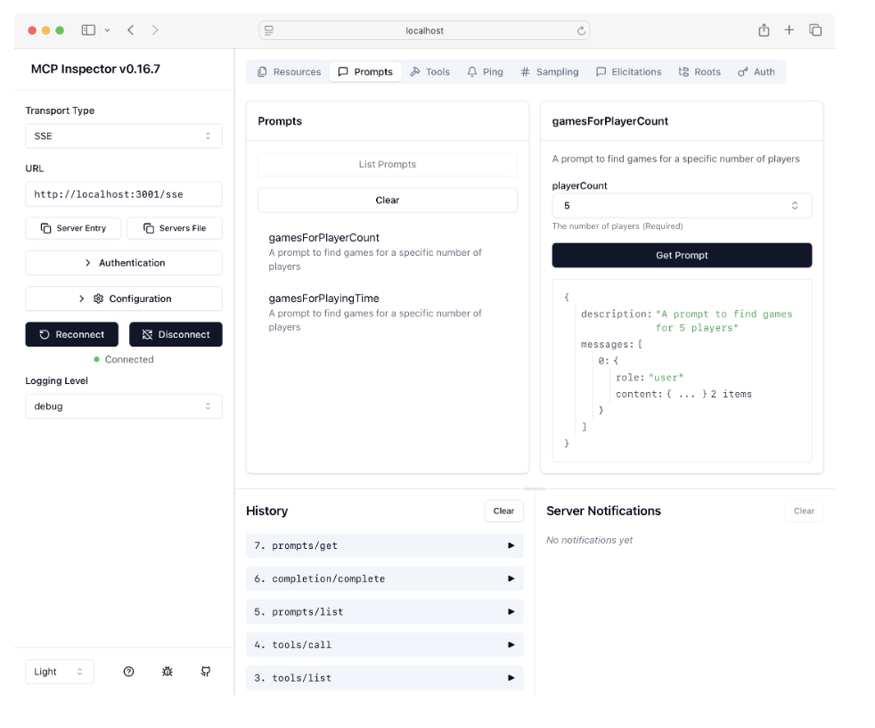

Now, let’s see how to add a resource to the MCP Server. For the sake of the example, suppose that you want to return a resource to the client that is a list of all of the games in the repository. The GameRepository that you defined earlier can help with this if you add a new method:
@Query("SELECT title FROM game ORDER BY title") List<String> findAllTitles();
With this simple method declared in the GameRepository interface, you can now define the resource. Declaring one or more resources is much the same as defining prompts, except that the bean method returns a list of resource specifications. The following listing shows how to do this.

Listing 7.6 Exposing a resource using Spring configuration
@Bean public List<McpServerFeatures.SyncResourceSpecification> gameResources(GameRepository gameRepository) { List<McpSchema.Role> audience = List.of(McpSchema.Role.USER); McpSchema.Annotations annotations = new McpSchema.Annotations(audience, 1.0); var gameListResource = new McpSchema.Resource( #1 "games://game-list", "Game List", "A list of games available in the repository", "text/plain", annotations ); var gameTitles = gameRepository.findAllTitles(); #2 var gameListText = new StringBuilder(); for (String title : gameTitles) { gameListText.append("- ").append(title).append("\n"); } var gameListResourceSpec = new McpServerFeatures.SyncResourceSpecification( #3 gameListResource, (exchange, request) -> { return new McpSchema.ReadResourceResult( List.of(new McpSchema.TextResourceContents( request.uri(), "text/plain", gameListText.toString()))); }); return List.of(gameListResourceSpec); #4 }

#1 Defines the resource
#2 Constructs a list of games
#3 Defines the resource specification
#4 Returns a list of specs

Here, instead of defining a prompt and prompt specification, this method defines a resource and resource specification. What’s somewhat different from defining a prompt is that before the specification is defined, the list of games is pulled from the repository and used to construct a String that will be the text of the resource.
Let’s see how this resource looks in the MCP Inspector. Open the inspector, connect to the MCP Server, and navigate to the Resources tab. Click List Resources, and you should see the Game List resource. After clicking on the resource, you should see the text, including a list of games, in the box at the far right. Figure 7.10 shows how this might look.
Figure 7.10: Viewing resources in the MCP Inspector

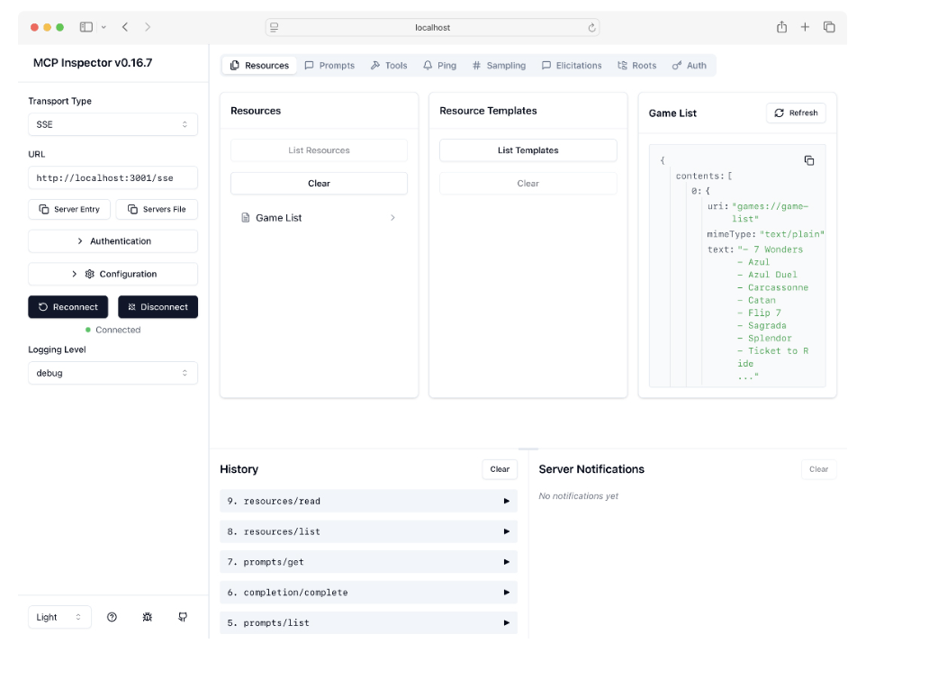
Now you have a couple of prompts and a resource exposed in your MCP Server. But there’s no denying that the code involved to get there is quite lengthy. Fortunately, there’s a community project that enables annotation-driven declaration of prompts and resources. Let’s have a look.

7.5.2 Applying annotation-driven prompts and resources
Recognizing that Spring AI itself may not be able to maintain all of the functionality that the community wants, the Spring AI team has set up a repository of community-contributed projects related to Spring AI (https://github.com/spring-ai-community). As these community-provided projects evolve and mature, they may someday graduate to become part of the main Spring AI project. But until then, they are ready to use in your Spring AI projects, albeit without official Spring AI support.
One such project is the mcp-annotations project. This project simplifies the process of defining prompts and resources with the help of annotations. This project is considered to be an “incubating” project, meaning that someday (even perhaps by the time you are reading this), it could be a component of Spring AI itself. Until then, you’ll need to add the following dependency to your MCP Server’s build to use it:
implementation 'com.logaritex.mcp:spring-ai-mcp-annotations:0.1.0'
Instead of declaring prompts and resources in @Bean-annotated methods, you’ll define them as methods in a service class. For example, consider how PromptProvider in listing 7.7 defines the same two prompts you defined earlier.

Listing 7.7 Declaring prompts with annotations
package com.example.mcpserver; import com.logaritex.mcp.annotation.McpArg; import com.logaritex.mcp.annotation.McpPrompt; import io.modelcontextprotocol.spec.McpSchema; import org.springframework.stereotype.Service; import java.util.List; @Service public class PromptProvider { @McpPrompt( name = "gamesForPlayerCount", description = "A prompt to find games for a specific number of players") #1 public McpSchema.GetPromptResult gamesForPlayerCount( @McpArg(name = "playerCount", description = "The number of players", required = true) Integer playerCount) { #2 var userMessage = new McpSchema.PromptMessage( #3 McpSchema.Role.USER, new McpSchema.TextContent( String.format("Find games for %s players", playerCount) )); return new McpSchema.GetPromptResult( String.format("A prompt to find games for %s players", playerCount), List.of(userMessage)); #4 } @McpPrompt( name = "gamesForPlayingTime", description = "A prompt to find games for a specific number of players") #1 public McpSchema.GetPromptResult gamesForPlayingTime( @McpArg(name = "timeInMinutes", description = "The time in minutes", required = true) Integer timeInMinutes) { #5 var userMessage = new McpSchema.PromptMessage( #6 McpSchema.Role.USER, new McpSchema.TextContent( String.format("Find games to play in %s minutes", timeInMinutes) )); return new McpSchema.GetPromptResult( String.format("A prompt to find games to play in %s minutes", timeInMinutes), List.of(userMessage)); #7 } }

#1 Defines prompt meta information
#2 Accepts arguments
#3 Defines user message
#4 Returns prompt result
#5 Accepts arguments
#6 Defines user message
#7 Returns prompt result

The code here isn’t much shorter than what you saw in listing 7.5. But in many ways, it is easier to read and understand. In fact, it’s not all too different from how a controller is defined in Spring MVC with annotations.
The @McpPrompt annotation on each method is analogous to Spring MVC’s @RequestMapping annotation (and related HTTP method-specific annotations). It defines the meta information for each prompt, including the prompt’s name and description, and tells Spring that this method should be called when the prompt is requested by the client. Each method also accepts an argument annotated with @McpArg, an annotation that can be compared to Spring MVC’s @RequestParam or @PathVariable annotations to designate inputs to the prompt.
In the body of the method, a PromptMessage is created that carries the fully constructed prompt text. Finally, the method concludes by returning a description for the prompt along with a list of messages (in these cases, the single user message).
Once you’ve defined the annotated prompt methods, you’ll need to declare a bean that exposes them as prompts in the MCP’s interface:
@Bean List<McpServerFeatures.SyncPromptSpecification> myPrompts( PromptProvider promptProvider) { return SpringAiMcpAnnotationProvider .createSyncPromptSpecifications(List.of(promptProvider)); }
This method returns either a list of SyncPromptSpecification or AsyncPromptSpecification, the same as the bean you defined in listing 7.5. But here, instead of several lengthy and tedious lines of code, it simply creates the list using a utility method from SpringAiMcpAnnotationProvider, passing in a list of one or more service beans that have @McpPrompt-annotated methods.
Resources can also be defined with annotations in much the same way as prompts. Start by writing a service class with one or more @McpResource-annotated methods. Listing 7.8 shows ResourceProvider, a service class that defines the same resource as you defined earlier in listing 7.6

Listing 7.8 Declaring resources with annotations
package com.example.mcpserver; import com.logaritex.mcp.annotation.McpResource; import io.modelcontextprotocol.spec.McpSchema; import org.springframework.stereotype.Service; import java.util.List; @Service public class ResourceProvider { private final GameRepository gameRepository; public ResourceProvider(GameRepository gameRepository) { #1 this.gameRepository = gameRepository; } @McpResource(uri = "games://game-list", name = "Game List", description = "A list of games available in the repository") public McpSchema.ReadResourceResult gameListResource (McpSchema.ReadResourceRequest request) { var gameTitles = gameRepository.findAllTitles(); #2 var gameListText = new StringBuilder(); for (String title : gameTitles) { gameListText.append("- ").append(title).append("\n"); } return new McpSchema.ReadResourceResult( #3 List.of(new McpSchema.TextResourceContents( request.uri(), "text/plain", gameListText.toString()))); } }

#1 Injects repository
#2 Constructs a list of games
#3 Defines the resource

The @McpResource method applied to the gameListResource() method specifies the meta information for the resource. This includes the name of the resource, a description, and the resource’s URI. The annotation also tells Spring to call this method when the game list resource is asked for.
The first thing that the gameListResource() method does is use the injected GameRepository to get a list of game titles from the database. It uses this list to create a String that will be the text of the resource.
Finally, the method returns a list of resource content items. In this case, there’s only one, a TextResourceContents that carries the resource’s URI, mime type, and the textual list of games.
It’s worth noting that if you want to define a resource from binary data, such as an image or sound file, you would create a BlobResourceContents instead of a TextResourceContents. The arguments to BlobResourceContents are the same as for TextResourceContents except that instead of passing text content to the third parameter, you pass in a String containing Base64-encoded binary content.
As with prompts, you’ll need to declare a @Bean to expose the @McpResource-annotated methods as resources:
@Bean public List<McpServerFeatures.SyncResourceSpecification> myResources( ResourceProvider resourceProvider) { return SpringAiMcpAnnotationProvider .createSyncResourceSpecifications(List.of(resourceProvider)); }
Again, this method is much simpler than the one in listing 7.6. It simply uses a utility method from SpringAiMcpAnnotationProvider to turn the @McpResource-annotated methods from ResourceProvider into a list of resource specifications.
If you start up the MCP Server and point the MCP Inspector at it, you’ll find the same prompts and resources as before. They should be identical in every way, except that they were defined with annotations.

Summary
- Model Context Protocol (MCP) is a specification established by Anthropic to standardize how to create reusable modules of tools, prompts, and resources for generative AI.
- Spring AI also provides both client- and server-side support for working with MCP.
- There are already over 1,000 MCP Servers available publicly that you can use in a Spring AI application to enable functionality beyond what an LLM is capable of on its own.
- Spring AI’s MCP supports both STDIO and HTTP+SEE transports for communication between a client and server.

Chapter 8: Generating With Voice and Pictures

This Chapter Covers
- Transcribing audio to text
- Generating audio from text
- Images as prompt context
- Generating images
Throughout history, humans have developed various methods of communication with one another. Perhaps the oldest form of human communication is voice-based, where people speak and listen to each other. Text-based communication has taken many forms, from early hieroglyphs and the origin of the alphabet by the Phoenicians to letters, emails, and SMS text messages. And sometimes an image can, indeed, paint a thousand words, meaning that works of art and photographs make for a powerful form of communication that text and voice cannot compete with.
Thus far, our project has focused on text-based interaction with the Board Game Buddy application. The questions asked about games are sent in as text, and the answers received are just more text. Since it will be humans who will ultimately be interacting with Board Game Buddy, it makes sense to offer more human-style communication with the application.
In this chapter, we’re going to use Spring AI to break away from text-based interaction, enabling speech-based and image-based communication in our application, both as input and output. Let’s start by seeing how Spring AI can enable us to add voice to an application.

8.1 Working with voice
Voice interaction with computers has long lived only in the realm of science fiction, from the computer on the Enterprise on Star Trek to Iron Man’s Jarvis. In recent years, voice interactions have become increasingly mainstream as assistants like Siri and Alexa have enabled hands-free, voice-driven user experiences. Voice offers a rich and natural means of interaction that is often more efficient and clear than typing, tapping, or clicking on a traditional user interface. After all, voice itself is one of the oldest forms of communication, predating computers by many millennia.
Being able to “listen” is an incredible ability that generative AI can activate in your Spring applications. By listening to an audio file and producing a textual representation of what it heard, your application can more naturally interact with users. Conversely, generating spoken audio from text enables your application to speak with your users just as naturally as they speak to your application.
Let’s see how to add speech capabilities to the Board Game Buddy application, starting with the ability to answer questions asked with voice.

8.1.1 Transcribing speech
Transcription is the process by which text is produced from spoken audio. Spring AI supports transcription through the TranscriptionModel interface, for which there are currently only two implementations: OpenAiAudioTranscriptionModel and AzureOpenAiAudioTranscriptionModel. While this limits you to working with only OpenAI or Azure’s OpenAI offering, that works out fine for the Board Game Buddy application, as we’ve been working with OpenAI all along anyway. You won’t even need to add any additional dependencies in your build to get started with transcription.
On the other hand, if you’ve chosen an API other than OpenAI, then you’re not entirely out of luck. You’ll need to
- Add the OpenAI starter dependency to your build as described in chapter 1.
- Specify the OpenAI API Key in your application configuration, which was also covered in chapter 1.
- Disable autoconfiguration for Open AI chat and embedding support so that it doesn’t clash with autoconfiguration for your chosen API.
To disable autoconfiguration for Open AI chat, add the following entries to your application.properties file:
spring.ai.openai.chat.enabled=false spring.ai.openai.embedding.enabled=false
These two properties will disable chat and embedding autoconfiguration for Open AI, but will leave voice-related auto-configuration enabled.
Now let’s add voice capabilities to Board Game Buddy. For that, you’ll create a service bean that implements a custom VoiceService interface. Create the following VoiceService interface in the com.example.boardgamebuddy package:
package com.example.boardgamebuddy; import org.springframework.core.io.Resource; public interface VoiceService { String transcribe(Resource audioFileResource); Resource textToSpeech(String text); }
The VoiceService interface defines the full voice experience for Board Game Buddy, handling both transcription of voice to text and the production of voice audio from text. The transcribe() method handles the job of transcribing an audio file (such as an MP3 or WAV file) to text. It accepts the audio file as a Resource, producing a String that contains the transcription text. Meanwhile, the textToSpeech() method flips things around and produces a Resource, which is an audio file containing the spoken text from the String parameter.
Now you need an implementation of VoiceService. Let’s first focus on implementing the transcribe() method. We’ll leave the textToSpeech() method minimally implemented for now, saving that for the next section. The following listing shows OpenAiVoiceService, the initial implementation of our VoiceService interface.

Listing 8.1 Implementing voice transcription
package com.example.boardgamebuddy; import org.springframework.ai.openai.OpenAiAudioTranscriptionModel; import org.springframework.ai.openai.audio.speech.SpeechModel; import org.springframework.core.io.ByteArrayResource; import org.springframework.core.io.Resource; import org.springframework.stereotype.Service; @Service public class OpenAiVoiceService implements VoiceService { private final OpenAiAudioTranscriptionModel transcriptionModel; public OpenAiVoiceService( OpenAiAudioTranscriptionModel transcriptionModel) { this.transcriptionModel = transcriptionModel; #1 } @Override public String transcribe(Resource audioFileResource) { return transcriptionModel.call(audioFileResource); #2 } @Override public Resource textToSpeech(String text) { throw new UnsupportedOperationException("Not implemented yet"); } }

#1 Injects transcription model
#2 Sends text for transcription

As you can see, OpenAiVoiceService is annotated with @Service, so it will be automatically discovered and created as a bean in the Spring application context. When that happens, OpenAiVoiceService will be injected with an OpenAiAudioTranscriptionModel via the constructor. Spring AI’s auto-configuration for OpenAI will have created that OpenAiAudioTranscriptionModel. But if you are using Azure’s OpenAI offering, you’ll need to inject an AzureOpenAiAudioTranscriptionModel instead.

NOTE
That last couple of sentences will no longer be required if https://mng.bz/xZ07 is applied.
The transcription takes place in the transcribe() method. Passing in the given Resource to the transcription model’s call() method and returning the String returned from call() couldn’t be any simpler. Under the covers, the audio file carried in the Resource is sent to OpenAI’s (or Azure OpenAI’s) transcription API to do the heavy lifting.
Having implemented the AudioService interface, you need to inject it into AskController.

Listing 8.2 Injecting AudioService into the AskController
package com.example.boardgamebuddy; import org.springframework.core.io.Resource; import org.springframework.web.bind.annotation.PostMapping; import org.springframework.web.bind.annotation.RequestBody; import org.springframework.web.bind.annotation.RequestHeader; import org.springframework.web.bind.annotation.RequestParam; import org.springframework.web.bind.annotation.RestController; import org.springframework.web.multipart.MultipartFile; @RestController public class AskController { private final BoardGameService boardGameService; private final VoiceService voiceService; public AskController(BoardGameService boardGameService, VoiceService voiceService) { #1 this.boardGameService = boardGameService; this.voiceService = voiceService; } // ... }

#1 Injects AudioService

Then put it to work to transcribe audio as the new audioAsk() method.

Listing 8.3 Sending a transcribed question to the askQuestion() method
@PostMapping(path="/audioAsk", produces = "application/json") #1 public Answer audioAsk( @RequestHeader(name="X_AI_CONVERSATION_ID", defaultValue = "default") String conversationId, @RequestParam("audio") MultipartFile audioBlob, #2 @RequestParam("gameTitle") String gameTitle) { #3 var transcription = voiceService.transcribe(audioBlob.getResource()); var transcribedQuestion = new Question(gameTitle, transcription); return boardGameService.askQuestion(transcribedQuestion, conversationId); }

#1 Handles /audioAsk
#2 Receives MultipartFile
#3 Receives gameTitle

You’ll notice that this new audioAsk() method is quite similar to the ask() method that we’ve been working with for several chapters. But it does differ in a few significant ways:
- It handles POST requests for /audioAsk instead of /ask.
- Instead of receiving a Question in the request body, it is given a MultipartFile, which is the audio file (that presumably contains the question in spoken form).
- Because it isn’t given a Question, it also receives the game title as a String parameter to establish which game the question pertains to.
Inside the audioAsk() method, a Resource is obtained from the audioBlob parameter and passed to the transcribe() method of the AudioService. The transcribed text that is returned is then used, along with the title of the game, to create a Question object. Finally, the Question is passed to the askQuestion() method of the BoardGameService to get the answer, which is then returned as an Answer object.
Presumably, some frontend application would record the user asking a question and submit it to the API. But since creating such an application is well outside of the scope of this book, you’ll need to create an audio file using whatever audio recording tools are at your disposal. This includes tools such as Audacity (https://www.audacityteam.org/), Windows Voice Recorder, or QuickTime. Whatever tool you choose, just be sure that you can save the audio as MP3, MP4, MPEG, MPGA, M4A, WAV, or WEBM, as those are the only audio formats supported by Open AI.

READY-MADE TEST AUDIO FILES
To make things a little easier for you, I’ve placed a handful of MP3 files in the test-audio directory of the Board Game Buddy project for this chapter. These files provide audio for asking some questions related to the game Burger Battle, including
- How many cards are dealt to each player?
- What is the Graveyard?
- What is Pickle Plague?
- Does Burger Force Field protect against Burgerpocalypse?
Feel free to use those audio files or create your own as you test the transcription features added to the project.
With an audio file handy, fire up the application and submit a request to the /audioAsk endpoint. Let’s say that you’ve created an audio file in which you ask, “What is the Graveyard?” Using HTTPie, you can submit the audio file and the game title to the /audioAsk endpoint like this:
$ http -f POST :8080/audioAsk \ audio@'test-audio/what_is_graveyard.mp3;type=audio/mp3' \ gameTitle="Burger Battle"
If everything works correctly, you’ll soon receive a response something like this:
{ "answer": "The Graveyard is where destroyed Battle Cards and ingredients are tossed during the game.", "game": "Burger Battle" }
Effectively, you have now enabled the Board Game Buddy API to “listen” to a user. But listening is only one side of the voice application coin. The other side involves enabling the application to produce a voice response. Let’s see how to use Spring AI to generate speech in the Board Game Buddy API.

8.1.2 Generating speech from text
Whereas OpenAiAudioTranscriptionModel is the Spring AI component that converts speech to text, SpeechModel is the component that converts text to speech. You’ll use SpeechModel to implement the textToSpeech() method from VoiceService that was left minimally implemented in the previous section. To start, inject SpeechModel into OpenAiVoiceService through its constructor:
package com.example.boardgamebuddy; import org.springframework.ai.openai.OpenAiAudioTranscriptionModel; import org.springframework.ai.openai.audio.speech.SpeechModel; import org.springframework.core.io.ByteArrayResource; import org.springframework.core.io.Resource; import org.springframework.stereotype.Service; @Service public class OpenAiVoiceService implements VoiceService { private final OpenAiAudioTranscriptionModel transcriptionModel; private final SpeechModel speechModel; public OpenAiVoiceService( OpenAiAudioTranscriptionModel transcriptionModel, SpeechModel speechModel) { this.transcriptionModel = transcriptionModel; this.speechModel = speechModel; } ... }
Now you can use it to replace the original implementation of textToSpeech() with one that produces audio output instead of throwing an exception. The following implementation should do the trick:
@Override public Resource textToSpeech(String text) { var speechBytes = speechModel.call(text); return new ByteArrayResource(speechBytes); }
Believe it or not, that’s all there is to it! The String that is passed into the textToSpeech() method is passed into SpeechModel’s call() method. In return, you get an array of byte that are the bytes that make up an audio file (which is MP3 by default). Finally, to satisfy the return type of Resource, a ByteArrayResource is created from the byte array and returned from textToSpeech().
Now create a new handler method in AskController that puts the new textToSpeech() method to work. The following audioAskAudioResponse() method takes inspiration from the audioAsk() method created before but uses textToSpeech() to return audio:
@PostMapping(path="/audioAsk", produces = "audio/mpeg") public Resource audioAskAudioResponse( @RequestHeader(name="X_AI_CONVERSATION_ID", defaultValue = "default") String conversationId, @RequestParam("audio") MultipartFile blob, @RequestParam("gameTitle") String game) { var transcription = voiceService.transcribe(blob.getResource()); var transcribedQuestion = new Question(game, transcription); var answer = boardGameService.askQuestion( transcribedQuestion, conversationId); return voiceService.textToSpeech(answer.answer()); }
The key thing that separates audioAskAudioResponse() from audioAsk() is that after receiving an Answer from the BoardGameService, it passes the text from the Answer to textToSpeech(). It then returns the Resource to the client. As a result, the client will receive bytes that make up an audio file.
Notice that the path given in @PostMapping is the same as before: /audioAsk. But the produces attribute is set to audio/mpeg, which ensures that this is the handler method called when the incoming request has an Accept header of audio/mpeg.
As with transcription, writing a client application that plays the audio to the user is well outside the scope of this book. But you can still try it out using HTTPie by specifying the Accept header and redirecting the output to an MP3 file like this:
$ http -f POST :8080/audioAsk \ audio@'test-audio/what_is_graveyard.mp3;type=audio/mp3' \ gameTitle="Burger Battle" accept:audio/mpeg > answer.mp3
After submitting the request through HTTPie, you won’t see the response in your terminal. But you should find a file named answer.mp3 in the current directory. Open that file in your favorite audio file player, and you should hear the answer to the question, “What is the Graveyard?”

SETTING TEXT-TO-SPEECH OPTIONS
Although working with the SpeechModel’s call() method is very straightforward, you could have written it a little differently:
public Resource textToSpeech(String text) { SpeechPrompt speechPrompt = new SpeechPrompt(text); SpeechResponse response = speechModel.call(speechPrompt); byte[] speechBytes = response.getResult().getOutput(); return new ByteArrayResource(speechBytes); }
Here, instead of simply passing a String to call(), you first create a SpeechPrompt and pass that to call(). And instead of getting back an array of byte, you get back a SpeechResponse and have to extract the bytes from the response.
Although the code is different, it is effectively doing the same thing. But why would you choose to do this? After all, it’s noticeably more complicated than the original implementation.
Even so, it affords you the opportunity to specify a few options for how the audio file is created, including
- The voice used in the audio
- The model used to create the audio
- The response format
To specify any of these options, you would create the SpeechPrompt with the text to be spoken, along with an options object. The options object, which is, in fact, an OpenAiAudioSpeechOptions, can be created using a builder, from which you can set one or more of the options.
For example, suppose that you want to use a different voice. By default, Spring AI chooses a voice named “Alloy” for you. But as of Spring AI 1.0.3 there are several voices to choose from:
- Alloy
- Ash
- Ballad
- Coral
- Echo
- Fable
- Nova
- Onyx
- Sage
- Shimmer
- Verse
Let’s say that you want the resulting audio to apply the Nova voice instead of Alloy. By creating an OpenAiAudioSpeechOptions object and calling voice(), you can do that like this:
public Resource textToSpeech(String text) { OpenAiAudioSpeechOptions options = OpenAiAudioSpeechOptions.builder() .voice(OpenAiAudioApi.SpeechRequest.Voice.NOVA) .build(); byte[] speechBytes = speechModel.call(text); return new ByteArrayResource(speechBytes); }
Similarly, you might want to change the model used to generate audio. Open AI supports two models, tts-1 and tts-1-hd. While the tts-1 model is sufficient for most use cases, the tts-1-hd model tends to produce a slightly more varied audio output. Spring AI defaults to sending text-to-speech prompts with the tts-1 model, but you can specify the tts-1-hd model like this:
public Resource textToSpeech(String text) { OpenAiAudioSpeechOptions options = OpenAiAudioSpeechOptions.builder() .voice(OpenAiAudioApi.SpeechRequest.Voice.NOVA) .model("tts-1-hd") .build(); byte[] speechBytes = speechModel.call(text); return new ByteArrayResource(speechBytes); }
Finally, the audio format produced is MP3 by default, but you can specify a different format by calling responseFormat() when creating the options object:
public Resource textToSpeech(String text) { OpenAiAudioSpeechOptions options = OpenAiAudioSpeechOptions.builder() .voice(OpenAiAudioApi.SpeechRequest.Voice.NOVA) .model("tts-1-hd") .responseFormat( OpenAiAudioApi.SpeechRequest.AudioResponseFormat.AAC) .build(); byte[] speechBytes = speechModel.call(text); return new ByteArrayResource(speechBytes); }
Here, the AAC format is chosen. But you can pick from any of the audio formats supported by OpenAI, including
- AAC
- FLAC
- MP3
- Opus
- PCM
- WAV
So far, you’ve seen how to use Spring AI’s transcription models to convert speech to text before sending it to an LLM and speech models to convert the textual response to speech as a response. But if you’re using an LLM from OpenAI, there is a more direct way to do this by sending the audio directly in the chat request and getting audio back in the response. Let’s see how that works.

8.1.3 Applying audio input and output directly
At the time of this writing, OpenAI offered two special audio-enabled models:
- GPT-4o Audio
- GPT-4o mini Audio
As their names suggest, these models are based on the GPT-4o and GPT-4o mini models, respectively, and they are as capable as those models in terms of completions. But these audio models can accept audio as part of a prompt and can produce audio in the response.
Consequently, you can pass audio directly into them without transcribing it to text first. And you can get audio directly from them without passing the textual answer to a voice model.
To put these models to work in Board Game Buddy, you will first need to decide which audio model you want to use. Although GPT-4o Audio is more capable, it is much more costly per 1M tokens than GPT-4o mini Audio. You are welcome to use either model, but in the interest of being economical, let’s pick GPT-4o mini Audio, by setting the model property in application.properties:
spring.ai.openai.chat.options.model=gpt-4o-mini-audio-preview
You probably noticed that the property value is slightly different from the actual model name. Firstly, it is all lowercase and has hyphens to separate the words. Also, at the time of this writing, these models are both considered preview models, so the value is suffixed with -preview.
Similarly, if you’d prefer the more capable audio model, you can set it like this:
spring.ai.openai.chat.options.model=gpt-4o-audio-preview
Next, you’ll need to make some changes to the askQuestion() method in SpringAiBoardGameService. The next listing shows the new version of the method that works with the audio models.

Listing 8.4 askQuestion() that sends and receives audio directly
@Override public AudioAnswer askQuestion(AudioQuestion question, String conversationId) { var gameNameMatch = String.format( "gameTitle == '%s'", normalizeGameTitle(question.gameTitle())); Media questionAudio = Media.builder() .data(question.questionAudio()) .mimeType(MimeTypeUtils.parseMimeType("audio/mp3")) .build(); #1 var chatResponse = chatClient.prompt() .user(userSpec -> userSpec .text("Answer the question from the given audio file.") .media(questionAudio)) #2 .system(systemSpec -> systemSpec .text(promptTemplate) .param("gameTitle", question.gameTitle())) .advisors(advisorSpec -> advisorSpec .param(FILTER_EXPRESSION, gameNameMatch) .param(CONVERSATION_ID, conversationId)) .options(OpenAiChatOptions.builder() .outputModalities(List.of("text", "audio")) #3 .outputAudio( new AudioParameters( Voice.ALLOY, AudioResponseFormat.MP3)) .build()) .call() .chatResponse(); var answerAudio = chatResponse.getResult() .getOutput() .getMedia() .getFirst() .getDataAsByteArray(); #4 return new AudioAnswer(question.gameTitle(), answerAudio); }

#1 Creates a Media object
#2 Adds Media to prompt
#3 Asks for audio output
#4 Extracts an audio response

This new askQuestion() method accepts an AudioQuestion instead of a Question. The AudioQuestion record is defined as follows:
package com.example.boardgamebuddy; import org.springframework.core.io.Resource; public record AudioQuestion(String gameTitle, Resource questionAudio) { }
AudioQuestion captures the game title as before, but instead of the question being given as a String, it is a Resource referencing the question audio. Using that resource, the askQuestion() method constructs a Media object. Then, when the user message is specified, the Media object is passed to the media() method of the user message specification. Because the user message must have text, it is given Answer the question from the given audio file. via the text() method.
That’s all that’s needed to pass the audio to the LLM as part of the prompt. The next several lines of askQuestion() are the same as you wrote in previous chapters. Before the prompt is sent to the LLM, a call to options() is made to request that the output be given as both text and as audio. And the audio is specified to use the ALLOY voice and be emitted in MP3 format.
After the prompt is sent, a call is made to chatResponse() instead of entity() or content(). The chatResponse() method returns a ChatResponse object, which carries a lot of details about the response from the LLM, including the audio response. The audio is extracted from the ChatResponse as an array of byte and used to create an AudioAnswer response.
Like AudioQuestion, the AudioAnswer record is a variation of Answer that carries the answer as a byte array instead of text. It looks like this:
package com.example.boardgamebuddy; public record AudioAnswer(String gameTitle, byte[] answerAudio) { }
Finally, you’ll need to tweak the audioAskAudioResponse() method in AskController to use the new askQuestion() method. The updated audioAskAudioResponse() method is as follows:
@PostMapping(path="/audioAsk", produces = "audio/mpeg") public byte[] audioAskAudioResponse( @RequestHeader(name="X_AI_CONVERSATION_ID", defaultValue = "default") String conversationId, @RequestParam("audio") MultipartFile blob, @RequestParam("gameTitle") String game) { var audioResource = blob.getResource(); var questionWithAudio = new AudioQuestion(game, audioResource); var answer = boardGameService.askQuestion( questionWithAudio, conversationId); return answer.answerAudio(); }
The key differences between this version of the method and the one you created in the previous section are that it doesn’t first transcribe the audio to text before sending it to askQuestion() and it doesn’t send the textual answer to VoiceService to create an MP3 file. Instead, it sends the Resource in an AudioQuestion and pulls the answer audio (as byte[]) from the AudioAnswer it gets.
Now let’s try it out. Using HTTPie, you can submit an MP3 file asking about what the graveyard is in Burger Battle like this:
$ http -f POST localhost:8080/audioAsk \ gameTitle="Burger Battle" \ audio@'test-audio/what_is_graveyard.mp3;type=audio/mp3' \ Accept:audio/mpeg > answer.mp3
As before, you’ll receive the answer in voice form in a file named answer.mp3. Open it up with your audio player of choice to get the answer.
Now that you’ve seen how to add voice capabilities to an application using Spring AI, let’s switch from sound to sight and see how to work with images, both as input and output in generative AI.

8.2 Asking questions about images
In chapter 4, you saw how retrieval-augmented generation (RAG) can be applied to add text from one or more documents in a prompt. This enabled your application to effectively chat with your documents. But textual context isn’t the only form of information that an AI-enabled application can converse with.
Several models also enable you to inject an image into a prompt as context and ask questions about what the LLM “sees” in the image. Among the APIs and models that support vision include
- OpenAI—GPT-4 with Vision, GPT-4o, GPT-4o-mini, GPT-5, GPT-5-mini, and GPT-5-nano
- Ollama—Llava, Bakllava, and Moondream
- Anthropic—All Claude models
- Google—All Gemini models
To see how Spring AI supports such vision interactions, let’s add an endpoint in the Board Game Buddy API that accepts an image, along with a game title and a question. One way this could be used is for a user to upload a photo of an in-progress game and ask questions about it. For example, in the game Burger Battle, the user might snap a picture of the cards they have played and ask whether their burger is safe from battle cards or what ingredients they need to win the game.
Enabling vision in Board Game Buddy starts by overloading the askQuestion() method in the BoardGameService interface to accept an image:
package com.example.boardgamebuddy; import org.springframework.core.io.Resource; public interface BoardGameService { Answer askQuestion(Question question, String conversationId); Answer askQuestion(Question question, Resource image, String imageContentType, String conversationId); }
Here, the new version of askQuestion() accepts a Resource, which is the image that was submitted. It also takes a String, which is the textual representation of the image’s MimeType. The following listing shows the implementation of this new askQuestion() method in SpringAiBoardGameService.

Listing 8.5 Adding an image to the user message as media
@Override public Answer askQuestion(Question question, Resource image, #1 String imageContentType, #1 String conversationId) { #1 var gameNameMatch = String.format( "gameTitle == '%s'", normalizeGameTitle(question.gameTitle())); var mediaType = MimeTypeUtils.parseMimeType(imageContentType); #2 return chatClient.prompt() .user(userSpec -> userSpec .text(question.question()) .media(mediaType, image)) #3 .system(systemSpec -> systemSpec .text(promptTemplate) .param("gameTitle", question.gameTitle())) .advisors(advisorSpec -> advisorSpec .param(FILTER_EXPRESSION, gameNameMatch) .param(CONVERSATION_ID, conversationId)) .call() .entity(Answer.class); }

#1 Accepts the image and type
#2 Parses MimeType
#3 Adds an image to the user message

This version of askQuestion() is much like the other version we’ve been working with throughout the book, but it includes a few lines of code dedicated to sending the image in the prompt. Before the prompt is sent, the imageContentType parameter is used to create a MimeType object, which will be needed when adding the image to the prompt.
Next, the submitted question isn’t simply passed into the user() method when creating the prompt. Instead, user() is given a lambda in which it sets the question as text on the user message specification by calling the text() method. Then, the image resource and the MimeType are passed into the media() method on the user message specification. This process is how the image is added to the prompt.
The rest of this askQuestion() is the same as the other askQuestion(). Because the ChatClient is already outfitted with advisors for RAG and conversations, the question about the image will also consider the game’s rules and chat history in addition to the image itself.
Now you’ll need to make use of the new askQuestion() method in AskController by creating a new handler method.

Listing 8.6 A new controller handler method to answer questions based on an image
@PostMapping(path="/visionAsk", produces = "application/json", consumes = "multipart/form-data") public Answer visionAsk( @RequestHeader(name="X_AI_CONVERSATION_ID", defaultValue = "default") String conversationId, @RequestPart("image") MultipartFile image, #1 @RequestPart("gameTitle") String game, @RequestPart("question") String questionIn) { var imageResource = image.getResource(); #2 var imageContentType = image.getContentType(); #3 var question = new Question(game, questionIn); return boardGameService.askQuestion( question, imageResource, imageContentType, conversationId); #4 }

#1 Receives multipart file
#2 Extracts image resource
#3 Extracts image type
#4 Calls the service with the image

In some ways, this new visionAsk() method is quite similar to the audioAsk() method created in listing 8.1 in that it accepts a file upload in a multipart request. But rather than receiving an audio file, it receives an image via the image parameter (in addition to the game title and question). The first thing it does with the image parameter is extract a Resource for the image by calling the getResource() method. It also calls getContentType() to get the textual content type that the askQuestion() method needs.
After constructing a Question object from the game title and question parameters, it calls the new askQuestion() method on the injected BoardGameService, passing in the image Resource and content type so that the image can provide context when answering the question.
There is one final change needed to make all of this work. By default, the maximum file size supported by Spring in a multipart request is 1 megabyte. But photos are often a bit larger than that. So, you’ll need to set the spring.servlet.multipart.max-file-size property in application.properties to allow for bigger file uploads:
spring.servlet.multipart.max-file-size=10MB
Here, the maximum file size is set to 10 megabytes, which is probably fine for most photos. But if you find your photos are larger, then adjust the setting accordingly.
Now, let’s try it out by firing up the application, submitting a photo, and asking a question or two about it. For example, suppose you are playing Burger Battle and have taken a picture of your in-progress burger like the one shown in figure 8.1.
Figure 8.1: A test image of an in-progress burger in the game Burger Battle
Larger View

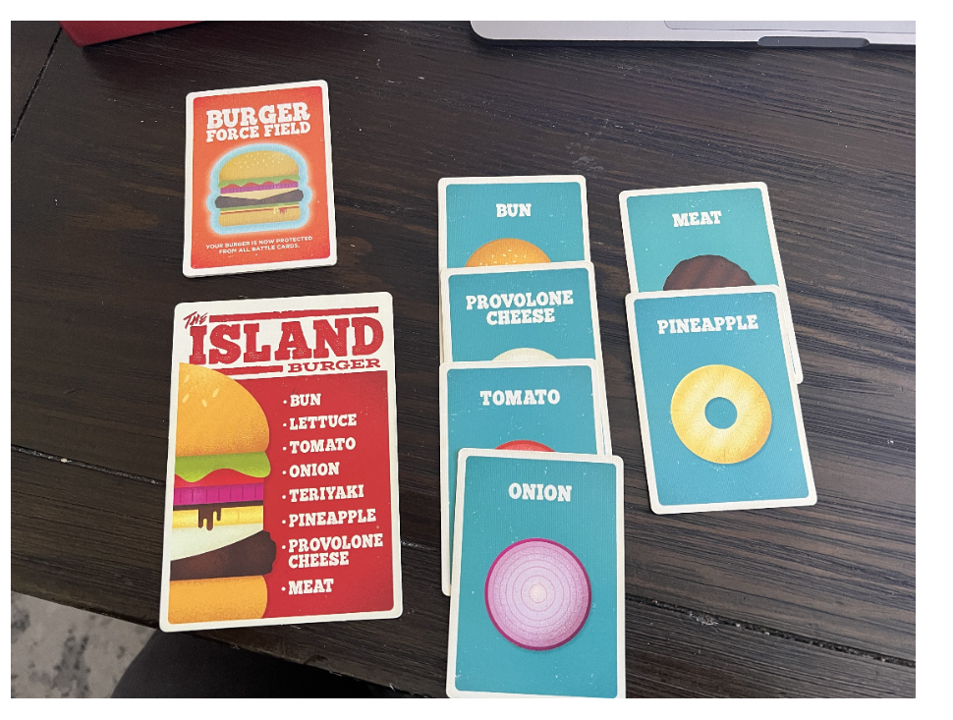
Using HTTPie, you can submit the photo in a similar manner to how you submitted audio earlier in this chapter. Here’s what the command-line use of HTTPie and response might look like if asking about what ingredients are needed to complete the burger whose card is shown in the image:
$ http -f POST :8080/visionAsk \ gameTitle="Burger Battle" \ question="What ingredients are still needed to complete this burger?" \ image@'test-images/BurgerBattle-3.jpg' -b { "answer": "You still need to add lettuce and teriyaki to complete The Island burger.", "game": "Burger Battle" }
A quick examination of the photo confirms that the response is correct. The Island Burger requires eight ingredients, but only six have been played so far. That leaves lettuce and teriyaki as the two missing ingredients.
READY-MADE TEST IMAGE FILES
Recognizing that you may not own a copy of Burger Battle to test with, I’ve included a handful of test images of the game in the test-images directory of the Board Game Buddy project for this chapter. Try submitting different images and asking any questions you want about those images.
Alternatively, you can take photos of some other game, making sure that the rules are loaded into the vector store, and ask questions about that game.
Try it one more time, this time asking if the burger is safe from being blown up if an opponent plays the Burger Bomb card:
$ http -f POST :8080/visionAsk \ gameTitle="Burger Battle" \ question="Can a Burger Bomb be played on this burger?" \ image@'test-images/BurgerBattle-3.jpg' -b { "answer": "No, a Burger Bomb cannot be played on this burger because it is protected by the Burger Force Field.", "game": "Burger Battle" }
The answer indicates that the LLM noticed from the image that the Burger Force Field card is in effect; therefore, the burger is safe from explosive destruction.
Feel free to try other questions and with different images to see how well it responds. For now, let’s explore how Spring AI can be used to create images, in addition to viewing them.

8.3 Generating images
One of the first experiences that many people have had with generative AI is using one of the image generation tools, such as Midjourney. Even as generative AI’s capabilities and reach expand into more aspects of everyday life, submitting text to a model and getting back a uniquely generated piece of artwork is still one of the most enjoyable things you can do with AI.
With Spring AI, it’s possible to add image generation to your applications. Spring AI provides ImageModel, an interface implemented for OpenAI, Azure OpenAI, Stability, and ZhiPuAI APIs to generate images based on a provided prompt.
We’ve been working with OpenAI throughout this book, so if you want to use OpenAI for image generation, you won’t need to add any additional dependencies in your build. But if you want to use one of the other models for image generation, you’ll need to add one of the following starter dependencies to the project build:
implementation 'org.springframework.ai:spring-ai-starter-model-azure-openai' implementation 'org.springframework.ai:spring-ai-starter-model-stability-ai' implementation 'org.springframework.ai:spring-ai-starter-model-zhipuai'
Then, to make sure that you are using the correct ImageModel implementation, set the corresponding spring.ai.model.image property:
spring.ai.model.image=azure-openai spring.ai.model.image=stabilityai spring.ai.model.image=zhipuai
Setting spring.ai.model.image will disable default autoconfiguration for the ImageModel and will force autoconfiguration for a specific ImageModel implementation. Effectively, you’ll be able to continue using OpenAI for everything you’ve used it for so far in this book while using one of the other models for image generation.
With the starter dependency for the API provider in your project’s build, autoconfiguration will do its magic and add an ImageModel to the Spring application context for you. All you need to do is inject it into your application code and make use of it.
To see how this works, let’s start by defining a service that submits image prompts for generation:
package com.example.boardgamebuddy; public interface ImageService { String generateImageForUrl(String instructions); byte[] generateImageForImageBytes(String instructions); }
As you can see, ImageService defines two methods. Both take a String containing instructions for creating the image as a parameter. The first method is expected to return a String with the URL for the generated image. Opening this link in a browser will display the image. The second returns a byte array, which is the bytes for the image itself. This byte array could be saved directly to disk as an image (PNG) file and viewed using any application that can load PNG files.
Generating images sounds like a complicated task. But since most of the work is done by the underlying model, it’s as easy as sending a request to the provider API. Making it even easier, Spring AI abstracts away the specifics of how the request is sent. The next listing shows how this is done in the implementation of the ImageService interface.

Listing 8.7 ImageService implementation based on Spring AI’s ImageModel
package com.example.boardgamebuddy; import org.slf4j.Logger; import org.slf4j.LoggerFactory; import org.springframework.ai.image.ImageModel; import org.springframework.ai.image.ImageOptions; import org.springframework.ai.image.ImageOptionsBuilder; import org.springframework.ai.image.ImagePrompt; import org.springframework.ai.image.ImageResponse; import org.springframework.stereotype.Service; import java.util.Base64; @Service public class SpringAiImageService implements ImageService { private static final Logger LOG = LoggerFactory.getLogger(SpringAiImageService.class); private final ImageModel imageModel; public SpringAiImageService(ImageModel imageModel) { this.imageModel = imageModel; } @Override public String generateImageForUrl(String instructions) { return generateImage(instructions, "url") .getResult() .getOutput() .getUrl(); #1 } @Override public byte[] generateImageForImageBytes(String instructions) { String base64Image = generateImage(instructions, "b64_json") .getResult() .getOutput() .getB64Json(); #2 return Base64.getDecoder().decode(base64Image); #3 } private ImageResponse generateImage(String instructions, String format) { LOG.info("Image prompt instructions: {}", instructions); var options = ImageOptionsBuilder.builder() .width(1024) .height(1024) .responseFormat(format) .build(); #4 var imagePrompt = new ImagePrompt(instructions, options); #5 return imageModel.call(imagePrompt); #6 } }

#1 Gets image URL
#2 Gets image as Base64
#3 Decodes into image bytes
#4 Builds image options
#5 Creates image prompt
#6 Submits prompt for generation

The bulk of the work in SpringAiImageService is performed in the private generateImage() method. After logging the instructions that were sent in, it creates an ImageOptions object on which you can specify options for how the image is produced. At a very minimum, you must specify the image width and height. In this example, the width and height are both set to produce a 1024 × 1024 image.
Alternatively, you could choose to set the image width and height as Spring configuration properties like this:
spring.ai.openai.image.options.height=1024 spring.ai.openai.image.options.width=1024
In addition to the image size, the response format is also set from the format parameter of the generateImage() method. The supported formats for OpenAI are either url or b64_json. When the response format is set to url, the image is generated, and a URL is returned, through which the image can be retrieved. Alternatively, when the response format is b64_json, the generated image is returned as a Base64-encoded string.
The response formation chosen is the reason that there are two public methods exposed in ImageService. Both generateImageForUrl() and generateImageForImageBytes() call on the generateImage() to send the image prompt to OpenAI. They each differ in the format that they produce.
The generateImageForUrl() method sends url as the format to generateImage(). After receiving the result, it extracts the URL from the result’s output and returns it to the caller. The caller can then turn around and make an HTTP GET request to that URL for up to 1 hour to receive the image.
Meanwhile, the generateImageForImageBytes() passes in b64_json for the format. Consequently, it will receive the image itself as a Base64-encoded string. On receiving the result, it uses the Base64 class from the JDK to decode the string into an array of bytes, which are the bytes for the image itself. The caller can then save those bytes to a file or, as you’ll see momentarily, simply return them from a controller’s handler method for the client to save to a file.
Let’s put the image service to work by creating a new controller in the Board Game Buddy application that calls on an injected ImageService to create images. For fun, and to keep this example focused on a specific use case, let’s create a controller that makes an artistic rendering of a burger when given the name of one of the burgers in the game Burger Battle. BurgerBattleArtController in the following listing shows how this can be done.

Listing 8.8 A controller that creates images of burgers from the game Burger Battle
package com.example.boardgamebuddy; import org.springframework.web.bind.annotation.GetMapping; import org.springframework.web.bind.annotation.RequestParam; import org.springframework.web.bind.annotation.RestController; @RestController public class BurgerBattleArtController { private final BoardGameService boardGameService; private final ImageService imageService; public BurgerBattleArtController(BoardGameService boardGameService, ImageService imageService) { #1 this.boardGameService = boardGameService; this.imageService = imageService; } @GetMapping(path="/burgerBattleArt") public String burgerBattleArt(@RequestParam("burger") String burger) { var instructions = getImageInstructions(burger); return imageService.generateImageForUrl(instructions); #2 } @GetMapping(path="/burgerBattleArt", produces = "image/png") public byte[] burgerBattleArtImage(@RequestParam("burger") String burger) { var instructions = getImageInstructions(burger); return imageService.generateImageForImageBytes(instructions); #3 } private String getImageInstructions(String burger) { var question = new Question( "Burger Battle", "What ingredients are on the " + burger + " burger?"); var answer = boardGameService.askQuestion( question, "art_conversation"); #4 return "A burger called " + burger + " " + "with the following ingredients: " + answer.answer() + ". " + "Style the background to match the name of the burger."; #5 } }

#1 Injects the ImageService
#2 Generates an image URL
#3 Generates image bytes
#4 Asks for ingredients
#5 Creates image instructions

Just as there were two different methods in ImageService—one for generating an image and returning a URL and one for generating an image and returning the image bytes—there are two similarly purposed methods in BurgerBattleArtController. Both handler methods handle HTTP GET requests for /burgerBattleArt, and both accept a request parameter named burger, which is the name of the burger to generate an image for. Where they differ, however, is that the burgerBattleArtImage() method is annotated with @GetMapping with a produces attribute that indicates this method will only handle requests when the Accept header is “image/png”. It calls the generateImageForImageBytes() method on the ImageService to do the real work of generating the image. On the other hand, if the request’s Accept header is not image/png, the burgerBattleArt() method will get the job and uses generateImageForUrl() to create the image and get a URL.
In both cases, the methods rely on the private getImageInstructions() to create the instructions for producing the image. This method takes advantage of the askQuestion() method from BoardGameService that you have developed throughout the book to ask about the ingredients for the specified burger. Since the instructions for Burger Battle include the burgers and their ingredients, it should have no trouble finding an answer to that question.

NOTE
Notice that a hard-coded conversation ID of art_conversation is sent, since conversation isn’t really important in this controller.
The getImageInstructions() method wraps up by creating and returning the instructions for generating the image. This method tells the model to create an image for the burger with the given ingredients and to style the background appropriately for the burger’s name.
Now it’s time to fire up the application and create some tasty burger art. Once the application is running, try asking it to create an image for the burger called “The Cowboy” by sending this request with HTTPie:
$ http :8080/burgerBattleArt?burger=Cowboy
After a few moments (images take a little longer to generate than simple questions and answers), you should receive a URL to the image. You’ll have up to 1 hour to request that image, so open it up as soon as you can in your web browser. Every rendering of a burger image will be different, but you might see something like what’s shown in figure 8.2.
Figure 8.2: An image generated for the Cowboy Burger
To avoid the two-step process of receiving and then opening a URL (not to mention the possibility of the URL expiring), you can try to fetch the image itself by setting the Accept header to image/png. For example, try using HTTPie like this to get an image of the Sunrise burger:
$ http :8080/burgerBattleArt?burger=Sunrise \ accept:image/png > sunrise.png
In this HTTPie incantation, the bytes returned from the request are redirected to a file named sunrise.png. Open that image in your favorite image viewer, and you might see something similar to what’s shown in figure 8.3.
Figure 8.3: An image generated for the Sunrise Burger
As you can see, ImageModel does quite an impressive job of generating images from some descriptive text. However, there are several options that you can specify to refine how it produces those images. You’ve already seen how to set the image width, height, and response format. Let’s take a look at a few other image generation options that may be useful to you.

8.3.1 Specifying image options
In listing 8.7, you saw how to use ImageOptionsBuilder to specify the width, height, and response format of the generated image. ImageOptionsBuilder offers a handful of additional methods to set other options, including those in table 8.1.

Table 8.1: ImageOptionsBuilder methods for setting image options
Method | Description
height(Integer) | The height of the image
model(String) | The name of the model to use. Either dall-e-2 or dall-e-3. Default: dall-e-3.
N(Integer) | The number of images to generate
responseFormat(String) | The format of the returned image. Either url or b64_json. Default: url.
style(String) | The image style. Either vivid or natural.
width(Integer) | The width of the image
Among these properties, one of the most interesting ones is the style() method. This method establishes whether you want a vivid (hyperrealistic) image or a natural (photorealistic) image. The default is vivid, but if you prefer a more photorealistic image, you can set it like this:
ImageOptions options = ImageOptionsBuilder.builder() .width(1024) .height(1024) .responseFormat(format) .style("natural") .build();
By applying the natural style, the resulting image appears less like a piece of art and more like a photograph. Figure 8.4 shows what the Cowboy burger might look like when the natural style is applied.
Figure 8.4: A natural, photorealistic rendering of the Cowboy Burger
An alternative to building the ImageOptions object via ImageOptionsBuilder is to use OpenAiImageOptions’s builder() method. The builder you get from this builder() method lets you set the same options as with ImageOptionsBuilder, as well as a few more that are specific to OpenAI. Table 8.2 lists the additional methods provided by OpenAiImageOptions.

Table 8.2: Additional methods for setting image options with OpenAiImageOptions
Method | Description
quality(String) | The quality of the image. Either standard or hd. Default: standard
user(String) | A string identifying the user making the request. Used by OpenAI for monitoring and abuse detection.
As an example of using OpenAiImageOptions to set the options for generating an image, consider this snippet of code that not only uses the natural style but also chooses hd quality to get a photorealistic image with finer details:
ImageOptions options = OpenAiImageOptions.builder() .height(1024) .width(1024) .responseFormat(format) .style("natural") .quality("hd") .build();
When the quality is hd, you might get a noticeably nicer and more detailed image, such as the one in figure 8.5.
Figure 8.5: A high-definition, photorealistic rendering of the Cowboy Burger
These same options can be specified as configuration properties. The following configuration properties are equivalent to their similarly named methods on ImageOptionsBuilder and OpenAiImageOptions:
- spring.ai.openai.image.options.model
- spring.ai.openai.image.options.n
- spring.ai.openai.image.options.quality
- spring.ai.openai.image.options.response-format
- spring.ai.openai.image.options.size
- spring.ai.openai.image.options.style
- spring.ai.openai.image.options.user
- spring.ai.openai.image.options.height
- spring.ai.openai.image.options.width
By setting image options in configuration properties, the values become the new defaults, making it unnecessary to specify them in Java. For instance, for all of the options shown thus far to generate a high-definition, photorealistic image 1024 × 1024 in dimension, you can set the following in application.properties:
spring.ai.openai.image.options.height=1024 spring.ai.openai.image.options.width=1024 spring.ai.openai.image.options.style=natural spring.ai.openai.image.options.quality=hd
With these properties set, you’d only need to specify them via the builder if you wanted to use a different value.

AZURE OPEN AI IMAGE OPTIONS
If you have chosen to use Azure’s OpenAI offering, you can use AzureOpenAiImageOptions instead of OpenAiImageOptions. AzureOpenAiImageOptions offers the same selection of image options as OpenAiImageOptions, with the addition of a deploymentName() method. This method specifies the deployment name used when connecting to the Azure OpenAI service.
For example, suppose that you have a deployment name of MyDeployment. In that case, you can create an image options object like this:
ImageOptions options = AzureOpenAiImageOptions.builder() .deploymentName("MyDeployment") .height(1024) .width(1024) .responseFormat(format) .style("natural") .quality("hd") .build();
As with OpenAI, you can also set these options in application.properties as configuration properties:
spring.ai.azure.openai.image.options.deployment-name="My Deployment" spring.ai.azure.openai.image.options.height=1024 spring.ai.azure.openai.image.options.width=1024 spring.ai.azure.openai.image.options.style=natural spring.ai.azure.openai.image.options.quality=hd
You’ll notice that the key difference between the OpenAI configuration properties and those for Azure OpenAI is the addition of azure in the middle of the property name.

Summary
- Spring AI enables integration with models that support audio and images.
- When working with OpenAI or Azure OpenAI, the transcription model makes it possible for your application to “listen” to audio files and produce textual transcriptions of those files.
- Also with OpenAI, you can generate audio files from text with Spring AI’s SpeechModel.
- You can add vision to your application (for underlying models that support it) by simply adding an image Resource to the prompt and asking questions about the image.
- Spring AI can also be used to generate images from text for models that support image generation.

Chapter 9: Observing AI Operations

This Chapter Covers
- Spring AI observability metrics
- Viewing observations in Prometheus and Grafana
- Tracing generative AI operations
In chapter 6, I asked you to think about your last visit to see the doctor. Think about that visit once again. I’ll bet that while you were there, the doctor or a nurse took all kinds of measurements, such as your temperature, blood pressure, and heart rate. They may have even taken blood and tested it for a variety of conditions. In some situations, you may have been given a CT scan to gain a more detailed view of how your body and systems are functioning. The measurements and tests gave them a high-level view of your overall health and likely informed their thoughts on how best to treat you.
Your applications can be thought of similarly to your health. Just as a doctor uses your vital statistics and test results to better understand your overall health, you can better understand the health and behavior of your application by observing various metrics that the application produces. Building observability and tracing into your application can give you valuable insights and clarity into the inner workings of the application.
In this chapter, you’ll learn about how to enable observability in your Spring AI applications and get to know the metrics Spring AI publishes. You’ll also learn how to build visual representations of those metrics using observability platforms such as Prometheus and Grafana. Then you’ll see how to peer even deeper into the underbelly of your application, taking advantage of tracing data published by Spring AI.

Summary
- Spring AI exposes several metrics via Micrometer that pertain to generative AI operations, vector store operations, and Spring AI’s ChatClient and advisors.
- These metrics can be consumed via the Actuator’s metrics endpoint or scraped by Prometheus for displaying as time-series graphs.
- By building a dashboard in Grafana that retrieves the metrics from Prometheus, you can gain visibility into all of the generative AI activity in your application.
- To gain deeper insight into how generative AI is used in your application, Spring AI also publishes tracing data that can be viewed in tracing tools such as Jaeger or Zipkin.

Chapter 10: Safeguarding Generative AI

This Chapter Covers
- Authorization-enabling retrieval-augmented generation results
- Securing tool invocations
- Mitigating adversarial prompts
Most organizations have documents that fall under one or more levels of classification, ranging from Top Secret to Confidential to Restricted access. And not every person has the same access to applications and services that others need to do their job. Security and information rights management are important aspects of any organization, as well as in software.
You’ve seen how retrieval-augmented generation (RAG) and tools make it possible to integrate generative AI with your documents and data. But not all documents and tools are intended for all users. It’s essential to secure access to documents and tools to prevent unauthorized users from gaining indirect access via an LLM.
Moreover, a cleverly phrased prompt submitted by a sneaky user could trick the LLM into doing something or revealing information that shouldn’t be exposed. You’ll need to apply guardrails that intercept a user’s questions and the LLM’s responses to ensure that sensitive responses aren’t returned to the users.
In this chapter, you’ll see how to apply Spring Security alongside Spring AI to hold back on answering questions for which a user doesn’t have the authority to see the answers. And you’ll learn how to use Spring AI advisors to prevent adversarial prompting techniques. Let’s start by looking at how to limit access to documents in a vector store to only users who are allowed to see those documents.

Summary
- Security is an important aspect of any application, including those built upon generative AI.
- Using Spring Security, you can restrict access to tool calls and documents in a vector store to only users authorized to access them.
- The nondeterministic nature of generative AI, along with the flexibility of natural language, leaves opportunities for hackers to use generative AI applications in unintended and harmful ways.
- Spring AI’s SafeGuardAdvisor, as well as custom advisors, can be applied to prevent and mitigate the effect of adversarial prompting techniques.

Chapter 11: Applying Generative AI Patterns

This Chapter Covers
- Summarizing lengthy content
- Translating text from one language to another
- Analyzing sentiment
You may have heard of Walt Disney Imagineering. This incredibly skilled group of individuals has, for decades, been behind the magic that goes into Disney theme parks and experiences. But what you may not know is that not all imagineers started in that role.
Walt Disney was known to assign tasks to people who didn’t have the background or skills to accomplish those tasks. Rolly Crump started as an animator but was tapped by Walt to create ride experiences, including It’s a Small World and the Haunted Mansion. Claude Coates started out as a background painter for animated films but went on to design ride vehicles for Pirates of the Caribbean and Mr. Toad’s Wild Ride. If you’ve ever ridden Haunted Mansion or Pirates of the Caribbean and found yourself humming the songs heard in those attractions, know that they were composed by X. Atencio, who started as an animator on films like Fantasia and Pinocchio. Even Tony Baxter, a more recent imagineer, started off scooping ice cream at Disneyland before eventually designing Big Thunder Mountain, Splash Mountain, and Star Tours. Sometimes people are capable of incredible things that their background wouldn’t suggest that they be any good at.
Throughout this book, you’ve seen how generative AI and, more specifically, Spring AI’s ChatClient, can be used to answer questions posed by a user. You might even think that’s all that ChatClient can be used for. But make no mistake. ChatClient is filled with potential beyond Q&A tasks.
In this chapter, we’ll examine a few other ways to use ChatClient. What you’ll see is that the code you write around ChatClient won’t be that different from what you’ve already done. It’s all in how you ask when writing the prompt. Let’s start with how to summarize lengthy content.

Summary
- Spring AI’s ChatClient is useful for much more than simply answering questions.
- ChatClient can be used to summarize text, distilling it into the essentials and a more easily digestible form.
- Internationalizing responses is made much simpler by using ChatClient and the underlying LLM to translate text from one language to another.
- Figuring out a user’s sentiment is another way to use ChatClient and generative AI.
- Ultimately, it’s how prompts are written that determine what ChatClient can do, making it capable of many things.

Chapter 12: Employing Agents

This Chapter Covers
- Agent essentials
- Implementing agentic workflow patterns
- Applying agentic planning with Embabel
What do you think of when you hear the word “agent”? The first thing that comes to mind for many is a secret agent, someone like James Bond, who undertakes dangerous missions to protect national and global security. Or maybe you think of a real estate agent, someone who helps homeowners buy and sell property. There are also gate agents at the airport who assist travelers as they jet off to various destinations. And then there are insurance agents, talent agents, customs agents, literary agents, and countless other kinds of agents.
Clearly, there are several kinds of agents, and there is no one definitive definition of what an agent is or does. But the one thing that is common among all of these agents is that they all do something. They all have a job in which they specialize, and their mission is to apply their training and skills to achieve their specific goals.
Generative AI agents are similar to other kinds of agents. There’s no clear consensus on what generative AI agents do or even what they are or how they’re created. Many think that an agent must be fully autonomous, making decisions on its own, to be considered an agent. Others believe that anything that interacts with an LLM and employs tools can be part of an agentic workflow. But what is almost universally agreed on is that an agent does something and is oriented toward achieving some goal.
In this chapter, you’ll explore ways to create agents with Spring AI. You won’t settle the debate over what an agent is. But you will see how to use Spring AI at the core of agentic solutions.

Summary
- Agents are ultimately about solving problems by following workflows.
- At the core of any agentic workflow is a component that interacts with LLMs. Spring AI’s ChatClient is a perfect fit for that job as an agent.
- There are several agentic workflow patterns defined in the community, including those defined by Anthropic, Google, and others.
- These workflow patterns are building blocks for creating larger workflows.
- One particular agentic pattern of great interest in planning in which the agent itself determines its own workflow to achieve goals.
- Embabel is an agentic framework based on Spring AI and Goal-Oriented Action Planning (GOAP) that enables agentic planning.

Index
- Symbols
- A
- B
- C
- D
- E
- F
- G
- H
- I
- J
- L
- M
- N
- O
- P
- Q
- R
- S
- T
- U
- V
- W
- X

Symbols
- @PostAuthorize annotation
- @Valid annotation
- "messages" property
- /collections endpoint
- @Tool-annotated methods, 2nd
- --stream switch
- /actuator/metrics endpoint
- /actuator/prometheus endpoint, 2nd
- @McpPrompt annotation
- @Bean-annotated methods
- "message" property
- /tmp/dropoff directory, 2nd
- -a parameter
- @PostMapping annotation
- @EnableMethodSecurity annotation
- @EnableWireMock annotation
- @McpResource method
- /audioAsk endpoint
- /ask endpoint, 2nd, 3rd, 4th
- {question_answer_context}
- @Bean method
- @Query annotation
- {rules} placeholder
- @Description annotation
- @Value annotation, 2nd
- @PreAuthorize annotation, 2nd
- @McpResource-annotated methods, 2nd, 3rd
- @EnableAgentShell annotation, 2nd
- @AchievesGoal annotation
Go to top of index

A
- ADK (Agent Development Kit)
- Azure OpenAI
  - specifying image options, 2nd
- adversarial prompting
  - preventing prompt leaks, 2nd
  - preventing prompts with sensitive terms, 2nd
- Answer record, 2nd
- Action interface
- Amazon Bedrock
- ai_chat_memory table
- agents, overview of
- ask() method, 2nd, 3rd, 4th, 5th, 6th
- audioAskAudioResponse() method, 2nd
- apply() method
- AskController
- Accept header
- act() method, 2nd
- AI tools
  - developing tools-enabled application, 2nd
  - digging deeper, 2nd
- askQuestion() method, 2nd, 3rd, 4th, 5th, 6th, 7th, 8th
- audioAsk() method, 2nd, 3rd, 4th
- Anthropic
  - agentic workflows and patterns
- actions command
- AudioQuestion
- availableTags property, 2nd
- ActionFailedException, 2nd
- ApplicationRunner bean
- AgentWorkflowAskController, 2nd, 3rd
- AudioService interface
- advisors() method, 2nd, 3rd
Go to top of index

B
- BlobResourceContents
- byte array
- BOM (bill of materials), 2nd
- build.gradle file, 2nd
- boardgame.rules.path property
- BoardGameService, 2nd
  - interface
Go to top of index

C
- chatResponse() method
- Chain component
- CSRF (Cross-Site Request Forgery)
- ChatMemory
  - bean, 2nd, 3rd
  - interface
- chatClientBuilder() method, 2nd
- complexityEnum() method
- CanaryWordAdvisor, 2nd, 3rd, 4th
- call() method, 2nd, 3rd
- Chain bean, 2nd
- ChatResponse object
- compose.yaml file, 2nd, 3rd
- CGI (Common Gateway Interface)
- ChatMemoryRepository
  - bean
- chat_memory table
- ChatClient, 2nd, 3rd, 4th, 5th, 6th
  - Builder, 2nd
  - bean
  - operations, 2nd
- chat operations, 2nd
- command subproperty
- ChatMemoryRepository bean
- COUNT data
- chatClient() method
- conversational memory, 2nd
  - adding
  - enabling persistent chat memory
  - overview, 2nd
  - specifying conversation ID, 2nd
- CONVERSATION_ID key
- ChatMemory bean
Go to top of index

D
- document loader
- documentReader() method
- documents
  - loading
- DocumentReader interface
- dropoff directory
- documentReader function, 2nd, 3rd
- db.vector.query.filter tag
- defaultToolCallbacks() method
- defaultOptions() method
- detail property
- defaultAdvisors() method
- determineGameMechanics() method, 2nd, 3rd, 4th, 5th
- docker compose command, 2nd
- DocumentRetriever interface
- determinePlayerCount() method, 2nd, 3rd
- dashboards, creating, 2nd
- DataSource bean
- defaultTools() method, 2nd
Go to top of index

E
- evaluating generated responses
  - ensuring relevant answers
  - factual accuracy, 2nd
- Evaluator interface
- extractGameTitle() method
- embeddings, defined
- execute command, 2nd, 3rd, 4th, 5th
- evaluateRelevancy() method, 2nd, 3rd
- evaluate() method
- Embabel, 2nd
  - accessing agent via MCP, 2nd
  - defining action to get game rules, 2nd
  - defining action to get game title
  - defining action to get rules filename
  - defining agent class
  - initializing project, 2nd
  - running agent via shell, 2nd
- export parameter, 2nd
Go to top of index

F
- FactCheckingEvaluator
- fileSupplier bean
- fatal-level logging
- Flux type
Go to top of index

G
- getGameRules() method
- generateImage() method
- GOAP (Goal-Oriented Action Planning), 2nd
- gameListResource() method
- generateImageForUrl() method
- Google Gemini
- getImageInstructions() method, 2nd
- go() method
- GameRepository, 2nd
  - interface
- getRulesFor() method, 2nd, 3rd, 4th, 5th, 6th
- generative AI
  - safeguarding, 2nd
  - safeguarding against adversarial prompting
  - security, securing tools, 2nd
- gpt-4o-mini model
- getPremiumContentFilterExpression() method
- GameTools class
- getCurrentTime() method
- getGameComplexity() method
- GameTitle object, 2nd
- gen_ai.client.operation metric
- GameRules object, 2nd, 3rd
- getTime() method
- generateImageForImageBytes() method
- getDocumentMatchExpression() method, 2nd
- generative AI patterns, 2nd
- gen_ai.token.type tag
Go to top of index

H
- help command
- HTTPie command line tool
Go to top of index

I
- input tokens, 2nd, 3rd
- ImageOptions object, 2nd
- ImageService interface, 2nd, 3rd
- ImageModel interface
- in-memory chat advisor, 2nd
- images
  - asking questions about, 2nd
  - generating
- ImageOptionsBuilder, 2nd
Go to top of index

J
- JsonParseException
- java.util.function package
Go to top of index

L
- localhost hostname
- loading, creating pipeline components
  - determining game title, 2nd
  - reading documents
  - splitting documents, 2nd
  - writing documents to vector store, 2nd
Go to top of index

M
- MessageWindowChatMemory, 2nd
- MultipartFile, 2nd
- MechanicsDeterminerAction, 2nd, 3rd
- metrics
  - endpoint
- MyDeployment
- ModerationService
- MCP (Model Context Protocol), 2nd, 3rd
  - clients, 2nd
  - creating MCP Server
  - overview, 2nd
- moderate() method
- ModerationException
- MessageChatMemoryAdvisor, 2nd, 3rd, 4th, 5th
  - prompt
- ModerationModel, 2nd, 3rd
Go to top of index

N
- natural style
Go to top of index

O
- OpenAiImageOptions
- output tokens, 2nd
- OpenAiAudioSpeechOptions, 2nd
- OpenAiVoiceService
- observability
  - Actuator metrics
Go to top of index

P
- prompts
  - inspecting for chat memory
  - stuffing with context, 2nd
- prompt engineering
- params map
- PromptChatMemoryAdvisor
  - prompt, 2nd
- PlayerCountAction
- produces attribute
- POST request, 2nd, 3rd, 4th, 5th
- ports entry
- param() method
- PostgresChatMemoryRepositoryDialect
- persistent chat memory
  - persisting chat memory to database
- points, defined
- PromptMessage
- PagePdfDocumentReader
- ParallelizerAction class, 2nd, 3rd
Go to top of index

Q
- QuestionAnswerAdvisor, 2nd, 3rd, 4th, 5th
- Question record
- Question object
Go to top of index

R
- RulesFile object
- resources, exposing
  - applying annotation-driven, 2nd
  - declaring beans, 2nd
- routing
- RAG (retrieval-augmented generation), 2nd, 3rd, 4th
  - applying modular RAG
  - controlling document access with
  - implementing
  - implementing with advisor
  - overview, 2nd
- RAG-enabled application
- RetrievalAugmentationAdvisor
- RuleFetcherAction, 2nd, 3rd
- repositories section
- roles, assigning, 2nd
- RewriteQueryTransformer
- Router
- RestClientCustomizer bean
- RelevancyEvaluator
Go to top of index

S
- SPRING_AI_OPENAI_API_KEY environment variable
- spring.ai.openai.api-key property, 2nd, 3rd
- spring.ai.kind tag
- spring.ai.vectorstore.qdrant.collection-name property
- schema.sql file
- self-evaluation, applying at runtime, 2nd
- spring.ai.chat.client metric, 2nd
- securityFilterChain() method
- SpringAiBoardGameServiceWireMockTests
- SpringAiBoardGameService class, 2nd, 3rd
- Spring AI
  - capabilities of, 2nd
  - getting started with, choosing model
  - initializing project, 2nd
  - observing operations, metrics in Prometheus
  - overview of
  - submitting prompts, 2nd
  - trying out, 2nd
  - writing tests, 2nd
- spring.ai.chat.memory.repository.jdbc.initialize-schema property
- summarizeRules() method, 2nd, 3rd
- SpringAiBoardGameServiceTests
- SpringAiBoardGameService
- spring.ai.advisor.type tag, 2nd
- summarizing content, 2nd
- spring.ai.chat.client.stream tag
- STDIO (Standard Input Output)
- spring.servlet.multipart.max-file-size property
- spring.ai.mcp.client.stdio.servers-configuration property
- spring.ai.mcp.client base property
- setup() method
- spring.ai.openai.chat.options.model property
- SyncPromptSpecification
- style() method
- spring.ai.advisor metric
- systemPromptTemplate.st template file
- splitter function, 2nd
- spring.ai.azure.openai.chat.options.deployment-name property
- spring.ai.ollama.init.pull-model-strategy property
- SecurityConfig class
- SPRING_DOCKER_COMPOSE_FILE environment variable
- spring.ai.vectorstore.qdrant.initialize-schema property
- shell profile
- submitting prompts for generation, 2nd
  - influencing response generation
  - response metadata, 2nd
- Spring Cloud Function
- sentiment analysis, 2nd
- SummarizerAction, 2nd
- spring.ai.model.image property
- SecurityFilterChain bean
- spring.ai.ollama.chat.model property
Go to top of index

T
- transcribe() method, 2nd
- textToSpeech() method, 2nd, 3rd
- top-p property
- tools property
- tracing AI operations, 2nd
- transport, HTTP+SSE
  - configuring client to use HTTP+SSE server, 2nd
  - configuring in MCP Server, 2nd
  - inspecting MCP Server, 2nd
- tokens, counting usage, 2nd
- templates, prompt templates
  - defining, 2nd
  - importing as resource, 2nd
- translating messages
  - building simple translator, 2nd
  - translating game rule answers, 2nd
- toolCallbackProvider() method
- TextResourceContents
- tool-driven generation, 2nd
  - AI tools
  - enables functions as tools, 2nd
  - implementing tools
- toolNames() method
- tts-1 model
- translating user queries, 2nd
- TikaDocumentReader
- TimeTools class
- TIP (Anthropic)
- TokenTextSplitter
Go to top of index

U
- user input moderation
- UserInput type
- user() method, 2nd, 3rd, 4th
- userDetailsService() method
- uvx command line tool
Go to top of index

V
- VectorStore
- vectorStoreConsumer definition
- vectorStoreConsumer function
- variability, adjusting, 2nd
- voice
  - applying audio input and output directly, 2nd
  - generating speech from text, 2nd
  - setting text-to-speech options, 2nd
  - transcribing speech, 2nd
- VoiceService interface, 2nd
- vector stores
  - operations, 2nd
  - setting up
  - storing chat memory in
Go to top of index

W
- workflows, agentic
  - chaining prompts, 2nd
  - parallelization, 2nd
  - routing tasks, 2nd
- withTopK() method
- withSimilarityThreshold() method
Go to top of index

X
- X_AI_CONVERSATION_ID header
Go to top of index

