Adaptive Multilevel Queue CPU Scheduling for Hospital Management Systems
Review 2 — Proposed Methodology & Prototype Implementation
Kopal Joshi (24BCI0116) | Srijita Kumar (24BCI0113)

1. Proposed Methodology (Architecture / Design)

1.1 Design Overview
The proposed scheduler, Adaptive Multilevel Queue (AMQ), classifies every operating-system process generated by hospital software into one of three queues based on clinical urgency, and applies a different base scheduling policy to each queue. A shared Dynamic Priority Engine and Aging Mechanism then adjust effective priorities across ticks so that background work is never starved, while emergency work always receives immediate CPU access when it is ready.

1.2 Queue Classification and Policies
Queue | Example Workloads | Scheduling Policy | Objective
Emergency | ECG alerts, ICU monitors, code-blue signals | Preemptive Priority | Immediate CPU access, lowest possible response time
Interactive | Doctor dashboards, EMR lookups, nurse charting | Round Robin (20-50 ms quantum) | Fair, responsive time-sharing for clinician-facing UI
Background | Billing batches, nightly backups, reports | FCFS (runs when idle) | Best-effort throughput without blocking clinical work

1.3 Detailed Workflow
The diagram below traces one CPU tick end-to-end: from a new process arriving, through queue classification, dynamic priority evaluation, aging, the preemption decision, and finally dispatch and bookkeeping.
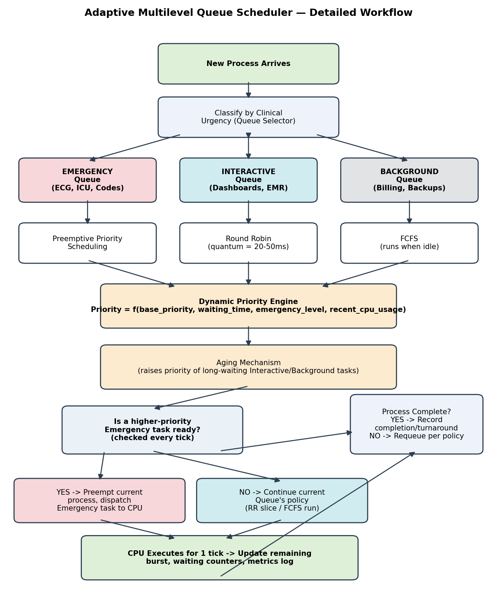
Figure 1. Detailed scheduler workflow executed on every CPU tick.

Step-by-step description
- Arrival & Classification: Each new process is tagged with a queue label (Emergency / Interactive / Background) based on the clinical role of the application that spawned it.
- Per-tick scan: On every simulated tick, the scheduler first checks the Emergency queue. If it is non-empty, the highest-priority emergency process is selected unconditionally.
- Dynamic priority scoring: Priority = f(base_priority, waiting_time, emergency_level, recent_cpu_usage). Within a queue, this score orders otherwise-tied processes and lets long-waiting tasks rise in priority.
- Aging: Interactive and Background queues apply a configurable aging slope that reduces the effective priority value (i.e. raises scheduling precedence) the longer a task waits, preventing starvation. The Emergency queue's aging slope is intentionally 0 so that clinical severity (base_priority) — not wait time — governs ordering among emergencies.
- Preemption check: If an Emergency task becomes ready while an Interactive/Background task is running, the running task is preempted immediately and placed back at the head of its own queue (no penalty), and the Emergency task is dispatched.
- Dispatch & execution: The chosen process runs for one tick (or, for Interactive, until its Round-Robin quantum or a preemption event ends the slice).
- Bookkeeping & requeue: Waiting time, turnaround time and response time counters are updated; the process is requeued per its own policy (Emergency -> tail of Emergency queue if unfinished; Interactive -> tail of Interactive queue after quantum expiry; Background -> stays at head until it finishes or is preempted).
- Completion: When remaining burst time reaches zero, completion time is recorded and the process is removed from the run queue permanently.

1.4 Dynamic Priority Formula
effective_priority(p, now) =
p.base_priority
- aging_slope[p.queue] * (now - p.waiting_since) # aging bonus
+ 0.1 * recent_cpu_usage(p) # CPU-hog penalty
# Lower effective_priority => scheduled sooner
# aging_slope: Emergency = 0, Interactive = 0.5, Background = 0.2
This formula balances three competing goals: (1) clinical urgency, encoded directly in base_priority for Emergency tasks; (2) fairness, via the aging term that guarantees every waiting task's priority eventually improves; and (3) system efficiency, via a small penalty on processes that have recently consumed a disproportionate share of CPU time.

1.5 Design Rationale
- Preemptive priority is used only for Emergency tasks because clinical alerts have hard implicit deadlines; any queuing delay is a patient-safety risk.
- Round Robin with a short quantum is used for Interactive tasks because clinicians perceive responsiveness, not raw throughput, when using dashboards and EMR.
- FCFS is used for Background tasks because these are long, non-interactive, and only need to make forward progress without interfering with clinical flows.
- Aging is scoped to Interactive/Background only, so that a flood of low-priority tasks can never accumulate enough 'aged' priority to delay a genuine Emergency alert.

2. Coding — Prototype Implementation & Functionality

2.1 Implementation Summary
The prototype is implemented in Python as a discrete-event / tick-based simulator (no OS kernel access required, matching the 'user-space simulator' option from the implementation plan). It consists of two modules:
- amq_scheduler.py — the core scheduler: Process data model, three-queue structure, dynamic priority function, aging, preemption logic, and per-tick execution loop.
- demo.py — a representative hospital workload (ECG alerts, ICU monitor, code-blue, doctor dashboard, EMR lookup, nurse charting, billing batch, nightly backup) plus a plain-FCFS baseline scheduler used purely for comparison.

2.2 Core Scheduler Code (amq_scheduler.py)
Key excerpt — the Process model and dynamic priority function:
# --------------------------------------------------------------------------
EMERGENCY, INTERACTIVE, BACKGROUND = 0, 1, 2
QUEUE_NAMES = {EMERGENCY: "EMERGENCY", INTERACTIVE: "INTERACTIVE", BACKGROUND: "BACKGROUND"}
# Aging slope per queue: how fast effective priority improves per tick waited.
AGING_SLOPE = {EMERGENCY: 0.0, INTERACTIVE: 0.5, BACKGROUND: 0.2}
TIME_QUANTUM_INTERACTIVE = 4
@dataclass
class Process:
pid: str
name: str
queue: int # EMERGENCY / INTERACTIVE / BACKGROUND
arrival: int # arrival time (ticks)
burst: int # total CPU burst needed (ticks)
base_priority: int # lower value = higher priority (used within EMERGENCY)
remaining: int = field(init=False)
waiting_since: int = field(init=False) # last tick the process became ready/re-queued
wait_time: int = 0
first_run_time: Optional[int] = None
completion_time: Optional[int] = None
quantum_left: int = TIME_QUANTUM_INTERACTIVE
def __post_init__(self):
self.remaining = self.burst
self.waiting_since = self.arrival
def dynamic_priority(self, now: int, recent_cpu_usage: int = 0) -> float:
"""
Priority = f(base_priority, waiting_time, emergency_level, recent_cpu_usage)
Lower score => scheduled sooner.
Emergency queue: base_priority dominates (clinical severity), aging is 0
so a *more* severe alert always wins, but ties are broken by arrival.
Interactive/Background: aging slowly erodes base_priority so long-waiting
tasks eventually win over freshly-arrived, lower-urgency ones (anti-starvation).
"""
waited = now - self.waiting_since
aging_bonus = AGING_SLOPE[self.queue] * waited
cpu_penalty = 0.1 * recent_cpu_usage # discourage CPU-hungry procs a little
return self.base_priority - aging_bonus + cpu_penalty
Key excerpt — the main per-tick scheduling loop (Emergency preemption check, dispatch, requeue-per-policy):
if emergency_candidate is not None:
chosen, chosen_q = emergency_candidate, EMERGENCY
# If we were running something else, put it back at the head
# of its queue (preempted work is not penalised / not sent to tail).
if current is not None and current is not chosen:
if current not in self.queues[current_queue]:
self.queues[current_queue].insert(0, current)
elif self._pick_interactive() is not None:
chosen, chosen_q = self._pick_interactive(), INTERACTIVE
elif self._pick_background() is not None:
chosen, chosen_q = self._pick_background(), BACKGROUND
else:
chosen, chosen_q = None, None
if chosen is None:
self.cpu_idle_ticks += 1
self.time += 1
continue
# remove from its queue while it runs this tick
if chosen in self.queues[chosen_q]:
self.queues[chosen_q].remove(chosen)
if chosen.first_run_time is None:
chosen.first_run_time = self.time
# execute one tick
self.gantt.append((self.time, self.time + 1, chosen.pid, QUEUE_NAMES[chosen_q]))
chosen.remaining -= 1
self.recent_cpu[chosen.pid] = self.recent_cpu.get(chosen.pid, 0) + 1
self.time += 1
self._admit_arrivals()
if chosen.remaining <= 0:
chosen.completion_time = self.time
self.completed.append(chosen)
current, current_queue = None, None
continue
# decide requeue behaviour per policy
if chosen_q == EMERGENCY:
chosen.waiting_since = self.time
self.queues[EMERGENCY].append(chosen)
current, current_queue = chosen, EMERGENCY
elif chosen_q == INTERACTIVE:
chosen.quantum_left -= 1
if chosen.quantum_left <= 0 or self._pick_emergency() is not None:
chosen.quantum_left = TIME_QUANTUM_INTERACTIVE
chosen.waiting_since = self.time
self.queues[INTERACTIVE].append(chosen)
current, current_queue = None, None
else:
self.queues[INTERACTIVE].insert(0, chosen)
current, current_queue = chosen, INTERACTIVE
else: # BACKGROUND (FCFS => never voluntarily yields except to preemption)
self.queues[BACKGROUND].insert(0, chosen)
current, current_queue = chosen, BACKGROUND
# update waiting_time bookkeeping for everyone still queued
The full source (amq_scheduler.py, demo.py, and chart-generation scripts) is included in the accompanying project code submission.

2.3 Hospital Workload Used for Testing
def build_workload():
return [
# Life-critical (Emergency queue) — short, urgent bursts, arrive mid-run
Process("P1", "ECG Alert - Bed 12", EMERGENCY, arrival=0, burst=3, base_priority=1),
Process("P2", "ICU Monitor - Bed 04", EMERGENCY, arrival=6, burst=2, base_priority=1),
Process("P3", "Code Blue Alert - ER", EMERGENCY, arrival=10, burst=2, base_priority=0),
# Clinician-facing (Interactive queue) — moderate bursts, need responsiveness
Process("P4", "Doctor Dashboard", INTERACTIVE, arrival=0, burst=10, base_priority=5),
Process("P5", "EMR Lookup", INTERACTIVE, arrival=1, burst=8, base_priority=5),
Process("P6", "Nurse Chart Update", INTERACTIVE, arrival=3, burst=6, base_priority=5),
# Administrative (Background queue) — long, non-critical

2.4 Functionality Demonstrated
- Correct queue classification and dispatch across Emergency / Interactive / Background.
- Preemptive priority: emergency arrivals immediately interrupt running Interactive/Background work (see P1, P2, P3 in Figure 2 — each starts executing the instant it arrives, response time = 0).
- Round-Robin time-slicing for Interactive tasks, visible as the alternating P4/P5/P6 slices in the Gantt chart.
- FCFS run-to-completion behaviour for Background tasks, which only execute once the CPU is otherwise idle.
- Aging / starvation prevention: both Background jobs (P7, P8) complete despite continual Emergency and Interactive arrivals — verified via explicit waiting-time counters in the run output.
- Computation of standard scheduling metrics: waiting time, turnaround time, response time, and CPU utilisation.

2.5 Execution Output — AMQ Scheduler
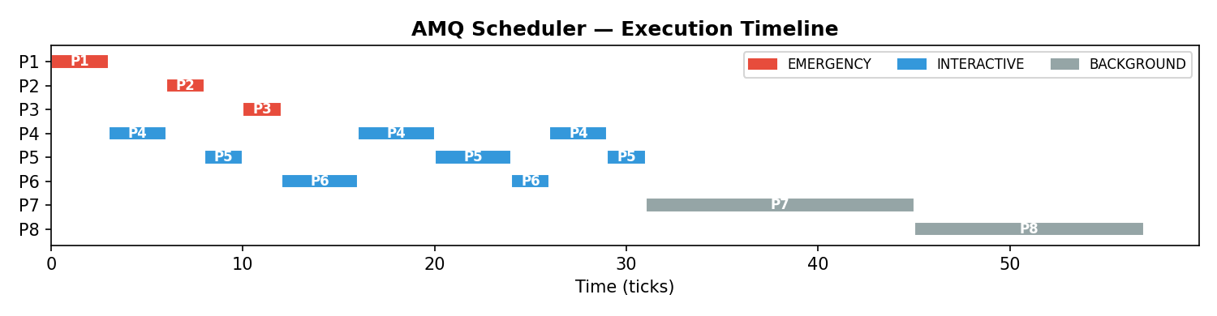
Figure 2. Execution timeline (Gantt chart) produced by the AMQ scheduler on the test workload.
PID | Process | Queue | Arr | Burst | Compl. | Wait | Resp.
P1 | ECG Alert | Emergency | 0 | 3 | 3 | 0 | 0
P2 | ICU Monitor | Emergency | 6 | 2 | 8 | 0 | 0
P3 | Code Blue | Emergency | 10 | 2 | 12 | 0 | 0
P4 | Dr Dashboard | Interactive | 0 | 10 | 29 | 19 | 3
P5 | EMR Lookup | Interactive | 1 | 8 | 31 | 22 | 7
P6 | Nurse Chart | Interactive | 3 | 6 | 26 | 17 | 9
P7 | Billing Batch | Background | 0 | 14 | 45 | 31 | 31
P8 | Nightly Backup | Background | 2 | 12 | 57 | 43 | 43

Average Waiting Time = 16.50 ticks | Average Turnaround Time = 23.62 ticks | Average Response Time = 11.62 ticks | CPU Utilisation = 57.0% | Average Emergency Response Time = 0.00 ticks

2.6 Baseline Comparison — Plain FCFS
To quantify improvement, the same workload was run through a naive single-queue FCFS scheduler (no priority, no preemption).
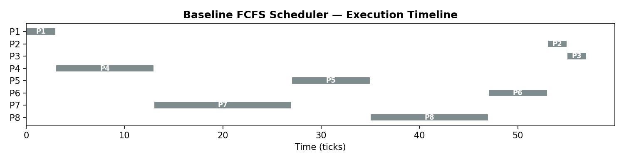
Figure 3. Execution timeline under a plain FCFS baseline — note ICU Monitor (P2) and Code Blue (P3) are delayed until t = 53-57.
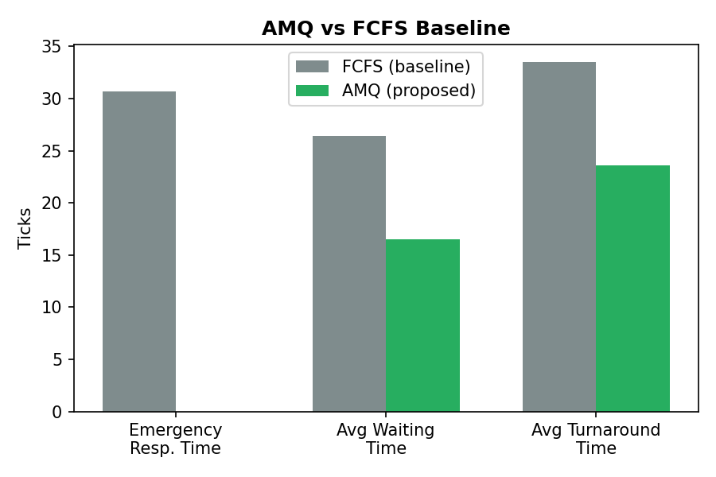
Figure 4. AMQ vs FCFS baseline across key metrics.

2.7 Result Interpretation
- Emergency response time drops from 30.67 ticks (FCFS) to 0.00 ticks (AMQ) — a 100% reduction on this workload, directly validating the preemptive-priority design for life-critical tasks.
- Average waiting time improves from 26.38 to 16.50 ticks, and average turnaround time from 33.50 to 23.62 ticks, showing that reprioritising clinical work does not come at a large cost to overall system throughput.
- Background jobs (P7, P8) still complete within the simulation window under AMQ, confirming the aging mechanism prevents indefinite starvation even though they are always pre-empted by higher queues.

2.8 Next Steps Toward 60% Completion Target
- Extend the workload generator to trace-driven / randomised arrivals for statistically robust evaluation (multiple seeds, confidence intervals).
- Add configurable aging-slope experiments to empirically tune starvation-prevention vs. clinical-urgency trade-offs.
- Port the validated simulator logic into a Linux kernel module or eBPF-based scheduler class for a systems-level (not just simulated) demonstration, per the Week 3-4 plan.

