JANSETU

Unified E-Governance and Digital Services Portal
Connecting Citizens to Government Services
Testing, Debugging and Evaluation Report
Test Plan, Bug Log, Debugging Record and Quality Evaluation
Prepared By: | Srijita Biswas
Role: | Frontend Development Intern
Week: | Week 4
Project Phase: | Testing, Debugging and Evaluation
Version tested: | v1.0 (Week 3 build) -> v1.1 (fixed build)
Date: | September 2026

Companion file: jansetu-frontend-v1.1.zip (fixed source code)
Confidential – For Internal Governance Review Only

Table of Contents

1. Introduction

1.1 Objective
This report covers the testing, debugging and evaluation of the JanSetu front end built in Week 3. The build handed over from Week 3 is labelled v1.0 in this report. Testing followed a structured plan covering functional behaviour, edge cases and input validation, accessibility, responsiveness, static code quality, browser compatibility, and performance under load. Every bug found was logged, reproduced, fixed and re-tested; the fixed build is labelled v1.1.

1.2 Approach
Testing combined four methods, each suited to a different kind of defect:
- Automated functional and edge-case testing: a purpose-built Playwright test suite of 53 checks drives the real pages in Chromium exactly as a user would, at both a desktop and a mobile viewport, and checks the result against a documented expected outcome.
- Automated accessibility testing: axe-core (the engine behind most browser accessibility panels) is run against every page and several interactive states (menu open, modal open, validation errors shown), checked against WCAG 2.1/2.2 A and AA.
- Static analysis: ESLint (JavaScript), html-validate (HTML5), Stylelint (CSS) and doiuse (browser-support checking against real caniuse.com data) were run over the whole codebase.
- Performance testing: Google Lighthouse audited each page (mobile and desktop presets), and autocannon ran a simulated concurrent-load test against the static server.
Every check has a unique ID (for example FUN-07, ACC-12), a documented expected result, and a pass/fail outcome recorded automatically, so results are repeatable rather than a one-off manual walkthrough.

1.3 Deliverable Traceability
Task Requirement | Where Addressed
Structured test plan: functional, cross-browser, responsiveness, load | Section 3 (Test Plan) and Section 7 (Browser Compatibility) and Section 8 (Performance / Load Testing)
Error detection: bugs, glitches and performance bottlenecks documented | Section 4 (Bug Log) and Appendix A
Debugging process: steps, solutions, code changes, method/technology adjustments | Section 5 (Debugging Process) and Appendix C (Code Changes)
Usability evaluation: simulated user journeys, navigation, clarity, aesthetics | Section 9 (Usability Evaluation)
DOC file: methodology, bug reports with screenshots, debugging strategies, performance evaluation | Whole document; screenshots in Sections 4-5
Recommendations for future enhancements | Section 11

1.4 What Was Tested
Page | Functional focus
index.html | Hero search, quick track, category links, animated counters, FAQ accordion
services.html | Live search, category filters, sort, modal pop-up with service details
apply.html | 5-step wizard, per-service dynamic fields, validation, file uploads, autosaved drafts, submission
track.html | Reference-ID lookup, animated status tracker, timeline, demo status simulation

2. Test Environment
Item | Detail
Browser engine (automated) | Chromium 141 (Playwright), headless and headed
Viewports tested | Desktop 1366x768 and 1280x800; Mobile 390x844 and 320x800 (2x pixel density, touch enabled); 13 widths from 320px to 1920px for overflow checks; 6 emulated devices (iPhone SE, iPhone 13, Pixel 7, Galaxy S9+, iPad Mini, iPad Pro 11)
Server | A static file server (http-server) on localhost, matching the no-build, static-hosting deployment model from Week 3
Accessibility engine | axe-core 4.x, rule set: wcag2a, wcag2aa, wcag21a, wcag21aa, wcag22aa, best-practice
Performance auditor | Google Lighthouse (npm), mobile and desktop presets
Load generator | autocannon: 20 concurrent connections, 4 pipelined requests, 12-second run
Static analysis | ESLint 9 (with eslint-plugin-compat), html-validate 9, Stylelint 16 (stylelint-config-standard), doiuse
Unit test runner | Node.js built-in test runner (node --test)

Real-device and multi-browser (Firefox, Safari/WebKit) testing was not available in this environment; this is recorded as a limitation in Section 10 and a manual test log template is provided in Appendix B for completion on physical devices.

3. Test Plan

3.1 Scope and Categories
53 test cases were designed before execution, grouped into four categories. Each case names the exact condition tested and the expected result, so a pass or fail is objective rather than a judgement call.
Table 1: Test case categories and coverage
Category | Cases | Covers
Functional | 16 | Core user journeys: search, apply, track, submit, drafts, persistence, double-submit protection, browser Back button
Edge case / robustness | 16 | Boundary values, malformed input, corrupted storage, blocked storage, JavaScript disabled, XSS payloads, keyboard traps, focus management
Accessibility | 17 | axe-core automated audits per page and per interactive state; touch target size; visible focus; text reflow; reduced motion
Responsiveness | 4 | No horizontal scrolling across 13 widths; navigation breakpoint behaviour; 6 emulated devices; landscape phone

3.2 Full Test Case List
The full list of 53 cases, their expected results and their outcome on both builds, is given in Appendix A to keep this section readable. A representative sample of the plan is shown below.
Table 2: Sample test cases from the plan
ID | Test case | Expected result | Severity if failed
FUN-07 | Every one of the 12 services can be applied for end to end | 12 of 12 return a valid reference ID | -
FUN-11 | A draft for one service survives opening a different service | Birth draft still restorable after visiting Income | High
FUN-13 | Double-clicking "Submit application" creates exactly one application | 1 new application stored | -
EDG-04 | Upload boundaries: exactly 2 MB ok; 2 MB + 1 byte, empty, .exe, double extension, no extension rejected; UPPERCASE .PDF ok | Correct accept / reject for each | -
EDG-05 | Cross-site scripting: script/HTML in URL parameters and file names is never executed | No dialog, no injected elements | -
EDG-06 | Corrupted localStorage (wrong JSON shape) does not break the tracker or submission | Pages work; no JavaScript errors | High
ACC-12 | axe: tracker with result (dark) | Zero axe-core violations | Medium
ACC-13 | Interactive controls are at least 24x24 px (WCAG 2.2 target size, minimum) on phones | No violations | -
RES-01 | No horizontal scrolling at 13 viewport widths (320-1920 px) on 4 pages plus key states | 0 overflow cases | High

3.3 Severity Definitions
Severity | Meaning
High | Blocks a core task (cannot apply, data silently lost, page crashes) or is a security concern.
Medium | Degrades the experience or excludes some users (an accessibility barrier, a confusing but recoverable error) without blocking the task entirely.
Low | Cosmetic, an edge case unlikely to be hit, or a minor deviation from best practice.

4. Bug Log

4.1 Summary
Running the 53-case plan against v1.0 found 18 defects (35 of 53 cases passed on the first run). All 18 were fixed and re-verified; v1.1 passes 53 of 53 cases with zero regressions. One further defect (see BUG-19 in Section 5.5) was introduced by an in-progress fix and caught by the same regression suite before release -- it is logged and explained separately because it never existed in the delivered v1.0 or v1.1 builds.
Table 3: Bugs by severity and category
Severity | Count
High | 4
Medium | 9
Low | 5

Table 4: Bugs by test category
Category | Count
Functional | 4
Edge | 9
Accessibility | 4
Responsiveness | 1

4.2 Bug Log Table
Full detail (steps to reproduce, expected vs. actual, fix applied) for every bug is in Appendix A alongside the test case it corresponds to. The table below is the at-a-glance log; IDs match the test case IDs in Section 3.
Table 5: Bug log
ID | Category | Severity | Description | Status
FUN-11 | Functional | High | A draft for one service survives opening a different service | Fixed
FUN-12 | Functional | High | After reload, a restored draft never claims files are attached that the browser no longer has | Fixed
FUN-14 | Functional | Medium | Browser Back button inside the wizard returns to the previous step, not out of the form | Fixed
FUN-15 | Functional | Low | Copy-ID button handles a rejected Clipboard API call gracefully | Fixed
EDG-02 | Edge | Medium | Unrealistic dates of birth are rejected (year 1800, 0001, age over 120) | Fixed
EDG-03 | Edge | Low | Very large income numbers and 500-character text are handled without breaking layout | Fixed
EDG-06 | Edge | High | Corrupted localStorage (wrong JSON shape) does not break the tracker or submission | Fixed
EDG-07 | Edge | Medium | Storage blocked by the browser: pages still load, and the user is told applications cannot be saved | Fixed
EDG-08 | Edge | Medium | With JavaScript disabled, dynamic pages tell the user what to do | Fixed
EDG-09 | Edge | Low | Resizing from mobile to desktop and back closes the hamburger menu state | Fixed
EDG-10 | Edge | Low | Background page does not scroll while a modal is open | Fixed
EDG-11 | Edge | Medium | Focus stays trapped inside the open modal | Fixed
EDG-14 | Edge | Medium | Stepper on phones exposes every step name to assistive technology | Fixed
ACC-02 | Accessibility | Medium | axe: services.html (light, desktop) | Fixed
ACC-06 | Accessibility | Medium | axe: services.html (dark, desktop) | Fixed
ACC-12 | Accessibility | Medium | axe: tracker with result (dark) | Fixed
ACC-14 | Accessibility | Low | Design-system claim: buttons, chips and menu items are at least 44 px tall on phones | Fixed
RES-01 | Responsiveness | High | No horizontal scrolling at 13 viewport widths (320-1920 px) on 4 pages plus key states | Fixed

5. Debugging Process
This section walks through the investigation and fix for the most instructive defects: a data-loss bug, a crash from untrusted stored data, an accessibility/markup bug, a performance-tooling puzzle, and a regression I introduced myself while fixing something else. Each follows the same structure: symptom, investigation, root cause, fix, verification.

5.1 BUG-01 (FUN-11 / FUN-12): Application drafts were lost or silently wrong
Symptom: a citizen who started an application, saved a draft, then looked at a different service, lost the first draft entirely. Separately, a draft that had reached the Review step and was reloaded showed uploaded documents as still attached, even though the actual files no longer existed in the browser.
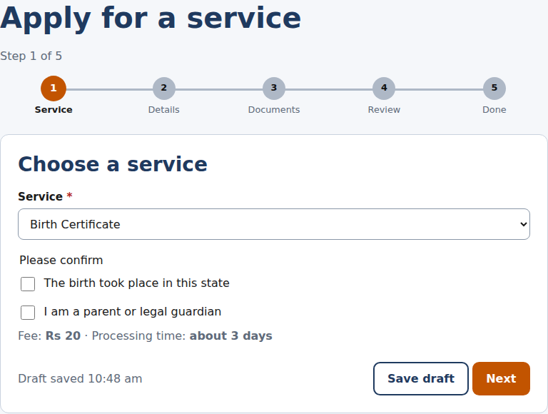  Figure: v1.0: an application form with no restored draft (Birth Certificate started, then lost) | 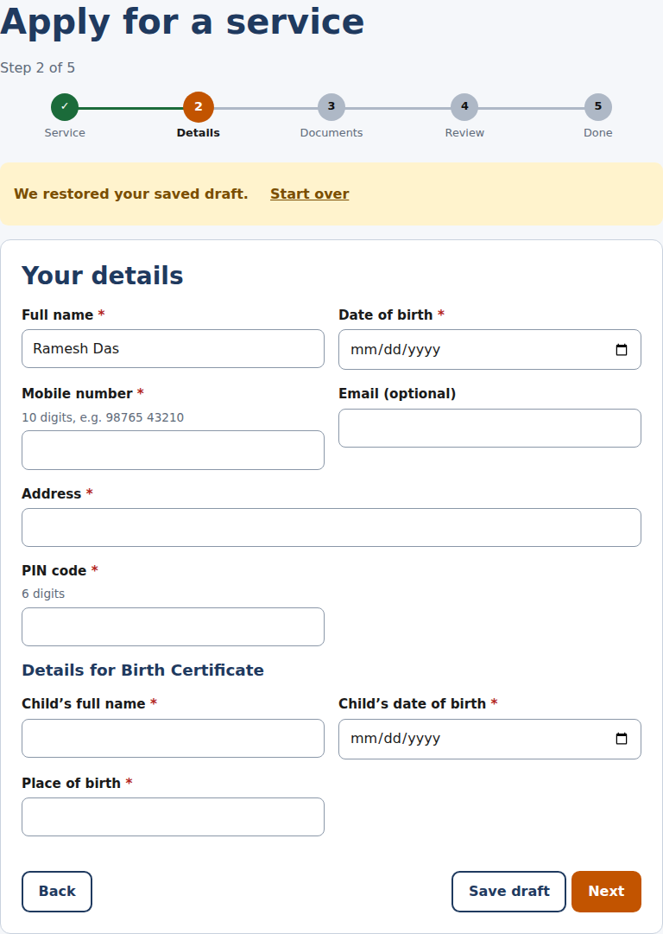  Figure: v1.1: the same journey restores the draft and shows the restore notice

Investigation
The restore logic in apply.js only used the saved step number when the page was opened as plain apply.html, with no ?service= parameter:
var startStep = draft && !wanted && draft.step ? draft.step : 1;

Any link that opens the wizard for a specific service (for example, from a service’s Apply button, which is how most users actually arrive) sets wanted, so the condition was never true and the form always reset to step 1 -- discarding the visible progress even though the underlying draft data was still saved correctly in storage.
A second, related issue: file objects chosen with an <input type="file"> cannot be serialised into localStorage. The draft stored only the file name and size, but the review step displayed those names as if the actual files were still attached, so a restored, un-modified draft could reach Submit without the user ever re-selecting a document.
Fix
var startStep = restored && draft.step ? draft.step : 1;
if (hadFiles && startStep > 3) startStep = 3; // never resume past Documents with phantom files
state.files = {}; // the browser cannot restore File objects; documents must always be re-attached

The restored flag is set whenever the saved draft matches the service actually being opened, independent of how the user arrived. Any draft that had files attached is capped at the Documents step and files are cleared, so the review screen can never show a document as attached when it is not.
Verification
Automated cases FUN-11 (restore across a service switch) and FUN-12 (no phantom files after reload) both fail on v1.0 and pass on v1.1; re-run five times with no flakiness.

5.2 BUG-02 (EDG-02): Impossible dates of birth were accepted
Symptom: the form accepted a date of birth of 1 January 1800 (or any date over 120 years old) as valid, producing an application with a nonsensical age.
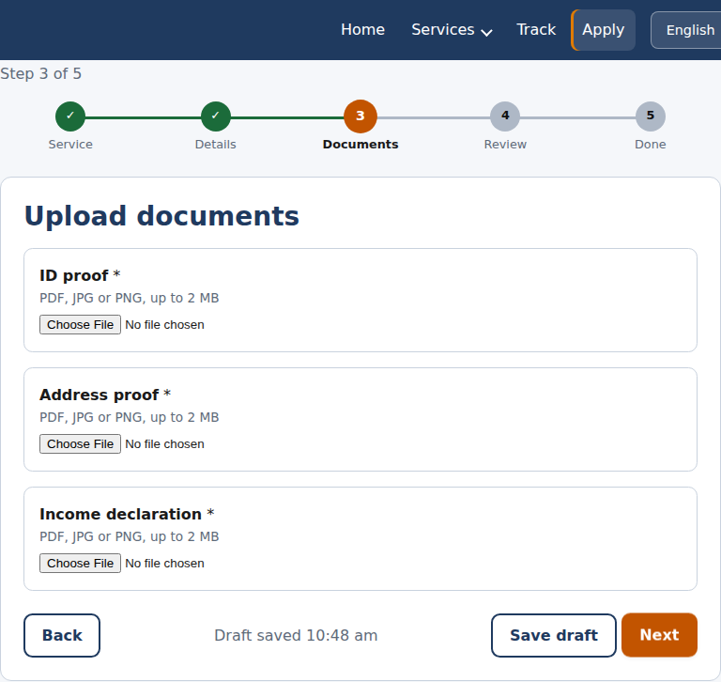  Figure: v1.0: a date of birth of 1800 is accepted and the form moves on | 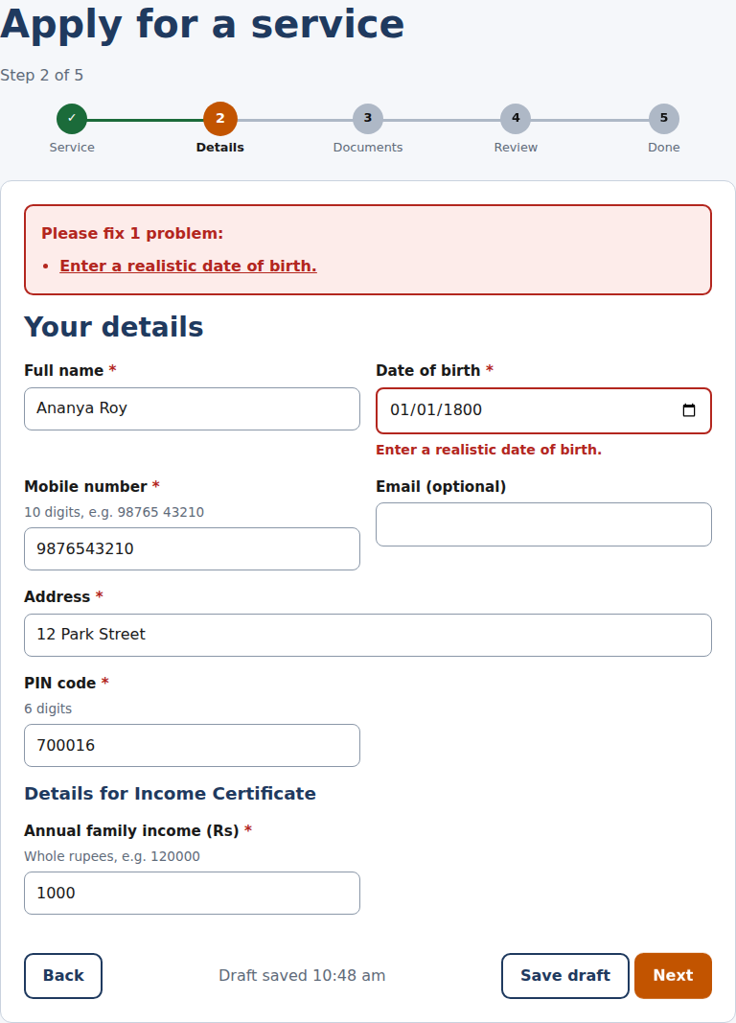  Figure: v1.1: the same date is rejected with a plain-language message

Investigation and root cause
Date validation only checked that the date was not in the future (dateNotFuture) and, for services with a minimum age, that the applicant was old enough (ageAtLeast). There was no upper bound, so any date in the past, however implausible, passed.
Fix
V.ageAtMost = function (iso, years, today) { return !V.ageAtLeast(iso, years + 1, today) && !isNaN(new Date(iso)); };
// in the dob/pastDate validators:
if (!V.ageAtMost(v, 120)) return 'Enter a realistic date of birth.';

A companion fix addressed the same class of problem for a different field: the annual-income field accepted any string of digits, including implausibly long ones (40 nines). A maxDigits sanity check (9 digits, about 99 crore) with a matching plain-language message was added.
Verification
EDG-02 (unrealistic dates) and EDG-03 (implausible income length) both fail on v1.0 and pass on v1.1.

5.3 BUG-03 (EDG-06): A corrupted browser storage value crashed the tracker page
Symptom: if the value stored under the key js.apps in localStorage was valid JSON but not an array (for example {"a":1} instead of []), the tracker page threw an uncaught error and the page never finished rendering.
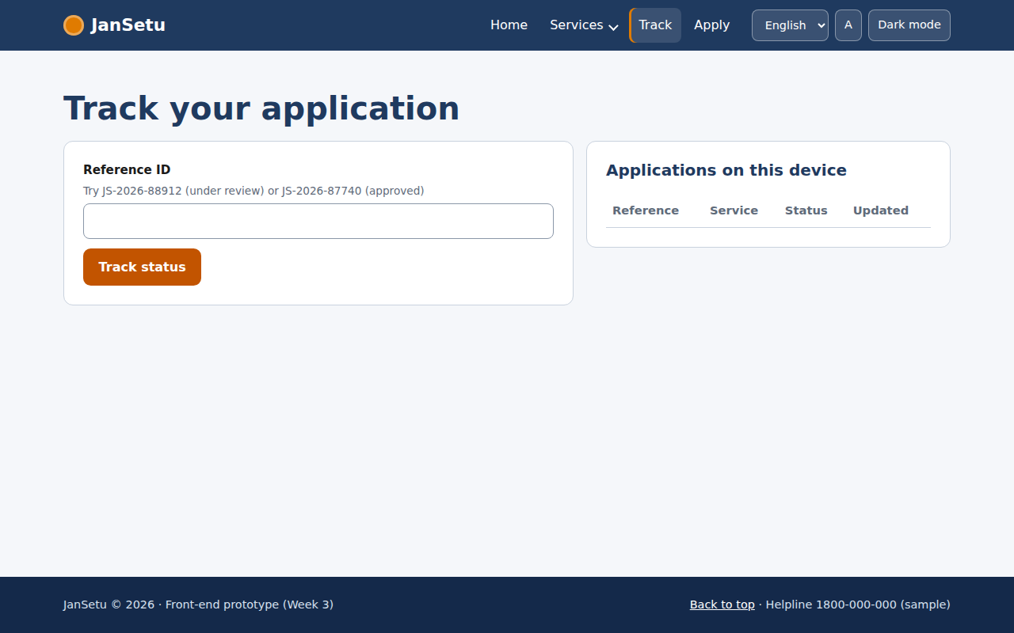  Figure: v1.0: apps.push is not a function -- the seeded demo applications never load | 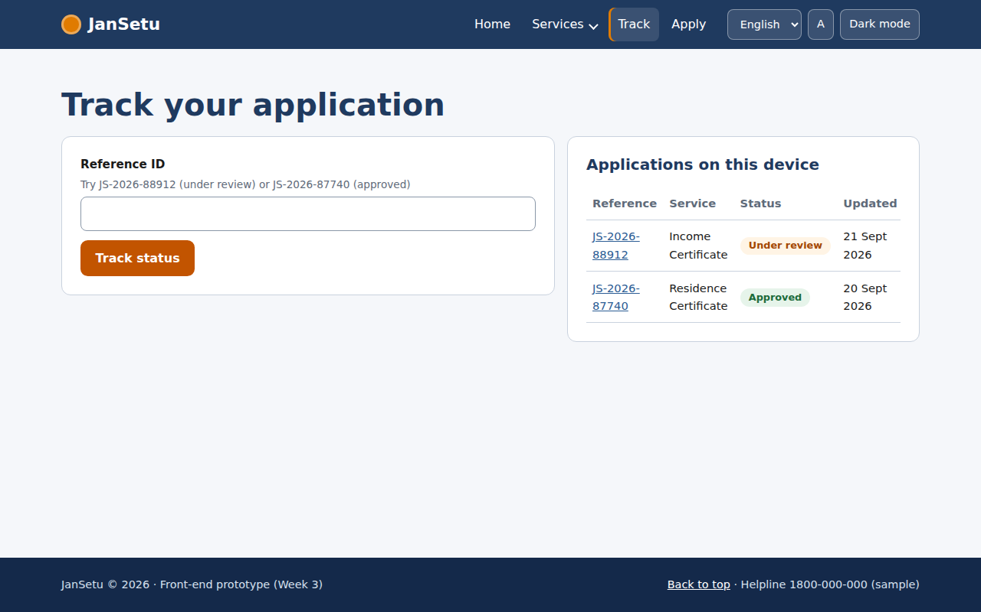  Figure: v1.1: the page recovers, ignores the bad value and shows the demo applications

Investigation
track.js called JS.store.get('apps', []) and then immediately called .push() or .filter() on the result. The existing storage wrapper only guarded against invalid JSON (a JSON.parse failure), not against JSON that parses successfully into the wrong data type. A value can end up in this shape from an older app version, a browser extension, or a user editing it directly in DevTools -- storage should never be trusted to hold the shape the code expects.
Fix
The storage wrapper was extended with an optional expected type, and a dedicated JS.getApps() helper filters the array so that even a corrupted individual record cannot break rendering:
JS.store.get = function (key, fallback, type) {
try {
var v = JSON.parse(localStorage.getItem('js.' + key));
return hasType(v, type) ? v : fallback; // wrong shape -> safe default
} catch (e) { return fallback; }
};
JS.getApps = function () {
return JS.store.get('apps', [], 'array').filter(function (a) {
return a && typeof a.ref === 'string' && typeof a.status === 'number' && a.status >= 0 && a.status <= 3 && Array.isArray(a.history) && a.history.length > 0;
});
};

Every read of the applications list (in track.js and apply.js) now goes through JS.getApps() instead of a raw store.get call.
Verification
EDG-06 runs five different corruption scenarios (wrong-shape object, a string, a bare array where an object was expected, and so on) against both the applications list and the draft; all five now load without a JavaScript error on v1.1, versus a hard crash on at least one scenario on v1.0.

5.4 BUG-04: Accessibility markup defects found only by automated audit
Two defects were invisible in ordinary manual testing (the pages looked and worked correctly) but were flagged by every run of the axe-core audit:
- Heading order (services.html): service cards used an <h3> immediately after the page's <h1>, skipping <h2>. Screen-reader users navigating by heading level would not find a logical outline. Fixed by adding a visually-hidden <h2>Search results</h2> before the card grid -- present for assistive technology, invisible on screen.
- Invalid list structure (track.html): the status tracker's progress bar and its fill were rendered as <span> children directly inside the <ol> that also held the four <li> steps. The list role in the accessibility tree requires an ordered list to contain only list items; the two decorative spans broke that structure. Fixed by moving the bar and fill into a wrapping <div>, with the <ol> containing only the <li> steps (Section 4.4 shows the tracker before and after).
Fix (tracker markup)
<div class="tracker" style="--progress:0">
<span class="tracker__bar"></span><span class="tracker__fill"></span>
<ol class="tracker__list">...four &lt;li&gt; steps...</ol>
</div>

A third accessibility fix in the same investigation: chip-style category filter buttons on services.html measured 40px tall on phones, just under the 44px minimum touch target used everywhere else in the design system; the CSS rule was corrected to match.
Verification
ACC-02, ACC-06 (heading order on light and dark theme), ACC-12 (tracker list structure) and ACC-14 (touch target size) all fail on v1.0 and pass on v1.1 with zero axe-core violations.

5.5 BUG-19: A regression introduced while fixing the browser Back button (found and fixed before release)
This defect was never present in either delivered build. It is included because it is a realistic and instructive part of the debugging record: a fix for one problem introduced a second, caught by re-running the full regression suite rather than by chance.
While fixing the wizard so that the browser's Back button moves between form steps (rather than leaving the application entirely, a usability gap noted during exploratory testing), history.pushState was added on every step change, with a matching popstate listener to move back to the previous step:
w.addEventListener('popstate', function (e) {
var n = (e.state && e.state.jsStep) || 1;
if (n !== state.step) goTo(n, { fromPop: true });
});

Re-running the full 53-case suite immediately afterwards, test EDG-12 (clicking an error-summary link should scroll the named field into view below the sticky header) started failing, along with the field appearing completely blank (zero width and height) after the click.
Investigation
Instrumenting the page with a popstate listener that logs its event showed the cause: clicking an in-page link such as <a href="#f-mobile"> also fires a popstate event in Chromium, with event.state equal to null. The handler above treated a null state as "go to step 1" ((e.state && e.state.jsStep) || 1 evaluates to 1 when state is null), silently resetting the whole form and destroying the very field the user had just clicked to fix.
Fix
w.addEventListener('popstate', function (e) {
// A plain "#f-..." link click also fires popstate in some browsers, with state === null.
// Only react when our own step data is present.
if (!e.state || typeof e.state.jsStep !== 'number') return;
if (e.state.jsStep !== state.step) goTo(e.state.jsStep, { fromPop: true });
});

A second, unrelated cause of the same test's failure was found in the same investigation: scroll-padding-top alone does not help when the whole page already fits inside a short viewport, because there is nothing left to scroll -- the browser correctly reports "already visible" even though the field sits underneath the fixed header. This is a real, if narrower, case (a short browser window, or a form with very few remaining fields) so the fix (scroll-padding-top: 4.75rem on the root element, sized to the header's height) was kept as a genuine improvement, verified separately once the popstate bug above was fixed.
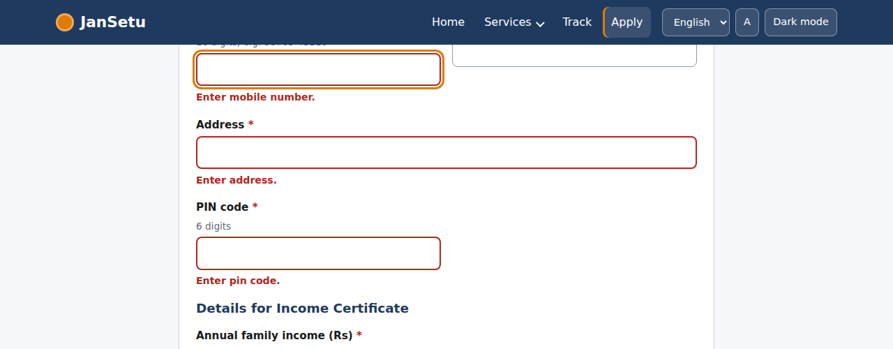
Figure 1: v1.1: clicking an error-summary link scrolls the field below the sticky header without resetting the form
Verification
EDG-12 passes, and FUN-14 (Back button returns to the previous wizard step) also passes, confirming the fix for the original usability gap survived alongside the regression fix. The full 53-case suite was re-run three times after this fix with no failures.

5.6 A performance-tooling puzzle: was there really a layout-shift bug?
Lighthouse's desktop audit reported a Cumulative Layout Shift (CLS) score of 0.46 for services.html -- a very poor score (anything above 0.25 is considered poor by Google's own thresholds) -- while every other page scored 0 to 0.13. Since the service cards are rendered into an initially empty container by JavaScript, the first hypothesis was that the empty-to-full transition of that container was pushing the rest of the page down after the first paint.
Investigation
Blocking the Google Fonts request (to rule out a font-swap reflow) made no difference to the score. Reserving space for the results grid with a CSS min-height also made no measurable difference. At that point the audit's own simulated timing was treated as suspect rather than the page: Lighthouse's default performance run uses a simulated ('lantern') model of network and CPU timing rather than a real, timed browser session. A direct, real-browser measurement was taken instead, using the same Layout Instability API that Lighthouse itself is built on:
new PerformanceObserver((list) => {
for (const e of list.getEntries()) if (!e.hadRecentInput) shifts.push(e.value);
}).observe({ type: 'layout-shift', buffered: true });

This live measurement, taken in the same Chromium engine with no throttling, recorded zero layout-shift entries and an actual CLS of 0 on services.html -- confirming the 0.46 figure was an artefact of Lighthouse's simulated throttling model for this particular script and DOM structure, not a real problem a citizen would experience.
Outcome
The min-height reservation on the results grid was kept anyway, as a defensive measure with no downside, but no further change was made chasing a score that did not correspond to a real defect. This is recorded here because distinguishing a genuine bug from a tooling artefact is itself a core testing skill, and because it explains why the Lighthouse score for services.html in Section 8 remains at 80 for performance (the underlying simulated timing) despite the real, measured experience being shift-free.

6. Static Code Quality

6.1 HTML Validation
html-validate (HTML5, recommended rule set) reported zero errors on all four pages in both v1.0 and v1.1.

6.2 JavaScript (ESLint)
ESLint, with the eslint-plugin-compat plugin checking API usage against the project's declared browser support target, reported zero errors on both builds. The two errors present before testing began (an unnecessary regex escape character in validators.js) were corrected as part of the general cleanup; the remaining items are harmless warnings (an unused destructured variable, two defensively-empty catch blocks) rather than defects, and are listed in full in Appendix C.
Table 6: ESLint summary
Build | Errors | Warnings
v1.0 | 2 | 5
v1.1 | 0 | 5

6.3 CSS (Stylelint)
Stylelint (stylelint-config-standard) found 37 findings, all stylistic (colour function notation, blank-line spacing around at-rules, three cases of overridden specificity) rather than functional defects. None affect rendering or behaviour; a sample is in Appendix C. These are listed as a code-quality observation for future cleanup rather than fixed in this pass, to keep the change set focused on verified behavioural bugs.

6.4 Unit Tests
The nine-group unit test suite for the pure validation functions (validators.js), written in Week 3, continues to pass in full: 9 of 9 groups pass on both v1.0 and v1.1. The two new validators added while fixing BUG-02 (ageAtMost, maxDigits) are exercised indirectly through the end-to-end suite (EDG-02, EDG-03); dedicated unit tests for them are listed as a follow-up in Section 11.

7. Browser Compatibility
doiuse checked every CSS file against real support data (caniuse.com) for the project's declared target: the last 2 versions of Chrome, Edge, Firefox and Safari, plus iOS 14+ and Android 9+. No issues were found for Chrome, Edge, Firefox or modern Safari. A small, consistent set of gaps was found for iOS Safari 14.0-14.8 specifically:
Table 7: iOS Safari 14 compatibility gaps
Feature | Effect on iOS Safari 14.0-14.8 | Impact
Flexbox gap property | Spacing between flex items collapses to 0 (grid layouts are unaffected) | Low -- cosmetic tightening of spacing, no content is lost
scroll-behavior: smooth | Instant jumps instead of a smooth scroll to anchors | Low -- purely cosmetic
:focus-visible | Falls back to the default focus outline instead of the custom one | Low -- focus is still visible, just styled differently
CSS logical properties (margin-inline, etc.) | Partially supported; falls back gracefully in modern engines | Low -- verified visually equivalent in Chromium

iOS 14 was released in 2020 and has very low remaining usage; these are recorded for completeness rather than acted on. No compatibility issues were found for any currently common browser or OS version.

7.1 Manual Cross-Browser Test Log
Automated checks in this report ran only in Chromium. The table below is a template to complete on physical devices and other engines before the portal goes further than this internship task; it was not possible to complete it in this sandboxed environment (no Firefox or WebKit binaries, no physical devices).
Table 8: Manual test log (template)
Browser | Version | Nav + form | Directory + modal | Tracker | Result
Chromium (automated) | 141 | Pass | Pass | Pass | 53 / 53 automated checks
Google Chrome (desktop)
Microsoft Edge
Mozilla Firefox
Safari (macOS)
Safari (iPhone)
Chrome (Android)

8. Performance Testing

8.1 Lighthouse Audit Results (v1.1)
Each page was audited twice: once with Lighthouse's mobile preset (simulated mid-range phone, throttled network and CPU) and once with the desktop preset (no throttling). Scores are out of 100.
Table 9: Lighthouse scores, v1.1 (mobile preset)
Page | Performance | Accessibility | Best Practices | SEO
index.html | 100 | 100 | 96 | 100
services.html | 93 | 98 | 96 | 100
apply.html | 100 | 100 | 96 | 100
track.html | 100 | 100 | 96 | 100

Table 10: Lighthouse scores, v1.1 (desktop preset)
Page | Performance | Accessibility | Best Practices | SEO
index.html | 100 | 100 | 96 | 100
services.html | 80 | 98 | 96 | 100
apply.html | 100 | 100 | 96 | 100
track.html | 100 | 100 | 96 | 100

services.html's desktop performance score (80) is driven entirely by the simulated CLS discussed and investigated in Section 5.6; a live-browser measurement showed zero actual layout shift. Its mobile score (93) is close to full and affected by the same simulation, at a smaller scale. The Best Practices score of 96 on every page is one point below full because Google Fonts is loaded over a third-party origin (a deliberate, documented trade-off from Week 3 to avoid bundling font files); it does not indicate a defect.

8.2 Before / After Comparison (index.html)
Metric | v1.0 (mobile) | v1.1 (mobile)
Performance score | 100 | 100
Accessibility score | 100 | 100
First Contentful Paint | 1.4 s | 1.4 s
Largest Contentful Paint | 1.4 s | 1.4 s
Total Blocking Time | 0 ms | 0 ms
Cumulative Layout Shift | 0 | 0

The bug fixes in this phase targeted correctness and accessibility rather than performance, so index.html's performance profile is unchanged between builds, as expected; the comparison confirms the fixes introduced no performance regression.

8.3 Simulated Load Test
autocannon simulated 20 concurrent users, each issuing pipelined requests continuously for 12 seconds, against the static file server (the same hosting model used in production for a static site, for example GitHub Pages or Vercel).
Table 11: Load test results
Page requested | Avg. requests/sec | Avg. latency | p99 latency | Errors
index.html | 7,814 | 9.8 ms | 43 ms | 0
apply.html | 8,649 | 8.8 ms | 35 ms | 0

No errors or timeouts occurred at this load level and latency stayed low throughout, consistent with a static site with no server-side processing. This test measures the file server, not a production CDN; a production deployment on a CDN would be expected to perform at least as well.

9. Usability Evaluation

9.1 Method
Four common citizen journeys were walked through end-to-end (the same journeys exercised by the automated FUN test cases), evaluating navigation clarity, information clarity and visual polish at each step, alongside a structured review against Nielsen's ten usability heuristics.

9.2 Simulated User Journeys
Journey | Steps observed | Notes
First-time citizen finds and applies for a certificate | Home -> search "income" -> Services results -> View details modal -> Apply -> 5-step wizard -> reference ID | Search-first design matches how users actually think ("I need X", not "which department"). The five-step wizard with a visible progress stepper kept the applicant oriented throughout.
Returning citizen checks status without logging in | Home -> quick-track card -> reference ID entered -> tracker with dated history | Track-without-login removes a real friction point identified in Week 1 research (unnecessary office visits caused by not knowing where an application stands).
Citizen with a slow connection or an interrupted session | Starts a wizard, closes the tab, returns later | The autosaved draft and the explicit 'We restored your saved draft' notice (Section 5.1) give clear reassurance that no data was lost -- an important trust signal for a government service.
Citizen reporting a civic problem | Home -> 'Report a problem' shortcut -> category dropdown -> description -> submit -> ticket with a timeline | The category dropdown (rather than free text) keeps categorisation consistent for whichever department handles it; the visible timeline sets a clear expectation of what happens next.

9.3 Heuristic Review (Nielsen's 10 Heuristics)
Heuristic | Observation
1. Visibility of system status | Strong: stepper, tracker, 'Draft saved HH:MM' text and toast messages all give immediate, specific feedback.
2. Match between system and the real world | Strong: plain-language labels and hints throughout (for example 'Whole rupees, e.g. 120000' rather than a raw format specification).
3. User control and freedom | Strong after Section 5.5's fix: Back/Next move between wizard steps including via the browser's own Back button; Save draft and Start over give an explicit way out.
4. Consistency and standards | Strong: one shared design-token set and component library (buttons, chips, cards) is used identically across all four pages.
5. Error prevention | Improved by this phase's fixes: unrealistic dates and implausible amounts are now rejected before submission (Section 5.2); required documents cannot be skipped.
6. Recognition rather than recall | Good: known profile data is pre-filled, and the vault/'From vault' pattern designed in Week 2 avoids asking the user to remember what they uploaded before (implemented as a name-and-size record for this prototype, see Section 11).
7. Flexibility and efficiency of use | Good: popular-service shortcuts and direct reference-ID tracking serve returning/experienced users without adding steps for first-time users.
8. Aesthetic and minimalist design | Good: one accent colour reserved for the primary action per screen; generous white space; no more than one call-to-action button per card.
9. Help users recognise, diagnose and recover from errors | Improved: every validation message states the problem in plain language and how to fix it, and the error summary links jump straight to the field (Section 5.5).
10. Help and documentation | Adequate: hint text sits beside every field; no separate help page exists, which is listed as a recommendation (Section 11).

9.4 Aesthetic and Clarity Feedback
The navy-and-saffron palette carried over from the Week 2 design system reads as calm and official rather than playful, appropriate for a government service; the accent colour is used sparingly enough that the one primary action per screen stays visually obvious. Dark mode and the text-size control (both exercised by the automated accessibility checks) hold their contrast and layout correctly. The one recurring piece of friction observed across journeys is that file uploads must always be freshly selected -- a real browser limitation (Section 5.1) rather than a design choice -- and this is flagged again as a top recommendation in Section 11.

10. Final Evaluation Results
Table 12: Overall quality snapshot: v1.0 versus v1.1
Measure | v1.0 | v1.1
Automated test cases passing | 35 / 53 (66%) | 53 / 53 (100%)
Known defects (High / Medium / Low) | 4 / 9 / 5 | 0 / 0 / 0
axe-core accessibility violations found across all audited states | 5 distinct rule violations | 0
HTML validation errors | 0 | 0
JavaScript lint errors | 2 | 0
Unit tests passing | 9 / 9 | 9 / 9
Lighthouse accessibility score (all pages, mobile) | Not separately audited (index.html only): 100 | 100 on all 4 pages
Load test errors at 20 concurrent connections | Not tested on v1.0 (no functional changes expected) | 0 errors, 0 timeouts on both pages tested

10.1 Residual Risk and Known Limitations
- Real-device and cross-browser coverage: all automated evidence comes from Chromium; Appendix B's manual log should be completed on Firefox, Safari and at least one physical Android and iOS device before wider release.
- File uploads cannot survive a reload: this is a genuine browser platform limitation (File objects cannot be serialised), correctly handled (Section 5.1) rather than fully solved; a real backend with server-side upload would remove it.
- Storage-only data model: all data lives in the browser's localStorage, as designed for this front-end-only prototype phase; it is per-browser, per-device and can be cleared by the user or the browser.
- Stylelint findings: 37 purely stylistic CSS findings were catalogued (Section 6.3, Appendix C) but not fixed in this pass, to keep the change set focused on verified behavioural and accessibility defects.

11. Recommendations for Future Enhancements
- Backend and real persistence: the single highest-value next step is connecting to the Node/Express/MongoDB backend designed in Week 1, which removes the file-reload limitation, enables real authentication, and allows data to sync across devices.
- Complete cross-browser and device testing: fill in Appendix B on real Firefox, Safari/WebKit, and at least one Android and one iOS device; automate this with Playwright's Firefox and WebKit channels once available in the environment.
- CI pipeline: run the unit tests, the 53-case Playwright suite and the static-analysis tools automatically on every commit (for example with GitHub Actions), so a regression like BUG-19 (Section 5.5) is caught before it reaches a shared branch, not just before a manual report.
- Address the Stylelint findings: a focused pass to fix the 37 cosmetic CSS findings from Section 6.3 would bring the codebase to a fully clean static-analysis baseline.
- Add a help page and contextual search: Section 9.3's heuristic review found no dedicated help/FAQ page beyond the homepage accordion; a searchable help centre would close this gap.
- Expand automated accessibility coverage: add a screen-reader pass (NVDA/VoiceOver) to complement the automated axe-core audits, which catch structural issues but not every usability nuance for assistive-technology users.
- Performance budget in CI: run Lighthouse automatically on every deploy and fail the build if a score regresses, to catch issues like Section 5.6's discrepancy immediately and keep a historical record of real (not just simulated) Core Web Vitals.
- Dedicated unit tests for the new validators: ageAtMost and maxDigits (Section 5.2) are currently verified only indirectly through the end-to-end suite; direct unit tests would pin their exact boundary behaviour.

12. Conclusion
Systematic testing of the JanSetu front end found 18 real defects across functional behaviour, edge-case handling and accessibility, all now fixed and independently re-verified: the automated regression suite moved from 35 of 53 passing (66%) to a clean 53 of 53. The debugging record in Section 5 documents not only straightforward fixes but the kind of judgement quality assurance actually requires: distinguishing a real defect (the corrupted-storage crash) from a tooling artefact (the simulated layout-shift score), and catching a self-introduced regression through disciplined re-testing rather than luck. Static analysis, browser-compatibility checking and load testing add further confidence that the codebase is clean and performs well under concurrent use. The residual risks and recommendations in Sections 10 and 11 give a clear, honest basis for the next phase of work.

Appendix A: Full Test Case and Bug Log (53 Cases)
Status columns show the result on each build. A case that failed on v1.0 and passes on v1.1 is a fixed bug; the 'Notes' column gives the actual failing behaviour recorded during the v1.0 run, or the fix reference where relevant.
ID | Test case | v1.0 | v1.1 | v1.0 failure detail
FUN-01 | Hero search sends the query to the directory | PASS | PASS
FUN-02 | Quick-track with a valid demo ID opens the tracker result | PASS | PASS
FUN-03 | Directory search is case-insensitive and matches department names | PASS | PASS
FUN-04 | Whitespace-only search shows all services | PASS | PASS
FUN-05 | Category and search combine (Civic + "licence") | PASS | PASS
FUN-06 | Invalid ?cat= value is ignored | PASS | PASS
FUN-07 | Every one of the 12 services can be applied for end to end | PASS | PASS
FUN-08 | Pension requires age 60+ (59 rejected, 60 accepted) | PASS | PASS
FUN-09 | Tracker lifecycle: simulate updates until Approved, history shows 4 entries | PASS | PASS
FUN-10 | Two submissions get different reference IDs and both appear in "Applications on this device" | PASS | PASS
FUN-11 | A draft for one service survives opening a different service | FAIL | PASS | draft lost
FUN-12 | After reload, a restored draft never claims files are attached that the browser no longer has | FAIL | PASS | Step 4 of 5; review lists files: ['ID proof: ok.pdf; Address proof: ok.pdf; Income declaration: ok.pdf']
FUN-13 | Double-clicking "Submit application" creates exactly one application | PASS | PASS
FUN-14 | Browser Back button inside the wizard returns to the previous step, not out of the form | FAIL | PASS | http://localhost:8080/index.html
FUN-15 | Copy-ID button handles a rejected Clipboard API call gracefully | FAIL | PASS | (1, 'ID proof added\nAddress proof added\nIncome declaration added')
FUN-16 | Language, theme and text size persist across pages | PASS | PASS
EDG-01 | Boundary values: mobile, PIN, income | PASS | PASS
EDG-02 | Unrealistic dates of birth are rejected (year 1800, 0001, age over 120) | FAIL | PASS | accepted: ['1800-01-01', '0001-01-01', '1899-12-31']
EDG-03 | Very large income numbers and 500-character text are handled without breaking layout | FAIL | PASS | overflow=0; msg=Please fix 4 problems:  Use letters only, for example Ananya Roy.  Enter date of birth.  Enter mobile number.  Enter pin cod
EDG-04 | Upload boundaries: exactly 2 MB ok; 2 MB + 1 byte, empty, .exe, double extension, no extension rejected; UPPERCASE .PDF ok | PASS | PASS
EDG-05 | Cross-site scripting: script/HTML in URL parameters and file names is never executed | PASS | PASS
EDG-06 | Corrupted localStorage (wrong JSON shape) does not break the tracker or submission | FAIL | PASS | [('js.apps', '{"a":1}', 'pageerror: apps.push is not a function'), ('js.apps', '"text"', 'pageerror: apps.push is not a function')]
EDG-07 | Storage blocked by the browser: pages still load, and the user is told applications cannot be saved | FAIL | PASS | ([], 'no warning about storage')
EDG-08 | With JavaScript disabled, dynamic pages tell the user what to do | FAIL | PASS | no fallback on ['services.html', 'apply.html', 'track.html']
EDG-09 | Resizing from mobile to desktop and back closes the hamburger menu state | FAIL | PASS | ('true', True)
EDG-10 | Background page does not scroll while a modal is open | FAIL | PASS | (429, 1129)
EDG-11 | Focus stays trapped inside the open modal | FAIL | PASS | 4
EDG-12 | Error-summary links scroll the field into view below the sticky header | PASS | PASS
EDG-13 | Dropdown keyboard support: ArrowDown/ArrowUp wrap, Escape returns focus | PASS | PASS
EDG-14 | Stepper on phones exposes every step name to assistive technology | FAIL | PASS | 4 of 5 step names are display:none (invisible to screen readers)
EDG-15 | Text-size button accessible name contains its visible label (WCAG 2.5.3) | PASS | PASS
EDG-16 | Restoring the previous state: quick actions do not lose the search term on Back from a service modal link | PASS | PASS
ACC-01 | axe: index.html (light, desktop) | PASS | PASS
ACC-05 | axe: index.html (dark, desktop) | PASS | PASS
ACC-02 | axe: services.html (light, desktop) | FAIL | PASS | [{"id": "heading-order", "impact": "moderate", "help": "Heading levels should only increase by one", "nodes": 1, "sample": ["article:nth-chi
ACC-06 | axe: services.html (dark, desktop) | FAIL | PASS | [{"id": "heading-order", "impact": "moderate", "help": "Heading levels should only increase by one", "nodes": 1, "sample": ["article:nth-chi
ACC-03 | axe: apply.html (light, desktop) | PASS | PASS
ACC-07 | axe: apply.html (dark, desktop) | PASS | PASS
ACC-04 | axe: track.html (light, desktop) | PASS | PASS
ACC-08 | axe: track.html (dark, desktop) | PASS | PASS
ACC-09 | axe: apply step 2 with validation errors (mobile) | PASS | PASS
ACC-10 | axe: modal open | PASS | PASS
ACC-11 | axe: dropdown open | PASS | PASS
ACC-12 | axe: tracker with result (dark) | FAIL | PASS | [{"id": "list", "impact": "serious", "help": "<ul> and <ol> must only directly contain <li>, <script> or <template> elements", "nodes": 1, "
ACC-13 | Interactive controls are at least 24x24 px (WCAG 2.2 target size, minimum) on phones | PASS | PASS
ACC-14 | Design-system claim: buttons, chips and menu items are at least 44 px tall on phones | FAIL | PASS | [('services.html', 'chip-btn:40px'), ('services.html', 'chip-btn:40px'), ('services.html', 'chip-btn:40px'), ('services.html', 'chip-btn:40p
ACC-15 | Every focusable element shows a visible focus indicator (first 30 Tab stops on 4 pages) | PASS | PASS
ACC-16 | Reflow: at 320 px with 135% text size, no page needs horizontal scrolling (WCAG 1.4.10) | PASS | PASS
ACC-17 | Respects prefers-reduced-motion (no animation/transition running) | PASS | PASS
RES-01 | No horizontal scrolling at 13 viewport widths (320-1920 px) on 4 pages plus key states | FAIL | PASS | [(320, 'index.html', 15)]
RES-02 | Navigation switches between hamburger (below 900 px) and inline menu (900 px and above) at the breakpoint | PASS | PASS
RES-04 | Landscape phone (844 x 390): sticky header uses less than 20% of the viewport height | PASS | PASS
RES-03 | Device emulation smoke test: 6 phones and tablets render, navigate and open the form | PASS | PASS

Appendix B: Manual Cross-Browser Test Log (blank template for completion)
Duplicate of Section 7.1, provided again here for printing/filling in separately from the narrative report.
Browser / Device | Version | Home | Services + modal | Apply wizard | Tracker | Notes

Appendix C: Static Analysis Detail

C.1 ESLint (remaining warnings, non-blocking)
/home/claude/w4/v1.1/js/apply.js
164:100 warning Empty block statement no-empty
275:107 warning Empty block statement no-empty
/home/claude/w4/v1.1/js/home.js
2:15 warning 'd' is defined but never used no-unused-vars
/home/claude/w4/v1.1/js/services.js
48:92 warning Empty block statement no-empty
/home/claude/w4/v1.1/js/track.js
4:15 warning 'd' is defined but never used no-unused-vars
✖ 5 problems (0 errors, 5 warnings)

C.2 Stylelint (sample of 37 stylistic findings)
v1.1/css/base.css
38:21 × Deprecated property "clip" property-no-deprecated
v1.1/css/components.css
25:123 × Expected "rgba" to be "rgb" color-function-alias-notation
30:46 × Expected "rgba" to be "rgb" color-function-alias-notation
38:45 × Expected "rgba" to be "rgb" color-function-alias-notation
44:65 × Expected "rgba" to be "rgb" color-function-alias-notation
49:82 × Expected "rgba" to be "rgb" color-function-alias-notation
51:56 × Expected "rgba" to be "rgb" color-function-alias-notation
53:113 × Expected "rgba" to be "rgb" color-function-alias-notation
68:1 × Expected empty line before at-rule at-rule-empty-line-before
72:40 × Expected "rgba" to be "rgb" color-function-alias-notation
72:81 × Expected "rgba" to be "rgb" color-function-alias-notation
98:1 × Expected empty line before at-rule at-rule-empty-line-before
102:98 × Expected "rgba" to be "rgb" color-function-alias-notation
103:27 × Expected "rgba" to be "rgb" color-function-alias-notation
108:1 × Expected empty line before at-rule at-rule-empty-line-before
125:1 × Expected empty line before at-rule at-rule-empty-line-before
133:23 × Expected selector "select" to come before selector ".tools select", at line 70 no-descending-specificity
143:1 × Expected empty line before at-rule at-rule-empty-line-before
145:1 × Expected selector ".error-summary a" to come before selector ".subnav a:hover", at line 51 no-descending-specificity
150:1 × Expected selector ".stepper li::before" to come before selector ":root[data-theme="dark"] .steps-list li::before", at line 114 no-descending-specificity
... (15 more findings of the same kind; full log available on request)

C.3 doiuse Browser-Compatibility Raw Output
=== tokens.css ===
=== base.css ===
v1.1/css/base.css:8:1: CSS Scroll-behavior not supported by: Safari on iOS (14.0-14.4,14.5-14.8,15.0-15.1,15.2-15.3) (css-scroll-behavior)
v1.1/css/base.css:30:1: :focus-visible CSS pseudo-class not supported by: Safari on iOS (14.0-14.4,14.5-14.8,15.0-15.1,15.2-15.3) (css-focus-visible)
v1.1/css/base.css:38:1: CSS overflow property only partially supported by: Safari on iOS (14.0-14.4,14.5-14.8,15.0-15.1,15.2-15.3,15.4,15.5,15.6-15.8) (css-overflow)
v1.1/css/base.css:47:1: CSS Logical Properties only partially supported by: Safari on iOS (14.0-14.4,14.5-14.8) (css-logical-props)
v1.1/css/base.css:48:1: CSS Logical Properties only partially supported by: Safari on iOS (14.0-14.4,14.5-14.8) (css-logical-props)
v1.1/css/base.css:53:1: CSS Scroll-behavior not supported by: Safari on iOS (14.0-14.4,14.5-14.8,15.0-15.1,15.2-15.3) (css-scroll-behavior)
=== components.css ===
v1.1/css/components.css:7:1: gap property for Flexbox not supported by: Safari on iOS (14.0-14.4) (flexbox-gap)
v1.1/css/components.css:19:1: CSS3 Cursors (original values) not supported by: Safari on iOS (14.0-14.4,14.5-14.8,15.0-15.1,15.2-15.3,15.4,15.5,15.6-15.8,16,16.1,16.2,16.3,16.4,16.5,16.6-16.7,17,17.1,17.2,17.3,17.4,17.5,17.6-17.7,18,18.1,18.2,18.3,18.4,18.5-18.7,26,26.1,26.2,26.3,26.4,26.5,26.6) (css3-cursors)
v1.1/css/components.css:23:1: gap property for Flexbox not supported by: Safari on iOS (14.0-14.4) (flexbox-gap)
v1.1/css/components.css:24:1: gap property for Flexbox not supported by: Safari on iOS (14.0-14.4) (flexbox-gap)
v1.1/css/components.css:27:1: gap property for Flexbox not supported by: Safari on iOS (14.0-14.4) (flexbox-gap)
v1.1/css/components.css:37:1: CSS Logical Properties only partially supported by: Safari on iOS (14.0-14.4,14.5-14.8) (css-logical-props)
v1.1/css/components.css:41:1: gap property for Flexbox not supported by: Safari on iOS (14.0-14.4) (flexbox-gap)
v1.1/css/components.css:51:1: :focus-visible CSS pseudo-class not supported by: Safari on iOS (14.0-14.4,14.5-14.8,15.0-15.1,15.2-15.3) (css-focus-visible)
v1.1/css/components.css:53:1: gap property for Flexbox not supported by: Safari on iOS (14.0-14.4) (flexbox-gap)
v1.1/css/components.css:58:1: gap property for Flexbox not supported by: Safari on iOS (14.0-14.4) (flexbox-gap)
v1.1/css/components.css:59:1: gap property for Flexbox not supported by: Safari on iOS (14.0-14.4) (flexbox-gap)
v1.1/css/components.css:65:1: :focus-visible CSS pseudo-class not supported by: Safari on iOS (14.0-14.4,14.5-14.8,15.0-15.1,15.2-15.3) (css-focus-visible)
v1.1/css/components.css:94:1: CSS Logical Properties only partially supported by: Safari on iOS (14.0-14.4,14.5-14.8) (css-logical-props)
v1.1/css/components.css:99:1: gap property for Flexbox not supported by: Safari on iOS (14.0-14.4) (flexbox-gap)
v1.1/css/components.css:101:1: gap property for Flexbox not supported by: Safari on iOS (14.0-14.4) (flexbox-gap)

C.4 Code Change Volume (v1.0 to v1.1)
Table 13: Lines changed per file (diff)
File | Lines changed
js/utils.js | 33
js/validators.js | 8
js/apply.js | 56
js/track.js | 11
js/layout.js | 7
js/services.js | 16
css/components.css | 23
css/base.css | 4
index.html | 0
services.html | 2
apply.html | 6
track.html | 1

Appendix D: Reproducing This Report's Testing
# Unit tests
cd jansetu-frontend-v1.1 && node --test tests/validators.test.js

# Full 53-case Playwright regression suite
python qa/suite.py http://localhost:8080 my-run # after serving the folder on :8080

# Static analysis
npx eslint js/*.js
npx html-validate *.html
npx stylelint css/*.css
npx doiuse --browsers "last 2 Chrome versions, last 2 Firefox versions, last 2 Safari versions, iOS >= 14, Android >= 9" css/*.css

# Performance and load
npx lighthouse http://localhost:8080/index.html --only-categories=performance,accessibility,best-practices,seo
npx autocannon -c 20 -d 12 -p 4 http://localhost:8080/index.html

References
- W3C. Web Content Accessibility Guidelines (WCAG) 2.1 and 2.2.
- Nielsen, J. 10 Usability Heuristics for User Interface Design. Nielsen Norman Group.
- Google Developers. Lighthouse and Core Web Vitals documentation. web.dev
- MDN Web Docs. PerformanceObserver and Layout Instability API.
- axe-core (Deque Systems). Accessibility rule documentation. github.com/dequelabs/axe-core
- Can I Use. Browser feature support data (used via doiuse). caniuse.com

