JANSETU

Unified E-Governance and Digital Services Portal
Connecting Citizens to Government Services
UI/UX Design Document and Wireframes
Designing and Wireframing the User Interface
Prepared By: | Srijita Biswas
Role: | Frontend Development Intern
Week: | Week 2
Project Phase: | UI/UX Design and Wireframing
Version: | 1.0
Date: | September 2026

Companion file: JanSetu_Interactive_Prototype.html (clickable prototype)
Confidential – For Internal Governance Review Only

Table of Contents

1. Introduction

1.1 Purpose
This document presents the user interface and user experience design for JanSetu, the unified E-Governance and Digital Services Portal defined in the Week 1 Requirements Specification. It turns the requirements, user roles and workflows into concrete screens: an information architecture, a design system, and high-fidelity wireframes for eleven key screens, each annotated to explain why it looks and behaves the way it does.
The design goal is simple: a citizen with limited digital literacy, using a low-cost phone on a slow network, should be able to find a service, apply, and track the result without help. Every decision in this document is tested against that goal.

1.2 Relationship to Week 1
Week 1 defined what JanSetu must do (31 functional requirements, 3 user roles, a 3-tier architecture and a React + Tailwind frontend). Week 2 defines how it should look and feel. The screens below map directly to the Week 1 modules: Authentication, Service Discovery, Service Application, Application Tracking, Document Vault, Grievance, and the Officer console.

1.3 Deliverable Traceability
Task Requirement | Where Addressed
High-fidelity wireframes for at least five key pages | Section 7: eleven screens (homepage, login, service directory, service detail, application form in two steps, dashboard, document vault, grievance, officer review, mobile views)
Annotations explaining design choices, navigation flows and interactive components | Section 4 (navigation), Section 7 (numbered annotations for every screen), Section 9 (interactions)
Research on UI/UX best practices, accessibility and usability | Sections 2, 3 and 10
Sketching and wireframing process | Section 6 (low-fidelity sketch, iteration log)
Design rationale: purpose, colour scheme, layout, contribution to service delivery | Section 5 (design system) and the rationale block under each screen in Section 7
Prototyping with interactive elements | Section 9 and the companion HTML prototype
Design process, challenges and how the design meets e-governance needs | Sections 6, 12 and 13

2. User Research and Analysis

2.1 Approach
The research was desk-based, using publicly available guidelines and platforms: the W3C Web Content Accessibility Guidelines (WCAG 2.1) [1], Nielsen’s ten usability heuristics [2], the GOV.UK Design System and Service Manual [3], the U.S. Web Design System [4], and the Guidelines for Indian Government Websites (GIGW) [5]. These were combined with the Week 1 personas and benchmarking of UMANG, DigiLocker and CPGRAMS. No primary user research with real citizens has been done yet; Section 11 plans it.

2.2 Findings and Design Implications
Table 1: Research findings and what they mean for JanSetu
Finding | Implication for the JanSetu design
Users arrive with a task (“I need an income certificate”), not a department name. | Search is the hero element; categories use everyday words, not department names.
Long forms cause drop-off, especially on mobile. | One question group per step, a visible progress bar, autosaved drafts and a five-step maximum.
Citizens fear making mistakes and losing data. | Inline validation with plain-language messages, ‘Save as draft’, and a review step before submission.
Repeated document uploads are the top irritation. | A document vault with ‘choose from vault’ in the Documents step.
Not knowing the status causes office visits. | Status tracker on the dashboard, tracking by reference ID without login, and notifications on every change.
Many users read in regional languages and use small screens. | Language switcher in the header, Noto Sans (supports Bengali and Devanagari), mobile-first layouts.
Government sites often fail contrast and keyboard tests. | AA contrast palette, visible focus ring, text-size and high-contrast controls, semantic structure.
Officers need speed and consistency. | A single queue with SLA chips, a side-by-side document review panel, standard rejection reasons.

2.3 Persona Journeys
Persona | Main task | Biggest risk | Design response
Ananya Roy, 21, student | Get an income certificate for a scholarship | Missing a deadline; re-uploading documents | Vault reuse, status tracker, action-needed alert on dashboard
Ramesh Das, 58, shopkeeper | Apply for a trade approval on a phone | Confusing jargon and small tap targets | Plain language, 44 px tap targets, Bengali UI, help panel in every step
Mr. S. Sen, 42, officer | Clear the daily queue | Incomplete files, unclear priorities | Queue with SLA chips, one-screen review, clarification action

3. Design Principles
# | Principle | What it means in practice
1 | Start with the task | Every page has one primary action, visually dominant (saffron button).
2 | Plain language | Short words and sentences, examples inside forms, no legal jargon; reading level of about grade 8.
3 | Never lose the user’s work | Autosave, drafts, confirmations, and clear ‘what happens next’ messages.
4 | Always show status | Users always know where they are (stepper, breadcrumbs) and what is happening to their request (tracker).
5 | Accessible by default | WCAG 2.1 AA colour contrast, keyboard operability, labels on all inputs, colour never the only signal.
6 | Mobile-first, low bandwidth | Layouts designed at 360 px first; light images; system-friendly font stack fallback.
7 | Consistent and trustworthy | One design system across citizen, officer and admin screens; visible security and privacy cues.

4. Information Architecture and Navigation

4.1 Sitemap
The sitemap groups screens by role. Public pages are reachable without login; citizen pages appear after authentication; officer and admin areas share the same shell with role-specific menus.
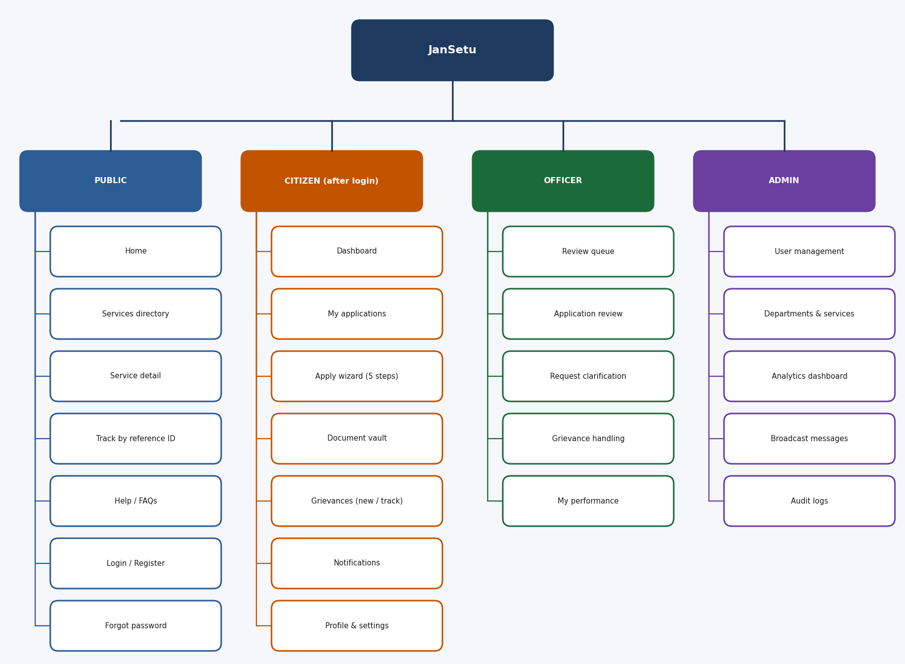
Figure 1: JanSetu sitemap by user role

4.2 Navigation Model
Pattern | Where used | Why
Utility bar (skip link, text size, contrast) | Top of every page | Accessibility controls always reachable; ‘Skip to content’ helps keyboard and screen-reader users.
Global header navigation | All pages: Home, Services, Track, Grievances, Help | Five items only, matching the citizen’s mental model; active page underlined.
Left sidebar | Logged-in citizen pages | Keeps dashboard, vault and grievances one click away; becomes bottom navigation on mobile.
Breadcrumbs | Service pages and the wizard | Shows depth and allows quick backtracking.
Stepper | Application wizard | Shows progress and lets users see how much is left.
Contextual links | Alerts, notifications, cards | Take the user straight to the action (for example ‘Upload now’).

4.3 Primary User Flow
Figure 2 shows the main journey: from the homepage to a submitted application, including login as a gate, the clarification loop, and the final download. The design keeps this journey to a small number of steps.
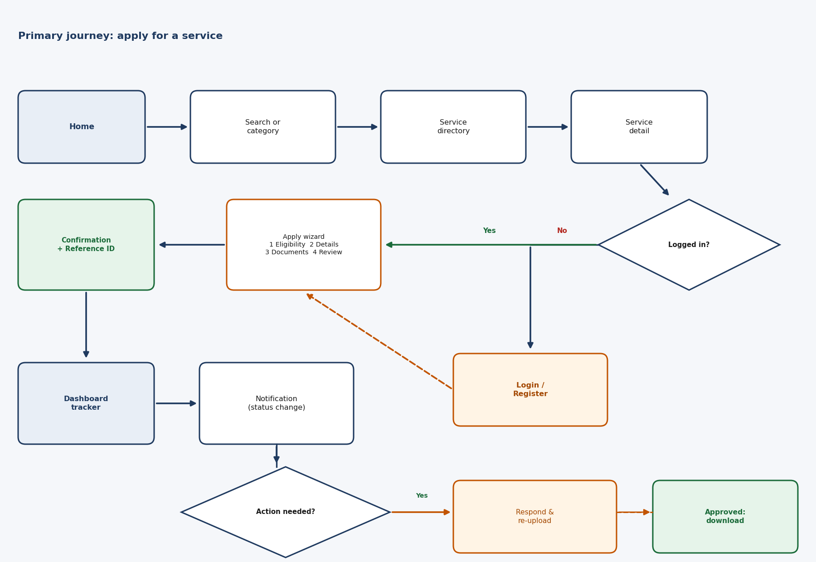
Figure 2: Primary user flow: discover, apply, track and respond
Table 2: Key task efficiency targets
Task | Route | Target
Find a service | Home > search > result | 2 clicks
Start an application (logged in) | Service detail > Apply online | 1 click
Complete the application | 5 wizard steps | Under 10 minutes
Check status | Dashboard (tracker) | 1 click; or Track by ID without login
Reuse a document | Documents step > From vault | 1 click
File a grievance | Grievances > New | Under 3 minutes

5. Design System
A small, consistent design system keeps the interface predictable and makes implementation in React and Tailwind straightforward. It is shown in Figure 3 and described below.
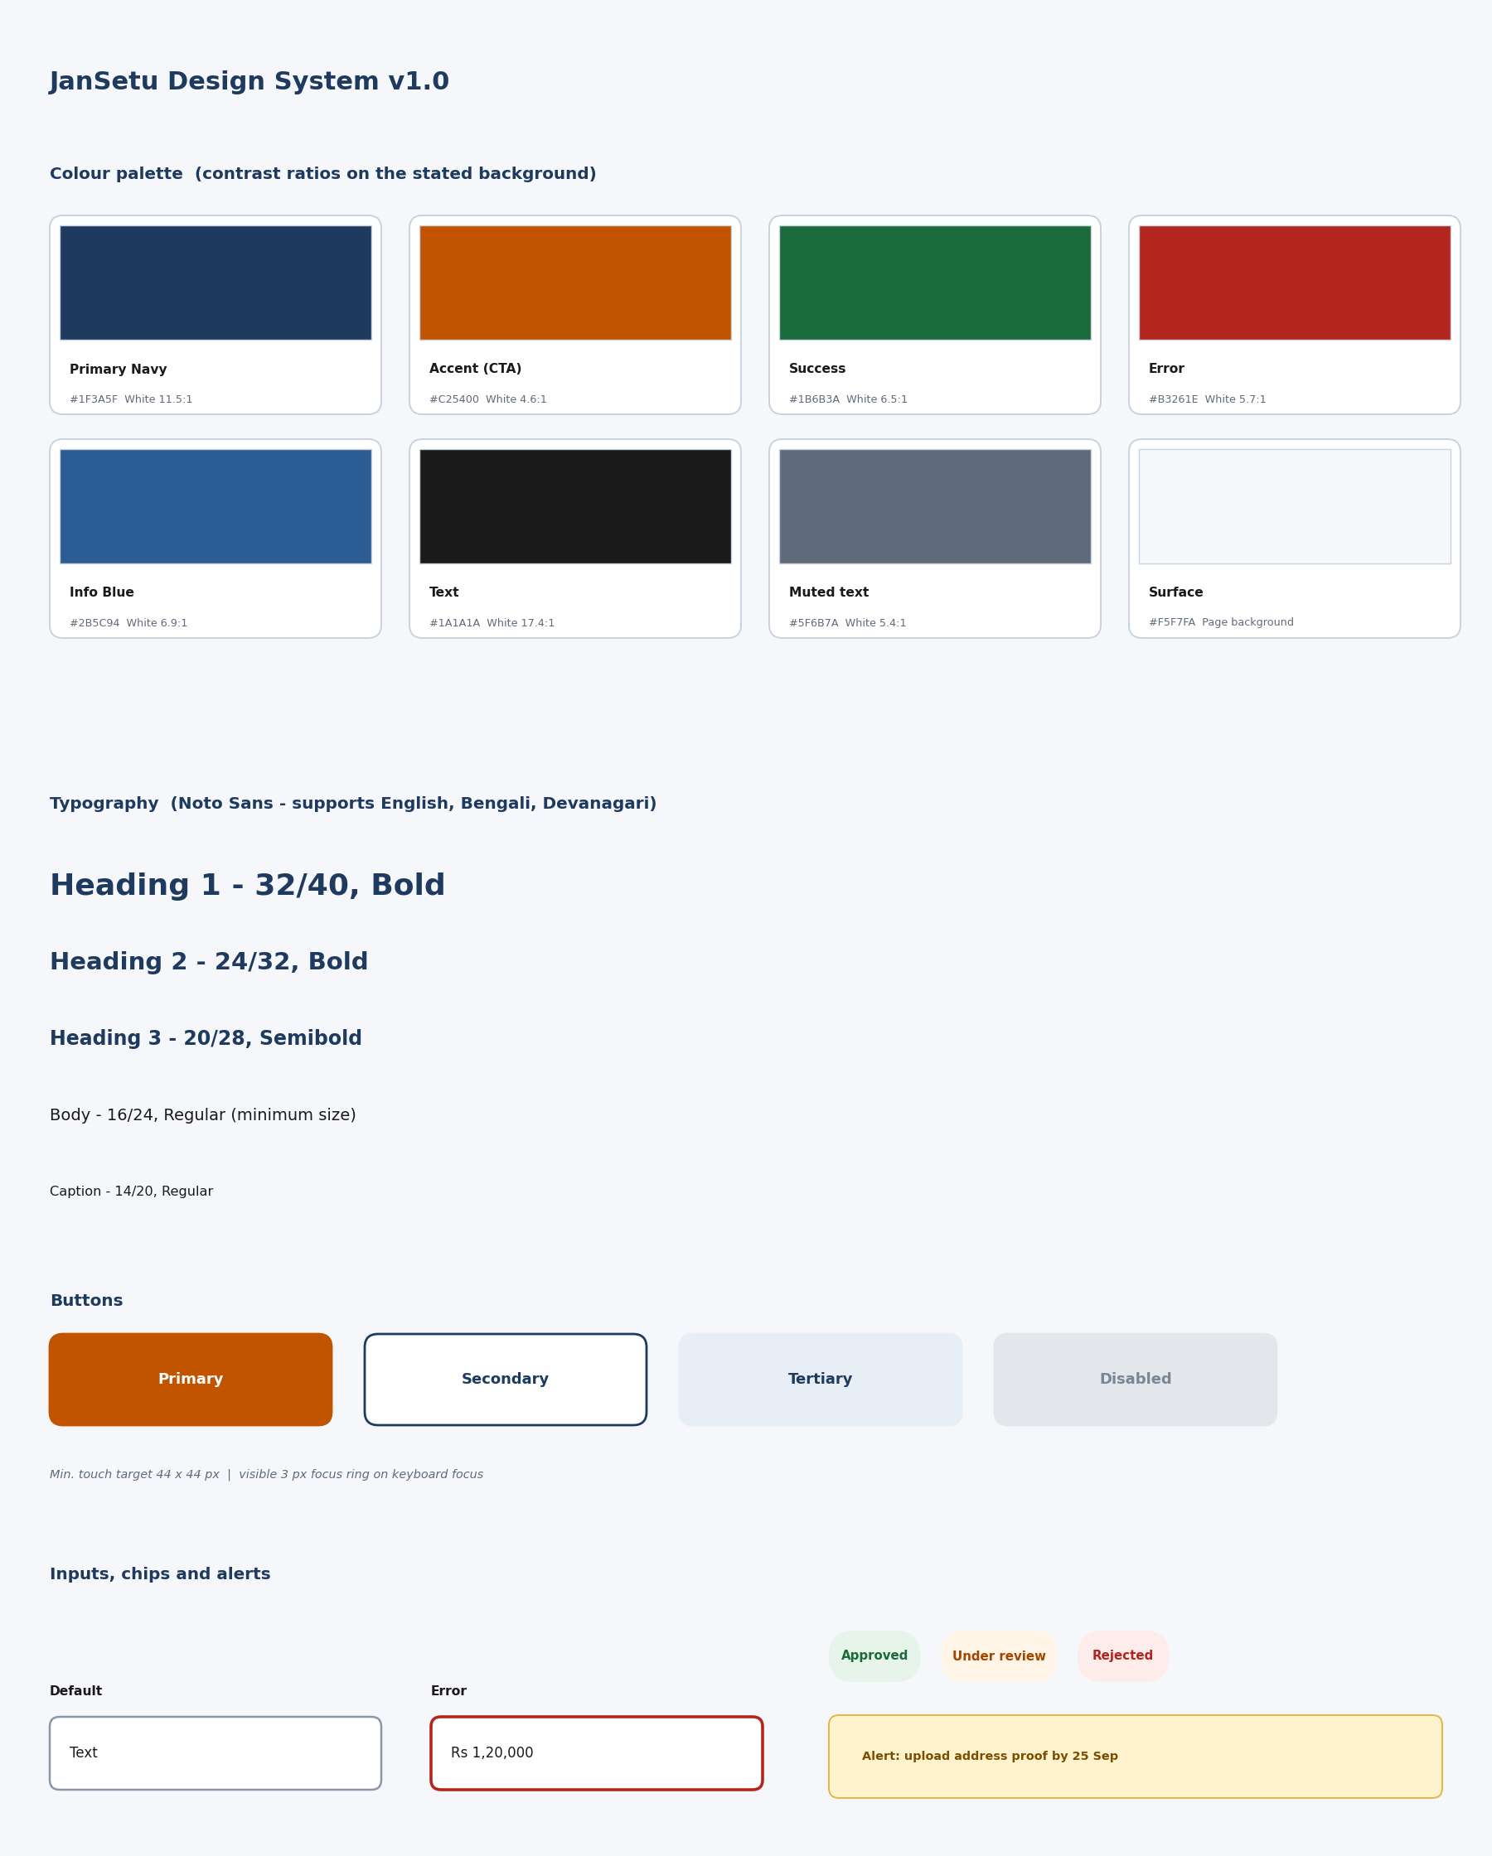
Figure 3: JanSetu design system: colour, typography, buttons, inputs, chips and alerts

5.1 Colour and Contrast
Navy conveys trust and authority; saffron gives a warm, distinctive call to action inspired by national colours; green and red are reserved for success and error. All text pairs below were calculated against the WCAG contrast formula.
Table 3: Colour tokens and measured contrast ratios
Token | Hex | Use | Contrast | WCAG AA
Primary navy | #1F3A5F | Header, headings, secondary buttons | 11.5:1 on white | Pass
Accent (CTA) | #C25400 | Primary buttons, active states | 4.6:1 with white text | Pass
Accent (decorative) | #E07B00 | Logo dot, underline, non-text graphics | 3.0:1 with white | Not for text
Success | #1B6B3A | Approved, verified | 6.5:1 on white | Pass
Error | #B3261E | Errors, rejected | 5.7:1 on white | Pass
Info blue | #2B5C94 | Links, info chips | 6.9:1 on white | Pass
Body text | #1A1A1A | Paragraphs | 17.4:1 on white | Pass
Muted text | #5F6B7A | Helper text, captions | 5.4:1 on white | Pass
Success text on tint | #1B6B3A on #E6F4EA | Status chips | 5.8:1 | Pass
Warning text on tint | #7A4E00 on #FFF3CD | Alerts | 6.5:1 | Pass

Design decision: the Week 1 saffron (#E07B00) gives only 3.0:1 contrast with white text, which fails WCAG AA for normal text. The call-to-action colour was darkened to #C25400 (4.6:1), and the lighter saffron is kept only for decoration.

5.2 Typography
The interface uses Noto Sans, which covers Latin, Bengali and Devanagari scripts with a consistent look, so English, Bengali and Hindi pages feel like one system. The minimum body size is 16 px; captions never go below 14 px in the built interface.
Style | Size / line height | Weight | Use
Heading 1 | 32 / 40 | Bold | Page titles
Heading 2 | 24 / 32 | Bold | Section titles
Heading 3 | 20 / 28 | Semibold | Card titles
Body | 16 / 24 | Regular | All content and form text
Caption | 14 / 20 | Regular | Helper text, timestamps

5.3 Layout, Grid and Spacing
- 8 px spacing scale (4, 8, 16, 24, 32, 48); 12-column grid on desktop, 8 on tablet, 4 on mobile.
- Content width capped at 1100 px so line length stays readable (about 70 characters).
- Cards with 12 px corner radius and a 1 px border; shadows only on hover to keep the page calm.
- Minimum tap target 44 x 44 px with at least 8 px between targets.

5.4 Component Inventory
Component | Variants and states | Used on
Button | Primary, secondary, tertiary, destructive; default, hover, focus, disabled, loading | All pages
Text input / select / textarea | Default, focus, filled, error, disabled; visible label above field | Login, wizard, grievance
Status chip | Success, in progress, warning, error, info (text + colour) | Dashboard, tracker, officer queue
Stepper | Completed, current, upcoming | Wizard, tracker
Card | Service card, stat card, document card, help card | Directory, dashboard, vault
Alert banner | Warning, error, success, info; dismissible | Dashboard, forms
Table | Sortable header, row hover, selected row | Applications, officer queue
File uploader | Empty, dragging, uploading, uploaded, error | Vault, wizard
Navigation | Header, sidebar, breadcrumb, bottom bar | All pages

5.5 Content and Tone
- Talk to the citizen: ‘Upload your address proof’, not ‘Address proof submission is mandatory’.
- Say what happens next: ‘We will notify you when the officer reviews it.’
- Errors explain how to fix: ‘Enter a whole number in rupees, e.g. 120000’.
- Use the same term everywhere (‘application’, ‘reference ID’, ‘vault’).

6. From Sketch to High-Fidelity Wireframe

6.1 Process
- Sketch: low-fidelity block layouts for the homepage and dashboard to test structure without colour or detail.
- Structure: sitemap and flow diagrams to confirm that every requirement from Week 1 has a screen.
- System: colour, typography and component rules defined before drawing pages, so screens stay consistent.
- High-fidelity wireframes: eleven screens drawn with real content, states and numbered annotations.
- Prototype and review: a clickable HTML prototype and a heuristic review against Nielsen’s ten heuristics.
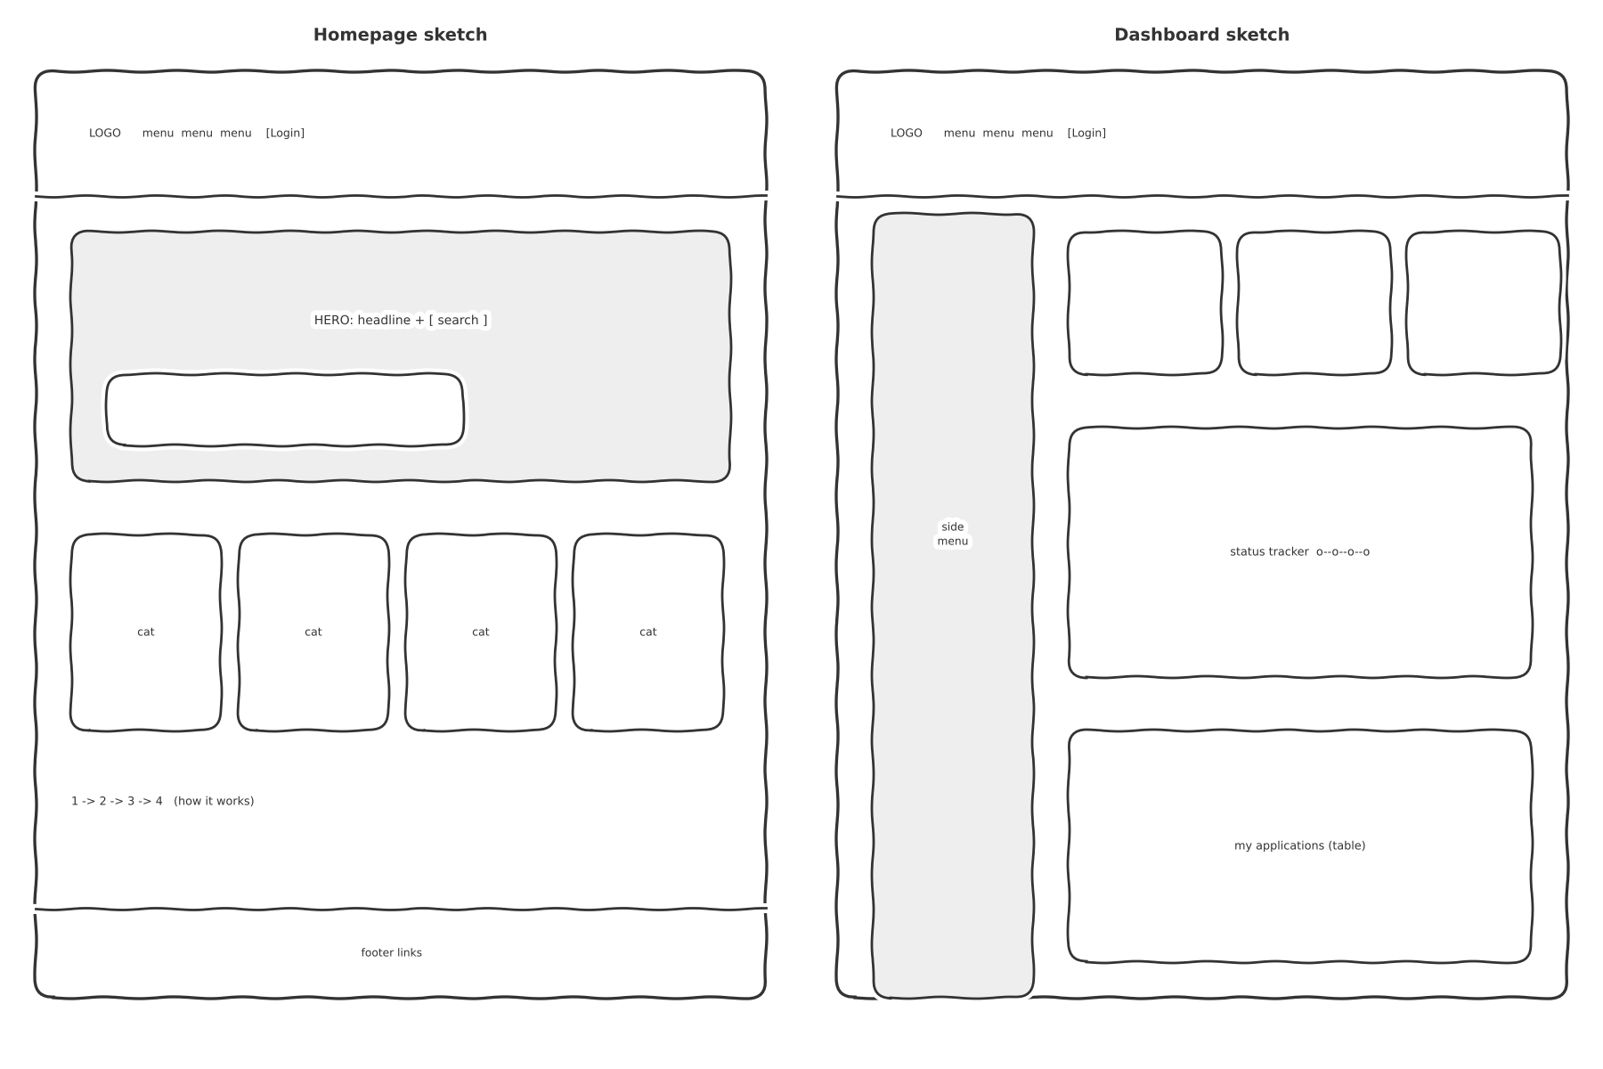
Figure 4: Low-fidelity sketches of the homepage and dashboard layout

6.2 Iteration Log
Change | Before | After | Reason
Accent colour | #E07B00 with white text | #C25400 | Contrast raised from 3.0:1 to 4.6:1 (WCAG AA).
Tracking access | Only after login | ‘Track your application’ card on the homepage | Reduces status-chasing visits; works without an account.
Wizard length | Seven steps in the first draft | Five steps: Eligibility, Details, Documents, Review, Submit | Fewer steps lowers abandonment; related fields merged.
Documents step | Upload only | Upload or ‘From vault’ | Removes repeated uploads, a top pain point.
Status display | Colour dots only | Chip with text label plus colour | Colour must not be the only signal.
Dashboard alert | Notification list only | Prominent ‘Action needed’ banner with a button | Users must see blocking actions first.
Sidebar on mobile | Hamburger menu | Bottom navigation bar | Thumb-reachable and always visible.

7. Page-by-Page Design
Each screen below shows a high-fidelity wireframe with numbered markers, followed by a table explaining each marked element and a short rationale covering layout, colour and how the page supports digital service delivery. Sample data is fictional.

7.1 Homepage
Purpose: let any visitor find a service or track an application within seconds, and build trust in the platform.
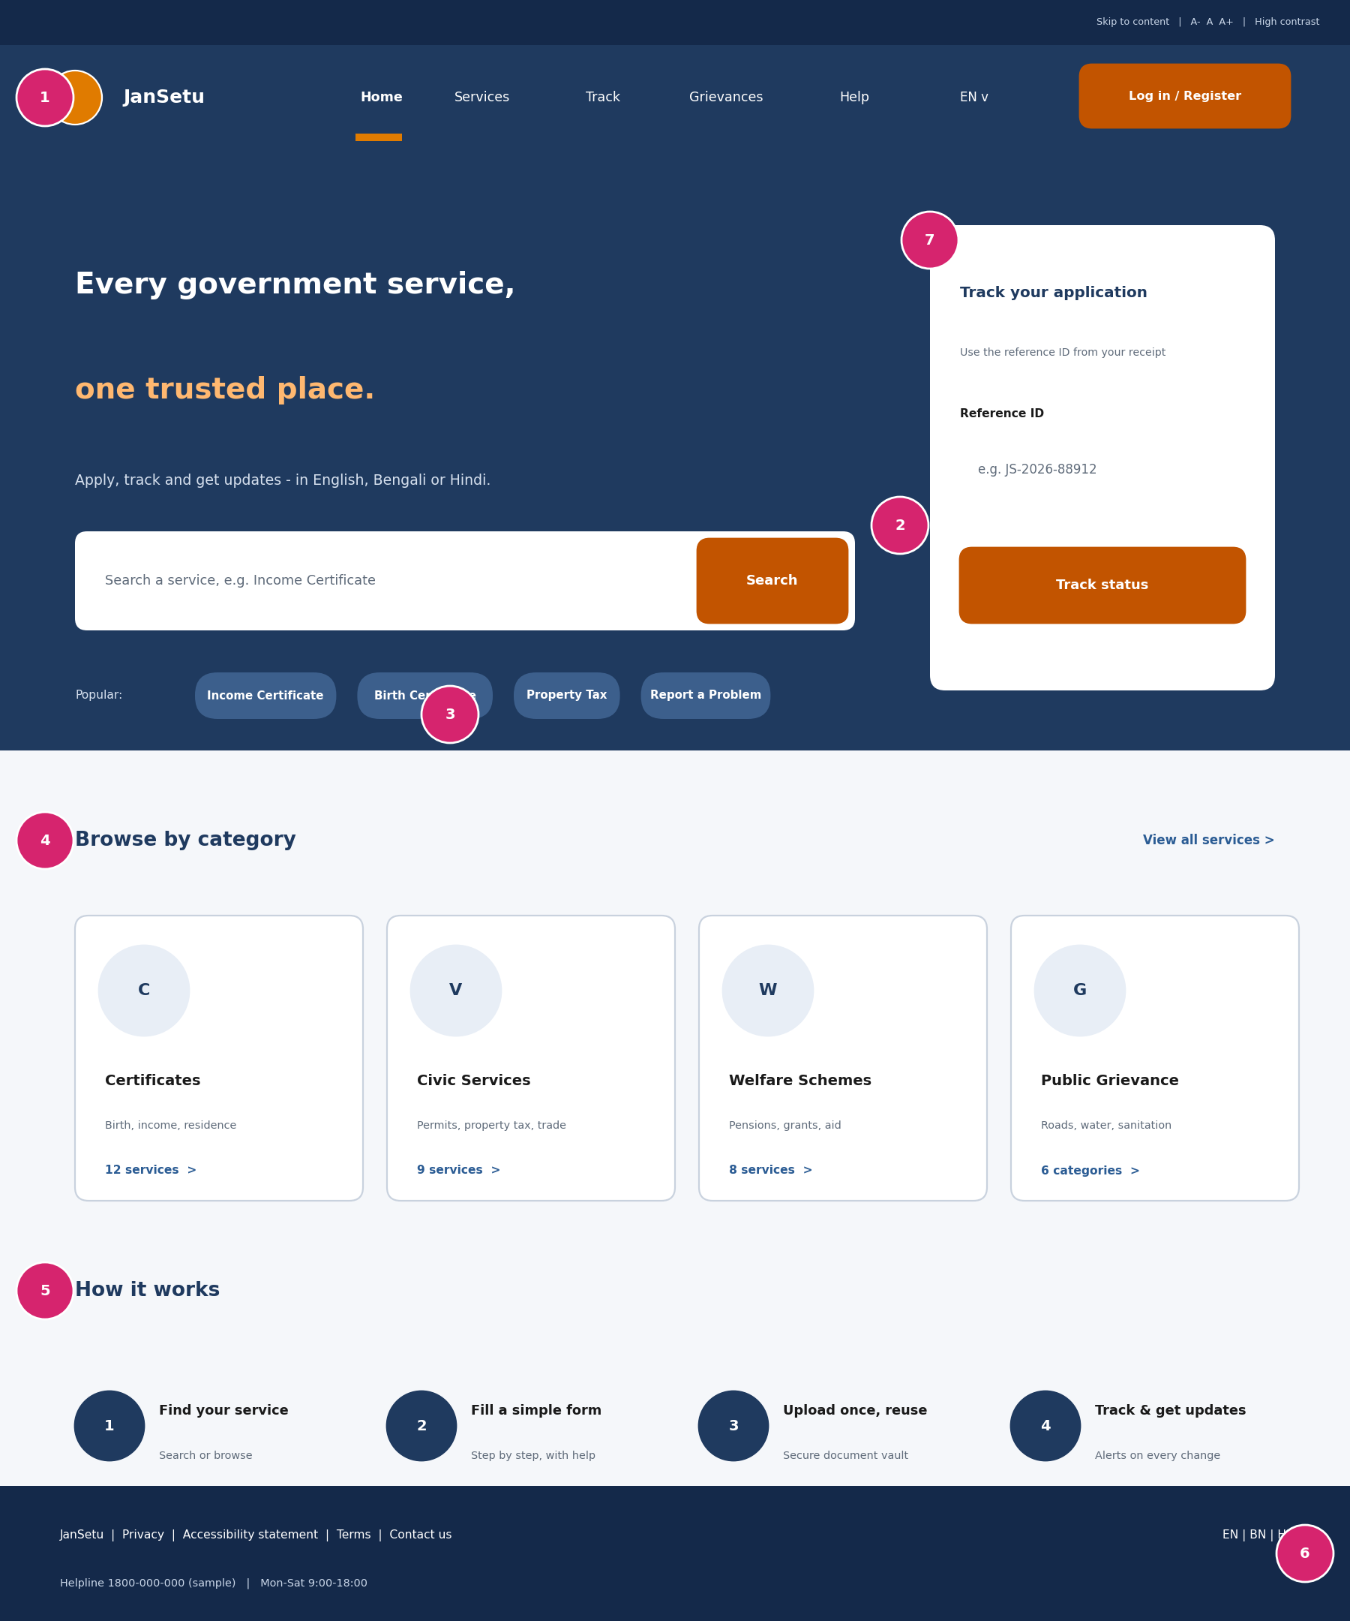
Figure 5: Homepage wireframe
# | Element | Design choice and rationale
1 | Utility bar and header | Skip link, text-size and high-contrast controls, five-item navigation, language switcher and a clear Log in / Register button.
2 | Hero and search | The largest element on the page. A plain-language headline and one search box put the user’s main task first.
3 | Popular services | Shortcut chips for the most-requested services save typing on mobile.
4 | Category cards | Four categories that mirror Week 1 service families; each shows a description and a count so users know what is inside.
5 | How it works | Four short steps reduce anxiety for first-time users.
6 | Footer | Helpline, accessibility statement and privacy links build trust and give a fallback for people who need human help.
7 | Track card | Reference-ID tracking without login, placed beside the hero so it is visible immediately.

Design rationale
- Layout: Two-column hero (search + track), then a four-column card grid; collapses to a single column on mobile.
- Colour: Navy hero with white text (11.5:1) and a saffron button; the second headline line uses a light saffron on navy for emphasis.
- Service delivery: Reduces time-to-first-action and directly addresses the ‘status black hole’ and ‘fragmented services’ problems from Week 1.

7.2 Login and Registration
Purpose: get citizens signed in quickly and safely, with easy recovery paths.
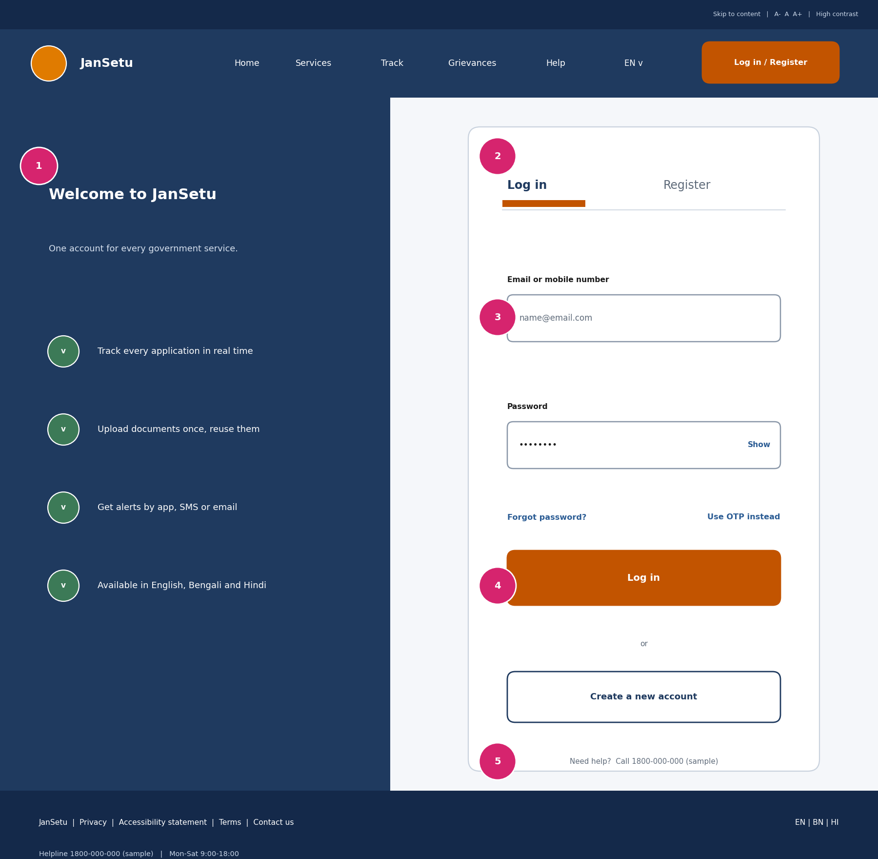
Figure 6: Login and registration wireframe
# | Element | Design choice and rationale
1 | Benefits panel | Reminds users why they are creating an account: tracking, vault, alerts, languages.
2 | Login / Register tabs | One page for both paths; the active tab has an underline as well as bold text.
3 | Input fields | Visible labels above fields, ‘Show’ toggle for password, ‘Forgot password?’ and ‘Use OTP instead’ for users who forget passwords.
4 | Primary and secondary actions | ‘Log in’ is the single filled button; ‘Create a new account’ is outlined so the hierarchy is clear.
5 | Help line | Human support offered at the moment users are most likely to get stuck.

Design rationale
- Layout: Split screen on desktop; the benefits panel is hidden on mobile so the form comes first.
- Colour: Navy panel and white card give strong contrast; errors use red with an icon and text.
- Service delivery: OTP login and simple recovery reduce lock-outs for low-literacy and shared-device users.

7.3 Service Directory
Purpose: help users find the right service through search and simple filters.
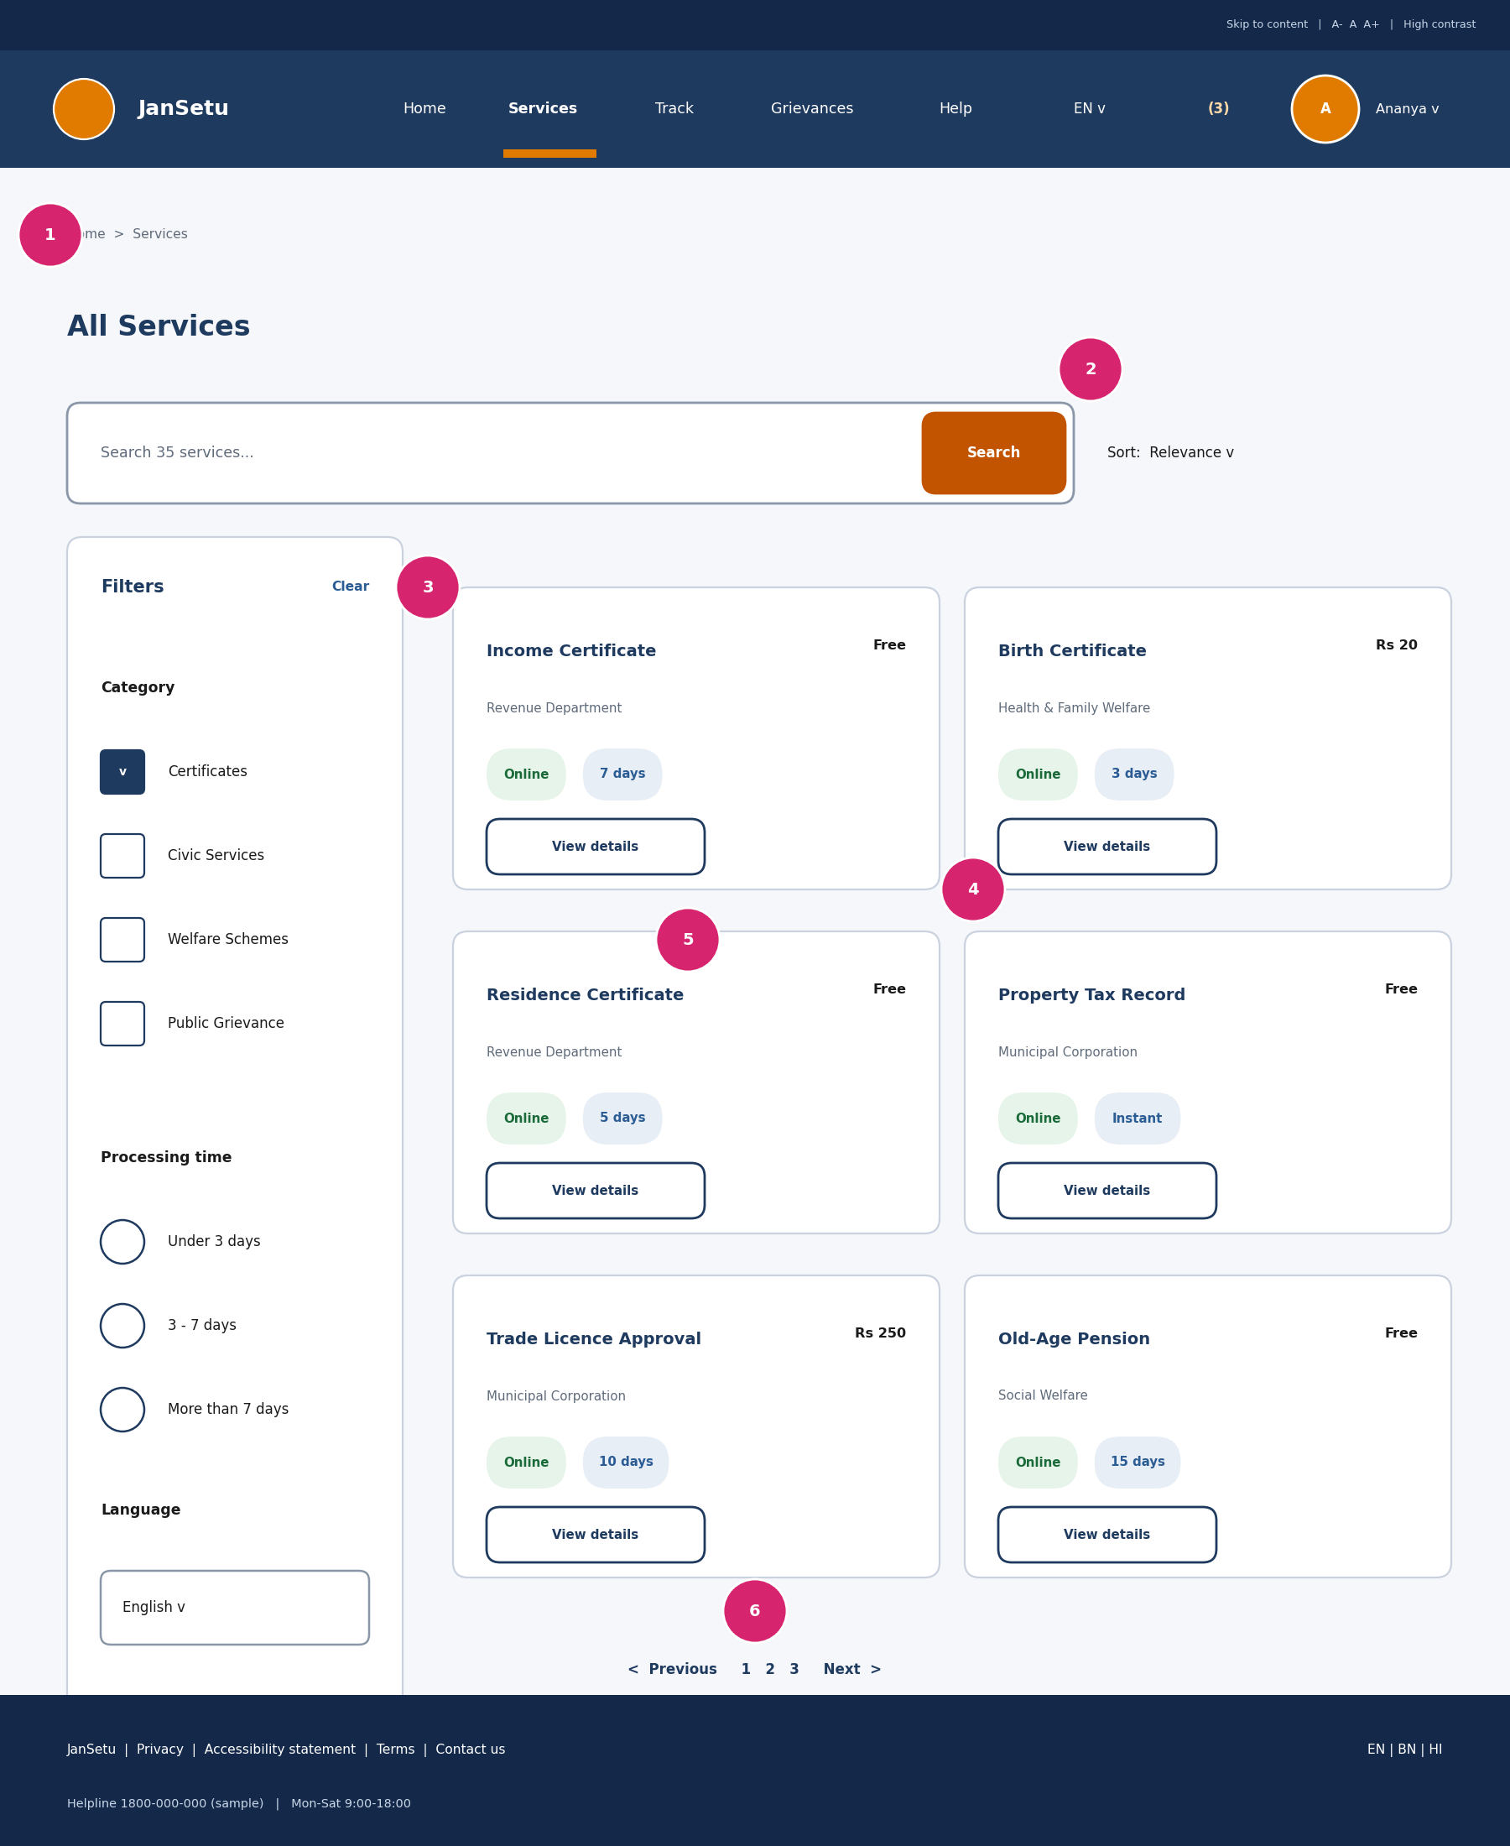
Figure 7: Service directory wireframe
# | Element | Design choice and rationale
1 | Breadcrumb | Shows location and allows one-click return to Home.
2 | Search and sort | Search is repeated here so users can refine without going back; sort options are limited to keep choices simple.
3 | Filter panel | Category, processing time and language filters with checkboxes and radio buttons; ‘Clear’ resets everything.
4 | Service card | Title, department, fee and a single ‘View details’ action.
5 | Status chips | ‘Online’ and processing time help users compare quickly; text, not colour alone.
6 | Pagination | Numbered pages with previous/next; on mobile, filters move into a slide-over drawer.

Design rationale
- Layout: Filters on the left, two-column card grid on the right; single column on mobile.
- Colour: Neutral white cards with navy titles and small green/blue chips keep the page calm and scannable.
- Service delivery: Directly delivers FR-06 and FR-07 (search and filtering) and hides department complexity from the citizen.

7.4 Service Detail
Purpose: give complete, honest information before the user commits to an application.
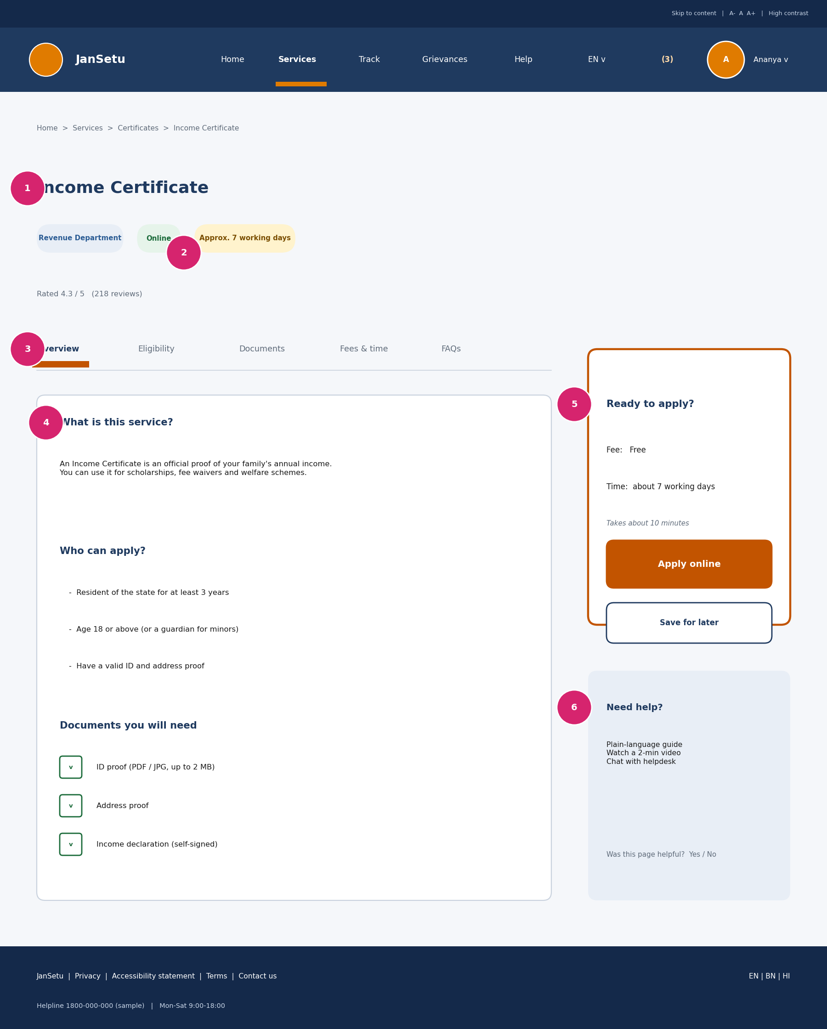
Figure 8: Service detail wireframe
# | Element | Design choice and rationale
1 | Title and department | Clear page title with department chip so users know who issues the document.
2 | Key facts | Fee, processing time and ‘Online’ status at a glance, using distinct chip colours with labels.
3 | Tabs | Overview, Eligibility, Documents, Fees & time and FAQs keep content short and organised.
4 | Content panel | Plain-language description, ‘Who can apply?’ and a checklist of documents to prepare.
5 | Apply card | A sticky card with an accent border and the only filled button on the page: ‘Apply online’; ‘Save for later’ as a secondary action.
6 | Help card | Guide, video and helpdesk chat for users who need support.

Design rationale
- Layout: Two-column layout; the apply card moves under the title on mobile and stays reachable through a sticky bottom button.
- Colour: The accent border and button draw the eye to the next step; the help card uses a soft blue tint to feel supportive rather than urgent.
- Service delivery: Implements FR-08 (service detail) and prevents rejected applications by showing eligibility and documents up front.

7.5 Application Form – Personal Details (Step 2)
Purpose: collect personal details with minimum effort and maximum confidence.
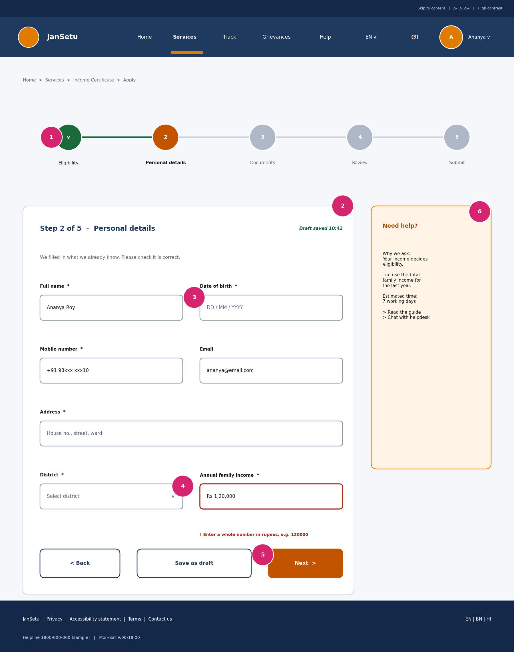
Figure 9: Application wizard, step 2
# | Element | Design choice and rationale
1 | Stepper | Five labelled steps; completed steps are green with a check, the current step is accent-coloured.
2 | Autosave indicator | ‘Draft saved’ reassures users that progress is not lost (FR-11).
3 | Form fields | One column pair, labels above fields, required fields marked, known data such as name pre-filled from the profile.
4 | Inline validation | The income field shows a red border, message and instruction (‘Enter a whole number in rupees’) next to the error.
5 | Action buttons | Back, Save as draft and Next; the primary button is filled and on the right.
6 | Help panel | Explains why a field is asked and gives tips in plain language.

Design rationale
- Layout: Form in a card with a side help panel on desktop; help collapses into an expandable ‘Need help?’ section on mobile.
- Colour: Errors use #B3261E with text and an icon; success uses green ticks. Focus rings are 3 px.
- Service delivery: Short, guided steps address the ‘complex application process’ problem and support FR-10 and FR-11.

7.6 Application Form – Documents (Step 3)
Purpose: attach the required documents by reusing the vault or uploading new files.
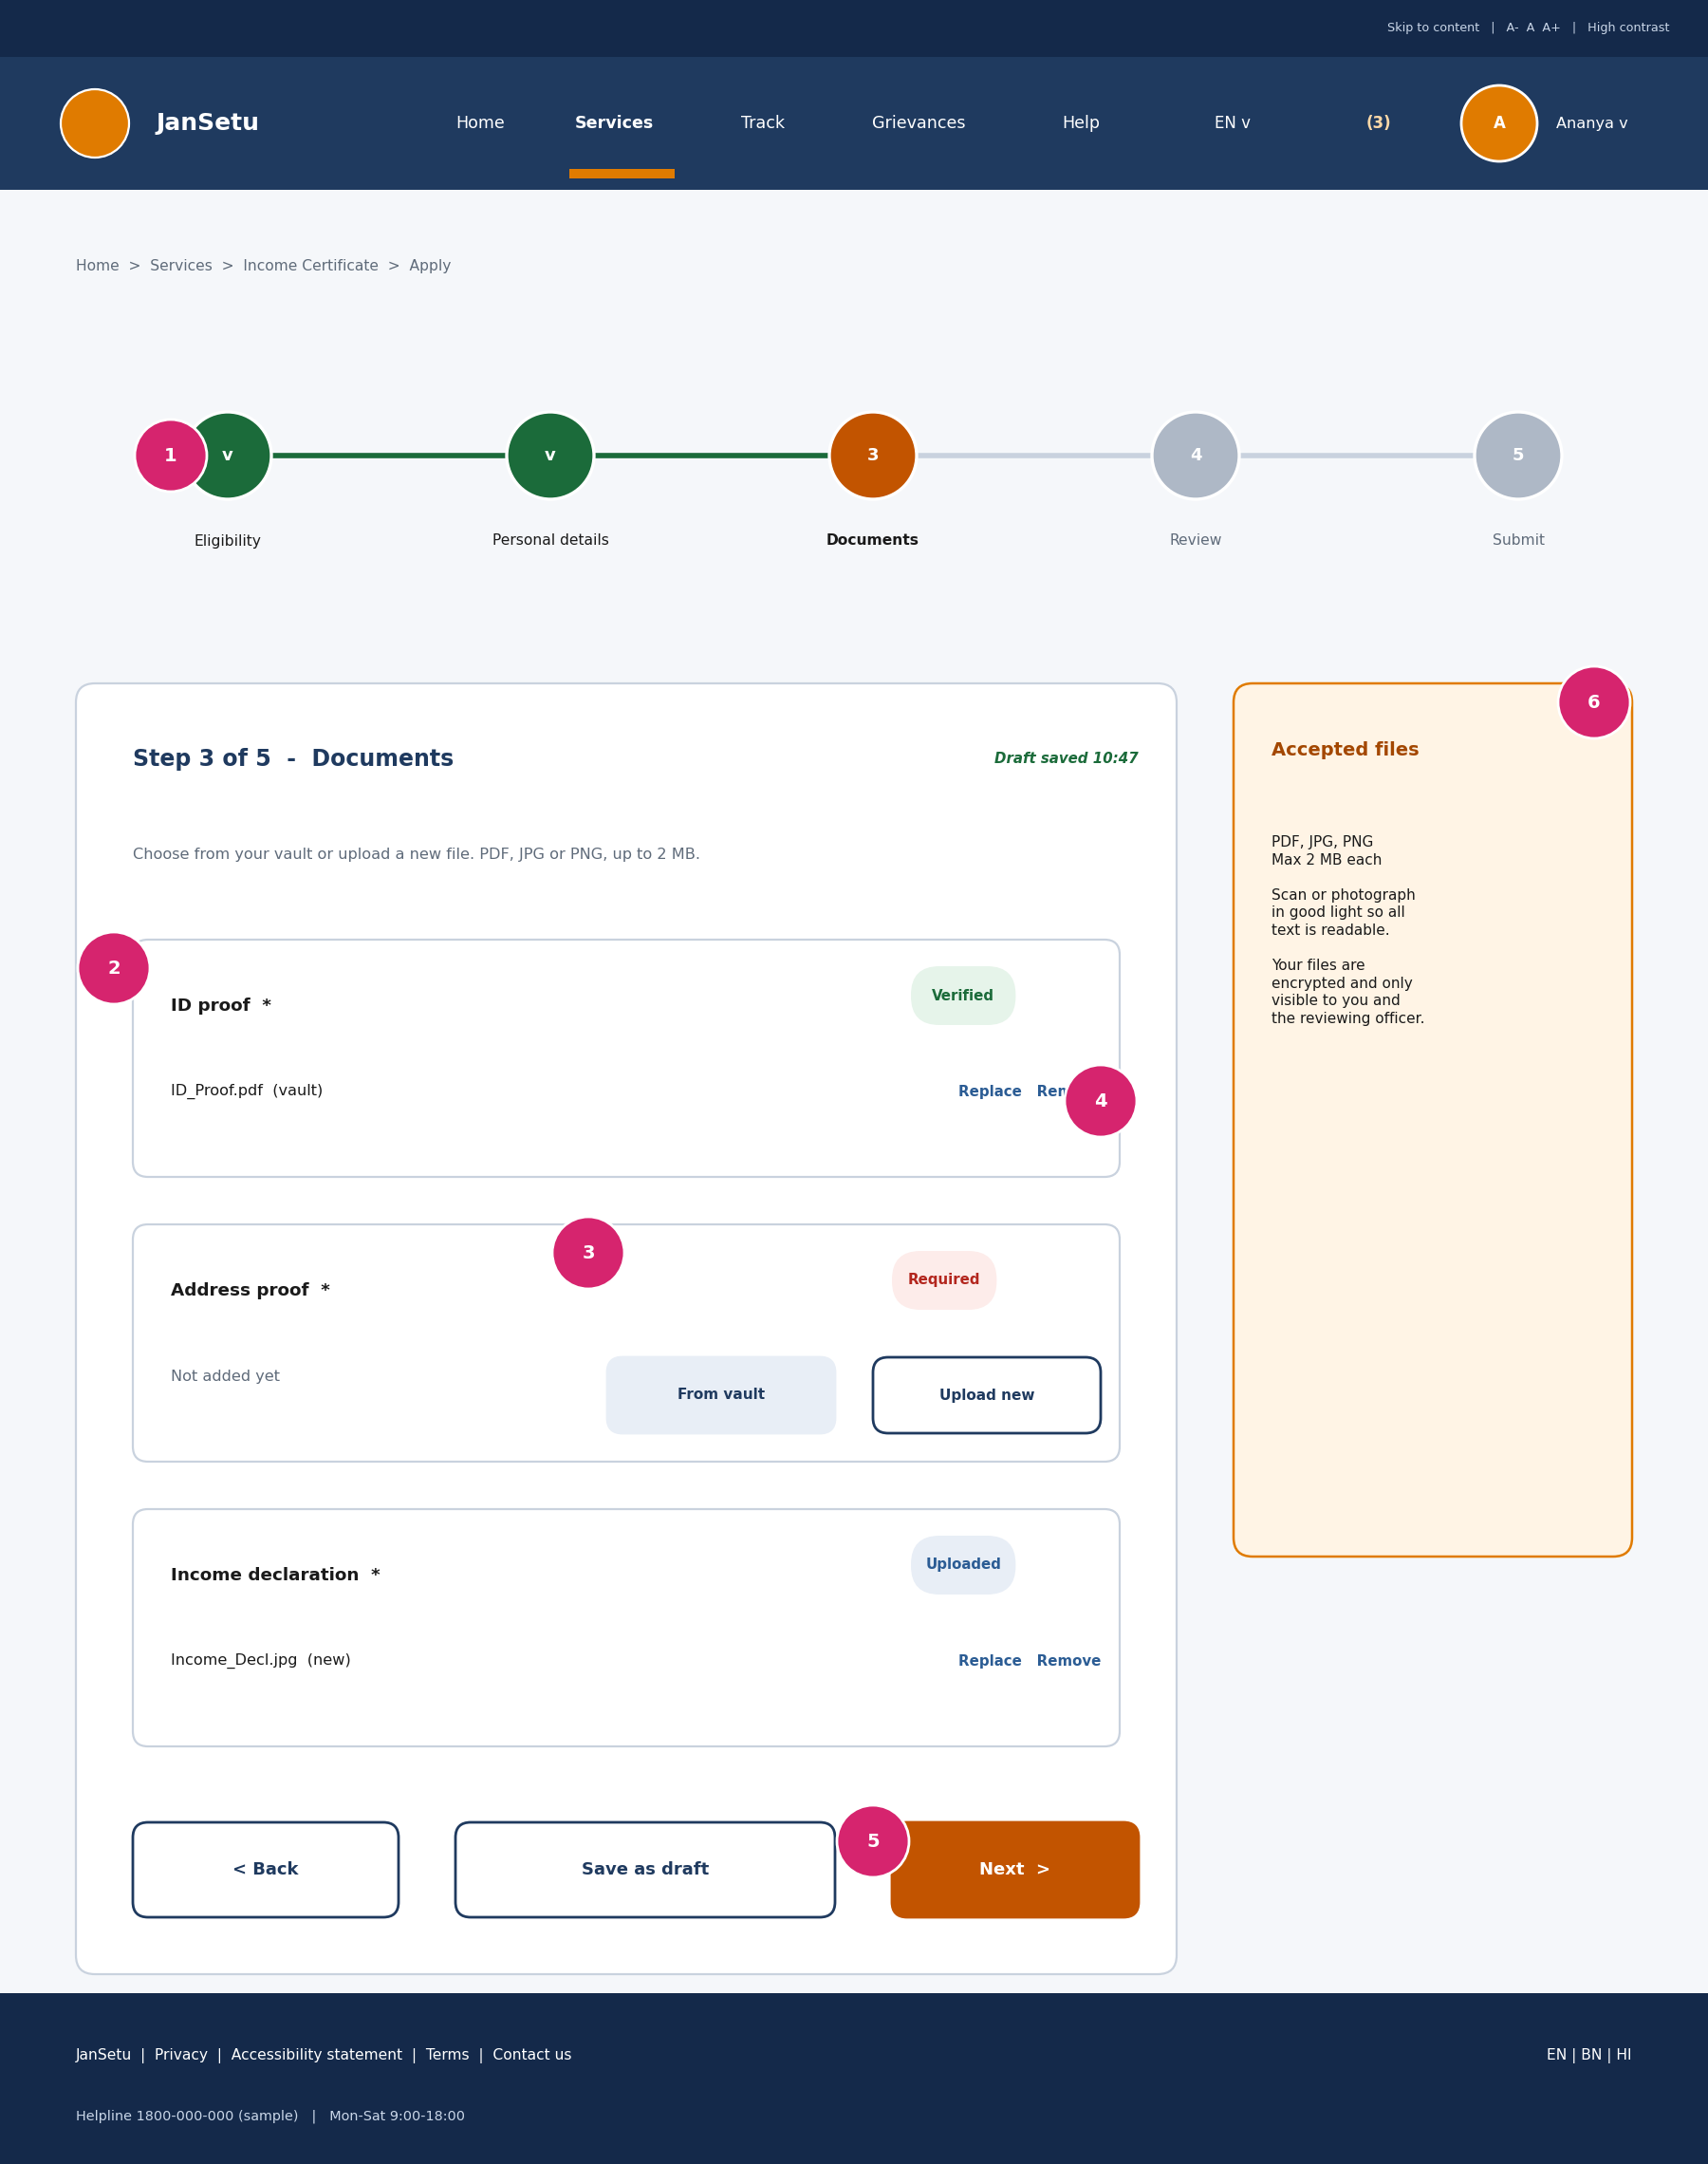
Figure 10: Application wizard, documents step
# | Element | Design choice and rationale
1 | Stepper | Step 3 highlighted; earlier steps show a check.
2 | Document slot with vault file | Shows the file name, source (vault) and a green ‘Verified’ chip; Replace and Remove links.
3 | Missing required document | Red ‘Required’ chip with two clear options: ‘From vault’ or ‘Upload new’.
4 | Manage actions | Text links for Replace and Remove keep the slot compact.
5 | Navigation buttons | Back, Save as draft, Next; Next is validated before moving on.
6 | Guidance panel | Accepted formats, size limit, scan tips and a privacy note.

Design rationale
- Layout: Each required document has its own card so users can complete them in any order.
- Colour: Status chips combine colour with text (Verified, Required, Uploaded).
- Service delivery: Vault reuse (FR-13) removes repeated document submission, one of the main problems identified in Week 1.

7.7 Citizen Dashboard
Purpose: show what is happening and what needs attention, at a glance.
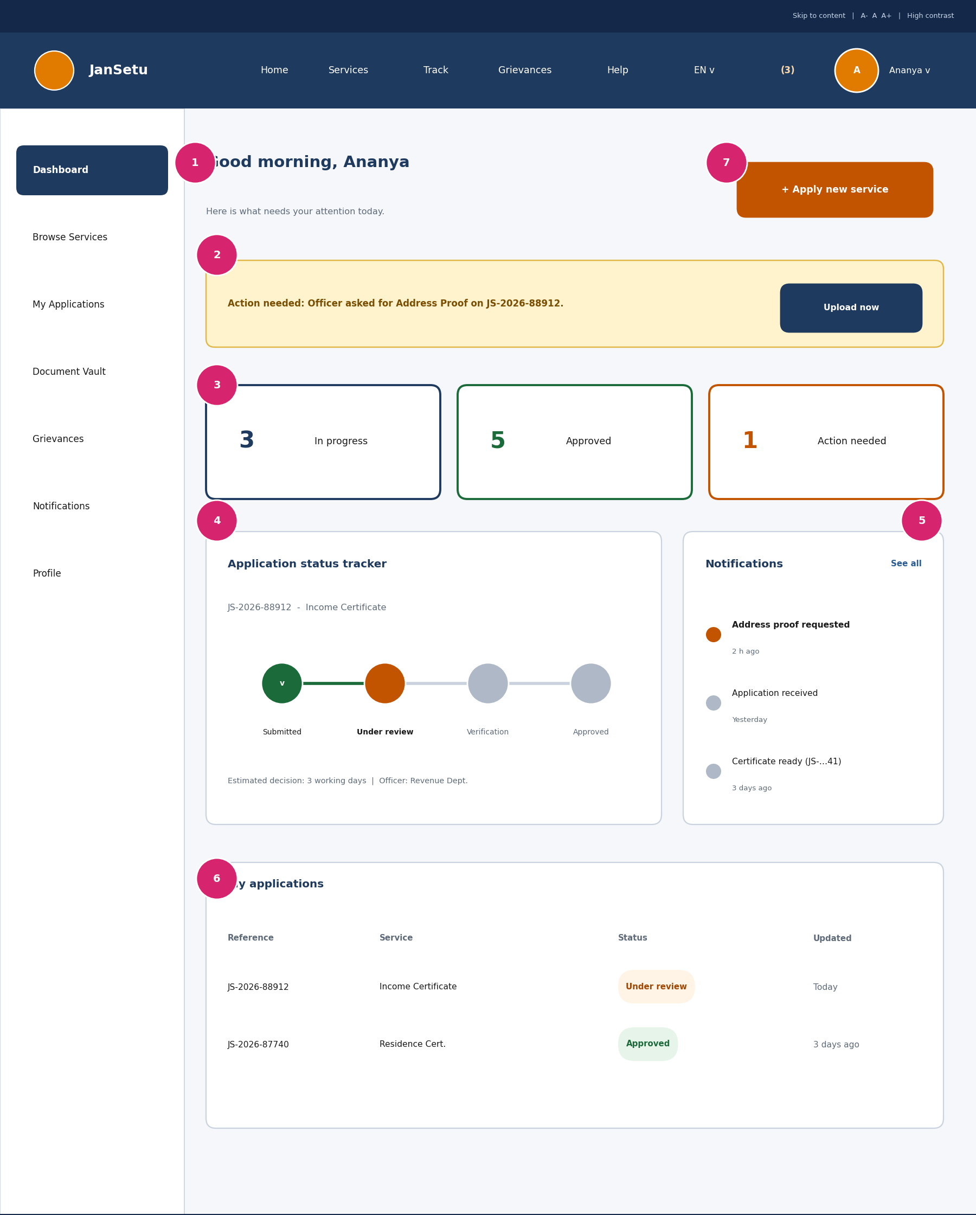
Figure 11: Citizen dashboard wireframe
# | Element | Design choice and rationale
1 | Greeting | Personal greeting and a one-line summary set a friendly tone.
2 | Action banner | A yellow alert appears above everything else when the officer needs something from the citizen, with a direct ‘Upload now’ button.
3 | Summary cards | In progress, Approved and Action needed; the last card uses the accent colour.
4 | Status tracker | Four-stage stepper with reference ID and estimated decision time (FR-16).
5 | Notifications | Most recent updates with unread markers and time stamps (FR-18).
6 | My applications table | Reference, service, status chip and last update; each row opens the detail view.
7 | Primary action | ‘Apply new service’ is always visible at the top right.

Design rationale
- Layout: Left sidebar navigation with a main area of stacked cards; on mobile the sidebar becomes a bottom bar and cards stack in one column.
- Colour: Neutral surfaces with colour used only for status, so the important items stand out.
- Service delivery: Answers the question ‘what is happening with my request?’ without any office visit, the core promise of JanSetu.

7.8 Document Vault
Purpose: give citizens one secure place to store and reuse their documents.
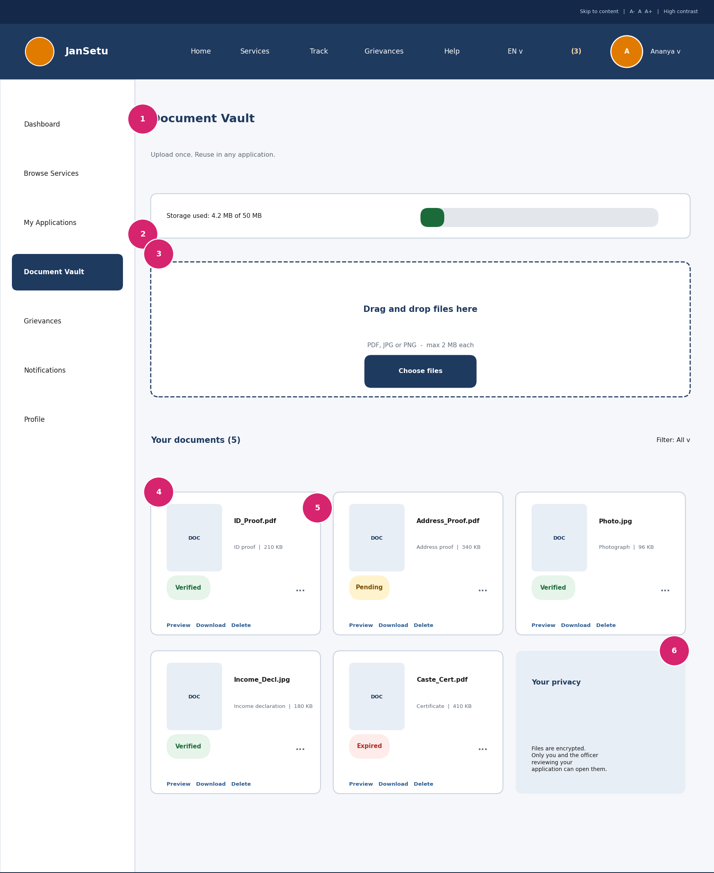
Figure 12: Document vault wireframe
# | Element | Design choice and rationale
1 | Page header | Title with the value proposition: ‘Upload once. Reuse in any application.’
2 | Storage meter | Shows used space so users are not surprised by limits.
3 | Drop zone | A large dashed area supports drag and drop and a ‘Choose files’ button for mobile.
4 | Document list | Cards with file name, type and size.
5 | Status and actions | Chips show Verified, Pending or Expired; Preview, Download and Delete are always available.
6 | Privacy note | Explains that files are encrypted and visible only to the owner and the assigned officer.

Design rationale
- Layout: Grid of document cards (three across on desktop, one column on mobile).
- Colour: Blue tint for privacy information, green for verified, amber for pending, red for expired.
- Service delivery: Implements FR-19 and turns repeated paperwork into a one-time task.

7.9 Grievance Filing and Tracking
Purpose: let citizens report a civic problem and follow its resolution.
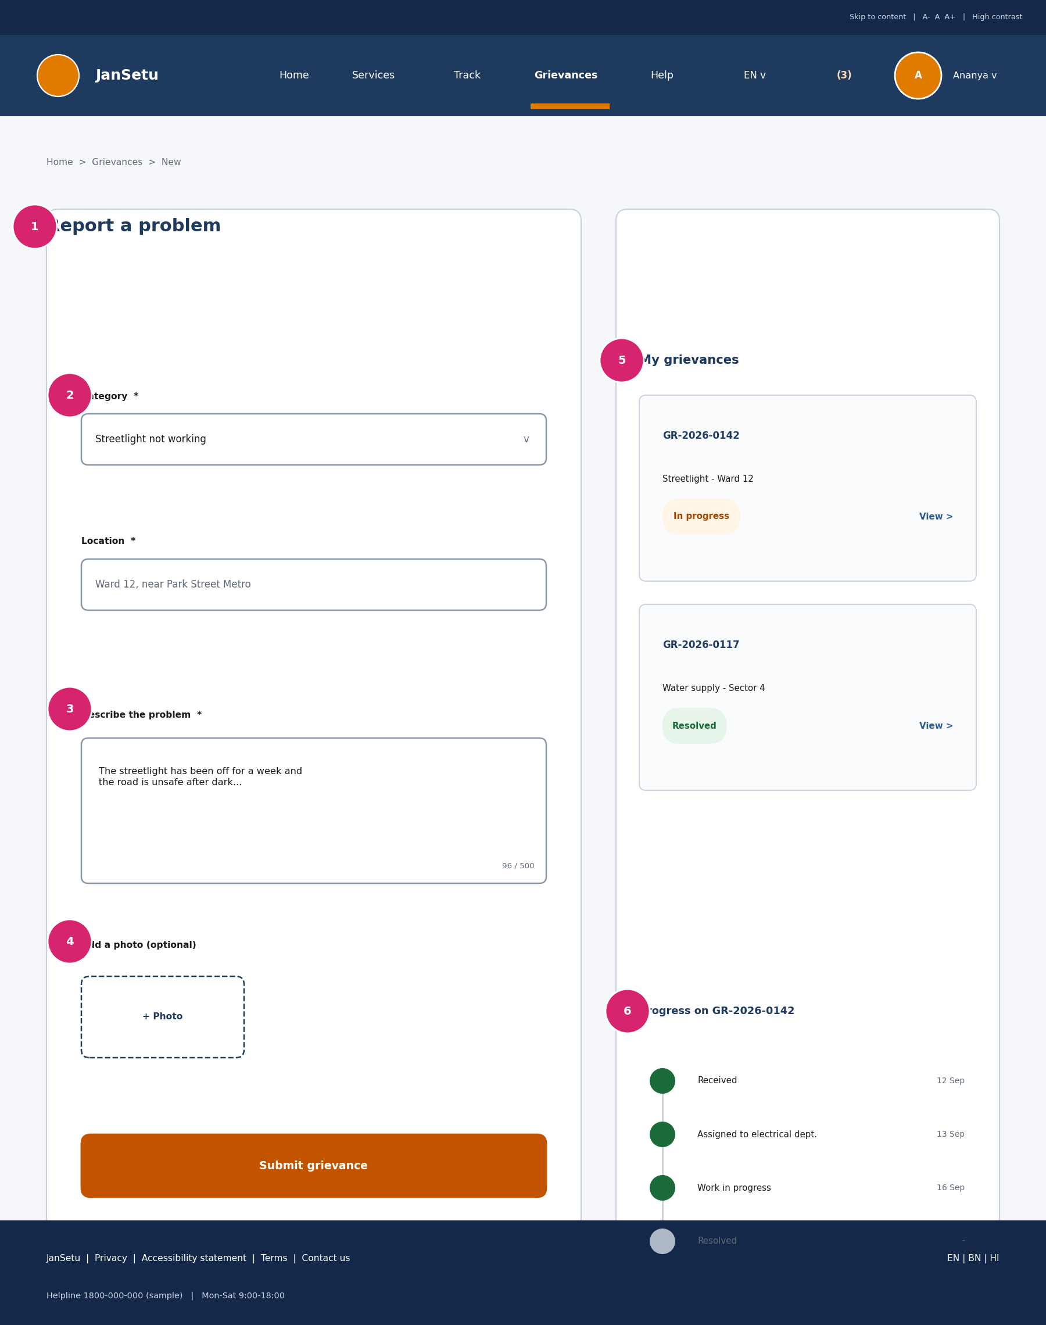
Figure 13: Grievance wireframe
# | Element | Design choice and rationale
1 | Page title | Direct, action-based wording: ‘Report a problem’.
2 | Category | A dropdown of common issues (streetlight, road, water, sanitation) avoids free-text categorisation.
3 | Description | Multi-line field with a character counter and an example.
4 | Photo upload | Optional, so users can show the problem without long text.
5 | My grievances | Each ticket shows ID, category and a status chip.
6 | Progress timeline | Received, Assigned, In progress, Resolved with dates, so the citizen sees movement.

Design rationale
- Layout: Form and history side by side on desktop; stacked on mobile with the form first.
- Colour: Status chips reuse the same colour meanings as applications for consistency.
- Service delivery: Supports FR-20 and FR-21 and closes the feedback loop between citizen and department.

7.10 Officer Review Queue
Purpose: help officers process applications quickly and consistently.
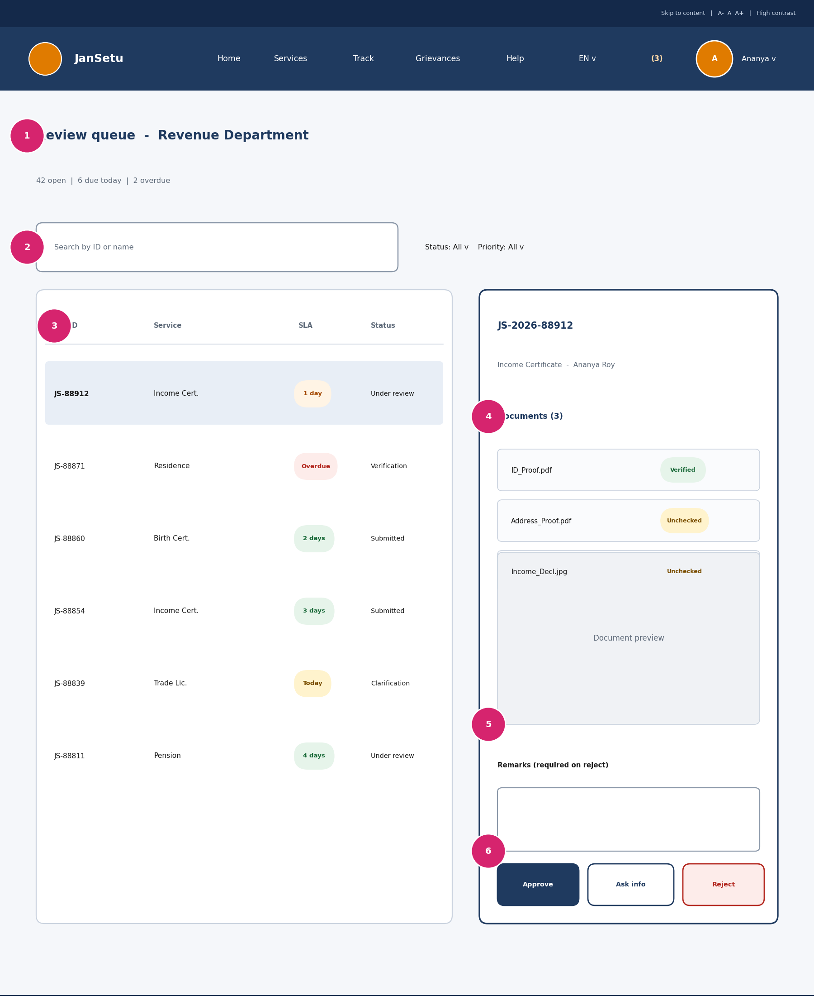
Figure 14: Officer review wireframe
# | Element | Design choice and rationale
1 | Queue header | Counts of open, due today and overdue items set priorities.
2 | Search and filters | Search by ID or name; filters for status and priority.
3 | Application table | SLA chip shows time left; overdue items are red and labelled; the selected row is highlighted.
4 | Document list | Each document has a status chip so the officer knows what is left to verify.
5 | Preview and remarks | In-page preview avoids opening new tabs; remarks are required for rejection.
6 | Decision actions | Approve, Ask for info and Reject, grouped and colour-coded, with Reject requiring confirmation.

Design rationale
- Layout: Master-detail layout so the officer never leaves the queue; on tablet the detail panel opens as a full-width page.
- Colour: Dense but calm: neutral surfaces, colour only for SLA and status.
- Service delivery: Delivers FR-23 to FR-26 and speeds up processing, which shortens waiting time for citizens.

7.11 Mobile Views
Purpose: confirm that the three most important journeys work on a 360 px screen. Officer and admin screens are designed for tablet and desktop.
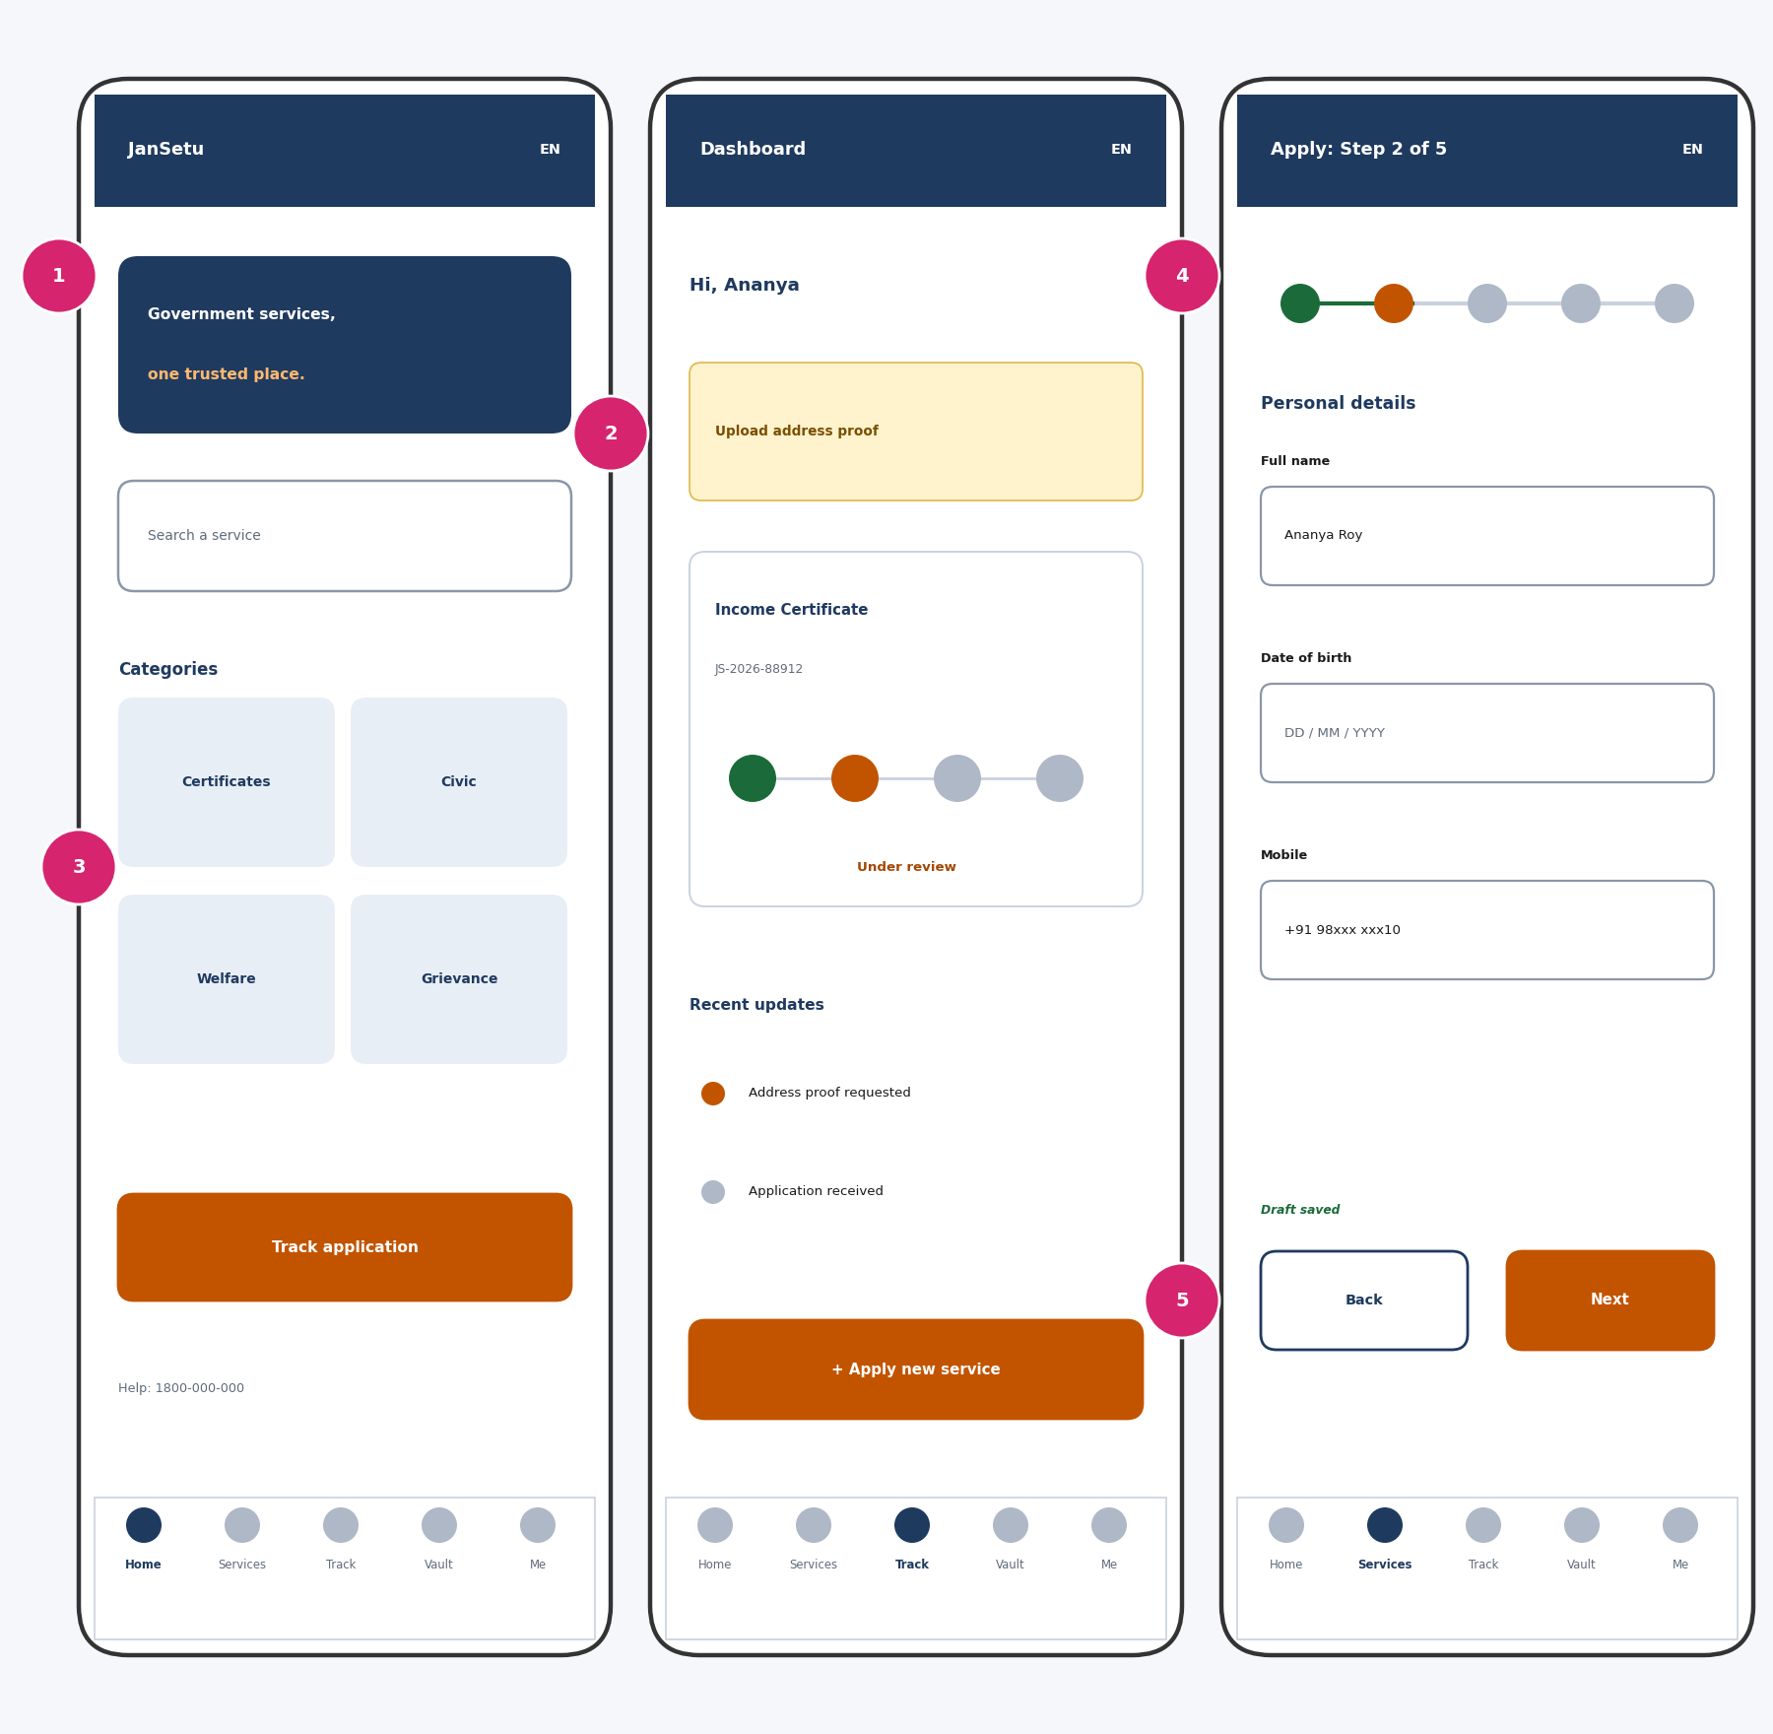
Figure 15: Mobile views: homepage, dashboard and application form
# | Element | Design choice and rationale
1 | Home hero and search | Compact hero with search first; a large ‘Track application’ button below the categories.
2 | Action banner | Same alert as desktop but shortened to one line with a tap target.
3 | Category tiles | Two-by-two tiles with large tap areas (at least 44 px).
4 | Compact stepper | Dots and a line keep progress visible without using vertical space.
5 | Back / Next buttons | Side-by-side, full-width buttons within thumb reach.

- Layout: single column, bottom navigation with five destinations, sticky primary actions.
- Colour: same tokens as desktop, so the brand and meaning stay identical.
- Service delivery: mobile phones are the main access route for many citizens, so every citizen journey is designed for them first.

8. Responsive Design
Table 4: Breakpoints and layout behaviour
Breakpoint | Width | Layout behaviour
Mobile | 320 – 599 px | Single column; bottom navigation; filters in a drawer; help panels collapse; full-width buttons.
Tablet | 600 – 1023 px | Two columns; sidebar collapses to icons; officer detail opens as a full page.
Desktop | 1024 px and above | Sidebar + content layout; side help panels; master-detail for officers.

- Images are compressed and lazy-loaded; no heavy hero images, to support slow networks.
- Text can be enlarged to 200% without loss of content or function.
- Touch targets are at least 44 px; no hover-only interactions.

9. Interaction Design and Prototype

9.1 Interaction Inventory
Component | Behaviour | Feedback
Search | Enter or button submits; results update with a live count | ‘6 services found’ announced to screen readers
Category filter | Selecting a filter updates results immediately | Result count changes; ‘Clear’ resets
Wizard Next | Validates the current step; blocks with clear messages if invalid | Focus moves to the first error
Autosave | Saves draft on step change and on ‘Save as draft’ | ‘Draft saved 10:42’ text
Vault selection | ‘From vault’ fills the slot in one click | Slot turns green with ‘Added’
Submit | Confirmation screen with reference ID | Success message and dashboard link
Status tracker | Updates when the officer changes status | Notification and toast message
Language switch | Changes interface text and font without reloading | Page language attribute updates

9.2 States
State | Design treatment
Loading | Skeleton placeholders for cards and tables; buttons show a spinner and stay disabled to prevent double submission.
Empty | Friendly message with a next step, e.g. ‘No applications yet – Browse services’.
Error | Inline message next to the field, plus a summary at the top on long forms; network errors offer ‘Try again’.
Success | Green check, confirmation text, reference ID and clear next action.
Offline / slow | Message that the draft is kept and will sync when the connection returns (planned).

9.3 Interactive Prototype
A clickable HTML prototype accompanies this document (JanSetu_Interactive_Prototype.html). It runs in any browser and simulates the main flows with sample data. Suggested click path for a demonstration:
- Home: search for ‘Income’, or click a popular chip, then open ‘Income Certificate’.
- Click ‘Apply online’; the prototype asks you to log in (any details work).
- Complete the five wizard steps. Try leaving fields empty to see inline validation; choose ‘From vault’ in the Documents step.
- Submit and note the reference ID; the Dashboard shows the new application.
- On the Dashboard use ‘Advance status’ to simulate the officer and watch the tracker and notifications update.
- Open the Vault to upload or delete a document, and Grievances to file and see a ticket.
- Switch language (English, Bengali, Hindi) and light/dark mode; resize the window to see the mobile layout.
The prototype is a design aid and not the final application: data is not stored, and the officer and admin consoles are shown as wireframes only.

10. Accessibility and Usability Compliance
Table 5: WCAG 2.1 AA alignment
Principle | Design measure | Status
Perceivable | AA contrast palette; text labels on all status chips; alt text for images; text resizable to 200%; Noto Sans for multiple scripts. | Designed; verify in build
Operable | Full keyboard operation; visible 3 px focus ring; skip-to-content link; 44 px tap targets; no time limits on forms; drafts autosaved. | Designed; verify in build
Understandable | Plain language; labels above fields; inline, specific error messages; consistent navigation; language attribute set. | Designed
Robust | Semantic HTML (header, nav, main, form, table); ARIA only where needed (live regions for status messages); tested with a screen reader in Week 5. | Planned

Accessibility will be checked again during build with automated tools (for example axe or Lighthouse) and a manual keyboard and screen-reader pass.

11. Usability Evaluation

11.1 Heuristic Review
A self-review of the wireframes against Nielsen’s ten heuristics [2] found the design aligned, with items to confirm through testing.
Heuristic | How the design responds
1. Visibility of system status | Stepper, tracker, autosave message, notifications.
2. Match with the real world | Everyday words, categories based on user tasks.
3. User control and freedom | Back, Save as draft, Cancel, Edit on review page.
4. Consistency and standards | One design system; same chip colours across modules.
5. Error prevention | Eligibility check first, validation before Next, review step, confirmation on Reject.
6. Recognition rather than recall | Pre-filled data, vault reuse, visible labels.
7. Flexibility and efficiency | Popular shortcuts, Track by ID, keyboard support.
8. Aesthetic and minimalist design | One primary action per page; limited colour.
9. Help users recover from errors | Specific messages that say how to fix the problem.
10. Help and documentation | Help panel on each step, FAQs, helpline.

11.2 Planned Usability Test
Item | Plan
Participants | 5 to 8 people: students, older adults and first-time smartphone users; 2 people who prefer Bengali or Hindi.
Method | Moderated, think-aloud test using the clickable prototype on a mobile phone and a laptop.
Tasks | 1) Find the Income Certificate. 2) Apply and attach a document from the vault. 3) Find the status of an application. 4) Report a streetlight problem.
Measures | Task success rate, time on task, number of errors, and a 1–5 satisfaction score.
Targets | At least 85% task success; application completed in under 10 minutes; satisfaction of 4/5 or higher.
Outcome | Findings are prioritised and fed into the Week 3 build backlog.

No user testing has been carried out yet; the results above are targets, not findings.

12. Challenges and How They Were Resolved
Challenge | Resolution
Serving very different users (low literacy to power users) with one interface | A simple default path with progressive disclosure: help text on demand, optional filters, and shortcuts for experienced users.
Contrast failure of the initial saffron accent | Measured contrast, darkened the CTA colour, and restricted the lighter saffron to decoration.
Long forms on small screens | Five short steps, one group of questions per step, autosave and sticky action buttons.
Showing complex status without overwhelming users | A four-stage tracker with plain labels; details in a timeline only when needed.
Supporting multiple scripts and languages | Noto Sans family, layouts with room for longer text, language switch in the header.
Designing officer tools that are fast but safe | Master-detail queue, SLA chips, mandatory remarks on rejection and confirmation on destructive actions.
Keeping the design realistic for a free-tier build | Reusable components, light pages and a design system that maps directly to Tailwind.

13. How the Design Meets E-Governance Needs
Week 1 objective | Design features
Centralise digital services | Single search, categories and directory; one account for all departments.
Simplify applications | Five-step wizard, pre-filled data, help panel, review step.
Improve transparency | Reference ID, status tracker, timeline, notifications, track without login.
Reduce documentation overhead | Document vault with reuse and verification status.
Ensure universal accessibility | AA contrast, keyboard support, multilingual UI, mobile-first layouts, 44 px targets.
Enhance communication | Action banner, notification panel, grievance tracking with timeline.

14. Handoff to Development (Week 3)

14.1 Component Mapping
Design component | React file (from Week 1 structure)
Header, utility bar, bottom nav | components/Navbar.jsx
Sidebar | components/Sidebar.jsx
Service card | components/ServiceCard.jsx
Stepper and tracker | components/StatusTracker.jsx, FormWizard.jsx
Notification panel | components/NotificationPanel.jsx
File uploader and vault card | components/FileUploader.jsx, pages/DocumentVault.jsx
Screens | pages/Home, Services, ServiceDetail, Apply, Dashboard, Grievances, Login

14.2 Design Tokens for Tailwind
// tailwind.config.js (extend)
colors: {
navy: '#1F3A5F', accent: '#C25400', saffron: '#E07B00',
success: '#1B6B3A', danger: '#B3261E', info: '#2B5C94',
ink: '#1A1A1A', muted: '#5F6B7A', surface: '#F5F7FA'
},
fontFamily: { sans: ['Noto Sans','Noto Sans Bengali','Noto Sans Devanagari','sans-serif'] },
spacing scale: 4 / 8 / 16 / 24 / 32 / 48 px

14.3 Next Steps
- Build the design tokens, layout shell and shared components in React + Tailwind.
- Implement the homepage, service directory, service detail and login screens with mock data.
- Implement the wizard, dashboard, vault and grievance screens; connect to the API in Week 5.
- Run the planned usability test and accessibility checks on the working build.

15. Conclusion
The JanSetu interface is designed around one idea: make government services feel as simple as everyday apps. A clear information architecture, an accessible design system, eleven annotated high-fidelity screens and a clickable prototype show how each Week 1 requirement becomes a usable experience. The design puts search and status first, protects users’ work, reuses documents, and works on small screens and in three languages. With the component mapping and tokens in Section 14, the design is ready for implementation in Week 3.

References
- W3C. Web Content Accessibility Guidelines (WCAG) 2.1. World Wide Web Consortium, 2018.
- Nielsen, J. 10 Usability Heuristics for User Interface Design. Nielsen Norman Group.
- UK Government Digital Service. GOV.UK Design System and Service Manual. https://design-system.service.gov.uk
- U.S. General Services Administration. U.S. Web Design System (USWDS). https://designsystem.digital.gov
- Government of India. Guidelines for Indian Government Websites (GIGW).
- United Nations DESA. UN E-Government Survey 2022. United Nations, 2022.

