JANSETU

Unified E-Governance and Digital Services Portal
Connecting Citizens to Government Services
Front-End Implementation Report
Code, Screenshots, Testing and Documentation
Prepared By: | Srijita Biswas
Role: | Frontend Development Intern
Week: | Week 3
Project Phase: | Front-End Implementation
Version: | 1.0
Date: | September 2026

Companion files: jansetu-frontend.zip (source code)
Confidential – For Internal Governance Review Only

Table of Contents

1. Introduction

1.1 Objective
This report documents the front-end implementation of the JanSetu e-governance portal. Following the requirements (Week 1) and the interface design (Week 2), the design was turned into working, responsive, interactive web pages using only HTML, CSS and JavaScript. The result is a four-page static site that can be opened in a browser without any build step or server.

1.2 What Was Built
Page | Purpose | Interactive components
index.html | Homepage | Responsive navigation with dropdown, hero search, animated counters, FAQ accordion, quick track form
services.html | Service directory | Live search, category filter chips, sort, modal pop-up with service details
apply.html | Application form | Dynamic multi-step form: per-service fields, inline validation, autosaved draft, file checks, reference ID
track.html | Track application | Animated progress tracker, timeline, ‘simulate officer update’ demo

All pages also include three personalisation controls in the header: language (English, Hindi, Bengali), text size, and dark mode.

1.3 Deliverable Traceability
Task Requirement | Where Addressed
Basic project structure with HTML, CSS and JavaScript | Section 2 and Appendix A
At least three interactive components | Section 4: navigation menu with dropdown, modal pop-up, dynamic multi-step form, plus tracker, accordion and counters
Responsive design across devices | Section 5 (breakpoints, desktop and mobile screenshots, overflow tests)
Report with code snippets, screenshots and explanation of coding decisions | Sections 3 and 4 (annotated snippets, screenshots, decisions)
Testing across browsers | Section 7 (unit tests, 84 automated end-to-end checks in Chromium, cross-browser matrix)
Challenges, solutions and potential improvements | Sections 8 and 9

1.4 How to Run the Demonstration
- Unzip jansetu-frontend.zip.
- Open index.html in a browser, or run python -m http.server 8000 inside the folder and visit http://localhost:8000.
- Try the demonstration path: search ‘tax’ on Services and open a card’s details; choose Apply and complete the five steps (try leaving fields empty first); then open Track, enter the new reference ID, and use ‘Demo: simulate officer update’.

2. Development Environment and Project Setup

2.1 Tools
Tool | Use
Visual Studio Code | Code editing (HTML, CSS, JavaScript)
Chromium / Chrome DevTools | Debugging, responsive device emulation, accessibility inspection
Node.js 18+ | Unit tests with the built-in test runner (node --test)
Python 3 + Playwright | Automated end-to-end tests and screenshot capture
Git and GitHub Pages | Version control and free hosting of the static site

2.2 Project Structure
jansetu-frontend/
index.html services.html apply.html track.html
css/
tokens.css design tokens (colours, spacing, dark theme)
base.css reset, typography, accessibility helpers
components.css buttons, nav, forms, modal, stepper, tracker
js/
utils.js helpers: storage, toast, escape, debounce
validators.js pure validation functions (also run in Node)
data.js service catalogue and FAQ content
i18n.js language strings (English, Hindi, Bengali)
layout.js header: menu, dropdown, theme, text size, language
accordion.js reusable accordion widget
home.js services.js apply.js track.js page scripts
tests/
validators.test.js unit tests (Node)
e2e_chromium.py end-to-end tests (Playwright)
package.json README.md

2.3 Setup Decisions
- No framework and no build step. The task is about core HTML, CSS and JavaScript. Plain files open from disk, deploy anywhere, and keep the focus on fundamentals.
- Classic scripts, one global namespace. Each script is wrapped in an IIFE and shares window.JanSetu. ES modules would need a server because browsers block them on file:// pages.
- One CSS entry per concern. tokens.css, base.css and components.css load in that order so components can rely on tokens and base rules.
- Static header and footer in every page. The navigation works even if JavaScript fails and avoids layout shift. The cost is repeating the markup in four files (see Section 9).

3. Coding Decisions and Best Practices
Decision | Reason
Semantic HTML (header, nav, main, section, article, form, dialog, table) | Gives screen readers and search engines structure for free; less ARIA needed.
Mobile-first CSS using min-width media queries | Base styles serve small screens; larger screens add layout. Keeps CSS smaller and simpler.
Design tokens as CSS custom properties | One place to change colour, spacing and the dark theme. Values match the Week 2 design system.
rem units and clamp() for type | The text-size control and browser zoom scale the whole interface.
Data-driven rendering (data.js) | Adding a service to the array updates the directory, the modal and the form with no HTML edits.
Event delegation | One listener on the results grid handles every card button, even after re-rendering.
Pure validators in a separate UMD file | Testable in Node without a browser; the same file runs in the page.
Escape all data before innerHTML (JS.esc) | Prevents cross-site scripting if data ever comes from a user or server.
Wrapped localStorage (never throws) | The site keeps working in private mode or when storage is blocked.
Native <dialog> for the modal | Built-in focus trap, Escape to close and inert background; less code and fewer bugs than a custom modal.
ARIA only where HTML is not enough (aria-expanded, aria-controls, aria-live, aria-invalid) | Follows the first rule of ARIA: use native elements first.
prefers-reduced-motion respected | Animations are disabled for users who ask their system to reduce motion.
Progressive enhancement | HTML holds the final counter values, forms are real forms, and the header works without scripts.

4. Implemented Components
Six interactive components were implemented; the first three below correspond to the task’s minimum. For each, this section shows the key code with numbered annotations, then screenshots at desktop (1366 x 768) and mobile (390 x 844) viewports. Screenshots were captured from the working site in Chromium.

4.1 Responsive Navigation Menu with Dropdown
Purpose: consistent site-wide navigation that works with mouse, touch and keyboard. On large screens the menu is a horizontal bar with a floating ‘Services’ dropdown; below 900 px it collapses into a hamburger button that opens a full-width panel.
HTML: header markup (excerpt)
<header class="site-header">
<div class="container header__bar">
<a class="brand" href="index.html"><span class="brand__mark" aria-hidden="true"></span>JanSetu</a>

<!-- Hamburger: visible on small screens only. aria-expanded / aria-controls describe its state to screen readers. -->
<button class="nav-toggle" type="button" aria-expanded="false" aria-controls="primary-nav"> <-- (1)
<span class="sr-only">Menu</span>
<span class="nav-toggle__bar"></span><span class="nav-toggle__bar"></span><span class="nav-toggle__bar"></span>
</button>

<nav id="primary-nav" class="nav" aria-label="Primary">
<ul class="nav__list">
<li><a class="nav__link" href="index.html"{{cur:home}} data-i18n="nav.home">Home</a></li>
<li class="has-sub"> <-- (2)
<button class="nav__link" type="button" aria-expanded="false" aria-controls="sub-services" aria-haspopup="true"{{cur:services}}>
<span data-i18n="nav.services">Services</span><span class="caret" aria-hidden="true"></span>
</button>
<ul class="subnav" id="sub-services" hidden> <-- (3)
<li><a href="services.html">All services</a></li>
<li><a href="services.html?cat=Certificates">Certificates</a></li>
<li><a href="services.html?cat=Civic">Civic services</a></li>
<li><a href="services.html?cat=Welfare">Welfare schemes</a></li>
<li><a href="services.html?cat=Grievance">Grievances</a></li>
</ul>
</li>
<li><a class="nav__link" href="track.html"{{cur:track}} data-i18n="nav.track">Track</a></li>

# | Explanation
1 | The hamburger is a real <button>. aria-expanded tells screen readers whether the menu is open; aria-controls names the panel it controls.
2 | The dropdown is a button plus a list, not a hover-only link, so it works on touch devices and with the keyboard.
3 | The hidden attribute keeps the list out of view and out of the tab order until it is opened.

CSS: mobile-first layout, desktop dropdown
.nav { display: none; position: absolute; inset: 100% 0 auto 0; background: var(--header-bg); <-- (1)
padding: 1rem; border-top: 1px solid rgba(255,255,255,.2); box-shadow: var(--shadow); }
.nav.is-open { display: block; }
...
.caret { width: .55rem; height: .55rem; border: solid currentColor; border-width: 0 2px 2px 0; transform: rotate(45deg); transition: transform .2s var(--ease); }
[aria-expanded="true"] > .caret { transform: rotate(-135deg); } <-- (2)
...
/* Desktop: inline nav, dropdown becomes a floating menu */
@media (min-width: 56.25rem) { <-- (3)
.nav-toggle { display: none; }
.nav { display: flex; position: static; align-items: center; gap: 1rem; padding: 0; border: 0; box-shadow: none; background: transparent; }
.nav__list { display: flex; gap: .25rem; }
.nav__link { width: auto; }
.has-sub { position: relative; }
.subnav { position: absolute; top: calc(100% + .35rem); left: 0; min-width: 14rem; margin: 0; padding: .35rem;
background: var(--surface); color: var(--ink); border: 1px solid var(--border); box-shadow: var(--shadow);
animation: pop .18s var(--ease); } <-- (4)
.subnav a:hover, .subnav a:focus-visible { background: var(--info-soft); }
.tools { margin: 0; padding: 0; border: 0; }
}

# | Explanation
1 | On small screens the nav is hidden until the hamburger adds the is-open class.
2 | The caret rotates by reading the ARIA state, so the visual state can never disagree with the accessible state.
3 | Breakpoint at 900 px: the hamburger disappears and the nav becomes an inline flex row.
4 | The dropdown fades in with a short keyframe animation (disabled for reduced motion).

JavaScript: hamburger, dropdown and keyboard support
function initNav() {
var toggle = $('.nav-toggle');
var nav = $('#primary-nav');
if (!toggle || !nav) return;

/* --- Hamburger: show / hide the nav panel on small screens --- */
function setMenu(open) { <-- (1)
nav.classList.toggle('is-open', open);
toggle.setAttribute('aria-expanded', String(open));
}
toggle.addEventListener('click', function () {
setMenu(toggle.getAttribute('aria-expanded') !== 'true');
});

/* --- Dropdown: a <button> controls a <ul>; aria-expanded tells assistive tech the state --- */
$$('.has-sub > button', nav).forEach(function (btn) {
var panel = d.getElementById(btn.getAttribute('aria-controls'));
function setSub(open) {
btn.setAttribute('aria-expanded', String(open));
panel.hidden = !open;
}
btn.addEventListener('click', function () {
setSub(btn.getAttribute('aria-expanded') !== 'true');
});
/* ArrowDown from the button jumps into the menu (keyboard pattern) */
btn.addEventListener('keydown', function (e) {
if (e.key === 'ArrowDown') { e.preventDefault(); setSub(true); panel.querySelector('a').focus(); } <-- (2)
});
panel.addEventListener('keydown', function (e) {
var links = $$('a', panel), i = links.indexOf(d.activeElement);
if (e.key === 'ArrowDown') { e.preventDefault(); links[(i + 1) % links.length].focus(); }
if (e.key === 'ArrowUp') { e.preventDefault(); links[(i - 1 + links.length) % links.length].focus(); }
});
btn._close = function () { setSub(false); };
});

/* Escape closes any open menu and returns focus to its button */
d.addEventListener('keydown', function (e) {
if (e.key !== 'Escape') return; <-- (3)
$$('.has-sub > button[aria-expanded="true"]', nav).forEach(function (b) { b._close(); b.focus(); });
if (toggle.getAttribute('aria-expanded') === 'true') { setMenu(false); toggle.focus(); }
});

/* Clicking outside closes the dropdown */
d.addEventListener('click', function (e) {
$$('.has-sub > button[aria-expanded="true"]', nav).forEach(function (b) {
if (!b.parentNode.contains(e.target)) b._close(); <-- (4)
});
});
}

# | Explanation
1 | One function updates both the CSS class and the ARIA attribute, keeping them in sync.
2 | Arrow keys move through menu items, following the WAI-ARIA disclosure navigation pattern.
3 | Escape closes open menus and returns focus to the button that opened them, so keyboard users never lose their place.
4 | Clicking anywhere outside the open dropdown closes it.

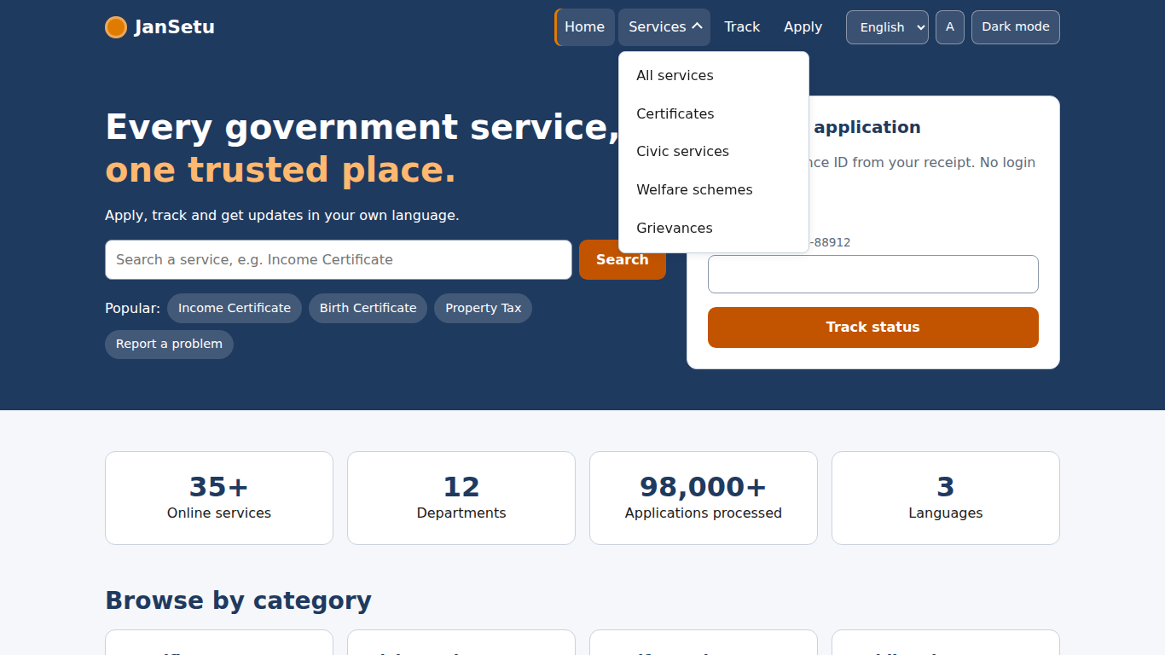  Figure 1: Desktop: Services dropdown open | 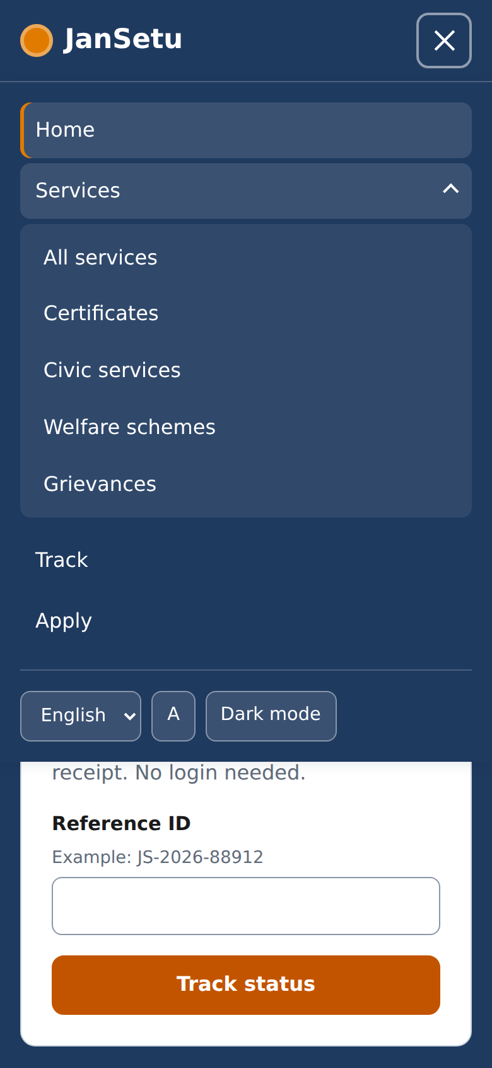  Figure 2: Mobile: hamburger panel with the dropdown expanded

Note: the desktop screenshot shows the header with the dropdown open; on mobile, the hamburger icon changes to a cross when the panel is open.

4.2 Service Directory: Live Search, Filters and Modal Pop-up
Purpose: help citizens find a service quickly, and show its details without leaving the page. Typing filters the list after a short pause, category chips narrow the results, and ‘View details’ opens a modal with eligibility and required documents.
JavaScript: filtering as a pure function
/* Pure function: takes the state, returns the matching services */
function filterServices(list, s) { <-- (1)
var term = s.q.trim().toLowerCase();
var out = list.filter(function (sv) {
var inCat = s.cat === 'All' || sv.cat === s.cat;
var hay = (sv.title + ' ' + sv.dept + ' ' + sv.desc).toLowerCase();
return inCat && (!term || hay.indexOf(term) !== -1); <-- (2)
});
if (s.sort === 'title') out.sort(function (a, b) { return a.title.localeCompare(b.title); });
if (s.sort === 'days') out.sort(function (a, b) { return a.days - b.days; });
return out;
}

function render() {
var list = filterServices(JS.SERVICES, state);
count.textContent = list.length + (list.length === 1 ? ' service found' : ' services found'); // read out by screen readers (aria-live) <-- (3)
if (!list.length) {
grid.innerHTML = '<div class="card empty" style="grid-column:1/-1"><h3>No services match your search</h3>' + <-- (4)
'<p class="muted">Try a shorter word, or clear the filters.</p><button class="btn btn--outline" id="clear">Clear filters</button></div>';
$('#clear').addEventListener('click', reset);
return;
}
grid.innerHTML = list.map(function (s) {
return '<article class="card card--hover service-card">' +
'<h3>' + esc(s.title) + '</h3><div class="muted">' + esc(s.dept) + '</div>' +
'<p>' + esc(s.desc) + '</p>' +
'<div><span class="chip chip--ok">Online</span> <span class="chip chip--info">' + (s.days === 1 ? '1 day' : s.days + ' days') + '</span> ' +
'<span class="chip chip--wait">' + esc(s.fee) + '</span></div>' +
'<div class="actions"><button class="btn btn--outline" data-open="' + s.id + '">View details</button>' +
'<a class="btn" href="apply.html?service=' + s.id + '">Apply</a></div></article>';
}).join('');
syncUrl();

# | Explanation
1 | A pure function: same input gives the same output and it touches no DOM, so it is easy to reason about and test.
2 | Search matches the title, department and description, case-insensitively.
3 | The result count sits in an aria-live region, so screen-reader users hear ‘1 service found’ after each change.
4 | An empty state explains what happened and offers ‘Clear filters’ rather than showing a blank page.

JavaScript: accessible modal using the native <dialog> element
/* Modal built on the native <dialog> element: showModal() gives us a focus trap,
Escape-to-close and an inert background for free. */
function openModal(id, trigger) {
var s = JS.getService(id);
$('#modal-title').textContent = s.title;
$('#modal-body').innerHTML =
'<p>' + esc(s.desc) + '</p>' +
'<p><span class="chip chip--info">' + esc(s.dept) + '</span> <span class="chip chip--ok">Approx. ' + s.days + ' days</span> <span class="chip chip--wait">Fee: ' + esc(s.fee) + '</span></p>' +
'<h3>Who can apply?</h3><ul>' + s.eligibility.map(function (e) { return '<li>' + esc(e) + '</li>'; }).join('') + '</ul>' +
'<h3>Documents you will need</h3><ul>' + s.docs.map(function (e) { return '<li>' + esc(e) + '</li>'; }).join('') + '</ul>';
$('#modal-apply').href = 'apply.html?service=' + s.id;
modal._trigger = trigger;
if (typeof modal.showModal === 'function') modal.showModal(); else modal.setAttribute('open', ''); <-- (1)
}
function closeModal() { if (modal.close) modal.close(); else modal.removeAttribute('open'); }

modal.addEventListener('click', function (e) { // click on the dark backdrop closes the dialog
var r = modal.getBoundingClientRect(); <-- (2)
var inside = e.clientX >= r.left && e.clientX <= r.right && e.clientY >= r.top && e.clientY <= r.bottom;
if (!inside) closeModal();
});
modal.addEventListener('close', function () { // return focus to the button that opened it
if (modal._trigger) modal._trigger.focus(); <-- (3)
});
$('#modal-close').addEventListener('click', closeModal);
$('#modal-dismiss').addEventListener('click', closeModal);

# | Explanation
1 | showModal() gives a focus trap, an inert page behind and Escape-to-close automatically.
2 | Clicks on the backdrop count as clicks on the dialog element itself; comparing the click position with the dialog box detects them.
3 | When the dialog closes, focus returns to the button that opened it (WCAG 2.4.3 Focus Order).

HTML and CSS for the modal
<dialog class="modal" id="service-modal" aria-labelledby="modal-title">
<div class="modal__head">
<h2 id="modal-title">Service</h2>
<button class="btn btn--ghost" id="modal-close" type="button" aria-label="Close dialog">&#10005;</button>
</div>
<div class="modal__body" id="modal-body"></div>
<div class="modal__foot">
<button class="btn btn--outline" id="modal-dismiss" type="button">Close</button>
<a class="btn" id="modal-apply" href="apply.html">Apply online</a>
</div>

/* ---------- Modal (native <dialog>) ---------- */
.modal { width: min(100% - 2rem, 38rem); max-height: calc(100vh - 2rem); padding: 0; color: var(--ink); background: var(--surface); border: 1px solid var(--border); border-radius: var(--radius); box-shadow: 0 20px 50px rgba(0,0,0,.35); overflow: auto; }
.modal[open] { animation: pop .22s var(--ease); }
.modal::backdrop { background: rgba(10, 20, 35, .6); }
.modal__head { display: flex; justify-content: space-between; align-items: start; gap: 1rem; padding: var(--space-3) var(--space-4); border-bottom: 1px solid var(--border); position: sticky; top: 0; background: var(--surface); }
.modal__head h2 { margin: 0; font-size: 1.3rem; }

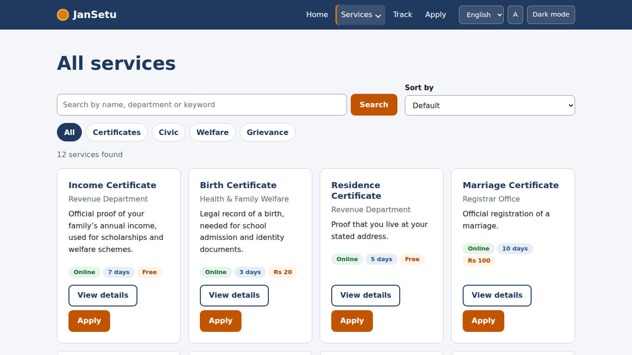  Figure 3: Desktop: service directory with filter chips |   Figure 4: Desktop: modal with eligibility and documents

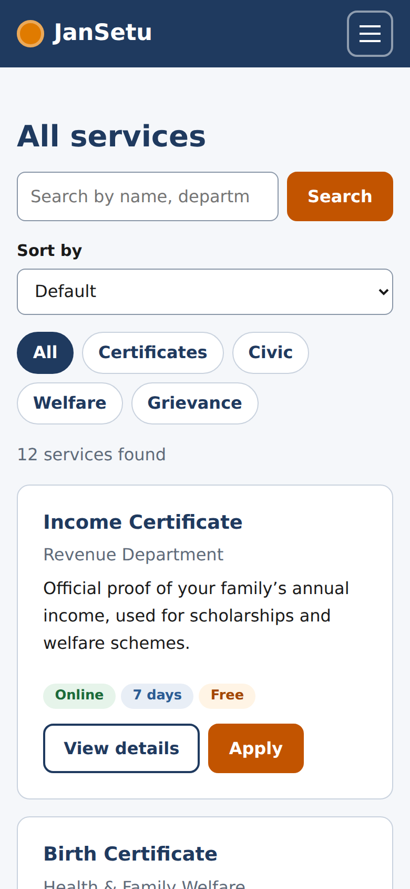  Figure 5: Mobile: directory in a single column |   Figure 6: Mobile: modal fits the small screen

4.3 Dynamic Multi-Step Application Form
Purpose: guide a citizen through an application in five short steps: Service, Details, Documents, Review, Done. The form is dynamic: the eligibility checks, the extra fields in step 2 and the list of required documents in step 3 all change with the selected service.
Service data drives the form (excerpt from data.js)
/* Each service can declare extra form fields (extra) that appear in step 2. */
JS.SERVICES = [
{ id: 'income', title: 'Income Certificate', dept: 'Revenue Department', cat: 'Certificates', days: 7, fee: 'Free',
desc: 'Official proof of your family\u2019s annual income, used for scholarships and welfare schemes.',
eligibility: ['I have lived in the state for at least 3 years', 'I am 18 years or older'],
docs: ['ID proof', 'Address proof', 'Income declaration'], <-- (2)
extra: [{ id: 'annualIncome', label: 'Annual family income (Rs)', type: 'text', kind: 'whole', hint: 'Whole rupees, e.g. 120000' }] }, <-- (1)
{ id: 'birth', title: 'Birth Certificate', dept: 'Health & Family Welfare', cat: 'Certificates', days: 3, fee: 'Rs 20',
desc: 'Legal record of a birth, needed for school admission and identity documents.',
eligibility: ['The birth took place in this state', 'I am a parent or legal guardian'],
docs: ['Hospital discharge slip', 'Parent ID proof'],
extra: [{ id: 'childName', label: 'Child\u2019s full name', type: 'text', kind: 'name' },
...

# | Explanation
1 | Each service can declare its own extra fields. ‘kind’ selects the validation rule.
2 | The documents list produces the upload slots in step 3.

JavaScript: building a field with label, hint and error
/* Build one form field. Every input gets a visible <label>, an optional hint
and an error <p>; aria-describedby links them so screen readers read all three. */ <-- (2)
function fieldHTML(f, value) {
var id = 'f-' + f.id, hint = f.hint ? '<span class="hint" id="' + id + '-hint">' + esc(f.hint) + '</span>' : '';
var desc = (f.hint ? id + '-hint ' : '') + id + '-err';
var attrs = ' id="' + id + '" name="' + f.id + '" aria-describedby="' + desc + '"' +
(f.optional ? '' : ' required') + (f.auto ? ' autocomplete="' + f.auto + '"' : '') + <-- (4)
(f.type === 'tel' || f.kind === 'pin' || f.kind === 'whole' ? ' inputmode="numeric"' : ''); <-- (3)
var control;
if (f.type === 'select') {
control = '<select' + attrs + '><option value="">Select\u2026</option>' + f.options.map(function (o) {
return '<option' + (o === value ? ' selected' : '') + '>' + esc(o) + '</option>'; }).join('') + '</select>';
} else {
control = '<input type="' + f.type + '"' + attrs + ' value="' + esc(value || '') + '">';
}
return '<div class="field' + (f.full ? ' full' : '') + '"><label for="' + id + '">' + esc(f.label) + <-- (1)
(f.optional ? '' : ' <span class="req" aria-hidden="true">*</span>') + '</label>' + hint + control +
'<p class="field__error" id="' + id + '-err"></p></div>';
}

# | Explanation
1 | Every input has a visible label linked by for/id; placeholders are never used as labels.
2 | Links the hint and the error message to the input so screen readers read them together.
3 | Opens the numeric keypad on phones for mobile numbers, PIN codes and amounts.
4 | Lets browsers autofill name, phone and address (WCAG 1.3.5).

JavaScript: validation by field kind and by step
/* Validate one field by its "kind". Returns an error message or '' when valid. */
function validateField(f, value) { <-- (1)
var v = String(value || '').trim();
if (!V.required(v)) return f.optional ? '' : 'Enter ' + f.label.toLowerCase().replace(' (optional)', '') + '.';
switch (f.kind) {
case 'name': return V.name(v) ? '' : 'Use letters only, for example Ananya Roy.';
case 'mobile': return V.mobile(v) ? '' : 'Enter a 10-digit mobile number starting with 6, 7, 8 or 9.'; <-- (2)
case 'email': return V.email(v) ? '' : 'Enter an email like name@example.com.';
case 'pin': return V.pincode(v) ? '' : 'Enter a 6-digit PIN code.';
case 'whole': return V.wholeNumber(v) ? '' : 'Enter a whole number, for example 120000.';
case 'pastDate': return V.dateNotFuture(v) ? '' : 'The date cannot be in the future.';
case 'dob': <-- (3)
if (!V.dateNotFuture(v)) return 'Date of birth cannot be in the future.';
var s = currentService(), min = s && s.minAge ? s.minAge : 18;
return V.ageAtLeast(v, min) ? '' : 'You must be at least ' + min + ' years old for this service.';
default: return '';
}
}

/* Validate the whole step; returns a list of {id, message} */
function validateStep(n) { <-- (4)
var errs = [], s = currentService();
if (n === 1) {
if (!s) errs.push({ id: 'service', message: 'Select a service to continue.' });
else if (state.elig.filter(Boolean).length < s.eligibility.length) errs.push({ id: 'eligibility', message: 'Please confirm all the statements to continue.' });
}
if (n === 2) {
BASE_FIELDS.concat(s.extra).forEach(function (f) {
var m = validateField(f, state.values[f.id]);
if (m) errs.push({ id: 'f-' + f.id, message: m });
});
}
if (n === 3) {
s.docs.forEach(function (name, i) {
if (!state.files[name]) errs.push({ id: 'doc-' + i, message: 'Upload ' + name + '.' });
});

# | Explanation
1 | One switch on the field ‘kind’ returns a plain-language message or an empty string.
2 | Rules live in validators.js, so they are shared and unit-tested.
3 | Age rules depend on the service (pension needs 60+, others 18+).
4 | Validating a whole step returns a list of problems, which feeds the error summary.

JavaScript: moving between steps and autosaving a draft
/* Show one step panel, update the stepper and move focus to the step heading */
function goTo(n) {
state.step = n;
$$('[data-step]').forEach(function (p) { p.hidden = +p.dataset.step !== n; });
$$('.stepper li').forEach(function (li, i) {
li.dataset.state = i + 1 < n ? 'done' : i + 1 === n ? 'current' : 'todo'; <-- (1)
if (i + 1 === n) li.setAttribute('aria-current', 'step'); else li.removeAttribute('aria-current');
});
$('#step-count').textContent = 'Step ' + Math.min(n, TOTAL) + ' of ' + TOTAL;
if (n === 2) renderStep2();
if (n === 3) renderDocs();
if (n === 4) renderReview();
$('#btn-back').hidden = n === 1 || n === 5;
$('#btn-next').hidden = n === 5;
$('#btn-save').hidden = n === 5;
$('#btn-next').textContent = n === 4 ? 'Submit application' : 'Next';
var h = $('[data-step="' + n + '"] h2');
if (h) { h.setAttribute('tabindex', '-1'); h.focus(); } <-- (2)
showErrors([]);
if (n < 5) save(true);
...
/* Autosave: everything except the File objects is stored in localStorage */
function save(quiet) {
if (state.step === 2) collect();
JS.store.set('draft', { step: Math.min(state.step, 4), serviceId: state.serviceId, values: state.values, elig: state.elig, files: state.files, at: new Date().toISOString() }); <-- (3)
var t = new Date().toLocaleTimeString('en-IN', { hour: '2-digit', minute: '2-digit' });
$('#draft-status').textContent = 'Draft saved ' + t;
if (quiet !== true) JS.toast('Draft saved. You can finish later.');
}
$('#btn-save').addEventListener('click', function () { save(); });
$('#steps-root').addEventListener('input', JS.debounce(function () { if (state.step < 5) save(true); }, 600));

# | Explanation
1 | The stepper is styled by a data-state attribute (done, current, todo), so CSS controls all visuals.
2 | After each step change focus moves to the step heading, so keyboard and screen-reader users know where they are.
3 | Draft data (except file objects, which browsers cannot store) is saved after 600 ms of inactivity and when the user clicks ‘Save draft’.

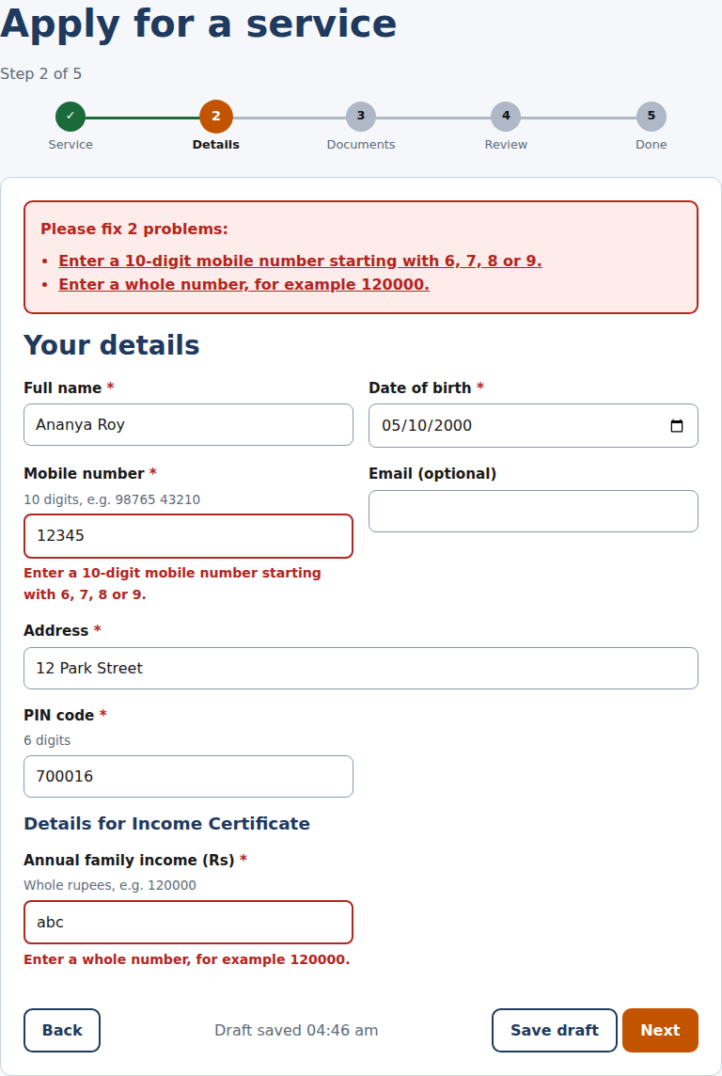  Figure 7: Desktop: step 2 with inline errors and error summary | 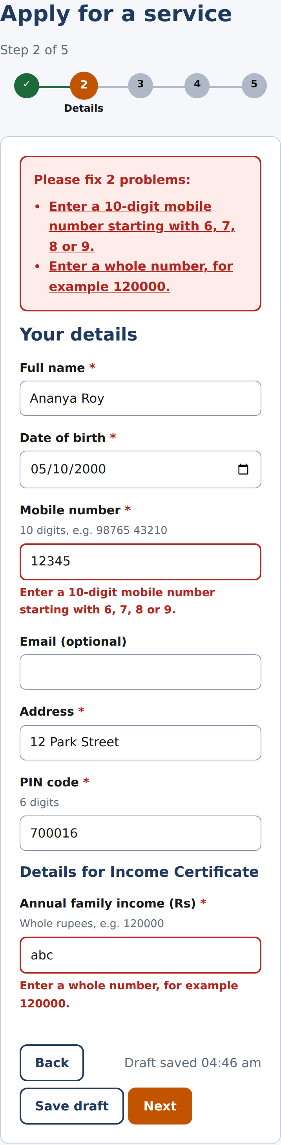  Figure 8: Mobile: the same step, single-column layout

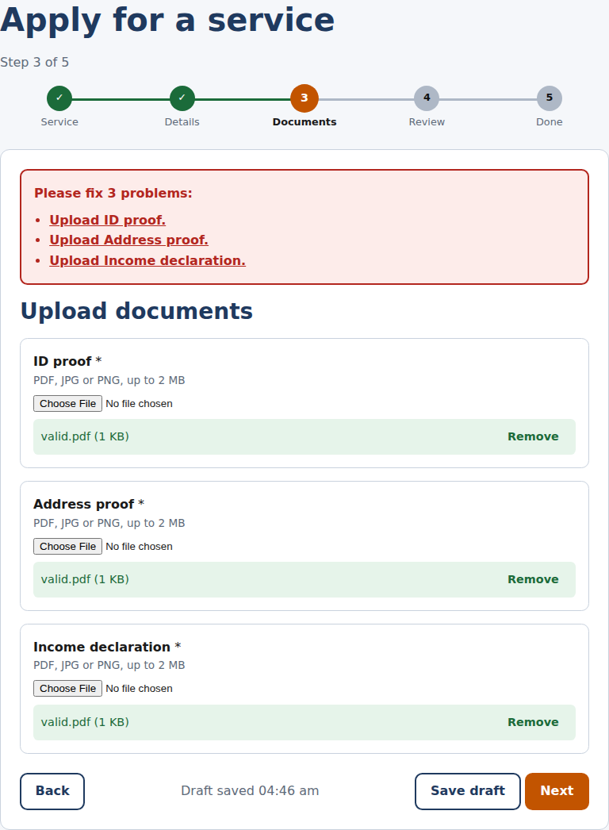  Figure 9: Desktop: step 3, document uploads with 2 MB / type checks | 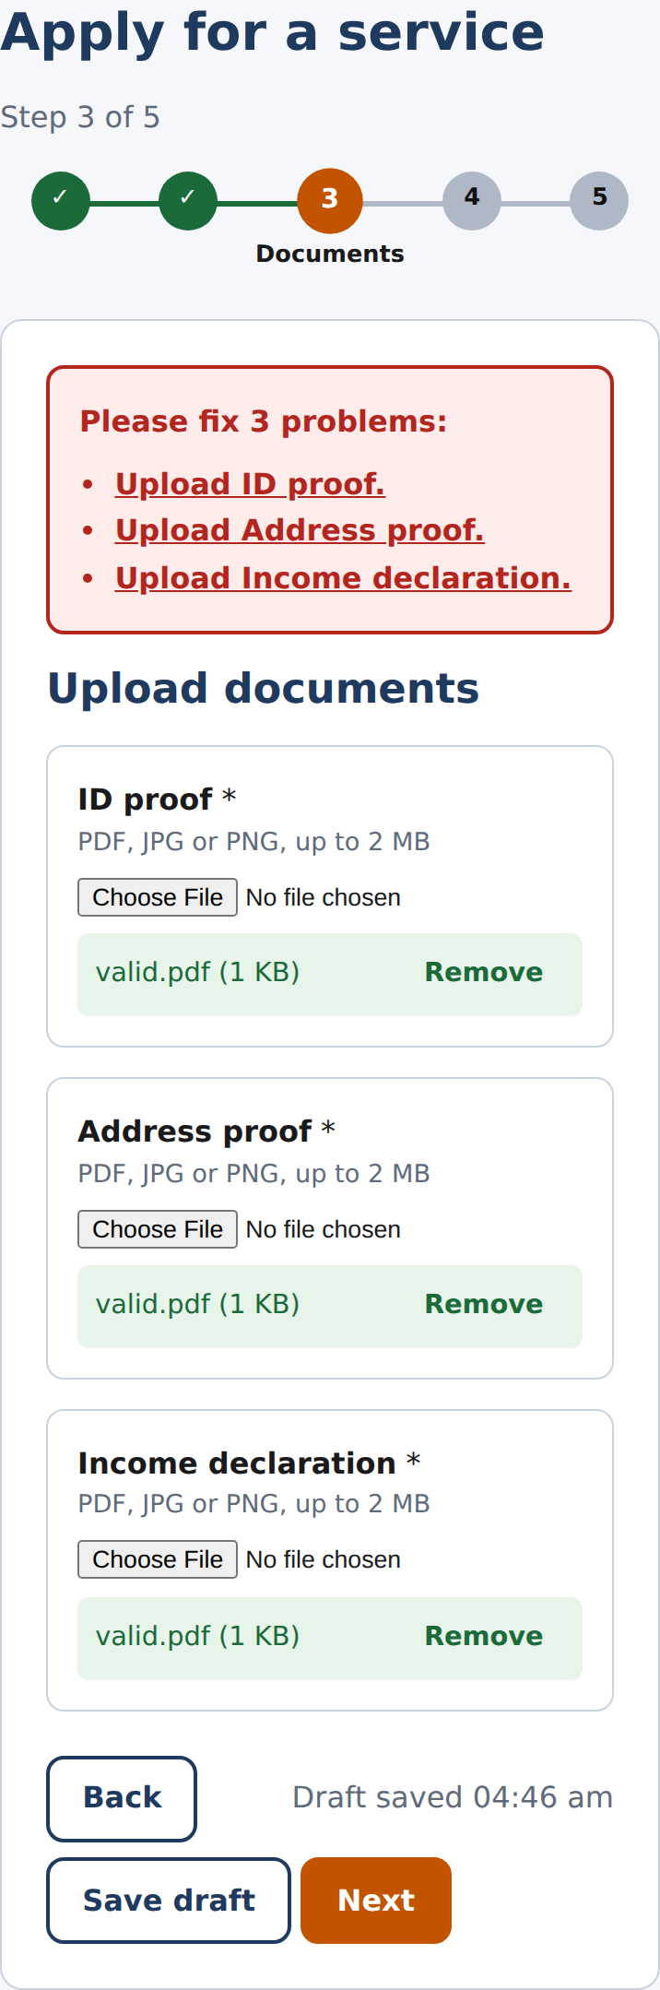  Figure 10: Mobile: step 3 (a summary of problems appears above)

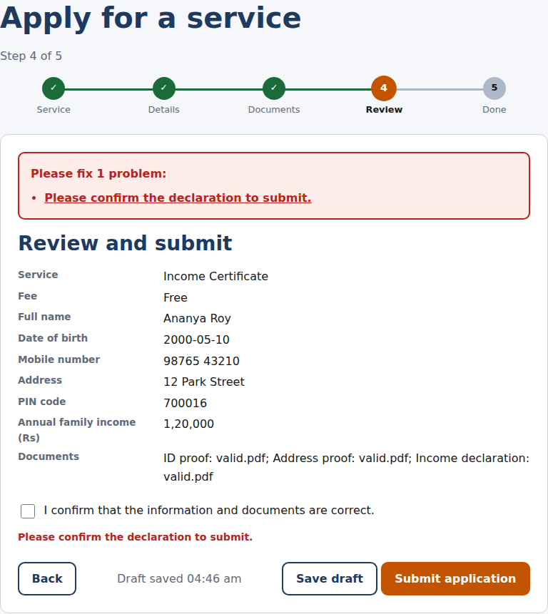  Figure 11: Desktop: review step | 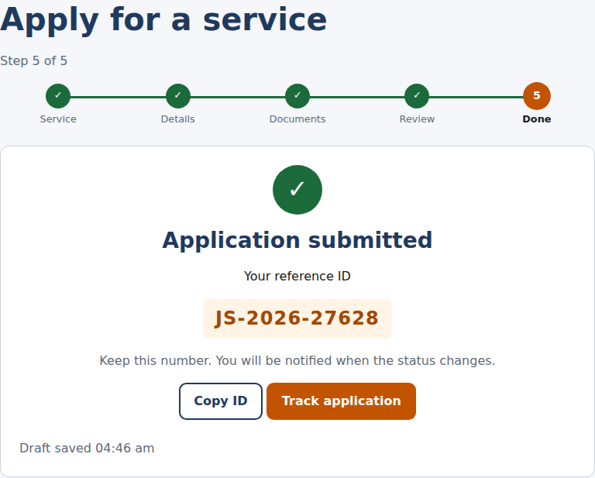  Figure 12: Desktop: success with reference ID | 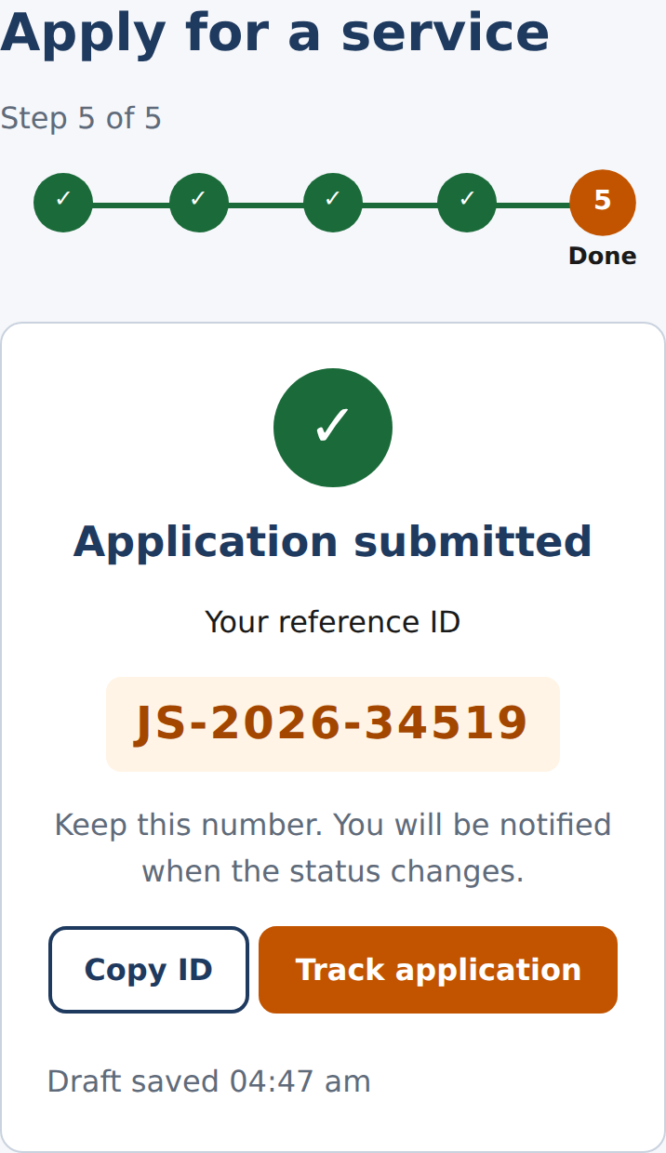  Figure 13: Mobile: success

The error summary at the top of the form lists every problem as a link to the offending field, and receives focus when it appears. Each invalid field also gets a red border, an inline message, and aria-invalid=true, so errors are never shown by colour alone.

4.4 Animated Application Tracker
Purpose: let citizens see where an application stands. The tracker shows four stages, a green progress bar that animates to the current stage, and a dated history. A demo button simulates an officer moving the application forward.
JavaScript: rendering the tracker and animating the bar
function chip(st) { return st === 3 ? '<span class="chip chip--ok">Approved</span>' : '<span class="chip chip--wait">' + JS.STATUS[st] + '</span>'; }

function show(app) {
var steps = JS.STATUS.map(function (name, i) {
var st = i < app.status || app.status === 3 ? 'done' : i === app.status ? 'current' : 'todo';
return '<li class="tracker__step" data-state="' + st + '"><span class="tracker__dot">' + (st === 'done' ? '\u2713' : i + 1) + '</span>' + name + '</li>'; <-- (1)
}).join('');
$('#result').innerHTML =
'<div class="card"><div style="display:flex;justify-content:space-between;align-items:flex-start;flex-wrap:wrap;gap:.5rem"><div><h2 style="margin:0">' + esc(app.title) + '</h2>' +
'<p class="muted" style="margin:0">Reference ' + esc(app.ref) + ' &middot; Submitted ' + JS.formatDate(app.created) + '</p></div>' + chip(app.status) + '</div>' +
'<ol class="tracker" style="--progress:0;list-style:none;padding:0" id="tracker"><span class="tracker__bar"></span><span class="tracker__fill"></span>' + steps + '</ol>' + <-- (2)
'<h3>History</h3><ul class="timeline">' + app.history.map(function (h) {
return '<li><strong>' + JS.STATUS[h.status] + '</strong> <span class="muted">' + JS.formatDate(h.at) + '</span></li>'; }).join('') + '</ul>' +
(app.status < 3 ? '<button class="btn btn--outline" id="simulate" data-ref="' + esc(app.ref) + '">Demo: simulate officer update</button>' : '<p class="notice notice--ok">Your certificate is ready to download.</p>') + '</div>';
/* Animate the green bar on the next frame so the CSS transition runs from 0 */
var t = $('#tracker');
requestAnimationFrame(function () { requestAnimationFrame(function () { t.style.setProperty('--progress', app.status / (JS.STATUS.length - 1)); }); }); <-- (3)
$('#result').focus(); <-- (4)
}

# | Explanation
1 | Stage styling comes from data-state, the same pattern as the stepper.
2 | The bar width is a CSS variable. Setting it to 0 first, then to the real value, lets the CSS transition play.
3 | Two animation frames are needed so the browser paints the starting width before the change; with one frame the bar jumps.
4 | Focus moves to the result so screen-reader users hear it.

CSS: progress bar driven by a custom property
.tracker__bar, .tracker__fill { position: absolute; top: 1rem; left: 12.5%; height: 4px; border-radius: 2px; }
.tracker__bar { width: 75%; background: #AEB8C6; }
.tracker__fill { width: calc(75% * var(--progress, 0)); background: var(--success); transition: width .9s var(--ease); } <-- (1)
.tracker__step { position: relative; z-index: 1; font-size: .8rem; color: var(--muted); }

# | Explanation
1 | calc(75% * var(--progress)) turns a 0-1 value into a width; the transition animates it.

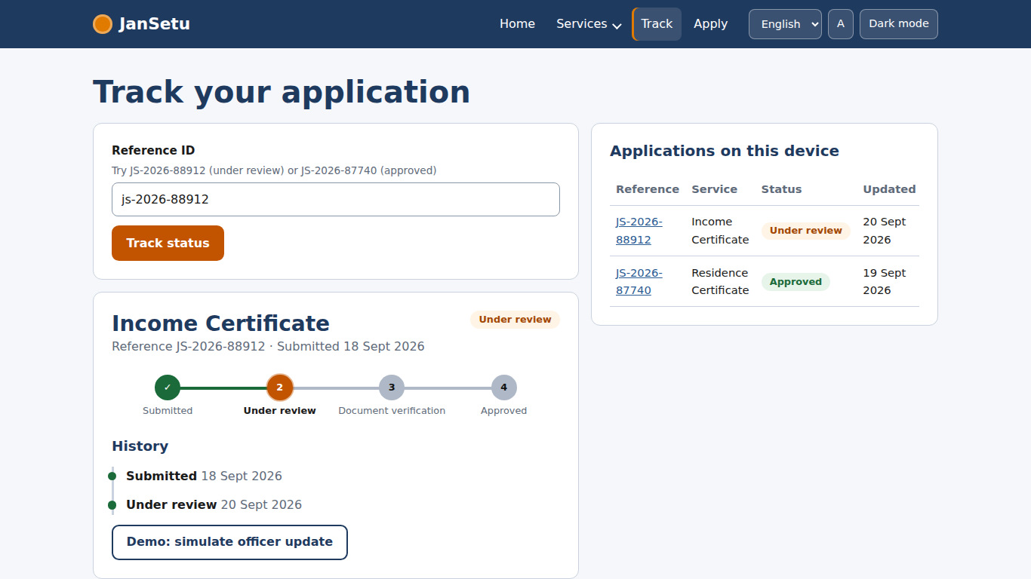  Figure 14: Desktop: tracker for an application under review | 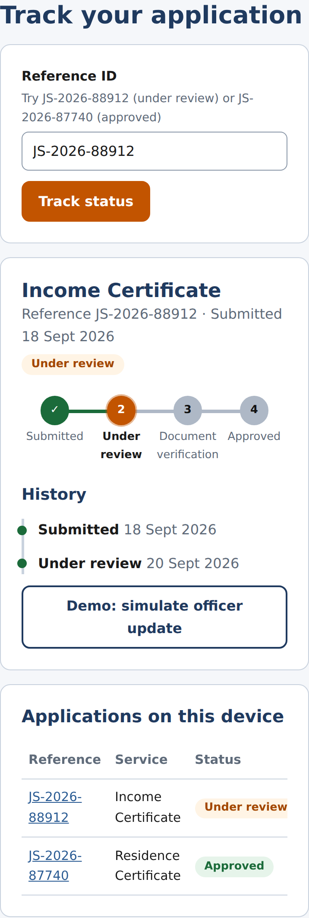  Figure 15: Mobile: tracker and history stacked

4.5 FAQ Accordion and Animated Counters
JavaScript: accessible accordion
JS.initAccordion = function (root) {
var buttons = JS.$$('.accordion__button', root);
buttons.forEach(function (btn) {
btn.addEventListener('click', function () {
var open = btn.getAttribute('aria-expanded') === 'true'; <-- (1)
buttons.forEach(function (b) { // close all, then open the clicked one
b.setAttribute('aria-expanded', 'false'); <-- (2)
d.getElementById(b.getAttribute('aria-controls')).hidden = true;
});
if (!open) {
btn.setAttribute('aria-expanded', 'true');
d.getElementById(btn.getAttribute('aria-controls')).hidden = false;
}
});
/* Up / Down / Home / End move between headers (WAI-ARIA accordion pattern) */
btn.addEventListener('keydown', function (e) {
var i = buttons.indexOf(btn), n = buttons.length, t = null;
if (e.key === 'ArrowDown') t = buttons[(i + 1) % n];
if (e.key === 'ArrowUp') t = buttons[(i - 1 + n) % n];
if (e.key === 'Home') t = buttons[0]; <-- (3)
if (e.key === 'End') t = buttons[n - 1];
if (t) { e.preventDefault(); t.focus(); }
});
});

# | Explanation
1 | Each header button reports whether its panel is open.
2 | Only one panel is open at a time, which keeps the page short.
3 | Up, Down, Home and End move between headers (WAI-ARIA accordion pattern).

JavaScript: counters that animate when scrolled into view
/* Animated counters: start counting only when the section scrolls into view */
function animate(el) {
var target = +el.dataset.count, suffix = el.dataset.suffix || '';
if (JS.reducedMotion()) { el.textContent = target.toLocaleString('en-IN') + suffix; return; } <-- (1)
var start = null, dur = 1400;
function frame(ts) {
if (start === null) start = ts;
var p = Math.min((ts - start) / dur, 1);
var eased = 1 - Math.pow(1 - p, 3); // ease-out cubic <-- (2)
el.textContent = Math.round(target * eased).toLocaleString('en-IN') + suffix;
if (p < 1) requestAnimationFrame(frame);
}
requestAnimationFrame(frame);
}
var counters = JS.$$('[data-count]');
if ('IntersectionObserver' in w && !JS.reducedMotion()) {
counters.forEach(function (c) { c.textContent = '0'; }); // the HTML holds the final numbers (works without JS); reset to 0 only when we will animate
var io = new IntersectionObserver(function (entries) { <-- (3)
entries.forEach(function (en) {
if (en.isIntersecting) { animate(en.target); io.unobserve(en.target); }
});
}, { threshold: 0.4 });
counters.forEach(function (c) { io.observe(c); });
} else {

# | Explanation
1 | Users who prefer reduced motion see the final number immediately.
2 | An ease-out curve makes the number slow down as it reaches the target.
3 | The animation starts only when the section becomes visible, saving work and making the effect noticeable.

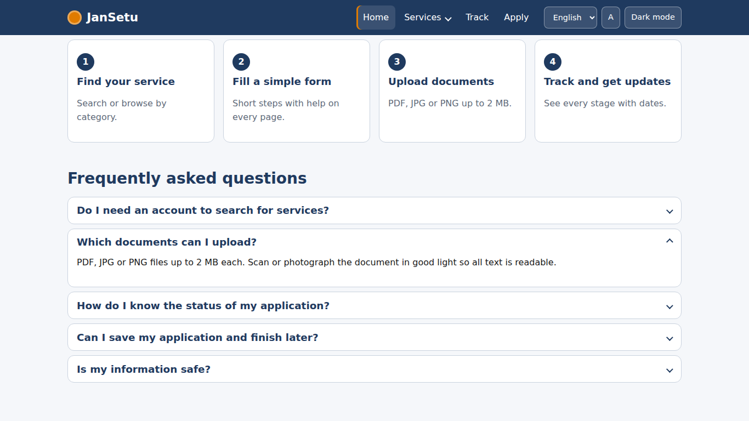  Figure 16: Desktop: FAQ accordion with one panel open | 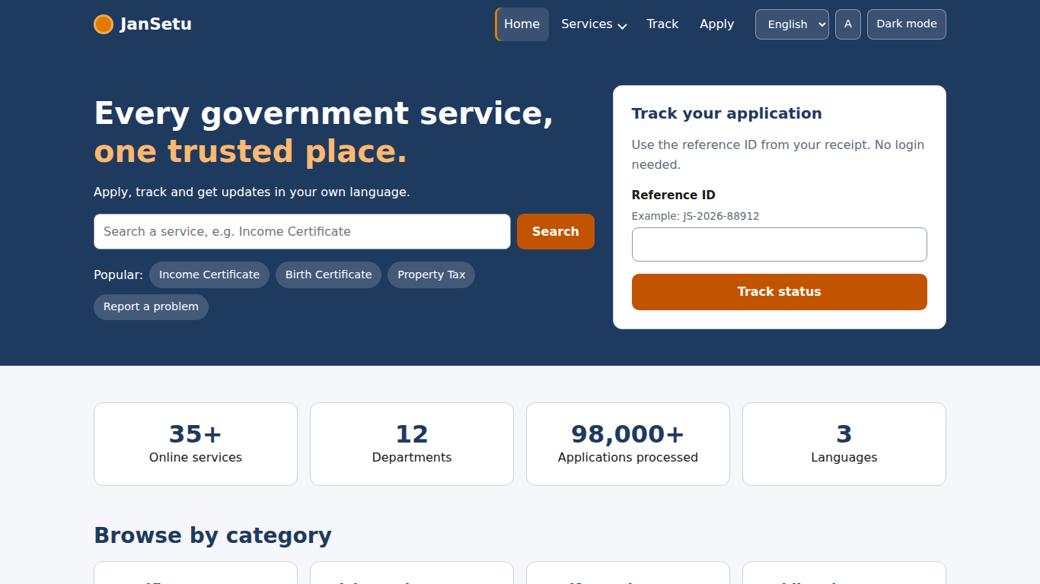  Figure 17: Desktop: homepage with counters

4.6 Personalisation: Dark Mode, Text Size and Language
Three header controls adapt the interface to the user. Dark mode swaps the colour tokens; text size changes the root font size so every rem-based measurement scales; the language switch replaces text using data-i18n attributes. Choices are stored in localStorage, and an inline script in each page head applies the saved theme before first paint to avoid a flash.
CSS: dark theme is only a set of token overrides
:root[data-theme="dark"] {
--ink: #EAF0F8; --muted: #A8B4C6;
--bg: #0F1724; --surface: #182335; --border: #33445C;
--heading: #BBD4F5; --link: #8DB6EA; --focus: #F5A04A;
--header-bg: #0B1626; --hero-bg: #12233D;
--accent-soft: #3A2410; --accent-text: #FFB870;
--success: #7FD3A0; --success-soft: #123524;
--danger: #FF9C94; --danger-soft: #3B1815;
--warn: #F2D27A; --warn-soft: #3A300E;
--info: #8DB6EA; --info-soft: #22344F;
...
}

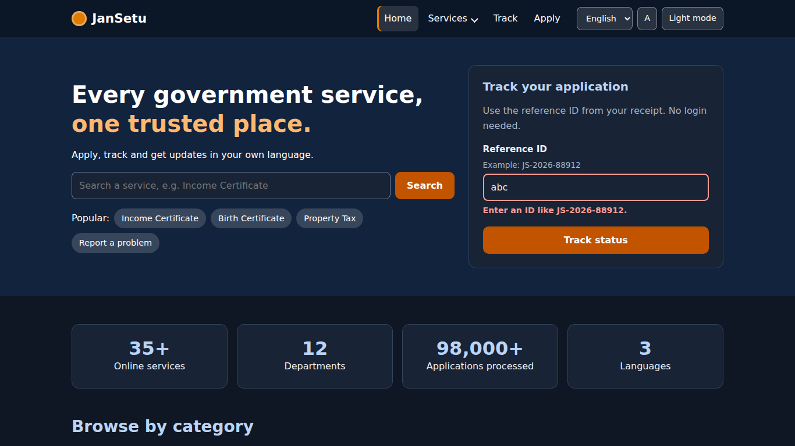  Figure 18: Desktop: dark mode | 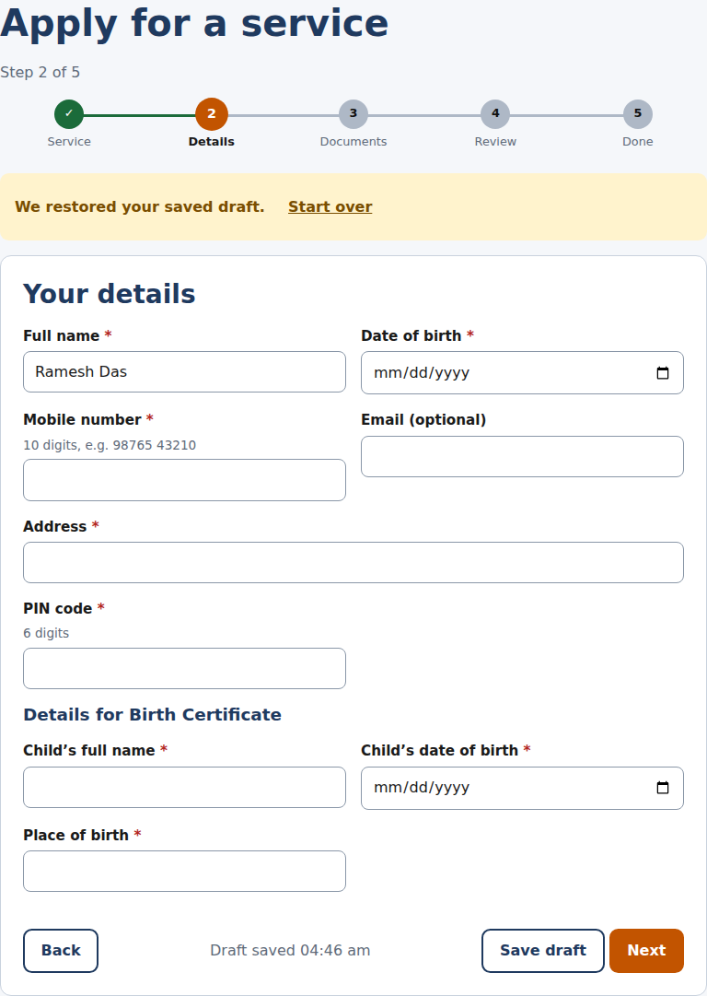  Figure 19: Desktop: draft restored after reload

The Hindi and Bengali strings are samples for the navigation, hero and track card, and should be reviewed by native speakers. Language switching was verified in the automated tests by checking the changed text and the html lang attribute; a Hindi screenshot is not included because the test machine had no Devanagari web font and the fallback font rendered conjuncts incorrectly.

5. Responsive Design

5.1 Techniques
Technique | Where used
Mobile-first CSS with min-width media queries | All components; breakpoints at 40 rem (640 px) and 56.25 rem (900 px).
Fluid layout: CSS Grid with auto-fit and minmax() | Service cards, category cards and steps reflow from 1 to 4 columns without extra breakpoints.
Flexbox for bars and toolbars | Header, search bar, wizard buttons.
clamp() for headings, min() for container width | Headline sizes scale smoothly; container is 100% minus 2 rem gutter, up to 70 rem.
Hamburger navigation below 900 px | Section 4.1.
Compact stepper on phones | Only the current step label is shown; all numbered circles stay visible.
min-width: 0 on grid children, table wrapped in overflow-x: auto | Prevents long text and tables from causing horizontal scrolling.
44 px minimum touch targets | Buttons, inputs, chips and menu items.

5.2 Breakpoints
Breakpoint | Width | Layout
Mobile (default) | 320 – 639 px | Single column; hamburger nav; stacked form fields; compact stepper.
Tablet | 640 – 899 px | Two-column form grid and four-column stats; hamburger nav.
Desktop | 900 px and above | Inline nav with dropdown; hero and results in multi-column layouts; two-column tracker page.

Figure 20: Homepage at 1366 x 768 | 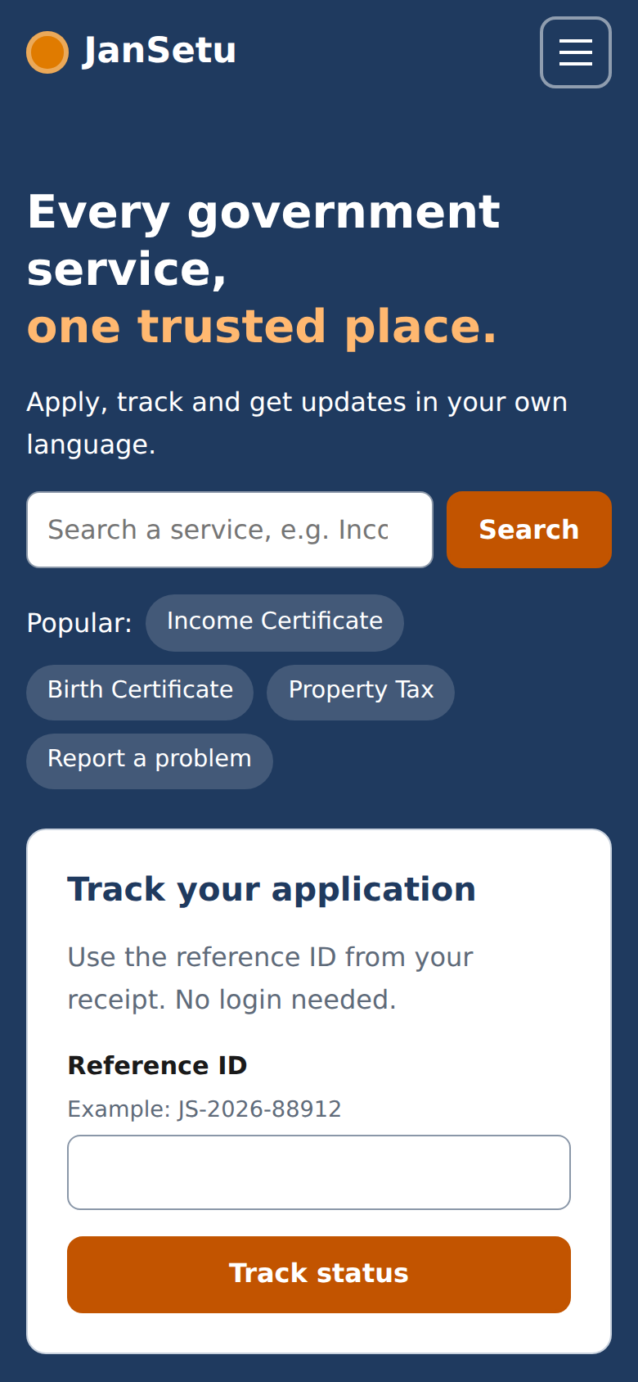  Figure 21: Homepage at 390 x 844

5.3 Overflow Checks
The automated tests loaded every page at 320 px and 390 px wide and confirmed that the page never scrolls sideways (document width not greater than window width), including the tracker page with a result displayed. All of these checks passed.

6. Accessibility Implementation
Feature | Implementation
Keyboard access | Every control is a native button, link or input. Dropdown, accordion and modal have arrow-key and Escape support. Skip link jumps to main content.
Visible focus | 3 px focus ring on every element via :focus-visible.
Labels and errors | Every input has a label (verified by an automated check on all four pages); errors use text, colour and aria-invalid; an error summary receives focus.
Screen-reader announcements | aria-live regions for the result count, draft status, toasts and tracker result.
Colour contrast | Palette uses measured AA-compliant pairs from the Week 2 design system; dark theme keeps text on surfaces readable.
Motion | Animations are short and switch off under prefers-reduced-motion.
Text scaling | rem units and a text-size control (100%, 118%, 135%).
Language | html lang attribute updates with the language switch.

Automated accessibility scanners (for example axe or Lighthouse) and a screen-reader pass were not run for this report; they are listed under improvements.

7. Testing

7.1 Unit Tests
The validation functions are pure, so they were unit-tested in Node with the built-in test runner (node --test tests/validators.test.js). Nine test groups cover required fields, names in several scripts, mobile numbers, email, PIN codes, whole numbers, dates and age (with an injected ‘today’), file rules and reference IDs. All 9 passed.
The unit tests found a real defect: names written in Bengali were rejected because vowel signs are combining marks, not letters. The name rule was changed to accept letters and combining marks in any script (\p{L}\p{M}).

7.2 End-to-End Tests
An automated script (tests/e2e_chromium.py, Playwright) drives the real pages in Chromium 141 at a desktop viewport (1366 x 768) and a mobile viewport (390 x 844, touch enabled, 2x pixel density). It performed 84 checks; 84 passed. Google Fonts requests were blocked during the tests so results do not depend on the network. The full list is in Appendix B.
Table 1: End-to-end results by area
Area | Checks | Passed
Navigation and header tools | 14 | 14
Homepage: accordion, counters, quick track | 7 | 7
Service directory and modal | 12 | 12
Application form and uploads | 30 | 30
Tracker | 6 | 6
Accessibility labels | 4 | 4
Mobile layout and stepper | 11 | 11
Total | 84 | 84

7.3 Browser Compatibility
Automated tests were run only in Chromium (the engine behind Chrome and Edge). Firefox and Safari were not available in the test environment, so they have not been tested. The table lists the features the site relies on and the minimum browser versions that support them, from public compatibility tables (verify on caniuse.com or MDN before relying on it). The last column is a blank checklist to fill in during manual testing.
Table 2: Features used and approximate minimum support
Feature | Chrome / Edge | Firefox | Safari
<dialog> and showModal() | 37 / 79 | 98 | 15.4
:focus-visible | 86 | 85 | 15.4
CSS Grid, custom properties, clamp(), min() | 79+ | 75+ | 13.1+
IntersectionObserver | 51 | 55 | 12.1
Unicode property escapes in regex (\p{L}) | 64 | 78 | 11.1
Clipboard API (with fallback) | 66 | 63 | 13.1
URLSearchParams, localStorage | All current | All current | All current

Table 3: Manual cross-browser test log (to be completed)
Browser | Version | Nav + dropdown | Directory + modal | Apply form | Tracker | Result
Chromium (automated) | 141 | Pass | Pass | Pass | Pass | 84 / 84 checks
Google Chrome (desktop)
Microsoft Edge
Mozilla Firefox
Safari (macOS)
Safari (iPhone)
Chrome (Android)

7.4 Limits of the Testing
- Mobile tests used Chromium’s device emulation, not physical phones; real-device behaviour (virtual keyboard, browser bars) may differ.
- No automated accessibility scanner or screen reader was used.
- Only file uploads of small test files were exercised; behaviour with very large photos was not measured.
- Performance (for example Lighthouse) was not measured.

8. Challenges and Solutions
Challenge | How it was solved
Buttons with the hidden attribute still appeared (for example ‘Back’ on step 1 and wizard buttons on the success screen). | Found in screenshot review: the .btn rule sets display: inline-flex, which overrides hidden. Fixed with a global rule [hidden] { display: none !important; } in base.css.
Bengali names failed validation. | A unit test caught it. Vowel signs are combining marks (\p{M}); the name pattern now allows letters and marks.
A draft reappeared after a successful submission. | The step function saved the draft on every step change, including the final one. Saving now happens only for steps 1–4.
The tracker progress bar jumped instead of animating. | CSS transitions need a painted starting state. The value is set to 0, then changed after two animation frames.
Long text (a hint with two reference IDs) stretched the tracker page beyond a 320 px screen. | Grid children default to min-width: auto. Setting min-width: 0 lets them shrink; an automated overflow test now covers this case.
A modal needs focus handling, Escape and backdrop clicks. | Used the native <dialog> element, and added a click-position check for the backdrop and focus return to the trigger button.
Selected files cannot be stored in localStorage, so drafts lose attachments. | Draft saves file names only; the interface states that files must be attached again. A future server or IndexedDB would remove this limit.
Screenshots were captured mid-animation (faded modal, counting numbers, toasts). | The screenshot helper clears toasts and waits for animations to finish before capturing.
Web fonts could not load in the test environment. | Tests block the font requests; CSS has a full fallback font stack, so layout does not depend on the fonts.
Repeated header and footer markup across four pages. | Accepted for a no-build static site; the header script is shared. Listed under improvements.

9. Potential Improvements
- Backend integration: replace localStorage with a REST API (Node/Express and MongoDB from Week 1), with real authentication, server-side validation and file storage.
- Reduce duplication: generate shared header and footer with a static-site generator, a small build script or web components.
- Accessibility audit: run axe and Lighthouse, then test with NVDA, VoiceOver and TalkBack; add a high-contrast mode.
- Cross-browser and device testing: complete the manual log in Section 7.3 on real devices.
- Performance: minify and bundle CSS and JavaScript, self-host fonts, lazy-load non-critical scripts and add a service worker for offline drafts.
- Complete translations: move all text to translation files and have Hindi and Bengali reviewed by native speakers.
- More features: login and dashboard, document vault, grievance form, officer console, notification centre.
- Testing: add a CI pipeline (GitHub Actions) that runs the unit and end-to-end tests on every commit, and add Firefox and WebKit to the Playwright runs.

10. Conclusion
The Week 2 design has been implemented as a working, responsive and accessible front end using HTML, CSS and JavaScript only. Six interactive components were built and documented, three of which (navigation with dropdown, modal pop-up and dynamic multi-step form) go well beyond the task’s minimum. The code is organised for readability, with design tokens, data-driven rendering, pure and tested validation, and accessibility built in. Nine unit tests and 84 end-to-end checks pass in Chromium at desktop and mobile sizes. The remaining work is real-device and multi-browser testing, an accessibility audit and connecting the interface to a backend.

Appendix A: File Inventory
File | Lines
index.html | 147
services.html | 103
apply.html | 148
track.html | 104
css/tokens.css | 48
css/base.css | 52
css/components.css | 230
js/utils.js | 61
js/validators.js | 61
js/data.js | 93
js/i18n.js | 40
js/layout.js | 94
js/accordion.js | 32
js/home.js | 63
js/services.js | 105
js/apply.js | 241
js/track.js | 77
tests/validators.test.js | 74
tests/e2e_chromium.py | 249
Total | 2022

Appendix B: End-to-End Check List
All checks below were run automatically (Chromium 141). ‘desktop’ checks ran at 1366 x 768; ‘mobile’ checks at 390 x 844 (and 320 px for overflow).
# | Check | Result
1 | desktop home: title present | PASS
2 | desktop nav: hamburger hidden, links visible | PASS
3 | desktop nav: dropdown closed by default | PASS
4 | desktop nav: click opens dropdown (aria-expanded=true) | PASS
5 | desktop nav: Escape closes dropdown and returns focus | PASS
6 | desktop nav: ArrowDown opens menu and focuses first link | PASS
7 | desktop nav: click outside closes dropdown | PASS
8 | desktop faq: first panel opens | PASS
9 | desktop faq: opening another closes the first | PASS
10 | desktop counters: animate to final values | PASS
11 | desktop home: quick track rejects bad ID | PASS
12 | desktop tools: dark mode toggles | PASS
13 | desktop tools: dark mode persists after reload | PASS
14 | desktop tools: text size increases | PASS
15 | desktop tools: language switch to Hindi | PASS
16 | desktop home: no JavaScript errors | PASS
17 | desktop services: 12 cards rendered from data | PASS
18 | desktop services: live search "tax" -> 1 result | PASS
19 | desktop services: result count announced | PASS
20 | desktop services: empty state message | PASS
21 | desktop services: clear filters restores all | PASS
22 | desktop services: category filter Welfare -> 3 | PASS
23 | desktop services: sort fastest first (1-day service on top) | PASS
24 | desktop modal: opens with service title | PASS
25 | desktop modal: Escape closes and returns focus to trigger | PASS
26 | desktop modal: backdrop click closes | PASS
27 | desktop services: URL parameters set filters | PASS
28 | desktop apply: step 1 blocks without a service | PASS
29 | desktop apply: step 1 blocks until eligibility confirmed | PASS
30 | desktop apply: reaches step 2 (dynamic fields for Income Certificate) | PASS
31 | desktop apply: empty step 2 lists 6 problems | PASS
32 | desktop apply: invalid inputs get aria-invalid | PASS
33 | desktop apply: mobile and income rules explained in plain language | PASS
34 | desktop apply: valid details reach step 3 | PASS
35 | desktop apply: step 3 requires all 3 documents | PASS
36 | desktop upload: .exe rejected | PASS
37 | desktop upload: 3 MB file rejected | PASS
38 | desktop upload: valid files listed | PASS
39 | desktop apply: review shows entered data | PASS
40 | desktop apply: declaration required | PASS
41 | desktop apply: submit shows valid reference ID | PASS
42 | desktop track: link opens the new application (Submitted) | PASS
43 | desktop draft: Save draft shows confirmation | PASS
44 | desktop draft: restored after reload | PASS
45 | desktop track: invalid ID format explained | PASS
46 | desktop track: unknown ID handled | PASS
47 | desktop track: demo ID shows Under review | PASS
48 | desktop track: simulate advances status to Document verification | PASS
49 | desktop track: approved application | PASS
50 | a11y: every form control on index.html has a label | PASS
51 | a11y: every form control on services.html has a label | PASS
52 | a11y: every form control on apply.html has a label | PASS
53 | a11y: every form control on track.html has a label | PASS
54 | mobile nav: hamburger visible, nav hidden | PASS
55 | mobile nav: hamburger opens panel (aria-expanded=true) | PASS
56 | mobile nav: dropdown expands inline | PASS
57 | mobile nav: Escape closes panel | PASS
58 | mobile layout: no horizontal scroll on index.html at 320px | PASS
59 | mobile layout: no horizontal scroll on index.html at 390px | PASS
60 | mobile layout: no horizontal scroll on services.html at 320px | PASS
61 | mobile layout: no horizontal scroll on services.html at 390px | PASS
62 | mobile layout: no horizontal scroll on apply.html at 320px | PASS
63 | mobile layout: no horizontal scroll on apply.html at 390px | PASS
64 | mobile layout: no horizontal scroll on track.html at 320px | PASS
65 | mobile layout: no horizontal scroll on track.html at 390px | PASS
66 | mobile modal: opens and fits the screen | PASS
67 | mobile apply: step 1 blocks without a service | PASS
68 | mobile apply: step 1 blocks until eligibility confirmed | PASS
69 | mobile apply: reaches step 2 (dynamic fields for Income Certificate) | PASS
70 | mobile apply: empty step 2 lists 6 problems | PASS
71 | mobile apply: invalid inputs get aria-invalid | PASS
72 | mobile apply: mobile and income rules explained in plain language | PASS
73 | mobile apply: valid details reach step 3 | PASS
74 | mobile apply: step 3 requires all 3 documents | PASS
75 | mobile upload: .exe rejected | PASS
76 | mobile upload: 3 MB file rejected | PASS
77 | mobile upload: valid files listed | PASS
78 | mobile apply: review shows entered data | PASS
79 | mobile apply: declaration required | PASS
80 | mobile apply: submit shows valid reference ID | PASS
81 | mobile stepper: only the current label is shown | PASS
82 | mobile layout: no horizontal scroll on track result at 320px | PASS
83 | mobile layout: no horizontal scroll on track result at 390px | PASS
84 | mobile home: no JavaScript errors | PASS

Appendix C: Reproducing the Tests and Screenshots
cd jansetu-frontend
node --test tests/validators.test.js
pip install playwright
playwright install chromium
python tests/e2e_chromium.py --shots screenshots

References
- MDN Web Docs. HTML, CSS and JavaScript references, including the <dialog> element and IntersectionObserver. developer.mozilla.org
- W3C. Web Content Accessibility Guidelines (WCAG) 2.1.
- W3C WAI. ARIA Authoring Practices Guide: Accordion, Disclosure Navigation and Dialog patterns.
- web.dev. Responsive design and Learn CSS. web.dev
- Node.js documentation. Test runner (node:test).
- Playwright documentation. playwright.dev

