Week 2 Report: Responsive Web Design
NOIRE Women’s Collection page (HTML + CSS)

1. Overview
For Week 2 I built a new page from scratch: the women’s collection page for NOIRE, my fashion website concept. It contains a banner, a category filter bar, a grid of 12 products with an editorial feature inside it, a size guide table, a services strip, a newsletter form and a footer. I chose a shop listing page on purpose, because it forces every hard responsive problem: image-heavy grids, a data table, a navigation bar and a toolbar that all need to work on a 320px phone and on a 1920px monitor.
The page is written with plain HTML and CSS and no JavaScript. The CSS is mobile-first: the base styles are the phone layout, and media queries only add layout as the screen gets wider.
Files:
- index.html: the page structure
- css/style.css: all styling, in numbered sections with the breakpoints at the top
- images/: every photo in several widths, in WebP and JPEG
- NOIRE_Week2_Report.docx: this report

2. Planning the layout
Before writing code I listed the content and decided what each piece should do at three sizes. The plan below guided the CSS.
Section | Phone (under 768px) | Tablet (768px+) | Desktop (1024px+)
Header | Logo, Wishlist, Bag and a menu button. Links open as a list | Logo, links and tools on one row | Same, with more spacing
Banner | Portrait photo, white text on a dark gradient | Wide photo, dark text on the light wall | Wider and taller, capped by min-height
Toolbar | Count and sort on one row, category chips scroll sideways | Chips wrap onto lines | Count, chips and sort on one row
Product grid | 2 columns | 3 columns | 4 columns
Editorial feature | Image above text | Image beside text | Image beside text
Size guide | Each row is a card | Normal table | Table beside the heading
Footer | 2 columns | 3 columns | 5 columns

3. Methods used

3.1 Mobile-first CSS with em breakpoints
I wrote the phone layout first and used min-width media queries so each breakpoint only adds rules. The breakpoints are in em units, not px, so they still work if a visitor has increased their browser font size.
Breakpoint | Pixels | What changes
30em | 480 | Newsletter form becomes one row, card minimum width grows
48em | 768 | Navigation becomes one row, banner switches to the wide crop, chips wrap, size guide becomes a table, footer 3 columns
64em | 1024 | Toolbar on one row, footer 5 columns, size guide sits beside its heading
90em | 1440 | Cards grow so the grid stays at 4 columns instead of 5

Breakpoints are placed where the content stops working, not at the width of particular devices. For example, 48em is where the header links finally fit on one line.

3.2 A flexible grid that builds its own columns
The product grid uses one rule for all screen sizes:
.product-grid {
display: grid;
gap: 1.5rem var(--gap);
grid-template-columns: repeat(auto-fill, minmax(min(100%, var(--card-min)), 1fr));
}

auto-fill packs in as many columns as fit when each column is at least --card-min wide, and 1fr lets the columns share leftover space. The breakpoints only change the ideal card width (8.5rem on phones, up to 16.5rem on large desktops). The column count then follows from the available space. I measured the result in the browser:
Viewport | Grid columns | Card width | Banner file loaded | Menu button | Size guide | Sideways scroll
320 px | 2 | 136 px | portrait-480 | Yes | Cards | None
390 px | 2 | 171 px | portrait-480 | Yes | Cards | None
768 px | 3 | 224 px | wide-800 | No | Table | None
1024 px | 4 | 219 px | wide-1200 | No | Table | None
1440 px | 4 | 315 px | wide-1920 | No | Table | None
844×390 (landscape phone) | 4 | 180 px | wide-1200 | No | Table | None

3.3 Fluid images
Images are the heaviest part of a shop page, so I treated them as a responsive problem in their own right:
- Fluid sizing. img { max-width: 100%; height: auto } keeps every image inside its container, and the width and height attributes on each img let the browser reserve space, so the layout does not jump while images load.
- Resolution switching. every product photo exists at 320, 480 and 626px wide. The srcset and sizes attributes tell the browser how wide the image will be shown (for example 46vw on a phone, 22vw on a laptop), and it downloads the smallest file that is still sharp.
- Modern formats. a picture element offers WebP first and falls back to JPEG. WebP files were about a third of the size: the 626px product photo is 39 KB as JPEG and 13 KB as WebP.
- Art direction. the banner uses picture with a media condition. Phones get a portrait crop of the model (with the text over a gradient at the bottom), and screens from 48em get a wide crop with the text on the light wall. Cropping in the image file, not just with CSS, keeps the model’s face in frame at every size.
- Consistent shapes. aspect-ratio: 4 / 5 with object-fit: cover keeps all product photos the same shape even though the sources differ.
To check the benefit, I measured the image bytes the page actually downloads after scrolling to the bottom, and compared it with a simple version where every product uses the 626px JPEG and the banner is the 1920px JPEG:
Version | Image data downloaded
Single-size JPEG images (no srcset, no WebP) | about 734 KB
Phone (390 px wide) with srcset and WebP | about 112 KB
Desktop (1440 px wide) with srcset and WebP | about 135 KB

These are measured at a device pixel ratio of 1 in Chromium, so a high-density phone will download the next size up.

3.4 Fluid typography and spacing
Text sizes come from a small scale built with clamp(), for example --step-3: clamp(2rem, 1.3rem + 3.4vw, 4.25rem) for the page title. The size has a minimum and a maximum and grows smoothly in between, so I did not need a media query for every heading. Page gutters and grid gaps use the same technique.

3.5 Container queries
Media queries respond to the viewport, but a component should respond to the space it actually has. The editorial feature card is a full-width row in the grid, and it switches from stacked to two columns with a container query:
.feature { grid-column: 1 / -1; container-type: inline-size; }
@container (min-width: 38rem) {
.feature__inner { grid-template-columns: 1.15fr 1fr; }
}

The product cards also use a container query, so their text grows when the card is wide enough (14rem). If the feature were moved into a narrow sidebar, it would stay stacked without any new media query.

3.6 Responsive navigation
On phones the menu is hidden behind a button. It is built with a visually hidden checkbox and a label styled as a hamburger; the :checked state shows the list. From 48em the button disappears and the links sit on one row. Because it uses no JavaScript, it works with the page as delivered, although Week 3 will add aria-expanded state with JavaScript.

3.7 A table that works on a phone
The size guide is a real HTML table with a caption and header cells, so screen readers can navigate it. On phones I turn each row into a small card: the header row is visually hidden, each cell becomes a flex row, and the label is added back from a data-label attribute using content: attr(data-label). From 48em the same markup is displayed as a normal table.

3.8 Other responsive details
- Horizontal scroll where it helps: the category chips scroll sideways on phones with scroll-snap and scroll-padding, so the row does not force the page to scroll and one chip is always partly visible to hint at more.
- Touch targets: chips, the menu button and the form buttons are at least 44px tall, and no information depends on hovering.
- Orientation and height: in landscape on a phone (short and wide) the sticky header is switched off, because it would take about 15% of the height.
- Input type: hover animations run only when (hover: hover) and (pointer: fine), so touch devices do not get sticky hover states.
- User settings: prefers-reduced-motion switches off transitions, and a small print stylesheet hides navigation and the newsletter.

4. How the design adjusts on different devices
The screenshots below were taken in Chromium’s device emulation at the widths in the table above.
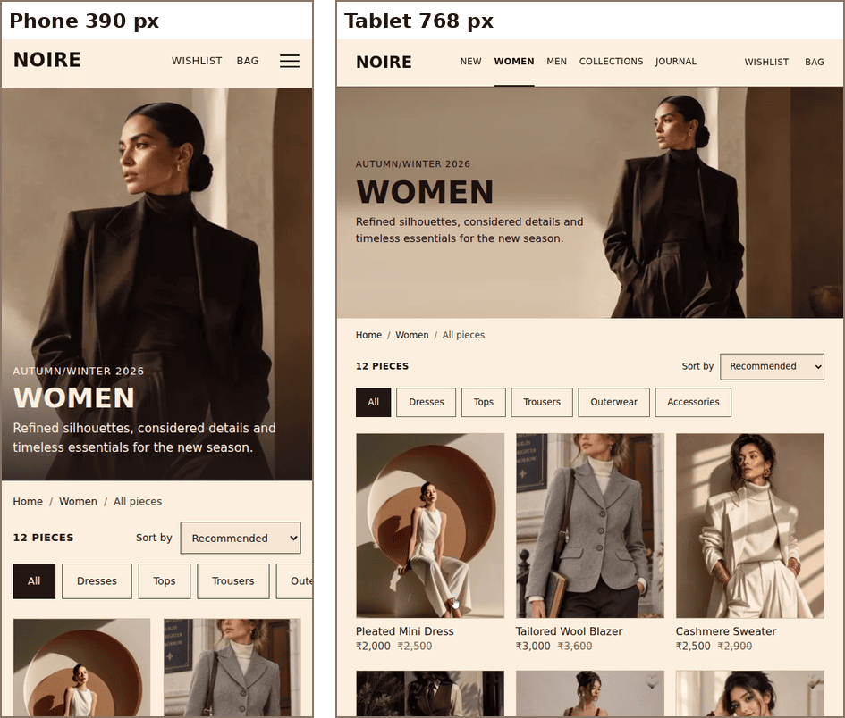
Figure 1: Phone (390 px) and tablet (768 px). The banner changes crop and the header switches from a menu button to inline links.

Figure 2: Desktop (1440 px). Toolbar on one row, 4-column grid.
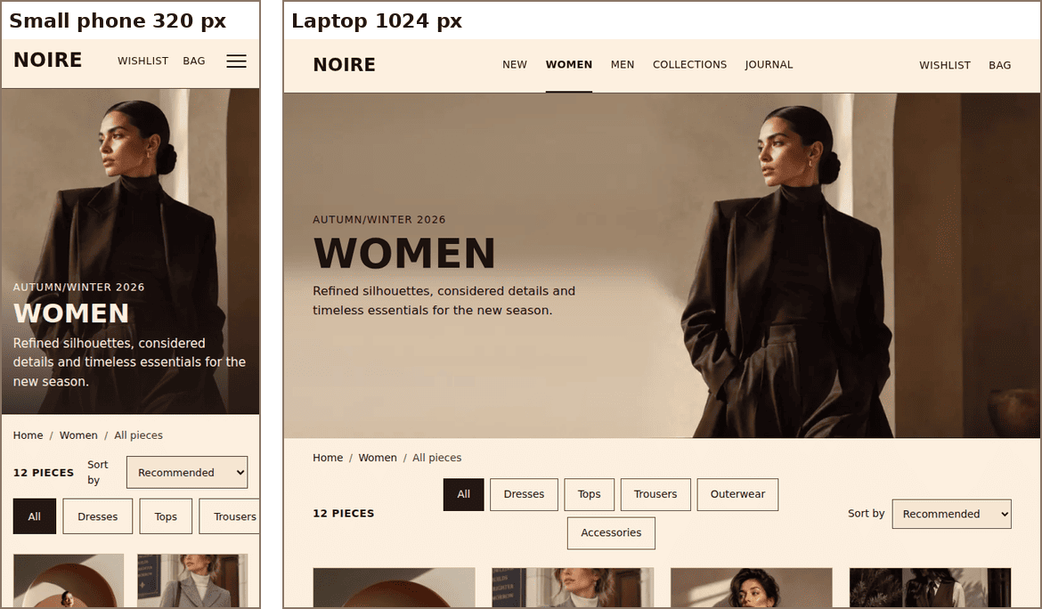
Figure 3: The smallest phone (320 px) and a laptop (1024 px).
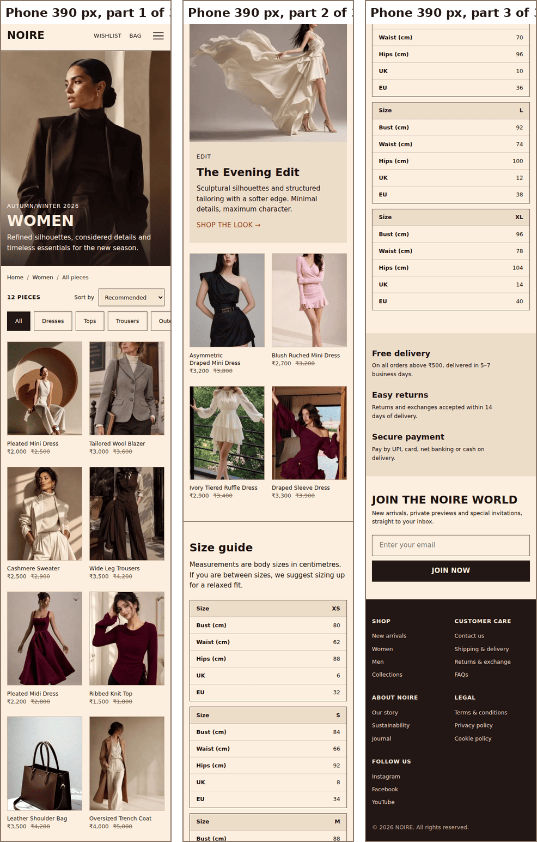
Figure 4: The whole page on a 390 px phone, in three parts. Two product columns, a stacked feature and card-style size guide.
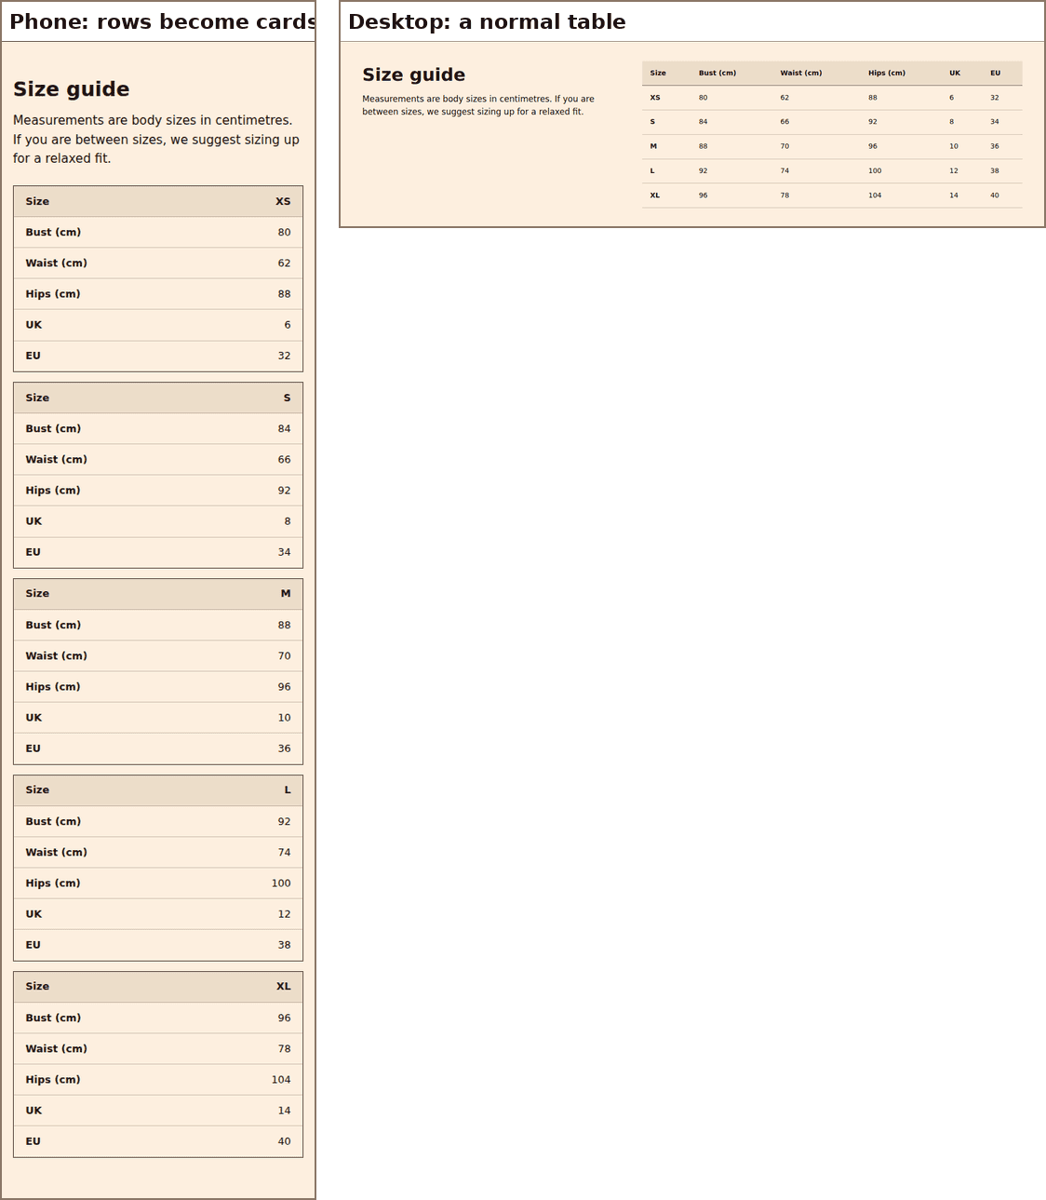
Figure 5: The size guide. On a phone each row becomes a card; on a desktop it is a normal table.
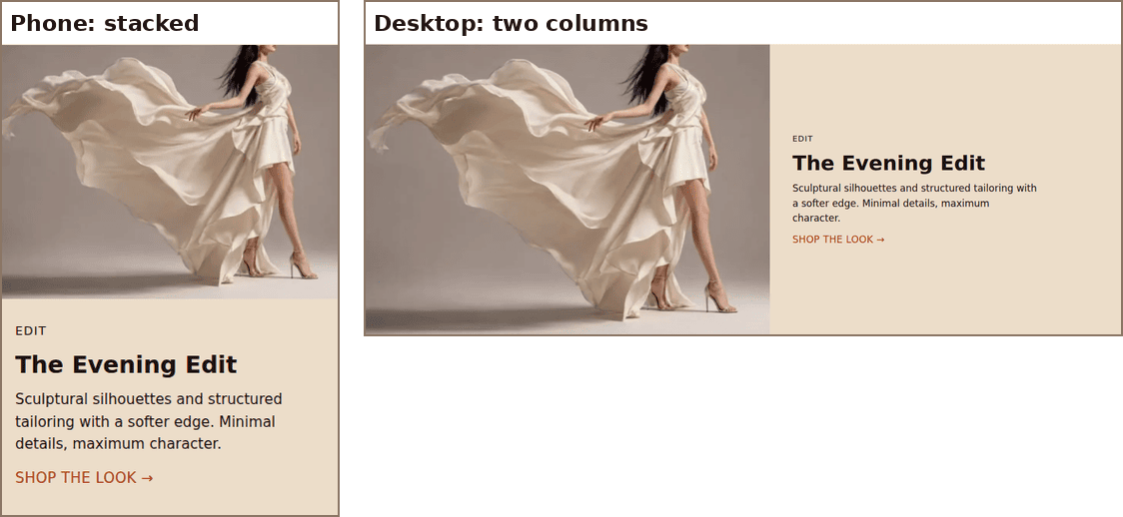
Figure 6: The editorial feature switches layout with a container query.
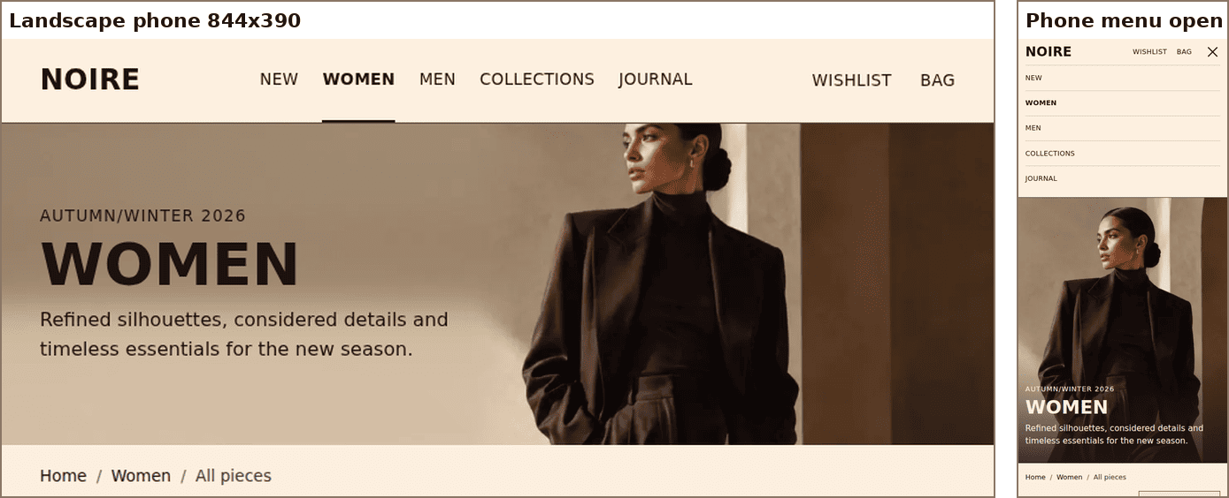
Figure 7: A landscape phone (844 × 390, header not sticky) and the phone menu open.

5. Testing
- Viewport testing. I used Chromium with an automated script at 320, 390, 768, 1024, 1440 and 844×390 (landscape) pixels, and read the computed grid columns, image files chosen and page width at each size.
- No sideways scroll. At every size the page width equalled the window width, meaning no horizontal scrolling.
- Validation. html-validate reports no errors for index.html. stylelint with stylelint-config-standard reports no errors for style.css; I turned off a small set of formatting-only rules such as blank lines before rules.
- Contrast. The link colour is #B03C15, which has a contrast of 5.3:1 on the cream background (WCAG AA needs 4.5:1). My Week 1 orange (#C9481F) measured 4.2:1, so I darkened it here.
- What is not tested. I have not tested on physical phones or in Safari and Firefox, and I have not tested with a screen reader yet. Browser emulation is close to, but not the same as, a real device.

6. Challenges and how I solved them
- Wrong column count. My first grid gave one column on a 390px phone, because the minimum card width (11rem) was too wide for two columns with a gap. I measured the column count in the browser and lowered the phone minimum to 8.5rem, then raised it at each breakpoint. Changing one variable per breakpoint was much simpler than writing column counts.
- Invalid HTML found by the validator. The first version put the h3 product names inside a span, which the validator rejected because a heading cannot be inside a span. I changed the wrapper to a div.
- Small-screen details. The chip row first snapped so the All chip touched the screen edge, ignoring the page padding. Adding scroll-padding-inline fixed it. The item count also wrapped onto two lines at 320px, fixed with white-space: nowrap.
- Text over photos. White text on the phone banner needed a dark gradient to be readable over the model’s coat, but on wide screens the same text would be unreadable on the light wall. I used different text colours per breakpoint, plus different image crops.
- Testing lazy-loaded images. Full-page screenshots showed blank images because of loading=lazy. I scrolled through the page before capturing, which is also how a real visitor loads it.
- Short screens. On a landscape phone a sticky header covers a large share of the screen, so I made it static at that size.

7. Limitations and next steps
- The category chips, the sort menu and the wish list are markup and styling only for now. Week 3 will make them work with JavaScript.
- The photos are cropped from a screen recording of my Figma prototype, so they are lower resolution than original photography would be.
- Links use # placeholders because this is a single page.

