Week 3 Technical Report: Integrating JavaScript
NOIRE Women’s Collection page: interactive user experience with plain JavaScript

1. Overview
In Week 2 I built a responsive collection page for NOIRE, my fashion website concept. In Week 3 I made that same page interactive using plain JavaScript, with no libraries or frameworks. The goal was to add behaviour that a shopper would really use: filtering and sorting the products, saving favourites, looking at a piece without leaving the page, building a bag, finding their size, and signing up to the newsletter with proper validation.
The most important design decision was progressive enhancement. The page still works without JavaScript: all 12 products are visible, the navigation links are visible, and controls that would be useless without a script (filter chips, sort menu, size finder, hearts) are simply not shown. JavaScript then adds the interactive parts on top. This keeps the HTML meaningful, avoids dead buttons, and means a script error can never leave the visitor with a blank page.
Files:
- index.html: the structure, with data-* attributes on each product and empty dialogs that the script fills
- css/style.css: Week 2 styles plus a section of styles for the new components
- js/main.js: all behaviour, in about 610 lines with numbered sections
- images/: responsive images from Week 2 (a few product photos were cleaned up)

2. Plan: features and objectives
Before writing code I listed each interaction with a clear objective, and what it needed from the HTML and CSS.
Feature | Objective (what the user gains) | JavaScript technique
Accessible mobile menu | Open and close the phone menu with correct screen reader state and keyboard support | Click and keydown events, aria-expanded, matchMedia
Category filter | Show only dresses, tops, and so on, with the count announced | State plus one render() function, hidden attribute, aria-pressed
Sorting | Order by price or name | Array sort with comparator functions
Wishlist | Save favourites that survive a page reload, see them together | localStorage, Set, event delegation, aria-pressed, live counter
Quick view dialog | Look at a piece and choose a size without leaving the page | Native dialog element, DOM building, validation
Bag drawer | Add, change quantity, remove, see the subtotal | Dynamic list rendering, state, localStorage, focus management
Size finder | Enter measurements and get a size recommendation | Form handling, number validation, DOM highlight
Newsletter validation | Clear, friendly errors instead of a browser tooltip | Regex, aria-invalid, aria-describedby, live regions
Motion and polish | Cards fade in as they scroll into view, header shadow, heart animation, toast messages | IntersectionObserver, Web Animations API, CSS transitions

3. Code structure
main.js is one self-contained file wrapped in a function, so nothing leaks into the global scope. It is organised in numbered sections, each with one job:
Section | Responsibility
1. Helpers | $ and $$ shortcuts, money formatting, a safe localStorage wrapper, and h() for building DOM nodes
2. State | One state object (category, sort, wishOnly, wish, bag, mySize). Product data is read from data-* attributes in the HTML
3. Toast and counters | Small status messages and the header badges
4. Header | Mobile menu and the shadow shown when the page scrolls
5. Product grid | render(), filter chips, sorting, wishlist hearts
6. Quick view | Fills and opens the product dialog, validates the size
7. Bag | Renders the bag list, quantity buttons, subtotal
8. Size finder | Validates inputs and recommends a size
9. Newsletter | Email validation and messages
10. Scroll reveal | IntersectionObserver animation
11. Start-up | Calls each initialiser in order

3.1 State in, DOM out
The filter, sort and wishlist controls do not edit the page directly. Each one only changes the state object and then calls render(), which works out the visible products, their order, the count text and the empty message. Having one place that updates the grid meant fewer bugs, because combinations (for example a category plus a sort plus the saved-only view) work without any extra code.
function render({ animate = true } = {}) {
const list = getVisible(); // filter + sort from state
const shown = new Set(list);
const showFeature = state.category === 'all' && !state.wishOnly;

const order = []; // visible items first, hidden after
list.forEach((p, i) => {
order.push(p.el);
if (showFeature && i === 7) order.push(feature);
});
/* ... */
grid.append(...order); // one batch of moves
products.forEach((p) => { p.el.hidden = !shown.has(p); });
countEl.textContent = `${list.length} ${list.length === 1 ? 'piece' : 'pieces'}`;
}

3.2 Event delegation
There is one click listener on the product grid, not one per product. It checks what was clicked with closest(): a heart toggles the wishlist, and the product link opens the quick view. This uses less memory, and it keeps working if products are re-ordered or added.
grid.addEventListener('click', (e) => {
const heart = e.target.closest('.heart');
if (heart) { toggleWish(heart.closest('.product').dataset.id); return; }
const link = e.target.closest('.product__link');
if (link && dialogsSupported) {
e.preventDefault();
openQuickView(byId.get(link.closest('.product').dataset.id));
}
});

3.3 Building the DOM safely
Bag rows and quick view content are created with a small helper, h(), that sets text with textContent and attributes with setAttribute. It never uses innerHTML for data, so a product name can never be interpreted as HTML. The only innerHTML use is a constant SVG string for the heart icon.

3.4 Saving data
The wishlist, bag and last size result are saved in localStorage under the noire. prefix. The wrapper catches errors, because localStorage can throw in private browsing or when it is disabled, and when data is read back it is checked (unknown product ids, bad quantities and the wrong types are dropped), so a corrupted value cannot break the page.

4. How each feature works

4.1 Mobile menu
In Week 2 the menu used a CSS-only checkbox. It worked, but it could not tell a screen reader whether the menu was open. I replaced it with a real button that toggles aria-expanded. The menu closes on Escape (and returns focus to the button), when a link is chosen, when the visitor clicks outside the header, and when the window is resized to desktop width. Without JavaScript the navigation simply stays visible as a list.

4.2 Filter and sort
The category chips are a group of toggle buttons that use aria-pressed. When a category is chosen, non-matching products get the hidden attribute, the count updates (for example "6 pieces"), and because the count is a live region, screen readers announce it. If nothing matches, an empty message with a reset button appears. The editorial feature card is only shown for the "All" view, and stays after the eighth product.

4.3 Wishlist
The hearts are added by JavaScript, since they do nothing without it. Each is a button with aria-pressed and a label naming the product. Saved ids are stored in localStorage, so they are still there after a reload. The header counter updates immediately, and the header Wishlist link becomes a toggle that shows only the saved pieces. Keyboard users can activate it with Enter or Space.

4.4 Quick view and bag
Clicking a product opens a native dialog element. showModal() gives me a focus trap, Escape to close and a backdrop for free, and I added closing on a backdrop click. The sizes are radio buttons, and if the visitor tries to add without choosing one, an error appears in a role="alert" region and focus moves to the first size. Accessories skip the size step. If the visitor has used the size finder, that size is pre-selected, with a note explaining why.
The bag is a second dialog styled as a drawer. Adding the same piece in the same size increases its quantity (up to 9), the plus and minus buttons and Remove update the subtotal straight away, and the bag is saved. Because the list is rebuilt after each change, keyboard focus would be lost, so I remember which button was used and focus it again after rendering.

4.5 Size finder
The finder reads the size guide table itself, so the table is the only place sizes are defined. The rule is that the recommendation is the smallest size whose bust, waist and hips are all at least as large as the visitor’s, so the largest measurement decides:
function recommend(m) {
let index = 0;
for (const key of ['bust', 'waist', 'hips']) {
const i = sizeRows.findIndex((row) => m[key] <= row[key]);
if (i === -1) return null; // above our range
index = Math.max(index, i);
}
return sizeRows[index];
}

Each field is validated (empty, or outside 60 to 140 cm) with an error under the field, aria-invalid, and focus on the first bad field. The matching table row is highlighted with a colour, a bold left edge and a border, so it does not rely on colour alone.

4.6 Newsletter validation
The form uses novalidate so I can show my own messages instead of the browser tooltip. The email is checked on submit, again on blur, and live after the first error, so the message disappears as soon as the address is valid. The error is linked to the field with aria-describedby and aria-invalid, and the success message is in a role="status" region. There is no backend, so a valid submission just shows the confirmation.

4.7 Animation
Cards fade and rise into place as they scroll into view, using an IntersectionObserver that stops watching each element once it has animated. The header gets a shadow when the page is scrolled, detected with an observer on a 1px sentinel element rather than a scroll listener. Hearts pop when toggled, and the grid fades briefly when the filter changes (Web Animations API). All of this is skipped when the visitor has prefers-reduced-motion turned on, and the reveal class is added by JavaScript so that visitors without it never get hidden content.

5. Screenshots
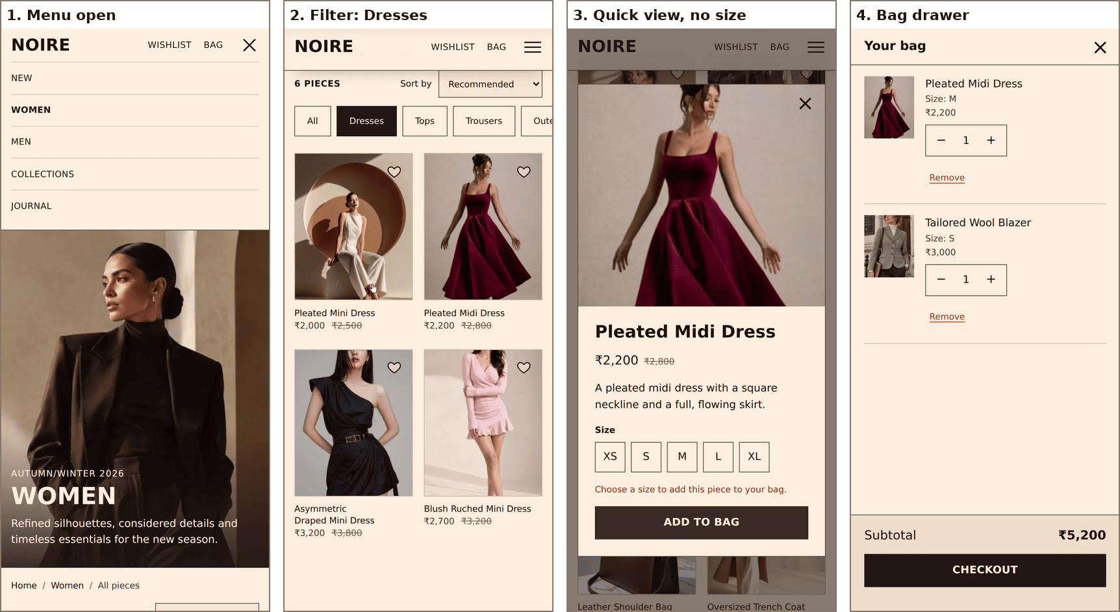
Figure 1: On a 390 px phone: menu, category filter, quick view validation and the bag drawer.
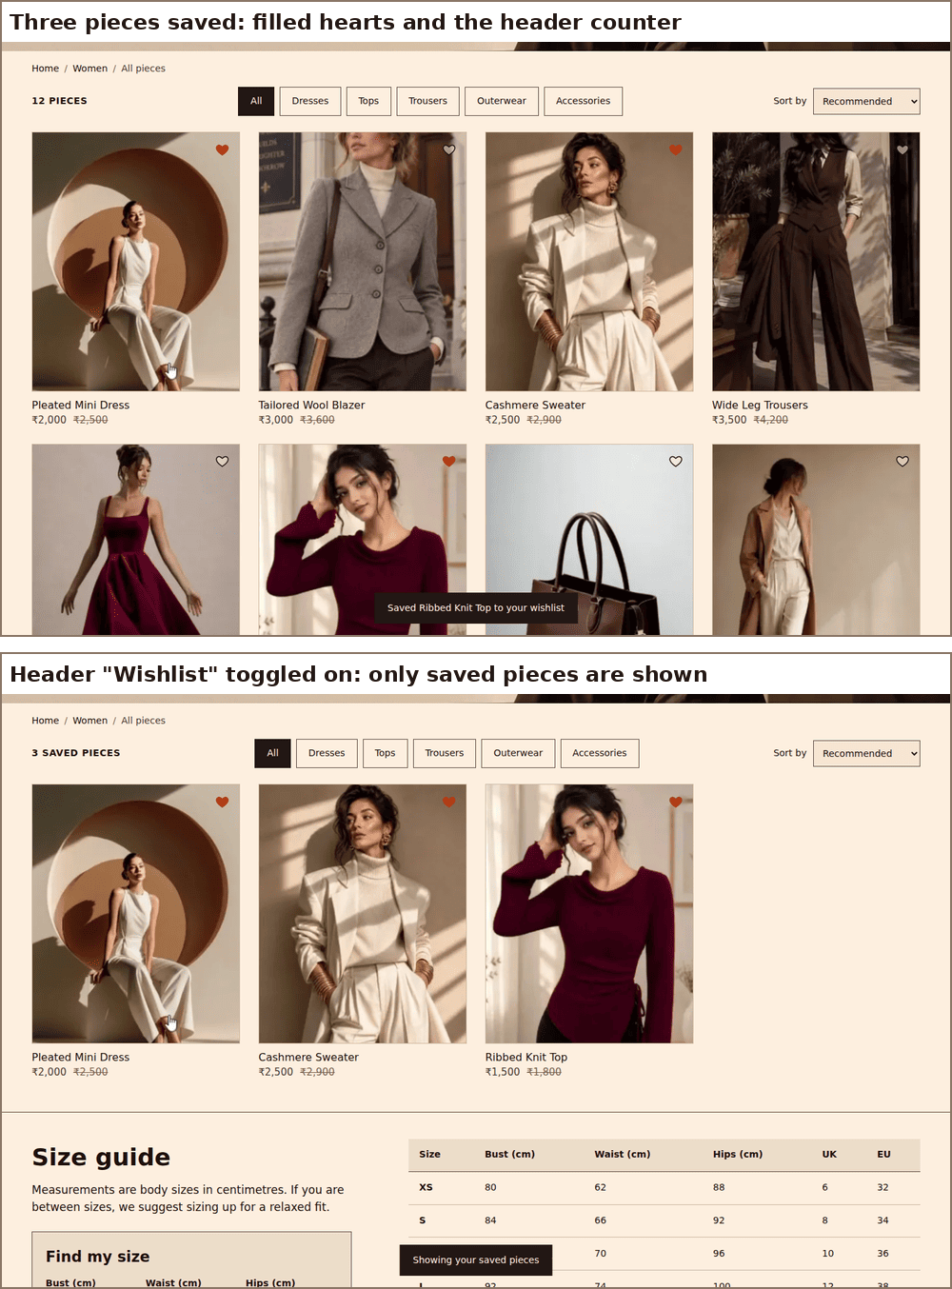
Figure 2: Wishlist hearts, the header counter and the saved-only view (desktop).
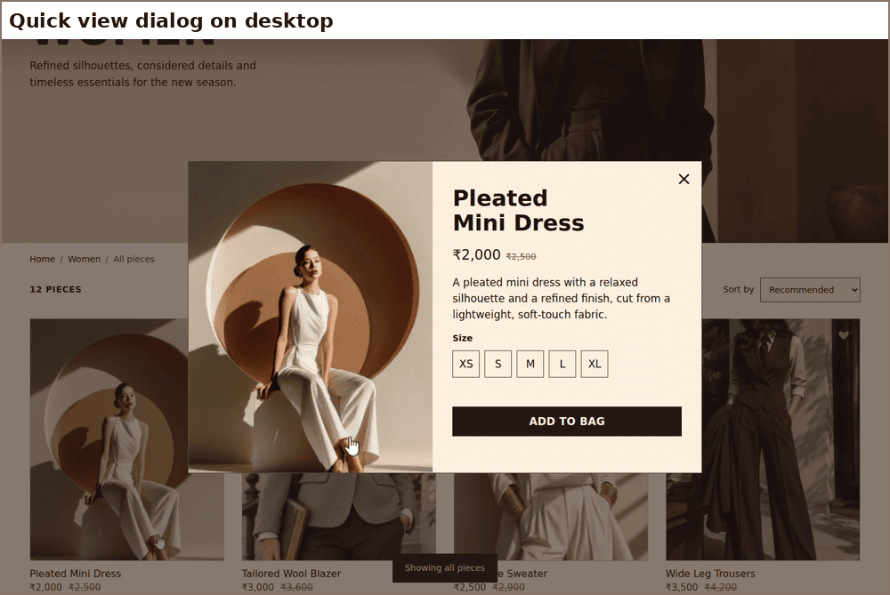
Figure 3: Quick view dialog on desktop.
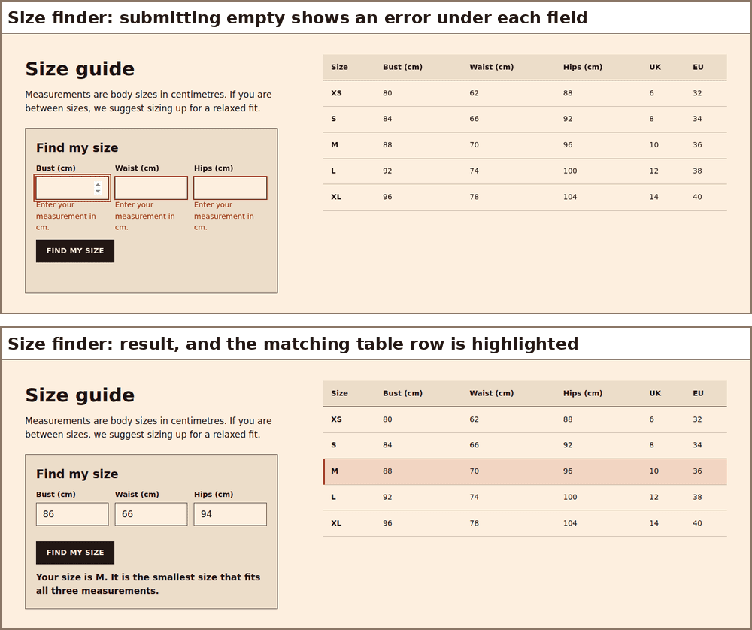
Figure 4: Size finder with validation errors and a recommended size.
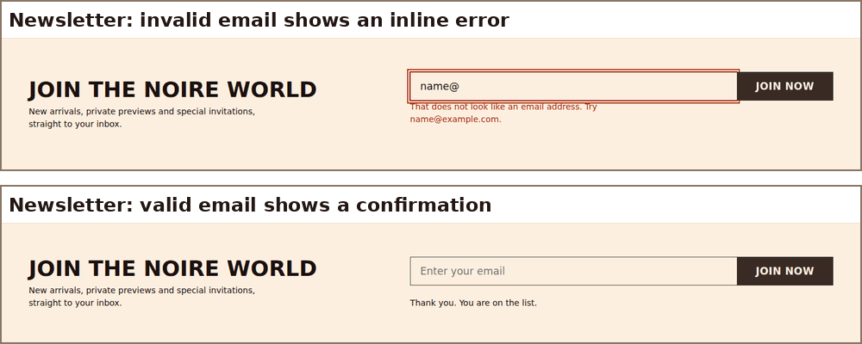
Figure 5: Newsletter validation states.

6. Integrating JavaScript without disrupting the layout
- A js class from the start: a one-line script in the head adds class="js" to the html element before the styles load. CSS that only makes sense with JavaScript (the collapsed phone menu) is written as .js .site-nav, so without JavaScript the menu stays open.
- hidden by default: chips, the sort menu and the size finder are in the HTML with the hidden attribute and are shown by the script. I added [hidden] { display: none !important } so that a rule such as display: flex can never accidentally reveal them.
- No layout shift: hearts are absolutely positioned on top of the product image, the toast is fixed, and dialogs are in the browser’s top layer, so none of them changes the size of the grid. Injected images have width and height attributes, so nothing jumps.
- Still responsive: at 320, 390, 768, 1024 and 1440 px the page had no horizontal scroll after using the interactions.
- User settings: scroll animations are switched off with reduced motion and are forced visible in print.

7. Accessibility of the interactions
- Buttons that toggle (menu, chips, hearts, wishlist link) expose their state with aria-expanded or aria-pressed.
- The piece count, form errors and status messages are in live regions, so changes are announced.
- Dialogs are native dialog elements, so focus is trapped and returned to the trigger on close; Escape works everywhere.
- Keyboard: everything works with Tab, Enter, Space and Escape. Focus is restored after the bag list is rebuilt.
- Touch targets: chips, hearts, bag buttons and size buttons are at least 44 px.
- The header counters get a full accessible name, such as "Bag, 3 items".

8. Testing
I wrote an automated browser script (Playwright with Chromium) that performs the interactions like a user and checks the result. All 55 checks pass:
Area | Checks (examples) | Result
Menu | Starts closed; opens; Escape closes it and returns focus | Pass
Filter and sort | Dresses gives 6 pieces; Accessories gives 1 piece; feature card hidden while filtered and after the 8th item in All; sort by price both ways and by name | Pass
Wishlist | 12 hearts added; badge counts; state survives a reload; saved-only view; toggling back | Pass
Quick view and bag | Dialog opens; adding without a size shows an error; badge and toast update; accessories have no size step; totals correct (2 × ₹2,000 + ₹3,500 = ₹7,500); plus, remove and checkout note; bag survives reload | Pass
Size finder | 88/70/96 gives M; 82/60/90 gives S; 150 cm is rejected with aria-invalid; above range gives the contact message; row highlighted; size pre-selected in quick view | Pass
Newsletter | Empty and bad email give errors; the error clears when valid; success message | Pass
Animation | All visible items revealed after scrolling; header shadow appears | Pass
Responsive | No horizontal scroll at 320, 390, 768, 1024, 1440 px; menu button hidden on desktop | Pass
No JavaScript | 12 products visible; nav visible; no dead controls; nothing hidden by the reveal animation | Pass
Console | No JavaScript errors during the whole run | Pass

Static checks: ESLint (recommended rules plus no-var, prefer-const, eqeqeq) reports no problems for main.js. html-validate and stylelint (with the standard config, minus a few formatting-only rules) report no problems for the HTML and CSS.
Not tested: physical phones and tablets, Safari and Firefox, and screen readers. The accessibility features above follow standard patterns, but I have not verified them with real assistive technology yet.

9. Debugging and optimisation

9.1 Problems found and fixed
- A missing id. My first test run failed with "Cannot read properties of null (reading scrollIntoView)". The script scrolls to #shop (and the header links fall back to it without JavaScript), but the products section had no id="shop", because Week 2 never linked to it. I added the id, and the same test now passes.
- Invalid markup in the dialogs. html-validate flagged an empty heading and an image without src in the dialog templates. I gave them placeholder content that the script replaces.
- Toast behind a dialog. The toast message is not in the top layer, so it appeared dimmed behind an open dialog. I now close the quick view before showing a toast, and messages inside the bag (such as the checkout note) are shown inside the bag.
- Lost focus. Rebuilding the bag list removed the button that had focus, so keyboard focus jumped to the top of the page. I store the item and action before rendering and refocus the matching button afterwards, falling back to the close button if the item was removed.
- Leftover marks in photos. Adding my own hearts made the marks left by the original design’s hearts visible in four photos, so I retouched them out.
- CSS lint findings. stylelint found duplicate selectors and specificity ordering problems (for example the newsletter button rules ahead of the bag buttons). I merged the duplicates and gave the bag buttons their own class.
- A test, not the page. One of my tests failed because the count uses text-transform: uppercase, so innerText returned "6 PIECES". The page was right; my test was comparing case-sensitively, so I fixed the test.

9.2 Performance
- Event delegation: one listener on the grid rather than 12 or more.
- IntersectionObserver for the header shadow and the reveal animation instead of scroll listeners, and elements are unobserved after animating once.
- render() moves the products with one grid.append(...order) call instead of many separate operations. I measured about 0.1 ms per filter click in Chromium.
- No libraries: main.js is 22.6 KB unminified, 7.2 KB gzipped, and style.css is 6.7 KB gzipped.
- Bag thumbnails use the 320 px image, not the full-size one.
- Script is loaded at the end of the body, so it does not block rendering.

10. Limitations and next steps
- Checkout is a placeholder. There is no backend, so the bag, wishlist and newsletter are stored only in this browser.
- Product data lives in the HTML. A real shop would load it from an API.
- Filter and sort choices are not saved in the URL, so refreshing resets them. Week 5 (SPA and history) is the natural place to add that.
- Week 4 will audit performance and accessibility with Lighthouse, WAVE and Axe, and I will test with a screen reader then.

