Week 4 Report: Performance and Accessibility
NOIRE Women’s Collection page: audit, fixes and measured results

1. Overview
In Week 4 I took the interactive collection page from Week 3 and treated it like a page I had been handed and asked to improve. I first measured it with real tools, then changed the HTML, CSS and JavaScript, then measured it again. I kept the Week 3 page unchanged as the “before” version, so every number in this report comes from comparing the same page before and after.
One thing surprised me: the Week 3 page already scored 99 for performance and 100 for accessibility in Lighthouse. If I had stopped there I would have found almost nothing. Most of the real problems were only found by testing what Lighthouse does not check: the page in different states (menu open, dialogs open, forms with errors), text on top of photos, keyboard order, and Windows High Contrast mode. That is why this report uses several tools together and shows what each one found.
Deliverables:
- src/index.html: the accessible page structure
- src/css/critical.css and src/css/style.css: optimised styling, split into above-the-fold and the rest
- src/js/main.js: the Week 3 behaviour with accessibility updates
- dist/: the production build (minified, critical CSS inlined, hashed file names), created by build.mjs
- This report

2. Tools and method
Tool | Used for
Lighthouse 13.5 (command line, headless Chromium 141) | Performance, accessibility, best practices and SEO scores. Mobile profile (simulated slow 4G, 4× CPU slowdown) and desktop profile. For the totals I used the median of three runs
axe-core 4.13 | Automated WCAG checks, run on 15 different page states (see section 5), not just the first load
Chromium DevTools protocol | Unused CSS (rule usage tracking), accessibility tree (accessible names, headings, landmarks), layout shifts and long tasks
Playwright scripts | Keyboard walk-through, target sizes, text-spacing test, forced-colours emulation, banner contrast measured from real pixels, 59 automated interaction checks
html-validate, stylelint, ESLint | Code quality of the HTML, CSS and JavaScript
esbuild, html-minifier-terser, fonttools, Pillow | Building: minification, font subsetting, AVIF/WebP images

WAVE and WebPageTest are not in this report. WAVE is a browser extension and WebPageTest is a hosted service, and I could not run either in my environment. Lighthouse and axe-core cover much of the same ground, but if I deploy the page I would also run both and compare.
A note on comparability: in my test environment the Google Fonts request in the Week 3 page was blocked, so the “before” page weight does not include any web font bytes. The real Week 3 page would have downloaded roughly 50 KB of fonts, so the real improvement is a little larger than the numbers below.

3. What I found before changing anything
Tool / check | Finding on the Week 3 page
Lighthouse mobile | Performance 99, Accessibility 100, Best practices 96, SEO 100. First Contentful Paint 1.4 s, Cumulative Layout Shift 0.016, 190 KiB transferred. The render-blocking insight estimated 650 ms lost to the Google Fonts stylesheet and style.css
Lighthouse network list | A 40 KB photo (p01-626.jpg) was downloaded on every visit although nobody could see it. It was the placeholder image inside the closed quick-view dialog
Lighthouse layout shift | The shift came from the product grid moving down when JavaScript un-hid the filter chips and sort menu
Lighthouse console | An error logged because the browser also requested /favicon.ico, which did not exist
axe-core, 15 states | 1 serious colour-contrast failure, repeated in 7 of the 15 states: the orange “Shop the look” link on the beige band measured 4.49:1 (WCAG AA needs 4.5:1)
Pixel-level contrast check | Axe could not test text over photos (it reports “incomplete”). Measuring the real pixels behind the banner text on a 390 px phone gave 2.6:1 for the small “Autumn/Winter 2026” line
Keyboard walk-through | Tab order did not match the screen: Wishlist and Bag received focus before the main navigation links, although they are shown on the right. The focus ring on the dark footer measured 2.9:1 (needs 3:1)
Forced-colours emulation | In Windows High Contrast mode the selected filter chip looked identical to the others, and the hamburger icon (drawn with background colour) disappeared
Target sizes | The breadcrumb links were 15 px tall, below the 24 px minimum in WCAG 2.2
Accessibility tree | Each product link read out the image description and then the name, for example “Ivory pleated mini dress against a terracotta circle backdrop Pleated Mini Dress…”. The three service headings were level 2 headings with no parent
CSS rule usage | 91% of rules matched during a full interaction run. The rest were hover, focus, print, reduced-motion and landscape rules, so there was no dead CSS to delete. But 7 colour values were repeated as literals and the newsletter button duplicated the .button styles

4. Performance improvements

4.1 Fonts: self-hosted and subset
The Google Fonts stylesheet was render-blocking and came from a third-party server. I downloaded Ubuntu Sans from the fontsource package and used fonttools to subset each weight to the characters the page really uses. Each file dropped from about 17 KB to about 9 KB. The rupee sign is not in the Latin subset, so I made a separate 0.7 KB file for it, selected with unicode-range. The two most important weights are preloaded, and font-display: swap shows text straight away.

4.2 Critical CSS
I split the stylesheet in two. critical.css holds only what is needed for the first screen at any size: fonts, tokens, header, banner, breadcrumb, toolbar and the product cards. The build inlines it into the HTML (3.0 KB gzipped). style.css holds the rest (dialogs, forms, size guide, footer, print) and loads with the preload-and-swap pattern, with a noscript fallback. The result is that the browser no longer waits for a stylesheet before it can paint.

4.3 Minification, hashing and a build script
build.mjs (about 80 lines) minifies CSS and JavaScript with esbuild, minifies the HTML, adds a content hash to the CSS and JavaScript file names, and writes a _headers file so hosts such as Netlify can cache hashed files for a year. I did not test the caching rules on a real host.
File | Source | Minified | Gzip
CSS (Week 3, one file) | 25.4 KB | 17.8 KB | 4.6 KB
CSS (Week 4: critical + rest) | 28.8 KB | 19.9 KB | 5.8 KB (3.0 inlined + 2.8 deferred)
JavaScript | 23.0 KB | 11.8 KB | 4.7 KB (Week 3 unminified: 7.0 KB)
HTML (with inlined critical CSS) | 31.1 KB | 36.7 KB | 8.2 KB (Week 3: 5.3 KB)

The total CSS is larger than in Week 3 on purpose: it now contains the self-hosted font declarations and the accessibility rules described below. The gain is that only 3.0 KB blocks rendering.

4.4 Images
- Modern formats. every image now has AVIF, WebP and JPEG versions in a picture element, and the browser picks the first format it supports. Across the whole set of 43 image files the totals are JPEG 1,426 KB, WebP 535 KB and AVIF 315 KB. For the banner (the largest image on the page) the phone file is 8 KB as AVIF against 16 KB as WebP.
- A hidden 40 KB download. the placeholder image inside the closed quick-view dialog now uses a tiny inline GIF, and the real image is set when the dialog opens. This alone removed 40 KB from every page load.
- No lazy loading above the fold. the first row of four product cards is above the fold on desktop, so I removed loading=“lazy” from them; the rest stay lazy.
- Smaller dialog images. the quick view and bag now use WebP instead of JPEG.

4.5 Layout shift
The chips, sort menu, menu button and size finder used to be hidden in the HTML and shown by JavaScript, which pushed the page down when they appeared. Now a class on the html element (set by a one-line script in the head) makes CSS show them from the first paint, and JavaScript only attaches behaviour. CLS in Lighthouse went from 0.016 to 0. I also tested a delayed font (1.5 seconds) and layout shift stayed at 0.001.

4.6 Rendering hints
The size guide, service strip and newsletter use content-visibility: auto, so the browser skips laying them out until the visitor scrolls near. I first applied it to the dark footer as well, and Lighthouse then reported false contrast failures for the footer text, because the tools could not read the footer background while its contents were skipped. I removed it from the footer and left a comment explaining why.

4.7 Smaller items
- Added an SVG favicon, which removed the console error for /favicon.ico.
- Moved the script to the head with defer, so the browser finds it early without blocking parsing.
- Added a theme-color meta tag.

4.8 Results
Lighthouse mobile (median of 3) | Week 3 | Week 4
Performance / Accessibility / Best practices / SEO | 99 / 100 / 96 / 100 | 99 / 100 / 100 / 100
First Contentful Paint | 1.39 s | 0.77 s
Speed Index | 1.39 s | 0.87 s
Largest Contentful Paint | 1.74 s | 1.67 s
Total Blocking Time | 0 ms | 121 ms
Cumulative Layout Shift | 0.016 | 0
Transferred | 190 KiB | 121 KiB (now includes 26 KB of fonts)
Requests | 16 | 18

Lighthouse desktop (1 run) | Week 3 | Week 4
Performance / Accessibility / Best practices / SEO | 100 / 100 / 96 / 100 | 100 / 100 / 100 / 100
First / Largest Contentful Paint | 0.4 s / 0.4 s | 0.24 s / 0.37 s
Cumulative Layout Shift | 0.003 | 0
Transferred | 200 KiB | 131 KiB

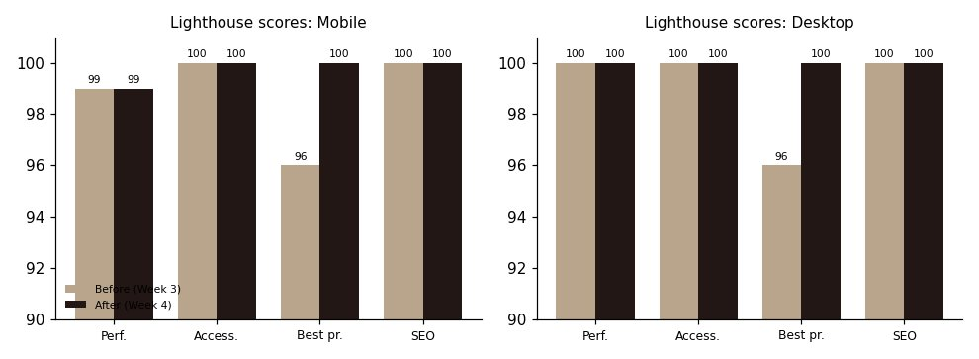
Figure 1: Lighthouse scores before and after (mobile median of three runs, desktop one run).

4.9 Things that did not improve, and what I tried that failed
- LCP. Largest Contentful Paint barely moved (1.74 s to 1.67 s). Lighthouse’s simulation is dominated by the slow-network round trips, and the LCP image only became 8 KB. In Lighthouse’s own trace of the real, unsimulated load the image is on screen after about 0.2 s in both versions (0.17 s before, 0.23 s after). The small increase is in render delay, probably from the deferred script and the stylesheet swap, and I did not investigate it further.
- TBT. Total Blocking Time went from 0 to 121 ms, which looks like a regression, but I do not think it is one. The same JavaScript still runs (about 15 ms of work at 4× slowdown), but the page now paints earlier, so that work falls after the first paint and is counted. With 4× CPU slowdown in a real browser the long tasks all finish before the first paint. Next step: split the start-up work so it runs in smaller pieces.
- A failed experiment. I tried a fallback font with metric overrides to reduce shifting when the web font arrives. I measured it with fonts delayed by 1.5 s: layout shift was 0.0103 with the fallback and 0.0012 without, so it made things worse in my test environment and I removed it.

5. Accessibility improvements
Each fix below was found by one of the tests in section 3 and re-checked afterwards. The WCAG numbers are the success criteria they relate to.
Problem | WCAG | Fix | Result
Orange link on beige band 4.49:1 | 1.4.3 | Accent colour darkened from #B03C15 to #A93813 | 5.7:1 on cream, 4.8:1 on the band. Axe: 0 violations in all 15 states (7 before)
Banner text over photo on phones 2.6:1 | 1.4.3 | Stronger, taller gradient behind the text | Worst-case measured 11.9:1. Checked at 7 widths: all pass
Tab order differed from the screen | 2.4.3, 1.3.2 | DOM order is now logo, menu button, nav, tools; the grid places them | Tab order: skip link, logo, five nav links, Wishlist, Bag, breadcrumb…
Focus ring 2.9:1 on the dark footer | 1.4.11 | Cream focus ring inside the footer | 15.5:1
Selected chip invisible in forced colours | 1.4.11, 1.4.1 | forced-colors rules using Highlight, ButtonText, Canvas | Selected chip, hearts, menu icon and size options are visible (Figure 4)
Breadcrumb and link targets under 24 px | 2.5.8 | Vertical padding added | No interactive element under 24 px on desktop or phone
Link names read the image text twice | 2.4.4, H2 technique | Grid photos are decorative (alt=“”); the link text names the piece; the full description is kept for the quick view image | Name reads “…Pleated Mini Dress Price: ₹2,000 was ₹2,500”
Heading outline | 1.3.1 | Service items are h3 under a visually hidden h2 | Clean h1, h2, h3 outline
Links that open dialogs | 4.1.2 | aria-haspopup=“dialog”; the Bag link also gets role=“button” and answers to Space | Checked in automated tests
Skip link target | 2.4.1 | main has tabindex=“-1” | Focus moves to the content
Placeholder text too light | 1.4.3 | ::placeholder colour set explicitly | 9.6:1
Animated content could stay hidden | 2.2.2, robustness | Keyboard focus reveals an element at once; printing reveals all | Verified in tests

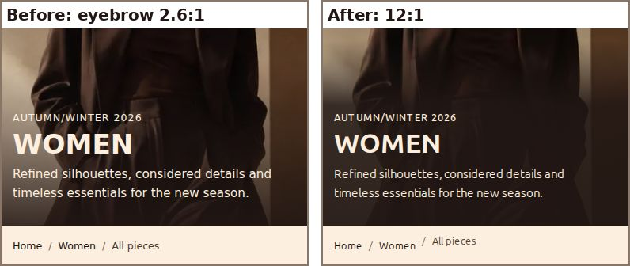
Figure 2: Phone banner before and after. The small “Autumn/Winter 2026” line is now easy to read.
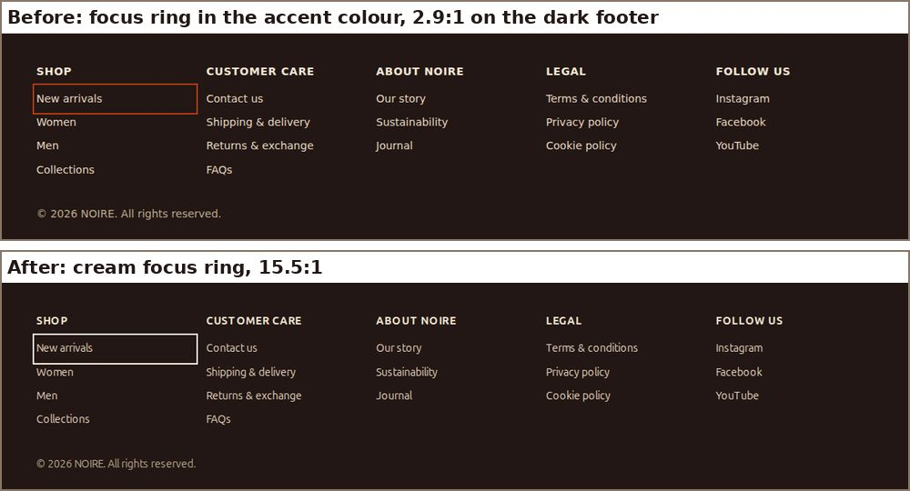
Figure 3: Keyboard focus in the footer before and after.
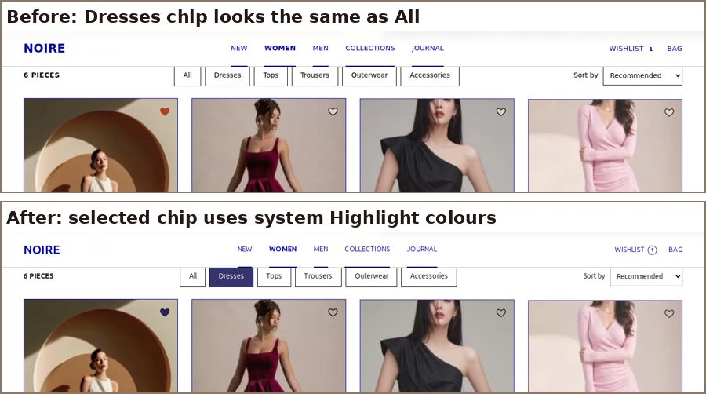
Figure 4: Forced-colours (Windows High Contrast) emulation before and after. The selected “Dresses” chip and the saved heart are now visible.

5.1 What was already good and stayed
- Landmarks (header, nav, main, footer), a skip link, labelled navigation regions, a language attribute and a descriptive page title.
- Toggle state exposed with aria-expanded and aria-pressed; the piece count in a live region; form errors linked with aria-describedby and aria-invalid.
- Native dialog elements, which trap focus and return it on close.
- prefers-reduced-motion support, and a layout that survives WCAG text-spacing overrides (0 px of sideways overflow) and reflows at 320 px.
I used ARIA only where HTML had no equivalent, and never to fix something a native element already does.

6. CSS optimisation
- Less repetition: repeated literal colours (error red, panel colour, hover colour, two line tints, overlay) became tokens: --error, --panel, --dark-hover, --line-soft, --line-mid, --overlay. A theme change is now one edit.
- One button style: the newsletter button no longer re-declares the button styles; it uses the shared .button class.
- No duplicates: each concern lives in one file and one section; there are no duplicate selectors, and !important appears only in the [hidden] rule and the reduced-motion reset. stylelint reports no problems.
- Efficient selectors: selectors are short and mostly single classes; container queries let cards and the feature card adapt to their own width.
- Unused rules: the rule-usage run showed no dead CSS, so nothing needed removing. The rules that did not match are all conditional (hover, focus, print, forced colours, reduced motion, landscape).

7. Testing summary
Check | Result
Lighthouse mobile (median of 3) | 99 / 100 / 100 / 100
Lighthouse desktop | 100 / 100 / 100 / 100
axe-core across 15 states (desktop and phone: initial, filtered, quick view, quick view error, bag, size finder errors, newsletter error, menu) | 0 violations (before: 7 states with 1)
Automated interaction tests (menu, filter, sort, wishlist, quick view, bag, size finder, newsletter, reveal, no-JavaScript mode, five widths) | 59 of 59 pass (55 from Week 3 plus 4 new accessibility checks)
html-validate, stylelint, ESLint | No problems (npm run check)
Layout regression: columns, card size and banner size at 390, 768, 1024, 1440 px | Identical to Week 3; page height within 2%
Keyboard: 30 tab stops on desktop | All have a visible focus ring; order matches the screen
Text-spacing override and 320 px reflow | No sideways overflow

Not tested: NVDA, JAWS or VoiceOver (I have not used a screen reader on it yet), real phones and tablets, Safari and Firefox, WAVE, WebPageTest, and the caching headers on a real host. The stacked table on phones keeps its table roles in Chromium; I have not checked other browsers.

8. Challenges and what I learned
- High scores hide problems. The page scored 99/100 out of the box, so most of the work was finding what the score does not cover. Testing states (menu open, dialogs, errors) and text over photos found more than the first Lighthouse run.
- Automated tools have blind spots. Axe reports “incomplete” for text over images. I measured the pixels behind the text myself. My first attempt used the whole text block, which overlapped the model’s dark coat and gave false failures at 768 px; using the real glyph boxes fixed that.
- Animation confuses checkers. Contrast checks failed on cards that were mid-way through the fade-in animation, which axe treats as partly transparent. I ran axe with reduced motion turned on so it sees the final state.
- A bug I introduced. After moving the image descriptions I found the quick-view image had lost its description, because my edit replaced the wrong occurrence of alt in a data attribute. I noticed it only because I re-read the accessible name of the product link. I added two tests so it cannot come back.
- Measure every change. The fallback font experiment and the content-visibility footer problem both looked like improvements and were not. Measuring each change separately made that clear.

9. Limitations and next steps
- Reduce Total Blocking Time by running the non-essential start-up work in smaller chunks.
- Deploy to a real host, run WAVE and WebPageTest, and check the caching headers.
- Test with a screen reader and on real devices, including Safari.
- The photos come from a screen recording of my prototype, so they are lower resolution than original photography would be.
- Week 5 will add routing and browser history, which is also the place to keep filter and sort choices in the URL.

