Week 5 Technical Report: Single Page Application
NOIRE: client-side routing, dynamic content and browser history

1. Project plan
The task was to simulate a small single page application (SPA): one HTML container, JavaScript that loads content into it without a full page reload, and navigation that behaves like a normal website (address bar, Back and Forward, refresh, deep links). I used NOIRE, my fashion website concept, and built it as a small storefront with eight pages: Home, Women (a filterable shop), a product page, a journal list, a single story, a wishlist, a bag, and an About page.
I designed the architecture before writing view code, because an SPA’s hard problems are all about coordination: what owns the current filters, what happens when a click and a slow network race each other, what happens when someone bookmarks a filtered page. Figure 1 shows the pieces and how data flows between them.
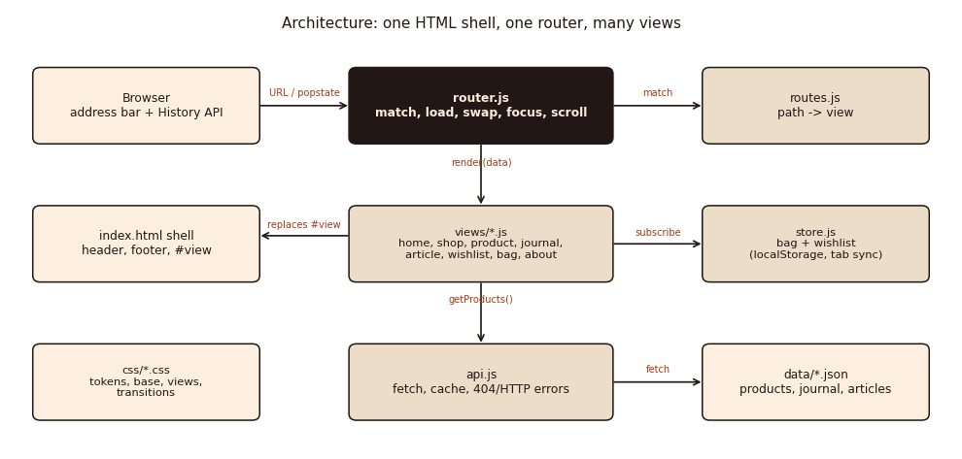
Figure 1: Architecture. The router is the only thing that touches the page shell; everything else only produces data or view elements.
Files:
- index.html: the shell (header, #view, footer, a live region for announcements)
- 404.html: fallback for hosts with no rewrite rule (see section 6)
- css/: tokens, base (the shell), components, views, transitions
- js/main.js, router.js, routes.js, store.js, api.js, utils.js, toast.js, and one module per page under js/views/
- data/products.json, data/journal.json, data/articles/*.json: the content the app loads
- tests/w5test.py, tests/w5axe.py: the automated checks described in section 7
- README.md, this report

2. Structuring the application

2.1 One shell, one router, many views
index.html contains the header, an empty main#view, and the footer, once. Every route is a small module in js/views/ that exports an object describing itself: a URL pattern, a loader that fetches the data it needs, and a render function that returns a DOM element. js/routes.js is the map from address to module; adding a page means writing one file and adding one line there.

2.2 The navigation lifecycle
Every click on an internal link, and every Back or Forward press, goes through the same eight steps, shown in Figure 2. Steps 4 and 5 are what make it feel like a real app rather than a toy: the router shows the old page until the new one’s data has arrived (a progress bar after 150 ms, a full skeleton after 300 ms), and it checks that the click it is finishing is still the most recent one before touching the screen.
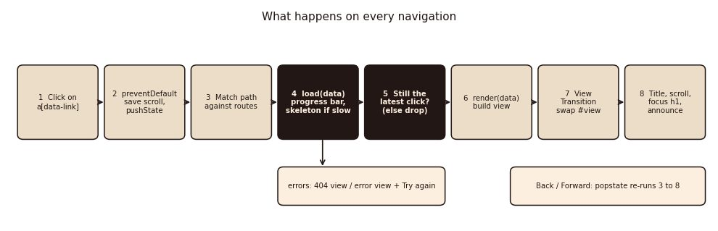
Figure 2: What happens on every navigation, from a click to the new page being announced.
async function render(source) {
const id = ++navId; // this navigation's ticket number
...
const data = await route.load({ params, query });
if (id !== navId) return; // a newer click already started; drop this one
const view = route.render(data, ctx);
await present({ route, params, query, view, title }, source, id);
}

2.3 The URL is the state
Filters on the shop page (category, sort, search) are never kept only in memory. They live in the query string, so /shop?category=Dresses&sort=price-asc is a complete description of what is on screen. Changing a filter calls history.pushState (search-as-you-type uses replaceState instead, so it does not fill history with one entry per keystroke) and the router repaints the product grid without rebuilding the page. This is also what makes the page bookmarkable, shareable and refreshable, and what makes Back step through filters one at a time.
select.addEventListener('change', () =>
ctx.router.navigate(shopUrl({ ...query, sort: select.value })));

const applySearch = debounce(() => {
query = { ...query, q: search.value.trim() };
ctx.router.replaceQuery({ q: query.q }); // updates the address bar, no new history entry
paint(); // repaints the grid in place
}, 250);

2.4 Content loaded on demand
Product, journal and article data live in separate JSON files under data/ and are fetched with the Fetch API. api.js caches each request (so going back to a page already visited is instant), turns a missing product or story into a specific NotFoundError, and turns a server or network failure into an HttpError that carries the status code. Nothing is bundled: opening only /journal never downloads the shop’s product data.

2.5 Two developer switches
?latency=1200 and ?fail=journal (documented in the README) slow down or fail requests on demand. I added them because loading and error states are exactly the parts of an SPA that are easy to build once and never see again; with these switches I could screenshot and test them on request rather than only during a real slow connection.

3. Dynamic content and DOM manipulation

3.1 Safe templates
Views build markup with a small tagged template, html‘...’, defined in utils.js. Every value interpolated into it is escaped automatically, so a product name or search term can never be interpreted as markup; the only way to insert raw HTML is to nest another html‘...’ result. This gave me the readability of writing HTML inline without reaching for innerHTML on untrusted strings.
export function html(strings, ...values) {
let out = strings[0];
values.forEach((value, i) => { out += toText(value) + strings[i + 1]; }); // toText() escapes
return new SafeHTML(out);
}

3.2 Views that update themselves
A route’s render() can return an onQuery(query) function. When only the query string changes (a new filter on an already-open shop page), the router calls onQuery instead of tearing the view down, so the product grid repaints but the rest of the page, and the visitor’s scroll position and focus, do not move. The bag and wishlist views subscribe to the shared store (store.js) and repaint themselves whenever it changes, including a change made from a different browser tab.

3.3 Shared state
store.js holds the wishlist and bag as one object, changed only by small action functions (toggleWish, addToBag, changeQty) that build a new object rather than editing the old one in place. It is saved to localStorage after every change and listens for the storage event, so two tabs of the same site stay in sync.

4. Fluid transitions between pages
css/transitions.css uses the View Transitions API: the router calls document.startViewTransition around the moment it swaps #view, and the browser cross-fades a snapshot of the old view into the new one. Only #view has a view-transition-name, so the header and footer never move or flicker during the transition. Browsers without the API (the router checks for it directly) get a CSS fallback: a plain fade-and-rise animation on the new content. Both are switched off automatically for prefers-reduced-motion.

5. Testing loading and error states
Every route shows three states on request: the normal page, a skeleton while data is loading (Figure 3, bottom left), and an error page with a Try again button that does not repeat a failure once the server has recovered, because api.js never caches a rejected request.
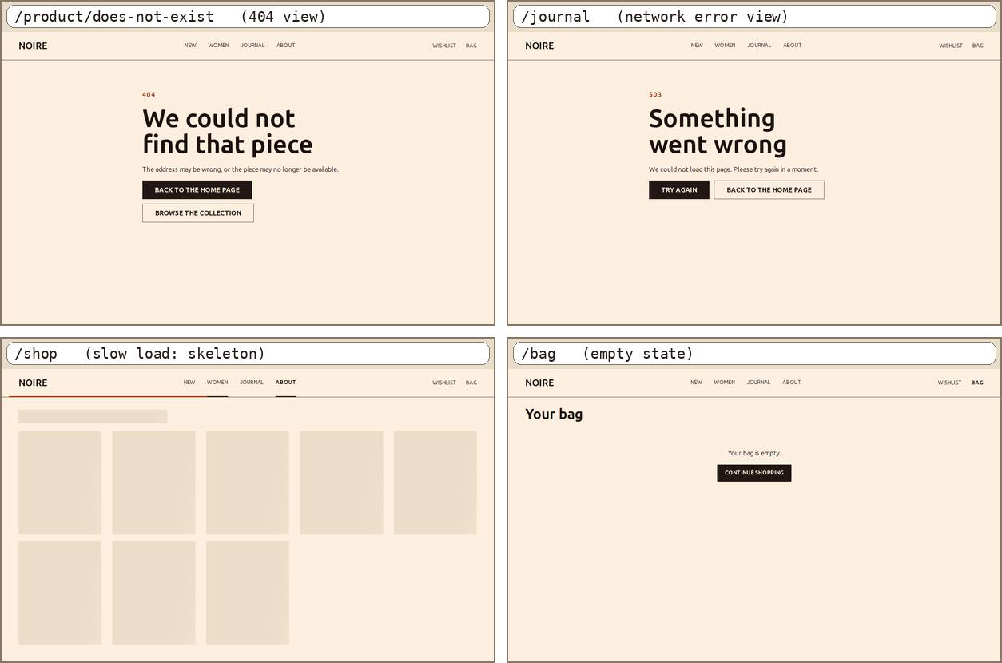
Figure 3: A 404 for an unknown product, a network error page, a skeleton during a slow load, and the empty bag state.

6. Deployment: routing on a static host
A single page application only works if the host sends every address to index.html; otherwise a deep link or a refresh asks the server for a path such as /product/pleated-mini-dress that does not exist as a file. Different hosts solve this differently. Netlify and Vercel read a redirect rule. GitHub Pages has no such rule, so I used its documented workaround: 404.html (the page GitHub Pages serves for any unknown address) saves the address the visitor asked for in sessionStorage and redirects to the app; main.js reads it back and hands it to the router before the first render.
The app also does not assume it lives at the domain root. Every internal URL is built through a small BASE helper that reads <base href> at start-up, so the same files work at / or under /a-repo-name/ without any code changes; only <base href> in index.html and 404.html needs to change.
I tested this by writing a small Node server (tests/ghserver.mjs) that reproduces GitHub Pages exactly: it serves the app under /noire/ and, for any other address, returns 404.html with a real HTTP 404 status. All of the sub-folder checks in section 7 ran against that server, not against my normal dev server.

7. Testing

7.1 Automated navigation tests
I wrote a Playwright script (tests/w5test.py) that drives a real Chromium browser and checks the result, covering: navigation without a reload, modified clicks (Ctrl/Cmd/Shift) being left to the browser, deep links, 404s and redirects, the URL as the source of truth for filters, scroll restoration, a slow page being superseded by a newer click, loading states, error states (server error, network failure, the ?fail= switch, and that Retry works once the fault clears), the bag and wishlist including cross-tab sync, View Transitions with a fallback check, the mobile menu, keyboard navigation, and the GitHub Pages simulation above.
Area | Example checks | Result
Navigation | No reload across 8 clicks; Back/Forward restore the right view; only one document request all session | Pass
Filters and URL | Chip and sort change the URL and repaint in place (same DOM node); search uses replaceState; refresh keeps the filter; deep link with two filters renders correctly | Pass
404 and errors | Unknown address, unknown product, unknown story, malformed %-encoding; server error (with status shown); offline; Retry recovers without a stale cache | Pass
Race conditions | A slow page opened, then abandoned for another page, never overwrites the newer page | Pass
Loading states | Progress bar after 150 ms; skeleton after 300 ms; both clear once the view is ready | Pass
Bag and wishlist | Add, change quantity, remove; totals correct; persists across reload; a second tab sees the change | Pass
Scroll and focus | Back restores scroll position; new pages start at the top; heading receives focus; route change is announced | Pass
Transitions | View Transitions API used when available; skipped under reduced motion; CSS fallback plays when the API is absent | Pass
Keyboard and mobile | Skip link, Enter on a link, Escape closes the phone menu and returns focus | Pass
GitHub Pages simulation | Sub-folder base path; deep link recovered through 404.html; unknown address still shows the app 404 | Pass

All 89 checks pass. Section 9 explains three that failed on the first run and what I changed.

7.2 Accessibility (axe-core)
I ran axe-core across 27 states: every route on desktop and phone, filtered and searched views, the error and skeleton states, and the phone menu open. The first run found one repeated issue: heading order was broken wherever a page went from an h1 straight to an h3 (product and story titles inside cards) with no h2 in between. I added a visually hidden h2 before each grid to fix it. The final run has 0 violations across all 27 states.

7.3 Performance (Lighthouse)
Lighthouse mobile (median of 3 runs) | Home | Shop | Product
Performance / Accessibility / Best practices / SEO | 100 / 100 / 100 / 100 | 100 / 100 / 100 / 100 | 100 / 100 / 100 / 100
First Contentful Paint | 1.0 s | 1.0 s | 1.1 s
Largest Contentful Paint | 1.8 s | 1.9 s | 1.8 s
Cumulative Layout Shift | 0 | 0 | 0
Transferred | 130 KiB | 152 KiB | 101 KiB

Home on desktop: 100/100/100/100, First Contentful Paint 0.29 s, Largest Contentful Paint 0.47 s.

7.4 Code quality
html-validate, stylelint (stylelint-config-standard) and ESLint (recommended rules plus no-var, prefer-const, eqeqeq) all report no problems on the final code (npm run lint).

8. Design decisions
- ES modules, no bundler: each route only imports what it needs (its view module and the api functions it calls). Nothing is bundled, so opening one page never downloads another page’s code.
- URL as state: the shop page keeps its filters in the query string rather than in a JavaScript variable, so the browser’s own history and bookmarking work for free.
- One router, not one router per feature: every navigation goes through one function (render) with one job at a time: match, load, decide stale-or-not, swap, announce. Adding the skeleton and the stale-click check both meant changing this one function, not every view.
- No component framework: a plain object made by html‘...’, rather than a class, keeps each view a small, readable function of its data.
- Prefer platform features: rather than build my own scroll and focus handling from nothing, I used history.scrollRestoration, native <dialog>-style focus patterns adapted to routing, and the View Transitions API, and wrote a CSS fallback only where a browser might lack the last one.

9. Challenges and how I solved them
- The skip link fought the router. The first version re-ran the router on every popstate event, including the one the browser fires when the skip link jumps to an in-page #anchor. That replayed the whole page and moved focus back to the heading, undoing the skip link. I now compare the path and query before and after the event, and only re-render when they actually changed.
- Race conditions. Typing in the search box while the previous keystroke’s filtered view was still the “current” one meant a fast typer could see a page repaint in the wrong order. Every navigation now carries an increasing id, and a result is only applied if its id is still the latest.
- A scroll-restoration test that tested itself. My first Back-button test clicked a product with Playwright’s .click(), which itself scrolls the target into view first, so the scroll position I was testing was destroyed before the click ever happened. I fixed the test to read the scroll position and open the product from JavaScript directly. This was a bug in my test, not in the router, but it is a good example of how easy it is to test the wrong thing.
- A large, avoidable layout shift. The empty #view had no height before its first page arrived, so the footer sat directly under the header and then jumped down once content loaded, a layout shift of 0.28 in Lighthouse, entirely self-inflicted by my own markup. Giving #view a minimum height of one screen fixed it to 0.
- A performance change that made things worse. I preloaded every JavaScript module with modulepreload, expecting it to help. Measured against three runs each, it made First Contentful Paint slightly worse (about 1.0 to 1.3 s) because it delayed the browser starting on the page’s own CSS and images to fetch code that was not needed yet. I removed it and rely on modules being small and cached instead.
- Contrast over a photo. axe-core flags text over a photo as “incomplete” rather than pass or fail, because it cannot read a background image. I reused the pixel-based contrast check from Week 4 (sampling the actual rendered pixels behind the hero text) and confirmed at least 5:1 contrast from 320px to 1920px.
- Simulating a host I do not have. GitHub Pages has no rewrite rule at all, so I could not test the deep-link fallback against my normal dev server. I wrote a second, deliberately strict Node server that behaves like GitHub Pages (wrong paths get a real 404, not index.html) and ran the sub-folder tests against that instead of assuming a friendlier server would behave the same way.

10. Limitations and next steps
- Not tested: real phones and tablets, Safari and Firefox, a screen reader, and an actual GitHub Pages deployment (only a local simulation of its rewrite behaviour).
- There is no build step, so JavaScript and CSS ship unminified; a production version would add the Week 4 build pipeline (minification, hashed file names, self-hosted fonts already carried over).
- Checkout, accounts and payment are out of scope for this demo, as in earlier weeks.
- The photos are cropped from a screen recording of my Figma prototype, so they are lower resolution than original photography would be.

