Reliability
Scale: ONLINE_BENEFITS
Case Processing Summary
 |  | N | %
Cases | Valid | 86 | 62.8
 | Excludedª | 51 | 37.2
 | Total | 137 | 100.0
a. Listwise deletion based on all variables in the procedure.

Reliability Statistics
Cronbach's Alpha | N of Items
.853 | 8

Scale: INSTORE_EXPERIENCE
Case Processing Summary
 |  | N | %
Cases | Valid | 94 | 68.6
 | Excludedª | 43 | 31.4
 | Total | 137 | 100.0
a. Listwise deletion based on all variables in the procedure.

Reliability Statistics
Cronbach's Alpha | N of Items
.809 | 7

Scale: SUSTAIN_ATT

Case Processing Summary
 |  | N | %
Cases | Valid | 137 | 100.0
 | Excludedª | 0 | .0
 | Total | 137 | 100.0
a. Listwise deletion based on all variables in the procedure.

Reliability Statistics
Cronbach's Alpha | N of Items
.757 | 6

Descriptives
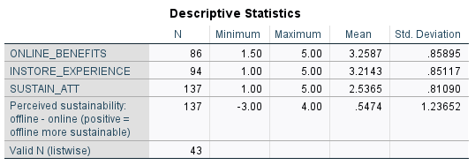

Frequencies
Statistics
 |  | Are you currently living in the UK? | Age: | Gender | What is your current employment status? | Have you purchased fashion products (e.g., clothing, accessories, footwear) within the last 12 months? | How often do you shop for fashion? | Where do you mostly shop for fashion?
N | Valid | 137 | 137 | 137 | 137 | 137 | 137 | 137
 | Missing | 0 | 0 | 0 | 0 | 0 | 0 | 0

Frequency Table

Are you currently living in the UK?
 |  | Frequency | Percent | Valid Percent | Cumulative Percent
Valid | YES | 137 | 100.0 | 100.0 | 100.0

Age:
 |  | Frequency | Percent | Valid Percent | Cumulative Percent
Valid | Gen Z | 98 | 71.5 | 71.5 | 71.5
 | Millennials | 28 | 20.4 | 20.4 | 92.0
 | Gen X | 9 | 6.6 | 6.6 | 98.5
 | Baby Boomers | 1 | .7 | .7 | 99.3
 | Older | 1 | .7 | .7 | 100.0
 | Total | 137 | 100.0 | 100.0

Gender
 |  | Frequency | Percent | Valid Percent | Cumulative Percent
Valid | Male | 68 | 49.6 | 49.6 | 49.6
 | Female | 65 | 47.4 | 47.4 | 97.1
 | Non-binary / trans gender | 1 | .7 | .7 | 97.8
 | Prefer not to say | 3 | 2.2 | 2.2 | 100.0
 | Total | 137 | 100.0 | 100.0

What is your current employment status?
 |  | Frequency | Percent | Valid Percent | Cumulative Percent
Valid | Student | 54 | 39.4 | 39.4 | 39.4
 | Employed (Full Time) | 58 | 42.3 | 42.3 | 81.8
 | Employed (Part Time) | 19 | 13.9 | 13.9 | 95.6
 | Unemployed | 5 | 3.6 | 3.6 | 99.3
 | Retired | 1 | .7 | .7 | 100.0
 | Total | 137 | 100.0 | 100.0

Have you purchased fashion products (e.g., clothing, accessories, footwear) within the last 12 months?
 |  | Frequency | Percent | Valid Percent | Cumulative Percent
Valid | No | 15 | 10.9 | 10.9 | 10.9
 | Yes | 122 | 89.1 | 89.1 | 100.0
 | Total | 137 | 100.0 | 100.0

How often do you shop for fashion?
 |  | Frequency | Percent | Valid Percent | Cumulative Percent
Valid | Weekly | 15 | 10.9 | 10.9 | 10.9
 | Monthly | 46 | 33.6 | 33.6 | 44.5
 | Every few months | 55 | 40.1 | 40.1 | 84.7
 | Rarely | 21 | 15.3 | 15.3 | 100.0
 | Total | 137 | 100.0 | 100.0

Where do you mostly shop for fashion?
 |  | Frequency | Percent | Valid Percent | Cumulative Percent
Valid | 1 | 11 | 8.0 | 8.0 | 8.0
 | 2 | 40 | 29.2 | 29.2 | 37.2
 | 3 | 43 | 31.4 | 31.4 | 68.6
 | 9 | 30 | 21.9 | 21.9 | 90.5
 | 10 | 13 | 9.5 | 9.5 | 100.0
 | Total | 137 | 100.0 | 100.0

Crosstabs
Case Processing Summary
 | Cases
 | Valid |  | Missing |  | Total
 | N | Percent | N | Percent | N | Percent
Age: * Where do you mostly shop for fashion? | 137 | 100.0% | 0 | 0.0% | 137 | 100.0%

Age: * Where do you mostly shop for fashion? Crosstabulation
 |  |  | Where do you mostly shop for fashion? |  |  |  |  | Total
 |  |  | 1 | 2 | 3 | 9 | 10
Age: | Gen Z | Count | 7 | 29 | 34 | 23 | 5 | 98
 |  | % within Age: | 7.1% | 29.6% | 34.7% | 23.5% | 5.1% | 100.0%
 |  | % within Where do you mostly shop for fashion? | 63.6% | 72.5% | 79.1% | 76.7% | 38.5% | 71.5%
 | Millennials | Count | 2 | 10 | 5 | 5 | 6 | 28
 |  | % within Age: | 7.1% | 35.7% | 17.9% | 17.9% | 21.4% | 100.0%
 |  | % within Where do you mostly shop for fashion? | 18.2% | 25.0% | 11.6% | 16.7% | 46.2% | 20.4%
 | Gen X | Count | 1 | 1 | 3 | 2 | 2 | 9
 |  | % within Age: | 11.1% | 11.1% | 33.3% | 22.2% | 22.2% | 100.0%
 |  | % within Where do you mostly shop for fashion? | 9.1% | 2.5% | 7.0% | 6.7% | 15.4% | 6.6%
 | Baby Boomers | Count | 0 | 0 | 1 | 0 | 0 | 1
 |  | % within Age: | 0.0% | 0.0% | 100.0% | 0.0% | 0.0% | 100.0%
 |  | % within Where do you mostly shop for fashion? | 0.0% | 0.0% | 2.3% | 0.0% | 0.0% | 0.7%
 | Older | Count | 1 | 0 | 0 | 0 | 0 | 1
 |  | % within Age: | 100.0% | 0.0% | 0.0% | 0.0% | 0.0% | 100.0%
 |  | % within Where do you mostly shop for fashion? | 9.1% | 0.0% | 0.0% | 0.0% | 0.0% | 0.7%
Total |  | Count | 11 | 40 | 43 | 30 | 13 | 137
 |  | % within Age: | 8.0% | 29.2% | 31.4% | 21.9% | 9.5% | 100.0%
 |  | % within Where do you mostly shop for fashion? | 100.0% | 100.0% | 100.0% | 100.0% | 100.0% | 100.0%

Chi-Square Tests
 | Value | df | Asymptotic Significance (2-sided)
Pearson Chi-Square | 25.328ª | 16 | .064
Likelihood Ratio | 18.496 | 16 | .296
Linear-by-Linear Association | .307 | 1 | .579
N of Valid Cases | 137
a. 17 cells (68.0%) have expected count less than 5. The minimum expected count is .08.

Symmetric Measures
 |  | Value | Asymptotic Standard Errorª | Approximate T^{b} | Approximate Significance
Ordinal by Ordinal | Kendall's tau-b | .054 | .082 | .664 | .507
 | Gamma | .091 | .137 | .664 | .507
N of Valid Cases |  | 137
a. Not assuming the null hypothesis.
b. Using the asymptotic standard error assuming the null hypothesis.

Nonparametric Correlations
Correlations
 |  |  | Age: | Where do you mostly shop for fashion?
Spearman's rho | Age: | Correlation Coefficient | 1.000 | .062
 |  | Sig. (2-tailed) | . | .468
 |  | N | 137 | 137
 | Where do you mostly shop for fashion? | Correlation Coefficient | .062 | 1.000
 |  | Sig. (2-tailed) | .468 | .
 |  | N | 137 | 137

Oneway


Descriptives
ONLINE_BENEFITS
 | N | Mean | Std. Deviation | Std. Error | 95% Confidence Interval for Mean |  | Minimum | Maximum
 |  |  |  |  | Lower Bound | Upper Bound
Gen Z | 62 | 3.3669 | .76984 | .09777 | 3.1714 | 3.5624 | 1.50 | 5.00
Millennials | 16 | 2.8984 | .96309 | .24077 | 2.3852 | 3.4116 | 1.50 | 4.75
Gen X | 7 | 3.3036 | 1.17229 | .44308 | 2.2194 | 4.3878 | 1.50 | 5.00
Baby Boomers | 1 | 2.0000 | . | . | . | . | 2.00 | 2.00
Total | 86 | 3.2587 | .85895 | .09262 | 3.0746 | 3.4429 | 1.50 | 5.00

Tests of Homogeneity of Variances
 |  | Levene Statistic | df1 | df2 | Sig.
ONLINE_BENEFITS | Based on Mean | 1.298 | 2 | 82 | .279
 | Based on Median | .930 | 2 | 82 | .399
 | Based on Median and with adjusted df | .930 | 2 | 71.095 | .399
 | Based on trimmed mean | 1.237 | 2 | 82 | .295

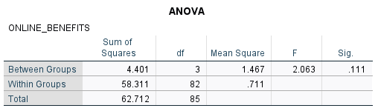
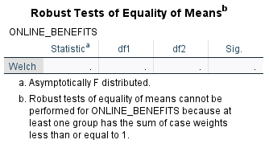
Oneway

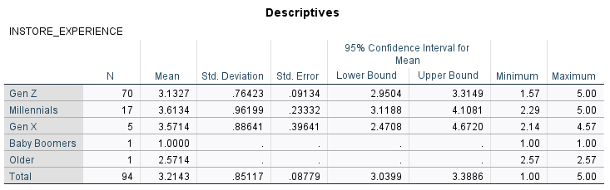
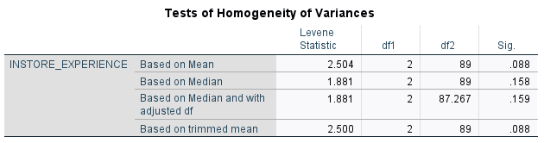
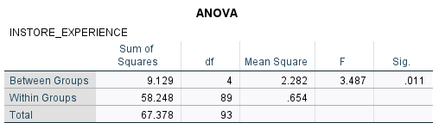
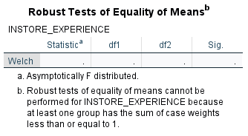

Oneway

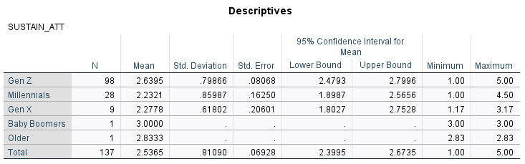
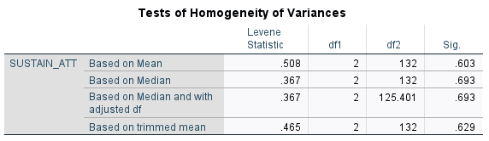
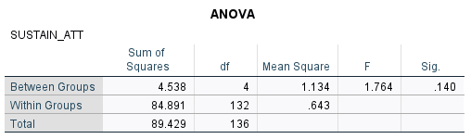
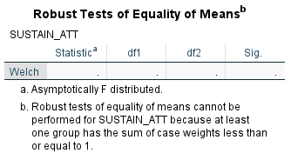

Univariate Analysis of Variance
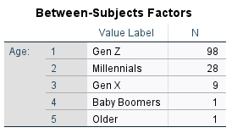
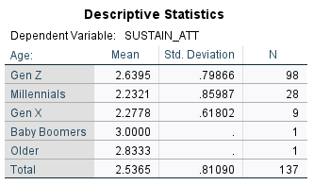


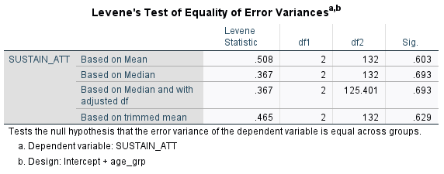
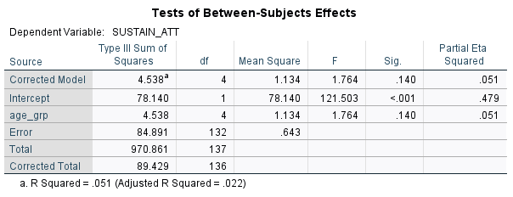

PLUM - Ordinal Regression
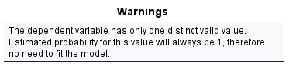
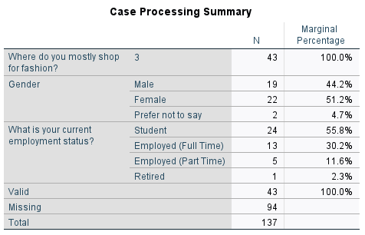

Frequencies

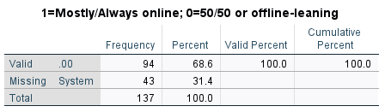

PLUM - Ordinal Regression



Frequencies



Frequencies

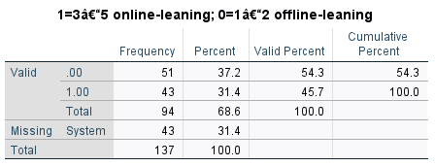

Results:
- Are the scales reliable? (Reliability)
Internal consistency was good for Online Benefits (α = .853, 8 items) and In-store Experience (α = .809, 7 items), and acceptable for Sustainability Attitudes (α = .757, 6 items).
- Who is in the sample & how they shop? (Descriptives & Frequencies)
The channel distribution was balanced: 37.2% offline-leaning (codes 1–2), 31.4% 50/50 (code 3), and 31.4% online-leaning (codes 9–10), N=137. Online and in-store drivers averaged just above the midpoint (M≈3.2–3.3). Mean perceived sustainability difference was positive (offline − online ≈ +0.55), indicating offline was viewed as more sustainable on average.
- Is age related to channel choice?
Age × channel was not statistically significant (Pearson χ²(16)=25.33, p=.064; many cells <5). Ordinal measures were negligible (τ-b=.054, p=.507; Γ=.091, p=.507), and Spearman’s ρ indicated no association (ρ=.062, p=.468) which means statistically, age is not linked to main channel in this dataset. Descriptively, younger people appear across all channels, but the relationship is too weak (and some cells are too small) to be confident.
- Do age groups differ on the composites?
Welch’s ANOVA found no significant differences in Online Benefits by age (report F, df, p). For In-store Experience and Sustainability Attitudes, [insert p-values] indicated [no/significant] differences; where significant, descriptive means suggested [e.g., Millennials > Gen Z], though post-hoc tests were limited by small cells.

