**Stream Data generation using Spark Project**

Srijith R

185001165

Use Case: **Smart Healthcare**

* Patient details received from sensors sent to kafka
* Data is streamed using Spark
* The structured stream data is analysed using SQL

**Output screenshots:**

1)Data from sensors sent to kafka

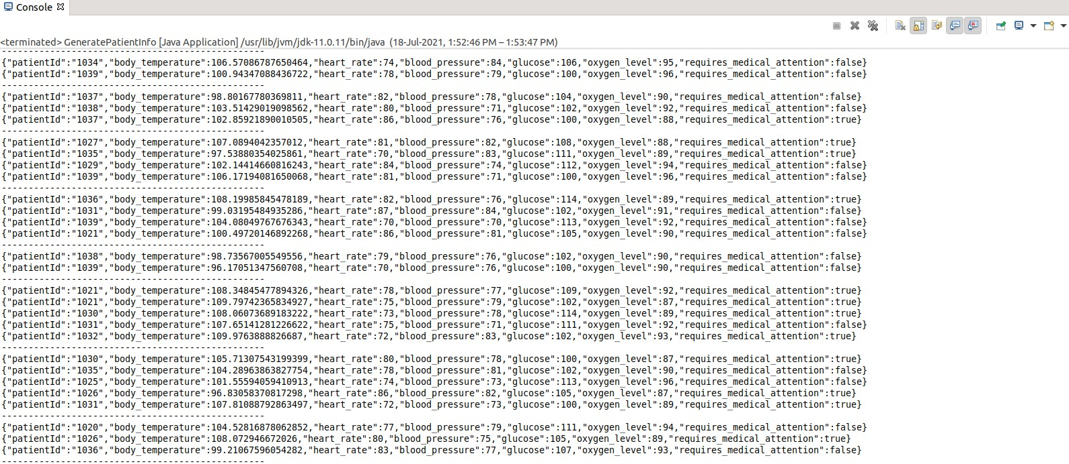

2)Data received by kafka

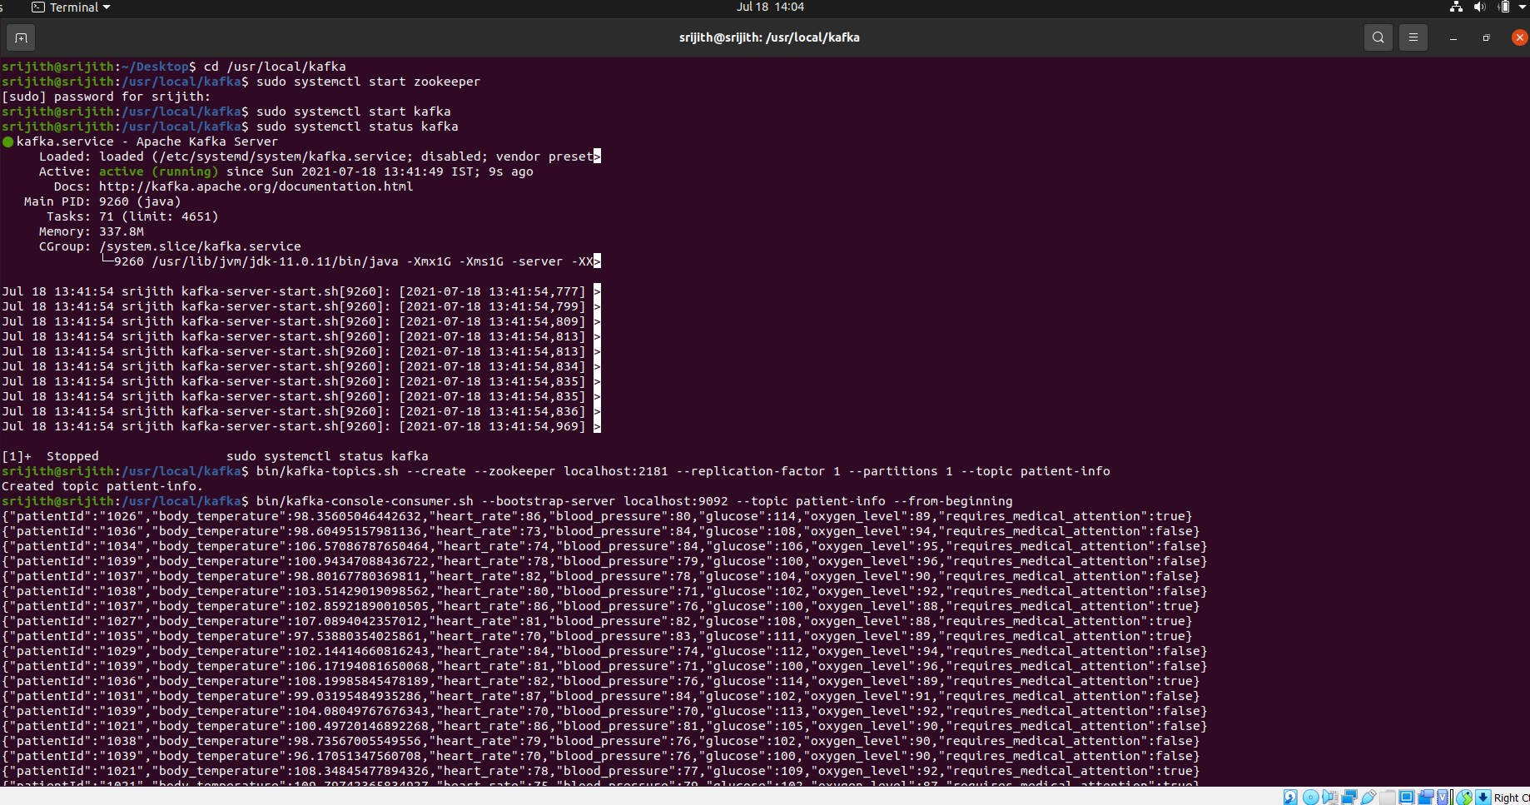

3)Structured data streaming using Spark

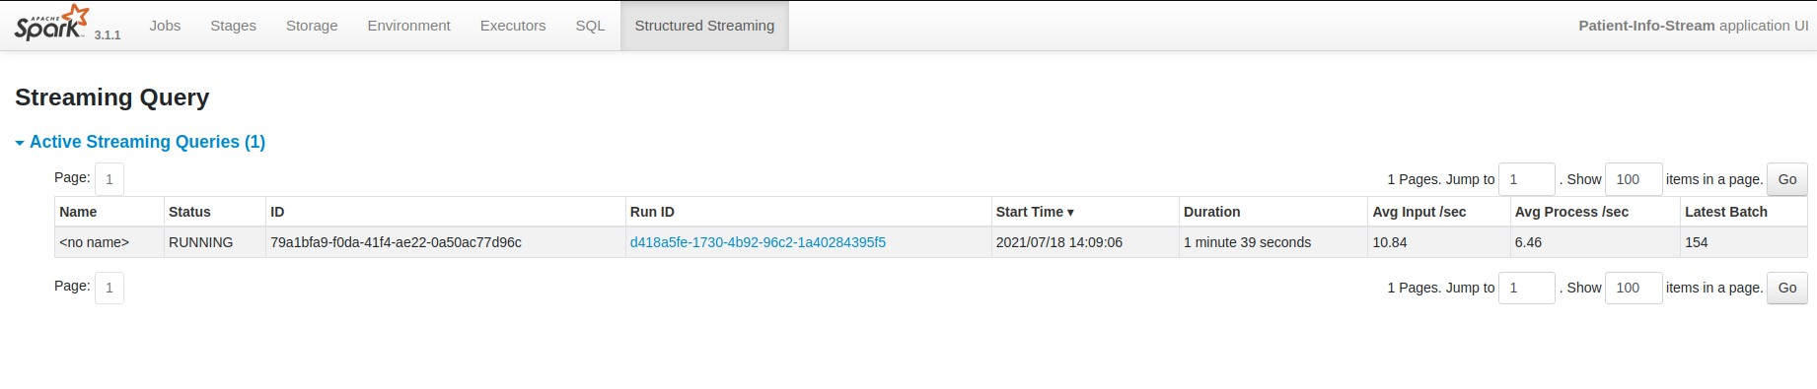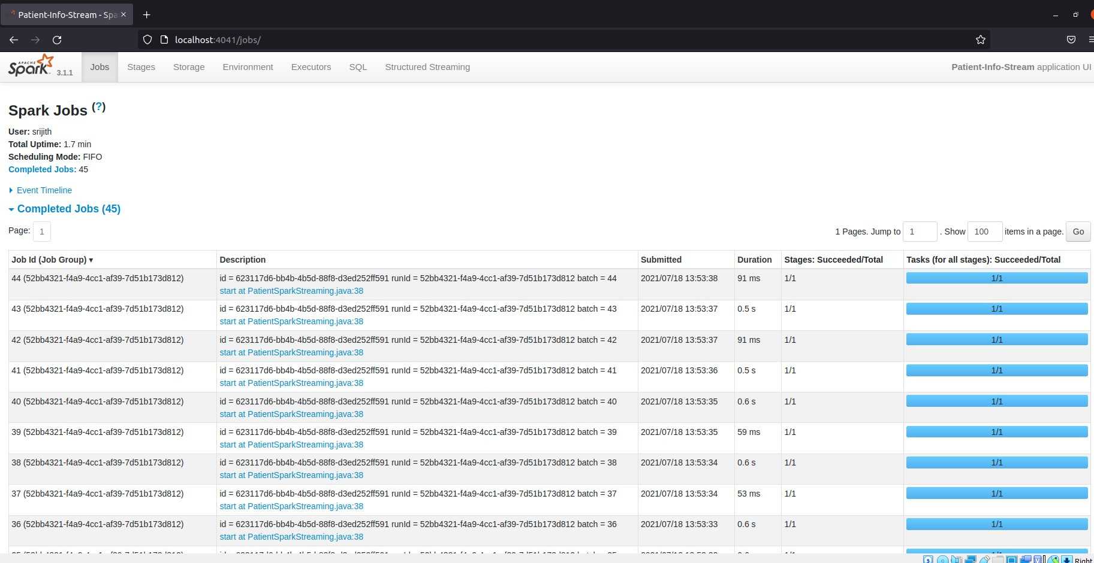

**4)SQL**

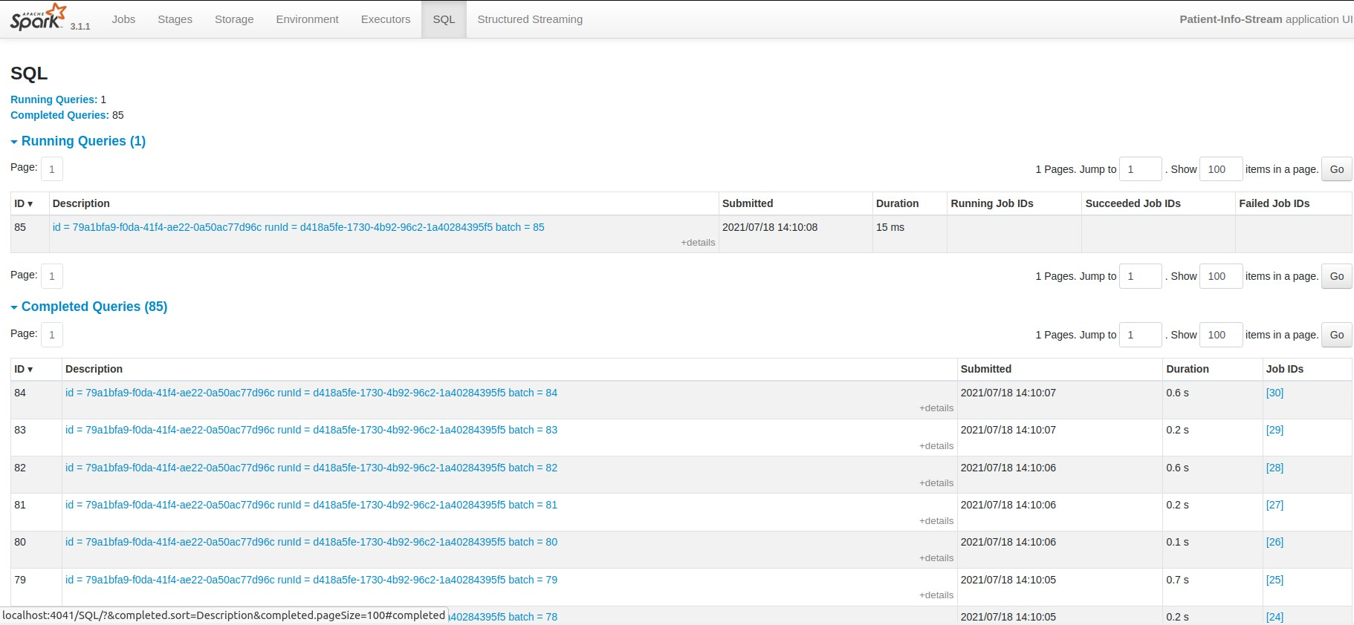

**FILTERING PATIENTS THAT REQUIRE MEDICAL ATTENTION**

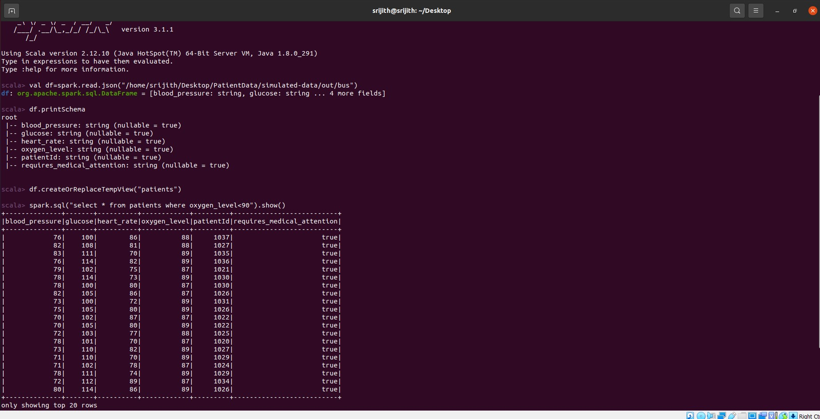

Simulated data file

