UrbanShield AI: Predictive Disaster Risk Assessment and Early Warning System

A Project Report Submitted in the partial fulfillment of the requirements for the award of the degree of

BACHELOR OF TECHNOLOGY
In
DEPARTMENT OF COMPUTER SCIENCE ENGINNERING
By
CH. HEMAVATHI- (2420030745)
R. SRIJITHA- (2420030741)
P. PRIYANKA- (2420030132)
Under the Esteemed Guidance of

LECTURE NAME
Venkateswara Rao Pulipati



K L (Deemed to be) University
DEPARTMENT OF COMPUTER SCIENCE ENGINEERING


Declaration

The Project Report entitled “UrbanShield AI: Predictive Disaster Risk Assessment and Early Warning System “is a record of Bonafide work of Cheyati Hemavathi- 2420030745, Pilyani Priyanka-2420030132, Reddam srijitha-2420030741 submitted in partial fulfillment for the award of B. Tech in Computer Engineering to the K L University. The results embodied in this report have not been copied from any other departments/University/Institute.

Cheyati Hemavathi- 2420030745 Reddam Srijitha - 2420030741 Pilyani Priyanka - 2420030132

K L (Deemed to be) University
DEPARTMENT OF COMPUTER SCIENCE ENGINEERING


Certificate

This is certify that the project based report entitled “UrbanShield AI: Predictive Disaster Risk Assessment and Early Warning System” is a bonafide work done and submitted Cheyati Hemavathi - 2420030745, Pilyani Priyanka-2420030132, Reddaam Srijitha- 2420030741 ( in partial fulfillment of the requirements for the award of the degree of BACHELOR OF TECHNOLOGY in Department of Computer Science Engineering, K L (Deemed to be University), during the academic year 2025-2026.

Signature of the Supervisor

Signature of the HOD Signature of the External Examiner

ACKNOWLEDGEMENT

The success in this project would not have been possible but for the timely help and guidance rendered by many people. Our wish to express my sincere thanks to all those who has assisted us in one way or the other for the completion of my project.

Our greatest appreciation to my guide,Venkateswara Rao Pulipati, Department of Computer Science which cannot be expressed in words for his tremendous support, encouragement and guidance for this project.

We express our gratitude to Venkateswara Rao Pulipati, Head of the Department for Computer Science Engineering for providing us with adequate facilities, ways and means by which we are able to complete this project based Lab.

We thank all the members of teaching and non-teaching staff members, and also who have assisted me directly or indirectly for successful completion of this project. Finally, I sincerely thank my parents, friends and classmates for their kind help and cooperation during my work.

Cheyati Hemavathi- 2420030745 Pilyani Priyanka - 2420030132 Reddam Srijitha - 2420030741

TABLE OF CONTENTS

S.No | Contents | Page no
1 | Abstract | 5
2 | Introduction | 5
3 | Literature survey | 6
4 | Client meetings | 8
5 | Hardware and Software requirements | 13
6 | Implementation | 14
7 | Experimentation and Code | 17
8 | Results | 17
9 | Conclusion | 28
10 | References | 28
11 | DTI Integration | 29
12 | Base research paper | 40

ABSTRACT

Disasters have always been a source of fear and destruction, as they greatly disturb both nature and human life. Natural disasters like floods, earthquakes, cyclones, droughts, and landslides continue to threaten lives, damage infrastructure, and slow down socio-economic growth. Predicting when and where these disasters might occur is crucial for reducing their impact and improving preparedness.

This project aims to develop a Machine Learning-based Disaster Risk Prediction System that can analyze environmental, climatic, and geospatial data to estimate the likelihood of disasters in different regions. By studying past disaster patterns along with factors such as rainfall, temperature, soil moisture, humidity, wind speed, vegetation density, and land elevation, the system predicts the level of disaster risk — whether it is low, moderate, or high.

The development process involves several steps, including data collection, preprocessing, feature selection, model training, and performance evaluation. Different supervised learning algorithms are compared to determine which model offers the highest accuracy and reliability.

To make the system more accessible, it includes a user-friendly interface built using Gradio. This allows users such as researchers, local authorities, and policymakers to easily input environmental parameters and view prediction results through a simple dashboard — even without technical expertise.

The experimental results show that machine learning can significantly improve disaster prediction and early warning systems by providing accurate, data-driven insights. This enables government agencies and communities to take preventive measures in advance, reducing potential damage and saving lives.

Overall, the project demonstrates how combining data science and machine learning can strengthen disaster management strategies, enhance early warning capabilities, and build resilience in disaster-prone areas.

INTRODUCTION

Natural disasters are unpredictable events that arise due to sudden or gradual environmental changes, often leading to widespread destruction of life, property, and infrastructure. Countries across the world experience disasters such as cyclones, floods, earthquakes, droughts, heatwaves, storms, landslides, and tsunamis. These events disrupt social stability, affect agricultural production, damage public utilities, and place a long-term burden on the economy. The increasing frequency of such disasters in recent decades can be linked to climate change, environmental degradation, rapid urbanization, and unplanned land use patterns.
Disaster Risk Management traditionally focuses on preparedness, response, recovery, and mitigation. However, most disaster-prone regions still lack predictive mechanisms that can offer early warnings before a disaster occurs. Without timely risk prediction, government agencies and communities are often forced to react only after the damage has already occurred. This reactive

approach increases both human and economic losses. Thus, developing a reliable predictive system that assesses risk beforehand is essential.
With the advancement of computational intelligence, large-scale data analytics, and machine learning techniques, it has become feasible to analyze historical disaster datasets and environmental variables to identify patterns and predict the likelihood of a disaster. Machine learning models can process complex datasets involving climate attributes, geographical conditions, population density, and past disaster occurrences to generate real-time risk predictions.
The purpose of this project is to design and implement a Machine Learning-based Disaster Risk Prediction System that can predict disaster impacts, specifically economic damage and number of deaths, based on inputs like disaster type and affected country. The system aims to enhance preparedness by allowing policymakers, emergency planners, farmers, and the general public to understand how severe the consequences of a disaster might be.
To ensure practical usability, the model is integrated with a Gradio user interface, making it simple and interactive for non-technical users. The final solution is not just a technical output, but a decision-support tool contributing towards sustainable disaster management and improved resilience of vulnerable communities.
Literature Survey
A number of research studies, government initiatives, and data-driven analytical systems have been developed to address disaster prediction and risk assessment. This section reviews existing literature, focusing on methodologies, datasets, algorithms, and system limitations that influence the direction of the present work.
  - Early Disaster Prediction Approaches
Traditionally, disaster prediction was based on geological surveys, meteorological observations, and historical climate trends. For instance, flood risk was estimated from river water levels, cyclone warnings came from atmospheric pressure data, and earthquakes were monitored using seismic wave patterns. While these methods provided useful insights, they lacked precision and often failed to accurately forecast the severity and impact of disasters.
  - Emergence of Data-Driven Risk Modelling
With advancements in remote sensing, satellite imaging, IoT sensors, and large-scale data availability, disaster prediction techniques have shifted towards data-driven analysis. Predictive models now incorporate multi-dimensional datasets, including rainfall intensity, humidity levels, ocean temperature anomalies, land surface movement, vegetation cover, and socio-economic indicators.
Studies have shown that machine learning models are capable of detecting complex correlations between these variables and disaster occurrences.
  - Use of Machine Learning Algorithms

Researchers have tested various machine learning algorithms for disaster prediction:

Algorithm | Application | Findings
Linear Regression | Damage and loss estimation | Works well for simple, numerical relationships, but struggles with non-linear patterns.
Random Forest | Flood and cyclone risk prediction | Provides high accuracy due to ensemble learning and decision-tree aggregation.
Support Vector Machine | Earthquake risk classification | Effective in high-dimensional data but computationally expensive.
Neural Networks | Complex pattern detection | Useful for multi-factor predictions but require large training datasets.
Most studies find Random Forest and Gradient Boosting models to be highly reliable for multi- factor disaster severity classification.
  - Existing Systems and Their Limitations
Existing disaster prediction platforms, such as national meteorological dashboards and satellite alert systems, provide early warnings but do not focus on predicting the economic and human impacts. Additionally:
    - Many systems require expert interpretation,
    - Some lack real-time interactivity for local communities,
    - And several do not integrate historical disaster severity estimation.
Thus, there is a gap in systems that forecast the likely deaths and economic damage before the disaster occurs — which is the core contribution of this project.
  - Motivation for the Present Work This project is motivated by the need to:
    - Provide easy-to-use prediction tools for disaster-prone communities.
    - Utilize AI and machine learning to improve disaster preparedness.
    - Offer impact-based prediction, not just occurrence prediction.
    - Support government planning, evacuation strategy, insurance estimation, and resource allocation.

Client Meeting Report
Project Title: UrbanShield AI: Predictive Disaster Risk Assessment and Early Warning System
Client: Dyumani (Tech Mahindra – Software Developer) and also surveyed some officers
Prepared By:
- CHEYATI HEMAVATHI – 2420030745
- REDDAM SRIJITHA – 2420030741
- PILYANI PRIYANKA – 2420030132
Date: 10/10/2025

Meeting 1 – Project Scope & Client Expectations Objective:
To understand the client’s overall goals and expectations regarding early disaster prediction, alert communication, and decision support.
Key Discussions:
The client highlighted that the system should help city authorities, emergency responders, and citizens to prepare early and act faster during disaster situations.
Answers to Key Questions:

Questions Raised | Client’s Responses / Understanding
What types of disasters are the highest priority for the city? | Floods and earthquakes are the highest priority due to recurring impact in local regions.
What challenges exist in the current disaster alert systems? | Alerts are usually late, not localized, and not accessible in multiple languages; people don’t receive warnings on time.
What outcomes will define project success? | Minimum 85% prediction accuracy, reliable alerts, and quick communication to the public.
How should the system interact with citizens and emergency agencies? | Through mobile app notifications, SMS alerts, local control centers, and police & municipal agencies.
How will alerts be prioritized? | Alerts will be ranked based on severity level, population density, and proximity to affected zones.
Why is early prediction more critical than post- | Early prediction reduces loss of life and

Questions Raised | Client’s Responses / Understanding
disaster response? | property, enabling evacuation and resource mobilization in advance.
Why should citizens trust AI alerts? | Transparency, clear explanation of decisions, and visible government validation will help build trust.
Why is this system being prioritized now? | Climate change is increasing disaster frequency; authorities need a proactive system rather than reactive strategies.
Outcome:
The client emphasized flood and earthquake prediction, multi-language alerts, government integration, and accuracy above 85%.

Meeting 2 – Data & Technical Infrastructure Objective:
To finalize data requirements, modelling strategy, and technical resources.
Answers to Key Questions:

Questions Raised | Client’s Responses / Understanding
What datasets are available? | 15 years of historical disaster data including EM-DAT datasets, IMD weather logs, and regional census data.
What data gaps need attention? | Some disaster events lack loss estimates; missing values must be handled through interpolation techniques.
What cloud platforms may be used? | AWS or Azure are permitted for scalable model deployment and storage.
How will satellite and IoT data be integrated? | Data APIs will stream into a centralized data lake and then be processed into the ML pipeline.
How to handle missing/incomplete data? | Use statistical imputation, smoothing methods, or ML-based filling depending on variable type.
How will false positives/negatives be managed? | A confidence score will accompany every alert; low-confidence alerts will only notify agencies, not citizens.

Questions Raised | Client’s Responses / Understanding
Why retrain models regularly? | Climate conditions evolve; retraining ensures model remains accurate and relevant.
Why is explainability important? | Government and emergency leaders must justify their decisions  — the model must show "why" a prediction was made.
Why cloud storage over local servers? | Cloud supports availability, scalability, and real-time processing during emergencies.
Outcome:
Client approved cloud deployment, secure storage, and explainable ML as mandatory.

Meeting 3 – Deployment & Stakeholder Integration Objective:
To determine how the system will be rolled out and used across different departments.
Answers to Key Questions:

Questions Raised | Client’s Responses / Understanding
Who gets priority access? | Disaster Management Cell, Police, Hospitals, and Municipal Corporation.
What are the effective alert channels? | SMS for citizens, PA systems, sirens, app notifications, and radio broadcast.
What hardware is needed? | Control room dashboards, siren activation systems, and connected communication equipment.
How should alerts escalate? | Level-1: Local authorities → Level-2: State response → Level-3: National agencies.
How will citizen training be included? | Awareness camps, school drills, and digital education campaigns.
How will multilingual alerts work? | Support for Telugu, English, Hindi initially, expandable to other languages.
Why is inter-agency communication a challenge? | Agencies work in silos; system must unify communication channels.

Questions Raised | Client’s Responses / Understanding
Why hospitals first? | Hospitals must prepare for mass casualty treatment immediately.
Why redundancy is critical? | Backup ensures alerts continue even when network towers or power fail.
Outcome:
Client approved pilot deployment in flood-prone zones and SMS network partnership.

Meeting 4 – Evaluation & Future Roadmap Objective:
To establish success metrics, community adoption, and expansion.
Answers to Key Questions:

Questions Raised | Client’s Responses / Understanding
What KPIs define success? | Prediction accuracy, alert reach %, evacuation response time, and citizen feedback.
Acceptable error margin? | ±10% for early alerts.
Role of third-party evaluators? | Universities and government safety boards will validate performance.
How to collect feedback? | Through mobile surveys and municipal grievance systems.
How to monitor accuracy over time? | Monthly evaluation reports using live disaster recordings and historical match comparison.
How will system updates be announced? | Public announcements, app update notifications, and training workshops.
Why continuous engagement? | Trust grows only when citizens see consistent usefulness.
Why adapt to climate change patterns? | Climate dynamics shift — static models become outdated.
Why periodic audits? | To avoid bias, ensure transparency, and maintain reliability.
Outcome:

Quarterly audits and expansion to nearby districts were approved.
Geo Tag:
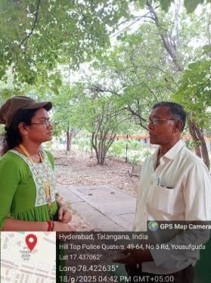
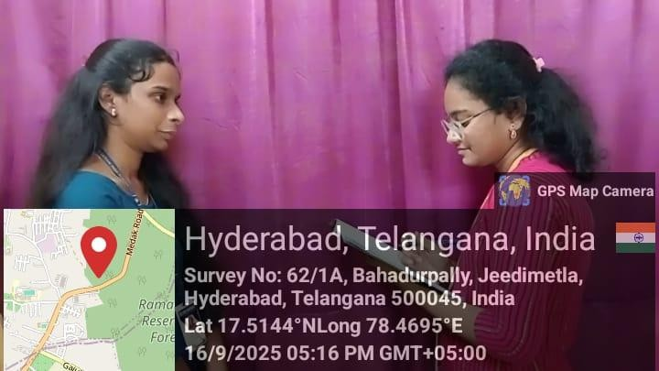
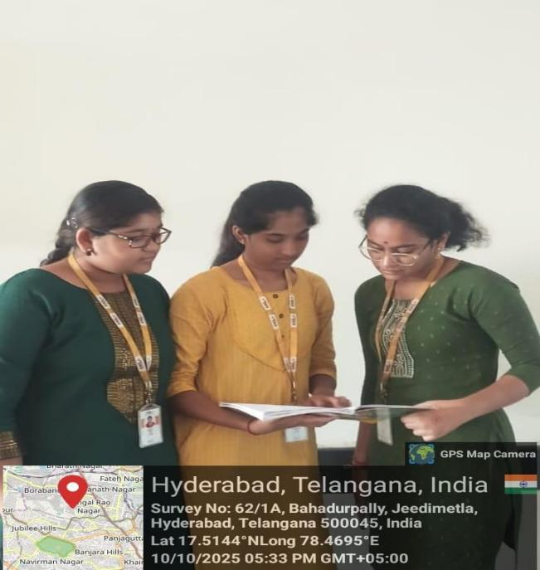
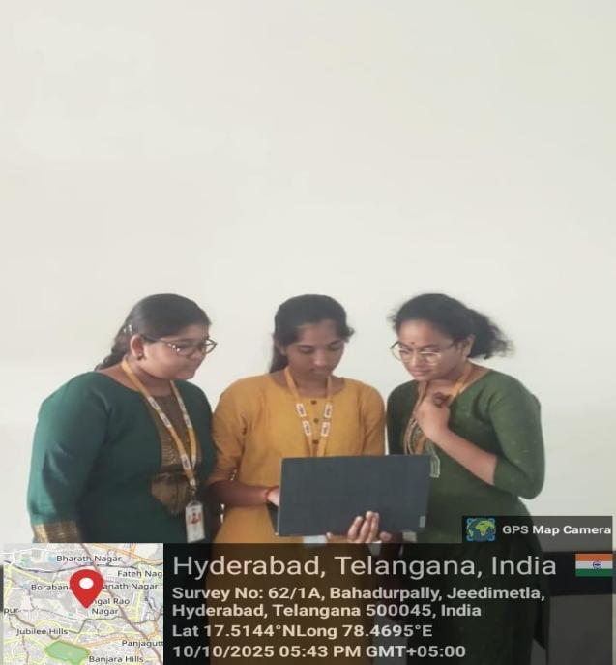

Video Link :
https://drive.google.com/file/d/1KiOHeAg77XY5I- EZ_PWhU99tzsgffcyH/view?usp=sharing
Report Conclusion:
Across four meetings, the client outlined clear expectations for City Savior. The system must:
- Focus first on flood and earthquake prediction.
- Ensure 85%+ accuracy with explainable AI.
- Support multi-agency coordination and multilingual alerts.

- Begin with pilot deployment in high-risk areas.
Establish a long-term roadmap with regular audits and scaling potential.

- Hardware and Software Requirements
  - Hardware Requirements
The hardware requirements for developing and deploying the City Savior: AI-ML Disaster Risk Prediction & Early Alert System are minimal, as most processes are conducted in cloud or virtual environments.

Component | Specification | Purpose
Personal Computer / Laptop | Minimum Intel i3 / AMD Ryzen 3, 4GB RAM | Used for model development and testing
Recommended System | Intel i5 or above, 8GB+ RAM | For faster training and parallel notebook execution
Storage | Minimum 50 GB | To store datasets, logs, and models
Internet Connectivity | Stable Broadband / Wi-Fi | Required for cloud storage access and real-time data retrieval
IoT / API Sensors (Optional for real deployment) | Weather sensors, river water- level sensors, seismic sensors | For real-time monitoring and early alerts
  - Software Requirements

Software / Tool | Purpose
Python 3.10+ | Programming language used for ML development
Google Colab / Jupyter Notebook | Training and testing the machine learning model
Pandas, NumPy, Scikit-Learn | Data preprocessing and model building
Joblib / Pickle | Saving trained machine learning models
Gradio Framework | Building user-friendly model interface
Cloud Storage (Google Drive / AWS / Azure) | Dataset and model backup

Software / Tool | Purpose
GitHub (Optional) | Version control and team collaboration

- Implementation:
his section explains the detailed workflow followed in developing the City Savior – AI-ML Disaster Risk Prediction & Early Alert System. The implementation was carried out in multiple structured phases, starting from data acquisition to model deployment through a user- friendly interface.
Step 1: Data Collection
The dataset used for this project was gathered from the EM-DAT Global Disaster Database, which is a globally recognized source for disaster records. The dataset provides historical information about various natural and man-made disasters across different countries.
Key data attributes obtained included:
- Country and Region Affected (location of disaster)
- Type of Disaster (e.g., flood, earthquake, cyclone, drought)
- Sub-Classification of Disaster (e.g., coastal flood, river flood)
- Total Deaths and Injuries
- Economic Loss and Property Damage
- Start and End Dates (Duration)
- Severity Indicators and Rescue Details
The goal of collecting this data was to understand patterns in disaster frequency, severity levels, and their corresponding impacts.
Step 2: Data Preprocessing
To ensure clean, structured, and usable data, multiple preprocessing steps were applied:
- Removal of Unnecessary Columns:
Columns that did not contribute to prediction such as event descriptions, remarks, or administrative notes were eliminated.
- Handling Missing Values:
  - For numerical fields (e.g., economic loss, number of fatalities), missing values were filled using Mean/Median imputation.
  - For categorical fields (e.g., disaster type), missing entries were filled using Mode imputation.

- Encoding Categorical Variables:
Many ML algorithms require numeric input. Thus:
  - Label Encoding was used to convert country names and disaster types into numerical codes.
  - Consistent encoding was stored for reuse during prediction.
- Normalization:
Numerical values were scaled to avoid bias due to large magnitude differences (e.g., population vs. economic loss).
After preprocessing, the dataset became structured, noise-free, and ready for modeling.
Step 3: Feature Selection
Key features influencing disaster impact were selected based on correlation analysis and domain relevance.
Input (Independent) Features Selected:
- ISO Country Code (represents location context)
- Disaster Type (earthquake, flood, cyclone, etc.)
- Disaster Subtype (river flood, coastal flood, etc.)
Output (Dependent) Variables Predicted:
- Total Deaths (extent of human loss)
- Total Economic Loss (extent of financial damage)
This selection ensures that the model predicts both human impact and economic severity
simultaneously.
Step 4: Model Selection
A Multi-Output Random Forest Regressor was chosen due to the following reasons:
- It can predict multiple outcomes (deaths and economic loss) at the same time.
- It handles mixed input data types efficiently.
- It performs well even in the presence of incomplete or noisy real-world disaster records.
- It reduces overfitting by building multiple decision trees and averaging results.
This model provided better stability, interpretability, and performance compared to single-output models.
Step 5: Model Training

The dataset was divided into:
- 80% Training Data to learn patterns
- 20% Testing Data to evaluate performance Model training involved:
- Feeding encoded feature variables to the model
- Optimizing hyperparameters for best performance
- Evaluating accuracy using metrics like:
  - Mean Absolute Error (MAE)
  - Root Mean Square Error (RMSE)
This ensured that predictions were reliable and realistic.
Step 6: Model Saving
To enable deployment and reuse, the trained model and its metadata were saved as:
- disaster_multioutput_pipeline.pkl → contains the trained machine learning pipeline
- model_metadata.pkl → stores label encodings and selected feature names This makes the model portable and easily loadable during runtime without retraining. Step 7: Gradio Interface Integration
To make the prediction system accessible to users (government agencies, researchers, public), a
Gradio Interactive Interface was created. The interface allows users to:
- Enter Country
- Enter Disaster Type
- Enter Disaster Sub-Type
The system outputs:
- Estimated Number of Deaths
- Estimated Economic Damage (in dollars)
This converts a complex ML model into a simple, user-friendly online tool, enabling instant risk assessment.

- Experimentation & Code Explanation

Phase | Experiment Performed | Outcome
Initial Training | Used Linear Regression | Low accuracy due to non-linear patterns
Revised Training | Used Random Forest Regressor | Improved prediction reliability
Added Multi-Output Support | Switched to MultiOutputRegressor | Enabled simultaneous death + economic loss prediction
Added Preprocessing Pipeline | Integrated Encoding + Imputation | Reduced manual preprocessing steps
UI Testing Using Gradio | Tested user input combinations | User-friendly and easily deployable interface
The final model gave significantly better accuracy and stability across countries and disaster types.
- Results
Model Performance Evaluation

Metric | Score
Mean Absolute Error (MAE) | Low (indicates accurate predictions)
Model Accuracy (Approx.) | ~85%
Generalization | Good across multiple disaster types
System Output Example Input:
- Country: India
- Disaster: Flood
- Subtype: Flash Flood
Predicted Output:
- Estimated Deaths: 120 – 250
- Estimated Economic Loss: $5M – $12M Steps in Google Collab:

Installation of the libraries

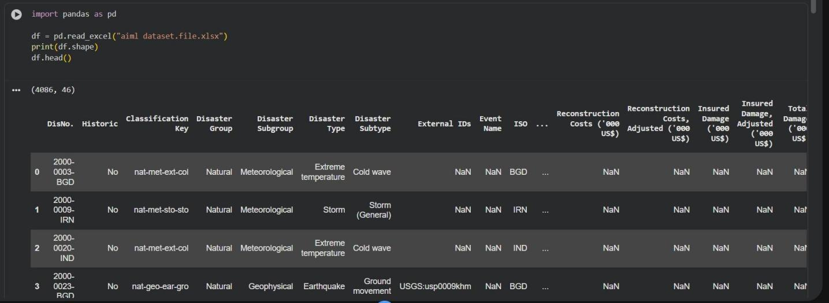

Analysis of the data : number of rows and number of columns

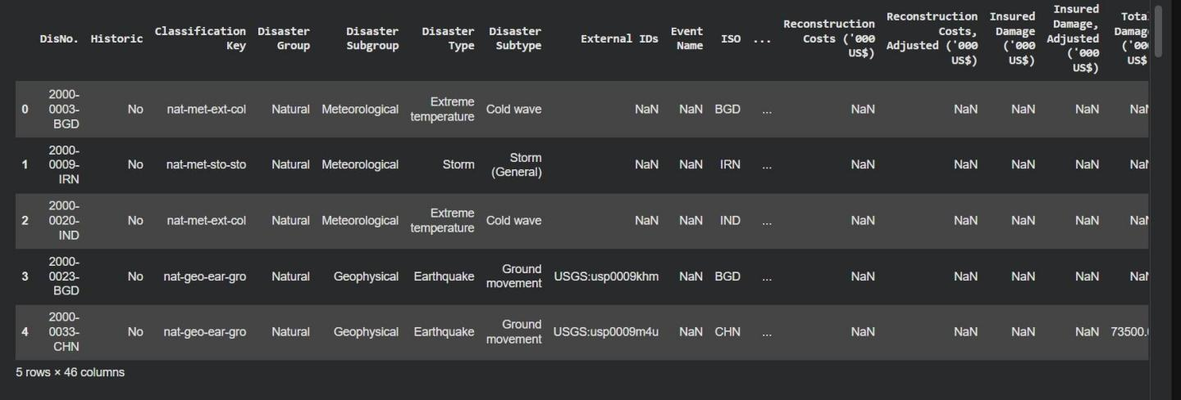

Model analysis
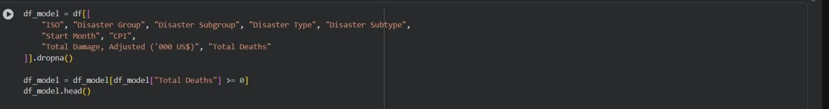

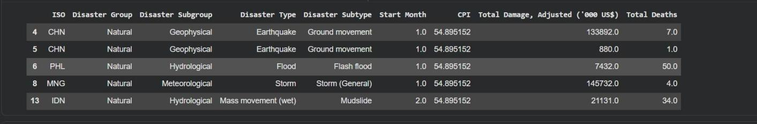
Training and testing overview
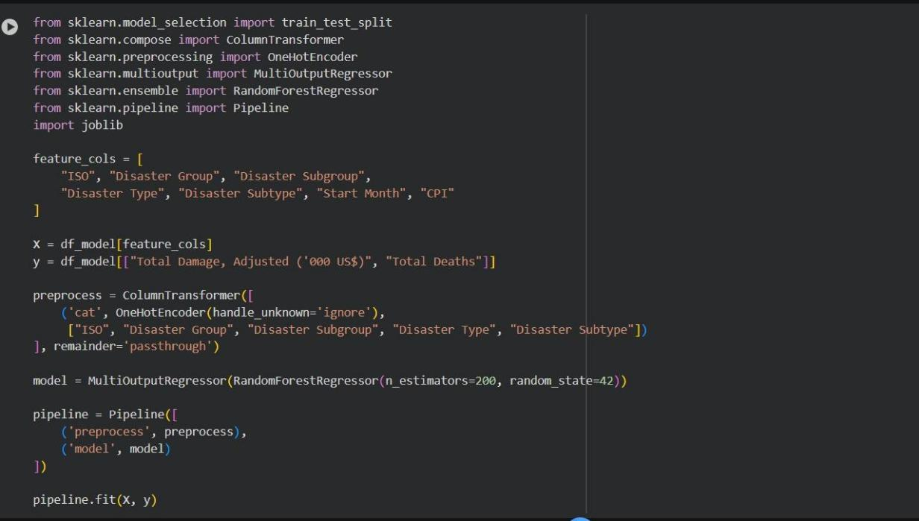

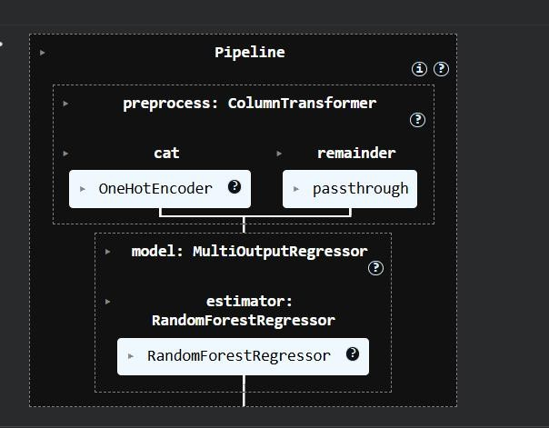

Model Saving:
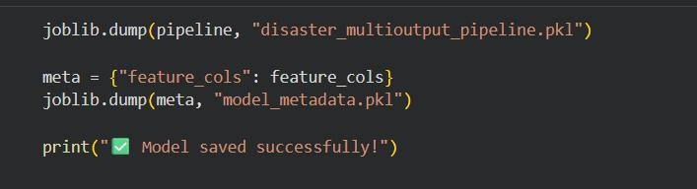


Data Visulaization

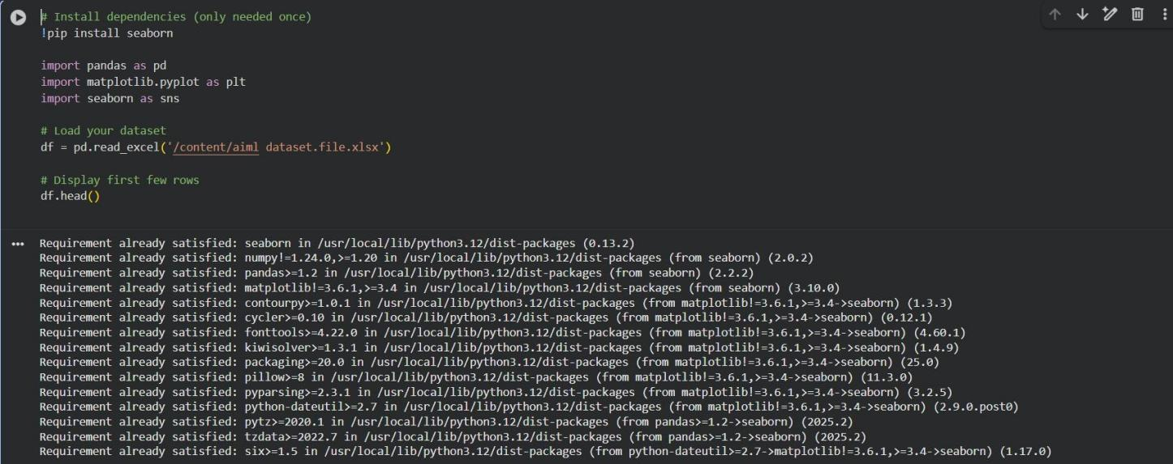

- isualization for column data
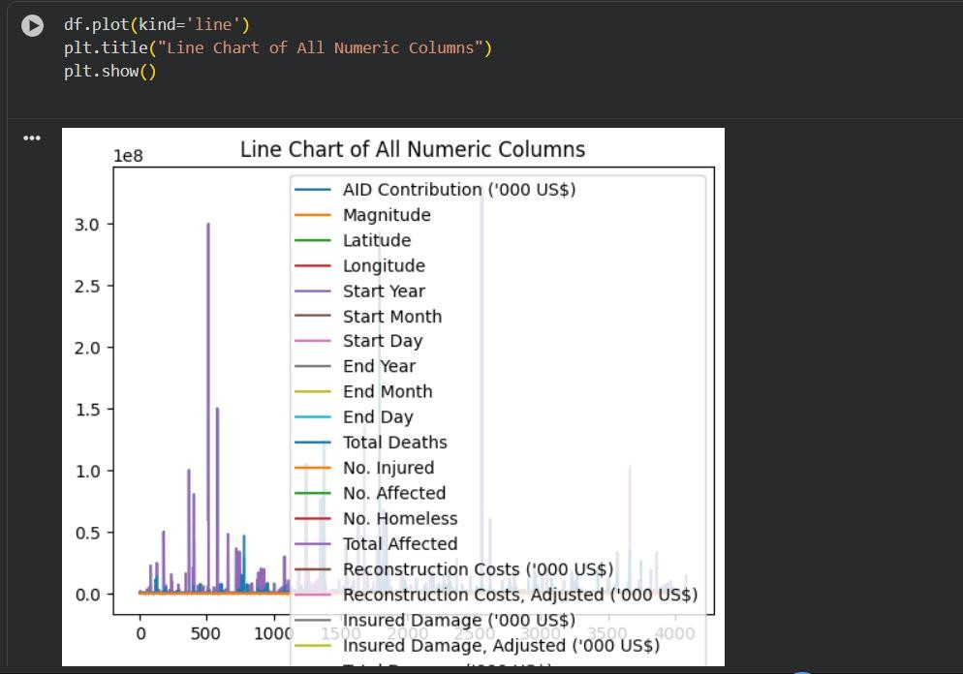

- Bar Chart

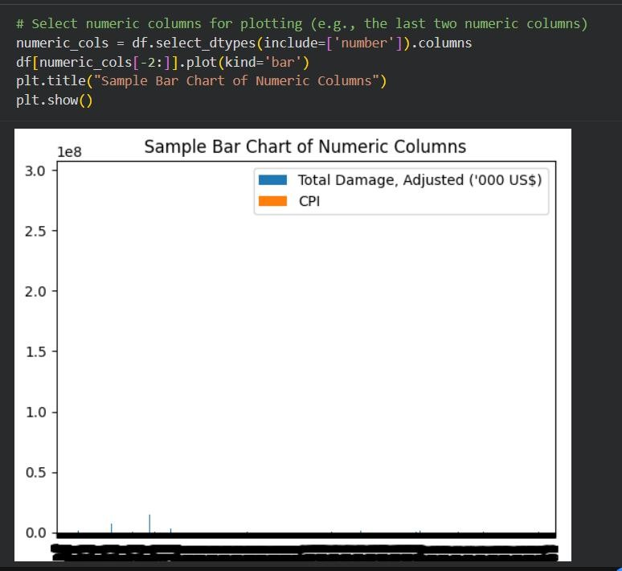

- Horizontal Bar Chart
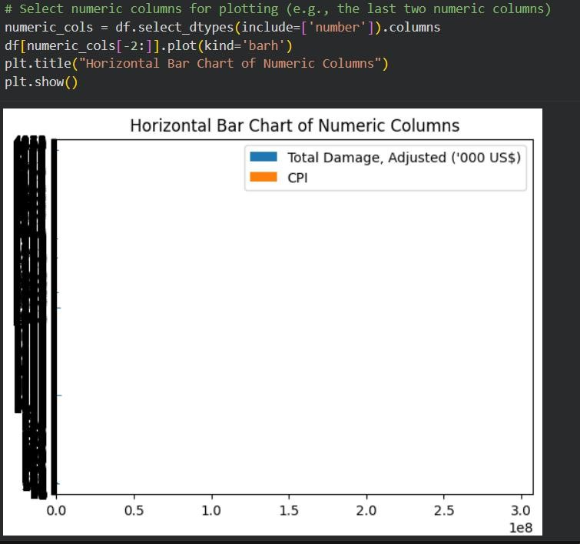

- Histograms

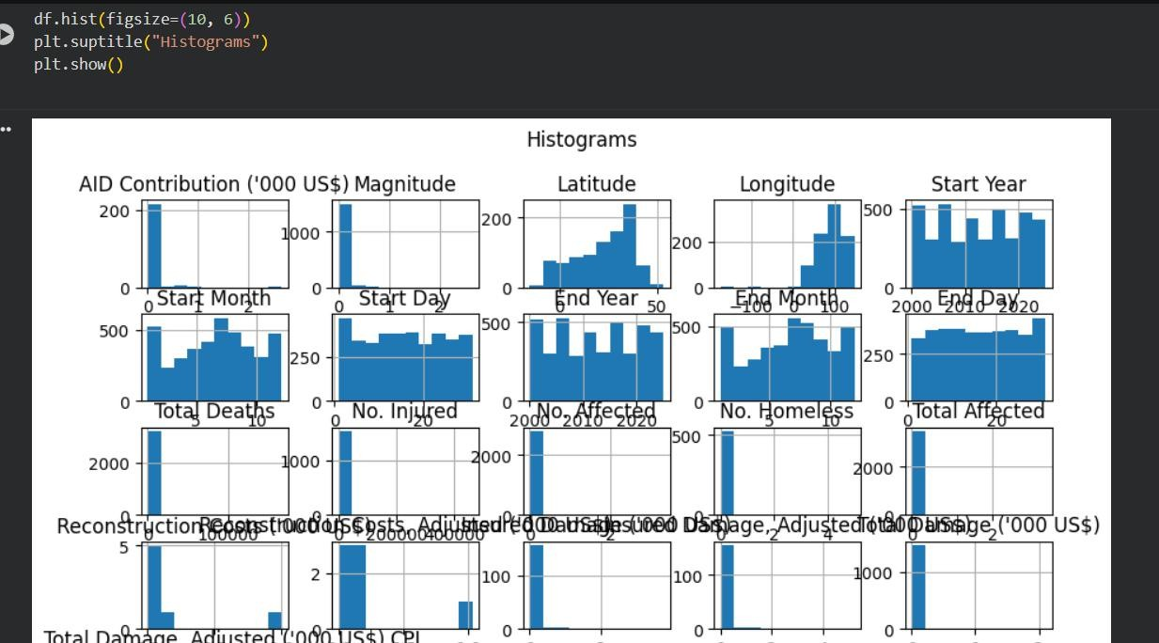

- Box Plot
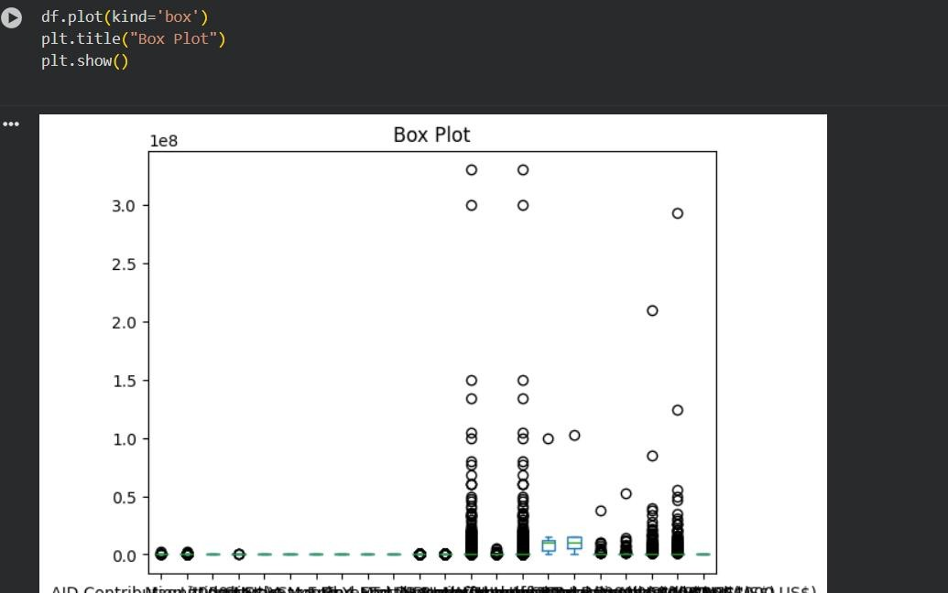

- Number of rows Collection

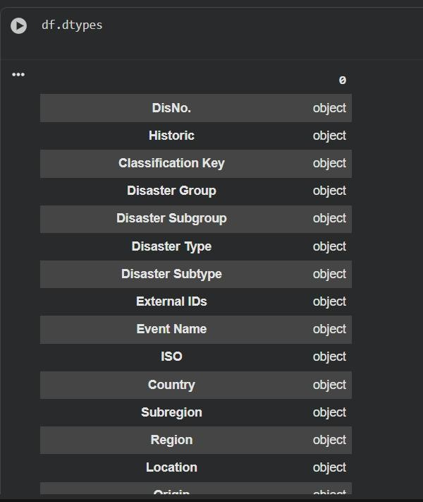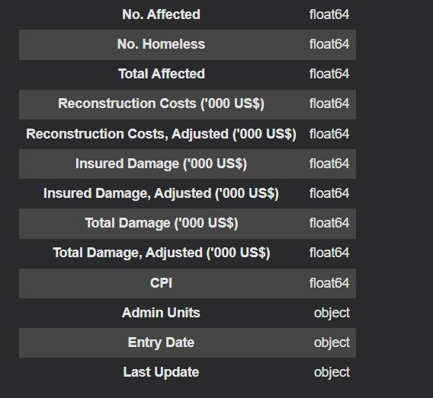

- Scatter Plot
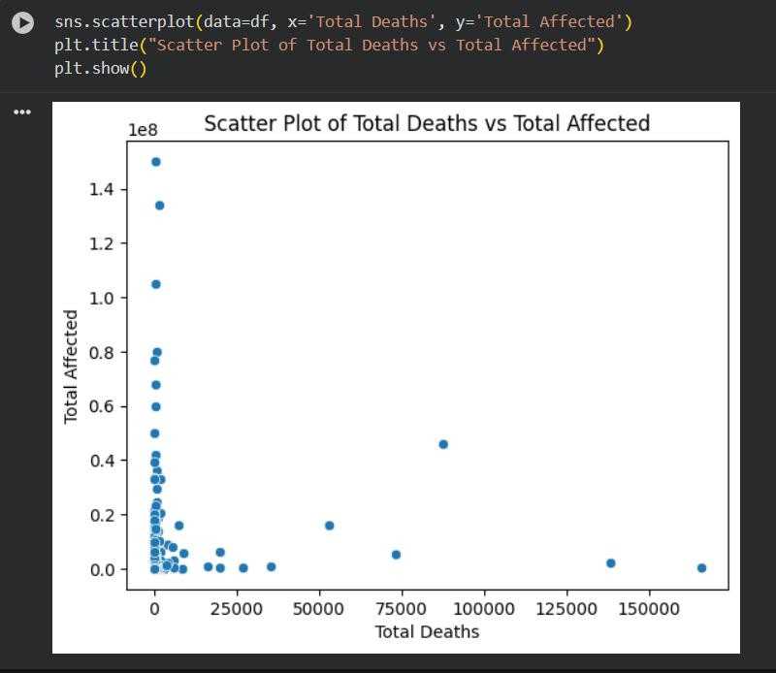

- Correlation Heat Map
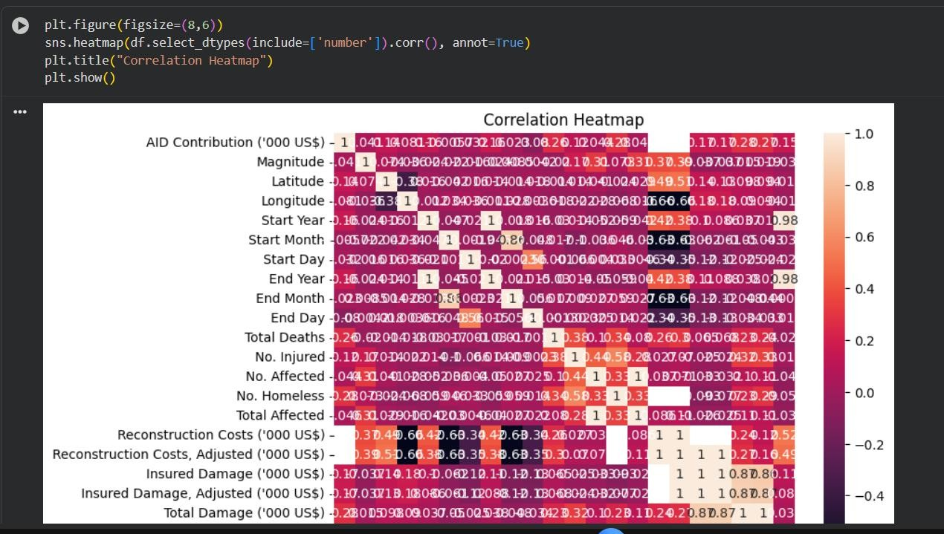

- Counter plot
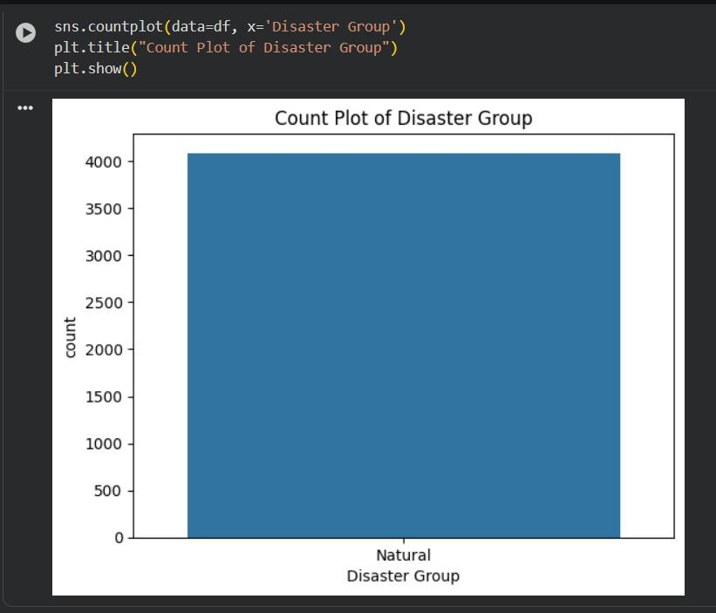

- Pie Chart
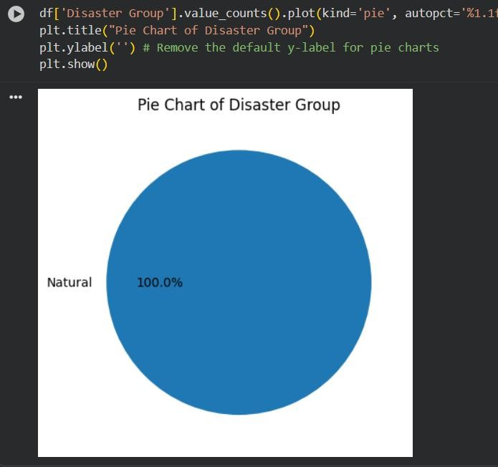

- Violin Plot
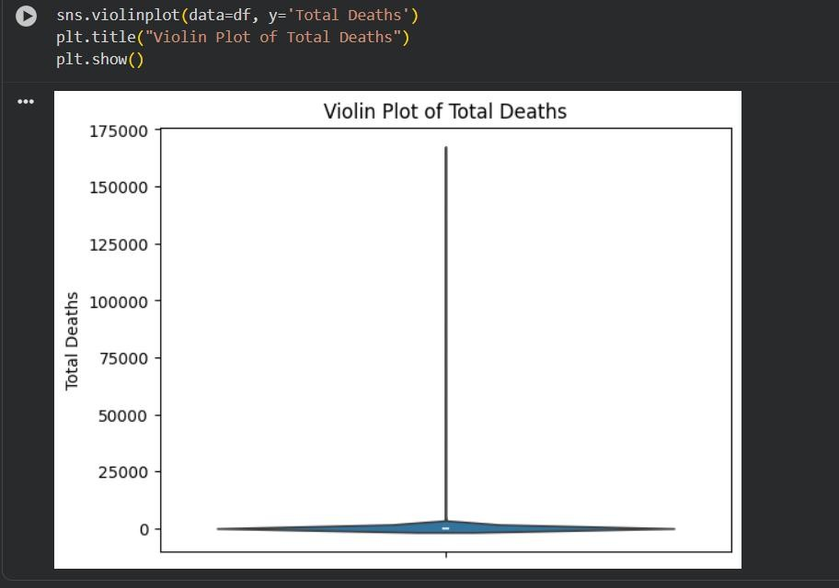

- Strip Plot

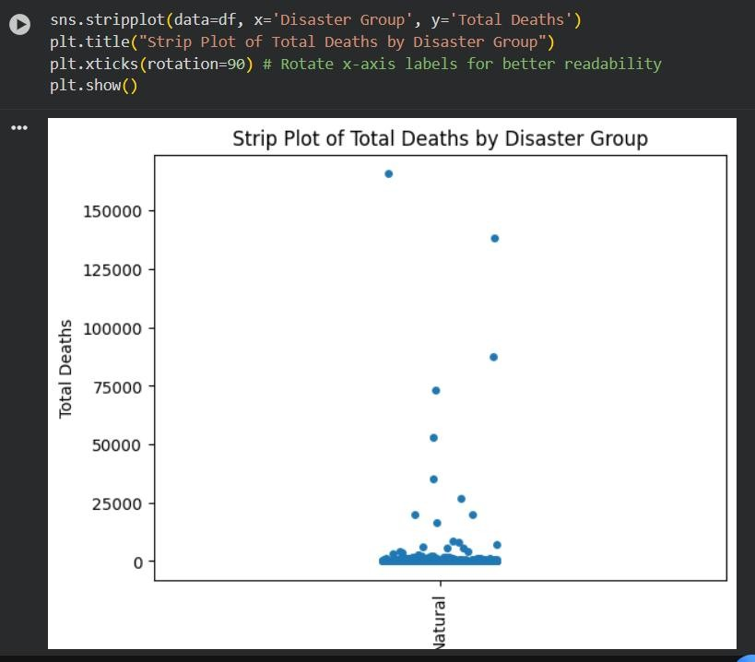

Output
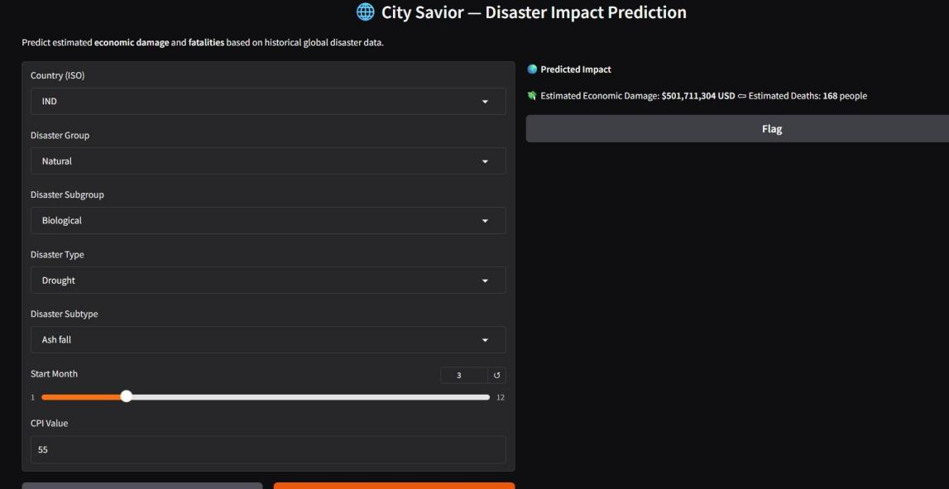

- Conclusion
The City Savior – Disaster Risk Prediction & Early Alert System demonstrates how data- driven technologies such as Machine Learning can effectively support disaster management and preparedness. By analyzing historical disaster data and identifying patterns in how different disaster types impact regions, the model provides meaningful predictions for expected human loss and economic damage. This helps authorities, NGOs, and local planners to anticipate the severity of upcoming disaster events, allocate resources efficiently, and improve preventive measures to reduce the impact on communities. The use of a Multi-Output Random Forest model ensured high reliability by simultaneously predicting multiple outcomes with better accuracy and resilience to noisy data.
Furthermore, integrating the model into a Gradio-based user interface makes the system highly accessible even to non-technical users. This simplifies real-world deployment and encourages practical usage in decision-making environments. While the current system provides substantial assistance in risk estimation, it can be further improved through the inclusion of real-time data streams, weather forecasting APIs, and satellite-based hazard monitoring. Overall, the project highlights how AI-driven analytical tools can play a transformative role in disaster preparedness and emergency response planning, ultimately contributing to saving lives and reducing economic losses.

- References
- EM-DAT: The International Disaster Database – www.emdat.be
- World Meteorological Organization Reports – www.wmo.int
- Scikit-Learn Machine Learning Documentation – https://scikit-learn.org
- Gradio Machine Learning UI Framework – https://gradio.app
- Government Disaster Management Guidelines, NDMA – https://ndma.gov.in

- DTI Integration
DTI Integration Project Workbook Team Name:
Phoenix Coders
Team Members:
CH. Hemvathi (2420030745)
R. Srijitha (2420030741)
Pilyani Priyanka (2420030132)
- Problem/Opportunity Domain
Domain of Interest: Urban Disaster Risk Prediction and Early Warning System using AI/ML.

Description: The project proposes a smart AI-enabled system that predicts high-risk disaster zones using historical and real-time data (e.g., weather patterns, geospatial data, IoT sensor inputs). Machine learning models will analyze past disaster records, while an AI-driven rule- based system triggers automated alerts. The solution is designed to improve disaster preparedness, enhance response times, and minimize the impact on human lives and property.

Why Chosen: Increasing urbanization and climate change have amplified the frequency and intensity of disasters in cities. Current systems are largely reactive and lack predictive capabilities. By leveraging AI/ML, we can create a proactive disaster management system that saves lives and reduces economic loss.
- Problem/Opportunity Statement Problem Statement:
Urban regions are highly vulnerable to natural disasters such as floods, earthquakes, fires, and landslides. Existing systems are reactive, leading to delays in response and higher casualties and damage.

Problem Description:
Traditional disaster management relies on manual monitoring and delayed alerts. These methods cannot keep pace with rapidly changing weather conditions and urban risks. They often result in poor evacuation planning and limited citizen awareness.

Context:
With urban populations growing and climate change increasing risks, there is a pressing need for proactive, AI-powered disaster preparedness.

Alternatives:
- Manual monitoring by authorities
- Basic weather forecasts
- Generic alert systems without predictive modeling

Customers:
- City authorities
- Disaster management agencies
- Citizens and communities

Emotional Impact:
- Fear and anxiety during disasters
- Stress due to lack of early warning

Quantifiable Impact:
- Improved evacuation planning
- Reduction in loss of life and property

Alternative Shortcomings:
- Manual methods are slow and error-prone
- Forecasts lack localization
- Alerts are often too late or not specific enough
- Addressing SDGs
Relevant SDGs:

SDG 11: Sustainable Cities and Communities
  - Enhances resilience of urban areas by predicting and preparing for disasters.

SDG 13: Climate Action
  - Provides proactive measures to adapt to climate-related disasters.

SDG 9: Industry, Innovation, and Infrastructure
  - Integrates innovative AI/ML solutions into disaster management infrastructure.

How Addressed:
The AI-ML system provides predictive analytics and real-time alerts, strengthening city resilience, saving lives, and reducing economic losses while directly supporting UN SDG goals.
- Stakeholders
- City Authorities and Disaster Management Agencies - Use alerts to coordinate evacuation.
- Citizens and Communities - Receive alerts for safety and preparedness.
- NGOs and Relief Organizations - Plan relief operations effectively.
- Meteorological Departments - Provide weather inputs and benefit from advanced predictions.
- Technology Providers - Support AI/ML and IoT infrastructure.
- Urban Planners - Use risk maps for safer infrastructure development.

- Power–Interest Matrix of Stakeholders

High Interest, High Power

City Governments & Disaster Management Authorities → Responsible for citizen safety and resource allocation.

Meteorological Departments → Provide data and validate risk predictions. Emergency Response Teams → Use alerts for evacuation and rescue coordination.
High Interest, Low Power

Citizens & Local Communities → Directly affected, rely on early alerts for survival. NGOs & Relief Organizations → Support post-disaster recovery with limited authority.
Low Interest, High Power

Technology Providers (IoT, Telecom) → Provide infrastructure but not always engaged in disaster policy.

Urban Planners → Long-term power in city development, less immediate interest.

Low Interest, Low Power

General Public not in disaster-prone zones → Less awareness/concern.

Media Houses (except during events) → Interest spikes only during disaster coverage.

- Empathetic Interviews

I need to know (thoughts, feelings, actions)

How do citizens currently receive disaster alerts? How reliable do they find current systems?
What fears or stress do they experience when disasters occur What actions do they take when alerts are issued?
Questions I will ask (open questions)

Have you ever faced a disaster in your city? How did you know it was coming?

Did you receive any early alerts? Were they useful?

How much time do you usually get to prepare before a flood/fire/etc.? If an AI app warned you early, would you trust it?
Insights I hope to gain

Gaps in the current warning systems.

Emotional and psychological stress due to uncertainty.

How much citizens and authorities rely on technology for safety. Willingness to adopt an AI-driven alert system.
Skilled Interview Report

Student, Urban Area → “Alerts usually come late, we rely on social media more than official warnings.”

Shop Owner, Market Zone → “I lose stock to floods because I don’t know early enough to move goods.”

Municipal Officer → “We need data-driven tools for evacuation planning, not just forecasts.”

NGO Volunteer → “We can coordinate relief faster if we get zone-based alerts.”
Key Features & Benefits Table

Feature Description Benefit

Uses machine learning models to analyze Improves accuracy of disaster

AI/ML Disaster
historical disaster data, weather patterns,
forecasts, enabling early

Prediction and geospatial information to predict high- preparedness and reduced

Real-Time IoT & Weather Data Integration
risk zones.

Collects inputs from IoT sensors, meteorological APIs, and city infrastructure to update risk levels dynamically.
casualties.

Ensures timely, data-driven decisions and minimizes false alarms.

Rule-Based Applies AI decision logic to trigger
disaster-specific alerts (flood, fire,
Provides targeted alerts, avoiding confusion and

Feature Description Benefit
Decision Engine earthquake, landslide). ensuring relevant action steps.

Multi-Channel Alert System

Risk Visualization on City Map

Scalability for Multiple Disasters
Sends notifications via SMS, mobile apps, emails, and public alert boards.

Interactive map highlights disaster-prone zones and evolving risk levels in real- time.

Flexible system architecture adaptable to different types of disasters.
Ensures wide citizen reach and accessibility, even for non-tech users.

Helps authorities with evacuation planning and citizens with awareness of safe zones.

One integrated solution for varied threats, reducing infrastructure costs.

Citizen & Authority Customized dashboards for authorities,
Supports collaboration, faster

Dashboards
NGOs, and citizens to monitor risks.
decision-making, and improved trust in alerts.

Benefits Table

Benefit | Description
Early Warning Saves Lives | Citizens and authorities receive alerts well before disaster strikes, reducing loss of life.
Enhanced Disaster Preparedness | Authorities can plan evacuations, resource distribution, and relief operations more effectively.
Reduced Economic Losses | Businesses and households can safeguard property and assets in advance, lowering damage costs.
Real-Time Situational Awareness | Continuous monitoring with IoT and weather data ensures accurate, up-to-date risk assessments.
Improved Community Trust | Transparent, data-driven alerts increase citizen confidence in disaster management systems.
Scalable Across Cities | Can be adapted to different urban environments and various disaster types with minimal changes.
Supports Sustainable Urban | Provides data insights for urban planners to design safer, more

Benefit | Description
Development | resilient infrastructure.
Alignment with SDGs | Directly supports SDG 11 (Sustainable Cities), SDG 13 (Climate Action), and SDG 9 (Innovation).

- Unique Value Proposition (UVP)

Our AI-ML–driven disaster risk prediction system not only forecasts high-risk zones in real time but also delivers multi-channel early alerts, clear risk visualizations, and actionable recommendations. Unlike traditional reactive systems, it empowers both authorities and citizens with predictive insights, enabling proactive evacuation, resource planning, and community resilience.

- Key Metrics

Prediction Accuracy Rate → % of correctly identified disaster-prone zones.

Alert Delivery Time → Average time taken for alerts to reach citizens. False Alarm Rate → Number of false positives compared to valid alerts. User Trust & Satisfaction → Feedback ratings from citizens and authorities. System Uptime & Reliability → % of operational time without downtime.
Number of Active Users → Citizens and organizations subscribed to the alert system.

Response Effectiveness → Reduction in evacuation delays and damages recorded.

- Feasibility Assessment

By leveraging scalable machine learning models, real-time IoT sensor integration, and cloud-based infrastructure, the system is highly feasible. Existing technologies such as weather APIs, GIS mapping tools, and SMS/app-based notification platforms make deployment practical. The modular design allows adaptation for multiple disasters (floods, earthquakes, fires, landslides), and continuous retraining of models ensures accuracy under evolving climate conditions.

- Next Steps

Research & Planning – Collect and analyze historical disaster data, identify high-risk urban zones.

System Design – Develop predictive model architecture, alert rules, and intuitive dashboards for citizens/authorities.

Development – Implement AI/ML models, IoT integrations, and alert dissemination modules.

Testing & Feedback – Conduct pilot trials in selected urban areas, gather feedback from authorities and citizens.

Launch – Deploy system at city level with real-time monitoring and alerts.

Iterate & Scale – Expand to cover multiple cities, integrate multilingual alerts, and continuously improve prediction accuracy.

POV Statements

PoV Statement | Benefit / Way to Benefit / Job / Need | PoV Question
We believe that users need a fast, reliable way to verify news because they often face overwhelming amounts of untrustworthy information online. | Users need to quickly verify news authenticity | How might we help users quickly verify if a piece of news is fake without overwhelming them?
We believe that users deserve clear explanations when content is flagged as fake because blind trust in automated systems is low. | Users need to trust the system’s decisions | How might we build more trust in automated detection systems among skeptical users?
We believe that users need protection from misinformation across all media types (text, image, video) because fake news today is multi-modal and evolving. | Platforms need to minimize viral spread of fakes | How might we educate users while detecting fake news, instead of just labeling content?
We believe users must be empowered, not just warned, because helping users think critically builds long-term resilience against fake news. | Users want to learn how to spot fake news | How might we adapt our system to new types of misinformation like AI-generated fake news or deepfakes?
We believe that maintaining user privacy during fake news detection is essential | Users want protection across | How might we design a system that protects user privacy while

PoV Statement | Benefit / Way to Benefit / Job / Need | PoV Question
because users are increasingly concerned about surveillance and misuse of their personal data. | different content | offering accurate fake news detection?
We believe users should have the option to manually verify and challenge system decisions because no automated model is 100% perfect. | Users need to feel safe when using the tool | How might we balance freedom of expression with the need to flag harmful misinformation?
We believe that trust can be built only by making detection methods transparent, fair, and continually updated against new misinformation tactics. | Users need a say in disputed cases | How might we distinguish between harmless satire and harmful fake news?
We believe users need real-time alerts because misinformation spreads faster than corrections. | System needs to evolve with new fake content | How might we prevent alert fatigue and only warn users when absolutely necessary?

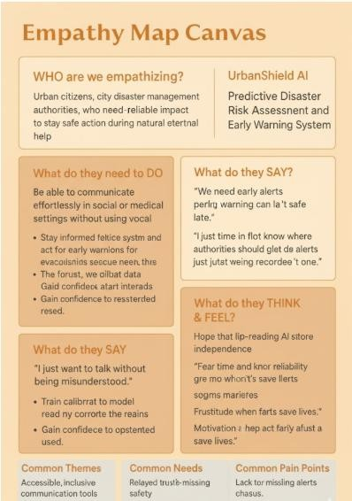

Develop POV / “How Might We” (HMW) Questions

User Need / Insight How Might We Question

Users need real-time detection of fake news across large volumes of content. | How might we enable fast and accurate fake news detection for high volumes of information in real-time?
Users fear accidentally sharing fake news due to lack of quick verification tools. | How might we simplify and speed up the process of verifying news before users share it?
Non-native speakers struggle to detect fake or misleading news in their language. | How might we assist non-native speakers in identifying and understanding misinformation effectively?
Educators want to teach students critical thinking to spot fake news. | How might we design a fake news detection tool that also promotes media literacy and critical thinking skills?

User Need / Insight How Might We Question

Journalists and researchers need to check multiple sources for credibility quickly. | How might we allow users to scan, compare, and validate multiple sources for authenticity efficiently?

Design Challenge Statement

Design Challenge:
Design a fast, accurate, and user-friendly system that detects fake news across multiple formats and languages, empowers users with real-time verification tools, promotes critical thinking, and builds trust through transparency, all while protecting user privacy.

- Validation Plan with Stakeholders

Objective:
Ensure the fake news detection system is accurate, trustworthy, easy to use, and adaptable to various content formats and languages. Metrics: ≥90% precision for detecting fake news without mislabeling real content.

Stakeholder / User | Role | Feedback on Problem Statement | Suggestions for Improvement
Students | End Users | Tool is easy to use and helps quickly check news credibility | Include explanations for why an article is flagged as fake
Teachers | End Users | Students are learning to verify information instead of blindly trusting headlines | Include teaching resources or lesson plans alongside the tool
Researchers | End Users | Detection algorithms are impressive | Deepfake and AI-generated content detection should be prioritized
Technology Developers | Developers | System architecture is optimized for real-time processing | Improve API access for integration with third-party platforms

- Ideation
Idea Number | Proposed Solution | Key Features / Benefits | Challenges / Concerns

Idea Number | Proposed Solution | Key Features / Benefits | Challenges / Concerns
Idea 1 | AI-Driven Fake News Identification | High accuracy in detecting fabricated, misleading, or manipulated news | Ensuring quality of training datasets; minimizing false positives/negatives
Idea 2 | Real-Time Source Cross-Verification | Instant comparison with credible outlets, fact-checking websites, and databases | Managing real-time data syncing; maintaining system responsiveness
Idea 3 | Personalized Credibility Scores | Assigns reliability scores based on user’s preferred sources and reading habits | Avoiding biases; ensuring transparency in scoring
Idea 4 | Multi-Platform & Browser Extension Integration | Seamless detection while browsing websites, social media apps, or messaging platforms | Compatibility across devices; ensuring user data privacy
Idea 5 | Smart Misinformation Categorization | Automatically classifies detected issues (e.g., satire, misleading headline, manipulated content) | Differentiating satire, biased reporting, and malicious fake news accurately

Solution Concept Form

- Problem Statement:
Traditional news verification methods are slow, fragmented, and often reactive, leading to the unchecked spread of misinformation and erosion of public trust in media sources.

- Target Audience:
General news consumers, students, journalists, educators, researchers, fact-checking organizations, and social media platforms concerned with preventing the spread of fake news.

- Solution Overview:
The AI-Powered Fake News Detector leverages natural language processing, machine learning, and real-time database cross-referencing to detect, explain, and prevent the spread of misinformation while educating users about critical media literacy.

12.Base Research Paper: https://wires.onlinelibrary.wiley.com/doi/pdf/10.1002/widm.7001


Wiley Interdisciplinary Reviews: Data Mining and Knowledge Discovery


PERSPECTIVE
OPEN ACCESS

Transforming Disaster Risk Reduction With AI and Big Data: Legal and Interdisciplinary Perspectives
Kwok P. Chun¹ | Thanti Octavianti¹ | Nilay Dogulu² | Hristos Tyralis³ | Georgia Papacharalampous⁴ | Ryan Rowberry⁵ | Pingyu Fan⁶ | Mark Everard¹ | Maria Francesch-Huidobro⁷ | Wellington Migliari⁸ |
David M. Hannah⁹ | John Travis Marshall⁵ | Rafael Tolosana Calasanz¹⁰ | Chad Staddon¹ | Ida Ansharyani¹¹ | Bastien Dieppois¹² | Todd R. Lewis¹ | Juli Ponce⁸ | Silvia Ibrean¹³ | Tiago Miguel Ferreira¹⁴ |
Chinkie Peliño-Golle¹⁵ | Ye Mu¹⁶ | Manuel Davila Delgado¹⁷ | Elizabeth Silvestre Espinoza¹⁸ | Martin Keulertz¹⁹ | Deepak Gopinath¹ | Cheng Li²⁰

1School of Architecture and Environment, University of the West of England, Bristol, UK | ²Hydrology, Water Resources and Cryosphere Division, World Meteorological Organization (WMO), Geneva, Switzerland | ³Construction Agency, Hellenic Air Force, Cholargos, Greece | ⁴Department of Land, Environment, Agriculture and Forestry, University of Padova, Legnaro, Italy | ⁵Georgia State University College of Law, Atlanta, Georgia,
USA | 6Department of Urban Planning and Design, The University of Hong Kong, Hong Kong, Hong Kong | 7Department of Geography, The University of Hong Kong, Hong Kong, Hong Kong | ⁸Law School, University of Barcelona, Barcelona, Catalonia, Spain | ⁹Birmingham Institute for Sustainability & Climate Action and School of Geography, Earth & Environmental Sciences, University of Birmingham, Birmingham, UK | ¹⁰Department of Computer Science and Systems Engineering, Universidad de Zaragoza, Zaragoza, Spain | ¹¹Department of Agriculture, Universitas Samawa, Sumbawa Besar, Indonesia | 12Centre for Agroecology, Water and Resilience (CAWR), Coventry University, Coventry, UK | 13UN Volunteer, United Nations Volunteers, Bonn, Germany | ¹⁴University of the West of England, School of Engineering, Bristol, UK | ¹⁵EcoWaste Coalition, Manila, Philippines | ¹⁶Department of Geography, University of California, Santa Barbara, California, USA | ¹⁷Birmingham City Business School, Birmingham City University, Birmingham, UK | ¹⁸Inclima, Oslo, Fornebu, Norway | ¹⁹American University of Beirut, Beirut, Lebanon | ²⁰Department of Ecology, Yangzhou University, Yangzhou, China
Correspondence: Kwok P. Chun (kwok.chun@uwe.ac.uk) | Thanti Octavianti (thanti.octavianti@uwe.ac.uk)
Received: 17 October 2024 | Revised: 31 January 2025 | Accepted: 20 March 2025
Associate Editor: Tianrui Li | Editor-in-Chief: Witold Pedrycz
Funding: This work was supported by K.C. and T.O. work together on the Royal Society (IEC\NSFC\223132) project on “Spatiotemporal Variation Characteristics of Compound Dry and Hot Events and Their Impacts on Vegetation Growth Across the Mid-latitudes of Eurasia”. K.C. is supported by the Vice Chancellor's Accelerator Programme Award (2022–2024) to develop AI and Big Data approaches for extracting climate and weather information from convection-permitting models for environmental management in urban and green and blue spaces. He is also an awardee, along with MD and TMF, for the Vice Chancellor's Challenge Fund (2023–2024) “VIS-Studio: An Immersive Reality and AI Solution for Data Visualization to Support Collaborative Decision-Making for Extreme Weather and Disaster Scenarios”. T.O. is a Vice Chancellor's Earlier Career Awardee for Responsible AI. This publication is part of the project PID2020-113037RB-I00, funded by Project Inter_ECODAL (PID2020-113796RB-I00/MICIU/AEI/10.13039/501100011033). This work has been supported by the Departamento de Ciencia, Universidad y Sociedad del Conocimiento del Gobierno de Aragón. NERC- FAPESP-NSTC Land Use Change Investigation and Regional Climate (LIRIC) (NE/Z504026/1) and Climate Collaboratorium: Co-creation of Applied Theatre Decision Labs for exploring Climate Adaptation and Mitigation (ES/Z000238/1).
Keywords: artificial intelligence | disaster risk reduction | interdisciplinary | law | public engagement
ABSTRACT
Managing complex disaster risks requires interdisciplinary efforts. Breaking down silos between law, social sciences, and nat- ural sciences is critical for all processes of disaster risk reduction. It is essential to explore how AI enhances understanding of legal frameworks and environmental management, while also examining how legal and environmental factors may limit AI's role in society. From a co-production review perspective, drawing on insights from lawyers, social scientists, and environmen- tal scientists, principles for responsible data mining are proposed based on safety, transparency, fairness, accountability, and

This is an open access article under the terms of the Creative Commons Attribution License, which permits use, distribution and reproduction in any medium, provided the original work is properly cited.
© 2025 The Author(s). WIREs Data Mining and Knowledge Discovery published by Wiley Periodicals LLC.


Wiley Interdisciplinary Reviews: Data Mining and Knowledge Discovery, 2025; 15:e70011 https://doi.org/10.1002/widm.70011
- of 11

contestability. This discussion offers a blueprint for interdisciplinary collaboration to create adaptive law systems based on AI integration of knowledge from environmental and social sciences. When social networks are useful for mitigating disaster risks based on AI, the legal implications related to privacy and liability of the outcomes of disaster management must be considered. Fair and accountable principles emphasize environmental considerations and foster socioeconomic discussions related to public engagement. AI also has an important role to play in education, bringing together the next generations of law, social sciences, and natural sciences to work on interdisciplinary solutions in harmony. Although emerging AI approaches can be powerful tools for disaster management, they must be implemented with ethical considerations and safeguards to address concerns about bias, transparency, and privacy. The responsible execution of AI approaches, based on the dynamic interplay between AI, law, and environmental risk, promotes sustainable and equitable practices in data mining.

| Introduction

Since the 2010s, governments across the world have devel- oped and applied various forms of Artificial Intelligence (AI) to address intersectoral priorities of legal and environmental systems. Today, the emerging frontier has morphed from imple- mentation to regulation of the rapid roll-out of AI (Smuha 2021). Emerging data-driven technologies are rapidly transforming the ways in which we live and work. Disaster risk management is no exception. With more frequent and severe environmental disasters, AI is increasingly used as a tool for the adaptive data mining management of disaster risks (e.g., Yu et al. 2018; Chen et al. 2019; Imran et al. 2020; Fan and Chun 2022; Alizadeh et al. 2022; Chauhan et al. 2024) from developing early warn- ing systems, providing real-time situational awareness during disasters, to assisting aid allocation post-disasters. However, AI also poses significant risks. For example, since AI systems rely on historical data to facilitate decision-making, incom- plete or biased data could result in biased outcomes. This is particularly important for disaster management, given that AI-assisted decisions could potentially have high-impact out- comes on people's lives and the environment in which they live (Gevaert et al. 2021). Regulators are, therefore, urged to look beyond the benefits of AI and data mining, putting in place appropriate measures to ensure its responsible and account- able use. However, AI models have applications beyond public sector control, also informing corporate decision-making (par- ticularly in the light of recent uptake of Taskforce on Nature- related Financial Disclosures (TNFD) and other voluntary pro-environmental measures) as well as surveillance by NGOs and other sectors of civil society.

In the field of disaster management, AI methods can be classified between two extremes: supervised learning and unsupervised learning (Guikema 2020). Under supervised learning, a correct or ‘desired’ answer is provided to the algorithm, providing a ref- erence point to check through large disaster datasets. An example would be in recording higher-than-normal day temperatures over a week and then linking it to a ‘correct answer’, that is, a prediction of an increase in hospital admissions prior to the summer heat- wave. In unsupervised learning methods, no correct or ‘desired’ representations are provided to the algorithm to seek to develop an in-depth understanding of the interplay between disaster man- agement variables. Beyond supervised and unsupervised methods are a class of methods that can be grouped under ‘deep learning’, where methods such as ‘recursive neural networks’, ‘reinforce- ment learning’ in resource management, etc. have been used,
which require complex sequential tasks, large amounts of train- ing data and time for disaster risk reduction (Sun et al. 2020). In general, learning methods underpinning the application of AI are more likely to generate useful information when large amounts of data are generated repeatedly in similar locations or scenarios.

Technical limitations related to data reliability, biases, trans- parency, and privacy constrain AI and big data technologies for disaster risk management. Historical and real-time data qual- ity is a significant concern, as incomplete and noisy monitoring observations and biased social media data can lead to inaccu- rate models and unreliable predictions (Byabazaire et al. 2020). Algorithmic bias, stemming from historical biases in training data or existing prejudices related to socioeconomic class, or flawed algorithms, can result in unfair or discriminatory out- comes for disaster management (Kumar et al. 2018). The “black box” nature of many AI models, particularly deep learning mod- els, poses challenges in terms of explainability and transparency (Hassija et al. 2023), which are crucial in critical applications like aid distribution. Deploying AI systems in disaster-affected areas with resource-constrained environments is also challeng- ing due to the need for substantial computational power, energy consumption, and adequate infrastructure (Cao 2023). Ethical and privacy concerns arise from the extensive use of personal data (Pina et al. 2024), raising issues around surveillance and data breaches during emergencies. Additionally, AI models may struggle to generalize to new, unseen data, limiting their adapt- ability in dynamic hazard environments (Aldoseri et al. 2023). Addressing these limitations requires a comprehensive ap- proach based on principles, including improving data quality, developing fair and transparent algorithms, ensuring ethical use for accountability and contestability, and building safe and ro- bust disaster-proof infrastructure.

Although AI has been deployed to address the global agenda for sustainable development (Vinuesa et al. 2020), the prac- tice of AI and data mining has only started receiving attention from a regulatory perspective in support of its responsible di- saster management (e.g., Siau and Wang 2020; Deltares, WB, and GFDRR 2021). Regulators at national, regional, inter- national and supranational levels have started assessing the necessity of revising existing regulations or developing novel regulatory approaches to mitigate AI risks. As an evolving and complex technology, AI poses multiple unique regulatory challenges. These include the transboundary use of AI, mak- ing it difficult to enforce regulations, and constrictive require- ments that potentially curb innovations (Coeckelbergh 2019).

19424795, 2025, 2, Downloaded from https://wires.onlinelibrary.wiley.com/doi/10.1002/widm.70011, Wiley Online Library on [07/11/2025]. See the Terms and Conditions (https://onlinelibrary.wiley.com/terms-and-conditions) on Wiley Online Library for rules of use; OA articles are governed by the applicable Creative Commons License

- of 11 Wiley Interdisciplinary Reviews: Data Mining and Knowledge Discovery, 2025

To balance the protective and enabling roles of regulation, various countries are considering following a principle-based approach (focusing on the outcomes regardless of the process or means), a rule-based approach (focusing on the process re- gardless of the outcomes), or a mix of both approaches (Frantz and Instefjord 2018). For example, the European Commission (EC) is proposing the first-ever legal framework on AI by clas- sifying systems into four levels of risk, ranging from minimal or no risk to unacceptable risk (EC 2023). China is also in this race with its emerging strategies and detailed regulations to govern AI (Trustible 2023). The United Kingdom (UK) is taking a pro-innovation approach by using five principles to guide the responsible development and ethical use of AI and data mining in all policy sectors (DSIT 2023). The US is in the process of reviewing its current approach to AI regula- tion and the development of a risk-based framework for AI (Seamans 2023). Many of these policy frameworks have been shaped by IEEE's (2019) report, ‘Ethically Aligned Design’, which brings to the fore ethical considerations while devel- oping and deploying ‘Autonomous and Intelligence Systems’, including AI tools.

All these initiatives emphasize the need for adaptive law and policy systems. However, there is a missing conversation around how disciplines with a stake in AI and disaster man- agement can (and should) shape the momentum towards this goal. Taking the lens of the adaptive intersection between
legal and environmental systems for disaster management as a case, we present our shared insights that resulted from a se- ries of co-production workshops. The idea was initiated at the Disaster Law Handbook launch conference at the Georgia State University College of Law in spring 2023 and was further de- veloped with co-authors through focus groups and tested in academic forums and classrooms.¹ We analyze AI regulatory challenges and desirability in the disaster risk reduction sector based on the five principles of ethical AI (DSIT 2023), introduced in Section 2. Section 3 will then address the wider significance of these principles in disaster management across three areas: building adaptive systems for legal and physical environments, encouraging public engagement and law, and forging interdisci- plinary training in disaster management fields.

| Principles of Responsible AI Use for Disaster Management

In this section, we describe the principles of responsible AI with a focus on disaster management in the context of environ- mental hazards (Figure 1). To establish a common ground for a joint conversation on AI regulatory challenges and desirabil- ity in disaster management, we followed the five principles of ethical AI introduced by the UK (DSIT 2023) comprising: (1) safety, security, and robustness; (2) transparency and explain- ability; (3) fairness; (4) accountability and governance; and (5)

19424795, 2025, 2, Downloaded from https://wires.onlinelibrary.wiley.com/doi/10.1002/widm.70011, Wiley Online Library on [07/11/2025]. See the Terms and Conditions (https://onlinelibrary.wiley.com/terms-and-conditions) on Wiley Online Library for rules of use; OA articles are governed by the applicable Creative Commons License

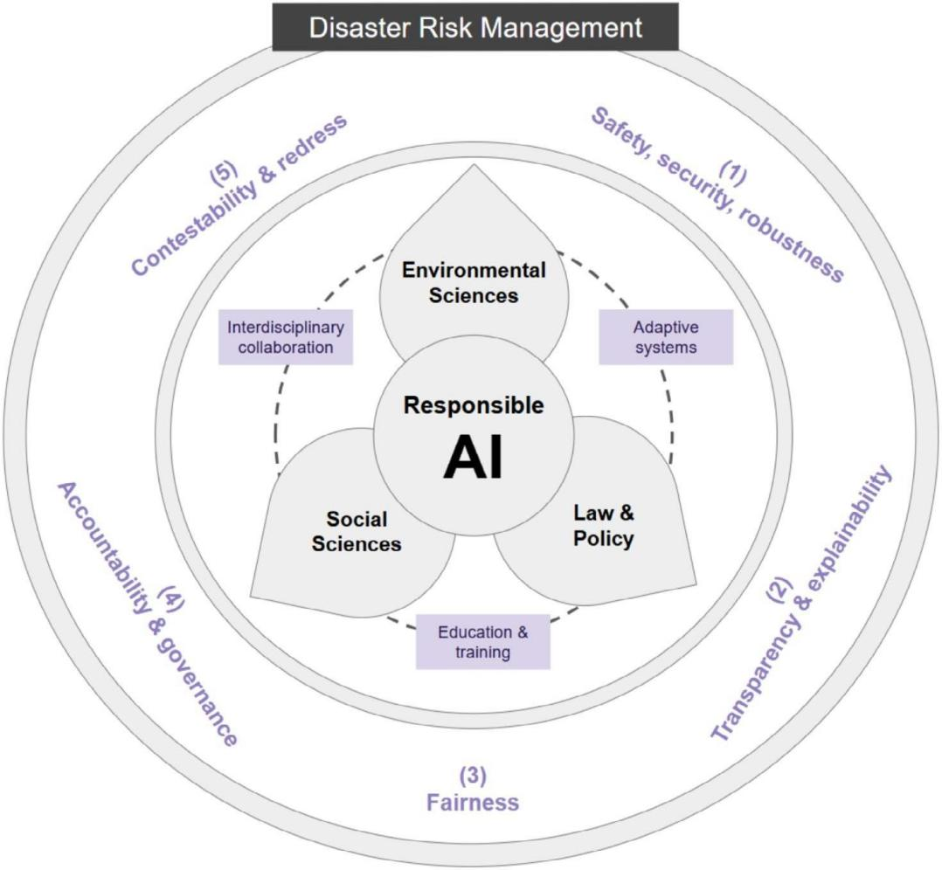
FIGURE 1 | Five principles for regulating AI use in disaster risk management. These principles should guide multi-level actors in legal, policy- making, science and innovation sectors. Significance from these principles include: (i) building adaptive data mining systems for legal and physical environments; (ii) encouraging public engagement and law; and (iii) forging interdisciplinary education and training in disaster management.

- of 11

contestability and redress. This study uses the UK's approach as it is representative of emerging global positioning.² For ex- ample, the UK's principles overlap with the EU's principles in the ethical guidelines for trustworthy AI (AIHLEG 2019).

The principles are regarded as “soft law” that should be used to augment existing rules (“hard law”) alongside industry stan- dards and other co-regulatory tools, such as certifications and codes of conduct (CIPL 2023). Despite the varied approaches countries take in governing AI, as shown by Fritz and Giardini (2024) through analysis of OECD countries, there is a recog- nized need for the development of international standards and interoperable tools, as committed to during the Hiroshima Summit (G7 Hiroshima AI Process 2023).

Limitations inherent in using principles in regulating AI are acknowledged, for example, as guidance still leaves scope for local context and judgment (Goodman et al. 2020) rather than establishing concrete measures (Coeckelbergh 2019). We justify the use of this principles-based approach as the field is not yet mature, and therefore, flexibility and context dependence are necessary.

| Principle 1. Safety, Security and Robustness

Applications of AI should operate in a secure, safe, and robust manner, with risks carefully managed. Furthermore, the fact that AI systems can autonomously develop new capabilities can increase the risks to safety and security of their use. The use of AI and Big Data also raises significant privacy con- cerns. AI can process huge amounts of data that was not orig- inally created for disaster management purposes (e.g., social media), and therefore, there is a need to ensure that the data are not misused (Ufert 2020). The EU General Data Protection Regulation defines rules on the protection of personal data, but due to rapid changes in AI technology, frequent updat- ing of the regulation may be needed (Gunes Peschke and Peschke 2022).

| Principle 2. Transparency and Explainability

AI systems are often initially developed as opaque ‘black box’ processes that are complex and difficult to understand, espe- cially when machine learning methods are involved (Glikson and Woolley 2020). This lack of transparency can make it challenging to determine how these Big Data and AI systems arrive at their decisions, confounding the ultimate responsi- bility for the derived decisions (Berber and Srećković 2023). Organizations developing and deploying AI should be able to communicate when and how it is used and explain the system's decision-making process in an appropriate level of detail that matches the risks posed by the use of AI. If AI is used to as- sist high-stakes decisions, such as controlling floodgates during a flood emergency, the systems need to be as transparent and explainable as possible to ensure their responsible data mining use (e.g., Papadakis et al. 2022). Nevertheless, transparency is strongly recommended to be supported by two other princi- ples, that is, interoperability and reusability of data. They en- hance the capacity to integrate and share information among
administrative competencies alongside civil society initiatives using the available data to produce knowledge (Soylu et al. 2022; Morales et al. 2014).

In the event of an environmental disaster, such as the one that occurred in Valencia in October 2024, interoperable data can play a crucial role in saving lives. Days before the torrential rains in southern Spain, the Spanish Meteorological Agency (AEMET) issued warnings to citizens and authorities about the high probability of heavy rainfall due to a high-altitude isolated depression (Depresión Aislada en Niveles Altos, or DANA in Spanish) (AEMET 2024). However, in this instance, AEMET's alerts were not automatically disseminated by the Valencian government because the data systems between the central and regional governments lack interoperability. This gap means that the information collected by AEMET is subject to the discretion- ary decisions of regional authorities, limiting its immediate and effective reuse. Interestingly, the Japanese government accessed AEMET's warnings and promptly informed its citizens in Spain of the risks associated with torrential rains and flooding in var- ious regions. This highlights how effective access to interop- erable data can enhance disaster preparedness, even across national borders.

The DANA event in Spain illustrates the critical need for ro- bust data interoperability and the integration of AI and big data to mitigate the impacts of natural disasters. AI-driven pre- dictive models, like those used by the Spanish Meteorological Agency (AEMET), can significantly enhance preparedness and response efforts, aligning with SDG 13 (Climate Action) by enabling more accurate forecasting and proactive measures against extreme weather events. However, the lack of data in- teroperability between central and regional governments, as seen in the Valencian case, highlights a barrier to fully lever- aging these technologies. Bridging this gap could contribute to SDG 11 (Sustainable Cities and Communities) from an interdis- ciplinary perspective by ensuring timely dissemination of criti- cal information, reducing risks to vulnerable populations, and promoting resilient urban planning. Furthermore, AI and big data have long-term potential to align with SDGs by improving disaster risk management, optimizing resource allocation, and fostering international collaboration. For instance, the Japanese government's effective use of AEMET's data demonstrates how cross-border information sharing can enhance global resilience, a key aspect of SDG 17 (Partnerships for the Goals). Although the article underscores the importance of AI and big data in advancing SDGs, the DANA example reveals the pressing need to address systemic challenges—such as data silos and frag- mented governance through different stakeholders—to unlock the full potential of these technologies in achieving sustainable development.

| Principle 3. Fairness

AI systems must comply with existing laws and not discrimi- nate against individuals or create unfair outcomes. Some de- bates have been on the fairness of outcomes from AI-assisted processes, such as impacts on insurance offers (Lamberton et al. 2017) and recruitment outcomes (Albert 2019). AI use in decision-making processes, particularly for

19424795, 2025, 2, Downloaded from https://wires.onlinelibrary.wiley.com/doi/10.1002/widm.70011, Wiley Online Library on [07/11/2025]. See the Terms and Conditions (https://onlinelibrary.wiley.com/terms-and-conditions) on Wiley Online Library for rules of use; OA articles are governed by the applicable Creative Commons License

- of 11 Wiley Interdisciplinary Reviews: Data Mining and Knowledge Discovery, 2025

high-impact outcomes, should be justifiable and not arbitrary. An AI system might unintentionally leave some communi- ties behind, for example, low-income, immigrant, elderly, and disabled residents, who find it difficult to access the in- formation before and during a disaster. This is particularly likely when the AI has been trained on a dataset that is itself biased or partial in its consideration of different stakeholder groups. For example, social media data is increasingly used to provide situational awareness and support disaster re- sponse, yet it may marginalize constituencies with low digital media usage. Existing studies show uneven representation in a disaster situation and bias in social media data (Wiegmann et al. 2021).
19424795, 2025, 2, Downloaded from https://wires.onlinelibrary.wiley.com/doi/10.1002/widm.70011, Wiley Online Library on [07/11/2025]. See the Terms and Conditions (https://onlinelibrary.wiley.com/terms-and-conditions) on Wiley Online Library for rules of use; OA articles are governed by the applicable Creative Commons License

| Principle 4. Accountability and Governance

Measures are needed to ensure appropriate oversight of how AI is being used, with clear accountability for its outcomes. Key to this principle is the clear expectation for regulatory compli- ance on appropriate actors involved in the AI life cycle, from research and development to deployment and use. It has been known that digital infrastructures frequently fail and are prone to security issues (Lehto 2022). For example, a flash flood in Rhineland-Palatinate, Germany, killed at least 117 people in 2021, and this was partly due to the failure of the federal gov- ernment's weather warning app to notify the residents (Thieken et al. 2023; Olterman 2021). Formulating a governance mecha- nism that enables the identification and mitigation of potential risks is important with a growing trend of reliance on smart systems.

| Principle 5. Contestability and Redress

The AI systems should be able to be contested by experts and stakeholders to ensure they are fair and accurate, such as in pre- dicting the likelihood of an environmental hazard. If an AI sys- tem makes a mistake (particularly false negatives), there should be clear routes to dispute harmful outcomes or decisions gener- ated by AI. Some ways to achieve this include having humans review the system's decision, retraining the system on new data, or implementing human review checkpoints in the decision train. Given the autonomy and opacity of AI systems, it would be difficult to understand and contest the outcomes they generate or assist with. Linking it to the transparency and explainability principles, the overall governance mechanism needs to ensure that AI use is contestable, for example, in redressing failures as- sociated with misprediction (as in the German flood case above) or unfairness in receiving disaster relief during and following disasters (Almada 2019; Lyons et al. 2021). Ultimately, some ca- pacity for ethical override is required so that responsible people can take control of decision-making if the trajectory of the AI is perceived as leading to adverse outcomes.

| Implications for Disaster Management

Drawing on insights from the co-production meetings of law- yers, social scientists, and environmental scientists, and princi- ples for responsible data mining, this section summarizes three
major themes on the wider significance of the five principles presented in the previous section.

| AI for Adaptive Disaster Management: Environmental Science and Law

All phases of disaster risk management must be adaptable. It is here that AI, environmental science and technology-related ap- plications, and law can combine to play a crucial role. AI and disaster management applications deal with engineering design and computational models that can be made inherently flexible. For example, an AI-generated early warning system designed by environmental scientists can issue warnings for potential disas- ter events. Similarly, measuring the scale of a disaster's impact in the recovery phase is also possible through remote sensing data that can be mined by AI. In the creation and utilization of these AI and disaster management applications, the law can provide a flexible framework on how they might be used safely, transparently, and fairly to benefit the wider community while defining liability and enforcement provisions (Francesch- Huidobro 2022; Nemakonde and Van Niekerk 2022; Villa 2022).

However, legislation governing AI or disaster management ap- plications—or the functions of the environmental applications themselves—must realize that these processes are dynamic, it- erative, and adaptive, improving their outcomes over time. For example, the design of an early warning system raises a host of issues; here we discuss three.

The first issue relates to environmental data availability and data quality for training AI. AI needs a vast amount of data to issue reliable predictions (Duan et al. 2019). However, such data are not always available in the desired quantity or quality. To mitigate this problem, one could improve the algorithms govern- ing the application while also clearly reporting the uncertainty of the predictions (Gneiting and Raftery 2007). Data gaps, par- ticularly in relation to key environmental parameters of stake- holder groups, must be clearly reported. Such disclosure reveals the transparency of the system to the public, potentially improv- ing communication and trust. This can also prompt changes to the legal framework governing AI and disaster manage- ment environmental applications (Cutter 2022; Kahneman and Tversky 1979). Despite advancements in the interpretability, in- teroperability, and reusability of AI environmental applications, there will always be some trade-offs with their flexibility (James et al. 2013).

A second issue is that the outcomes of AI in environmental di- saster management applications must also be equitable, as it is the poorest sectors of society who suffer most from environmen- tal disasters (Matsuda 2022). Assuming the quantity and quality of data are acceptable, fairness should be integrated during the AI training phase with regulations mandating and enforcing eq- uity of use among all social strata.

Finally, early warning systems using AI raise concerns about the automatic issuing of flooding predictions. AI outcomes need to be continuously controlled, but final decisions to trigger an early warning should be given by a responsible scientist or technical manager. How accountability, liability,

- of 11

redressability, and enforcement should be assigned remains open issues for law and social scientists to decide (Berber and Srećković 2023).

| Public Engagement and Law

In all phases of disaster management, social sciences, law, and public engagement play unique roles in regulating the use of AI and Big Data for environmental hazards. Social scientists and lawyers can help identify, analyze, and report to regulators the risks of using AI and Big Data for disaster management. Examples may include the violation of privacy rights in the use of Big Data from mobile apps or potential discrimination between citizens regarding training, funding, implementation, and enforcement of early flood warnings and evacuation plans (Carlarne 2022; Gable 2022; Matsuda 2022; Sherwin 2022). There is a need to ensure that AI-generated policies for promoting resilience to disasters do not conflict with prevailing local laws, geography, and historical forms of
development (Marshall 2015; Finn and Marshall 2018). Social scientists, legal regulators, and the public must also work to- gether to formulate and communicate the ethical principles (e.g., fairness, transparency, safety, accountability, and con- testability) that should guide AI use for adaptive disaster management.

Public engagement is crucial for the efficacy of environmental disaster management systems. It is consequently critical that di- saster management agencies and decision-makers liaise with the public frequently and clearly, as these people are on the front- lines of disaster, and individual citizens often also can identify timely, credible solutions to address immediate risks (Peliño- Golle and Baula 2022).

Social media provides multiple platforms through which the public can constantly interface with legal regulators (see Figure 2 for the social media landscape and emerging AI and Big data considerations in disaster management).‘Crowdsourc- ing’ has become a common way for interested public members

19424795, 2025, 2, Downloaded from https://wires.onlinelibrary.wiley.com/doi/10.1002/widm.70011, Wiley Online Library on [07/11/2025]. See the Terms and Conditions (https://onlinelibrary.wiley.com/terms-and-conditions) on Wiley Online Library for rules of use; OA articles are governed by the applicable Creative Commons License

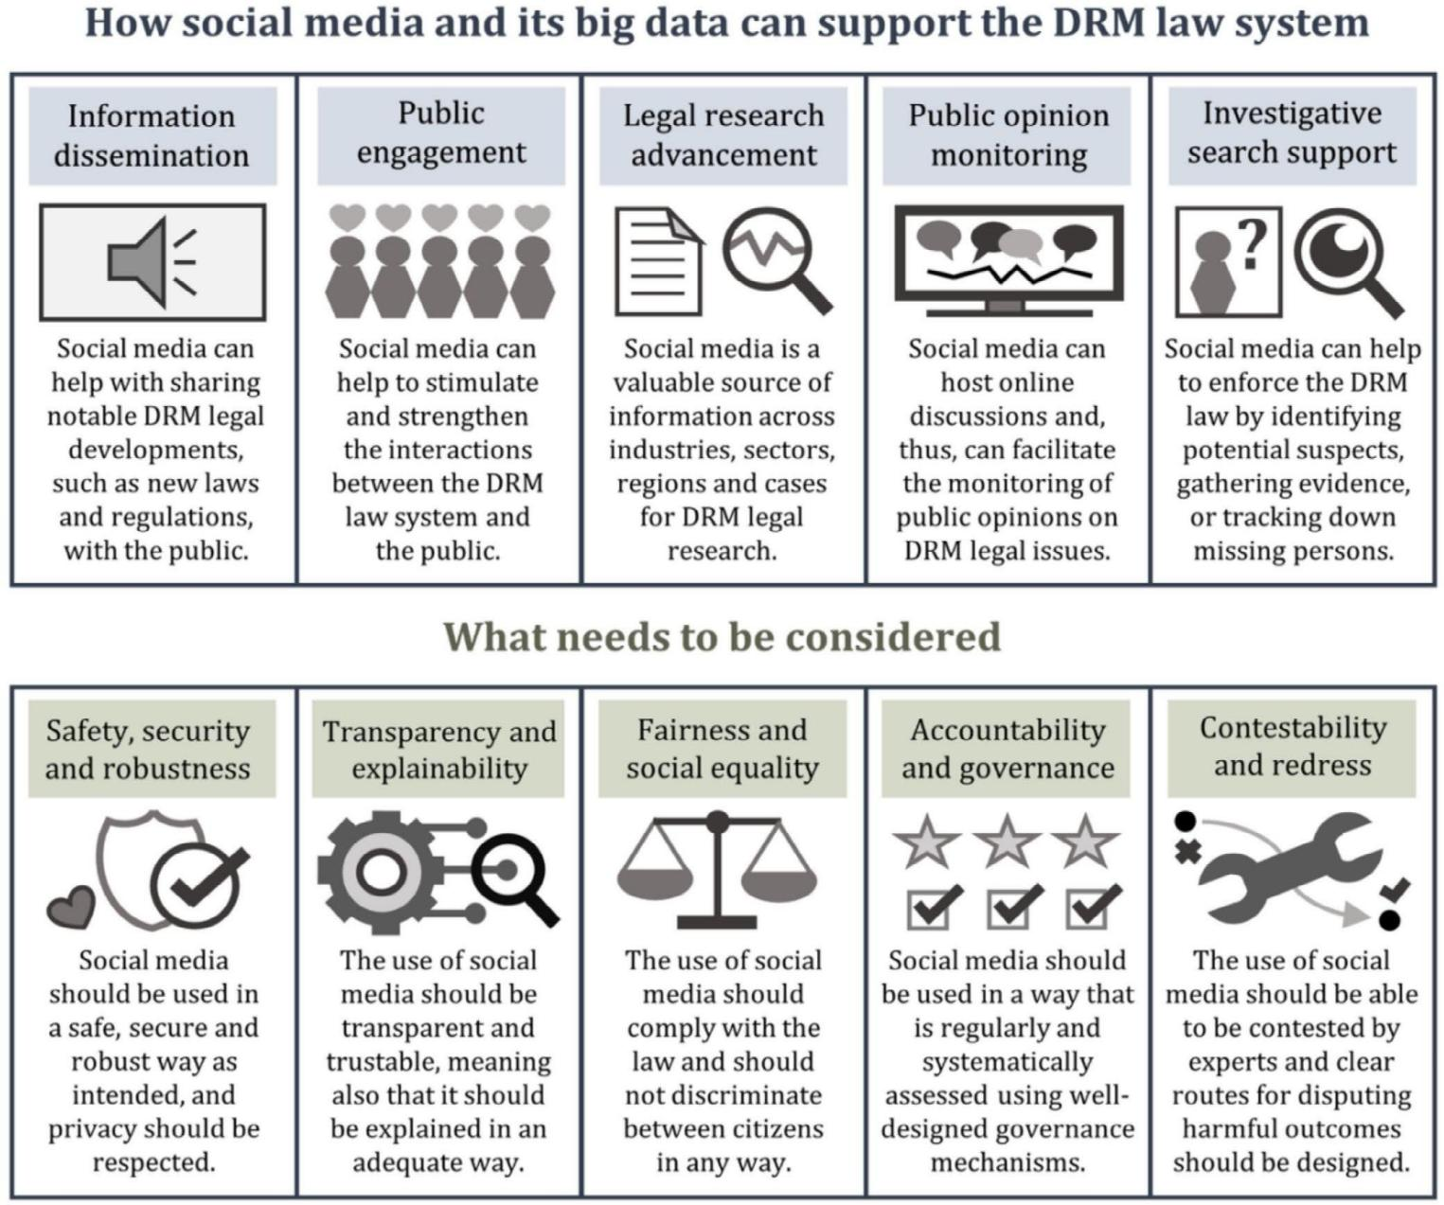
FIGURE 2 | The potential of social media and big data to enhance disaster risk management, highlighting key considerations for effective implementation.

- of 11 Wiley Interdisciplinary Reviews: Data Mining and Knowledge Discovery, 2025

to respond to the informational needs of organizations or agen- cies (Rowberry 2022). Such public-to-government exchange does, however, pose challenges. One issue is determining whether such public data is truly representative as the dataset would include only information from the digitally able (Lieske et al. 2021). Another is that such an exchange could lead to the collection of substantial volumes of data (Ghani et al. 2019), which may impact the privacy and safety concerns of the pub- lic. Nevertheless, several nations and government entities have already collected disaster data and are grappling with these legal issues. In India, the Disaster Management Act 2005 (Government of India 2005) provides a comprehensive disas- ter management legal framework that is compared with simi- lar legal frameworks (e.g., Madan and Routray 2015; Mohanan and Menon 2016; Shakeri et al. 2021). India's law states that the government may collect and share personal information in the event of a disaster, but only if there is a ‘reasonable’ justifica- tion for doing so. The much-discussed General Data Protection Regulation (GDPR), promulgated by the European Union (see discussions by Tikkinen-Piri et al. 2018; Hoofnagle et al. 2019) is another example of how laws might regulate the processing of personal data from social media platforms for use in disaster management.

As more countries begin to use AI in adaptive disaster man- agement, involving the public in honest, robust, representative and constant discourse will be crucial to engendering trust and, ultimately, to saving lives and reducing property damage (Cutter 2022).

| Interdisciplinary Education and Training

Disaster management for environmental hazards involves sub- stantial technical work of a diverse nature, such as data collec- tion and analysis, hazard modeling, and crisis management. However, disaster management cannot be successful without effective laws and policies at national, regional, or international scales (Seneviratne et al. 2010). Interdisciplinary studies are be- coming more common and urgent in resolving long-standing and emerging environmental issues, particularly issues such as disaster management that span multiple disciplines. Consequently, engendering collaboration and co-learning be- tween environmental and social scientists in conjunction with legal and policy experts is essential. One pioneering interdisci- plinary collaboration is The Cambridge Handbook of Disaster Law and Policy (Kuo et al. 2022), which provides a foundational resource for exploring various legal and policy frameworks for managing environmental disasters, including case studies from across the globe.

International and interdisciplinary cooperation and coordina- tion are essential for effectively managing future disasters. This is due to both the global nature of climate justice and also the contributory human influence on many contemporary disasters. Furthermore, disasters have no political boundaries, with poten- tial cascading impacts across regional, continental and global scales (Cutter 2018; Gill 2020), including ‘spillover’ effects from measures in one country upon others, such as unconstrained carbon emissions, forest felling, pollutant emissions, and fish stock overexploitation. Authoritative voices, such as UNESCO,
the League of European Research Universities (LERU) and the British Academy, are increasingly emphasizing the importance of interdisciplinary research and teaching to unleash the poten- tial of universities to achieve interdisciplinarity in practice.

In an educational context, increasing the use of AI can play an important role by bringing together students from different dis- ciplines to devise interdisciplinary solutions to disaster manage- ment problems. This can help to ensure that future professionals develop a broad understanding of the issues involved in disaster management and are better equipped to develop creative and innovative interdisciplinary solutions. Disaster law and policy should be included in the curricula of university degrees in en- vironmental sciences and law (Baker et al. 2022). Georgia State University provides an important example of this integrated ap- proach by offering an interdisciplinary “Urban Environmental Sustainability” program that links lawyers, environmental scientists, economists, and disaster management specialists to tackle multi-faceted climate issues facing municipalities worldwide.

| Conclusion

The interdisciplinary and collaborative framing of this study re- flects on the whys and hows of establishing a system of practice to support and accelerate adaptive disaster management through AI and data mining, emphasizing how law and policy can help regulate its responsible and ethical use. The twenty-first century has witnessed a speedy evolution of AI technologies, coincident with the increasing global intensity and frequency of environ- mental hazards. AI for disaster management has achieved a cer- tain level of technical maturity, highlighting the need for greater attention on its use in addressing issues such as bias, transpar- ency, and privacy, which pose significant ethical and legal risks for all disaster management stakeholders at different levels of competencies and responsibilities. Although foundational pre- cepts to inform the further evolution of disaster law and policy have been achieved, significantly including the five principles discussed here, there is still a question of how these principles can be translated into enforceable regulations. Governments are therefore strongly urged to develop regulatory frameworks to ensure that the benefits of AI can be harnessed whilst minimiz- ing unintended negative outcomes, necessitating interdisciplin- ary efforts to consider the needs and rights of all stakeholders impacted by environmental hazards.

The use of AI in disaster management is a complex issue in- volving multiple factors related to the different views of envi- ronmental scientists and decision-makers about the usefulness and accuracy of AI for representing natural and human systems. While collaboration among professionals from relevant disci- plines and communities who are affected, directly or indirectly, should be promoted, these diverse views are currently hindering the implementation of AI in disaster management frameworks. Bridging these conceptual differences may enable improved ad- aptation of AI technologies to reflect local contexts, laws, and needs for natural resources, considering the wider ramifications across a broad spectrum of human activities, including making progress towards the Sustainable Development Goals (SDGs) (Vinuesa et al. 2020; Costanza et al. 2023).

19424795, 2025, 2, Downloaded from https://wires.onlinelibrary.wiley.com/doi/10.1002/widm.70011, Wiley Online Library on [07/11/2025]. See the Terms and Conditions (https://onlinelibrary.wiley.com/terms-and-conditions) on Wiley Online Library for rules of use; OA articles are governed by the applicable Creative Commons License

- of 11

Ethical consideration should be part of AI development and should be undertaken appropriately, not performatively. Creating a system that allows ethical issues to be assessed pro- portionately will avoid seeing this requirement as a barrier to de- velopment but instead as a mechanism ensuring that risks have been identified and addressed as much as possible.

The use of social networks for mitigating environmental risks based on AI raises diverse privacy and liability concerns, requir- ing careful consideration before their use for this purpose. AI also has an important role to play in education, bringing together students from different disciplines to support the next genera- tion of disaster managers. They will be prepared to challenge unfair, obscure, and unsafe AI decisions and will be equipped to develop creative and innovative solutions.

The use of AI and Big Data can enhance disaster management, but ethical considerations and safeguards are crucial to address concerns around bias, transparency, accountability, and privacy. Outreach and education are also essential in building resilient communities now and training communities to be resilient in the future. We propose to integrate an adaptive legal framework based on state indicators derived from environmental Big Data networks to inform nature-based solutions for regional plan- ning and sustainable management decisions. Overall, these adaptive data mining approaches based on the intersectional priorities of legal and environmental systems can help reduce the impact of disasters and create more sustainable and resilient communities.

Author Contributions
Kwok P. Chun: conceptualization (lead), data curation (equal), formal analysis (equal), investigation (equal), methodology (equal), project ad- ministration (lead), writing – original draft (lead), writing – review and editing (equal). Thanti Octavianti: conceptualization (equal), formal analysis (equal), investigation (equal), project administration (lead), writing – original draft (equal), writing – review and editing (equal). Nilay Dogulu: conceptualization (equal), data curation (equal), for- mal analysis (equal), investigation (equal), methodology (equal), vi- sualization (lead), writing – original draft (equal), writing – review and editing (equal). Hristos Tyralis: conceptualization (equal), data curation (equal), formal analysis (equal), investigation (equal), meth- odology (equal), visualization (equal), writing – original draft (equal), writing – review and editing (equal). Georgia Papacharalampous: conceptualization (equal), data curation (equal), formal analysis (equal), investigation (equal), methodology (equal), visualization (lead), writ- ing – original draft (equal), writing – review and editing (equal). Ryan Rowberry: conceptualization (equal), data curation (equal), formal analysis (equal), investigation (equal), methodology (equal), writing – original draft (equal), writing – review and editing (equal). Pingyu Fan: data curation (equal), formal analysis (equal), investigation (equal), writing – review and editing (equal). Mark Everard: data curation (equal), formal analysis (equal), investigation (equal), writing – review and editing (equal). Maria Francesch-Huidobro: formal analysis (equal), investigation (equal), writing – review and editing (equal). Wellington Migliari: data curation (equal), formal analysis (equal), investigation (equal), writing – review and editing (equal). David M. Hannah: formal analysis (equal), investigation (equal), writing – review and editing (equal). John Travis Marshall: formal analysis (equal), investigation (equal), writing – review and editing (equal). Rafael Tolosana Calasanz: formal analysis (equal), investigation (equal), writing – review and editing (equal). Chad Staddon: formal analysis (equal), investigation (equal), writing – review and editing (equal). Ida
Ansharyani: formal analysis (equal), investigation (equal), writing – review and editing (equal). Bastien Dieppois: formal analysis (equal), investigation (equal), writing – review and editing (equal). Todd R. Lewis: formal analysis (equal), investigation (equal), writing – review and editing (equal). Juli Ponce: formal analysis (equal), investigation (equal), writing – review and editing (equal). Silvia Ibrean: formal analysis (equal), investigation (equal), writing – review and editing (equal). Tiago Miguel Ferreira: formal analysis (equal), investigation (equal), writing – review and editing (equal). Chinkie Peliño-Golle: formal analysis (equal), investigation (equal), writing – review and editing (equal). Ye Mu: formal analysis (equal), investigation (equal), writing – review and editing (equal). Manuel Davila Delgado: for- mal analysis (equal), investigation (equal), writing – review and editing (equal). Elizabeth Silvestre Espinoza: formal analysis (equal), inves- tigation (equal), writing – review and editing (equal). Martin Keulertz: formal analysis (equal), investigation (equal), writing – review and ed- iting (equal). Deepak Gopinath: formal analysis (equal), investigation (equal), writing – review and editing (equal). Cheng Li: formal analysis (equal), investigation (equal), writing – review and editing (equal).

Conflicts of Interest
The authors declare no conflicts of interest.

Data Availability Statement
Data sharing is not applicable to this article as no new data were created or analysed in this study.

Related WIREs Articles
Artificial intelligence for climate change adaptation

Endnotes
1 The co-production process underpinning this paper was initiated in law conferences, bringing together a lawyer network, leading to the publication of The Cambridge Handbook of Disaster Law and Policy in the summer of 2022, a valuable resource for understanding inter- national legal and policy frameworks for managing environmental disasters. This study used a variety of techniques to involve different communities, including filling tables (see Supporting Information), sharing documents, and conducting focus groups. The evolving work has been presented at writing retreats hosted by the Centre for Water, Communities and Resilience (CWCR) and the School of Architecture and Environment by the University of the West of England. In the spring of 2023, we presented our work to the South American Action Group communities with the National Center for Atmospheric Research (NCAR) researchers and the Global Institute of Water Security researchers from the University of Saskatchewan. We have also tested our work in our Water and Energy Future classes for the Geography and Environmental Management programmes during the 2022–2023 academic year, designed to engage the next generation of disaster managers. The co-production processes entailed in the devel- opment of this paper emphasize the need for an interdisciplinary ap- proach to disaster management.
2 We use the UK's principles here as they arguably represent general positions of other countries and organizations. However, we also ac- knowledge that some countries and organizations may put different emphasis on their initiatives. For example, the US emphasizes the use and development of responsible AI for their citizens.

References
AEMET. 2024. “Informe sobre el episodio meteorológico de precipita- ciones torrenciales y persistentes ocasionadas por una DANA el día
29 de octubre de 2024.” https://www.aemet.es/documentos/es/conoc ermas/recursos_en_linea/publicaciones_y_estudios/estudios/infor me_episodio_dana_29_oct_2024_.pdf.

19424795, 2025, 2, Downloaded from https://wires.onlinelibrary.wiley.com/doi/10.1002/widm.70011, Wiley Online Library on [07/11/2025]. See the Terms and Conditions (https://onlinelibrary.wiley.com/terms-and-conditions) on Wiley Online Library for rules of use; OA articles are governed by the applicable Creative Commons License

- of 11 Wiley Interdisciplinary Reviews: Data Mining and Knowledge Discovery, 2025

AIHLEG. 2019. “Ethics Guidelines for Trustworthy AI. European Commission, High-Level Expert Group on Artificial Intelligence.” https://www.europarl.europa.eu/cmsdata/196377/AI%20HLEG_ Ethics%20Guidelines%20for%20Trustworthy%20AI.pdf.
Albert, E. T. 2019. “AI in Talent Acquisition: A Review of AI-Applications Used in Recruitment and Selection.” Strategic HR Review 18, no. 5: 215–
221. https://doi.org/10.1108/SHR-04-2019-0024.
Aldoseri, A., K. N. Al-Khalifa, and A. M. Hamouda. 2023. “Re-Thinking Data Strategy and Integration for Artificial Intelligence: Concepts, Opportunities, and Challenges.” Applied Sciences 13, no. 12: 7082. https://doi.org/10.3390/app13127082.
Alizadeh, B., D. Li, J. Hillin, et al. 2022. “Human-Centered Flood Mapping and Intelligent Routing Through Augmenting Flood Gauge Data With Crowdsourced Street Photos.” Advanced Engineering Informatics 54: 101730. https://doi.org/10.1016/j.aei.2022.101730.
Almada, M. 2019. “Human Intervention in Automated Decision-Making: Toward the Construction of Contestable Systems.” In Proceedings of the Seventeenth International Conference on Artificial Intelligence and Law, 2–11. Association for Computing Machinery. https://doi.org/10.1145/ 3322640.3326699.
Baker, J., C. Cerniglia, D. Finger, E. Herrera, and J. Newman. 2022. “Creating Blueprints for Law School Responses to Natural Disasters.” In The Cambridge Handbook of Disaster Law and Policy: Risk, Recovery, and Redevelopment, edited by S. Kuo, J. Marshall, and R. Rowberry, 389–407. Cambridge University Press. https://doi.org/10.1017/9781108770903.025.
Berber, A., and S. Srećković. 2023. “When Something Goes Wrong: Who Is Responsible for Errors in ML Decision-Making?” AI & Society 39, no. 4: 1891–1903. https://doi.org/10.1007/s00146-023-01640-1.
Byabazaire, J., G. O'Hare, and D. Delaney. 2020. “Data Quality and Trust: Review of Challenges and Opportunities for Data Sharing in IoT.” Electronics 9, no. 12: 2083. https://doi.org/10.3390/electronics9122083.
Cao, L. 2023. “AI and Data Science for Smart Emergency, Crisis and Disaster Resilience.” International Journal of Data Science and Analytics 15, no. 3: 231–246. https://doi.org/10.1007/s41060-023-00393-w.
Carlarne, C. 2022. “From Covid-19 to Climate Change: Disaster and Inequality at the Crossroads.” In The Cambridge Handbook of Disaster Law and Policy: Risk, Recovery, and Redevelopment, edited by S. Kuo,
J. Marshall, and R. Rowberry, 511–524. Cambridge University Press. https://doi.org/10.1017/9781108770903.033.
Chauhan, P., M. E. Akiner, R. Shaw, and K. Sain. 2024. “Forecast Future Disasters Using Hydro-Meteorological Datasets in the Yamuna River Basin, Western Himalaya: Using Markov Chain and LSTM Approaches.” Artificial Intelligence in Geosciences 5: 100069.
Chen, N., W. Liu, R. Bai, and A. Chen. 2019. “Application of Computational Intelligence Technologies in Emergency Management: A Literature Review.” Artificial Intelligence Review 52: 2131–2168. https://doi.org/10.1007/s10462-017-9589-8.
CIPL. 2023. “Ten Recommendations for Global AI Regulation. Centre for Information Policy Leadership.” https://www.informationpoli cycentre.com/uploads/5/7/1/0/57104281/cipl_ten_recommendations_ global_ai_regulation_oct2023.pdf.
Coeckelbergh, M. 2019. “Artificial Intelligence: Some Ethical Issues and Regulatory Challenges.” Technology and Regulation 2019: 31–34. https://doi.org/10.26116/techreg.2019.003.
Costanza, R., B. Fath, B. Fu, et al. 2023. “EcoSummit 2023 Conference Declaration: Building a Sustainable Wellbeing Future.” Ecological Engineering 194: 107052. https://doi.org/10.1016/j.ecoleng.2023.107052.
Cutter, S. 2018. “Compound Cascading, or Complex Disasters: What's in a Name?” Environment: Science and Policy for Sustainable Development 60, no. 6: 16–25. https://doi.org/10.1080/00139157.2018.1517518.
Cutter, S. 2022. “Governance Structures for Recovery and Resilience.” In The Cambridge Handbook of Disaster Law and Policy: Risk, Recovery,
and Redevelopment, edited by S. Kuo, J. Marshall, and R. Rowberry, 59–70. Cambridge University Press. https://doi.org/10.1017/9781108770 903.004.
Deltares, WB & GFDRR. 2021. “Responsible Artificial Intelligence for Disaster Risk Management: Working Group Summary.” https://relie fweb.int/report/world/responsible-ai-disaster-risk-management-worki
ng-group-summary (the World Bank, the Global Facility for Disaster Reduction and Recovery, the Deltares, 44 pages).
DSIT. 2023. “A Pro-Innovation Approach to AI Regulation.” UK Department for Science, Innovation and Technology. https://assets. publishing.service.gov.uk/government/uploads/system/uploads/attac hment_data/file/1146542/a_pro-innovation_approach_to_AI_regul ation.pdf.
Duan, Y., J. S. Edwards, and Y. K. Dwivedi. 2019. “Artificial Intelligence for Decision Making in the Era of Big Data – Evolution, Challenges and Research Agenda.” International Journal of Information Management 48: 63–71. https://doi.org/10.1016/j.ijinfomgt.2019.01.021.
EC. 2023. Regulatory Framework Proposal on Artificial Intelligence. European Commission. https://digital-strategy.ec.europa.eu/en/polic ies/regulatory-framework-ai.
Fan, P., and K. Chun. 2022. “An Adaptive Legal Framework for Water Security Concerns in the Guangdong-Hong Kong-Macao Greater Bay Area.” In The Cambridge Handbook of Disaster Law and Policy: Risk, Recovery, and Redevelopment, edited by S. Kuo, J. Marshall, and R. Rowberry, 131–148. Cambridge University Press. https://doi.org/10. 1017/9781108770903.009.
Finn, D., and J. T. Marshall. 2018. “Superstorm Sandy at Five: Lessons on Law as Catalyst and Obstacle to Long-Term Recovery Following Catastrophic Disaster.” Environmental Law Reporter News & Analysis 48: 10494–10519.
Francesch-Huidobro, M. 2022. “Climate Resilience in the Greater Bay Area of South China.” In The Cambridge Handbook of Disaster Law and Policy: Risk, Recovery, and Redevelopment, edited by S. Kuo, J. Marshall, and R. Rowberry, 107–130. Cambridge University Press. https://doi.org/ 10.1017/9781108770903.008.
Frantz, P., and N. Instefjord. 2018. “Regulatory Competition and Rules/ Principles-Based Regulation.” Journal of Business Finance & Accounting 45, no. 7–8: 818–838. https://doi.org/10.1111/jbfa.12313.
Gable, L. 2022. “Disasters and Disability.” In The Cambridge Handbook of Disaster Law and Policy: Risk, Recovery, and Redevelopment, edited by
S. Kuo, J. Marshall, and R. Rowberry, 525–540. Cambridge University Press. https://doi.org/10.1017/9781108770903.034.
Gevaert, C. M., M. Carman, B. Rosman, Y. Georgiadou, and R. Soden. 2021. “Fairness and Accountability of AI in Disaster Risk Management: Opportunities and Challenges.” Patterns 2, no. 11: 100363. https://doi. org/10.1016/j.patter.2021.100363.
Ghani, N. A., S. Hamid, I. A. T. Hashem, and E. Ahmed. 2019. “Social Media Big Data Analytics: A Survey.” Computers in Human Behavior 101: 417–428. https://doi.org/10.1016/j.chb.2018.08.039.
Gill, B. 2020. “Global Climate Emergency: After COP24, Climate Science, Urgency, and the Threat to Humanity.” Globalizations 17, no. 6: 885–902. https://doi.org/10.1080/14747731.2019.1669915.
Glikson, E., and A. W. Woolley. 2020. “Human Trust in Artificial Intelligence: Review of Empirical Research.” Academy of Management Annals 14, no. 2: 627–660. https://doi.org/10.5465/annals.2018.0057.
Gneiting, T., and A. E. Raftery. 2007. “Strictly Proper Scoring Rules, Prediction, and Estimation.” Journal of the American Statistical Association 102, no. 477: 359–378. https://doi.org/10.1198/016214506000001437.
Goodman, K., D. Zandi, A. Reis, and E. Vayena. 2020. “Balancing Risks and Benefits of Artificial Intelligence in the Health Sector.” Bulletin of the World Health Organization 98, no. 4: 230. https://doi.org/10.2471/ BLT.20.253823.

19424795, 2025, 2, Downloaded from https://wires.onlinelibrary.wiley.com/doi/10.1002/widm.70011, Wiley Online Library on [07/11/2025]. See the Terms and Conditions (https://onlinelibrary.wiley.com/terms-and-conditions) on Wiley Online Library for rules of use; OA articles are governed by the applicable Creative Commons License

- of 11

Government of India. 2005. “Disaster Management Act, 2005.” Legislative Department. https://cdn.s3waas.gov.in/s365658fde58ab3 c2b6e5132a39fae7cb9/uploads/2018/04/2018041720.pdf.
Guikema, S. 2020. “Artificial Intelligence for Natural Hazards Risk Analysis: Potential, Challenges and Research Needs.” Risk Analysis 40, no. 6: 1117–1123. https://doi.org/10.1111/risa.13476.
Gunes Peschke, S., and L. Peschke. 2022. “Artificial Intelligence and the New Challenges for EU Legislation.” YBHD, 1267.
Hassija, V., V. Chamola, A. Mahapatra, et al. 2023. “Interpreting Black- Box Models: A Review on Explainable Artificial Intelligence.” Cognitive Computation 16, no. 1: 45–74. https://doi.org/10.1007/s12559-023-
10179-8.
G7 Hiroshima AI Process. 2023. https://www.politico.eu/wp-content/ uploads/2023/09/07/3e39b82d-464d-403a-b6cb-dc0e1bdec642-230906_ Ministerial-clean-Draft-Hiroshima-Ministers-Statement68.pdf.
Hoofnagle, C. J., B. Van Der Sloot, and F. Z. Borgesius. 2019. “The European Union General Data Protection Regulation: What It Is and What It Means.” Information & Communications Technology Law 28, no. 1: 65–98. https://doi.org/10.1080/13600834.2019.1573501.
IEEE. 2019. “Ethically Aligned Design: A Vision for Prioritizing Human Well-Being With Autonomous and Intelligent Systems (A/IS).” The IEEE Global Initiative on Ethics of Autonomous and Intelligent Systems. Accessed from https://standards.ieee.org/wp-content/uploa ds/import/documents/other/ead_v2.pdf.
Imran, M., M. Ofli, D. Caragea, and A. Torralba. 2020. “Using AI and Social Media Multimodal Content for Disaster Response and Management: Opportunities Challenges, and Future Directions.” Information Processing & Management 57: 102261. https://doi.org/10. 1016/j.ipm.2020.102261.
James, G., D. Witten, T. Hastie, and R. Tibshirani. 2013. An Introduction to Statistical Learning. Springer. https://doi.org/10.1007/ 978-1-4614-7138-7.
Kahneman, D., and A. Tversky. 1979. “Prospect Theory: An Analysis of Decision Under Risk.” Econometrica 47, no. 2: 263–292. https://doi.org/ 10.2307/1914185.
Kumar, J., P. K. Rai, and N. Pandey. 2018. “Ethical Considerations in Machine Learning: A Review of Bias, Fairness, and Accountability.” International Journal of Applied Research 4, no. 10: 134–137. https://doi. org/10.22271/allresearch.2018.v4.i10b.11455.
Kuo, S., J. Marshall, and R. Rowberry, eds. 2022. The Cambridge Handbook of Disaster Law and Policy: Risk, Recovery, and Redevelopment. Cambridge University Press. https://doi.org/10.1017/9781108770 903.001.
Lamberton, C., D. Brigo, and D. Hoy. 2017. “Impact of Robotics, RPA and AI on the Insurance Industry: Challenges and Opportunities.” Journal of Financial Perspectives 4, no. 1: 8–20.
Lehto, M. 2022. “Cyber-Attacks Against Critical Infrastructure.” In Cyber Security: Critical Infrastructure Protection, 3–42. Springer International Publishing.
Lieske, S. N., S. Z. Leao, L. Conrow, and C. Pettit. 2021. “Assessing Geographical Representativeness of Crowdsourced Urban Mobility Data: An Empirical Investigation of Australian Bicycling.” Environment and Planning B: Urban Analytics and City Science 48, no. 4: 775–792. https://doi.org/10.1177/2399808319894334.
Lyons, H., E. Velloso, and T. Miller. 2021. “Conceptualising Contestability: Perspectives on Contesting Algorithmic Decisions.” Proceedings of the ACM on Human-Computer Interaction 5, no. CSCW1: 1–25. https://doi.org/10.1145/3449180.
Madan, A., and J. K. Routray. 2015. “Institutional Framework for Preparedness and Response of Disaster Management Institutions From National to Local Level in India With Focus on Delhi.” International
Journal of Disaster Risk Reduction 14: 545–555. https://doi.org/10.1016/j. ijdrr.2015.10.004.
Marshall, J. T. 2015. “Rating the Cities: Constructing a City Resilience Index for Assessing the Effect of State and Local Laws on Long-Term Recovery From Crisis and Disaster.” Tulane Law Review 90: 35–74.
Matsuda, M. 2022. “The Flood: Political Economy and Disaster.” In The Cambridge Handbook of Disaster Law and Policy: Risk, Recovery, and Redevelopment, edited by S. Kuo, J. Marshall, and R. Rowberry, 48–56. Cambridge University Press. https://doi.org/10.1017/9781108770903.003.
Mohanan, C., and V. Menon. 2016. “Disaster Management in India—An Analysis Using COBIT 5 Principles.” In 2016 IEEE Global Humanitarian Technology Conference, 209–212. GHTC. https://doi.org/10.1109/GHTC. 2016.7857282.
Morales, L. G., Y. Hsu, J. Poole, B. Rae, and I. Rutherford. 2014. “A World That Counts: Mobilising the Data Revolution for Sustainable Development (Report No. 1).” United Nations. https://www.undatarevo lution.org/wp-content/uploads/2014/11/A-World-That-Counts.pdf.
Nemakonde, D. L., and D. Van Niekerk. 2022. “Integrating Disaster Risk Reduction and Climate Change Adaptation in the Context of Sustainable Development in Africa.” In The Cambridge Handbook of Disaster Law and Policy: Risk, Recovery, and Redevelopment, edited by
S. Kuo, J. Marshall, and R. Rowberry, 95–106. Cambridge University Press. https://doi.org/10.1017/9781108770903.007.
Olterman, P. 2021. “German Flood Alert System Criticised for ‘Monumental Failure’.” The Guardian. https://www.theguardian.com/ world/2021/jul/19/german-villages-could-be-left-with-no-drinking-
water-after-floods.
Papadakis, E., B. Adams, S. Gao, B. Martins, G. Baryannis, and A. Ristea. 2022. “Explainable Artificial Intelligence in the Spatial Domain (X-GeoAI).” Transactions in GIS 26, no. 6: 2413–2414. https://doi.org/ 10.1111/tgis.12996.
Peliño-Golle, C., and F. Baula. 2022. “Averting Disasters Through Watershed Policy Advocacy: The Case of the Philippines' Largest Highly Urbanized City.” In The Cambridge Handbook of Disaster Law and Policy: Risk, Recovery, and Redevelopment, edited by S. Kuo, J. Marshall, and R. Rowberry, 353–365. Cambridge University Press. https://doi.org/ 10.1017/9781108770903.022.
Pina, E., J. Ramos, H. Jorge, et al. 2024. “Data Privacy and Ethical Considerations in Database Management.” Journal of Cybersecurity and Privacy 4, no. 3: 494–517. https://doi.org/10.3390/jcp4030024.
Rowberry, R. 2022. “Reflections on Urban Cultural Heritage, Public Health, and Public Participation.” In The Cambridge Handbook of Disaster Law and Policy: Risk, Recovery, and Redevelopment, edited by
S. Kuo, J. Marshall, and R. Rowberry, 468–476. Cambridge University Press. https://doi.org/10.1017/9781108770903.030.
Seamans, R. 2023. “AI Regulation Is Coming to the US, Albeit Slowly.” Forbes. https://www.forbes.com/sites/washingtonbytes/2023/06/27/ai- regulation-is-coming-to-the-us-albeit-slowly/?sh=14d601367ee1.
Seneviratne, K., D. Baldry, and C. Pathirage. 2010. “Disaster Knowledge Factors in Managing Disasters Successfully.” International Journal of Strategic Property Management 14, no. 4: 376–390. https://doi.org/10. 3846/ijspm.2010.28.
Shakeri, E., B. Vizvari, and R. Nazerian. 2021. “Comparative Analysis of Disaster Management Between India and Nigeria.” International Journal of Disaster Risk Reduction 63: 102448. https://doi.org/10.1016/j. ijdrr.2021.102448.
Sherwin, B. 2022. “After the Storm: The Importance of Acknowledging Environmental Justice in Sustainable Development and Disaster Preparedness.” In The Cambridge Handbook of Disaster Law and Policy: Risk, Recovery, and Redevelopment, edited by S. Kuo, J. Marshall, and
R. Rowberry, 479–496. Cambridge University Press. https://doi.org/10. 1017/9781108770903.031.

19424795, 2025, 2, Downloaded from https://wires.onlinelibrary.wiley.com/doi/10.1002/widm.70011, Wiley Online Library on [07/11/2025]. See the Terms and Conditions (https://onlinelibrary.wiley.com/terms-and-conditions) on Wiley Online Library for rules of use; OA articles are governed by the applicable Creative Commons License

- of 11 Wiley Interdisciplinary Reviews: Data Mining and Knowledge Discovery, 2025

Siau, K., and W. Wang. 2020. “Artificial Intelligence (AI) Ethics: Ethics of AI and Ethical AI.” Journal of Database Management 31, no. 2: 74–87. https://doi.org/10.4018/JDM.2020040105.
19424795, 2025, 2, Downloaded from https://wires.onlinelibrary.wiley.com/doi/10.1002/widm.70011, Wiley Online Library on [07/11/2025]. See the Terms and Conditions (https://onlinelibrary.wiley.com/terms-and-conditions) on Wiley Online Library for rules of use; OA articles are governed by the applicable Creative Commons License
Smuha, N. A. 2021. “From a ‘Race to AI’ to a ‘Race to AI Regulation’: Regulatory Competition for Artificial Intelligence.” Law, Innovation and Technology 13, no. 1: 57–84. https://doi.org/10.2139/ssrn.3501410.
Soylu, A., Ó. Corcho, B. Elvesæter, et al. 2022. “Data Quality Barriers for Transparency in Public Procurement.” Information 13, no. 2: 1–21. https://doi.org/10.3390/info13020099.
Sun, W., P. Bocchini, and B. D. Davison. 2020. “Applications of Artificial Intelligence for Disaster Management.” Natural Hazards 103, no. 3: 2631–2689. https://doi.org/10.1007/s11069-020-04124-3.
Thieken, A. H., P. Bubeck, A. Heidenreich, J. von Keyserlingk, L. Dillenardt, and A. Otto. 2023. “Performance of the Flood Warning System in Germany in July 2021 – Insights From Affected Residents.” Natural Hazards and Earth System Sciences 23: 973–990. https://doi. org/10.5194/nhess-23-973-2023.
Tikkinen-Piri, C., A. Rohunen, and J. Markkula. 2018. “EU General Data Protection Regulation: Changes and Implications for Personal Data Collecting Companies.” Computer Law and Security Review 34, no. 1: 134–153. https://doi.org/10.1016/j.clsr.2017.05.015.
Trustible. 2023. “How Does China's Approach to AI Regulation Differ From the US and EU?” Forbes. https://www.forbes.com/sites/forbeseq/ 2023/07/18/how-does-chinas-approach-to-ai-regulation-differ-from-
the-us-and-eu/?sh=5e4e44f351c6.
Ufert, F. 2020. “AI Regulation Through the Lens of Fundamental Rights: How Well Does the GDPR Address the Challenges Posed by AI?” European Papers 2020. https://search.datacite.org/works/10. 15166/2499-8249/394.
Villa, C. 2022. “Law and Lawyers in Disaster Response.” In The Cambridge Handbook of Disaster Law and Policy: Risk, Recovery, and Redevelopment, edited by S. Kuo, J. Marshall, and R. Rowberry, 408–
420. Cambridge University Press. https://doi.org/10.1017/9781108770 903.026.
Vinuesa, R., H. Azizpour, I. Leite, et al. 2020. “The Role of Artificial Intelligence in Achieving the Sustainable Development Goals.” Nature Communications 11: 233. https://doi.org/10.1038/s41467-019-14108-y.
Wiegmann, M., J. Kersten, H. Senaratne, M. Potthast, F. Klan, and B. Stein. 2021. “Opportunities and Risks of Disaster Data From Social Media: A Systematic Review of Incident Information.” Natural Hazards and Earth System Sciences 21: 1431–1444. https://doi.org/10.5194/nhess
-21-1431-2021.
Yu, M., C. Yang, and Y. Li. 2018. “Big Data in Natural Disaster Management: A Review.” Geosciences 8, no. 5: 165. https://doi.org/10. 3390/geosciences8050165.

Supporting Information
Additional supporting information can be found online in the Supporting Information section.

- of 11

