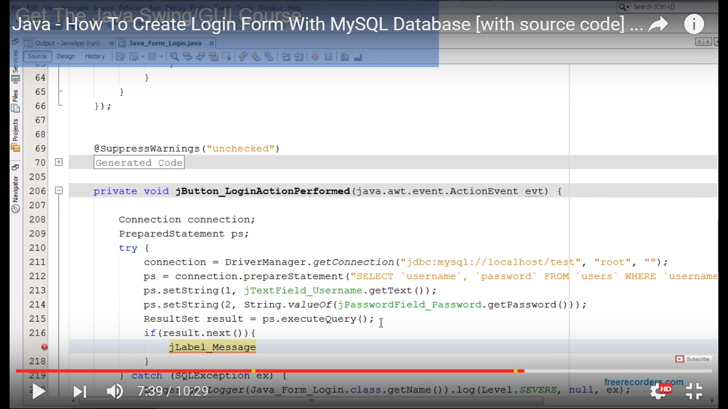

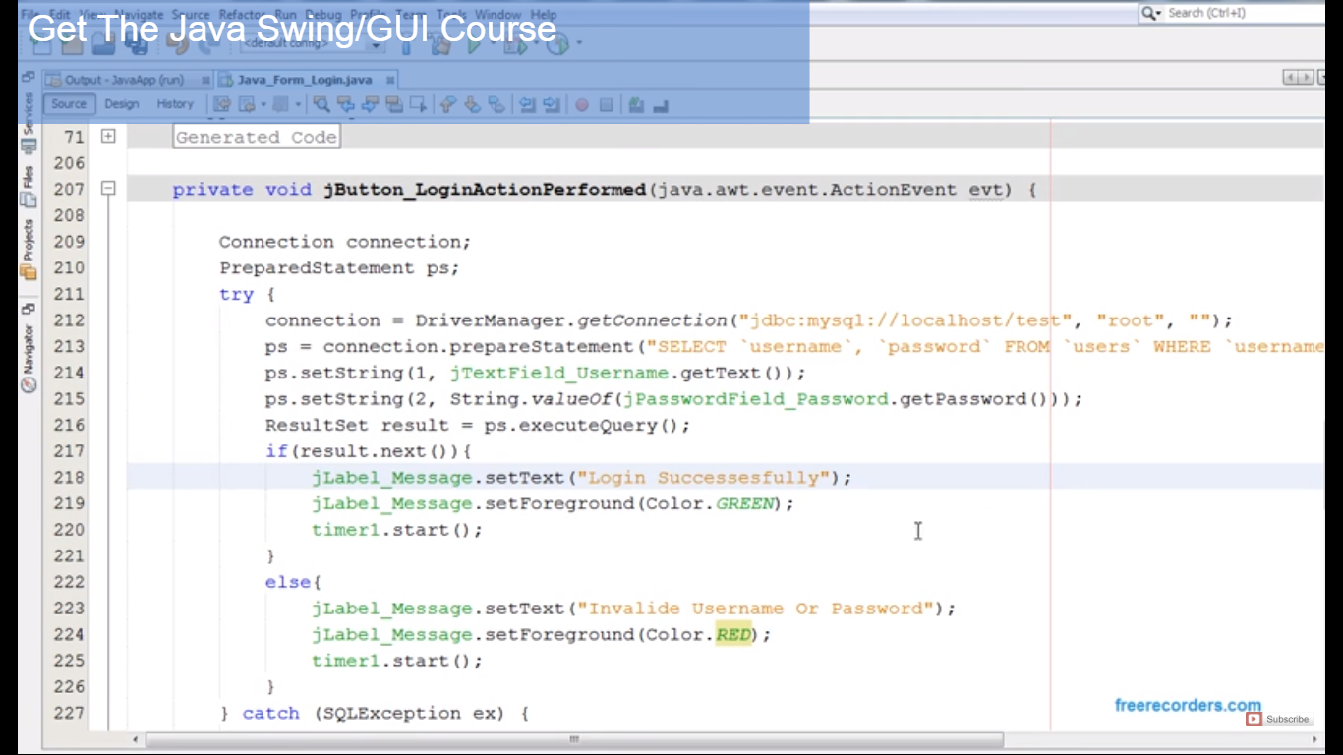

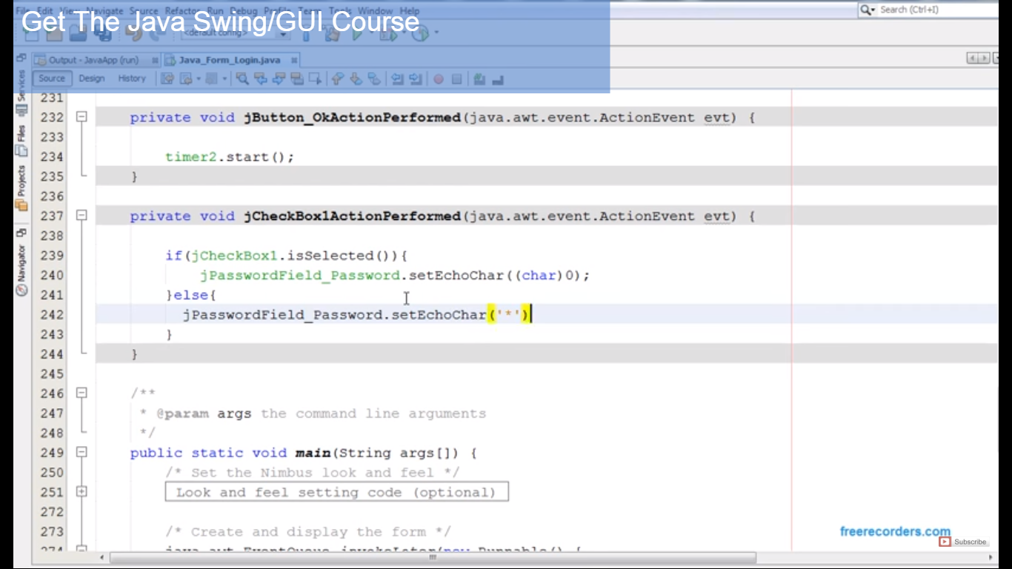

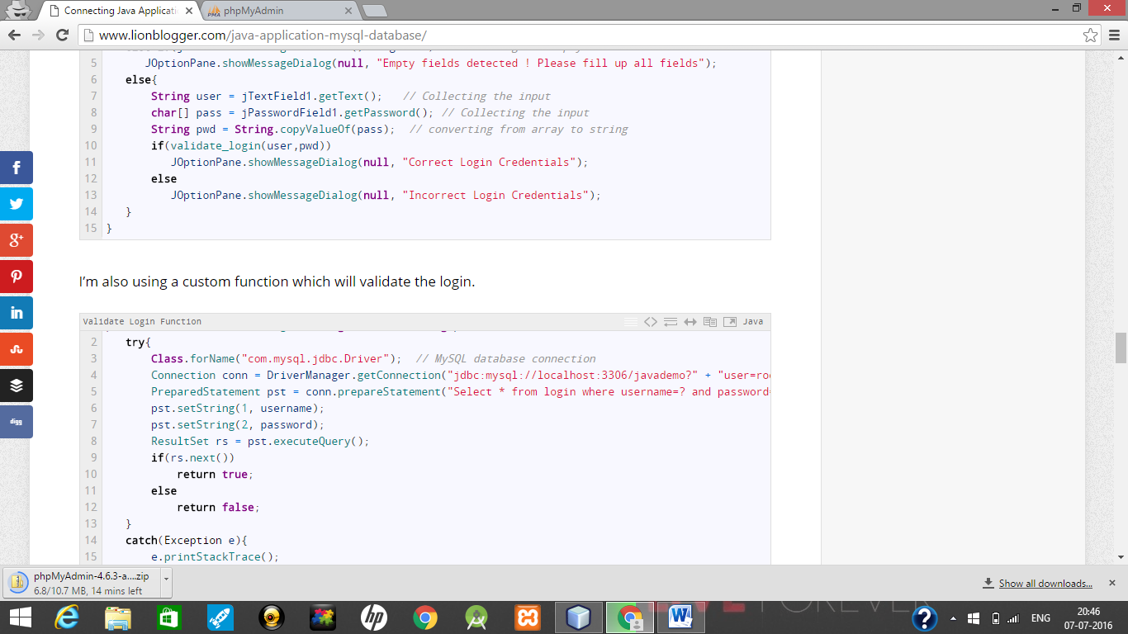

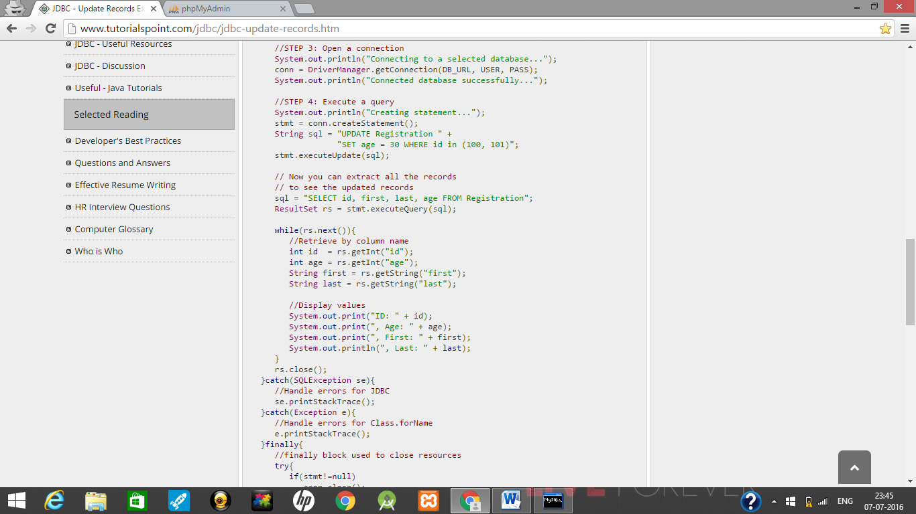

Database-tnp

Table1-student

Tabel2-company

Table3-events

Insert into applicant

Loginid varchar primarykey

Pass varchar notnull

Securityques varchar notnull

Ans varchar notnull

Sname varchar notnull

Fname varchar notnull

Mname varchar notnull

**Gender**

Dob char(10) notnull check like()

Email varchar notnull unique

Mobile int(10) notnull unique

Address varchar notnull

Branch varchar notnull

College varchar notnull

Semester int(1) notnull

10per float(5) notnull

10pass int(4) notnull

12per float(5) notnull

12pass int(4) notnull

1per float(5) notnull

1pass int(4) notnull

2per float(5) notnull

2pas int(4) notnull

3per float(5) notnull

3pass int(4) notnull

4per float(5) notnull

4pass int(4) notnull

Nation varchar notnull

Lang varchar notnull

Obectivej varchar notnull

Insert into recruiter

Loginid varchar primarykey

Pass varchar notnull

Securityques varchar notnull

Ans varchar notnull

cname varchar notnull

contactno int(11) unique notnull

address varchar notnull unique

email varchar notnull

departments varchar notnull

vacancies int_3_ notnull

specification varchar notnull

Insert into events

Cname varchar unique notnull

Date char(11) notnull

Venue varchar notnull