**MCUs (Microcontrollers)**

A **microcontroller** is a small and low-cost microcomputer, which is designed to perform the specific tasks of embedded systems like displaying microwave’s information, receiving remote signals, etc.

The general microcontroller consists of the processor, the memory (RAM, ROM, EPROM), Serial ports, peripherals (timers, counters), etc.

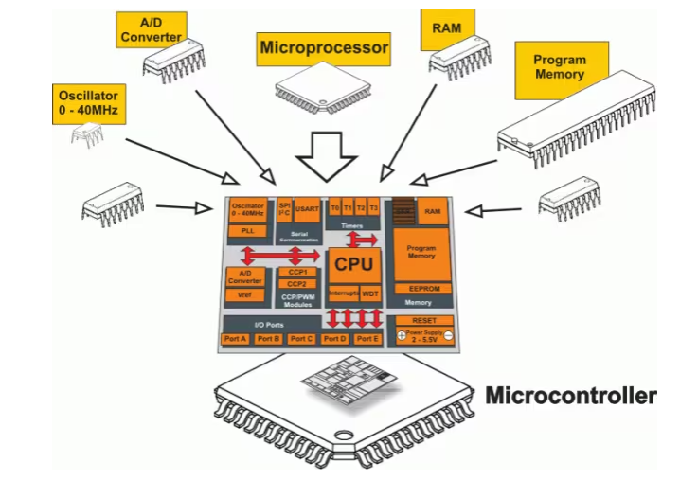

**Difference between Microprocessor and Microcontroller**

The following table highlights the differences between a microprocessor and a microcontroller −

|  |  |
| --- | --- |
| **Microcontroller** | **Microprocessor** |
| Microcontrollers are used to execute a single task within an application. | Microprocessors are used for big applications. |
| Its designing and hardware cost is low. | Its designing and hardware cost is high. |
| Easy to replace. | Not so easy to replace. |
| It is built with CMOS technology, which requires less power to operate. | Its power consumption is high because it must control the entire system. |
| It consists of CPU, RAM, ROM, I/O ports. | It does not consist of RAM, ROM, I/O ports. It uses its pins to interface to peripheral devices. |

**Types of Microcontrollers**

Microcontrollers are divided into various categories based on memory, architecture, bits, and instruction sets. Following is the list of their types −

Based on bit configuration, the microcontroller is further divided into three categories.

* **8-bit microcontroller** − This type of microcontroller is used to execute arithmetic and logical operations like addition, subtraction, multiplication division, etc. For example, Intel 8031 and 8051 are 8 bits microcontroller.
* **16-bit microcontroller** − This type of microcontroller is used to perform arithmetic and logical operations where higher accuracy and performance is required. For example, Intel 8096 is a 16-bit microcontroller.
* **32-bit microcontroller** − This type of microcontroller is generally used in automatically controlled appliances like automatic operational machines, medical appliances, etc.

**Memory**

Based on the memory configuration, the microcontroller is further divided into two categories.

* **External memory microcontroller** − This type of microcontroller is designed in such a way that they do not have a program memory on the chip. Hence, it is named as external memory microcontroller. For example: Intel 8031 microcontroller.
* **Embedded memory microcontroller** − This type of microcontroller is designed in such a way that the microcontroller has all programs and data memory, counters and timers, interrupts, I/O ports are embedded on the chip. For example: Intel 8051 microcontroller.

**Instruction Set**

Based on the instruction set configuration, the microcontroller is further divided into two categories.

* **CISC** − CISC stands for complex instruction set computer. It allows the user to insert a single instruction as an alternative to many simple instructions.
* **RISC** − RISC stands for Reduced Instruction Set Computers. It reduces the operational time by shortening the clock cycle per instruction.

**Applications of Microcontrollers**

Microcontrollers are widely used in various devices such as −

* Light sensing and controlling devices like LED.
* Temperature sensing and controlling devices like microwave oven, chimneys.
* Fire detection and safety devices like Fire alarm.
* Measuring devices like Volt Meter.

A microcontroller (MCU) is a compact integrated circuit that incorporates various components to perform a wide range of tasks in embedded systems. The key parts of an MCU include:

1. **Processor Core:**

* The processor core is the central processing unit (CPU) responsible for executing instructions and performing calculations. It can be based on different architectures, such as ARM, AVR, PIC, or others.

1. **Memory**

* **Flash memory (program memory):** Stores the firmware or program code that the MCU executes. Flash memory is non-volatile, allowing the code to persist even when power is removed.
* **RAM (data memory):** Provides temporary storage for data during program execution. RAM is volatile, and its contents are lost when power is turned off.

1. **Clock and Oscillator:**

* The clock circuit generates the timing signals required for the MCU's operation. It provides the timing reference for the processor core and other components.

1. **Peripherals:**

* **Timers and Counters**: Used for timekeeping, generating delays, or counting external events.
* **Communication Interfaces**: Include UART, SPI, I2C, CAN, and other interfaces for communication with external devices or other MCUs.
* **Analog to Digital converter (ADC):** Converts analog signals from sensors or external devices into digital values.
* **Digital to Analog converter (DAC):** Converts digital values into analog signals.
* **GPIO (General Purpose Input/Output):** Provides pins for digital input and output operations.
* **PWM (pulse width modulation):** Used for generating analog-like signals, often used for controlling motor speed or LED brightness.

1. **Control Unit:**

* The control unit manages the flow of instructions, controls the operation of peripherals, and ensures the proper execution of the program.

1. **Reset and power management:**

* **Reset circuit:** Handles system resets and ensures proper initialization during power-up.
* **Power management unit**: Manages power consumption and may include sleep modes to reduce power when the MCU is idle.

1. **Clock management:**

* **Clock source selection**: Allows the MCU to use different clock sources and adjust clock frequencies.
* **Clock dividers: divide** the clock frequency to provide various clock speeds for different components.

1. **Watchdog timer**

* A watchdog timer is a timer that resets the MCU if it does not receive a periodic "kick" or reset. It helps prevent the system from getting stuck in an undesired state.

1. **Interrupt controller:**

* Manages interrupts generated by various sources, allowing the MCU to respond to external events promptly.

1. **Debugging and programming interface:**

* **JTAG or SWD (Serial Wire Debug):** Provides a means for debugging and programming the MCU.

1. **Security features:**

* Some modern MCUs include security features, such as encryption modules, secure boot mechanisms, and memory protection, to enhance the device's security.

1. **Analog components**:

* Some MCUs include integrated analog components, such as operational amplifiers or comparators, to facilitate analog signal processing