//Git repo initialization

vlab@VEDA2F107 MINGW64 ~/Desktop

$ cd MyGit/

vlab@VEDA2F107 MINGW64 ~/Desktop/MyGit

$ git init

Initialized empty Git repository in C:/Users/vlab/Desktop/MyGit/.git/

vlab@VEDA2F107 MINGW64 ~/Desktop/MyGit (master)

$ ls

hello.txt

vlab@VEDA2F107 MINGW64 ~/Desktop/MyGit (master)

$ git status

On branch master

No commits yet

Untracked files:

(use "git add <file>..." to include in what will be committed)

hello.txt

nothing added to commit but untracked files present (use "git add" to track)

vlab@VEDA2F107 MINGW64 ~/Desktop/MyGit (master)

$ git add hello.txt

vlab@VEDA2F107 MINGW64 ~/Desktop/MyGit (master)

$ git status

On branch master

No commits yet

Changes to be committed:

(use "git rm --cached <file>..." to unstage)

new file: hello.txt

vlab@VEDA2F107 MINGW64 ~/Desktop/MyGit (master)

$ touch script.txt

vlab@VEDA2F107 MINGW64 ~/Desktop/MyGit (master)

$ touch web.html

vlab@VEDA2F107 MINGW64 ~/Desktop/MyGit (master)

$ git status

On branch master

No commits yet

Changes to be committed:

(use "git rm --cached <file>..." to unstage)

new file: hello.txt

Untracked files:

(use "git add <file>..." to include in what will be committed)

script.txt

web.html

vlab@VEDA2F107 MINGW64 ~/Desktop/MyGit (master)

$ git add .

vlab@VEDA2F107 MINGW64 ~/Desktop/MyGit (master)

$ git status

On branch master

No commits yet

Changes to be committed:

(use "git rm --cached <file>..." to unstage)

new file: hello.txt

new file: script.txt

new file: web.html

vlab@VEDA2F107 MINGW64 ~/Desktop/MyGit (master)

$ git status

On branch master

No commits yet

Changes to be committed:

(use "git rm --cached <file>..." to unstage)

new file: hello.txt

new file: script.txt

new file: web.html

Changes not staged for commit:

(use "git add/rm <file>..." to update what will be committed)

(use "git restore <file>..." to discard changes in working directory)

deleted: web.html

vlab@VEDA2F107 MINGW64 ~/Desktop/MyGit (master)

$ git add .

vlab@VEDA2F107 MINGW64 ~/Desktop/MyGit (master)

$ git status

On branch master

No commits yet

Changes to be committed:

(use "git rm --cached <file>..." to unstage)

new file: hello.txt

new file: script.txt

vlab@VEDA2F107 MINGW64 ~/Desktop/MyGit (master)

$ git rm script.txt

error: the following file has changes staged in the index:

script.txt

(use --cached to keep the file, or -f to force removal)

vlab@VEDA2F107 MINGW64 ~/Desktop/MyGit (master)

$ git rm -f script.txt

rm 'script.txt'

vlab@VEDA2F107 MINGW64 ~/Desktop/MyGit (master)

$ git status

On branch master

No commits yet

Changes to be committed:

(use "git rm --cached <file>..." to unstage)

new file: hello.txt

vlab@VEDA2F107 MINGW64 ~/Desktop/MyGit (master)

$ touch script.txt

vlab@VEDA2F107 MINGW64 ~/Desktop/MyGit (master)

$ git add .

git: 'add.' is not a git command. See 'git --help'.

The most similar command is

add

vlab@VEDA2F107 MINGW64 ~/Desktop/MyGit (master)

$ git add .

vlab@VEDA2F107 MINGW64 ~/Desktop/MyGit (master)

$ git status

On branch master

No commits yet

Changes to be committed:

(use "git rm --cached <file>..." to unstage)

new file: hello.txt

new file: script.txt

//to keep committed file back to the staging area

vlab@VEDA2F107 MINGW64 ~/Desktop/MyGit (master)

$ git rm --cached script.txt

rm 'script.txt'

vlab@VEDA2F107 MINGW64 ~/Desktop/MyGit (master)

$ git status

On branch master

No commits yet

Changes to be committed:

(use "git rm --cached <file>..." to unstage)

new file: hello.txt

Untracked files:

(use "git add <file>..." to include in what will be committed)

script.txt

//Git username gmail initialization

vlab@VEDA2F107 MINGW64 ~/Desktop/MyGit (master)

$ git config --global user.email "lochu5vilehya@gmail.com"

vlab@VEDA2F107 MINGW64 ~/Desktop/MyGit (master)

$ git config --global user.name "Lochani"

//to set cr-lf

vlab@VEDA2F107 MINGW64 ~/Desktop/GIT/cherrypick (1.0)

$ git config --global core.autocrlf true

vlab@VEDA2F107 MINGW64 ~/Desktop/MyGit (master)

$ git commit --help

vlab@VEDA2F107 MINGW64 ~/Desktop/MyGit (master)

$ git commit -m "initial commit"

[master (root-commit) c33d4dc] initial commit

3 files changed, 1 insertion(+)

create mode 100644 hello.txt

create mode 100644 script.txt

create mode 100644 web.html

vlab@VEDA2F107 MINGW64 ~/Desktop/MyGit (master)

$ git log

commit c33d4dc1e853391825b5afc6b4b9f25278100555 (HEAD -> master)

Author: Lochani <lochu5vilehya@gmail.com>

Date: Mon Mar 4 17:17:33 2024 +0530

initial commit

//detached head

vlab@VEDA2F107 MINGW64 ~/Desktop/MyGit (master)

$ git log

commit c45367190f3b5d37a4c3747f57833a5ae4514985 (HEAD -> master)

Author: Lochani <lochu5vilehya@gmail.com>

Date: Mon Mar 4 17:33:55 2024 +0530

modified text in script

commit bb8ca8e68f8ad2b2f1c6d25893438f304831fac3

Author: Lochani <lochu5vilehya@gmail.com>

Date: Mon Mar 4 17:23:33 2024 +0530

untracked files

commit 093da3c369fce507e351acb6dfe52aab7afcd7ba

Author: Lochani <lochu5vilehya@gmail.com>

Date: Mon Mar 4 17:21:17 2024 +0530

new file added

commit c33d4dc1e853391825b5afc6b4b9f25278100555

Author: Lochani <lochu5vilehya@gmail.com>

Date: Mon Mar 4 17:17:33 2024 +0530

initial commit

vlab@VEDA2F107 MINGW64 ~/Desktop/MyGit (master)

$ git checkout bb8ca8e68f8ad2b2f1c6d25893438f304831fac3

Note: switching to 'bb8ca8e68f8ad2b2f1c6d25893438f304831fac3'.

You are in 'detached HEAD' state. You can look around, make experimental

changes and commit them, and you can discard any commits you make in this

state without impacting any branches by switching back to a branch.

If you want to create a new branch to retain commits you create, you may

do so (now or later) by using -c with the switch command. Example:

git switch -c <new-branch-name>

Or undo this operation with:

git switch -

Turn off this advice by setting config variable advice.detachedHead to false

HEAD is now at bb8ca8e untracked files

vlab@VEDA2F107 MINGW64 ~/Desktop/MyGit ((bb8ca8e...))

$ git checkout master

Previous HEAD position was bb8ca8e untracked files

Switched to branch 'master'

//GIT revert

vlab@VEDA2F107 MINGW64 ~/Desktop/MyGit ((c453671...))

$ git checkout master

Previous HEAD position was c453671 modified text in script

Switched to branch 'master'

vlab@VEDA2F107 MINGW64 ~/Desktop/MyGit (master)

$ git revert 92b0f51f57fcb615182c7b38d08bd1e84f2b4491

[master fc86003] Reapply "modified text in script"

1 file changed, 1 insertion(+)

vlab@VEDA2F107 MINGW64 ~/Desktop/MyGit (master)

$ git log

commit fc860031729715825f3a3a08f7de9ce7062d2137 (HEAD -> master)

Author: Lochani <lochu5vilehya@gmail.com>

Date: Tue Mar 5 08:55:55 2024 +0530

Reapply "modified text in script"

This reverts commit 92b0f51f57fcb615182c7b38d08bd1e84f2b4491.

commit 92b0f51f57fcb615182c7b38d08bd1e84f2b4491

Author: Lochani <lochu5vilehya@gmail.com>

Date: Tue Mar 5 08:50:11 2024 +0530

Revert "modified text in script"

This reverts commit c45367190f3b5d37a4c3747f57833a5ae4514985.

commit c45367190f3b5d37a4c3747f57833a5ae4514985

Author: Lochani <lochu5vilehya@gmail.com>

Date: Mon Mar 4 17:33:55 2024 +0530

modified text in script

commit bb8ca8e68f8ad2b2f1c6d25893438f304831fac3

Author: Lochani <lochu5vilehya@gmail.com>

Date: Mon Mar 4 17:23:33 2024 +0530

untracked files

commit 093da3c369fce507e351acb6dfe52aab7afcd7ba

Author: Lochani <lochu5vilehya@gmail.com>

Date: Mon Mar 4 17:21:17 2024 +0530

new file added

commit c33d4dc1e853391825b5afc6b4b9f25278100555

Author: Lochani <lochu5vilehya@gmail.com>

Date: Mon Mar 4 17:17:33 2024 +0530

initial commit

vlab@VEDA2F107 MINGW64 ~/Desktop/MyGit (master)

$ git log --oneline

2164071 (HEAD -> master) added two more lines in bye.txt

871a6f9 text added in bye.txt

fc86003 Reapply "modified text in script"

92b0f51 Revert "modified text in script"

c453671 modified text in script

bb8ca8e untracked files

093da3c new file added

c33d4dc initial commit

//Git reset

vlab@VEDA2F107 MINGW64 ~/Desktop/MyGit (master)

$ git reset --hard fc86003

HEAD is now at fc86003 Reapply "modified text in script"

vlab@VEDA2F107 MINGW64 ~/Desktop/MyGit (master)

$ git log --oneline

fc86003 (HEAD -> master) Reapply "modified text in script"

92b0f51 Revert "modified text in script"

c453671 modified text in script

bb8ca8e untracked files

093da3c new file added

c33d4dc initial commit

//Gitignore

vlab@VEDA2F107 MINGW64 ~/Desktop/MyGit (master)

$ cat .gitignore

#auto generated file

script.txt

#pictures

Capture.png

#auto gen dirs.

f1/*

vlab@VEDA2F107 MINGW64 ~/Desktop/MyGit (master)

$ mkdir f1

vlab@VEDA2F107 MINGW64 ~/Desktop/MyGit (master)

$ cd f1

vlab@VEDA2F107 MINGW64 ~/Desktop/MyGit/f1 (master)

$ cat >> f1.txt

hello

vlab@VEDA2F107 MINGW64 ~/Desktop/MyGit/f1 (master)

$ cd ..

vlab@VEDA2F107 MINGW64 ~/Desktop/MyGit (master)

$ git status

On branch master

Changes not staged for commit:

(use "git add <file>..." to update what will be committed)

(use "git restore <file>..." to discard changes in working directory)

modified: .gitignore

modified: AutoGen/a.txt

Untracked files:

(use "git add <file>..." to include in what will be committed)

a.txt

no changes added to commit (use "git add" and/or "git commit -a")

vlab@VEDA2F107 MINGW64 ~/Desktop/MyGit (master)

$ git add .

warning: in the working copy of 'a.txt', LF will be replaced by CRLF the next time Git touches it

vlab@VEDA2F107 MINGW64 ~/Desktop/MyGit (master)

$ git commit -m "new folder f1"

[master 03a8e0a] new folder f1

3 files changed, 4 insertions(+), 1 deletion(-)

create mode 100644 a.txt

vlab@VEDA2F107 MINGW64 ~/Desktop/MyGit (master)

$ git status

On branch master

nothing to commit, working tree clean

vlab@VEDA2F107 MINGW64 ~/Desktop/MyGit (master)

$ cd f1

vlab@VEDA2F107 MINGW64 ~/Desktop/MyGit/f1 (master)

$ cat >> f1.txt

gfxgy

ljhx

wkjh

vlab@VEDA2F107 MINGW64 ~/Desktop/MyGit/f1 (master)

$ cd ..

vlab@VEDA2F107 MINGW64 ~/Desktop/MyGit (master)

$ git status

On branch master

nothing to commit, working tree clean

vlab@VEDA2F107 MINGW64 ~/Desktop/GIT/git_branching (master)

$ git checkout -b dev

Switched to a new branch 'dev'

vlab@VEDA2F107 MINGW64 ~/Desktop/GIT/git_branching (dev)

$ git checkout master

Switched to branch 'master'

vlab@VEDA2F107 MINGW64 ~/Desktop/GIT/git_branching (master)

$ git branch bugs

vlab@VEDA2F107 MINGW64 ~/Desktop/GIT/git_branching (master)

$ git branch -a

bugs

dev

* master

vlab@VEDA2F107 MINGW64 ~/Desktop/GIT/git_branching (master)

$ git checkout bugs

Switched to branch 'bugs'

vlab@VEDA2F107 MINGW64 ~/Desktop/GIT/git_branching (bugs)

$ git branch -a

* bugs

dev

master

vlab@VEDA2F107 MINGW64 ~/Desktop/GIT/git_branching (bugs)

$ git checkout master

Switched to branch 'master'

vlab@VEDA2F107 MINGW64 ~/Desktop/GIT/git_branching (master)

$ git branch -d bugs

Deleted branch bugs (was eb8a4a5).

vlab@VEDA2F107 MINGW64 ~/Desktop/GIT/git_branching (master)

$ git branch -a

dev

* master

vlab@VEDA2F107 MINGW64 ~/Desktop/GIT/git_branchi

$ git checkout dev

Switched to branch 'dev'

vlab@VEDA2F107 MINGW64 ~/Desktop/GIT/git_branching (dev)

$ git status

On branch dev

Changes not staged for commit:

(use "git add <file>..." to update what will be committed)

(use "git restore <file>..." to discard changes in working directory)

modified: lib/file2.txt

no changes added to commit (use "git add" and/or "git commit -a")

vlab@VEDA2F107 MINGW64 ~/Desktop/GIT/git_branching (dev)

$ git add .

vlab@VEDA2F107 MINGW64 ~/Desktop/GIT/git_branching (dev)

$ git commit -m "lib/file2 edited"

[dev 1a14447] lib/file2 edited

1 file changed, 1 insertion(+)

vlab@VEDA2F107 MINGW64 ~/Desktop/GIT/git_branching (dev)

$ git add .

vlab@VEDA2F107 MINGW64 ~/Desktop/GIT/git_branching (dev)

$ git status

On branch dev

Changes to be committed:

(use "git restore --staged <file>..." to unstage)

modified: src/file.txt

vlab@VEDA2F107 MINGW64 ~/Desktop/GIT/git_branching (dev)

$ git commit -m "src/file edited"

[dev 23c2812] src/file edited

1 file changed, 1 insertion(+)

vlab@VEDA2F107 MINGW64 ~/Desktop/GIT/git_branching (dev)

$ git log

commit 23c2812d56566f9401e211927f6a6a3245552ff0 (HEAD -> dev)

Author: Lochani <lochu5vilehya@gmail.com>

Date: Tue Mar 5 10:50:34 2024 +0530

src/file edited

commit 1a144478891293a254b06ca6c9bd304c3c1e6e8a

Author: Lochani <lochu5vilehya@gmail.com>

Date: Tue Mar 5 10:49:34 2024 +0530

lib/file2 edited

commit eb8a4a59f2789932b58b0969683605c9d0c8f3c1 (master)

Author: Lochani <lochu5vilehya@gmail.com>

Date: Tue Mar 5 10:43:44 2024 +0530

initial commit

vlab@VEDA2F107 MINGW64 ~/Desktop/GIT/git_branching (bugs)

$ cd login

vlab@VEDA2F107 MINGW64 ~/Desktop/GIT/git_branching/login (bugs)

$ vi hello.txt

vlab@VEDA2F107 MINGW64 ~/Desktop/GIT/git_branching/login (bugs)

$ ls

hello.txt

vlab@VEDA2F107 MINGW64 ~/Desktop/GIT/git_branching/login (bugs)

$ git add .

warning: in the working copy of 'login/hello.txt', LF will be replaced by CRLF the next time Git touches it

vlab@VEDA2F107 MINGW64 ~/Desktop/GIT/git_branching/login (bugs)

$ git commit -m "hello.txt in login"

[bugs b41f54b] hello.txt in login

1 file changed, 1 insertion(+)

create mode 100644 login/hello.txt

vlab@VEDA2F107 MINGW64 ~/Desktop/GIT/git_branching/login (bugs)

$ cd ..

vlab@VEDA2F107 MINGW64 ~/Desktop/GIT/git_branching (bugs)

$ ls

lib/ log.txt login/ src/

vlab@VEDA2F107 MINGW64 ~/Desktop/GIT/git_branching (bugs)

$ git checkout master

Switched to branch 'master'

vlab@VEDA2F107 MINGW64 ~/Desktop/GIT/git_branching (master)

$ ls

lib/ src/

vlab@VEDA2F107 MINGW64 ~/Desktop/GIT/git_branching (master)

$ git checkout bugs

Switched to branch 'bugs'

vlab@VEDA2F107 MINGW64 ~/Desktop/GIT/git_branching (bugs)

$ git branch dummy

vlab@VEDA2F107 MINGW64 ~/Desktop/GIT/git_branching (bugs)

$ git branch

* bugs

dev

dummy

master

vlab@VEDA2F107 MINGW64 ~/Desktop/GIT/git_branching (bugs)

$ cat .git/refs/heads/master

1ea96362bee48a4cb0186a96016cbc04123e5258

vlab@VEDA2F107 MINGW64 ~/Desktop/GIT/git_branching (bugs)

$ git log

commit b41f54bbb7e50f46235ac6256755e8e69e8f7c9e (HEAD -> bugs, dummy)

Author: Lochani <lochu5vilehya@gmail.com>

Date: Tue Mar 5 11:11:27 2024 +0530

hello.txt in login

commit 0f1b3a224b5ebca0b133d54631d00d0041fad379

Author: Lochani <lochu5vilehya@gmail.com>

Date: Tue Mar 5 11:04:59 2024 +0530

login folder added for logging

commit bf567b881138289c5ab34262ea73b1962765bf6e (dev)

Author: Lochani <lochu5vilehya@gmail.com>

Date: Tue Mar 5 10:54:58 2024 +0530

release version 1.0

commit 23c2812d56566f9401e211927f6a6a3245552ff0

Author: Lochani <lochu5vilehya@gmail.com>

Date: Tue Mar 5 10:50:34 2024 +0530

src/file edited

commit 1a144478891293a254b06ca6c9bd304c3c1e6e8a

Author: Lochani <lochu5vilehya@gmail.com>

Date: Tue Mar 5 10:49:34 2024 +0530

lib/file2 edited

commit eb8a4a59f2789932b58b0969683605c9d0c8f3c1

Author: Lochani <lochu5vilehya@gmail.com>

Date: Tue Mar 5 10:43:44 2024 +0530

initial commit

vlab@VEDA2F107 MINGW64 ~/Desktop/GIT/git_branching (bugs)

$ cat .git/refs/heads/bugs

b41f54bbb7e50f46235ac6256755e8e69e8f7c9e

vlab@VEDA2F107 MINGW64 ~/Desktop/GIT/git_branching (bugs)

$ cat .git/refs/heads/dummy

b41f54bbb7e50f46235ac6256755e8e69e8f7c9e

vlab@VEDA2F107 MINGW64 ~/Desktop/GIT/git_branching (bugs)

$ cat .git/HEAD

ref: refs/heads/bugs

vlab@VEDA2F107 MINGW64 ~/Desktop/GIT/git_branching (bugs)

$ git checkout dummy

Switched to branch 'dummy'

vlab@VEDA2F107 MINGW64 ~/Desktop/GIT/git_branching (dummy)

$ cat .git/HEAD

ref: refs/heads/dummy

vlab@VEDA2F107 MINGW64 ~/Desktop/GIT/git_branching (dummy)

$ git branch

bugs

dev

* dummy

master

vlab@VEDA2F107 MINGW64 ~/Desktop/GIT/git_branching (dummy)

$ git branch -m new_branch //to create branch

vlab@VEDA2F107 MINGW64 ~/Desktop/GIT/git_branching (new_branch)

$ git branch

bugs

dev

master

* new_branch

vlab@VEDA2F107 MINGW64 ~/Desktop/GIT/git_branching (master)

$ git branch

bugs

dev

* master

new_branch

vlab@VEDA2F107 MINGW64 ~/Desktop/GIT/git_branching (master)

$ git checkout new_branch

Switched to branch 'new_branch'

vlab@VEDA2F107 MINGW64 ~/Desktop/GIT/git_branching (new_branch)

$ ls

lib/ log.txt login/ src/

vlab@VEDA2F107 MINGW64 ~/Desktop/GIT/git_branching (new_branch)

$ cat >> log.txt

hello mam

how are you

vlab@VEDA2F107 MINGW64 ~/Desktop/GIT/git_branching (new_branch)

$ git status

On branch new_branch

Changes not staged for commit:

(use "git add <file>..." to update what will be committed)

(use "git restore <file>..." to discard changes in working directory)

modified: log.txt

no changes added to commit (use "git add" and/or "git commit -a")

vlab@VEDA2F107 MINGW64 ~/Desktop/GIT/git_branching (new_branch)

$ git add .

warning: in the working copy of 'log.txt', LF will be replaced by CRLF the next time Git touches it

g

vlab@VEDA2F107 MINGW64 ~/Desktop/GIT/git_branching (new_branch)

$ git commit -m "log.txt edited"

[new_branch 4481071] log.txt edited

1 file changed, 2 insertions(+)

vlab@VEDA2F107 MINGW64 ~/Desktop/GIT/git_branching (new_branch)

$ git checkout master

Switched to branch 'master'

//Git delete branch

vlab@VEDA2F107 MINGW64 ~/Desktop/GIT/git_branching (master)

$ git branch -d new_branch

error: the branch 'new_branch' is not fully merged

hint: If you are sure you want to delete it, run 'git branch -D new_branch'

hint: Disable this message with "git config advice.forceDeleteBranch false"

vlab@VEDA2F107 MINGW64 ~/Desktop/GIT/git_branching (master)

$ git branch -D new_branch

Deleted branch new_branch (was 4481071).

//Git merging

vlab@VEDA2F107 MINGW64 ~/Desktop/GIT/git_branching (master)

$ git branch

bugs

dev

* master

vlab@VEDA2F107 MINGW64 ~/Desktop/GIT/git_branching (master)

$ git checkout -b new_feature //to create branch

Switched to a new branch 'new_feature'

vlab@VEDA2F107 MINGW64 ~/Desktop/GIT/git_branching (new_feature)

$ ls

index.txt lib/ src/

vlab@VEDA2F107 MINGW64 ~/Desktop/GIT/git_branching (new_feature)

$ vi new.txt

vlab@VEDA2F107 MINGW64 ~/Desktop/GIT/git_branching (new_feature)

$ git add .

warning: in the working copy of 'new.txt', LF will be replaced by CRLF the next time Git touches it

vlab@VEDA2F107 MINGW64 ~/Desktop/GIT/git_branching (new_feature)

$ git commit -m "new file added"

[new_feature 6ba3361] new file added

1 file changed, 1 insertion(+)

create mode 100644 new.txt

vlab@VEDA2F107 MINGW64 ~/Desktop/GIT/git_branching (new_feature)

$ git checkout master

Switched to branch 'master'

vlab@VEDA2F107 MINGW64 ~/Desktop/GIT/git_branching (master)

$ git merge new_feature //to merge

Updating 1ea9636..6ba3361

Fast-forward

new.txt | 1 +

1 file changed, 1 insertion(+)

create mode 100644 new.txt

vlab@VEDA2F107 MINGW64 ~/Desktop/GIT/git_branching (master)

$ git branch dummy_branch

vlab@VEDA2F107 MINGW64 ~/Desktop/GIT/git_branching (master)

$ ls

index.txt lib/ new.txt src/

vlab@VEDA2F107 MINGW64 ~/Desktop/GIT/git_branching (master)

$ vi index.txt

vlab@VEDA2F107 MINGW64 ~/Desktop/GIT/git_branching (master)

$ git add .

vlab@VEDA2F107 MINGW64 ~/Desktop/GIT/git_branching (master)

$ git commit -m "changes done to index file"

[master 4931eba] changes done to index file

1 file changed, 1 insertion(+)

vlab@VEDA2F107 MINGW64 ~/Desktop/GIT/git_branching (master)

$ git checkout dummy_branch

Switched to branch 'dummy_branch'

vlab@VEDA2F107 MINGW64 ~/Desktop/GIT/git_branching (dummy_branch)

$ vi dummy.txt

vlab@VEDA2F107 MINGW64 ~/Desktop/GIT/git_branching (dummy_branch)

$ git add .

warning: in the working copy of 'dummy.txt', LF will be replaced by CRLF the next time Git touches it

vlab@VEDA2F107 MINGW64 ~/Desktop/GIT/git_branching (dummy_branch)

$ git commit -m "dummy file"

[dummy_branch fdc643b] dummy file

1 file changed, 1 insertion(+)

create mode 100644 dummy.txt

vlab@VEDA2F107 MINGW64 ~/Desktop/GIT/git_branching (dummy_branch)

$ git checkout master //to switch branch

Switched to branch 'master'

vlab@VEDA2F107 MINGW64 ~/Desktop/GIT/git_branching (master)

$ git merge dummy_branch

Merge made by the 'ort' strategy.

dummy.txt | 1 +

1 file changed, 1 insertion(+)

create mode 100644 dummy.txt

//Git merge conflict!!!

vlab@VEDA2F107 MINGW64 ~/Desktop/GIT/merging (master)

$ cat >> hello.txt

helloo

hiii

vlab@VEDA2F107 MINGW64 ~/Desktop/GIT/merging (master)

$ git add .

warning: in the working copy of 'hello.txt', LF will be replaced by CRLF the next time Git touches it

vlab@VEDA2F107 MINGW64 ~/Desktop/GIT/merging (master)

$ git commit -m "added text hello"

[master 35faf3d] added text hello

1 file changed, 2 insertions(+)

create mode 100644 hello.txt

vlab@VEDA2F107 MINGW64 ~/Desktop/GIT/merging (master)

$ git checkout -b hello_branch

Switched to a new branch 'hello_branch'

vlab@VEDA2F107 MINGW64 ~/Desktop/GIT/merging (hello_branch)

$ ls

hello.txt index.txt

vlab@VEDA2F107 MINGW64 ~/Desktop/GIT/merging (hello_branch)

$ vi hello.txt

vlab@VEDA2F107 MINGW64 ~/Desktop/GIT/merging (hello_branch)

$ git add .

warning: in the working copy of 'hello.txt', LF will be replaced by CRLF the next time Git touches it

vlab@VEDA2F107 MINGW64 ~/Desktop/GIT/merging (hello_branch)

$ git commit -m "hello branch first commit"

[hello_branch 5451a9b] hello branch first commit

1 file changed, 1 insertion(+)

vlab@VEDA2F107 MINGW64 ~/Desktop/GIT/merging (hello_branch)

$ git checkout master

Switched to branch 'master'

vlab@VEDA2F107 MINGW64 ~/Desktop/GIT/merging (master)

$ vi hello.txt

vlab@VEDA2F107 MINGW64 ~/Desktop/GIT/merging (master)

$ git add .

vlab@VEDA2F107 MINGW64 ~/Desktop/GIT/merging (master)

$ git commit -m "added new text"

[master 8ab7b39] added new text

1 file changed, 3 insertions(+)

vlab@VEDA2F107 MINGW64 ~/Desktop/GIT/merging (master)

$ git merge hello_branch

Auto-merging hello.txt

CONFLICT (content): Merge conflict in hello.txt

Automatic merge failed; fix conflicts and then commit the result.

vlab@VEDA2F107 MINGW64 ~/Desktop/GIT/merging (master|MERGING)

$ git merge --abort

vlab@VEDA2F107 MINGW64 ~/Desktop/GIT/merging (master)

$ git merge hello_branch

Auto-merging hello.txt

CONFLICT (content): Merge conflict in hello.txt

Automatic merge failed; fix conflicts and then commit the result.

vlab@VEDA2F107 MINGW64 ~/Desktop/GIT/merging (master|MERGING)

$ vi hello.txt

vlab@VEDA2F107 MINGW64 ~/Desktop/GIT/merging (master|MERGING)

$ git add .

vlab@VEDA2F107 MINGW64 ~/Desktop/GIT/merging (master|MERGING)

$ git commit -m "merged successfully"

[master 0d501c6] merged successfully

vlab@VEDA2F107 MINGW64 ~/Desktop/GIT/merging (master)

$ git log

commit 0d501c6c452780fb89db2516461f1e1d477d3023 (HEAD -> master)

Merge: 8ab7b39 5451a9b

Author: Lochani <lochu5vilehya@gmail.com>

Date: Tue Mar 5 14:24:02 2024 +0530

merged successfully

commit 8ab7b3934d6ed0d3132858ddb4a832a2f46e2160

Author: Lochani <lochu5vilehya@gmail.com>

Date: Tue Mar 5 14:20:53 2024 +0530

added new text

commit 5451a9ba928bbac20c12a553a4380c6f4db1251f (hello_branch)

Author: Lochani <lochu5vilehya@gmail.com>

Date: Tue Mar 5 14:19:58 2024 +0530

hello branch first commit

commit 35faf3d82a3225b4da0b96e57e2298e1783c623d

Author: Lochani <lochu5vilehya@gmail.com>

Date: Tue Mar 5 14:18:55 2024 +0530

added text hello

commit 465fc7232e3a03addfd973353c70ae49e8c5c9c6

Merge: 0e72694 be8d6d0

Author: Lochani <lochu5vilehya@gmail.com>

Date: Tue Mar 5 14:15:16 2024 +0530

Merge branch 'feature'

commit 0e72694835aaabd5eb4e3f1c4ad6b4eab176455b

Author: Lochani <lochu5vilehya@gmail.com>

Date: Tue Mar 5 14:08:19 2024 +0530

second change

commit c396d83d88a253226f4bcf48d5c37164f50b38ac

Author: Lochani <lochu5vilehya@gmail.com>

Date: Tue Mar 5 14:06:27 2024 +0530

master changes

commit be8d6d0cb5c4f1c11e22b156428d670d59ed5ad2 (feature)

Author: Lochani <lochu5vilehya@gmail.com>

Date: Tue Mar 5 14:05:36 2024 +0530

changes in feature branch

commit bfa79d8448ec9d89e330ebd537da2427d5f0c1c1

Author: Lochani <lochu5vilehya@gmail.com>

Date: Tue Mar 5 14:04:23 2024 +0530

initial commit

vlab@VEDA2F107 MINGW64 ~/Desktop/GIT/merging (master)

$ git log --oneline –graph //log graph

* 0d501c6 (HEAD -> master) merged successfully

|\

| * 5451a9b (hello_branch) hello branch first commit

* | 8ab7b39 added new text

|/

* 35faf3d added text hello

* 465fc72 Merge branch 'feature'

|\

| * be8d6d0 (feature) changes in feature branch

* | 0e72694 second change

* | c396d83 master changes

|/

//Git rebase

vlab@VEDA2F107 MINGW64 ~/Desktop/GIT

$ mkdir rebase

vlab@VEDA2F107 MINGW64 ~/Desktop/GIT

$ cd rebase

vlab@VEDA2F107 MINGW64 ~/Desktop/GIT/rebase

$ git init

Initialized empty Git repository in C:/Users/vlab/Desktop/GIT/rebase/.git/

vlab@VEDA2F107 MINGW64 ~/Desktop/GIT/rebase (master)

$ vi master.txt

vlab@VEDA2F107 MINGW64 ~/Desktop/GIT/rebase (master)

$ git add .

warning: in the working copy of 'master.txt', LF will be replaced by CRLF the next time Git touches it

vlab@VEDA2F107 MINGW64 ~/Desktop/GIT/rebase (master)

$ git commit -m "master commit"

[master (root-commit) 84eb478] master commit

1 file changed, 1 insertion(+)

create mode 100644 master.txt

vlab@VEDA2F107 MINGW64 ~/Desktop/GIT/rebase (master)

$ git branch feature

vlab@VEDA2F107 MINGW64 ~/Desktop/GIT/rebase (master)

$ git branch

feature

* master

vlab@VEDA2F107 MINGW64 ~/Desktop/GIT/rebase (master)

$ vi master1.txt

vlab@VEDA2F107 MINGW64 ~/Desktop/GIT/rebase (master)

$ git add .

warning: in the working copy of 'master1.txt', LF will be replaced by CRLF the next time Git touches it

vlab@VEDA2F107 MINGW64 ~/Desktop/GIT/rebase (master)

$ git commit -m "master1 commit"

[master b8f9ef7] master1 commit

1 file changed, 1 insertion(+)

create mode 100644 master1.txt

vlab@VEDA2F107 MINGW64 ~/Desktop/GIT/rebase (master)

$ vi master2.txt

vlab@VEDA2F107 MINGW64 ~/Desktop/GIT/rebase (master)

$ git add .

warning: in the working copy of 'master2.txt', LF will be replaced by CRLF the next time Git touches it

vlab@VEDA2F107 MINGW64 ~/Desktop/GIT/rebase (master)

$ git commit -m "master2 commit"

[master b15768d] master2 commit

1 file changed, 1 insertion(+)

create mode 100644 master2.txt

vlab@VEDA2F107 MINGW64 ~/Desktop/GIT/rebase (master)

$ git log

commit b15768d28a43e435c3508944b042a6a9e130edcf (HEAD -> master)

Author: Lochani <lochu5vilehya@gmail.com>

Date: Tue Mar 5 15:00:01 2024 +0530

master2 commit

commit b8f9ef769e3de0493b84c164cffca2c4029d4745

Author: Lochani <lochu5vilehya@gmail.com>

Date: Tue Mar 5 14:59:33 2024 +0530

master1 commit

commit 84eb4787737115c6e96e8580fd7717b88b10aead (feature)

Author: Lochani <lochu5vilehya@gmail.com>

Date: Tue Mar 5 14:58:37 2024 +0530

master commit

vlab@VEDA2F107 MINGW64 ~/Desktop/GIT/rebase (master)

$ git checkout feature

Switched to branch 'feature'

vlab@VEDA2F107 MINGW64 ~/Desktop/GIT/rebase (feature)

$ vi feature1.txt

vlab@VEDA2F107 MINGW64 ~/Desktop/GIT/rebase (feature)

$ git add .

warning: in the working copy of 'feature1.txt', LF will be replaced by CRLF the next time Git touches it

vlab@VEDA2F107 MINGW64 ~/Desktop/GIT/rebase (feature)

$ git commit -m "feature1 added"

[feature d15d371] feature1 added

1 file changed, 1 insertion(+)

create mode 100644 feature1.txt

vlab@VEDA2F107 MINGW64 ~/Desktop/GIT/rebase (feature)

$ vi feature2.txt

vlab@VEDA2F107 MINGW64 ~/Desktop/GIT/rebase (feature)

$ git add .

warning: in the working copy of 'feature2.txt', LF will be replaced by CRLF the next time Git touches it

g

vlab@VEDA2F107 MINGW64 ~/Desktop/GIT/rebase (feature)

$ git commit -m "feature2 added"

[feature ddf3e75] feature2 added

1 file changed, 1 insertion(+)

create mode 100644 feature2.txt

vlab@VEDA2F107 MINGW64 ~/Desktop/GIT/rebase (feature)

$ git clog

git: 'clog' is not a git command. See 'git --help'.

The most similar commands are

clone

log

vlab@VEDA2F107 MINGW64 ~/Desktop/GIT/rebase (feature)

$ git log

commit ddf3e752517e1f63c37f742fa5ffb6295ff23a40 (HEAD -> feature)

Author: Lochani <lochu5vilehya@gmail.com>

Date: Tue Mar 5 15:02:07 2024 +0530

feature2 added

commit d15d371a81838add35c077edc466575684e79477

Author: Lochani <lochu5vilehya@gmail.com>

Date: Tue Mar 5 15:01:34 2024 +0530

feature1 added

commit 84eb4787737115c6e96e8580fd7717b88b10aead

Author: Lochani <lochu5vilehya@gmail.com>

Date: Tue Mar 5 14:58:37 2024 +0530

master commit

vlab@VEDA2F107 MINGW64 ~/Desktop/GIT/rebase (feature)

$ git log --oneline

ddf3e75 (HEAD -> feature) feature2 added

d15d371 feature1 added

84eb478 master commit

vlab@VEDA2F107 MINGW64 ~/Desktop/GIT/rebase (feature)

$ git checkout master

Switched to branch 'master'

vlab@VEDA2F107 MINGW64 ~/Desktop/GIT/rebase (master)

$ git log --oneline

b15768d (HEAD -> master) master2 commit

b8f9ef7 master1 commit

84eb478 master commit

vlab@VEDA2F107 MINGW64 ~/Desktop/GIT/rebase (master)

$ git rebase feature

Successfully rebased and updated refs/heads/master.

vlab@VEDA2F107 MINGW64 ~/Desktop/GIT/rebase (master)

$ git log --oneline

891090b (HEAD -> master) master2 commit

2afcda7 master1 commit

ddf3e75 (feature) feature2 added

d15d371 feature1 added

84eb478 master commit

vlab@VEDA2F107 MINGW64 ~/Desktop/GIT/rebase (master)

$ git log --oneline --graph

* 891090b (HEAD -> master) master2 commit

* 2afcda7 master1 commit

* ddf3e75 (feature) feature2 added

* d15d371 feature1 added

* 84eb478 master commit

//Git interacting rebase

vlab@VEDA2F107 MINGW64 ~/Desktop/GIT/git_interacting_rebase

$ git init

Initialized empty Git repository in C:/Users/vlab/Desktop/GIT/git_interacting_rebase/.git/

vlab@VEDA2F107 MINGW64 ~/Desktop/GIT/git_interacting_rebase (master)

$ git status

On branch master

No commits yet

Untracked files:

(use "git add <file>..." to include in what will be committed)

home.txt

nothing added to commit but untracked files present (use "git add" to track)

vlab@VEDA2F107 MINGW64 ~/Desktop/GIT/git_interacting_rebase (master)

$ git add .

warning: in the working copy of 'home.txt', LF will be replaced by CRLF the next time Git touches it

vlab@VEDA2F107 MINGW64 ~/Desktop/GIT/git_interacting_rebase (master)

$ git commit -m "master first commit"

[master (root-commit) 0850c31] master first commit

1 file changed, 1 insertion(+)

create mode 100644 home.txt

vlab@VEDA2F107 MINGW64 ~/Desktop/GIT/git_interacting_rebase (master)

$ git checkout -b new

Switched to a new branch 'new'

vlab@VEDA2F107 MINGW64 ~/Desktop/GIT/git_interacting_rebase (new)

$ vi feature.txt

vlab@VEDA2F107 MINGW64 ~/Desktop/GIT/git_interacting_rebase (new)

$ git add .

warning: in the working copy of 'feature.txt', LF will be replaced by CRLF the next time Git touches it

vlab@VEDA2F107 MINGW64 ~/Desktop/GIT/git_interacting_rebase (new)

$ git commit -m "new first commit"

[new 02920c7] new first commit

1 file changed, 1 insertion(+)

create mode 100644 feature.txt

vlab@VEDA2F107 MINGW64 ~/Desktop/GIT/git_interacting_rebase (new)

$ vi feature.txt

vlab@VEDA2F107 MINGW64 ~/Desktop/GIT/git_interacting_rebase (new)

$ git add .

warning: in the working copy of 'feature.txt', LF will be replaced by CRLF the next time Git touches it

vlab@VEDA2F107 MINGW64 ~/Desktop/GIT/git_interacting_rebase (new)

$ git commit -m "new second commit"

[new f25a817] new second commit

1 file changed, 1 insertion(+)

vlab@VEDA2F107 MINGW64 ~/Desktop/GIT/git_interacting_rebase (new)

$ vi feature.txt

vlab@VEDA2F107 MINGW64 ~/Desktop/GIT/git_interacting_rebase (new)

$ git add .

warning: in the working copy of 'feature.txt', LF will be replaced by CRLF the next time Git touches it

vlab@VEDA2F107 MINGW64 ~/Desktop/GIT/git_interacting_rebase (new)

$ git commit -m "new third commit"

[new 1868f6d] new third commit

1 file changed, 1 insertion(+)

vlab@VEDA2F107 MINGW64 ~/Desktop/GIT/git_interacting_rebase (new)

$ vi feature.txt

vlab@VEDA2F107 MINGW64 ~/Desktop/GIT/git_interacting_rebase (new)

$ git add .

warning: in the working copy of 'feature.txt', LF will be replaced by CRLF the next time Git touches it

vlab@VEDA2F107 MINGW64 ~/Desktop/GIT/git_interacting_rebase (new)

$ git commit -m "new fourth commit"

[new 165eb5f] new fourth commit

1 file changed, 1 insertion(+)

vlab@VEDA2F107 MINGW64 ~/Desktop/GIT/git_interacting_rebase (new)

$ git log --oneline

165eb5f (HEAD -> new) new fourth commit

1868f6d new third commit

f25a817 new second commit

02920c7 new firxt commit

0850c31 (master) master first commit

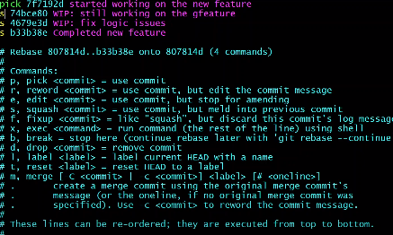

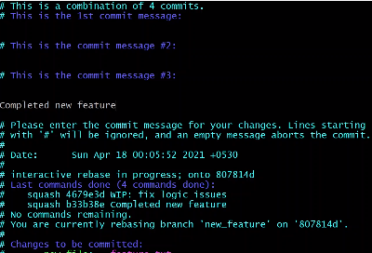

vlab@VEDA2F107 MINGW64 ~/Desktop/GIT/git_interacting_rebase (new)

$ git rebase -i master

[detached HEAD 2bbe718] implemented new feature

Date: Tue Mar 5 15:31:19 2024 +0530

1 file changed, 4 insertions(+)

create mode 100644 feature.txt

Successfully rebased and updated refs/heads/new.

vlab@VEDA2F107 MINGW64 ~/Desktop/GIT/git_interacting_rebase (new)

$ git log --oneline

2bbe718 (HEAD -> new) implemented new feature

0850c31 (master) master first commit

//Git diff and git show

vlab@VEDA2F107 MINGW64 ~/Desktop/GIT/git_interacting_rebase (new)

$ vi home.txt

vlab@VEDA2F107 MINGW64 ~/Desktop/GIT/git_interacting_rebase (new)

$ git status

On branch new

Changes not staged for commit:

(use "git add <file>..." to update what will be committed)

(use "git restore <file>..." to discard changes in working directory)

modified: home.txt

no changes added to commit (use "git add" and/or "git commit -a")

vlab@VEDA2F107 MINGW64 ~/Desktop/GIT/git_interacting_rebase (new)

$ git add .

warning: in the working copy of 'home.txt', LF will be replaced by CRLF the next time Git touches it

vlab@VEDA2F107 MINGW64 ~/Desktop/GIT/git_interacting_rebase (new)

$ git commit -m "wrong text in home.txt"

[new d11983a] wrong text in home.txt

1 file changed, 1 insertion(+)

vlab@VEDA2F107 MINGW64 ~/Desktop/GIT/git_interacting_rebase (new)

$ git log --oneline

d11983a (HEAD -> new) wrong text in home.txt

2bbe718 implemented new feature

0850c31 (master) master first commit

vlab@VEDA2F107 MINGW64 ~/Desktop/GIT/git_interacting_rebase (new)

$ git add .

vlab@VEDA2F107 MINGW64 ~/Desktop/GIT/git_interacting_rebase (new)

$ vi home.txt

vlab@VEDA2F107 MINGW64 ~/Desktop/GIT/git_interacting_rebase (new)

$ git add .

warning: in the working copy of 'home.txt', LF will be replaced by CRLF the next time Git touches it

vlab@VEDA2F107 MINGW64 ~/Desktop/GIT/git_interacting_rebase (new)

$ git status

On branch new

Changes to be committed:

(use "git restore --staged <file>..." to unstage)

modified: home.txt

vlab@VEDA2F107 MINGW64 ~/Desktop/GIT/git_interacting_rebase (new)

$ git show d11983a

commit d11983a95dfbff478ad4e8594e1e67fd6d7f7e6a (HEAD -> new)

Author: Lochani <lochu5vilehya@gmail.com>

Date: Tue Mar 5 15:48:03 2024 +0530

wrong text in home.txt

**diff --git a/home.txt b/home.txt**

**index 8a07d72..15cd727 100644**

**--- a/home.txt**

**+++ b/home.txt**

@@ -1 +1,2 @@

hello home

+welcm

vlab@VEDA2F107 MINGW64 ~/Desktop/GIT/git_interacting_rebase (new)

$ git diff --cached

**diff --git a/home.txt b/home.txt**

**index 15cd727..5d8392a 100644**

**--- a/home.txt**

**+++ b/home.txt**

@@ -1,2 +1,2 @@

hello home

-welcm

+welcome

vlab@VEDA2F107 MINGW64 ~/Desktop/GIT/git_interacting_rebase (new)

$ git status

On branch new

nothing to commit, working tree clean

vlab@VEDA2F107 MINGW64 ~/Desktop/GIT/git_interacting_rebase (new)

$ git log

commit 38a4d29435c82020c83aa9b35752a1e737980414 (HEAD -> new)

Author: Lochani <lochu5vilehya@gmail.com>

Date: Tue Mar 5 15:48:03 2024 +0530

wrong text in home.txt

commit 2bbe718e6a22833b30c985b0a736e33dd41f7426

Author: Lochani <lochu5vilehya@gmail.com>

Date: Tue Mar 5 15:31:19 2024 +0530

implemented new feature

commit 0850c31c82c8229a5a50ccda89760b78407636af (master)

Author: Lochani <lochu5vilehya@gmail.com>

Date: Tue Mar 5 15:30:22 2024 +0530

master first commit

vlab@VEDA2F107 MINGW64 ~/Desktop/GIT/git_interacting_rebase (new)

$ git log --oneline

38a4d29 (HEAD -> new) wrong text in home.txt

2bbe718 implemented new feature

0850c31 (master) master first commit

vlab@VEDA2F107 MINGW64 ~/Desktop/GIT/git_interacting_rebase (new)

$ git show 38a4d29

commit 38a4d29435c82020c83aa9b35752a1e737980414 (HEAD -> new)

Author: Lochani <lochu5vilehya@gmail.com>

Date: Tue Mar 5 15:48:03 2024 +0530

wrong text in home.txt

**diff --git a/home.txt b/home.txt**

**index 8a07d72..5d8392a 100644**

**--- a/home.txt**

**+++ b/home.txt**

@@ -1 +1,2 @@

hello home

+welcome

//Git cherry-pick

vlab@VEDA2F107 MINGW64 ~/Desktop/GIT/cherrypick (master)

$ vi index.txt

vlab@VEDA2F107 MINGW64 ~/Desktop/GIT/cherrypick (master)

$ git add .

warning: in the working copy of 'index.txt', LF will be replaced by CRLF the next time Git touches it

vlab@VEDA2F107 MINGW64 ~/Desktop/GIT/cherrypick (master)

$ git commit -m "initial commit"

[master (root-commit) b7441c3] initial commit

1 file changed, 1 insertion(+)

create mode 100644 index.txt

vlab@VEDA2F107 MINGW64 ~/Desktop/GIT/cherrypick (master)

$ git branch 1.0

vlab@VEDA2F107 MINGW64 ~/Desktop/GIT/cherrypick (master)

$ git branch 2.0

vlab@VEDA2F107 MINGW64 ~/Desktop/GIT/cherrypick (master)

$ git branch 3.0

vlab@VEDA2F107 MINGW64 ~/Desktop/GIT/cherrypick (master)

$ git branch

1.0

2.0

3.0

* master

vlab@VEDA2F107 MINGW64 ~/Desktop/GIT/cherrypick (master)

$ git checkout 3.0

Switched to branch '3.0'

vlab@VEDA2F107 MINGW64 ~/Desktop/GIT/cherrypick (3.0)

$ vi feature.txt

vlab@VEDA2F107 MINGW64 ~/Desktop/GIT/cherrypick (3.0)

$ git add .

warning: in the working copy of 'feature.txt', LF will be replaced by CRLF the next time Git touches it

g

vlab@VEDA2F107 MINGW64 ~/Desktop/GIT/cherrypick (3.0)

$ git commit -m "feature 3.0"

[3.0 0d653df] feature 3.0

1 file changed, 1 insertion(+)

create mode 100644 feature.txt

vlab@VEDA2F107 MINGW64 ~/Desktop/GIT/cherrypick (3.0)

$ git log --oneline

0d653df (HEAD -> 3.0) feature 3.0

b7441c3 (master, 2.0, 1.0) initial commit

vlab@VEDA2F107 MINGW64 ~/Desktop/GIT/cherrypick (3.0)

$ vi bug.txt

vlab@VEDA2F107 MINGW64 ~/Desktop/GIT/cherrypick (3.0)

$ git add .

warning: in the working copy of 'bug.txt', LF will be replaced by CRLF the next time Git touches it

vlab@VEDA2F107 MINGW64 ~/Desktop/GIT/cherrypick (3.0)

$ git commit -m "fixed bug 3.0"

[3.0 b45906f] fixed bug 3.0

1 file changed, 1 insertion(+)

create mode 100644 bug.txt

vlab@VEDA2F107 MINGW64 ~/Desktop/GIT/cherrypick (3.0)

$ git log --oneline

b45906f (HEAD -> 3.0) fixed bug 3.0

0d653df feature 3.0

b7441c3 (master, 2.0, 1.0) initial commit

vlab@VEDA2F107 MINGW64 ~/Desktop/GIT/cherrypick (3.0)

$ git checkout 2.0

Switched to branch '2.0'

vlab@VEDA2F107 MINGW64 ~/Desktop/GIT/cherrypick (2.0)

$ git log --oneline

b7441c3 (HEAD -> 2.0, master, 1.0) initial commit

vlab@VEDA2F107 MINGW64 ~/Desktop/GIT/cherrypick (2.0)

$ ls

index.txt

vlab@VEDA2F107 MINGW64 ~/Desktop/GIT/cherrypick (2.0)

$ git cherry pick b45906f

fatal: unknown commit pick

vlab@VEDA2F107 MINGW64 ~/Desktop/GIT/cherrypick (2.0)

$ git cherry pick b45906f

fatal: unknown commit pick

vlab@VEDA2F107 MINGW64 ~/Desktop/GIT/cherrypick (2.0)

$ git cherry-pick b45906f

[2.0 aed562f] fixed bug 3.0

Date: Tue Mar 5 16:25:01 2024 +0530

1 file changed, 1 insertion(+)

create mode 100644 bug.txt

vlab@VEDA2F107 MINGW64 ~/Desktop/GIT/cherrypick (2.0)

$ git log

commit aed562f12c27ec9a846d6caab9a83dc430e95b12 (HEAD -> 2.0)

Author: Lochani <lochu5vilehya@gmail.com>

Date: Tue Mar 5 16:25:01 2024 +0530

fixed bug 3.0

commit b7441c3e88be640e7c3d9ae6b40d8f90d306cf4a (master, 1.0)

Author: Lochani <lochu5vilehya@gmail.com>

Date: Tue Mar 5 16:22:54 2024 +0530

initial commit

vlab@VEDA2F107 MINGW64 ~/Desktop/GIT/cherrypick (2.0)

$ ls

bug.txt index.txt

vlab@VEDA2F107 MINGW64 ~/Desktop/GIT/cherrypick (2.0)

$ git checkout 1.0

Switched to branch '1.0'

vlab@VEDA2F107 MINGW64 ~/Desktop/GIT/cherrypick (1.0)

$ ls

index.txt

vlab@VEDA2F107 MINGW64 ~/Desktop/GIT/cherrypick (1.0)

$ git cherry-pick b45906f

[1.0 ff55624] fixed bug 3.0

Date: Tue Mar 5 16:25:01 2024 +0530

1 file changed, 1 insertion(+)

create mode 100644 bug.txt

vlab@VEDA2F107 MINGW64 ~/Desktop/GIT/cherrypick (1.0)

$ ls

bug.txt index.txt

vlab@VEDA2F107 MINGW64 ~/Desktop/GIT/cherrypick (1.0)

$ git log --oneline

ff55624 (HEAD -> 1.0) fixed bug 3.0

b7441c3 (master) initial commit

//Git diff and git diff head

vlab@VEDA2F107 MINGW64 ~/Desktop/GIT/cherrypick (1.0)

$ git diff head

**diff --git a/bug.txt b/bug.txt**

**index e7aa317..6bb4631 100644**

**--- a/bug.txt**

**+++ b/bug.txt**

@@ -1 +1,3 @@

fixed the bug //commited

+hgghghghhj //staged

+helloooo //working dir

vlab@VEDA2F107 MINGW64 ~/Desktop/GIT/cherrypick (1.0)

$ git diff

**diff --git a/bug.txt b/bug.txt**

**index 3f39ebc..6bb4631 100644**

**--- a/bug.txt**

**+++ b/bug.txt**

@@ -1,2 +1,3 @@

fixed the bug

hgghghghhj

+helloooo

//Git Reset

vlab@VEDA2F107 MINGW64 ~/Desktop/GIT/cherrypick (1.0)

$ vi index.txt

vlab@VEDA2F107 MINGW64 ~/Desktop/GIT/cherrypick (1.0)

$ git add .

warning: in the working copy of 'index.txt', LF will be replaced by CRLF the next time Git touches it

vlab@VEDA2F107 MINGW64 ~/Desktop/GIT/cherrypick (1.0)

$ git config --global core.autocrlf true

vlab@VEDA2F107 MINGW64 ~/Desktop/GIT/cherrypick (1.0)

$ git add .

vlab@VEDA2F107 MINGW64 ~/Desktop/GIT/cherrypick (1.0)

$ git status

On branch 1.0

Changes to be committed:

(use "git restore --staged <file>..." to unstage)

modified: index.txt

vlab@VEDA2F107 MINGW64 ~/Desktop/GIT/cherrypick (1.0)

$ git log --oneline

6897f47 (HEAD -> 1.0) new bug commit

ff55624 fixed bug 3.0

b7441c3 (master) initial commit

vlab@VEDA2F107 MINGW64 ~/Desktop/GIT/cherrypick (1.0)

$ git reset head --mixed

Unstaged changes after reset:

M index.txt

vlab@VEDA2F107 MINGW64 ~/Desktop/GIT/cherrypick (1.0)

$ git status

On branch 1.0

Changes not staged for commit:

(use "git add <file>..." to update what will be committed)

(use "git restore <file>..." to discard changes in working directory)

modified: index.txt

no changes added to commit (use "git add" and/or "git commit -a")

vlab@VEDA2F107 MINGW64 ~/Desktop/GIT/cherrypick (1.0)

$ vi index.txt

vlab@VEDA2F107 MINGW64 ~/Desktop/GIT/cherrypick (1.0)

$ git status

On branch 1.0

Changes not staged for commit:

(use "git add <file>..." to update what will be committed)

(use "git restore <file>..." to discard changes in working directory)

modified: index.txt

no changes added to commit (use "git add" and/or "git commit -a")

vlab@VEDA2F107 MINGW64 ~/Desktop/GIT/cherrypick (1.0)

$ git add .

warning: in the working copy of 'index.txt', LF will be replaced by CRLF the next time Git touches it

vlab@VEDA2F107 MINGW64 ~/Desktop/GIT/cherrypick (1.0)

$ git status

On branch 1.0

Changes to be committed:

(use "git restore --staged <file>..." to unstage)

modified: index.txt

vlab@VEDA2F107 MINGW64 ~/Desktop/GIT/cherrypick (1.0)

$ vi index.txt

vlab@VEDA2F107 MINGW64 ~/Desktop/GIT/cherrypick (1.0)

$ git status

On branch 1.0

Changes to be committed:

(use "git restore --staged <file>..." to unstage)

modified: index.txt

Changes not staged for commit:

(use "git add <file>..." to update what will be committed)

(use "git restore <file>..." to discard changes in working directory)

modified: index.txt

vlab@VEDA2F107 MINGW64 ~/Desktop/GIT/cherrypick (1.0)

$ git reset head --hard

HEAD is now at 6897f47 new bug commit

vlab@VEDA2F107 MINGW64 ~/Desktop/GIT/cherrypick (1.0)

$ git status

On branch 1.0

nothing to commit, working tree clean

//Git stash

vlab@VEDA2F107 MINGW64 ~/Desktop/GIT/stash (master)

$ vi index.txt

vlab@VEDA2F107 MINGW64 ~/Desktop/GIT/stash (master)

$ git add .

vlab@VEDA2F107 MINGW64 ~/Desktop/GIT/stash (master)

$ git commit -m "initial commit"

[master (root-commit) 2db6840] initial commit

1 file changed, 0 insertions(+), 0 deletions(-)

create mode 100644 index.txt

vlab@VEDA2F107 MINGW64 ~/Desktop/GIT/stash (master)

$ vi index.txt

vlab@VEDA2F107 MINGW64 ~/Desktop/GIT/stash (master)

$ git checkout -b feature

Switched to a new branch 'feature'

vlab@VEDA2F107 MINGW64 ~/Desktop/GIT/stash (feature)

$ git checkout master

Switched to branch 'master'

M index.txt

vlab@VEDA2F107 MINGW64 ~/Desktop/GIT/stash (master)

$ git status

On branch master

Changes not staged for commit:

(use "git add <file>..." to update what will be committed)

(use "git restore <file>..." to discard changes in working directory)

modified: index.txt

no changes added to commit (use "git add" and/or "git commit -a")

vlab@VEDA2F107 MINGW64 ~/Desktop/GIT/stash (master)

$ git checkout feature

Switched to branch 'feature'

M index.txt

vlab@VEDA2F107 MINGW64 ~/Desktop/GIT/stash (feature)

$ git checkout master

Switched to branch 'master'

M index.txt

vlab@VEDA2F107 MINGW64 ~/Desktop/GIT/stash (master)

$ vi index.txt

vlab@VEDA2F107 MINGW64 ~/Desktop/GIT/stash (master)

$ git checkout feature

Switched to branch 'feature'

M index.txt

vlab@VEDA2F107 MINGW64 ~/Desktop/GIT/stash (feature)

$ git status

On branch feature

Changes not staged for commit:

(use "git add <file>..." to update what will be committed)

(use "git restore <file>..." to discard changes in working directory)

modified: index.txt

no changes added to commit (use "git add" and/or "git commit -a")

vlab@VEDA2F107 MINGW64 ~/Desktop/GIT/stash (feature)

$ git add .

warning: in the working copy of 'index.txt', LF will be replaced by CRLF the next time Git touches it

vlab@VEDA2F107 MINGW64 ~/Desktop/GIT/stash (feature)

$ git commit -m "text in index"

[feature dc1b67c] text in index

1 file changed, 2 insertions(+)

vlab@VEDA2F107 MINGW64 ~/Desktop/GIT/stash (feature)

$ git checkout master

Switched to branch 'master'

vlab@VEDA2F107 MINGW64 ~/Desktop/GIT/stash (master)

$ vi index,txt

vlab@VEDA2F107 MINGW64 ~/Desktop/GIT/stash (master)

$ git checkout feature

error: Your local changes to the following files would be overwritten by checkout:

index.txt

Please commit your changes or stash them before you switch branches.

Aborting

vlab@VEDA2F107 MINGW64 ~/Desktop/GIT/stash (master)

$ git stash

warning: in the working copy of 'index.txt', LF will be replaced by CRLF the next time Git touches it

Saved working directory and index state WIP on master: 2db6840 initial commit

vlab@VEDA2F107 MINGW64 ~/Desktop/GIT/stash (master)

$ git stash list

stash@{0}: WIP on master: 2db6840 initial commit

vlab@VEDA2F107 MINGW64 ~/Desktop/GIT/stash (master)

$ git stash pop

On branch master

Changes not staged for commit:

(use "git add <file>..." to update what will be committed)

(use "git restore <file>..." to discard changes in working directory)

modified: index.txt

no changes added to commit (use "git add" and/or "git commit -a")

Dropped refs/stash@{0} (c2abc5e9ebff79d99e55109bd987bd509e93a552)

vlab@VEDA2F107 MINGW64 ~/Desktop/GIT/stash (master)

$ git stash list

vlab@VEDA2F107 MINGW64 ~/Desktop/GIT/stash (master)

$ git stash save 'new one"

> ^C

vlab@VEDA2F107 MINGW64 ~/Desktop/GIT/stash (master)

$ git stash save "new one"

Saved working directory and index state On master: new one

vlab@VEDA2F107 MINGW64 ~/Desktop/GIT/stash (master)

$ git stash list

stash@{0}: On master: new one

vlab@VEDA2F107 MINGW64 ~/Desktop/GIT/stash (master)

$ git stash apply

On branch master

Changes not staged for commit:

(use "git add <file>..." to update what will be committed)

(use "git restore <file>..." to discard changes in working directory)

modified: index.txt

no changes added to commit (use "git add" and/or "git commit -a")

vlab@VEDA2F107 MINGW64 ~/Desktop/GIT/stash (master)

$ git stash list

stash@{0}: On master: new one

vlab@VEDA2F107 MINGW64 ~/Desktop/GIT/stash (master)

$ git checkout master

Already on 'master'

M index.txt

vlab@VEDA2F107 MINGW64 ~/Desktop/GIT/stash (master)

$ git checkout feature

error: Your local changes to the following files would be overwritten by checkout:

index.txt

Please commit your changes or stash them before you switch branches.

Aborting

vlab@VEDA2F107 MINGW64 ~/Desktop/GIT/stash (master)

$ git stash list

stash@{0}: On master: new one

vlab@VEDA2F107 MINGW64 ~/Desktop/GIT/stash (master)

$ git status

On branch master

Changes not staged for commit:

(use "git add <file>..." to update what will be committed)

(use "git restore <file>..." to discard changes in working directory)

modified: index.txt

no changes added to commit (use "git add" and/or "git commit -a")

vlab@VEDA2F107 MINGW64 ~/Desktop/GIT/stash (master)

$ git reset head --hard

HEAD is now at 2db6840 initial commit

vlab@VEDA2F107 MINGW64 ~/Desktop/GIT/stash (master)

$ git checkout feature

Switched to branch 'feature'

vlab@VEDA2F107 MINGW64 ~/Desktop/GIT/stash (feature)

$ git status apply

On branch feature

nothing to commit, working tree clean

vlab@VEDA2F107 MINGW64 ~/Desktop/GIT/stash (feature)

$ git stash apply

Auto-merging index.txt

CONFLICT (content): Merge conflict in index.txt

On branch feature

Unmerged paths:

(use "git restore --staged <file>..." to unstage)

(use "git add <file>..." to mark resolution)

both modified: index.txt

no changes added to commit (use "git add" and/or "git commit -a")

vlab@VEDA2F107 MINGW64 ~/Desktop/GIT/stash (feature)

$ vi index.txt

vlab@VEDA2F107 MINGW64 ~/Desktop/GIT/stash (feature)

$ git status

On branch feature

Unmerged paths:

(use "git restore --staged <file>..." to unstage)

(use "git add <file>..." to mark resolution)

both modified: index.txt

no changes added to commit (use "git add" and/or "git commit -a")

vlab@VEDA2F107 MINGW64 ~/Desktop/GIT/stash (feature)

$ git add .

vlab@VEDA2F107 MINGW64 ~/Desktop/GIT/stash (feature)

$ git commit -m "final commit"

[feature 562455b] final commit

1 file changed, 1 insertion(+), 2 deletions(-)

vlab@VEDA2F107 MINGW64 ~/Desktop/GIT/stash (feature)

$ git status

On branch feature

nothing to commit, working tree clean

vlab@VEDA2F107 MINGW64 ~/Desktop/GIT/stash (feature)

$ git stash list

stash@{0}: On master: new one

//Git stash commands

vlab@VEDA2F107 MINGW64 ~/Desktop/GIT/stash (feature)

$ git stash list

stash@{0}: On master: new one

vlab@VEDA2F107 MINGW64 ~/Desktop/GIT/stash (feature)

$ git checkout master

Switched to branch 'master'

vlab@VEDA2F107 MINGW64 ~/Desktop/GIT/stash (master)

$ vi index.txt

vlab@VEDA2F107 MINGW64 ~/Desktop/GIT/stash (master)

$ git add .

warning: in the working copy of 'index.txt', LF will be replaced by CRLF the next time Git touches it

vlab@VEDA2F107 MINGW64 ~/Desktop/GIT/stash (master)

$ git commit -m "heelo'

> ^C

vlab@VEDA2F107 MINGW64 ~/Desktop/GIT/stash (master)

$ git commit -m "heelo"

[master c14dd34] heelo

1 file changed, 1 insertion(+)

vlab@VEDA2F107 MINGW64 ~/Desktop/GIT/stash (master)

$ git checkout feature

Switched to branch 'feature'

vlab@VEDA2F107 MINGW64 ~/Desktop/GIT/stash (feature)

$ vi index.txt

vlab@VEDA2F107 MINGW64 ~/Desktop/GIT/stash (feature)

$ git status

On branch feature

Changes not staged for commit:

(use "git add <file>..." to update what will be committed)

(use "git restore <file>..." to discard changes in working directory)

modified: index.txt

no changes added to commit (use "git add" and/or "git commit -a")

vlab@VEDA2F107 MINGW64 ~/Desktop/GIT/stash (feature)

$ git stash save "feature file"

Saved working directory and index state On feature: feature file

vlab@VEDA2F107 MINGW64 ~/Desktop/GIT/stash (feature)

$ git stash list

stash@{0}: On feature: feature file

stash@{1}: On master: new one

vlab@VEDA2F107 MINGW64 ~/Desktop/GIT/stash (feature)

$ git stash apply

On branch feature

Changes not staged for commit:

(use "git add <file>..." to update what will be committed)

(use "git restore <file>..." to discard changes in working directory)

modified: index.txt

no changes added to commit (use "git add" and/or "git commit -a")

vlab@VEDA2F107 MINGW64 ~/Desktop/GIT/stash (feature)

$ git reset head --hard

HEAD is now at 562455b final commit

vlab@VEDA2F107 MINGW64 ~/Desktop/GIT/stash (feature)

$ git status

On branch feature

nothing to commit, working tree clean

vlab@VEDA2F107 MINGW64 ~/Desktop/GIT/stash (feature)

$ git stash list

stash@{0}: On feature: feature file

stash@{1}: On master: new one

vlab@VEDA2F107 MINGW64 ~/Desktop/GIT/stash (feature)

$ git stash show

index.txt | 2 +-

1 file changed, 1 insertion(+), 1 deletion(-)

vlab@VEDA2F107 MINGW64 ~/Desktop/GIT/stash (feature)

$ git stash show -p

**diff --git a/index.txt b/index.txt**

**index 8b13789..098a11d 100644**

**--- a/index.txt**

**+++ b/index.txt**

@@ -1 +1 @@

-

+featureee

vlab@VEDA2F107 MINGW64 ~/Desktop/GIT/stash (feature)

$ git stash show stash@{1} -p

**diff --git a/index.txt b/index.txt**

**index e69de29..ce01362 100644**

**--- a/index.txt**

**+++ b/index.txt**

@@ -0,0 +1 @@

+hello

vlab@VEDA2F107 MINGW64 ~/Desktop/GIT/stash (feature)

$ git stash drop stash@{1}

Dropped stash@{1} (7a0f171d217995e7040b7dc7d62804b369e03b42)

vlab@VEDA2F107 MINGW64 ~/Desktop/GIT/stash (feature)

$ git stash list

stash@{0}: On feature: feature file

vlab@VEDA2F107 MINGW64 ~/Desktop/GIT/stash (feature)

$ git stash clear

vlab@VEDA2F107 MINGW64 ~/Desktop/GIT/stash (feature)

$ git stash list

vlab@VEDA2F107 MINGW64 ~/Desktop/GIT/stash (feature)

$ vi index.txt

vlab@VEDA2F107 MINGW64 ~/Desktop/GIT/stash (feature)

$ git stash save "new feature stash"

Saved working directory and index state On feature: new feature stash

vlab@VEDA2F107 MINGW64 ~/Desktop/GIT/stash (feature)

$ git stash list

stash@{0}: On feature: new feature stash

vlab@VEDA2F107 MINGW64 ~/Desktop/GIT/stash (feature)

$ git stash branch new_feature stash@{0}

Switched to a new branch 'new_feature'

On branch new_feature

Changes not staged for commit:

(use "git add <file>..." to update what will be committed)

(use "git restore <file>..." to discard changes in working directory)

modified: index.txt

no changes added to commit (use "git add" and/or "git commit -a")

Dropped stash@{0} (61d4cc393637a1a34008a0363a1d0501afebc248)

vlab@VEDA2F107 MINGW64 ~/Desktop/GIT/stash (new_feature)

$ git status

On branch new_feature

Changes not staged for commit:

(use "git add <file>..." to update what will be committed)

(use "git restore <file>..." to discard changes in working directory)

modified: index.txt

no changes added to commit (use "git add" and/or "git commit -a")

//Git checkout command other usage

vlab@VEDA2F107 MINGW64 ~/Desktop/GIT/git_branching (master)

$ ls

dummy.txt hello.txt index.txt lib/ new.txt src/

vlab@VEDA2F107 MINGW64 ~/Desktop/GIT/git_branching (master)

$ git log --oneline

e2796cc (HEAD -> master) Merge branch 'feature'

a17b5c6 changes done in hello.txt (master)

b2b7c09 (feature) edited hello.txt

bb6fab0 hello.txt added

e48c9a3 Merge branch 'dummy_branch'

fdc643b (dummy_branch) dummy file

4931eba changes done to index file

6ba3361 (new_feature) new file added

1ea9636 index.txt is committed

bf567b8 (dev) release version 1.0

23c2812 src/file edited

1a14447 lib/file2 edited

eb8a4a5 initial commit

vlab@VEDA2F107 MINGW64 ~/Desktop/GIT/git_branching (master)

$ git checkout Head~4

Note: switching to 'Head~4'.

You are in 'detached HEAD' state. You can look around, make experimental

changes and commit them, and you can discard any commits you make in this

state without impacting any branches by switching back to a branch.

If you want to create a new branch to retain commits you create, you may

do so (now or later) by using -c with the switch command. Example:

git switch -c <new-branch-name>

Or undo this operation with:

git switch -

Turn off this advice by setting config variable advice.detachedHead to false

HEAD is now at 4931eba changes done to index file

vlab@VEDA2F107 MINGW64 ~/Desktop/GIT/git_branching ((4931eba...))

$ git checkout master

Previous HEAD position was 4931eba changes done to index file

Switched to branch 'master'

vlab@VEDA2F107 MINGW64 ~/Desktop/GIT/git_branching (master)

$ vi dummy.txt

vlab@VEDA2F107 MINGW64 ~/Desktop/GIT/git_branching (master)

$ vi hello.txt

vlab@VEDA2F107 MINGW64 ~/Desktop/GIT/git_branching (master)

$ git status

On branch master

Changes not staged for commit:

(use "git add <file>..." to update what will be committed)

(use "git restore <file>..." to discard changes in working directory)

modified: dummy.txt

modified: hello.txt

no changes added to commit (use "git add" and/or "git commit -a")

vlab@VEDA2F107 MINGW64 ~/Desktop/GIT/git_branching (master)

$ git checkout head hello.txt

Updated 1 path from fc2bee8

vlab@VEDA2F107 MINGW64 ~/Desktop/GIT/git_branching (master)

$ git status

On branch master

Changes not staged for commit:

(use "git add <file>..." to update what will be committed)

(use "git restore <file>..." to discard changes in working directory)

modified: dummy.txt

no changes added to commit (use "git add" and/or "git commit -a")

vlab@VEDA2F107 MINGW64 ~/Desktop/GIT/git_branching (master)

$ git checkout -- dummy.txt

vlab@VEDA2F107 MINGW64 ~/Desktop/GIT/git_branching (master)

$ git status

On branch master

nothing to commit, working tree clean

//Git switch and restore commands

vlab@VEDA2F107 MINGW64 ~/Desktop/GIT/git_branching (master)

$ git branch

bugs

dev

dummy_branch

feature

* master

new_feature

vlab@VEDA2F107 MINGW64 ~/Desktop/GIT/git_branching (master)

$ git switch feature

Switched to branch 'feature'

vlab@VEDA2F107 MINGW64 ~/Desktop/GIT/git_branching (feature)

$ git switch -c hello

Switched to a new branch 'hello'

vlab@VEDA2F107 MINGW64 ~/Desktop/GIT/git_branching (hello)

$ git switch master

Switched to branch 'master'

vlab@VEDA2F107 MINGW64 ~/Desktop/GIT/git_branching (master)

$ git log --oneline

e2796cc (HEAD -> master) Merge branch 'feature'

a17b5c6 changes done in hello.txt (master)

b2b7c09 (hello, feature) edited hello.txt

bb6fab0 hello.txt added

e48c9a3 Merge branch 'dummy_branch'

fdc643b (dummy_branch) dummy file

4931eba changes done to index file

6ba3361 (new_feature) new file added

1ea9636 index.txt is committed

bf567b8 (dev) release version 1.0

23c2812 src/file edited

1a14447 lib/file2 edited

eb8a4a5 initial commit

vlab@VEDA2F107 MINGW64 ~/Desktop/GIT/git_branching (master)

$ git switch a17b5c6

fatal: a branch is expected, got commit 'a17b5c6'

hint: If you want to detach HEAD at the commit, try again with the --detach option.

vlab@VEDA2F107 MINGW64 ~/Desktop/GIT/git_branching (master)

$ ls

dummy.txt hello.txt index.txt lib/ new.txt src/

vlab@VEDA2F107 MINGW64 ~/Desktop/GIT/git_branching (master)

$ vi index.txt

vlab@VEDA2F107 MINGW64 ~/Desktop/GIT/git_branching (master)

$ git add .

vlab@VEDA2F107 MINGW64 ~/Desktop/GIT/git_branching (master)

$ vi index.txt

vlab@VEDA2F107 MINGW64 ~/Desktop/GIT/git_branching (master)

$ git status

On branch master

Changes to be committed:

(use "git restore --staged <file>..." to unstage)

modified: index.txt

Changes not staged for commit:

(use "git add <file>..." to update what will be committed)

(use "git restore <file>..." to discard changes in working directory)

modified: index.txt

vlab@VEDA2F107 MINGW64 ~/Desktop/GIT/git_branching (master)

$ git restore --staged index.txt

vlab@VEDA2F107 MINGW64 ~/Desktop/GIT/git_branching (master)

$ git status

On branch master

Changes not staged for commit:

(use "git add <file>..." to update what will be committed)

(use "git restore <file>..." to discard changes in working directory)

modified: index.txt

no changes added to commit (use "git add" and/or "git commit -a")

vlab@VEDA2F107 MINGW64 ~/Desktop/GIT/git_branching (master)

$ git restore index.txt

vlab@VEDA2F107 MINGW64 ~/Desktop/GIT/git_branching (master)

$ git status

On branch master

nothing to commit, working tree clean

//Git cloning

vlab@VEDA2F107 MINGW64 ~/Desktop/GIT/GitRemoteConnec (master)

$ cd ..

vlab@VEDA2F107 MINGW64 ~/Desktop/GIT

$ mkdir clone

vlab@VEDA2F107 MINGW64 ~/Desktop/GIT

$ cd clone

vlab@VEDA2F107 MINGW64 ~/Desktop/GIT/clone

$ git clone https://github.com/JDStraughan/html5-snake.git

Cloning into 'html5-snake'...

remote: Enumerating objects: 46, done.

remote: Total 46 (delta 0), reused 0 (delta 0), pack-reused 46

Receiving objects: 100% (46/46), 9.39 KiB | 505.00 KiB/s, done.

Resolving deltas: 100% (15/15), done.

vlab@VEDA2F107 MINGW64 ~/Desktop/GIT/clone

$ ls

html5-snake/

vlab@VEDA2F107 MINGW64 ~/Desktop/GIT/clone

$ cd html5-snake/

vlab@VEDA2F107 MINGW64 ~/Desktop/GIT/clone/html5-snake (master)

$ ls

README.md game.js index.html page.css

vlab@VEDA2F107 MINGW64 ~/Desktop/GIT/clone/html5-snake (master)

$ git status

On branch master

Your branch is up to date with 'origin/master'.

nothing to commit, working tree clean

vlab@VEDA2F107 MINGW64 ~/Desktop/GIT/clone/html5-snake (master)

$ git log --oneline

4e30495 (HEAD -> master, origin/master, origin/HEAD) Merge pull request #1 from themightychris/master

7d11cf1 var declarations, minor syntax errors, some style incosistency, and no global object prototype modification

ab188d1 Updating for firefox - thanks simevidas for fix!

e3fe18a README for GitHub

d63b8e6 Adding some instructions.

1668a1a Snakes should be green Messages should be drawn last for layering

004e697 Add control key text

0d773b9 Speed up more often

c1f6202 Basic layout updates

bcc6926 Moving css to external and updating title

45ef7bd Snake size is proportionate to canvas size Canvas must be 640x480 or 320x240

14e4c21 Show the score

e00d93a Replaced this with named scope for readability Updated food spawn generation to proper ratio against snake size (provided snake is 8px in 320x240 and 16px in 640x480)

d939ae2 Added requestAnimationFrame() Added fps clocking Refactored drawing of boxes to game.drawBox() Reset snake also resets direction (defaults left) Increase fps every 8 food consumptions to increase difficulty Simplified food.set()

b4b4271 Initial commit of working poc game

vlab@VEDA2F107 MINGW64 ~/Desktop/GIT/clone/html5-snake (master)

$ code . //to open file in vs code

//Git SSH key set up

vlab@VEDA2F107 MINGW64 ~

$ ssh-keygen

Generating public/private ed25519 key pair.

Enter file in which to save the key (/c/Users/vlab/.ssh/id_ed25519):

Enter passphrase (empty for no passphrase):

Enter same passphrase again:

Your identification has been saved in /c/Users/vlab/.ssh/id_ed25519

Your public key has been saved in /c/Users/vlab/.ssh/id_ed25519.pub

The key fingerprint is:

SHA256:Tr2v08aH11dPHwFb2ts84Yqw85huE+bMT1DqK33X/i0 vlab@VEDA2F107

The key's randomart image is:

+--[ED25519 256]--+

| |

| . . |

| . * |

| .o + |

| So. ..=|

| o.+.. ==|

| B.=+..oo*|

| . X*+=oE.*|

| +=B*oo.o=|

+----[SHA256]-----+

vlab@VEDA2F107 MINGW64 ~

$ cd .ssh

vlab@VEDA2F107 MINGW64 ~/.ssh

$ ls

id_ed25519 id_ed25519.pub known_hosts

vlab@VEDA2F107 MINGW64 ~/.ssh

$ cat id_ed25519

id_ed25519 id_ed25519.pub

vlab@VEDA2F107 MINGW64 ~/.ssh

$ cat id_ed25519

id_ed25519 id_ed25519.pub

vlab@VEDA2F107 MINGW64 ~/.ssh

$ cat id_ed25519.pub

ssh-ed25519 AAAAC3NzaC1lZDI1NTE5AAAAIJ6JtI2YQKiUPN3lujgXAgiCdM35IzOjAqKRd8tlZ6xb vlab@VEDA2F107

vlab@VEDA2F107 MINGW64 ~/.ssh

$ ssh -T git@github.com

Hi lochu-55! You've successfully authenticated, but GitHub does not provide shell access.

vlab@VEDA2F107 MINGW64 ~/.ssh

//Git remote add,remove,rename

vlab@VEDA2F107 MINGW64 ~/Desktop/GIT

$ cd MyGit

vlab@VEDA2F107 MINGW64 ~/Desktop/GIT/MyGit (master)

$ git branch

* master

vlab@VEDA2F107 MINGW64 ~/Desktop/GIT/MyGit (master)

$ git remote

vlab@VEDA2F107 MINGW64 ~/Desktop/GIT/MyGit (master)

$ git remote -v

vlab@VEDA2F107 MINGW64 ~/Desktop/GIT/MyGit (master)

$ git remote add origin https://github.com/lochu-55/My_GIT_Repo.git

vlab@VEDA2F107 MINGW64 ~/Desktop/GIT/MyGit (master)

$ git remote -v

origin https://github.com/lochu-55/My_GIT_Repo.git (fetch)

origin https://github.com/lochu-55/My_GIT_Repo.git (push)

vlab@VEDA2F107 MINGW64 ~/Desktop/GIT/MyGit (master)

$ git remote rename origin githuburl

vlab@VEDA2F107 MINGW64 ~/Desktop/GIT/MyGit (master)

$ git remote

githuburl

vlab@VEDA2F107 MINGW64 ~/Desktop/GIT/MyGit (master)

$ git remote -v

githuburl https://github.com/lochu-55/My_GIT_Repo.git (fetch)

githuburl https://github.com/lochu-55/My_GIT_Repo.git (push)

vlab@VEDA2F107 MINGW64 ~/Desktop/GIT/MyGit (master)

$ git remote remove githuburl

vlab@VEDA2F107 MINGW64 ~/Desktop/GIT/MyGit (master)

$ git remote -v

vlab@VEDA2F107 MINGW64 ~/Desktop/GIT/MyGit (master)

$ git remote add origin https://github.com/lochu-55/My_GIT_Repo.git

vlab@VEDA2F107 MINGW64 ~/Desktop/GIT/MyGit (master)

$ git remote -v

origin https://github.com/lochu-55/My_GIT_Repo.git (fetch)

origin https://github.com/lochu-55/My_GIT_Repo.git (push)

//Git push

vlab@VEDA2F107 MINGW64 ~/Desktop/GIT/git1 (branch1)

$ git remote add origin1 git@github.com:lochu-55/god.git

vlab@VEDA2F107 MINGW64 ~/Desktop/GIT/git1 (branch1)

$ git push origin1 branch1

Enumerating objects: 3, done.

Counting objects: 100% (3/3), done.

Writing objects: 100% (3/3), 218 bytes | 218.00 KiB/s, done.

Total 3 (delta 0), reused 0 (delta 0), pack-reused 0 (from 0)

To github.com:lochu-55/god.git

* [new branch] branch1 -> branch1

vlab@VEDA2F107 MINGW64 ~/Desktop/GIT/git1 (branch1)

$ git switch -

Switched to branch 'master'

vlab@VEDA2F107 MINGW64 ~/Desktop/GIT/git1 (master)

$ git push origin1 branch1

Everything up-to-date

vlab@VEDA2F107 MINGW64 ~/Desktop/GIT/git1 (master)

$ git push origin1 master

Total 0 (delta 0), reused 0 (delta 0), pack-reused 0 (from 0)

remote:

remote: Create a pull request for 'master' on GitHub by visiting:

remote: https://github.com/lochu-55/god/pull/new/master

remote:

To github.com:lochu-55/god.git

* [new branch] master -> master

vlab@VEDA2F107 MINGW64 ~/Desktop/GIT/git1 (master)

$ ls

file1

vlab@VEDA2F107 MINGW64 ~/Desktop/GIT/git1 (master)

$ git push origin master

remote: Repository not found.

fatal: repository 'https://github.com/lochu-55/god.git/' not found

vlab@VEDA2F107 MINGW64 ~/Desktop/GIT/git1 (master)

$ git remote

origin

origin1

vlab@VEDA2F107 MINGW64 ~/Desktop/GIT/git1 (master)

$ git remote remove origin1

vlab@VEDA2F107 MINGW64 ~/Desktop/GIT/git1 (master)

$ git remote remove origin

vlab@VEDA2F107 MINGW64 ~/Desktop/GIT/git1 (master)

$ git remote add origin git@github.com:lochu-55/god.git

vlab@VEDA2F107 MINGW64 ~/Desktop/GIT/git1 (master)

$ ls

file1

vlab@VEDA2F107 MINGW64 ~/Desktop/GIT/git1 (master)

$ git push origin master

Everything up-to-date

vlab@VEDA2F107 MINGW64 ~/Desktop/GIT/git1 (master)

$ cd ..

vlab@VEDA2F107 MINGW64 ~/Desktop/GIT

$ cd git1

vlab@VEDA2F107 MINGW64 ~/Desktop/GIT/git1 (master)

$ cat >> file2

hello

file2

vlab@VEDA2F107 MINGW64 ~/Desktop/GIT/git1 (master)

$ git push origin master

Everything up-to-date

vlab@VEDA2F107 MINGW64 ~/Desktop/GIT/git1 (master)

$ git status

On branch master

Untracked files:

(use "git add <file>..." to include in what will be committed)

file2

nothing added to commit but untracked files present (use "git add" to tra

vlab@VEDA2F107 MINGW64 ~/Desktop/GIT/git1 (master)

$ git add .

warning: in the working copy of 'file2', LF will be replaced by CRLF the me Git touches it

vlab@VEDA2F107 MINGW64 ~/Desktop/GIT/git1 (master)

$ git commit -m "file2 added"

[master 8e58fb6] file2 added

1 file changed, 2 insertions(+)

create mode 100644 file2

vlab@VEDA2F107 MINGW64 ~/Desktop/GIT/git1 (master)

$ ls

file1 file2

vlab@VEDA2F107 MINGW64 ~/Desktop/GIT/git1 (master)

$ git push origin master

Enumerating objects: 4, done.

Counting objects: 100% (4/4), done.

Delta compression using up to 4 threads

Compressing objects: 100% (2/2), done.

Writing objects: 100% (3/3), 275 bytes | 275.00 KiB/s, done.

Total 3 (delta 0), reused 0 (delta 0), pack-reused 0 (from 0)

To github.com:lochu-55/god.git

27db2cc..8e58fb6 master -> master

vlab@VEDA2F107 MINGW64 ~/Desktop/GIT/git1 (master)

$ git pull origin master

From github.com:lochu-55/god

* branch master -> FETCH_HEAD

Already up to date.

//git push upstream (-u option)

vlab@VEDA2F107 MINGW64 ~/Desktop/GIT/git1 (feature)

$ git branch

branch1

* feature

master

new_branch

vlab@VEDA2F107 MINGW64 ~/Desktop/GIT/git1 (feature)

$ git push origin feature:new_branch

Enumerating objects: 4, done.

Counting objects: 100% (4/4), done.

Delta compression using up to 4 threads

Compressing objects: 100% (2/2), done.

Writing objects: 100% (3/3), 280 bytes | 280.00 KiB/s, done.

Total 3 (delta 1), reused 0 (delta 0), pack-reused 0 (from 0)

remote: Resolving deltas: 100% (1/1), completed with 1 local object.

To github.com:lochu-55/god.git

07f4b20..d64b3b4 feature -> new_branch

vlab@VEDA2F107 MINGW64 ~/Desktop/GIT/git1 (feature)

$ vi feature.txt

vlab@VEDA2F107 MINGW64 ~/Desktop/GIT/git1 (feature)

$ git add .

warning: in the working copy of 'feature.txt', LF will be replaced by CRLF the next time Git touches it

vlab@VEDA2F107 MINGW64 ~/Desktop/GIT/git1 (feature)

$ git commit -m "feature added"

[feature 99fb4b9] feature added

1 file changed, 1 insertion(+)

create mode 100644 feature.txt

vlab@VEDA2F107 MINGW64 ~/Desktop/GIT/git1 (feature)

$ git push

fatal: The current branch feature has no upstream branch.

To push the current branch and set the remote as upstream, use

git push --set-upstream origin feature

To have this happen automatically for branches without a tracking

upstream, see 'push.autoSetupRemote' in 'git help config'.

vlab@VEDA2F107 MINGW64 ~/Desktop/GIT/git1 (feature)

$ git push -u origin1 feature

Enumerating objects: 4, done.

Counting objects: 100% (4/4), done.

Delta compression using up to 4 threads

Compressing objects: 100% (2/2), done.

Writing objects: 100% (3/3), 280 bytes | 280.00 KiB/s, done.

Total 3 (delta 1), reused 0 (delta 0), pack-reused 0 (from 0)

remote: Resolving deltas: 100% (1/1), completed with 1 local object.

remote:

remote: Create a pull request for 'feature' on GitHub by visiting:

remote: https://github.com/lochu-55/god/pull/new/feature

remote:

To https://github.com/lochu-55/god.git

* [new branch] feature -> feature

branch 'feature' set up to track 'origin1/feature'.

vlab@VEDA2F107 MINGW64 ~/Desktop/GIT/git1 (feature)

$ vi feature.txt

vlab@VEDA2F107 MINGW64 ~/Desktop/GIT/git1 (feature)

$ git add .

warning: in the working copy of 'feature.txt', LF will be replaced by CRLF the next time Git touches it

vlab@VEDA2F107 MINGW64 ~/Desktop/GIT/git1 (feature)

$ git commit -m "second feature commit"

[feature e376f75] second feature commit

1 file changed, 1 insertion(+)

vlab@VEDA2F107 MINGW64 ~/Desktop/GIT/git1 (feature)

$ git push

Enumerating objects: 5, done.

Counting objects: 100% (5/5), done.

Delta compression using up to 4 threads

Compressing objects: 100% (2/2), done.

Writing objects: 100% (3/3), 280 bytes | 280.00 KiB/s, done.

Total 3 (delta 1), reused 0 (delta 0), pack-reused 0 (from 0)

remote: Resolving deltas: 100% (1/1), completed with 1 local object.

To https://github.com/lochu-55/god.git

99fb4b9..e376f75 feature -> feature

//git remote branch tracking

vlab@VEDA2F107 MINGW64 ~/Desktop/GIT

$ cd git_remote_tracking/

vlab@VEDA2F107 MINGW64 ~/Desktop/GIT/git_remote_tracking

$ git clone https://github.com/lochu-55/god.git

Cloning into 'god'...

remote: Enumerating objects: 24, done.

remote: Counting objects: 100% (24/24), done.

remote: Compressing objects: 100% (13/13), done.

remote: Total 24 (delta 6), reused 18 (delta 2), pack-reused 0

Receiving objects: 100% (24/24), done.

Resolving deltas: 100% (6/6), done.

vlab@VEDA2F107 MINGW64 ~/Desktop/GIT/git_remote_tracking

$ ls

god/

vlab@VEDA2F107 MINGW64 ~/Desktop/GIT/git_remote_tracking

$ cd god

vlab@VEDA2F107 MINGW64 ~/Desktop/GIT/git_remote_tracking/god (branch1)

$ git checkout master

Switched to a new branch 'master'

branch 'master' set up to track 'origin/master'.

vlab@VEDA2F107 MINGW64 ~/Desktop/GIT/git_remote_tracking/god (master)

$ git branch

branch1

* master

vlab@VEDA2F107 MINGW64 ~/Desktop/GIT/git_remote_tracking/god (master)

$ ls

bye.txt file1 file2

vlab@VEDA2F107 MINGW64 ~/Desktop/GIT/git_remote_tracking/god (master)

$ git branch -r

origin/HEAD -> origin/branch1

origin/branch1

origin/feature

origin/master

origin/new_branch

vlab@VEDA2F107 MINGW64 ~/Desktop/GIT/git_remote_tracking/god (master)

$ ls

bye.txt file1 file2

vlab@VEDA2F107 MINGW64 ~/Desktop/GIT/git_remote_tracking/god (master)

$ git switch feature

Switched to a new branch 'feature'

branch 'feature' set up to track 'origin/feature'.

vlab@VEDA2F107 MINGW64 ~/Desktop/GIT/git_remote_tracking/god (feature)

$ ls

branch.txt bye.txt feature.txt file1 file2 hello.txt new_branch

vlab@VEDA2F107 MINGW64 ~/Desktop/GIT/git_remote_tracking/god (feature)

$ git branch -r

origin/HEAD -> origin/branch1

origin/branch1

origin/feature

origin/master

origin/new_branch

vlab@VEDA2F107 MINGW64 ~/Desktop/GIT/git_remote_tracking/god (feature)

$ git checkout master

Switched to branch 'master'

Your branch is up to date with 'origin/master'.

vlab@VEDA2F107 MINGW64 ~/Desktop/GIT/git_remote_tracking/god (master)

$ vi master.txt

vlab@VEDA2F107 MINGW64 ~/Desktop/GIT/git_remote_tracking/god (master)

$ git add .

warning: in the working copy of 'master.txt', LF will be replaced by CRLF the next time Git touches it

vlab@VEDA2F107 MINGW64 ~/Desktop/GIT/git_remote_tracking/god (master)

$ git commit -m "master added"

[master d9b336b] master added

1 file changed, 1 insertion(+)

create mode 100644 master.txt

vlab@VEDA2F107 MINGW64 ~/Desktop/GIT/git_remote_tracking/god (master)

$ git status

On branch master

Your branch is ahead of 'origin/master' by 1 commit.

(use "git push" to publish your local commits)

nothing to commit, working tree clean

vlab@VEDA2F107 MINGW64 ~/Desktop/GIT/git_remote_tracking/god (master)

$ git remote

origin

vlab@VEDA2F107 MINGW64 ~/Desktop/GIT/git_remote_tracking/god (master)

$ git push origin master

Enumerating objects: 4, done.

Counting objects: 100% (4/4), done.

Delta compression using up to 4 threads

Compressing objects: 100% (2/2), done.

Writing objects: 100% (3/3), 278 bytes | 278.00 KiB/s, done.

Total 3 (delta 1), reused 0 (delta 0), pack-reused 0 (from 0)

remote: Resolving deltas: 100% (1/1), completed with 1 local object.

To https://github.com/lochu-55/god.git

30408c3..d9b336b master -> master

vlab@VEDA2F107 MINGW64 ~/Desktop/GIT/git_remote_tracking/god (master)

$ git status

On branch master

Your branch is up to date with 'origin/master'.

nothing to commit, working tree clean

vlab@VEDA2F107 MINGW64 ~/Desktop/GIT/git_remote_tracking/god (master)

$ git log --oneline

d9b336b (HEAD -> master, origin/master) master added

30408c3 Create bye.txt

8e58fb6 file2 added

27db2cc (origin/branch1, origin/HEAD, branch1) first commit

//restore command usage

vlab@VEDA2F107 MINGW64 ~/Desktop/GIT/git-fetch (master)

$ vi kk.txt

vlab@VEDA2F107 MINGW64 ~/Desktop/GIT/git-fetch (master)

$ ls

fetch.txt index.txt kk.txt

vlab@VEDA2F107 MINGW64 ~/Desktop/GIT/git-fetch (master)

$ git add .

warning: in the working copy of 'kk.txt', LF will be replaced by CRLF the next time Git touches it

vlab@VEDA2F107 MINGW64 ~/Desktop/GIT/git-fetch (master)

$ git status

On branch master

Changes to be committed:

(use "git restore --staged <file>..." to unstage)

new file: kk.txt

vlab@VEDA2F107 MINGW64 ~/Desktop/GIT/git-fetch (master)

$ git commit -m "kk"

[master 3b67c82] kk

1 file changed, 1 insertion(+)

create mode 100644 kk.txt

vlab@VEDA2F107 MINGW64 ~/Desktop/GIT/git-fetch (master)

$ vi kk.txt

vlab@VEDA2F107 MINGW64 ~/Desktop/GIT/git-fetch (master)

$ git status

On branch master

Changes not staged for commit:

(use "git add <file>..." to update what will be committed)

(use "git restore <file>..." to discard changes in working directory)

modified: kk.txt

no changes added to commit (use "git add" and/or "git commit -a")

vlab@VEDA2F107 MINGW64 ~/Desktop/GIT/git-fetch (master)

$ git restore kk.txt

vlab@VEDA2F107 MINGW64 ~/Desktop/GIT/git-fetch (master)

$ vi kk.txt

vlab@VEDA2F107 MINGW64 ~/Desktop/GIT/git-fetch (master)

$ git status

On branch master

nothing to commit, working tree clean

vlab@VEDA2F107 MINGW64 ~/Desktop/GIT/git-fetch (master)

$ vi kk.txt

vlab@VEDA2F107 MINGW64 ~/Desktop/GIT/git-fetch (master)

$ git add kk.txt

vlab@VEDA2F107 MINGW64 ~/Desktop/GIT/git-fetch (master)

$ cat kk.txt

hiiii

bye

vlab@VEDA2F107 MINGW64 ~/Desktop/GIT/git-fetch (master)

$ git restore --staged kk.txt

vlab@VEDA2F107 MINGW64 ~/Desktop/GIT/git-fetch (master)

$ cat kk.txt

hiiii

bye

vlab@VEDA2F107 MINGW64 ~/Desktop/GIT/git-fetch (master)

$ git status

On branch master

Changes not staged for commit:

(use "git add <file>..." to update what will be committed)

(use "git restore <file>..." to discard changes in working directory)

modified: kk.txt

no changes added to commit (use "git add" and/or "git commit -a")

vlab@VEDA2F107 MINGW64 ~/Desktop/GIT/git-fetch (master)

$ git restore kk.txt

vlab@VEDA2F107 MINGW64 ~/Desktop/GIT/git-fetch (master)

$ cat kk.txt

hiiii

vlab@VEDA2F107 MINGW64 ~/Desktop/GIT/git-fetch (master)

$ git ls-files

fetch.txt

index.txt

kk.txt

vlab@VEDA2F107 MINGW64 ~/Desktop/GIT/git-fetch (master)

$ git restore --staged kk.txt

vlab@VEDA2F107 MINGW64 ~/Desktop/GIT/git-fetch (master)

$ git ls-files

fetch.txt

index.txt

kk.txt

vlab@VEDA2F107 MINGW64 ~/Desktop/GIT/git-fetch (master)

$ cat kk.txt

hiiii

vlab@VEDA2F107 MINGW64 ~/Desktop/GIT/git-fetch (master)

$ git status

On branch master

nothing to commit, working tree clean

vlab@VEDA2F107 MINGW64 ~/Desktop/GIT/git-fetch (master)

$ git status

On branch master

nothing to commit, working tree clean

vlab@VEDA2F107 MINGW64 ~/Desktop/GIT/git-fetch (master)

$ git restore --staged kk.txt

vlab@VEDA2F107 MINGW64 ~/Desktop/GIT/git-fetch (master)

$ git status

On branch master

nothing to commit, working tree clean

vlab@VEDA2F107 MINGW64 ~/Desktop/GIT/git-fetch (master)

$ git ls-files

fetch.txt

index.txt

kk.txt

//Git fetch and pull

vlab@VEDA2F107 MINGW64 ~/Desktop/GIT/git-pull (master)

$ git fetch origin master

From github.com:lochu-55/My_GIT_Repo

* branch master -> FETCH_HEAD

vlab@VEDA2F107 MINGW64 ~/Desktop/GIT/git-pull (master)

$ ls

AutoGen/ a.txt bye.txt hello.txt

vlab@VEDA2F107 MINGW64 ~/Desktop/GIT/git-pull (master)

$ git status

On branch master

nothing to commit, working tree clean

vlab@VEDA2F107 MINGW64 ~/Desktop/GIT/git-pull (master)

$ git merge FETCH_HEAD

Updating 62447d7..36756ac

Fast-forward

bye.txt | 1 +

1 file changed, 1 insertion(+)

vlab@VEDA2F107 MINGW64 ~/Desktop/GIT/git-pull (master)

$ LS

AutoGen a.txt bye.txt hello.txt

vlab@VEDA2F107 MINGW64 ~/Desktop/GIT/git-pull (master)

$ cat bye.txt

hello

everyone

how are you

bye

vlab@VEDA2F107 MINGW64 ~/Desktop/GIT/git-pull (master)

$ git fetch origin master

From github.com:lochu-55/My_GIT_Repo

* branch master -> FETCH_HEAD

vlab@VEDA2F107 MINGW64 ~/Desktop/GIT/git-pull (master)

$ cat bye.txt

hello

everyone

how are you

bye

vlab@VEDA2F107 MINGW64 ~/Desktop/GIT/git-pull (master)

$ git branch -r

origin/master

vlab@VEDA2F107 MINGW64 ~/Desktop/GIT/git-pull (master)

$ git log origin/master

commit 01e3f078b14142f28ced1e13f231baeb08e503a4 (origin/master)

Author: lochu-55 <93853130+lochu-55@users.noreply.github.com>

Date: Wed Mar 13 10:57:48 2024 +0530

Update byeeeee

commit 36756acf7f6acd476874e7406aa6cf13c4d17aff (HEAD -> master)

Author: lochu-55 <93853130+lochu-55@users.noreply.github.com>

Date: Wed Mar 13 10:51:29 2024 +0530

Update bye.txt

commit 62447d75ab8b2c2c5569692b68f583a148ccbfd4

Author: lochu-55 <93853130+lochu-55@users.noreply.github.com>

Date: Wed Mar 13 10:45:36 2024 +0530

Update a.txt

commit 03a8e0a30f67708dd4817619cb493b51739ab15d

Author: Lochani <lochu5vilehya@gmail.com>

Date: Tue Mar 5 10:00:49 2024 +0530

new folder f1

commit afe6c767cc0236ba5618e34422edae0b2cc4d084

Author: Lochani <lochu5vilehya@gmail.com>

Date: Tue Mar 5 09:58:46 2024 +0530

modified folder autogen

commit f167cb884765b6a3218071533002d5094b797181

Author: Lochani <lochu5vilehya@gmail.com>

Date: Tue Mar 5 09:49:57 2024 +0530

modified the autogen in gitignore

commit 4588fe90995d536fb7cd16e5ec5dc1c995b4e83e

Author: Lochani <lochu5vilehya@gmail.com>

Date: Tue Mar 5 09:47:54 2024 +0530

vlab@VEDA2F107 MINGW64 ~/Desktop/GIT/git-pull (master)

$ ^C

vlab@VEDA2F107 MINGW64 ~/Desktop/GIT/git-pull (master)

$ git show 01e3f078b14142f28ced1e13f231baeb08e503a4

commit 01e3f078b14142f28ced1e13f231baeb08e503a4 (origin/master)

Author: lochu-55 <93853130+lochu-55@users.noreply.github.com>

Date: Wed Mar 13 10:57:48 2024 +0530

Update byeeeee

**diff --git a/bye.txt b/bye.txt**

**index 8abec41..dbf34eb 100644**

**--- a/bye.txt**

**+++ b/bye.txt**

@@ -2,3 +2,4 @@ hello

everyone

how are you

bye

+lolll

vlab@VEDA2F107 MINGW64 ~/Desktop/GIT/git-pull (master)

$ git status

On branch master

nothing to commit, working tree clean

vlab@VEDA2F107 MINGW64 ~/Desktop/GIT/git-pull (master)

$ git pull origin

You asked to pull from the remote 'origin', but did not specify

a branch. Because this is not the default configured remote

for your current branch, you must specify a branch on the command line.

vlab@VEDA2F107 MINGW64 ~/Desktop/GIT/git-pull (master)

$ git pull origin master

From github.com:lochu-55/My_GIT_Repo

* branch master -> FETCH_HEAD

Updating 36756ac..01e3f07

Fast-forward

bye.txt | 1 +

1 file changed, 1 insertion(+)

vlab@VEDA2F107 MINGW64 ~/Desktop/GIT/git-pull (master)

$ git log --oneline

01e3f07 (HEAD -> master, origin/master) Update byeeeee

36756ac Update bye.txt

62447d7 Update a.txt

03a8e0a new folder f1

afe6c76 modified folder autogen

f167cb8 modified the autogen in gitignore

4588fe9 modify text in a

1a83c98 added autogen dir to gitignore

a3d713a added dir

e7839b6 fixed file tracking

84a1091 added gitignore

0e37699 text edited in script

90b91c6 added text to the bye file

fc86003 Reapply "modified text in script"

92b0f51 Revert "modified text in script"

c453671 modified text in script

bb8ca8e untracked files

093da3c new file added

//Git pull conflicts(if we modify the same file in both remote and local repo)

vlab@VEDA2F107 MINGW64 ~/Desktop/GIT/git-pull (master)

$ vi hello.txt

vlab@VEDA2F107 MINGW64 ~/Desktop/GIT/git-pull (master)

$ git commit -am "modified in local repo"

warning: in the working copy of 'hello.txt', LF will be replaced by CRLF the next time Git touches it

[master 58e5a21] modified in local repo

1 file changed, 2 insertions(+), 1 deletion(-)

vlab@VEDA2F107 MINGW64 ~/Desktop/GIT/git-pull (master)

$ git pull origin master

remote: Enumerating objects: 5, done.

remote: Counting objects: 100% (5/5), done.

remote: Compressing objects: 100% (2/2), done.

remote: Total 3 (delta 1), reused 0 (delta 0), pack-reused 0

Unpacking objects: 100% (3/3), 936 bytes | 7.00 KiB/s, done.

From github.com:lochu-55/My_GIT_Repo

* branch master -> FETCH_HEAD

01e3f07..6000d0c master -> origin/master

Auto-merging hello.txt

CONFLICT (content): Merge conflict in hello.txt

Automatic merge failed; fix conflicts and then commit the result.

vlab@VEDA2F107 MINGW64 ~/Desktop/GIT/git-pull (master|MERGING)

$ vi hello.txt

vlab@VEDA2F107 MINGW64 ~/Desktop/GIT/git-pull (master|MERGING)

$ git add .

vlab@VEDA2F107 MINGW64 ~/Desktop/GIT/git-pull (master|MERGING)

$ git commit -m "resolved pull conflict"

[master 220cb8b] resolved pull conflict

vlab@VEDA2F107 MINGW64 ~/Desktop/GIT/git-pull (master)

$ git status

On branch master

nothing to commit, working tree clean

vlab@VEDA2F107 MINGW64 ~/Desktop/GIT/git-pull (master)

$ git log --oneline

220cb8b (HEAD -> master) resolved pull conflict

6000d0c (origin/master) modify in remote repo

58e5a21 modified in local repo

01e3f07 Update byeeeee

36756ac Update bye.txt

62447d7 Update a.txt

03a8e0a new folder f1

afe6c76 modified folder autogen

f167cb8 modified the autogen in gitignore

4588fe9 modify text in a

1a83c98 added autogen dir to gitignore

a3d713a added dir

e7839b6 fixed file tracking

84a1091 added gitignore

0e37699 text edited in script

90b91c6 added text to the bye file

fc86003 Reapply "modified text in script"

92b0f51 Revert "modified text in script"

c453671 modified text in script

bb8ca8e untracked files

093da3c new file added

c33d4dc initial commit

vlab@VEDA2F107 MINGW64 ~/Desktop/GIT/git-pull (master)

$ git push origin master

Enumerating objects: 10, done.

Counting objects: 100% (10/10), done.

Delta compression using up to 4 threads

Compressing objects: 100% (4/4), done.

Writing objects: 100% (6/6), 588 bytes | 588.00 KiB/s, done.

Total 6 (delta 2), reused 0 (delta 0), pack-reused 0 (from 0)

remote: Resolving deltas: 100% (2/2), completed with 1 local object.

To github.com:lochu-55/My_GIT_Repo.git

6000d0c..220cb8b master -> master

//Gitpages creation

vlab@VEDA2F107 MINGW64 ~/Desktop/GIT/git-page

$ git clone git@github.com:lochu-55/gitpage.github.io.git

Cloning into 'gitpage.github.io'...

warning: You appear to have cloned an empty repository.

vlab@VEDA2F107 MINGW64 ~/Desktop/GIT/git-page

$ cd gitpage.github.io

vlab@VEDA2F107 MINGW64 ~/Desktop/GIT/git-page/gitpage.github.io (main)

$ vi index.html

vlab@VEDA2F107 MINGW64 ~/Desktop/GIT/git-page/gitpage.github.io (main)

$ git add .

warning: in the working copy of 'index.html', LF will be replaced by CRLF the next time Git touches it

vlab@VEDA2F107 MINGW64 ~/Desktop/GIT/git-page/gitpage.github.io (main)

$ git commit -m "index.html added"

[main (root-commit) e7fba2c] index.html added

1 file changed, 1 insertion(+)

create mode 100644 index.html

vlab@VEDA2F107 MINGW64 ~/Desktop/GIT/git-page/gitpage.github.io (main)

$ git push -u origin main

Enumerating objects: 3, done.

Counting objects: 100% (3/3), done.

Writing objects: 100% (3/3), 229 bytes | 32.00 KiB/s, done.

Total 3 (delta 0), reused 0 (delta 0), pack-reused 0 (from 0)

To github.com:lochu-55/gitpage.github.io.git

* [new branch] main -> main

branch 'main' set up to track 'origin/main'.

vlab@VEDA2F107 MINGW64 ~/Desktop/GIT/git-page/gitpage.github.io (main)

$ vi index.html

vlab@VEDA2F107 MINGW64 ~/Desktop/GIT/git-page/gitpage.github.io (main)

$ git add .

warning: in the working copy of 'index.html', LF will be replaced by CRLF the next time Git touches it

vlab@VEDA2F107 MINGW64 ~/Desktop/GIT/git-page/gitpage.github.io (main)

$ git commit -m "index file modified"

[main 9264c11] index file modified

1 file changed, 1 insertion(+)

vlab@VEDA2F107 MINGW64 ~/Desktop/GIT/git-page/gitpage.github.io (main)

$ git push

Enumerating objects: 5, done.

Counting objects: 100% (5/5), done.

Writing objects: 100% (3/3), 269 bytes | 67.00 KiB/s, done.

Total 3 (delta 0), reused 0 (delta 0), pack-reused 0 (from 0)

To github.com:lochu-55/gitpage.github.io.git

e7fba2c..9264c11 main -> main

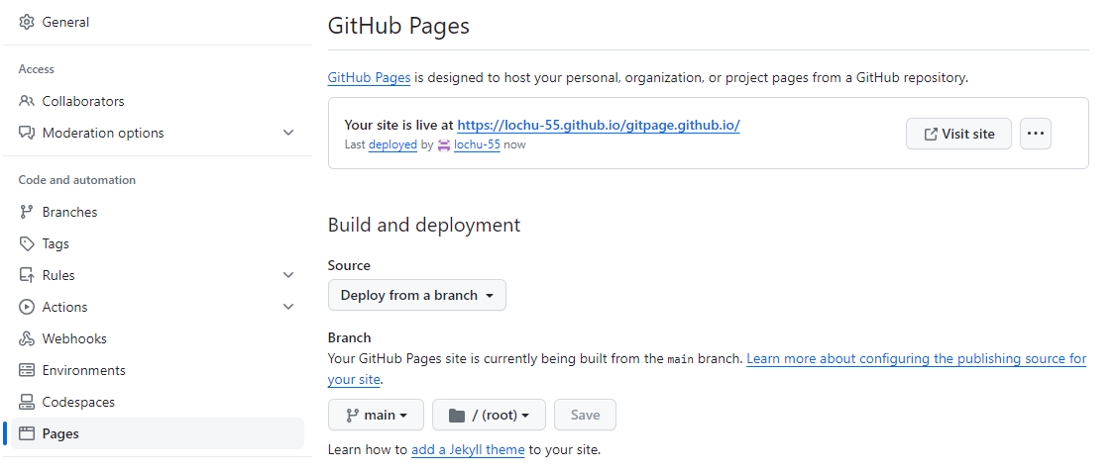

vlab@VEDA2F107 MINGW64 ~/Desktop/GIT/git-page

$ git clone git@github.com:lochu-55/GitWebPage.git

Cloning into 'GitWebPage'...

warning: You appear to have cloned an empty repository.

vlab@VEDA2F107 MINGW64 ~/Desktop/GIT/git-page

$ cd GitWebPage/

vlab@VEDA2F107 MINGW64 ~/Desktop/GIT/git-page/GitWebPage (main)

$ vi index.html

vlab@VEDA2F107 MINGW64 ~/Desktop/GIT/git-page/GitWebPage (main)

$ git add .

warning: in the working copy of 'index.html', LF will be replaced by CRLF the next time Git touches it

vlab@VEDA2F107 MINGW64 ~/Desktop/GIT/git-page/GitWebPage (main)

$ git commit -m "index added"

[main (root-commit) 19c77cc] index added

1 file changed, 44 insertions(+)

create mode 100644 index.html

vlab@VEDA2F107 MINGW64 ~/Desktop/GIT/git-page/GitWebPage (main)

$ git checkout -b feature

Switched to a new branch 'feature'

vlab@VEDA2F107 MINGW64 ~/Desktop/GIT/git-page/GitWebPage (feature)

$ vi feature.html

vlab@VEDA2F107 MINGW64 ~/Desktop/GIT/git-page/GitWebPage (feature)

$ vi styles.css

vlab@VEDA2F107 MINGW64 ~/Desktop/GIT/git-page/GitWebPage (feature)

$ git status

On branch feature

Untracked files:

(use "git add <file>..." to include in what will be committed)

feature.html

styles.css

nothing added to commit but untracked files present (use "git add" to track)

vlab@VEDA2F107 MINGW64 ~/Desktop/GIT/git-page/GitWebPage (feature)

$ git add .

warning: in the working copy of 'feature.html', LF will be replaced by CRLF the next time Git touches it

warning: in the working copy of 'styles.css', LF will be replaced by CRLF the next time Git touches it

vlab@VEDA2F107 MINGW64 ~/Desktop/GIT/git-page/GitWebPage (feature)

$ git commit -m "added feature styles"

[feature 20fedac] added feature styles

2 files changed, 93 insertions(+)

create mode 100644 feature.html

create mode 100644 styles.css

vlab@VEDA2F107 MINGW64 ~/Desktop/GIT/git-page/GitWebPage (feature)

$ git push -u origin feature

Enumerating objects: 7, done.

Counting objects: 100% (7/7), done.

Delta compression using up to 4 threads

Compressing objects: 100% (6/6), done.

Writing objects: 100% (7/7), 1.36 KiB | 1.36 MiB/s, done.

Total 7 (delta 1), reused 0 (delta 0), pack-reused 0 (from 0)

remote: Resolving deltas: 100% (1/1), done.

To github.com:lochu-55/GitWebPage.git

* [new branch] feature -> feature

branch 'feature' set up to track 'origin/feature'.

vlab@VEDA2F107 MINGW64 ~/Desktop/GIT/git-page/GitWebPage (feature)

$ git checkout main

Switched to branch 'main'

Your branch is based on 'origin/main', but the upstream is gone.

(use "git branch --unset-upstream" to fixup)

vlab@VEDA2F107 MINGW64 ~/Desktop/GIT/git-page/GitWebPage (main)

$ git push -u origin main

Total 0 (delta 0), reused 0 (delta 0), pack-reused 0 (from 0)

remote:

remote: Create a pull request for 'main' on GitHub by visiting:

remote: https://github.com/lochu-55/GitWebPage/pull/new/main

remote:

To github.com:lochu-55/GitWebPage.git

* [new branch] main -> main

branch 'main' set up to track 'origin/main'.

vlab@VEDA2F107 MINGW64 ~/Desktop/GIT/git-page/GitWebPage (main)

$ git log

commit 19c77cceb5a0d4dc26b931dc07bf00fef7c79f74 (HEAD -> main, origin/main)

Author: lochani <lochu5vilehya@gmail.com>

Date: Wed Mar 13 14:22:46 2024 +0530

index added

vlab@VEDA2F107 MINGW64 ~/Desktop/GIT/git-page/GitWebPage (main)

$ git checkout feature

Switched to branch 'feature'

Your branch is up to date with 'origin/feature'.

vlab@VEDA2F107 MINGW64 ~/Desktop/GIT/git-page/GitWebPage (feature)

$ git log

commit 20fedacbdccd8a45e059fe28c17d922178340427 (HEAD -> feature, origin/feature)

Author: lochani <lochu5vilehya@gmail.com>

Date: Wed Mar 13 14:25:16 2024 +0530

added feature styles

commit 19c77cceb5a0d4dc26b931dc07bf00fef7c79f74 (origin/main, main)

Author: lochani <lochu5vilehya@gmail.com>

Date: Wed Mar 13 14:22:46 2024 +0530

index added

vlab@VEDA2F107 MINGW64 ~/Desktop/GIT/git-page/GitWebPage (feature)

$ git log --oneline

20fedac (HEAD -> feature, origin/feature) added feature styles

19c77cc (origin/main, main) index added

vlab@VEDA2F107 MINGW64 ~/Desktop/GIT/git-page/GitWebPage (feature)

$ git branch -r

origin/feature

origin/main

vlab@VEDA2F107 MINGW64 ~/Desktop/GIT/git-page/GitWebPage (feature)

$ git branch

* feature

Main

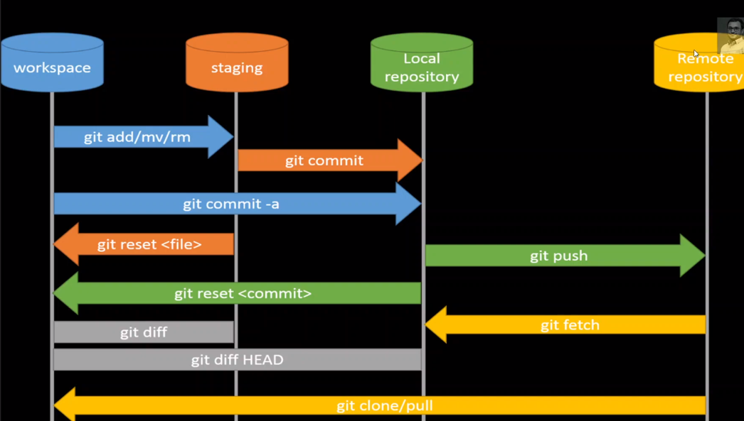

vlab@VEDA2F107 MINGW64 ~/Desktop/GIT/git-pull-req-conflict

$ git clone git@github.com:lochu-55/GitWebPage.git

Cloning into 'GitWebPage'...

remote: Enumerating objects: 41, done.

remote: Counting objects: 100% (41/41), done.

remote: Compressing objects: 100% (25/25), done.

remote: Total 41 (delta 11), reused 30 (delta 7), pack-reused 0

Receiving objects: 100% (41/41), 7.84 KiB | 730.00 KiB/s, done.

Resolving deltas: 100% (11/11), done.

vlab@VEDA2F107 MINGW64 ~/Desktop/GIT/git-pull-req-conflict

$ cd GitWebPage/

vlab@VEDA2F107 MINGW64 ~/Desktop/GIT/git-pull-req-conflict/GitWebPage (feature)

$ ls

feature.html hello.txt index.html main.txt styles.css

vlab@VEDA2F107 MINGW64 ~/Desktop/GIT/git-pull-req-conflict/GitWebPage (feature)

$ vi main.txt

vlab@VEDA2F107 MINGW64 ~/Desktop/GIT/git-pull-req-conflict/GitWebPage (feature)

$ git add .

vlab@VEDA2F107 MINGW64 ~/Desktop/GIT/git-pull-req-conflict/GitWebPage (feature)

$ git commit -m "added hii in main git"

[feature eef824d] added hii in main git

1 file changed, 1 insertion(+)

vlab@VEDA2F107 MINGW64 ~/Desktop/GIT/git-pull-req-conflict/GitWebPage (feature)

$ git branch

* feature

vlab@VEDA2F107 MINGW64 ~/Desktop/GIT/git-pull-req-conflict/GitWebPage (feature)

$ git push -u origin feature

Enumerating objects: 5, done.

Counting objects: 100% (5/5), done.

Delta compression using up to 4 threads

Compressing objects: 100% (2/2), done.

Writing objects: 100% (3/3), 270 bytes | 67.00 KiB/s, done.

Total 3 (delta 1), reused 0 (delta 0), pack-reused 0 (from 0)

remote: Resolving deltas: 100% (1/1), completed with 1 local object.

remote: Bypassed rule violations for refs/heads/feature:

remote:

remote: - Changes must be made through a pull request.

remote:

To github.com:lochu-55/GitWebPage.git

78e65b9..eef824d feature -> feature

branch 'feature' set up to track 'origin/feature'.

vlab@VEDA2F107 MINGW64 ~/Desktop/GIT/git-pull-req-conflict/GitWebPage (feature)

$ git pull

remote: Enumerating objects: 5, done.

remote: Counting objects: 100% (5/5), done.

remote: Compressing objects: 100% (2/2), done.

remote: Total 3 (delta 1), reused 0 (delta 0), pack-reused 0

Unpacking objects: 100% (3/3), 929 bytes | 4.00 KiB/s, done.

From github.com:lochu-55/GitWebPage

* [new branch] lochu-55-patch-1 -> origin/lochu-55-patch-1

Already up to date.

vlab@VEDA2F107 MINGW64 ~/Desktop/GIT/git-pull-req-conflict/GitWebPage (feature)

$ git branch

* feature

vlab@VEDA2F107 MINGW64 ~/Desktop/GIT/git-pull-req-conflict/GitWebPage (feature)

$ git checkout main

Switched to a new branch 'main'

branch 'main' set up to track 'origin/main'.

vlab@VEDA2F107 MINGW64 ~/Desktop/GIT/git-pull-req-conflict/GitWebPage (main)

$ git branch

feature

* main

vlab@VEDA2F107 MINGW64 ~/Desktop/GIT/git-pull-req-conflict/GitWebPage (main)

$ git pull

Already up to date.

vlab@VEDA2F107 MINGW64 ~/Desktop/GIT/git-pull-req-conflict/GitWebPage (main)

$ git push

Everything up-to-date

vlab@VEDA2F107 MINGW64 ~/Desktop/GIT/git-pull-req-conflict/GitWebPage (main)

$ ls

feature.html hello.txt hii.txt index.html main.txt styles.css

vlab@VEDA2F107 MINGW64 ~/Desktop/GIT/git-pull-req-conflict/GitWebPage (main)

$ vi hii.txt

vlab@VEDA2F107 MINGW64 ~/Desktop/GIT/git-pull-req-conflict/GitWebPage (main)

$ git add .

g

vlab@VEDA2F107 MINGW64 ~/Desktop/GIT/git-pull-req-conflict/GitWebPage (main)

$ git commit -m "update hii in main git"

[main 7b057f3] update hii in main git

1 file changed, 1 insertion(+)

vlab@VEDA2F107 MINGW64 ~/Desktop/GIT/git-pull-req-conflict/GitWebPage (main)

$ git push

To github.com:lochu-55/GitWebPage.git

! [rejected] main -> main (fetch first)

error: failed to push some refs to 'github.com:lochu-55/GitWebPage.git'

hint: Updates were rejected because the remote contains work that you do not

hint: have locally. This is usually caused by another repository pushing to

hint: the same ref. If you want to integrate the remote changes, use

hint: 'git pull' before pushing again.

hint: See the 'Note about fast-forwards' in 'git push --help' for details.

vlab@VEDA2F107 MINGW64 ~/Desktop/GIT/git-pull-req-conflict/GitWebPage (main)

$ git pull

remote: Enumerating objects: 5, done.

remote: Counting objects: 100% (5/5), done.

remote: Compressing objects: 100% (2/2), done.

remote: Total 3 (delta 1), reused 0 (delta 0), pack-reused 0

Unpacking objects: 100% (3/3), 922 bytes | 5.00 KiB/s, done.

From github.com:lochu-55/GitWebPage

b619faf..3fb1c52 main -> origin/main

Auto-merging hii.txt

CONFLICT (content): Merge conflict in hii.txt

Automatic merge failed; fix conflicts and then commit the result.

vlab@VEDA2F107 MINGW64 ~/Desktop/GIT/git-pull-req-conflict/GitWebPage (main|MERGING)

$ vi hii.txt

vlab@VEDA2F107 MINGW64 ~/Desktop/GIT/git-pull-req-conflict/GitWebPage (main|MERGING)

$ git add .

vlab@VEDA2F107 MINGW64 ~/Desktop/GIT/git-pull-req-conflict/GitWebPage (main|MERGING)

$ git commit -m "resolved conflict in hii"

[main 3cca11e] resolved conflict in hii

vlab@VEDA2F107 MINGW64 ~/Desktop/GIT/git-pull-req-conflict/GitWebPage (main)

$ git push

Enumerating objects: 10, done.

Counting objects: 100% (10/10), done.

Delta compression using up to 4 threads

Compressing objects: 100% (4/4), done.

Writing objects: 100% (6/6), 548 bytes | 548.00 KiB/s, done.

Total 6 (delta 2), reused 0 (delta 0), pack-reused 0 (from 0)

remote: Resolving deltas: 100% (2/2), completed with 1 local object.

To github.com:lochu-55/GitWebPage.git

3fb1c52..3cca11e main -> main

vlab@VEDA2F107 MINGW64 ~/Desktop/GIT/git-pull-req-conflict/GitWebPage (main)

$ ls

feature.html hello.txt hii.txt index.html main.txt styles.css

vlab@VEDA2F107 MINGW64 ~/Desktop/GIT/git-pull-req-conflict/GitWebPage (main)

$ git branch

feature

* main

vlab@VEDA2F107 MINGW64 ~/Desktop/GIT/git-pull-req-conflict/GitWebPage (main)

$ git branch -r

origin/HEAD -> origin/feature

origin/bugfix

origin/feature

origin/lochu-55-patch-1

origin/main

vlab@VEDA2F107 MINGW64 ~/Desktop/GIT/git-pull-req-conflict/GitWebPage (main)

$ git branch -D origin/lochu-55-patch-1

error: branch 'origin/lochu-55-patch-1' not found.

Did you forget --remote?

vlab@VEDA2F107 MINGW64 ~/Desktop/GIT/git-pull-req-conflict/GitWebPage (main)

$ git branch -r

origin/HEAD -> origin/feature

origin/bugfix

origin/feature

origin/lochu-55-patch-1

origin/main

vlab@VEDA2F107 MINGW64 ~/Desktop/GIT/git-pull-req-conflict/GitWebPage (main)

$ git fetch --prune

From github.com:lochu-55/GitWebPage

- [deleted] (none) -> origin/lochu-55-patch-1

remote: Enumerating objects: 4, done.

remote: Counting objects: 100% (4/4), done.

remote: Compressing objects: 100% (2/2), done.

remote: Total 2 (delta 1), reused 0 (delta 0), pack-reused 0

Unpacking objects: 100% (2/2), 947 bytes | 9.00 KiB/s, done.

eef824d..e0cade1 feature -> origin/feature

vlab@VEDA2F107 MINGW64 ~/Desktop/GIT/git-pull-req-conflict/GitWebPage (main)

$ git branch -r

origin/HEAD -> origin/feature

origin/bugfix

origin/feature

origin/main

vlab@VEDA2F107 MINGW64 ~/Desktop/GIT/git-pull-req-conflict/GitWebPage (main)

$ git switch bugfix

Switched to a new branch 'bugfix'

branch 'bugfix' set up to track 'origin/bugfix'.

vlab@VEDA2F107 MINGW64 ~/Desktop/GIT/git-pull-req-conflict/GitWebPage (bugfix)

$ ls

feature.html hello.txt hii.txt index.html main.txt styles.css

vlab@VEDA2F107 MINGW64 ~/Desktop/GIT/git-pull-req-conflict/GitWebPage (bugfix)

$ vi main.txt

vlab@VEDA2F107 MINGW64 ~/Desktop/GIT/git-pull-req-conflict/GitWebPage (bugfix)

$ git status

On branch bugfix

Your branch is up to date with 'origin/bugfix'.

Changes not staged for commit:

(use "git add <file>..." to update what will be committed)

(use "git restore <file>..." to discard changes in working directory)

modified: main.txt

no changes added to commit (use "git add" and/or "git commit -a")

vlab@VEDA2F107 MINGW64 ~/Desktop/GIT/git-pull-req-conflict/GitWebPage (bugfix)

$ git add .

vlab@VEDA2F107 MINGW64 ~/Desktop/GIT/git-pull-req-conflict/GitWebPage (bugfix)

$ git commit -m "edited main in bugfix"

[bugfix decd7e9] edited main in bugfix

1 file changed, 1 insertion(+)

vlab@VEDA2F107 MINGW64 ~/Desktop/GIT/git-pull-req-conflict/GitWebPage (bugfix)

$ git push

Enumerating objects: 5, done.

Counting objects: 100% (5/5), done.

Delta compression using up to 4 threads

Compressing objects: 100% (2/2), done.

Writing objects: 100% (3/3), 272 bytes | 272.00 KiB/s, done.

Total 3 (delta 1), reused 0 (delta 0), pack-reused 0 (from 0)

remote: Resolving deltas: 100% (1/1), completed with 1 local object.

To github.com:lochu-55/GitWebPage.git

b50eafd..decd7e9 bugfix -> bugfix

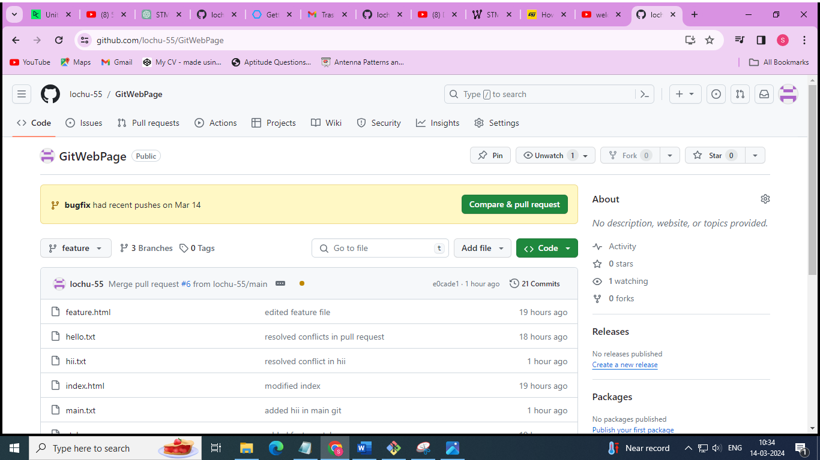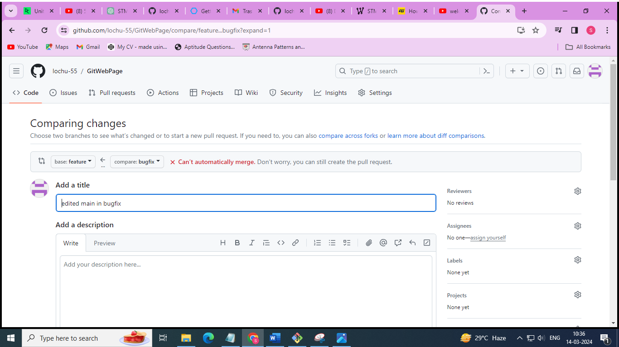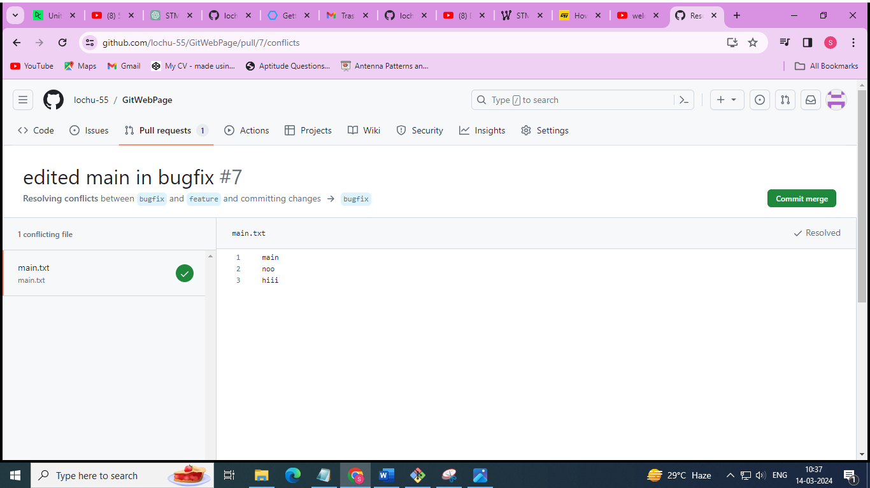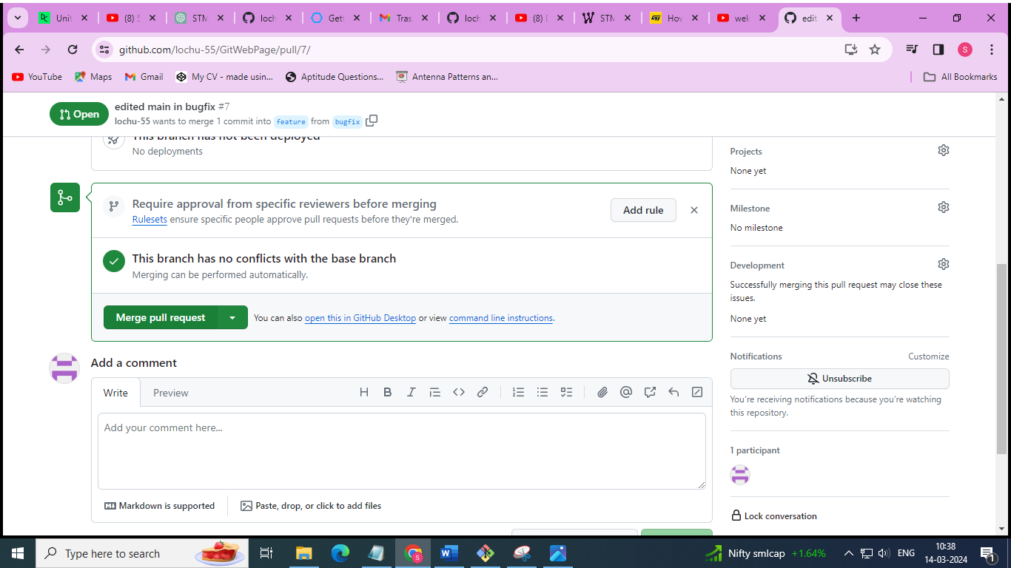

//GIT tags

vlab@VEDA2F107 MINGW64 ~/Desktop/GIT

$ git clone https://github.com/InstaPy/InstaPy.git

Cloning into 'InstaPy'...

remote: Enumerating objects: 12944, done.

remote: Counting objects: 100% (2/2), done.

remote: Compressing objects: 100% (2/2), done.

remote: Total 12944 (delta 0), reused 2 (delta 0), pack-reused 12942

Receiving objects: 100% (12944/12944), 81.70 MiB | 4.38 MiB/s, done.

Resolving deltas: 100% (8717/8717), done.

vlab@VEDA2F107 MINGW64 ~/Desktop/GIT

$ cd InstaPy/

vlab@VEDA2F107 MINGW64 ~/Desktop/GIT/InstaPy (master)

$ git branch -r

origin/HEAD -> origin/master

origin/dependabot/npm_and_yarn/docusaurus/express-4.18.2

origin/dependabot/npm_and_yarn/docusaurus/http-cache-semantics-4.1.1

origin/dependabot/npm_and_yarn/docusaurus/json5-1.0.2

origin/dependabot/npm_and_yarn/docusaurus/ua-parser-js-0.7.33

origin/dev

origin/gh-pages

origin/login_xpath_update

origin/master

origin/new_graphql_approach_integrate-it_on_relationship_later

vlab@VEDA2F107 MINGW64 ~/Desktop/GIT/InstaPy (master)

$ git tag

0.1.1

0.1.2

0.1.3

0.2.0

0.2.1

0.2.2

0.2.3

0.3.0

0.3.1

0.3.2

0.3.3

0.3.4

0.4.0

0.4.1

0.4.2

0.4.3

0.5.0

0.5.1

0.5.2

0.5.3

0.5.4

0.5.5

0.5.6

0.5.7

0.5.8

0.6.0

0.6.1

0.6.10

0.6.11

0.6.12

0.6.13

0.6.14

0.6.15

0.6.16

0.6.2

0.6.3

0.6.4

0.6.5

0.6.6

0.6.7

0.6.8

0.6.9

legacy

v0.1.0

vlab@VEDA2F107 MINGW64 ~/Desktop/GIT/InstaPy (master)

$ git tag -l *6*

0.5.6

0.6.0

0.6.1

0.6.10

0.6.11

0.6.12

0.6.13

0.6.14

0.6.15

0.6.16

0.6.2

0.6.3

0.6.4

0.6.5

0.6.6

0.6.7

0.6.8

0.6.9

vlab@VEDA2F107 MINGW64 ~/Desktop/GIT/InstaPy (master)

$ git diff 0.6.2 0.6.3

**diff --git a/.travis.yml b/.travis.yml**

**index 850a2b7..918f8dd 100644**

**--- a/.travis.yml**

**+++ b/.travis.yml**

@@ -1,5 +1,4 @@

dist: xenial

-sudo: false

language: python

python: "3.7"

cache: pip

@@ -9,7 +8,7 @@ branches:

- legacy

- experimental

-install: pip install tox tox-venv

+install: pip install tox

//GIT light-weighted tags

vlab@VEDA2F107 MINGW64 ~/Desktop/GIT

$ mkdir git-tag

vlab@VEDA2F107 MINGW64 ~/Desktop/GIT

$ cd git-tag

vlab@VEDA2F107 MINGW64 ~/Desktop/GIT/git-tag

$ git init

Initialized empty Git repository in C:/Users/vlab/Desktop/GIT/git-tag/.git/

vlab@VEDA2F107 MINGW64 ~/Desktop/GIT/git-tag (master)

$ vi index.txt

vlab@VEDA2F107 MINGW64 ~/Desktop/GIT/git-tag (master)

$ git add .

warning: in the working copy of 'index.txt', LF will be replaced by CRLF the next time Git touches it

vlab@VEDA2F107 MINGW64 ~/Desktop/GIT/git-tag (master)

$ git commit -m "initial commit"

[master (root-commit) aec5ff0] initial commit

1 file changed, 1 insertion(+)

create mode 100644 index.txt

g

vlab@VEDA2F107 MINGW64 ~/Desktop/GIT/git-tag (master)

$ git log

commit aec5ff0ce22808d1d5415730a42f5c8d29b10bb8 (HEAD -> master)

Author: lochani <lochu5vilehya@gmail.com>

Date: Thu Mar 14 14:07:05 2024 +0530

initial commit

vlab@VEDA2F107 MINGW64 ~/Desktop/GIT/git-tag (master)

$ git tag

vlab@VEDA2F107 MINGW64 ~/Desktop/GIT/git-tag (master)

$ git tag v1.0.0

vlab@VEDA2F107 MINGW64 ~/Desktop/GIT/git-tag (master)

$ git tag

v1.0.0

vlab@VEDA2F107 MINGW64 ~/Desktop/GIT/git-tag (master)

$ vi index.txt

vlab@VEDA2F107 MINGW64 ~/Desktop/GIT/git-tag (master)

$ git add .

warning: in the working copy of 'index.txt', LF will be replaced by CRLF the next time Git touches it

vlab@VEDA2F107 MINGW64 ~/Desktop/GIT/git-tag (master)

$ git commit -m "second commit"

[master 65ae680] second commit

1 file changed, 1 insertion(+)

vlab@VEDA2F107 MINGW64 ~/Desktop/GIT/git-tag (master)

$ fit log

bash: fit: command not found

vlab@VEDA2F107 MINGW64 ~/Desktop/GIT/git-tag (master)

$ git log

commit 65ae680011b2f65768a76118ec230f1badb4bc9d (HEAD -> master)

Author: lochani <lochu5vilehya@gmail.com>

Date: Thu Mar 14 14:08:24 2024 +0530

second commit

commit aec5ff0ce22808d1d5415730a42f5c8d29b10bb8 (tag: v1.0.0)

Author: lochani <lochu5vilehya@gmail.com>

Date: Thu Mar 14 14:07:05 2024 +0530

initial commit

vlab@VEDA2F107 MINGW64 ~/Desktop/GIT/git-tag (master)

$ git checkout v1.0.0

Note: switching to 'v1.0.0'.

You are in 'detached HEAD' state. You can look around, make experimental

changes and commit them, and you can discard any commits you make in this

state without impacting any branches by switching back to a branch.

If you want to create a new branch to retain commits you create, you may

do so (now or later) by using -c with the switch command. Example:

git switch -c <new-branch-name>

Or undo this operation with:

git switch -

Turn off this advice by setting config variable advice.detachedHead to false

HEAD is now at aec5ff0 initial commit

vlab@VEDA2F107 MINGW64 ~/Desktop/GIT/git-tag ((v1.0.0))

$ cat index.txt

this is first commit

vlab@VEDA2F107 MINGW64 ~/Desktop/GIT/git-tag ((v1.0.0))

$ git switch -

Previous HEAD position was aec5ff0 initial commit

Switched to branch 'master'

vlab@VEDA2F107 MINGW64 ~/Desktop/GIT/git-tag (master)

$ cat index.txt

this is first commit

this is 2nd commit

vlab@VEDA2F107 MINGW64 ~/Desktop/GIT/git-tag (master)

$ git log --oneline

65ae680 (HEAD -> master) second commit

aec5ff0 (tag: v1.0.0) initial commit

vlab@VEDA2F107 MINGW64 ~/Desktop/GIT/git-tag (master)

$ git tag v1.0.1

vlab@VEDA2F107 MINGW64 ~/Desktop/GIT/git-tag (master)

$ git log --oneline

65ae680 (HEAD -> master, tag: v1.0.1) second commit

aec5ff0 (tag: v1.0.0) initial commit

vlab@VEDA2F107 MINGW64 ~/Desktop/GIT/git-tag (master)

$ git tag

v1.0.0

v1.0.1

vlab@VEDA2F107 MINGW64 ~/Desktop/GIT/git-tag (master)

$ git diff v1.0.0 v1.0.1

**diff --git a/index.txt b/index.txt**

**index 2ed441a..a0c73a5 100644**

**--- a/index.txt**

**+++ b/index.txt**

@@ -1 +1,2 @@

this is first commit

+this is 2nd commit

//GIT Annotated tags and push in github

vlab@VEDA2F107 MINGW64 ~/Desktop/GIT/git-tag (master)

$ vi new.txt

vlab@VEDA2F107 MINGW64 ~/Desktop/GIT/git-tag (master)

$ git add .

warning: in the working copy of 'new.txt', LF will be replaced by CRLF the next time Git touches it

vlab@VEDA2F107 MINGW64 ~/Desktop/GIT/git-tag (master)

$ git commit -m "new feature"

[master ccb6107] new feature

1 file changed, 1 insertion(+)

create mode 100644 new.txt

vlab@VEDA2F107 MINGW64 ~/Desktop/GIT/git-tag (master)

$ git tag -a v1.1.0

hint: Waiting for your editor to close the file... unix2dos: converting file C:/Users/vlab/Desktop/GIT/git-tag/.git/TAG_EDITMSG to DOS format...

dos2unix: converting file C:/Users/vlab/Desktop/GIT/git-tag/.git/TAG_EDITMSG to Unix format...

vlab@VEDA2F107 MINGW64 ~/Desktop/GIT/git-tag (master)

$ git show v1.1.0

tag v1.1.0

Tagger: lochani <lochu5vilehya@gmail.com>

Date: Thu Mar 14 14:52:24 2024 +0530

this is annoted tag :)

commit ccb6107f094306ad7961cec76c77dcd809467429 (HEAD -> master, tag: v1.1.0)

Author: lochani <lochu5vilehya@gmail.com>

Date: Thu Mar 14 14:52:12 2024 +0530

new feature

**diff --git a/new.txt b/new.txt**

**new file mode 100644**

**index 0000000..3e75765**

**--- /dev/null**

**+++ b/new.txt**

@@ -0,0 +1 @@

+new

vlab@VEDA2F107 MINGW64 ~/Desktop/GIT/git-tag (master)

$ git show v1.0.0

commit aec5ff0ce22808d1d5415730a42f5c8d29b10bb8 (tag: v1.0.0)

Author: lochani <lochu5vilehya@gmail.com>

Date: Thu Mar 14 14:07:05 2024 +0530

initial commit

**diff --git a/index.txt b/index.txt**

**new file mode 100644**

**index 0000000..2ed441a**

**--- /dev/null**

**+++ b/index.txt**

@@ -0,0 +1 @@

+this is first commit

vlab@VEDA2F107 MINGW64 ~/Desktop/GIT/git-tag (master)

$ git log --oneline

ccb6107 (HEAD -> master, tag: v1.1.0) new feature

65ae680 (tag: v1.0.1) second commit

aec5ff0 (tag: v1.0.0) initial commit

vlab@VEDA2F107 MINGW64 ~/Desktop/GIT/git-tag (master)

$ git remote add origin https://github.com/lochu-55/Git_tag.git

vlab@VEDA2F107 MINGW64 ~/Desktop/GIT/git-tag (master)

$ git push -u origin master

Enumerating objects: 9, done.

Counting objects: 100% (9/9), done.

Delta compression using up to 4 threads

Compressing objects: 100% (4/4), done.

Writing objects: 100% (9/9), 713 bytes | 356.00 KiB/s, done.

Total 9 (delta 0), reused 0 (delta 0), pack-reused 0 (from 0)

remote:

remote: Create a pull request for 'master' on GitHub by visiting:

remote: https://github.com/lochu-55/Git_tag/pull/new/master

remote:

To https://github.com/lochu-55/Git_tag.git

* [new branch] master -> master

branch 'master' set up to track 'origin/master'.

vlab@VEDA2F107 MINGW64 ~/Desktop/GIT/git-tag (master)

$ git tag

v1.0.0

v1.0.1

v1.1.0

vlab@VEDA2F107 MINGW64 ~/Desktop/GIT/git-tag (master)

$ git push origin v1.1.0

Enumerating objects: 1, done.

Counting objects: 100% (1/1), done.

Writing objects: 100% (1/1), 170 bytes | 170.00 KiB/s, done.

Total 1 (delta 0), reused 0 (delta 0), pack-reused 0 (from 0)

To https://github.com/lochu-55/Git_tag.git

* [new tag] v1.1.0 -> v1.1.0

vlab@VEDA2F107 MINGW64 ~/Desktop/GIT/git-tag (master)

$ git push origin --tags

Total 0 (delta 0), reused 0 (delta 0), pack-reused 0 (from 0)

To https://github.com/lochu-55/Git_tag.git

* [new tag] v1.0.0 -> v1.0.0

* [new tag] v1.0.1 -> v1.0.1

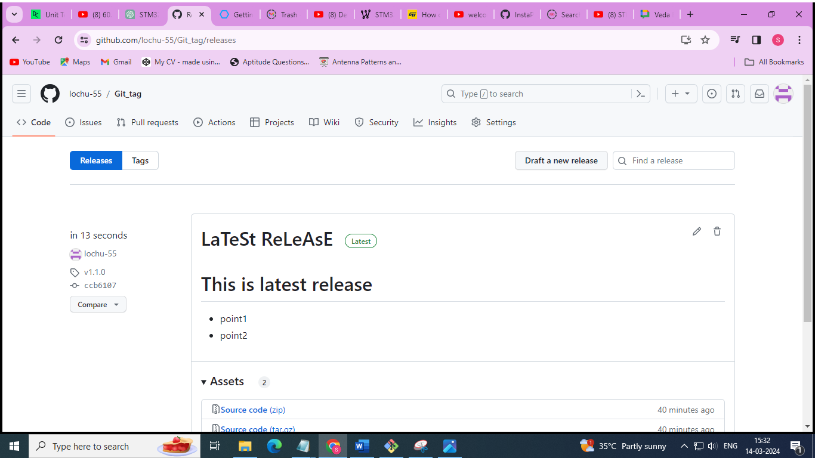

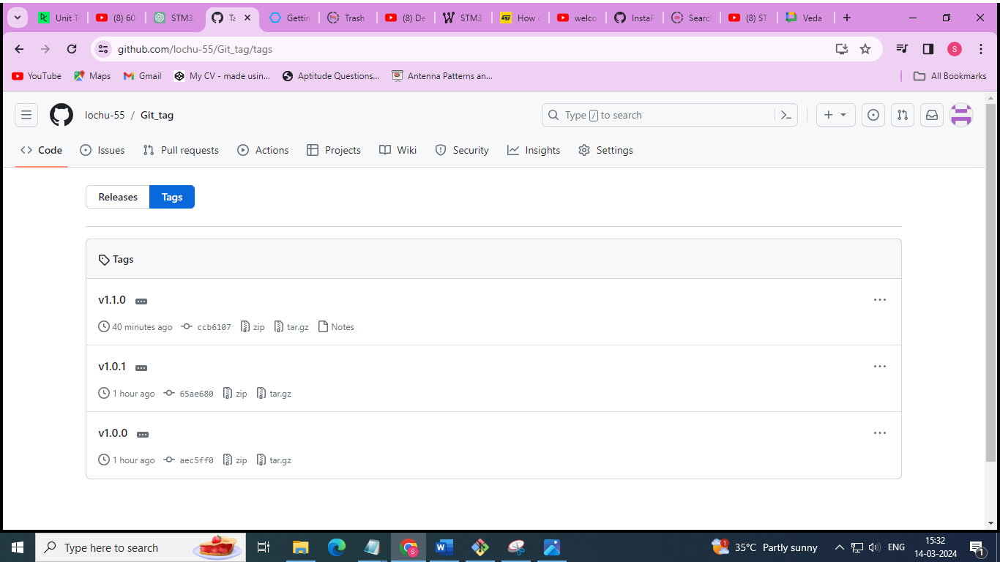

//Git reflog

$ cd git_branching/

vlab@VEDA2F107 MINGW64 ~/Desktop/GIT/git_branching (master)

$ git reflog

e2796cc (HEAD -> master) HEAD@{0}: checkout: moving from hello to master

b2b7c09 (hello, feature) HEAD@{1}: checkout: moving from feature to hello

b2b7c09 (hello, feature) HEAD@{2}: checkout: moving from master to feature

e2796cc (HEAD -> master) HEAD@{3}: checkout: moving from 4931eba2eaf4d1c3d92fe2a8c5b1d2ec5e30fe76 to master

4931eba HEAD@{4}: checkout: moving from master to Head~4

e2796cc (HEAD -> master) HEAD@{5}: merge feature: Merge made by the 'ort' strategy.

a17b5c6 HEAD@{6}: commit: changes done in hello.txt (master)

bb6fab0 HEAD@{7}: checkout: moving from feature to master

b2b7c09 (hello, feature) HEAD@{8}: checkout: moving from master to feature

bb6fab0 HEAD@{9}: checkout: moving from feature to master

b2b7c09 (hello, feature) HEAD@{10}: commit: edited hello.txt

bb6fab0 HEAD@{11}: checkout: moving from master to feature

bb6fab0 HEAD@{12}: commit: hello.txt added

e48c9a3 HEAD@{13}: checkout: moving from new_feature to master

6ba3361 (new_feature) HEAD@{14}: checkout: moving from dummy_branch to new_feature

fdc643b (dummy_branch) HEAD@{15}: checkout: moving from master to dummy_branch

e48c9a3 HEAD@{16}: merge dummy_branch: Merge made by the 'ort' strategy.

4931eba HEAD@{17}: checkout: moving from dummy_branch to master

fdc643b (dummy_branch) HEAD@{18}: commit: dummy file

6ba3361 (new_feature) HEAD@{19}: checkout: moving from master to dummy_branch

4931eba HEAD@{20}: commit: changes done to index file

6ba3361 (new_feature) HEAD@{21}: merge new_feature: Fast-forward

1ea9636 HEAD@{22}: checkout: moving from new_feature to master

6ba3361 (new_feature) HEAD@{23}: commit: new file added

1ea9636 HEAD@{24}: checkout: moving from master to new_feature

1ea9636 HEAD@{25}: checkout: moving from new_branch to master

4481071 HEAD@{26}: commit: log.txt edited

b41f54b (bugs) HEAD@{27}: checkout: moving from master to new_branch

1ea9636 HEAD@{28}: checkout: moving from new_branch to master

b41f54b (bugs) HEAD@{29}: Branch: renamed refs/heads/dummy to refs/heads/new_branch

b41f54b (bugs) HEAD@{31}: checkout: moving from bugs to dummy

b41f54b (bugs) HEAD@{32}: checkout: moving from master to bugs

1ea9636 HEAD@{33}: commit: index.txt is committed

bf567b8 (dev) HEAD@{34}: checkout: moving from bugs to master

b41f54b (bugs) HEAD@{35}: checkout: moving from master to bugs

bf567b8 (dev) HEAD@{36}: checkout: moving from bugs to master

b41f54b (bugs) HEAD@{37}: checkout: moving from master to bugs

bf567b8 (dev) HEAD@{38}: checkout: moving from bugs to master

b41f54b (bugs) HEAD@{39}: commit: hello.txt in login

0f1b3a2 HEAD@{40}: checkout: moving from master to bugs

bf567b8 (dev) HEAD@{41}: checkout: moving from bugs to master

0f1b3a2 HEAD@{42}: checkout: moving from master to bugs

bf567b8 (dev) HEAD@{43}: checkout: moving from bugs to master

0f1b3a2 HEAD@{44}: commit: login folder added for logging

bf567b8 (dev) HEAD@{45}: checkout: moving from dev to bugs

bf567b8 (dev) HEAD@{46}: checkout: moving from master to dev

bf567b8 (dev) HEAD@{47}: merge dev: Fast-forward

eb8a4a5 HEAD@{48}: checkout: moving from dev to master

bf567b8 (dev) HEAD@{49}: commit: release version 1.0

23c2812 HEAD@{50}: commit: src/file edited

1a14447 HEAD@{51}: commit: lib/file2 edited

eb8a4a5 HEAD@{52}: checkout: moving from master to dev

eb8a4a5 HEAD@{53}: checkout: moving from bugs to master

eb8a4a5 HEAD@{54}: checkout: moving from master to bugs

eb8a4a5 HEAD@{55}: checkout: moving from dev to master

eb8a4a5 HEAD@{56}: checkout: moving from master to dev

eb8a4a5 HEAD@{57}: commit (initial): initial commit

vlab@VEDA2F107 MINGW64 ~/Desktop/GIT/git_branching (master)

$ git branch

bugs

dev

dummy_branch

feature

hello

* master

new_feature

vlab@VEDA2F107 MINGW64 ~/Desktop/GIT/git_branching (master)

$ git reflog show bugs

b41f54b (bugs) bugs@{0}: commit: hello.txt in login

0f1b3a2 bugs@{1}: commit: login folder added for logging

bf567b8 (dev) bugs@{2}: branch: Created from HEAD

vlab@VEDA2F107 MINGW64 ~/Desktop/GIT/git_branching (master)

$ git reflog show hello

b2b7c09 (hello, feature) hello@{0}: branch: Created from HEAD

vlab@VEDA2F107 MINGW64 ~/Desktop/GIT/git_branching (master)

$ git reflog show feature

b2b7c09 (hello, feature) feature@{0}: commit: edited hello.txt

bb6fab0 feature@{1}: branch: Created from HEAD

vlab@VEDA2F107 MINGW64 ~/Desktop/GIT/git_branching (master)

$ git reflog show dev

bf567b8 (dev) dev@{0}: commit: release version 1.0

23c2812 dev@{1}: commit: src/file edited

1a14447 dev@{2}: commit: lib/file2 edited

eb8a4a5 dev@{3}: branch: Created from HEAD

vlab@VEDA2F107 MINGW64 ~/Desktop/GIT/git_branching (master)

$ git reflog show dev@{2}

1a14447 dev@{2}: commit: lib/file2 edited

eb8a4a5 dev@{3}: branch: Created from HEAD

vlab@VEDA2F107 MINGW64 ~/Desktop/GIT/git_branching (master)

$ git log --oneline

e2796cc (HEAD -> master) Merge branch 'feature'

a17b5c6 changes done in hello.txt (master)

b2b7c09 (hello, feature) edited hello.txt

bb6fab0 hello.txt added

e48c9a3 Merge branch 'dummy_branch'

fdc643b (dummy_branch) dummy file

4931eba changes done to index file

6ba3361 (new_feature) new file added

1ea9636 index.txt is committed

bf567b8 (dev) release version 1.0

23c2812 src/file edited

1a14447 lib/file2 edited

eb8a4a5 initial commit

vlab@VEDA2F107 MINGW64 ~/Desktop/GIT/git_branching (master)

$ git reflog show master

e2796cc (HEAD -> master) master@{0}: merge feature: Merge made by the 'ort' strategy.

a17b5c6 master@{1}: commit: changes done in hello.txt (master)

bb6fab0 master@{2}: commit: hello.txt added

e48c9a3 master@{3}: merge dummy_branch: Merge made by the 'ort' strategy.

4931eba master@{4}: commit: changes done to index file

6ba3361 (new_feature) master@{5}: merge new_feature: Fast-forward

1ea9636 master@{6}: commit: index.txt is committed

bf567b8 (dev) master@{7}: merge dev: Fast-forward

eb8a4a5 master@{8}: commit (initial): initial commit

vlab@VEDA2F107 MINGW64 ~/Desktop/GIT/git_branching (master)

$ git reflog show master@{1.week.ago}

e2796cc (HEAD -> master) master@{Tue Mar 5 12:16:55 2024 +0530}: merge feature: Merge made by the 'ort' strategy.

a17b5c6 master@{Tue Mar 5 12:15:16 2024 +0530}: commit: changes done in hello.txt (master)

bb6fab0 master@{Tue Mar 5 12:12:06 2024 +0530}: commit: hello.txt added

e48c9a3 master@{Tue Mar 5 11:42:52 2024 +0530}: merge dummy_branch: Merge made by the 'ort' strategy.

4931eba master@{Tue Mar 5 11:41:40 2024 +0530}: commit: changes done to index file

6ba3361 (new_feature) master@{Tue Mar 5 11:40:23 2024 +0530}: merge new_feature: Fast-forward

1ea9636 master@{Tue Mar 5 11:20:08 2024 +0530}: commit: index.txt is committed

bf567b8 (dev) master@{Tue Mar 5 10:55:24 2024 +0530}: merge dev: Fast-forward

eb8a4a5 master@{Tue Mar 5 10:43:44 2024 +0530}: commit (initial): initial commit

vlab@VEDA2F107 MINGW64 ~/Desktop/GIT/git_branching (master)

$ git diff master master@{1.week.ago}

vlab@VEDA2F107 MINGW64 ~/Desktop/GIT/git_branching (master)

$ git reflog show master@{3.week.ago}

warning: log for 'master' only goes back to Tue, 5 Mar 2024 10:43:44 +0530

vlab@VEDA2F107 MINGW64 ~/Desktop/GIT/git_branching (master)

$ git reflog show master@{2.week.ago}

warning: log for 'master' only goes back to Tue, 5 Mar 2024 10:43:44 +0530

vlab@VEDA2F107 MINGW64 ~/Desktop/GIT/git_branching (master)

$ git reflog show master@{yesterday}

e2796cc (HEAD -> master) master@{Tue Mar 5 12:16:55 2024 +0530}: merge feature: Merge made by the 'ort' strategy.

a17b5c6 master@{Tue Mar 5 12:15:16 2024 +0530}: commit: changes done in hello.txt (master)

bb6fab0 master@{Tue Mar 5 12:12:06 2024 +0530}: commit: hello.txt added

e48c9a3 master@{Tue Mar 5 11:42:52 2024 +0530}: merge dummy_branch: Merge made by the 'ort' strategy.

4931eba master@{Tue Mar 5 11:41:40 2024 +0530}: commit: changes done to index file

6ba3361 (new_feature) master@{Tue Mar 5 11:40:23 2024 +0530}: merge new_feature: Fast-forward

1ea9636 master@{Tue Mar 5 11:20:08 2024 +0530}: commit: index.txt is committed

bf567b8 (dev) master@{Tue Mar 5 10:55:24 2024 +0530}: merge dev: Fast-forward

eb8a4a5 master@{Tue Mar 5 10:43:44 2024 +0530}: commit (initial): initial commit

vlab@VEDA2F107 MINGW64 ~/Desktop/GIT/git_branching (master)

$ git reflog show master@{6.day.ago}

e2796cc (HEAD -> master) master@{Tue Mar 5 12:16:55 2024 +0530}: merge feature: Merge made by the 'ort' strategy.

a17b5c6 master@{Tue Mar 5 12:15:16 2024 +0530}: commit: changes done in hello.txt (master)

bb6fab0 master@{Tue Mar 5 12:12:06 2024 +0530}: commit: hello.txt added

e48c9a3 master@{Tue Mar 5 11:42:52 2024 +0530}: merge dummy_branch: Merge made by the 'ort' strategy.

4931eba master@{Tue Mar 5 11:41:40 2024 +0530}: commit: changes done to index file

6ba3361 (new_feature) master@{Tue Mar 5 11:40:23 2024 +0530}: merge new_feature: Fast-forward

1ea9636 master@{Tue Mar 5 11:20:08 2024 +0530}: commit: index.txt is committed

bf567b8 (dev) master@{Tue Mar 5 10:55:24 2024 +0530}: merge dev: Fast-forward

eb8a4a5 master@{Tue Mar 5 10:43:44 2024 +0530}: commit (initial): initial commit

vlab@VEDA2F107 MINGW64 ~/Desktop/GIT/git_branching (master)

$ git diff master master@{2}

**diff --git a/hello.txt b/hello.txt**

**index 410ca14..ce01362 100644**

**--- a/hello.txt**

**+++ b/hello.txt**

@@ -1,2 +1 @@

hello

-bye

vlab@VEDA2F107 MINGW64 ~/Desktop/GIT/git-tag (login)

$ vi index.txt

vlab@VEDA2F107 MINGW64 ~/Desktop/GIT/git-tag (login)

$ git add .

vlab@VEDA2F107 MINGW64 ~/Desktop/GIT/git-tag (login)

$ git commit -m "hello in index"

[login e1e01d0] hello in index

1 file changed, 2 insertions(+)

vlab@VEDA2F107 MINGW64 ~/Desktop/GIT/git-tag (login)

$ cat index.txt

this is first commit

this is 2nd commit

this is 3rd commit

hello

vlab@VEDA2F107 MINGW64 ~/Desktop/GIT/git-tag (login)

$ git log --oneline

e1e01d0 (HEAD -> login) hello in index

5a04b45 (org/master, master) added bye to new

1d7c8ce added line to new

ccb6107 (tag: v1.1.0, origin/master) new feature

65ae680 (tag: v1.0.1) second commit

aec5ff0 (tag: v1.0.0) initial commit

vlab@VEDA2F107 MINGW64 ~/Desktop/GIT/git-tag (login)

$ git reset 5a04b45

Unstaged changes after reset:

M index.txt

vlab@VEDA2F107 MINGW64 ~/Desktop/GIT/git-tag (login)

$ git log --oneline

5a04b45 (HEAD -> login, org/master, master) added bye to new

1d7c8ce added line to new

ccb6107 (tag: v1.1.0, origin/master) new feature

65ae680 (tag: v1.0.1) second commit

aec5ff0 (tag: v1.0.0) initial commit

vlab@VEDA2F107 MINGW64 ~/Desktop/GIT/git-tag (login)

$ cat index.txt

this is first commit

this is 2nd commit

this is 3rd commit

hello

vlab@VEDA2F107 MINGW64 ~/Desktop/GIT/git-tag (login)

$ git reset 5a04b45 --hard

HEAD is now at 5a04b45 added bye to new

vlab@VEDA2F107 MINGW64 ~/Desktop/GIT/git-tag (login)

$ cat index.txt

this is first commit

this is 2nd commit

vlab@VEDA2F107 MINGW64 ~/Desktop/GIT/git-tag (login)

$ git reflog show login

5a04b45 (HEAD -> login, org/master, master) login@{0}: reset: moving to 5a04b45

e1e01d0 login@{1}: commit: hello in index

5a04b45 (HEAD -> login, org/master, master) login@{2}: reset: moving to 5a04b45

9d5bd4f login@{3}: commit: third line added to index

5a04b45 (HEAD -> login, org/master, master) login@{4}: branch: Created from HEAD

vlab@VEDA2F107 MINGW64 ~/Desktop/GIT/git-tag (login)

$ git reset login@{1} --hard

HEAD is now at e1e01d0 hello in index

vlab@VEDA2F107 MINGW64 ~/Desktop/GIT/git-tag (login)

$ git log --oneline

e1e01d0 (HEAD -> login) hello in index

5a04b45 (org/master, master) added bye to new

1d7c8ce added line to new

ccb6107 (tag: v1.1.0, origin/master) new feature

65ae680 (tag: v1.0.1) second commit

aec5ff0 (tag: v1.0.0) initial commit

//Git alias

vlab@VEDA2F107 MINGW64 ~/Desktop/GIT/git-tag (master)

$ git config --list --show-origin

file:C:/Users/vlab/AppData/Local/Programs/Git/etc/gitconfig diff.astextplain.textconv=astextplain

file:C:/Users/vlab/AppData/Local/Programs/Git/etc/gitconfig filter.lfs.clean=git-lfs clean -- %f

file:C:/Users/vlab/AppData/Local/Programs/Git/etc/gitconfig filter.lfs.smudge=git-lfs smudge -- %f

file:C:/Users/vlab/AppData/Local/Programs/Git/etc/gitconfig filter.lfs.process=git-lfs filter-process

file:C:/Users/vlab/AppData/Local/Programs/Git/etc/gitconfig filter.lfs.required=true

file:C:/Users/vlab/AppData/Local/Programs/Git/etc/gitconfig http.sslbackend=openssl

file:C:/Users/vlab/AppData/Local/Programs/Git/etc/gitconfig http.sslcainfo=C:/Users/vlab/AppData/Local/Programs/Git/mingw64/etc/ssl/certs/ca-bundle.crt

file:C:/Users/vlab/AppData/Local/Programs/Git/etc/gitconfig core.autocrlf=true

file:C:/Users/vlab/AppData/Local/Programs/Git/etc/gitconfig core.fscache=true

file:C:/Users/vlab/AppData/Local/Programs/Git/etc/gitconfig core.symlinks=false

file:C:/Users/vlab/AppData/Local/Programs/Git/etc/gitconfig pull.rebase=false

file:C:/Users/vlab/AppData/Local/Programs/Git/etc/gitconfig credential.helper=manager

file:C:/Users/vlab/AppData/Local/Programs/Git/etc/gitconfig credential.https://dev.azure.com.usehttppath=true

file:C:/Users/vlab/AppData/Local/Programs/Git/etc/gitconfig init.defaultbranch=master

file:C:/Users/vlab/.gitconfig core.editor=notepad

file:C:/Users/vlab/.gitconfig core.autocrlf=true

file:C:/Users/vlab/.gitconfig user.name=lochani

file:C:/Users/vlab/.gitconfig user.email=lochu5vilehya@gmail.com

file:C:/Users/vlab/.gitconfig credential.usehttppath=true

file:.git/config core.repositoryformatversion=0

file:.git/config core.filemode=false

file:.git/config core.bare=false

file:.git/config core.logallrefupdates=true

file:.git/config core.symlinks=false

file:.git/config core.ignorecase=true

file:.git/config remote.origin.url=https://github.com/lochu-55/Git_tag.git

file:.git/config remote.origin.fetch=+refs/heads/*:refs/remotes/origin/*

file:.git/config branch.master.remote=origin

file:.git/config branch.master.merge=refs/heads/master

file:.git/config remote.org.url=https://github.com/lochu-55/Git_tag.git

file:.git/config remote.org.fetch=+refs/heads/*:refs/remotes/org/*

vlab@VEDA2F107 MINGW64 ~/Desktop/GIT/git-tag (master)

$ git config --list --show-origin --global

file:C:/Users/vlab/.gitconfig core.editor=notepad

file:C:/Users/vlab/.gitconfig core.autocrlf=true

file:C:/Users/vlab/.gitconfig user.name=lochani

file:C:/Users/vlab/.gitconfig user.email=lochu5vilehya@gmail.com

file:C:/Users/vlab/.gitconfig credential.usehttppath=true

vlab@VEDA2F107 MINGW64 ~/Desktop/GIT/git-tag (master)

$ git status

On branch master

Your branch is ahead of 'origin/master' by 2 commits.

(use "git push" to publish your local commits)

nothing to commit, working tree clean

vlab@VEDA2F107 MINGW64 ~/Desktop/GIT/git-tag (master)

$ git s

On branch master

Your branch is ahead of 'origin/master' by 2 commits.

(use "git push" to publish your local commits)

nothing to commit, working tree clean

vlab@VEDA2F107 MINGW64 ~/Desktop/GIT/git-tag (master)

$ git config --global alias.l "log"

vlab@VEDA2F107 MINGW64 ~/Desktop/GIT/git-tag (master)

$ git l

commit 5a04b45d7f1900c00a50e3ab5676f60192f151da (HEAD -> master, org/master)

Author: lochani <lochu5vilehya@gmail.com>

Date: Thu Mar 14 15:50:41 2024 +0530

added bye to new

commit 1d7c8ce4fd5035c9048928276ddb2d434973289f

Author: lochani <lochu5vilehya@gmail.com>

Date: Thu Mar 14 15:48:11 2024 +0530

added line to new

commit ccb6107f094306ad7961cec76c77dcd809467429 (tag: v1.1.0, origin/master)

Author: lochani <lochu5vilehya@gmail.com>

Date: Thu Mar 14 14:52:12 2024 +0530

new feature

commit 65ae680011b2f65768a76118ec230f1badb4bc9d (tag: v1.0.1)

Author: lochani <lochu5vilehya@gmail.com>

Date: Thu Mar 14 14:08:24 2024 +0530

second commit

commit aec5ff0ce22808d1d5415730a42f5c8d29b10bb8 (tag: v1.0.0)

Author: lochani <lochu5vilehya@gmail.com>

Date: Thu Mar 14 14:07:05 2024 +0530

initial commit

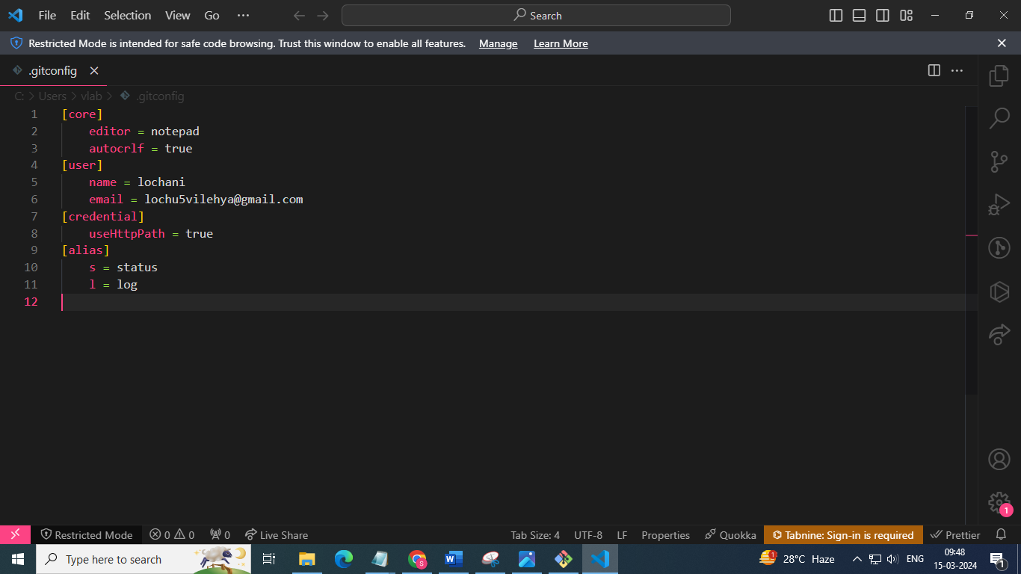

The **git archive** command is used to create a tar or zip archive of a specified Git tree. This can be useful for creating snapshots of a project at a specific commit or branch without including the entire Git history.

Here's the basic syntax for **git archive**:

Where:

* **<format>** specifies the format of the archive (e.g., tar, zip).
* **<file>** specifies the name of the output archive file.
* **<branch/commit>** specifies the branch or commit to create the archive from.

For example, to create a tar archive of the **main** branch and save it as **project.tar**, you would run:

Similarly, you can create a zip archive by specifying **--format=zip**.

vlab@VEDA2F107 MINGW64 ~/Desktop/GIT/git-tag (master)

$ git archive --format=tar --output=tag.tar master

vlab@VEDA2F107 MINGW64 ~/Desktop/GIT/git-tag (master)

$ ls

index.txt new.txt tag.tar

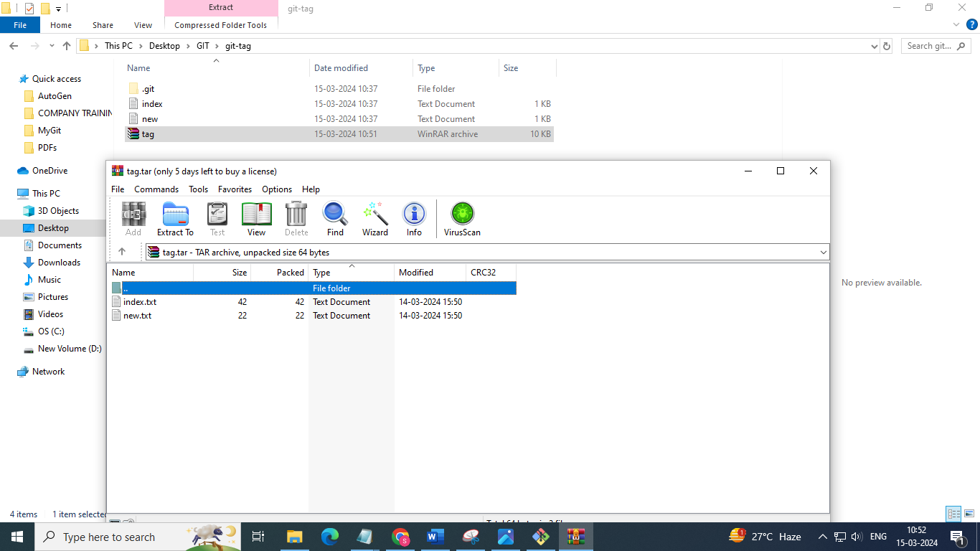

vlab@VEDA2F107 MINGW64 ~/Desktop/GIT/git-tag (master)

$ git ls-remote -h --

From https://github.com/lochu-55/Git_tag.git

de77fae13e85881c7bd127a3556166262b8a3ff8 refs/heads/main

5a04b45d7f1900c00a50e3ab5676f60192f151da refs/heads/master