1. Setup Apache Tomcat on Ubuntu Virtual Machine

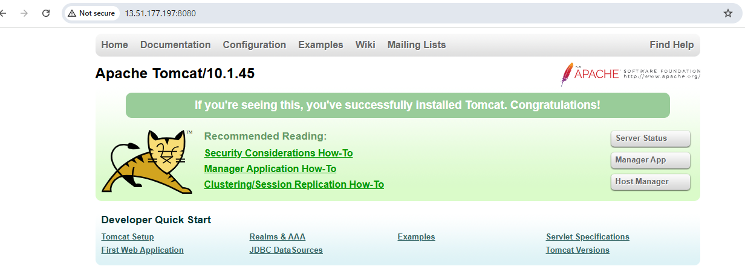

1. Docker setup completed

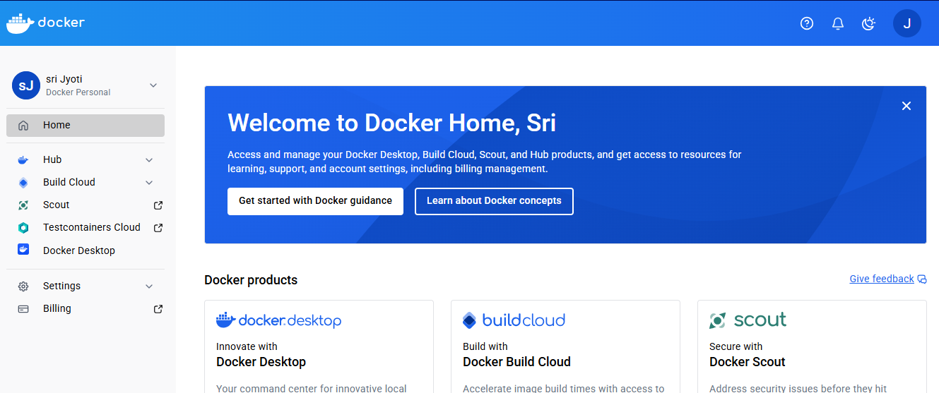

1. Install Jenkins

