**Imported necessary libraries**: selenium, BeautifulSoup, pandas, matplotlib.

**Used Chrome WebDriver**

**Scraped job details** including:

* Job Title
* Company Name
* Salary
* Skills
* Location  
  *(Location scraping was tricky due to nested HTML — solved with Google search & trial-and-error parsing)*
* Scraped first 5 pages of job listings.
* Stored results into a Pandas DataFrame for easy handling.

**Results**:

* 215 jobs found across first 5 pages.
* Top 5 job locations identified.
* Top 10 in-demand skills extracted.
* Visualization:
* Bar chart for top 5 job locations.
* Pie chart for job distribution across locations.

**Visuals**

**Top 5 Job Locations (Bar Chart)**

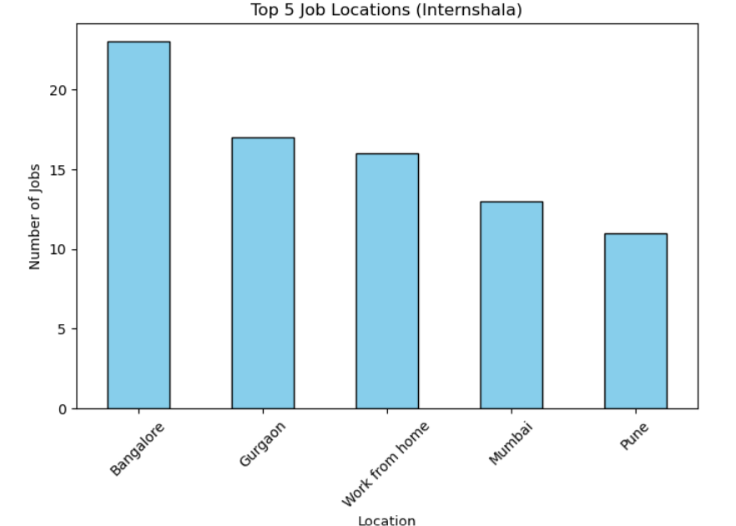

**Distribution of Jobs by Location (Pie Chart)**

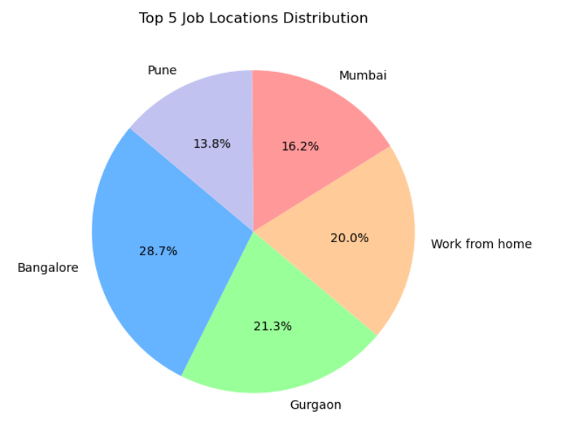

**Challenges Faced**

**Dynamic content loading** → used time.sleep() and scrollTo to ensure data was fully loaded.

**Location extraction** → required handling nested tags (<p> with <span> and <a> elements).

**Skills parsing** → initially concatenated strings incorrectly, later fixed by extracting each <a> tag.

**Maximize window issue** → replaced with set_window_size() since headless mode doesn’t support maximize_window().