**DEPLOYEMENT**

**What is CloudFormation?**

* CloudFormation is a declarative way of outlining your AWS Infrastructure, for any resources (most of them are supported).
* For example, within a CloudFormation template, you say:
  + I want a security group
  + I want two EC2 instances using this security group
  + I want an S3 bucket
  + I want a load balancer (ELB) in front of these machines
* Then CloudFormation creates those for you, in the right order, with the exact configuration that you specify

**Benefits of AWS CloudFormation**

* Infrastructure as code
  + No resources are manually created, which is excellent for control
  + Changes to the infrastructure are reviewed through code
* Cost
  + Each resources within the stack is tagged with an identifier so you can easily see how much a stack costs you
  + You can estimate the costs of your resources using the CloudFormation template
  + Savings strategy: In Dev, you could automation deletion of templates at 5 PM and recreated at 8 AM, safely
* Productivity
  + Ability to destroy and re-create an infrastructure on the cloud on the fly
  + Automated generation of Diagram for your templates!
  + Declarative programming (no need to figure out ordering and orchestration)
* Don’t re-invent the wheel
  + Leverage existing templates on the web!
  + Leverage the documentation
* Supports (almost) all AWS resources:
  + Everything we’ll see in this course is supported
  + You can use “custom resources” for resources that are not supported

**CloudFormation Stack Designer**

* Example: WordPress CloudFormation Stack
* We can see all the resources
* We can see the relations between the components

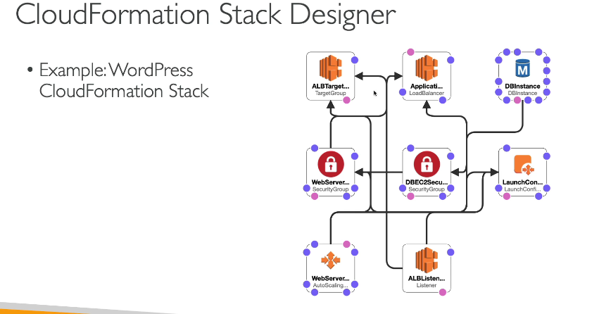

**AWS Cloud Development Kit (CDK)**

* Define your cloud infrastructure using a familiar language:
  + JavaScript/TypeScript, Python, Java, and .NET
* The code is “compiled” into a CloudFormation template (JSON/YAML)
* You can therefore deploy infrastructure and application runtime code together
  + Great for Lambda functions
  + Great for Docker containers in ECS / EKS

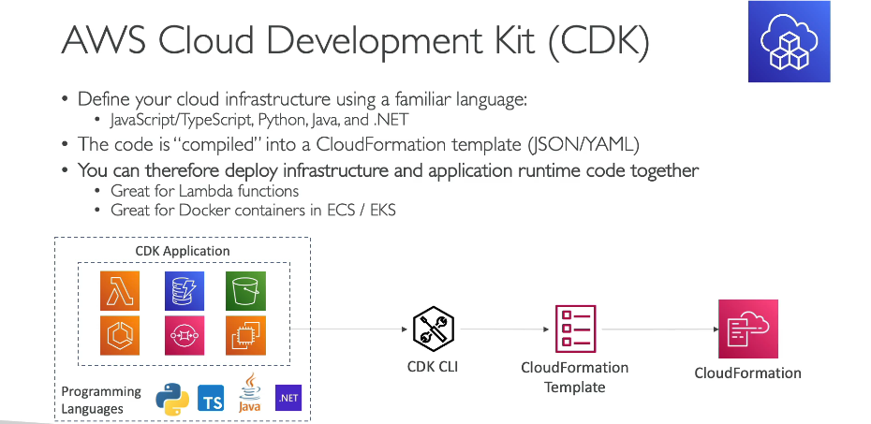

**AWS Elastic Beanstalk Overview**

* Elastic Beanstalk is a developer centric view of deploying an application on AWS
* It uses all the component’s we’ve seen before: EC2, ASG, ELB, RDS, etc…
* But it’s all in one view that’s easy to make sense of!
* We still have full control over the configuration
* Beanstalk = Platform as a Service (PaaS)
* Beanstalk is free but you pay for the underlying instances
* Managed service
  + Instance configuration / OS is handled by Beanstalk
  + Deployment strategy is configurable but performed by Elastic Beanstalk
  + Capacity provisioning
  + Load balancing & auto-scaling
* Application health-monitoring & responsiveness
* Just the application code is the responsibility of the developer
* Three architecture models:
  + Single Instance deployment: good for dev
  + LB + ASG: great for production or pre-production web applications
  + ASG only: great for non-web apps in production (workers, etc..)
* Support for many platforms:
  + Go
  + Java SE
  + Java with Tomcat
  + .NET on Windows Server with IIS
  + Node.js
  + PHP
  + Python
  + Ruby
  + Packer Builder
  + Single Container Docker
  + Multi-Container Docker
  + Preconfigured Docker
* If not supported, you can write your custom platform.

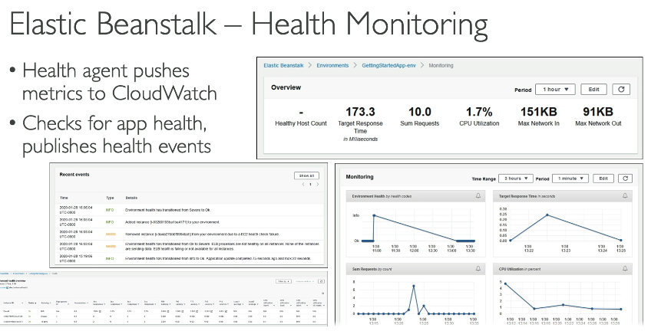

**AWS CodeDeploy**

* We want to deploy our application automatically
* Works with EC2 Instances
* Works with On-Premises Servers
* Hybrid service
* Servers / Instances must be provisioned and configured ahead of time with the CodeDeploy Agent
* 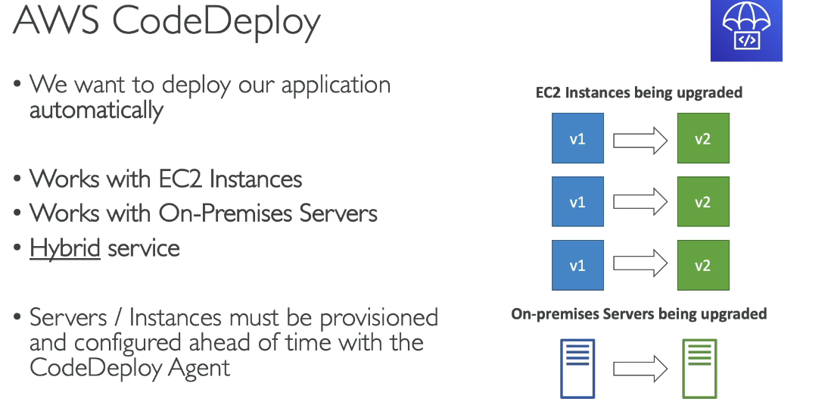

**AWS CodeCommit**

* Before pushing the application code to servers, it needs to be stored somewhere
* Developers usually store code in a repository, using the Git technology
* A famous public offering is GitHub, AWS’ competing product is CodeCommit
* CodeCommit:
  + Source-control service that hosts Git-based repositories
  + Makes it easy to collaborate with others on code
  + The code changes are automatically versioned
* Benefits:
  + Fully managed
  + Scalable & highly available
  + Private, Secured, Integrated with AWS

**AWS CodeBuild**

* Code building service in the cloud (name is obvious)
* Compiles source code, run tests, and produces packages that are ready to be deployed (by CodeDeploy for example)
* Benefits:
  + Fully managed, serverless
  + Continuously scalable & highly available
  + Secure
  + Pay-as-you-go pricing – only pay for the build time

**AWS CodePipeline**

* Orchestrate the different steps to have the code automatically pushed to production
* Code => Build => Test => Provision => Deploy
* Basis for CICD (Continuous Integration & Continuous Delivery)
* Benefits:
  + Fully managed, compatible with CodeCommit, CodeBuild, CodeDeploy, Elastic Beanstalk, CloudFormation, GitHub, 3rd-party services (GitHub…) & custom plugins…
  + Fast delivery & rapid updates
* CodePipeline: orchestration layer
  + CodeCommit => CodeBuild => CodeDeploy => Elastic Beanstalk

**AWS CodeArtifact**

* Software packages depend on each other to be built (also called code dependencies), and new ones are created
* Storing and retrieving these dependencies is called artifact management
* Traditionally you need to setup your own artifact management system
* CodeArtifact is a secure, scalable, and cost-effective artifact management for software development
* Works with common dependency management tools such as Maven, Gradle, npm, yarn, twine, pip, and NuGet
* Developers and CodeBuild can then retrieve dependencies straight from CodeArtifact

**AWS CodeStar**

* Unified UI to easily manage software development activities in one place
* “Quick way” to get started to correctly set-up CodeCommit, CodePipeline, CodeBuild, CodeDeploy, Elastic Beanstalk, EC2, etc…
* Can edit the code ”in-the-cloud” using AWS Cloud9
* AWS CodeStar will be discontinued as of July 2024 It can still appear in the exam. It has a replacement named "CodeCatalyst".

**AWS Cloud9**

* AWS Cloud9 is a cloud IDE (Integrated Development Environment) for writing, running and debugging code
* “Classic” IDE (like IntelliJ, Visual Studio Code…) are downloaded on a computer before being used
* A cloud IDE can be used within a web browser, meaning you can work on your projects from your office, home, or anywhere with internet with no setup necessary
* AWS Cloud9 also allows for code collaboration in real-time (pair programming)(working togeteher in a project in same time)

**AWS Systems Manager (SSM)**

* Helps you manage your EC2 and On-Premises systems at scale
* Another Hybrid AWS service
* Get operational insights about the state of your infrastructure
* Suite of 10+ products
* Most important features are:
  + Patching automation for enhanced compliance
  + Run commands across an entire fleet of servers
  + Store parameter configuration with the SSM Parameter Store
* Works for both Windows and Linux OS

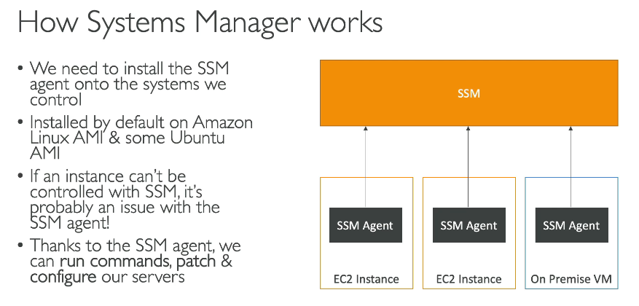

**Systems Manager - SSM Session Manager**

* Allows you to start a secure shell on your EC2 and on-premises servers
* No SSH access, bastion hosts, or SSH keys needed
* No port 22 needed (better security)
* Supports Linux, macOS, and Windows
* Send session log data to S3 or CloudWatch Logs