**Project Name: ScrapYard**

**Project Member:**

|  |  |
| --- | --- |
| **PRN No.** | **Name** |
| 220343120020 | B SRIKANT |
| 220343120002 | ABHISHEK MAGDUM |
| 220343120038 | PRATIK JADHAV |
| 220343120078 | PRADIP SONAWANE |

**Abstract:**

ScrapYard is a user friendly web application in which anybody can sell their scrap to us on an amazing value. We are just trying to maximize resource value and minimize environmental impact. It provides the user with different Scrap Types and their price. In order to facilitate online scrap selling a Dump cart is provided to user. You just order and our Collector will take care of everything. To develop this App number of technologies must be studied SPRINGBOOT, REACT, MySQL, BOOTSTRAP.

This project deals with developing ScrapYard website for Online Scrap Collection door to door. It provides the user with a list of different category of Scrap. In order to facilitate, online customer Registration is provided to the user. The system is implemented using a 4-tier approach, with a backend database, a middle tier of SPRINGBOOT, REACT and web browser as the front end client, backend server.

In order to develop an ScrapYard website, a number of Technologies must be studied and understood. These include 3 tier architecture, server and client side scripting techniques, implementation technologies such as SPRINGBOOT, REACT, BOOTSTRAP, programming language (such as Core Java, Advance Java,HTML,CSS,Js), relational databases (such as MySQL).

This is a project with the objective to develop a basic website where a customer provided with best service. Where the user will be given the power to sell the scrap on our website about would be able to contriute review it. Thus, resulting in a better communication and trust between the general customer and collector.

**Implementation Technologies:**

1. **Spring Boot:**

Spring Boot is **an open source Java-based framework used to create a micro Service**. It is developed by Pivotal Team and is used to build stand-alone and production ready spring applications. This chapter will give you an introduction to Spring Boot and familiarizes you with its basic concepts.

# 1.1 Features of Spring Boot:

## **1. Web Development**

It is well suited Spring module for web application development. We can easily create a self-contained HTTP server using embedded Tomcat, Jetty or Undertow. We can use the spring-boot- starter-web module to start and running application quickly.

## **2 .SpringApplication**

It is a class which provides the convenient way to bootstrap a spring application which can be started from main method. You can call start your application just by calling a static run() method.

**public** **static** **void** main(String[] args){

    SpringApplication.run(className.**class**, args);

}

## **3. Application Events and Listeners**

Spring Boot uses events to handle variety of tasks. It allows us to create factories file that are used to add listeners. we can refer it by using ApplicationListener key. Always create factories file in META-INF folder like: **META-INF/spring.factories**

## **4 Admin Support**

Spring Boot provides the facility to enable admin related features for the application. It is used to access and manage application remotely. We can enable it by simply using spring.application.admin.enabled property.

## **5. Externalized Configuration**

Spring Boot allows us to externalize our configuration so that we can work with the same application in different environments. Application use YAML files to externalize configuration.

## **6. Properties Files**

Spring Boot provides rich set of Application Properties. So, we can use that in properties file of our project. Properties file is used to set properties like: **server-port = 8080** and many others. It helps to organize application properties.

## **7.YAML Support**

It provides convenient way for specifying hierarchical configuration. It is a superset of JSON. The SpringApplication class automatically support YAML. It is successful alternative of properties.

## 8. **Type-safe Configuration**

Strong type-safe configuration is provided to govern and validate the configuration of application. Application configuration is always a crucial task which should be type-safe. We can also use annotation provided by this library

## 9. **Logging**

Spring Boot uses Common logging for all internal logging. Logging dependencies are managed by default. We should not change logging dependencies, if there is no required customization is needed.

## 10. **Security**

Spring Boot applications are spring bases web applications. So, it is secure by default with basic authentication on all HTTP endpoints. A rich set of Endpoints are available for develop a secure Spring Boot application.

### **1.2 Advantages of** **Spring Boot**:

Developers have a lot of reasons that they choose Spring Boot to build microservices for mobile apps and web applications. The following list describes some of the top advantages that you can get by switching to Spring Boot.

#### **1.Spring Boot works well with several servlet containers**

Spring Boot works well with some of the most popular embedded servlet containers. Spring Boot uses [Tomcat](https://www.adservio.fr/post/tomcat-performance-best-practices" \t "_blank) as its default, but you can easily swap it for Jetty, Undertow, Resin, and Wildfly. You get to choose the option that improves the specific types of functionality that concern you most.

Just as importantly, Spring Boot automatically identifies the servlet you set as the new default during the boot sequence. These Advantages of Spring Boot give you the flexibility to choose embedded servers that suit your needs best.

#### **2.Bootstrapping saves memory space**

Spring Boot uses Boot Initializer to compile the source language. This bootstrapping technique makes it possible for users to save space on their devices and load applications quickly.

#### **3.Decreased boilerplate code**

Spring Boot’s in-memory database and embedded server (Tomcat) decrease or eliminate the boilerplate code typically needed to set up an application.

Without lots of boilerplate code, development teams can shorten their development times and update cycles, leading to more satisfied users and more productive employees. It’s yet another of the advantages of Spring Boot that helps developers save time.

#### **4.No XML configuration required**

Spring project developers can choose to use annotations or XML configurations. The option to avoid XML configurations appeals to a lot of software engineers who don’t want to go through the extra steps required.

#### **5.WAR files are not required**

While Spring Boot can use WAR (web application resource) files, they are not necessary. Instead, Spring Boot can rely on JAR (Java resource).

JAR has a shorter, simpler structure that makes them useful for developers and users. The lightweight files work quickly to connect applications with the tools they need to function.

The option to use either WAR or JAR also benefits development teams. If someone in the group doesn’t have experience with JAR, they can rely on WAR. It might have a subtle effect on speed, but it helps developers bring their products to market as fast as possible.

#### **6.POM dependency management**

Spring Boot doesn’t force you to use a parent POM (project object model). Adding the spring-boot-dependencies artifact lets you manage dependencies without relying on a parent POM or XML file.

#### **7.A large community of helpful users**

Like many open-source tools, Spring Boot has a large community of users full of people who enjoy sharing their insights and creations.

No matter what level of experience you have with Spring’s ecosystem of products, you can find helpful tutorials and discussions online.

Another advantage of having such a large community of users is that you can often find existing code that closely resembles what you want to build.

Instead of starting from scratch, you can access the code and adjust it to meet your needs. [GitHub’s Spring Boot page](https://github.com/spring-projects/spring-boot" \t "_blank) is always a good place to start.

1. **REACT Js**

React is a **JavaScript** library created by **Facebook**React is a **User Interface** (UI) library.React is a tool for building **UI components**

**React Features:**

Currently, ReactJS gaining quick popularity as the best JavaScript framework among web developers. It is playing an essential role in the front-end ecosystem. The important features of ReactJS are as following.

### **1.JSX**

JSX stands for JavaScript XML. It is a JavaScript syntax extension. Its an XML or HTML like syntax used by ReactJS. This syntax is processed into JavaScript calls of React Framework. It extends the ES6 so that HTML like text can co-exist with JavaScript react code. It is not necessary to use JSX, but it is recommended to use in ReactJS.

### **2.Components**

ReactJS is all about components. ReactJS application is made up of multiple components, and each component has its own logic and controls. These components can be reusable which help you to maintain the code when working on larger scale projects.

### **3.One-way Data Binding**

ReactJS is designed in such a manner that follows unidirectional data flow or one-way data binding. The benefits of one-way data binding give you better control throughout the application. If the data flow is in another direction, then it requires additional features. It is because components are supposed to be immutable and the data within them cannot be changed. Flux is a pattern that helps to keep your data unidirectional. This makes the application more flexible that leads to increase efficiency.

### **4.Virtual DOM**

A virtual DOM object is a representation of the original DOM object. It works like a one-way data binding. Whenever any modifications happen in the web application, the entire UI is re-rendered in virtual DOM representation. Then it checks the difference between the previous DOM representation and new DOM. Once it has done, the real DOM will update only the things that have actually changed. This makes the application faster, and there is no wastage of memory.

### **5.Simplicity**

ReactJS uses JSX file which makes the application simple and to code as well as understand. We know that ReactJS is a component-based approach which makes the code reusable as your need. This makes it simple to use and learn.

### **6.Performance**

ReactJS is known to be a great performer. This feature makes it much better than other frameworks out there today. The reason behind this is that it manages a virtual DOM. The DOM is a cross-platform and programming API which deals with HTML, XML or XHTML. The DOM exists entirely in memory. Due to this, when we create a component, we did not write directly to the DOM. Instead, we are writing virtual components that will turn into the DOM leading to smoother and faster performance.

### **ADVANTAGES OF REACTJS**

* **Intuitive**  
  ReactJS is extremely intuitive to work with and provides interactivity to the layout of any UI. Plus, it enables fast and quality assured application development that in turn saves tome for both - clients and developers.
* **Declarative**  
  ReactJS enables significant data changes that result in automatic alteration in the selected parts of user interfaces. Owing to this progressive functionality, there is no additional function that you need to perform to update your user interface.
* **Provides Reusable Components**  
  ReactJS provides reusable components that developers have the authority to reuse and create a new application . Reusability is exactly like a remedy for developers. This platform gives the developers the authority to reuse the components build for some other application having the same functionality. Thereby, reducing the development effort and ensuring a flawless performance.
* **JavaScript library**

A strong blend of JavaScript and HTML syntax is always used, which automatically simplifies the entire process of writing code for the planned project. The JS library consists several functions including one that converts the HTML components into required functions and transforms the entire project so that it is easy to understand.

* **Components Support**

ReactJS is a perfect combination of JavaScript and HTML tags. The usage of the HTML tags and JS codes, make it easy to deal with a vast set of data containing the document object model. During this time, ReactJS works as a mediator which represents the DOM and assists to decide which component needs changes to get the exact results.

* **SEO-friendly**

React JS was introduced after immense research and improvements by Facebook. Naturally, it stands out from the crowd and allows developers to build amazing, SEO-friendly user interfaces across browsers and engines.

* **Proficient Data Binding**

ReactJS trails one-way data binding. This means that absolutely anyone can track all the changes made to any particular segment of the data. This is a symbol of its simplicity.

**3.** **MySQL**

MySQL, the most popular Open Source SQL database management system, is developed, distributed, and supported by Oracle Corporation.

**Features of MySQL:**

* **MySQL is a database management system.**

A database is a structured collection of data. It may be anything from a simple shopping list to a picture gallery or the vast amounts of information in a corporate network. To add, access, and process data stored in a computer database, you need a database management system such as MySQL Server. Since computers are very good at handling large amounts of data, database management systems play a central role in computing, as standalone utilities, or as parts of other applications.

* **MySQL databases are relational.**

A relational database stores data in separate tables rather than putting all the data in one big storeroom. The database structures are organized into physical files optimized for speed. The logical model, with objects such as databases, tables, views, rows, and columns, offers a flexible programming environment.

* **MySQL software is Open Source.**

Open Source means that it is possible for anyone to use and modify the software. Anybody can download the MySQL software from the Internet and use it without paying anything.

* **The MySQL Database Server is very fast, reliable, scalable, and easy to use.**

MySQL Server was originally developed to handle large databases much faster than existing solutions and has been successfully used in highly demanding production environments for several years. Although under constant development, MySQL Server today offers a rich and useful set of functions. Its connectivity, speed, and security make MySQL Server highly suited for accessing databases on the Internet.

* **MySQL Server works in client/server or embedded systems.**

The MySQL Database Software is a client/server system that consists of a multithreaded SQL server that supports different back ends, several different client programs and libraries, administrative tools, and a wide range of application programming interfaces (APIs).

1. **Hardware and Software Requirements (Minimum):**

**Hardware:**

1. Intel i3 processor 3rd generation or later / AMD Ryzen 200 2nd generation or later

2. 2 GB ddr3 ram.

3. Windows 7 Home edition or later.

4. 200 GB Sata HDD Space

5. Data Connection 200 kbps

**Software:**

1. Eclipse Oxygen.3a Release (4.7.3a)
2. MySQL 5.7 with Workbench 8.0
3. Google Chrome version 79.0
4. VS Code
5. **ER Diagram:**

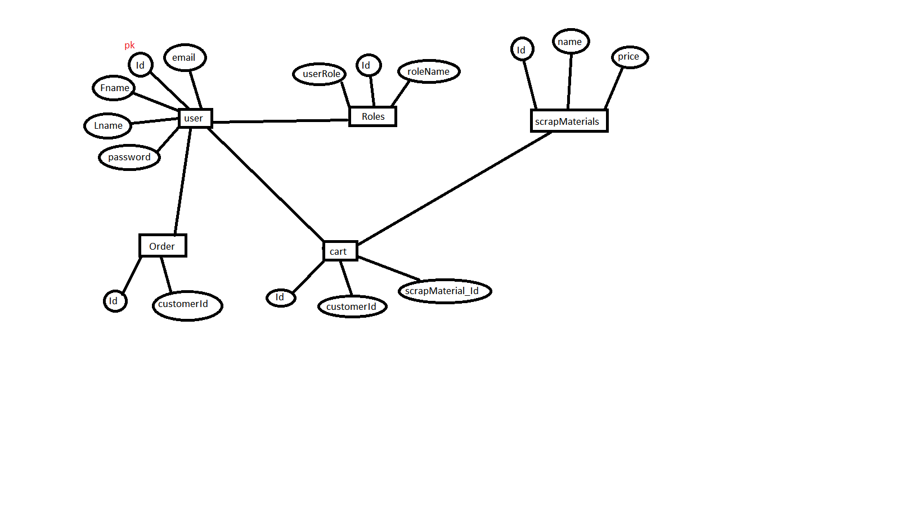

Figure 1: ER Diagram

1. **Table Structures:**
2. **Table name: User**

**Column name Type**

Id int(PRI) auto\_increment

Fname varchar(20) YES

Lname varchar(20) YES

password varchar(20) YES

1. mailId varchar(40) YES

Address varchar(40) YES

Ph\_No varchar(20) YES

1. **Table name: Roles**

**Column name Type**

Id int PRI auto\_increment

role\_Name varchar(50) YES

User\_role varchar(10) YES

1. **Table name: Cart**

**Column name Type**

Id int NO PRI auto\_increment

CustomerId int YES MUL

ScrapMaterialId varchar(40) YES

1. **Table name: ScrapMaterials**

**Column name Type**

Id int NO PRI auto\_increment

Name int YES MUL

ScrapPrice varchar(40) YES

1. **Table name: Order**

**Column name Type**

Id int NO PRI auto\_increment

U\_id int YES MUL

1. **UML Diagrams:**

**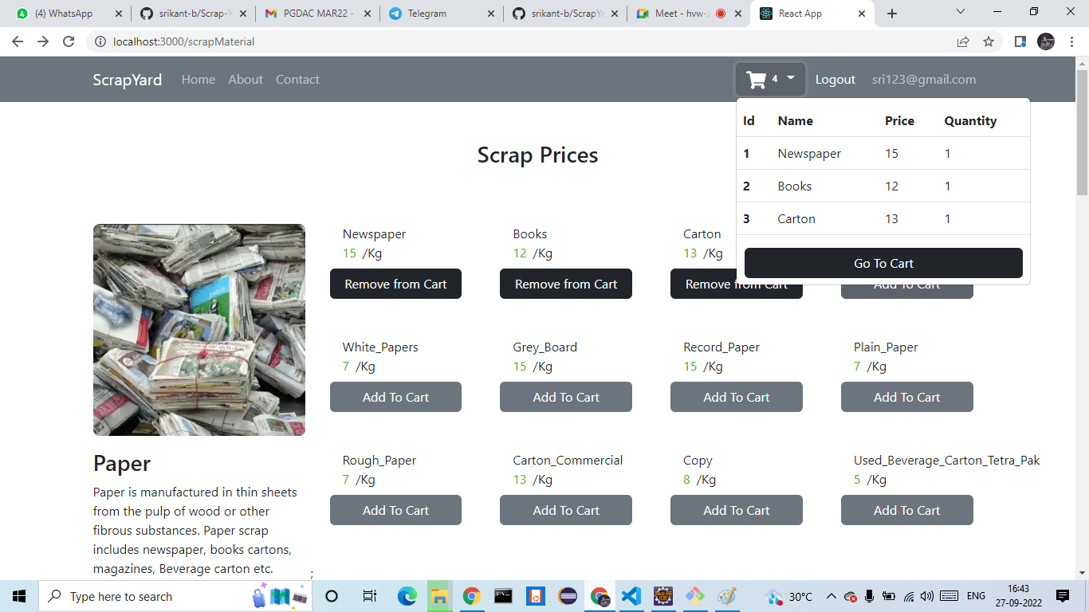**

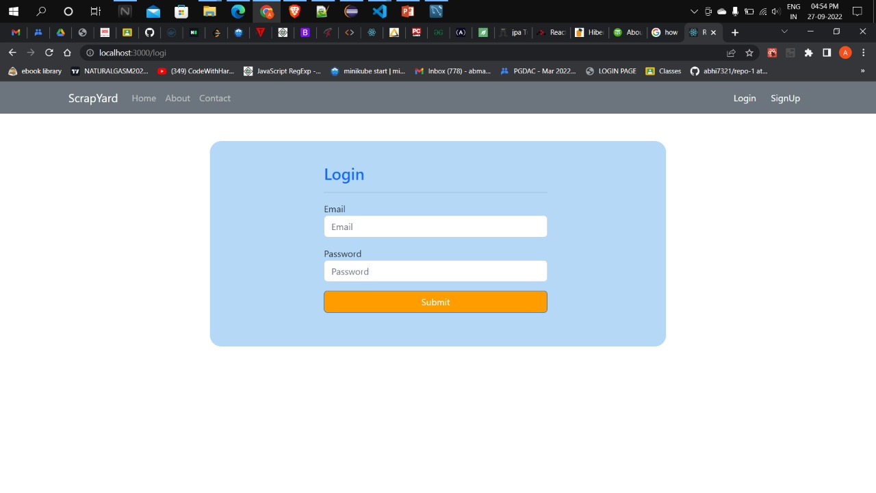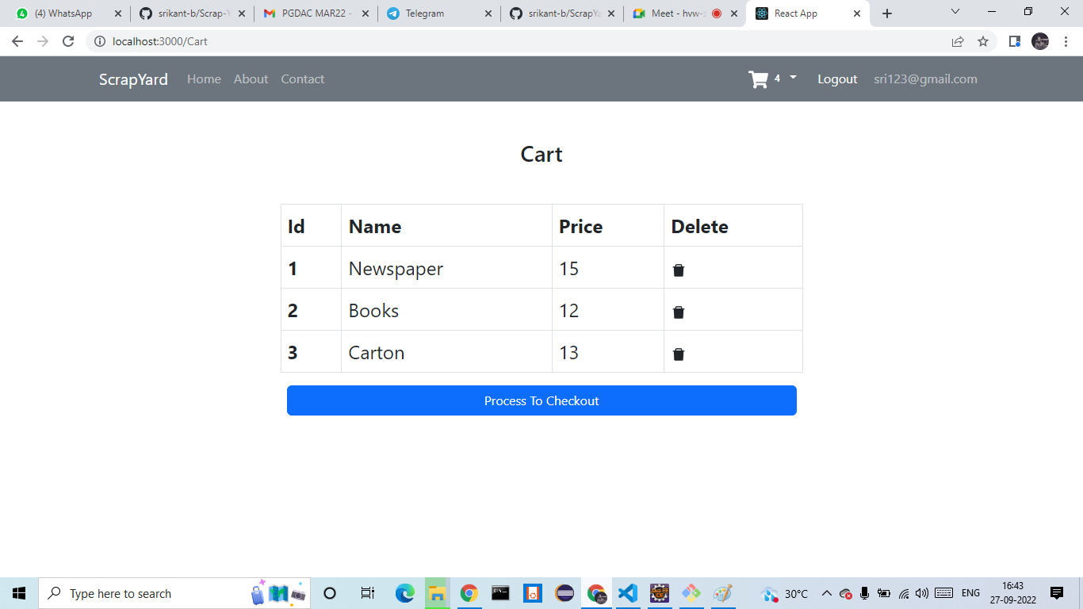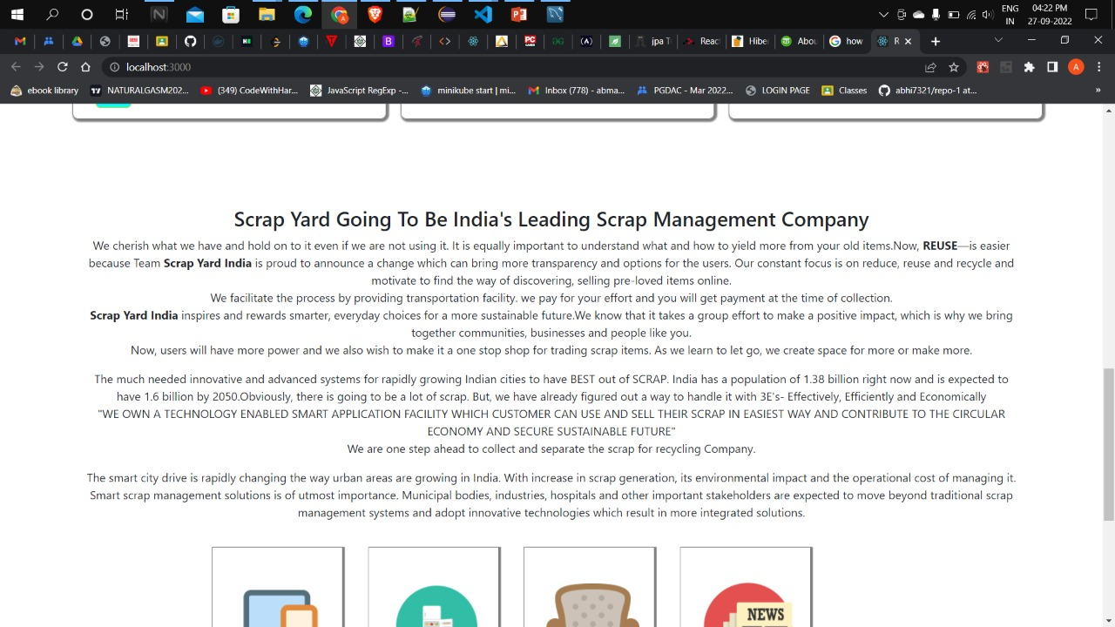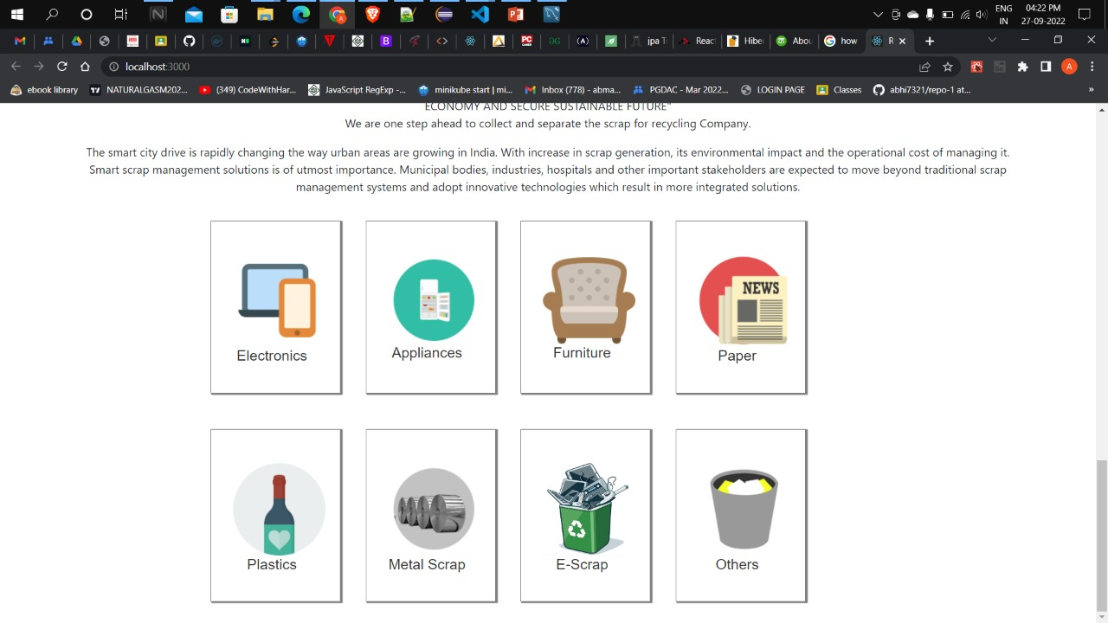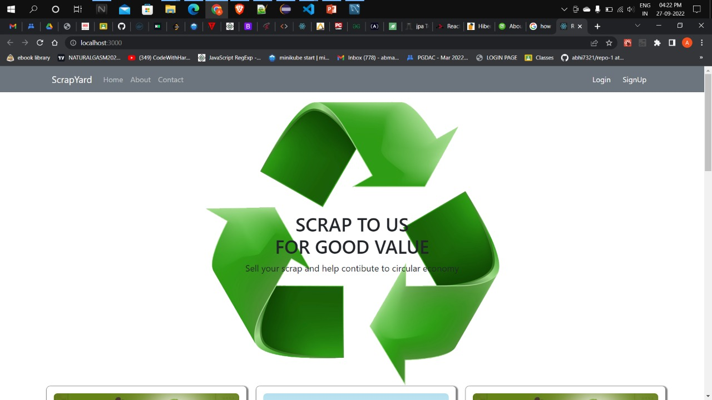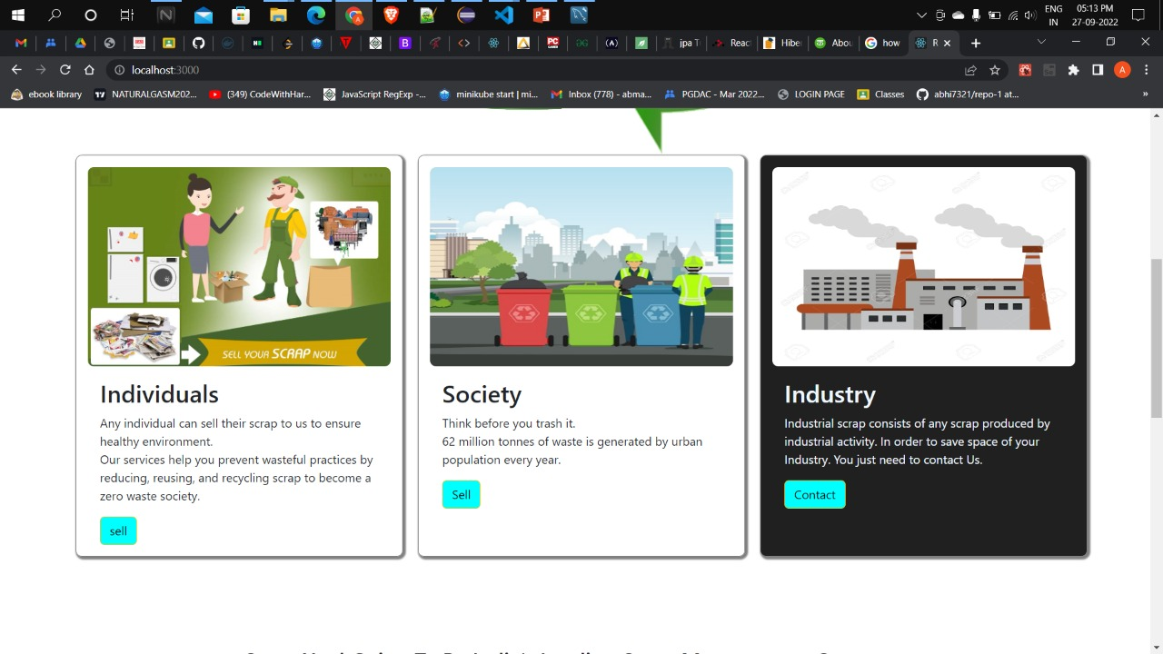

Figure 2: Use Case

1. **End to End Flow of Application:**

**Users -** Customer , Collector , Admin

**Customer:**

Customer sells the scrap to us (Admin) and in turn they get the amazing value for their scrap.

**COLLECTOR**:-

Collector gets the information about the Customer like name of customer , address , contact , etc .

**Admin:**

1. Admin will login as Admin from the ‘**Admin login**’ page and will be able to make useful changes
2. **Future Scope of Project:**

Improvement can be done in payment method .

Improvement in design of collector Api.

Mobile Application.

Tracking System.

Advertisements Zone for Recycling companies.

Recycled Products e-commerce

Chat BOT

**Thank You!**