1. ReactJS-HOL :-

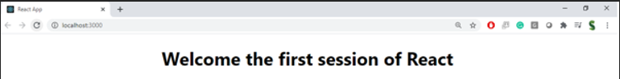

1. ReactJS-HOL :-

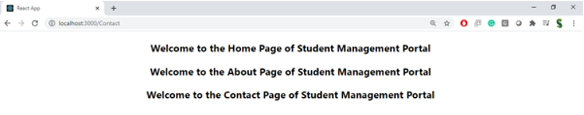

1. ReactJS-HOL :-

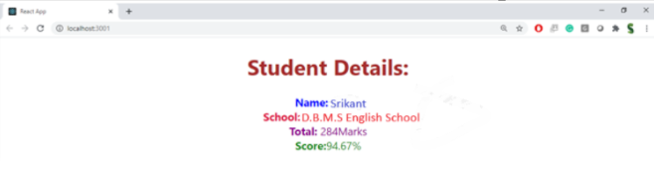

1. ReactJS-HOL :-



1. ReactJS-HOL :-

