Week 8 :

1. GIT-HOL :

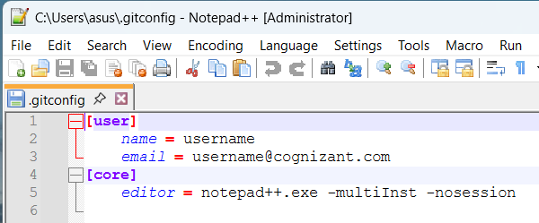

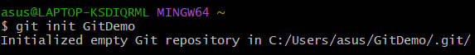





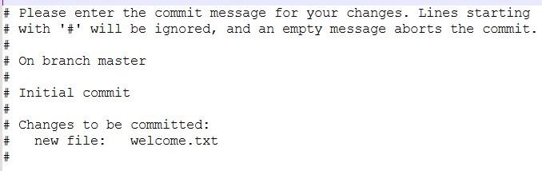

1. GIT-HOL :



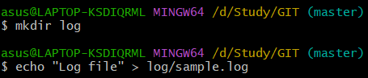

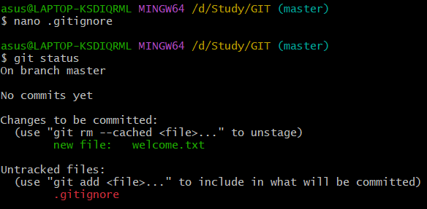

1. GIT-HOL :

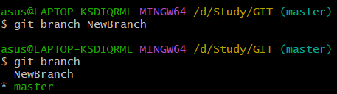

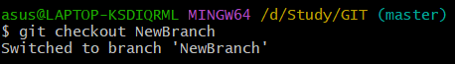

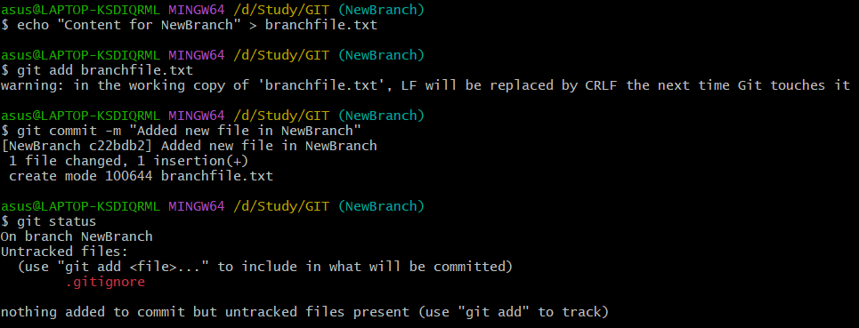

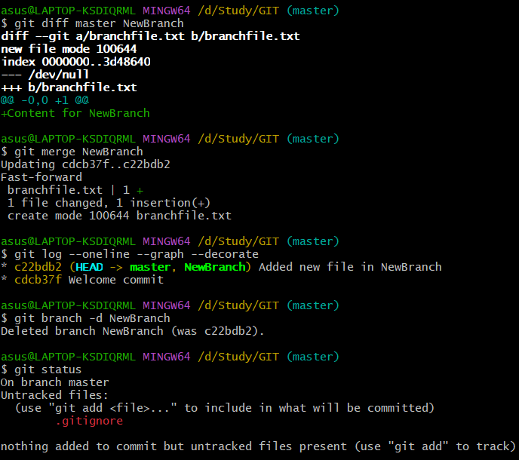

1. GIT-HOL :

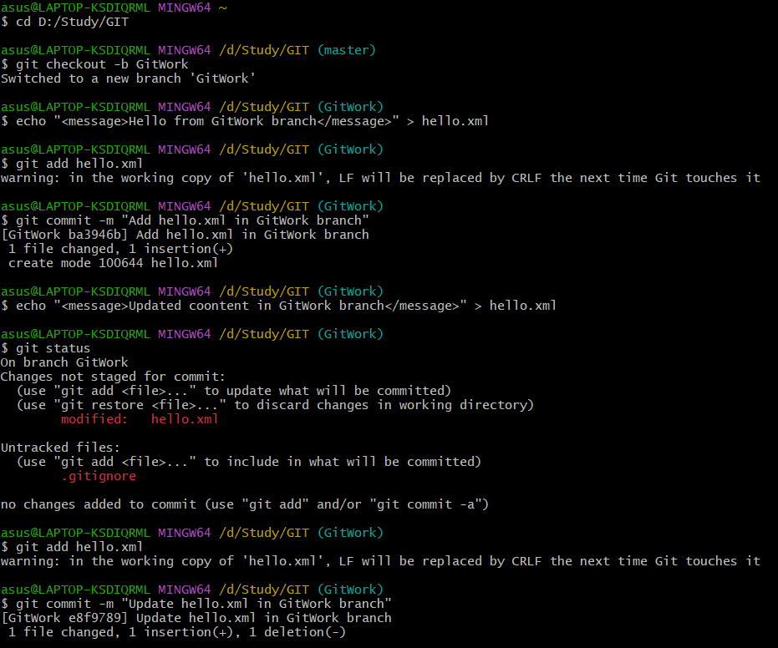

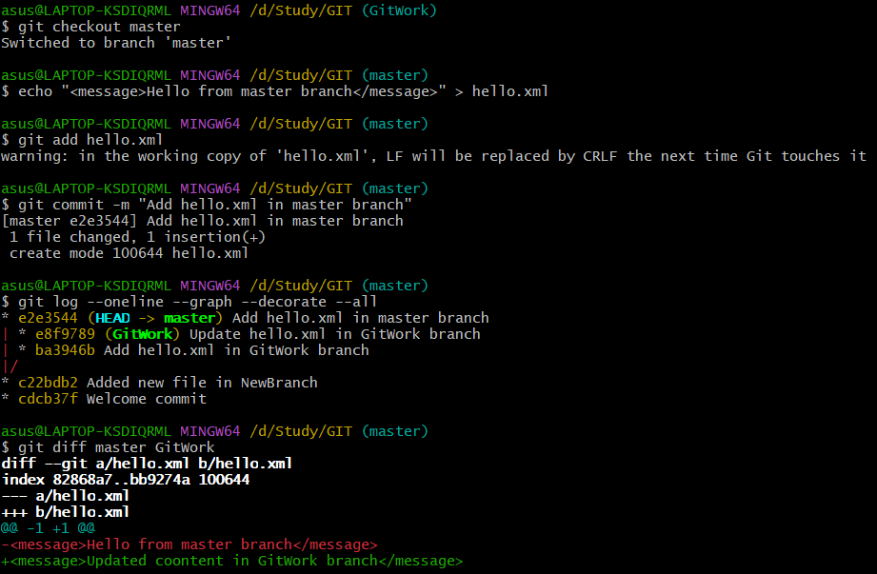

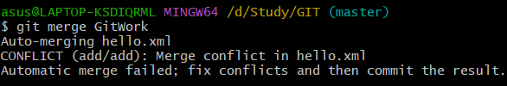

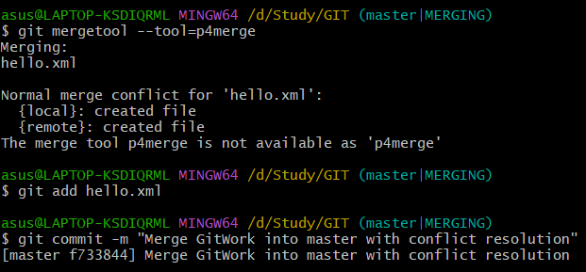

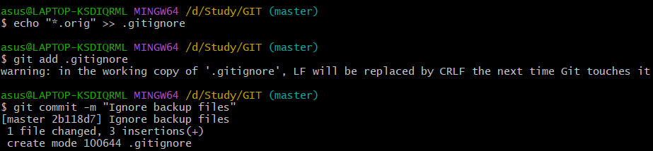

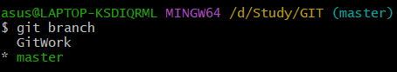

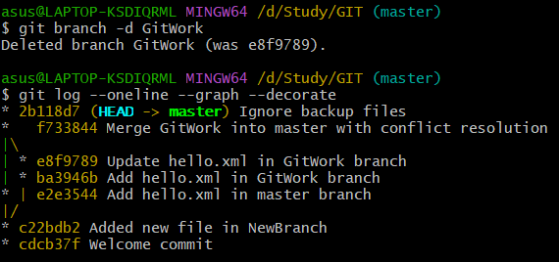

1. GIT-HOL :

Commands :

git branch –a

\*master

git-hol-3

remotes/origin/master

remotes/origin/git-hol-3

git pull origin master

git checkout git-hol-3

git push origin git-hol-3

git fetch origin

git log origin/git-hol-3 –oneline

git log git-hol-3 --oneline