<https://sourcecodehero.com/login-and-registration-system-in-django-with-source-code/>

These are the step’s to run a Login And Registration System Project in Django

1. **pip install virtualenv**

First, You need to install the virtualenv, Open a command prompt by going to the project folder directory and typing CMD. After opening the CMD type ” **pip install virtualenv** “.  
  
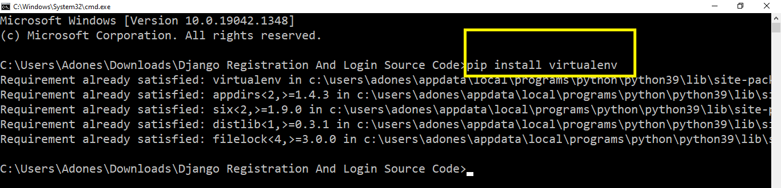

1. **virtualenv env**

Then, after installing virtualenv just type “**virtualenv env**” and enter.  
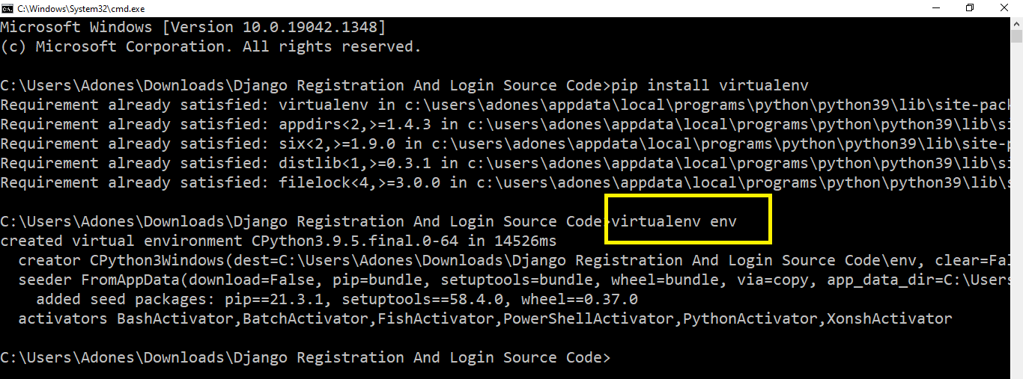

1. **cd env/Scripts**

Next, just type ” **cd env/Scripts**” and press enter.  
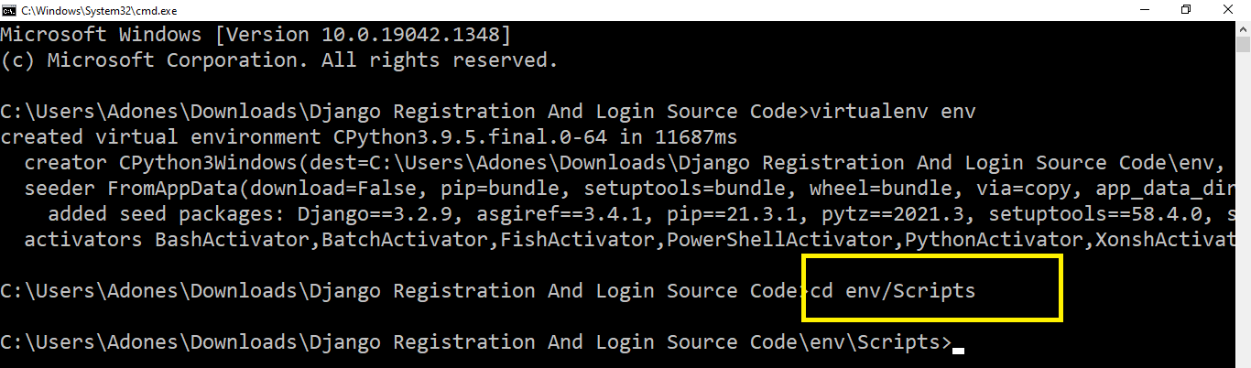

1. **activate**

Next, you need to type “**activate**” then press enter.  
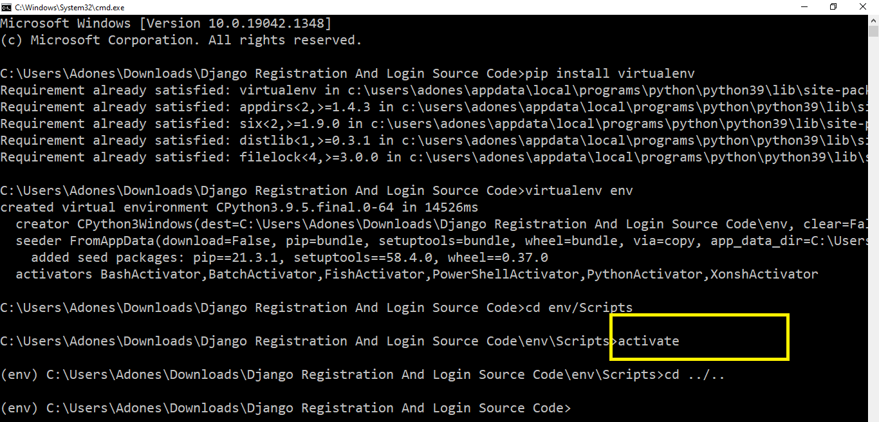

1. **cd ../..**

Next, after you activate just type the command “**cd../..**“  
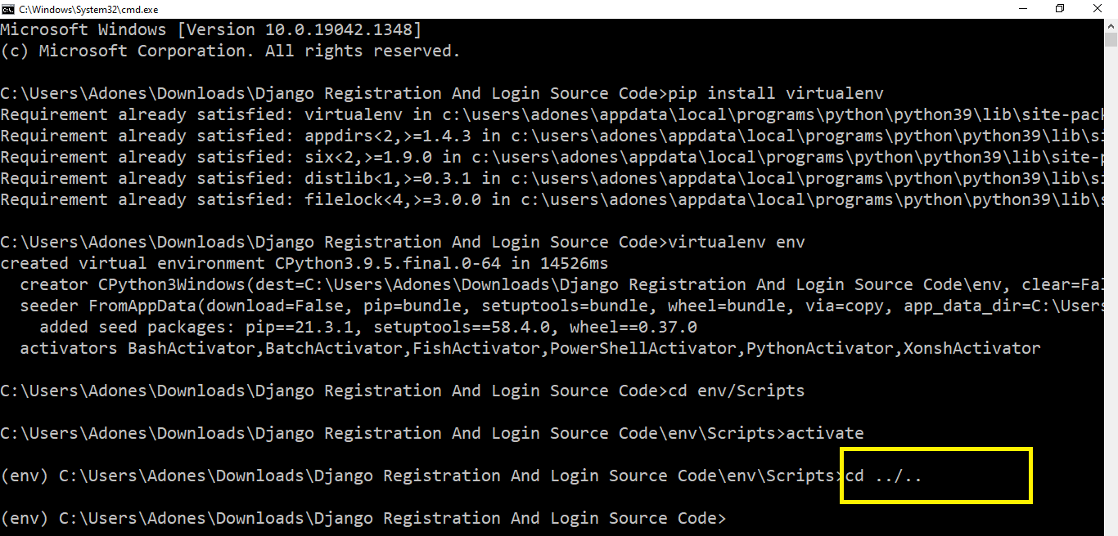

1. **Install Django**

Next, type the command “**pip install django**”.  
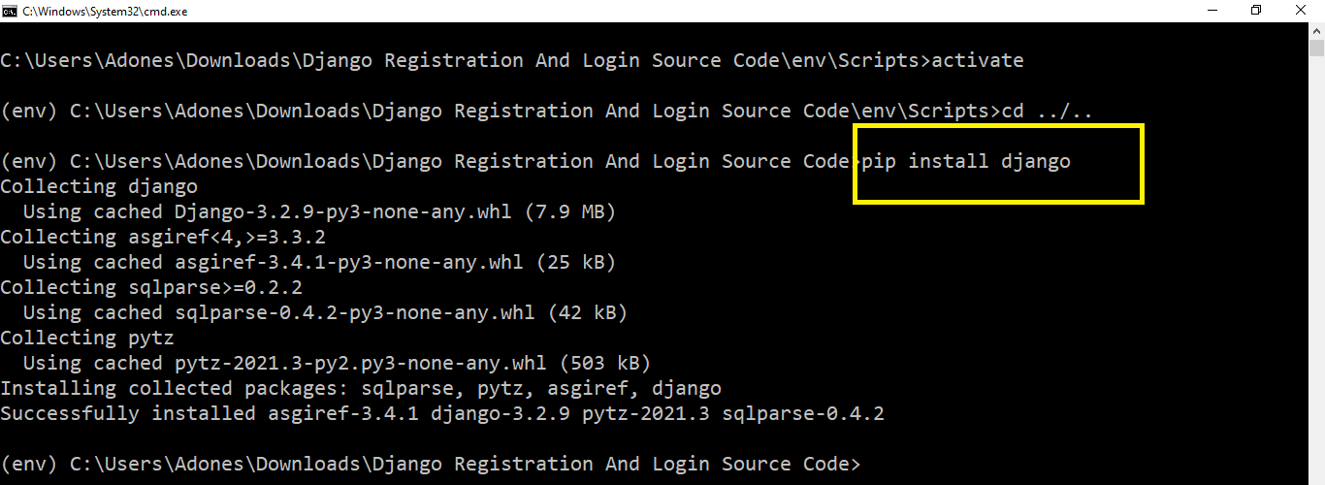

1. **pip install -r requirements.txt**

Next, type the command ” **pip install -r requirements.txt** ” to install requirements.  
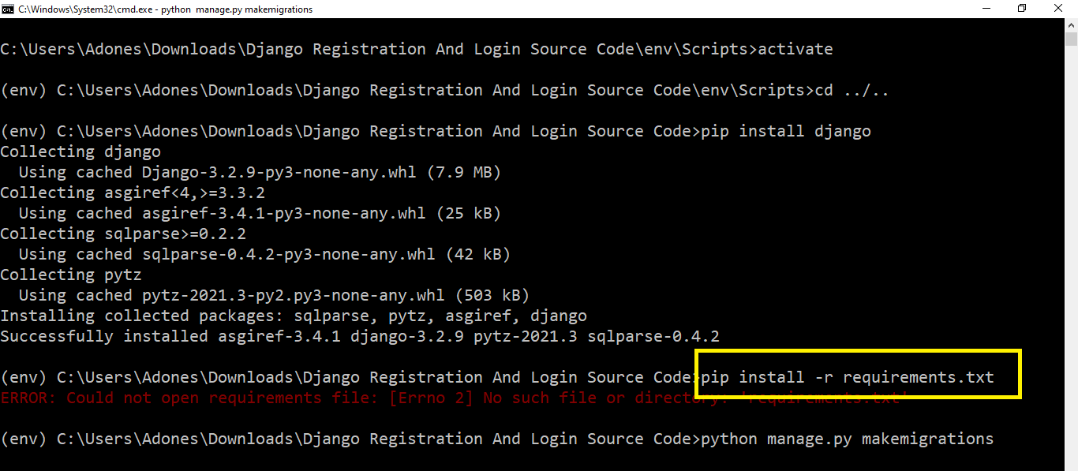

1. **python manage.py makemigrations**

Next, after installing the requirements type this command ” **python manage.py makemigrations**” to create a tables in the database.  
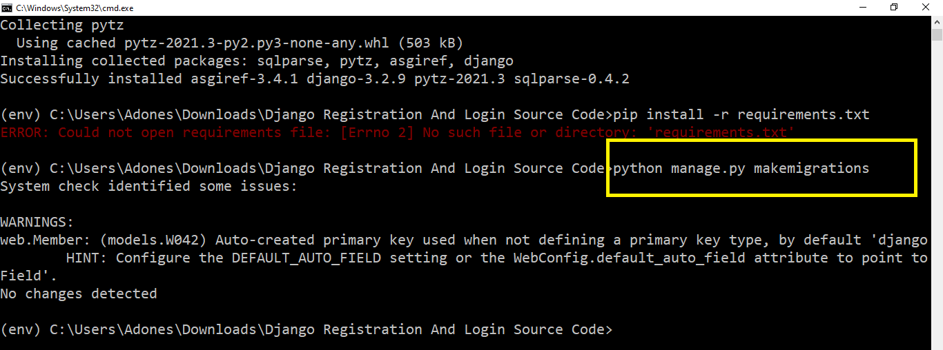

1. **python manage.py migrate –run-syncdb**

Next, after making migrations type this command ” **python manage.py migrate –run-syncdb** ” to migrate the tables in database.  
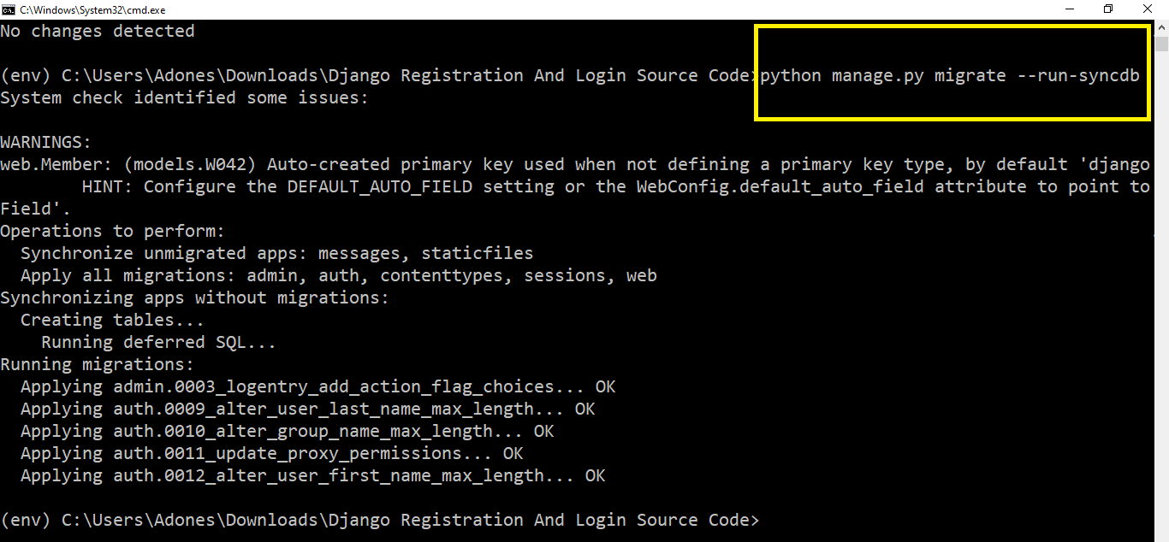

1. **python manage.py createsuperuser**

After migration of database you need to create super user to login in the admin account, just you need is to type the command ” **python manage.py createsuperuser** “.  
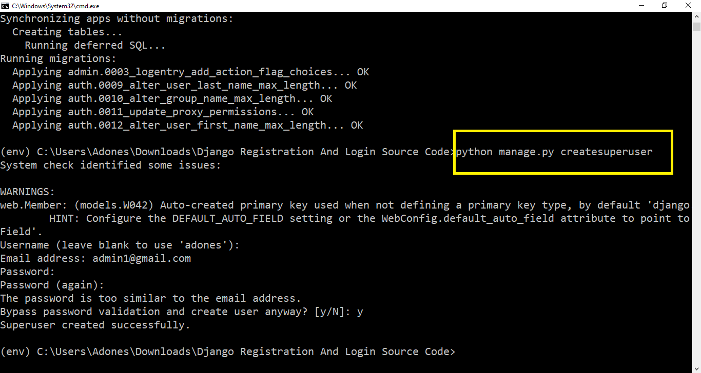

1. **python manage.py runserver**

Lastly, after creating super user just type the command ” **python manage.py runserver** “. It should only be used for testing and launching your project; it should not be utilized for live website deployment.  
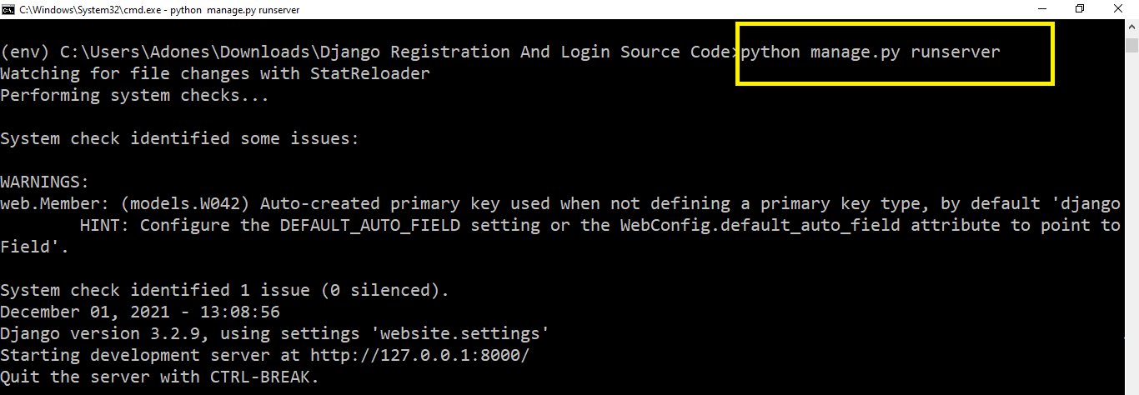

1. **http://127.0.0.1:8000/**

Finally, To access your project dashboard, type or copy this “**http://127.0.0.1:8000/**” into your browser.  
