1. Search for “**Software center**” in your windows machine



1. Search for “git” and enter

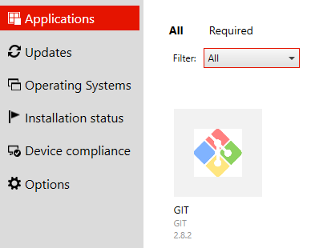

1. Select “Install “

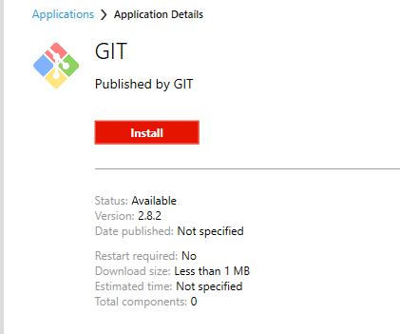

1. Once successfully installed go to “Git Bash” using Windows search
2. Check the basic command “git –version” is working fine or not



1. Configure your username using the following command:

git config --global user.name "manikumar"

1. Configure your email address using the following command:

git config --global user.email "manikumar@dbs.com"

1. git clone ssh://git@bitbucket.sgp.dbs.com:7999/p2p-sg/paylah-consumer.git **(or)** https://youronebankid@bitbucket.sgp.dbs.com:8443/dcifgit/scm/p2p-sg/paylah-consumer.git
2. If you see any ssl handshake errors, input following commands to ignore to trust your local.

git config --global http.sslVerify false

1. Please do not commit/changes in “master” You need to switch to release branch
2. Checkout branch level using below command

git checkout **release/Release_Server_2018_6.3.0**

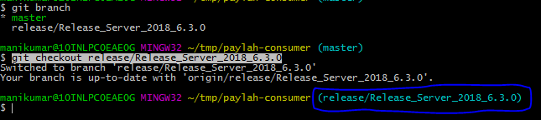

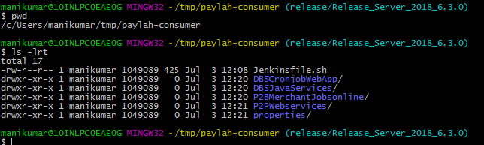

1. Now Branch “**release/Release_Server_2018_6.3.0”** is ready for development
2. You can also use “**Source Tree**” for same in “software center” from step-1

You can see GIT useful commands in below url for your ease.

* <https://confluence.sgp.dbs.com:8443/dcifcnfl/display/PPSG/Basic+Git+commands>