19th-Feb-2018- (Monday)-session-1

Why Oracle?

* It is the choice of richest client in the world.
* It has more number of powerful features to provide Enterprise Level Solution from small to large scale requirements.
* It is considered that Oracle developers can work in any kind of Database Management System Software.
* A System is referred to any Business.
* DBMS is not a software it is a formal principle of storing, organizing, arranging and manipulating the users data.
* A Software that can arrange, store, organize, manipulate, implement the End-users business data by providing Scalability, Reliability, Security, Consistency, Concurrency, Integrity is referred as **Database Management System** Software.
* Oracle is one of such Identified DBMS software.

20th-Feb-2018- (Tuesday)-session-2

1.DataBase Management System

2.Relational DataBase Management System

3.Object Oriented DataBase Management System

4.Object Relational DataBase Management System

* System is a collection of objects and events.
* As per the System, that particular type of object and their associated event should take place.
* Where there is a system, there must be Objects; and where there is a Objects events will exists; and finally when Objects and associated events are there, there must be one System exists.
* A System cannot exist without Objects & Events. And Objects and events would work/behave based on some rules which are framed by the business, called as logical boundaries of the system.
* So, every System defines some boundaries to control its participating Objects and the Events. These are nothing but rules, otherwise objects will behave their own way.

21st-Feb-2018 – (Wednesday)-session-3

*Responsibility Of the Database Developer:*

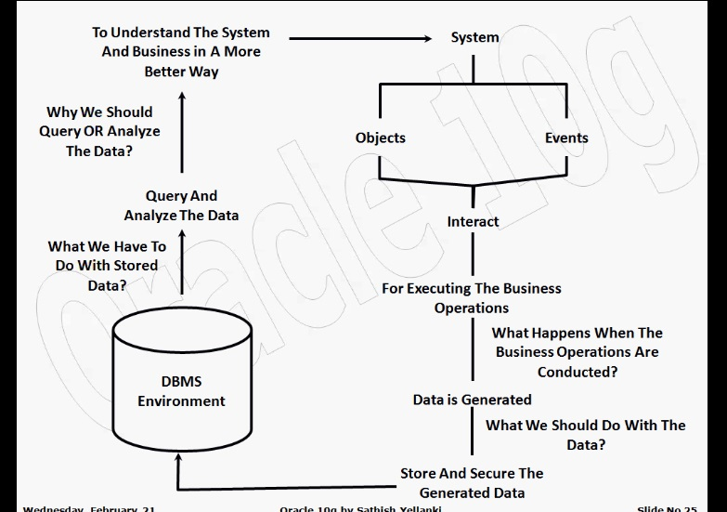

22nd-Feb-2018- (Thursday)-session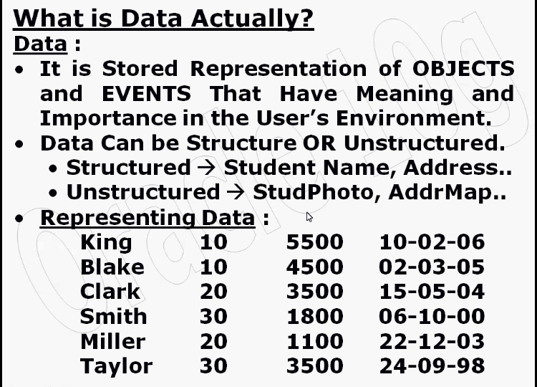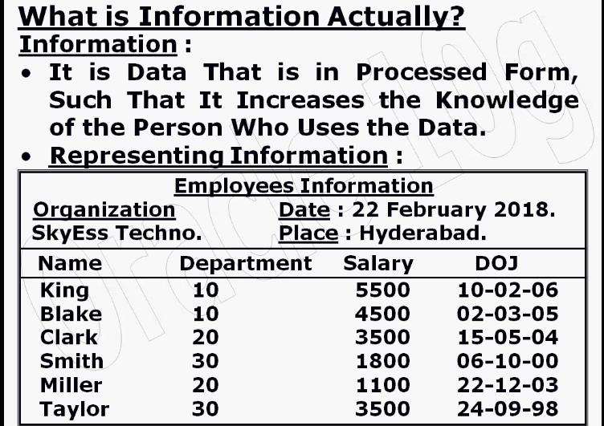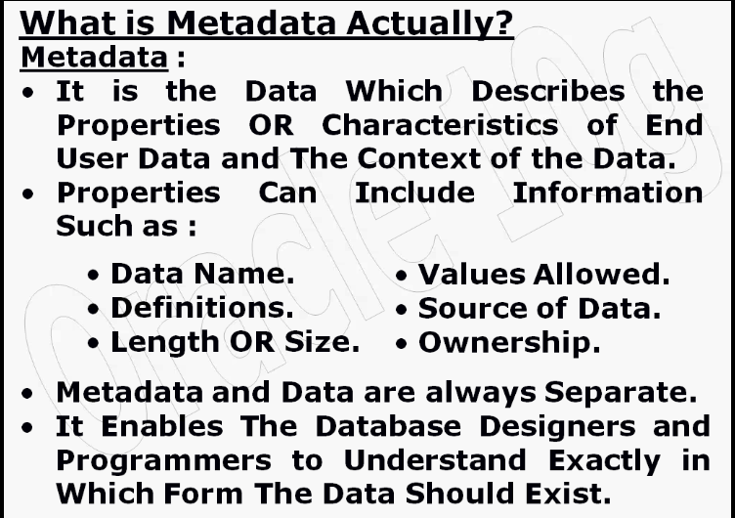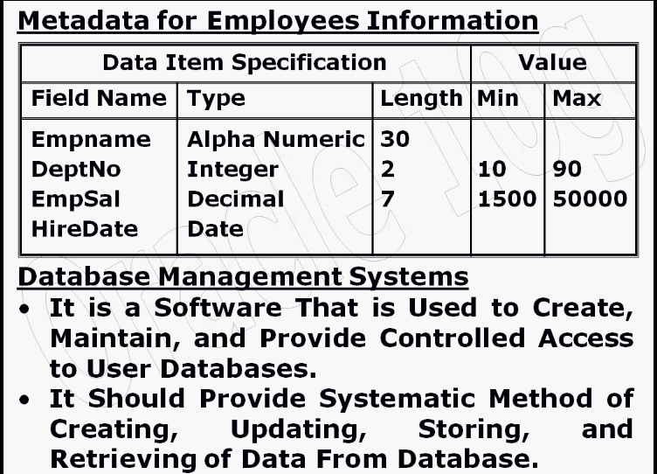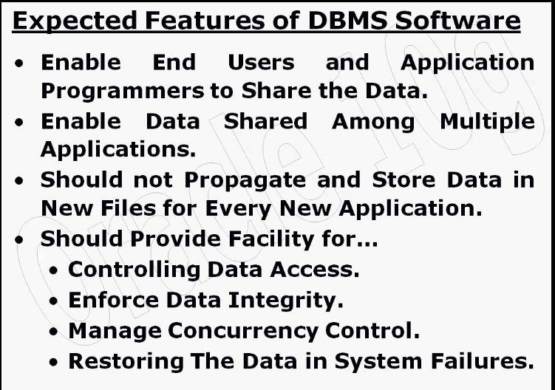

23rd-Feb-2018-(Friday)- session-5

Refer Images:

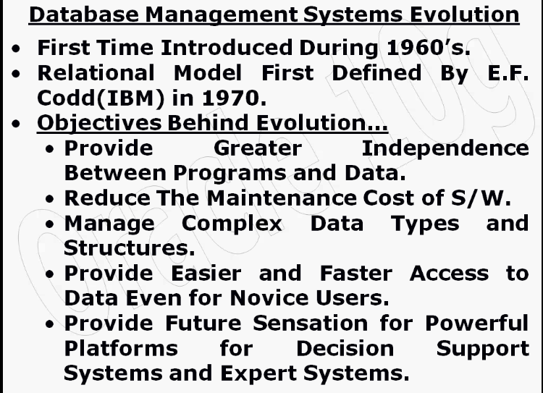

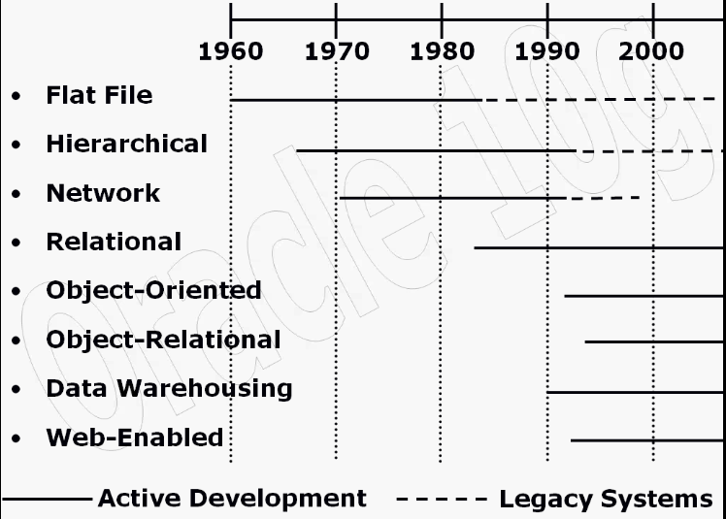

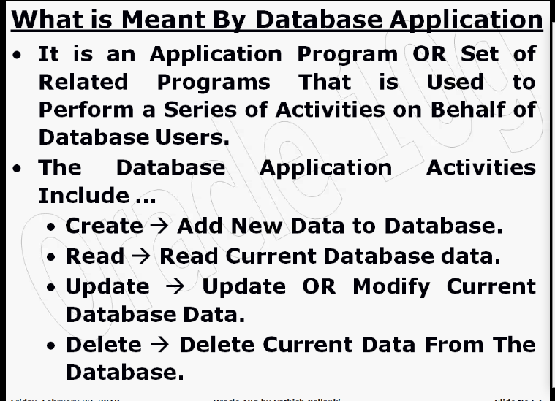

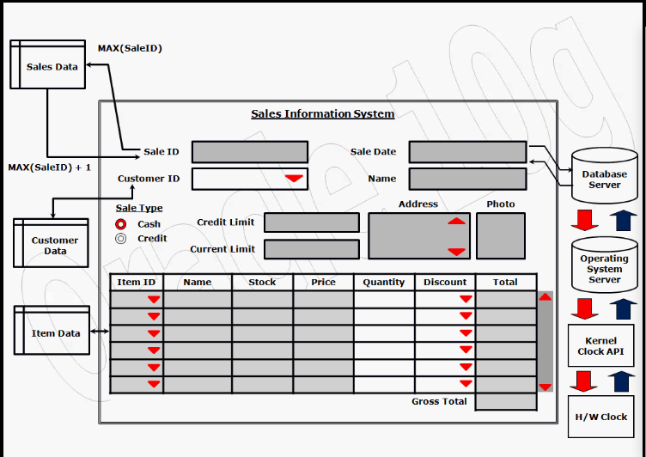

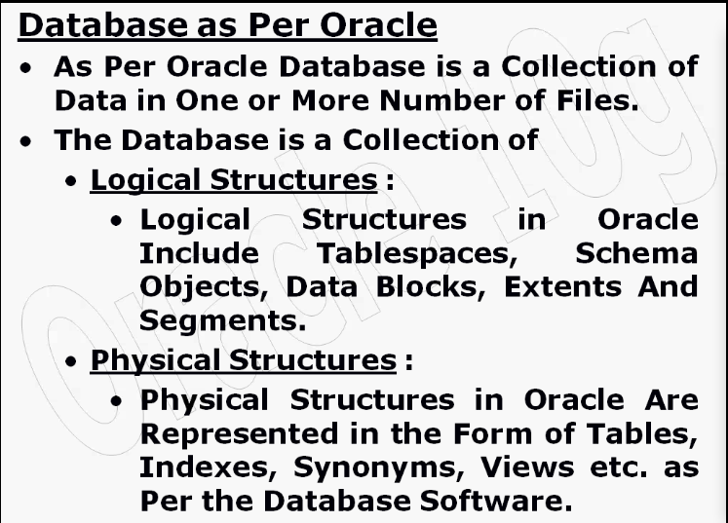

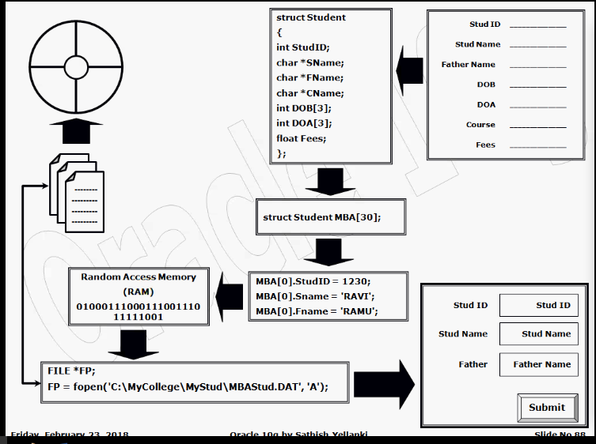

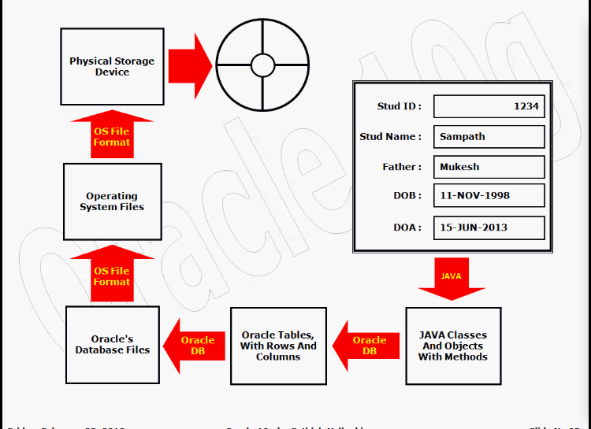

26th-Feb-2018-(Monday) session-6

missed

27th-Feb-2018-(Tuesday) session-7

missed

28th-Feb-2018-(Wednesday) session-8

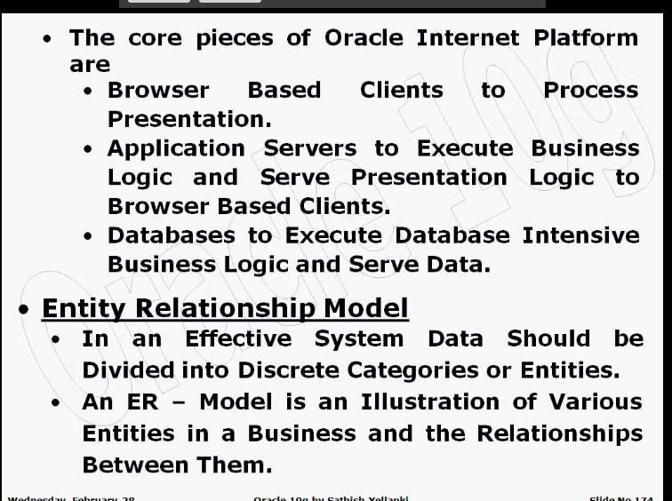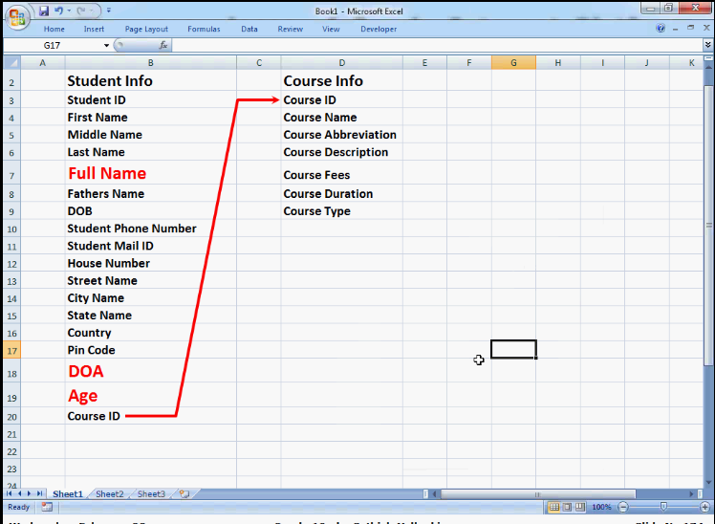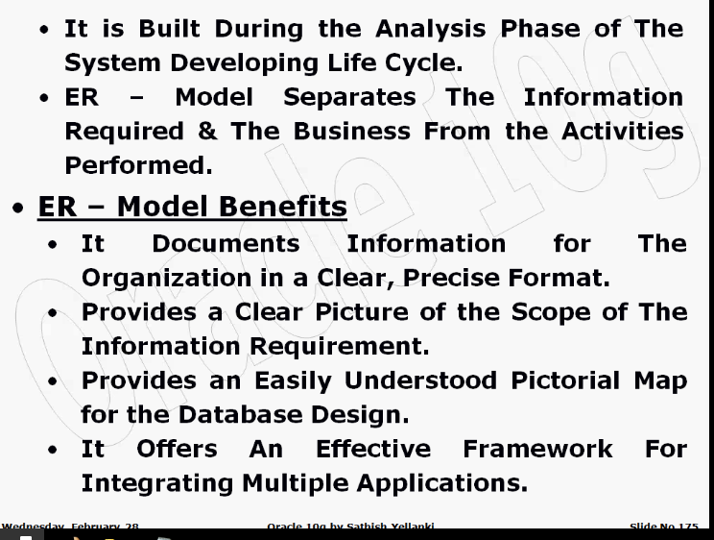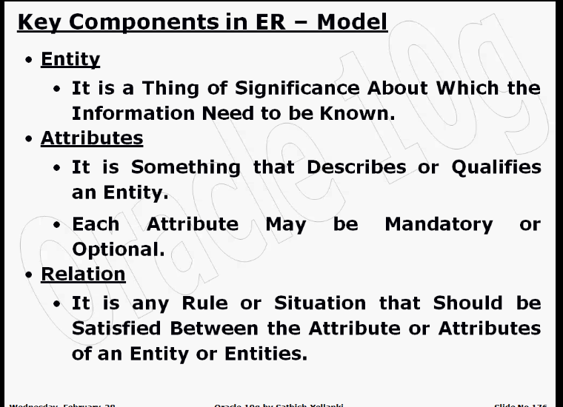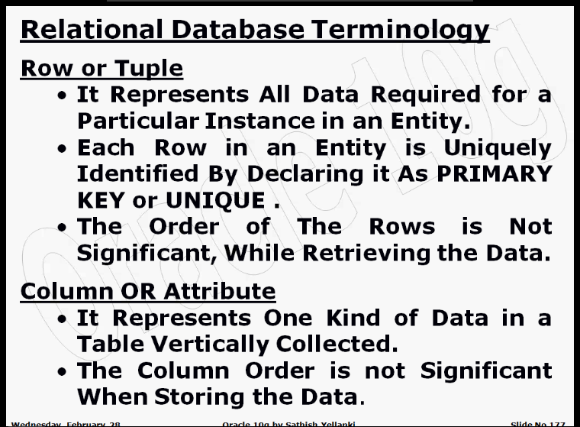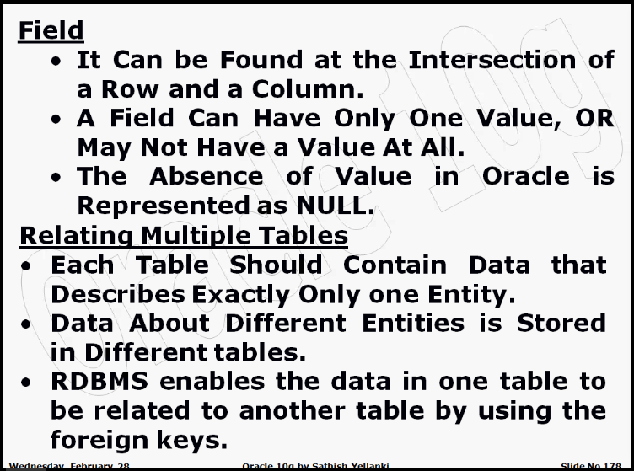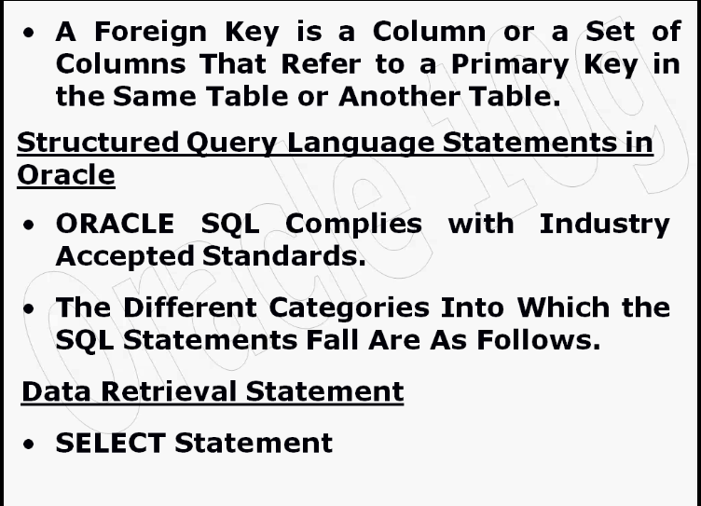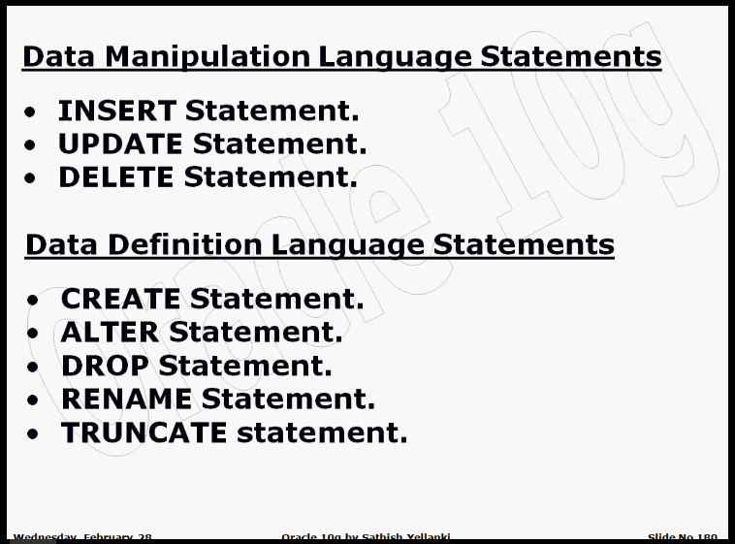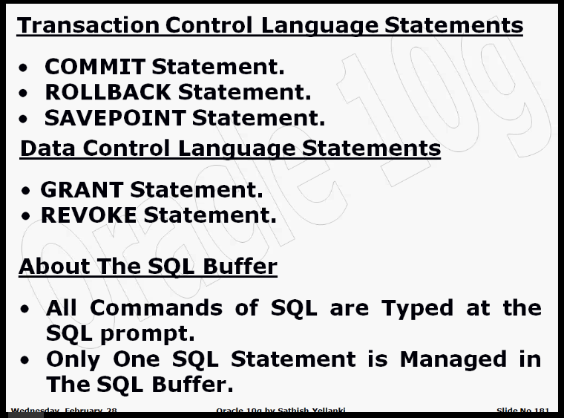

1st -Mar-2018-(Thursday) session-9 Oracle Network Architecture and SQL Buffer

2nd-Mar-2018-(Friday) session-10 Oracle Installation

5th-Mar-2018-(Monday) session-11 What is Table

6th-Mar-2018-(Tuesday) session-12 (Table Creation Syntax and Data Types)

* Whenever Numbers have to be represented, we have to Define the Precision and Scale. The Precision Represents the Total Number of Digits Including the Decimal Point. A Scale represents the number of digits to be managed to Represent the Decimal Position.
* Number Datatype Always Promises the Decimal Point into a Fixed position. There may be certain Situation in Which We need a Decimal Point Anywhere Within the Entire number. In these cases, if Number Datatype is used, we have to go with the double the size of the actual value what we will store. In order to Avoid this Extra space, we have a Float Datatype which is an Object Oriented Type Provided from 9i, which gives the facility of Keeping the Decimal Point Anywhere Within the number.
* When Float Data type is Declared, we declare only the Precision but not the Scale.
* Date is a Relational Datatype, but Timestamp is an Object Oriented Datatype.
* LONGRAW is a datatype to maintain audio, video, image. Which is an old datatype which Oracle almost is not using in any real-time projects now. The alternate to this we have Large Object Datatypes like BLOB, CLOB. These data types stores the data in the form of Binary Format , which is highly secure, without special mechanism nobody can manipulate the data.
* Disadvantage of LONGRAW data type is it stores the Audio, Video, Images directly into database, which creates a Performance problem. Second problem is it converts the data into Hexadecimal values and stores into database, which can be manipulated easily by anyone. So Security is the another Concern.
* If we want to store Character data as an Object in place of LONG we can use CLOB as alternate. And its size also 4GB, which is double the Size of LONG datatype. We can have any number of CLOB object in a table unlike LONG.

7th-Mar-2018-(Wed) session-13 (Data Types)

8th-Mar-2018-(Thu) session-14 (Table Created and Insert discussion)

* Once a table is created the Fundamental Details of the table are stored with in One of the Metadata Object by Name TAB. We can start querying this Metadata to List All the Tables VIEWs, SYNONYMs and the Materialized VIEWs that are part of That Specific User.
  + - * SELECT * FROM TAB;
      * SELECT * FROM TAB WHERE TabType=’TABLE’;
* Once a Table is Created We Can Always know the Structure of the Table for Operational References by Using the DESCRIBE Command.
* DESCRIBE Command Displays the Exact Order with Which the Columns are Created at the Time of Creating the table.
  + - Eg: DESCRIBE Student
* Within the Oracles Architecture Once a Table is Created, only its Structure is Stored in the database as an Object but Not the Source Code. If We want the Source Code as a Reference, We Must Save the Source Code Externally Separately.

9th-Mar-2018-(Fri) session-15 (Insert Statement discussion)

* Whenever we do any Transaction the transaction is placed into a temporary memory Location Called as Rollback Segment Area. These Changes w.r.t Data will be Made Permanent Only When the User Executes Commit Statement.
* Without issuing the Commit Statement If We Close the Session These Changes are rolled back from the Rollback Segment Area.
* Every Transaction that is Constructed in Oracle Is Localized to That Session, Therefore Until the Owner of The Session does not Commits the Transaction, the Other Sessions cannot see the Corresponding Changes.
* The Current Changes Done Are Locked Within the Rollback Segment Area Under the Control of the Current User. Till the Current User does not Commits the Changes are Temporarily Applied.
* Until We do not Instruct and Design the Tables as Per the Standards of RDBMS Oracle Tables Can Accept Duplicated Records.
* According to the Situation that Demands We Can Always Insert the Data Only to the Columns For Which the Values are available. For All Such Columns to which the Values are not provided Oracle Implicitly Generates NULL State.
* While Presenting the Data NULL Gets Represented As a Space on the Screen, But in Technical State NULL is Not Equal to Space Nor Zero.
* Once the Record Has Been Inserted into The Table Any Missing Value to that Record Are Always Updated at the Latter Stage.
* All the Data values which Are Character Are case sensitive within The Table. And All The Dates are Format Sensitive.
* After the Table Name If the Column Names Are Declared than we Have to Definitely provide All the Values to Those Columns, Exactly to the Order with Which the Columns are Declared with Insert Statements.
* Error Codes:

ORA-00913- Too many values

ORA-00947- Not Enough Values

12th-Mar-2018-(Mon) session-16 (Substitution Variables)

* Once one SQL Statement has been Executed It Always stays in SQL buffer till the Next Statement is Typed. Taking this as an Advantage We Can Always Use Substitution Variables to Supply the data values at runtime to test and debug the SQL Statements.

13th-Mar-2018-(Tue) session-17(Querying Database - SELECT Statement Started)

* **1-** State of the Relation:

Mandatory

Optional

**2-** Cardinality of the Relation

1-1

1-*

*-*

Ways to Calculate the Cardinality:

T->C

C->T

C->C

T->T

* In a Table, all Columns needs to Mandatory Is Not A Rule. But All Columns can be Mandatory.
* **According to RDBMS Rule1:** When Cardinality Test is conducted from Table to Column, all Columns should be One-to-One Only. If Any of the Column is having Many Relation than it is Violating **1st Normal Form**, and High Amount of Data Redundancy and Anomalies will be formed.
* **According to RDBMS Rule2:** From the Column to Table when Cardinality test is Conducted there should be at least One Column which is having One-to-One state from Both the Side, and that Column Can be Used as Identifier Column. If it is not than it is violating Second Normal Form and that Table Can’t Contain Consistent Data. More than One Column is accepted.

14th-Mar-2018-(Wed) session-18(Querying Database – Contd...)

* Projecting All Columns Using * Operator
* Projecting Specific Columns
* Applying Arithmetic Operators
* NVL Function

Eg: **SELECT** Ename,Job,Sal,Comm,Sal+NVL(Comm,0)

**FROM** Emp;

**SELECT** Ename,Job,Sal,Comm,Sal+NVL(Comm,700)

**FROM** Emp;

**SELECT** Ename,Job,Sal,Comm,Sal+NVL(Comm+2000-Comm,700)

**FROM** Emp;

**SELECT** Ename,Job,Sal,Comm,Sal+NVL(Comm+1000,700)

**FROM** Emp;

22th-Mar-2018-(Thur) session-19(Querying Database – Contd...)