**REPORT:**

**Capstone Project - Covid Test Centers Segmenting and Clustering in Toronto**

**Introduction: Business Problem**

COVID-19 has impacted the whole world at unprecedented levels.

Governments and Health care departments are put under extreme pressure to come up with various tasks in the battle against this pandemic. One of many such projects is setting up test centers to assess patients.

In this project, we'll be segmenting and clustering the Covid-19 Test centers in city of Toronto.

By plotting the test centers on the city map gives us a visual of how they are spread across this vast city with a population of 3 million.

At the end using Foursquare and ‘K nearest neighbors’ data science concepts we find the 10 most common venues around each of the test centers. This will help in understanding what kind of businesses or amenities exist around each test center.

Stakeholders for the insights achieved can be many;

a) Government officials while planning more test centers in other neighborhoods than the present ones.

b) Patients to quickly identify what kind of services/amenities exist around each test center e.g Parking centers.

c) Businesses to take extra precautions for possible exposure due to increased influx of people in the neighborhood.

**Data:**

To achieve the solution, we begin with the official datasets provided by Govt of Onatrio in their website that list the Covid test centers across the Province.

**URL:** <https://data.ontario.ca/dataset/8ba078b2-ca9b-44c1-b5db-9674d85421f9/resource/04bede2c-5e30-4a05-b890-cd407043485e/download/assessment-centre-locations.csv>

Along with test center name file contains city name, postal_code, latitude and longitude details that we'll be using when plotting maps (using Folium) and when segmenting and clustering while finding 10 most common venues around each test center present in Toronto (using Four Square API).

**Pandas Data Frame;**

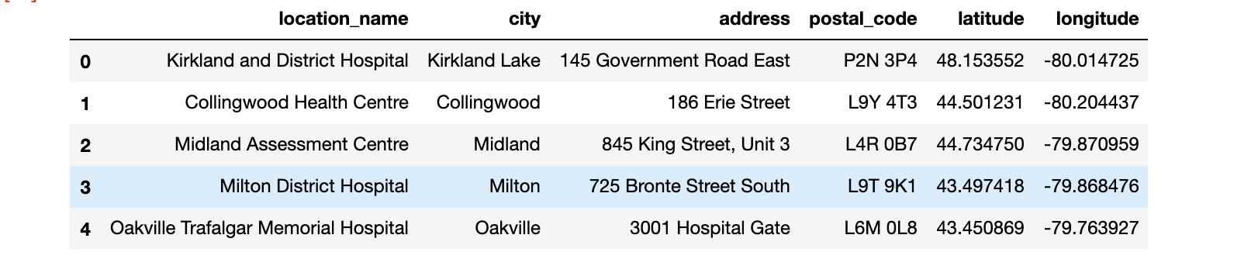

**Methodology**

In the first step, we have collected the required data which contained below fields;

1. **location**_**name**
2. **city**
3. **address**
4. **postal_code**
5. **latitude**
6. **longitude**

We also performed necessary data wrangling for smooth analysis further.

In the Second step in our analysis we will start using Four Sqaure API for finding the nearby venues around each test center.

In third and final step we will focus on plotting our findings on maps using Folium and then use K nearest neighbor clustering, thereby finding the n most common venues around each test center.

Using **Foursquare API** we got all the nearby venues;

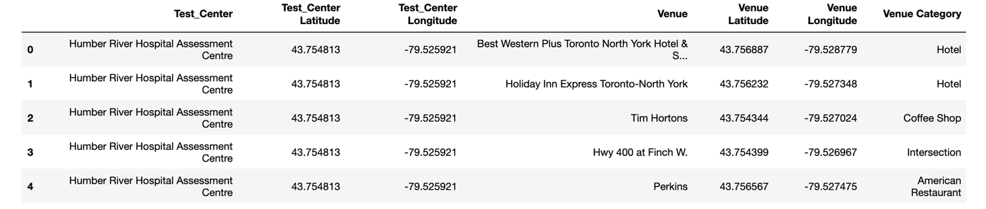

**K nearest neighbor** clustering

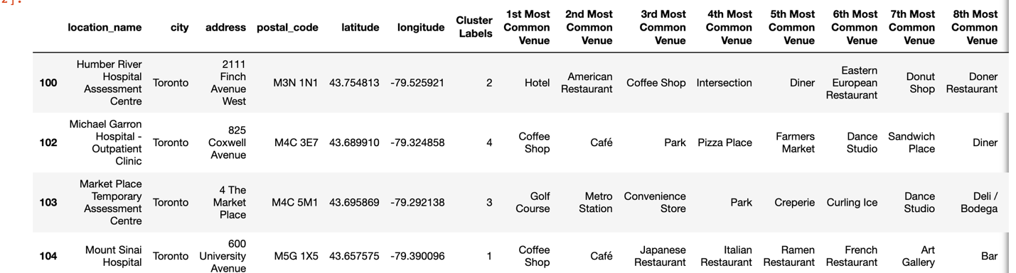

Plotting our findings on Toronto map using **Folium;**

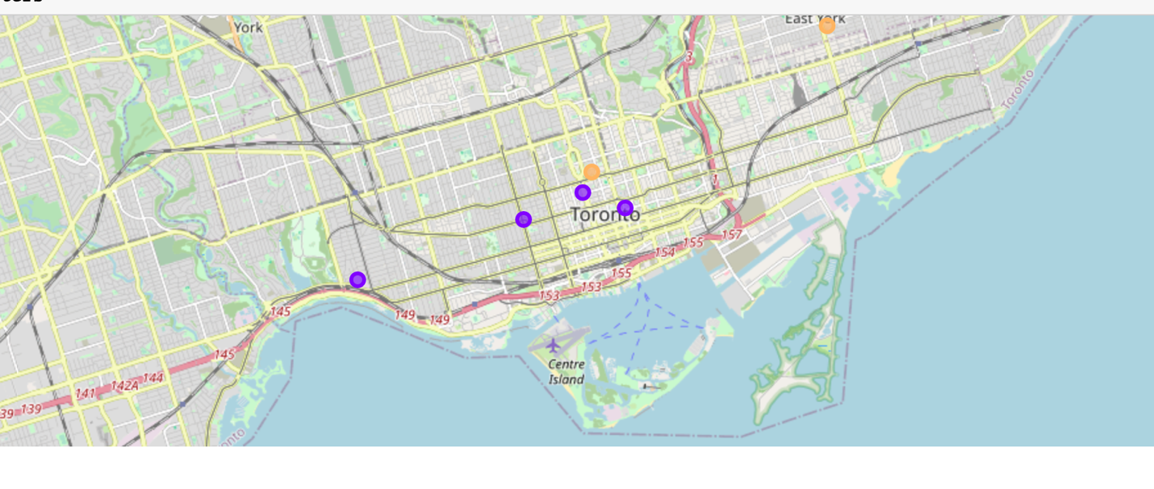

**Results and Discussion**

Here we are with all the results for analysis.

First using the datasets we narrowed down to COVID test centers available in city of Toronto.

This we achieved by narrowing down from all the locations listed in the province of Ontario's dataset.

As observed we have 5 locations across the city in different neighborhoods.

In order to understand proximity of each of those we plotted them on map and this gave us an insight of a visual representation of their presence.

Next using Four Square we identified most common business amenities available around each of the test center location.

For this we used the latitude and longitude of the respective test centers and used the Four Square's features to fetch each of the venues around it.

Finally using K-nearest-neighbors data science algorithm we segmented and clustered each of the above mentioned locations.

**Conclusion**

Purpose of this project was to identify COVID test center locations across Toronto. And the results of this will help the stake holders as mentioned below;  
a) Government officials while planning more test centers in other neighborhoods than the present ones.  
b) Patients to quickly identify what kind of services/amenities exist around each test center e.g Parking centers.  
c) Businesses to take extra precautions for possible exposure due to increased influx of people in the neighborhood.

Considering the results, we achieved by plotting test centers on Toronto map and by finding the most common venues around each test center we can conclude that we have addressed the business problem we started with.