Important Questions
- Types of joins in Sql Server

Rretrieve data from multiple tables using the JOIN clause, there are five types of joins:

- inner join
- left outer join or Left Join
- right outer join or Right Join
- full outer join or Full join
- cross join

Example:
CREATE TABLE #EMP
(
EMPID BIGINT,
EMPNAME VARCHAR(100),
PLACE VARCHAR(100)
)

INSERT INTO #EMP
SELECT 101,'SAIRAM','HYDERABAD'
UNION ALL
SELECT 101,'SAIRAM','SECUNDRABAD'
UNION ALL
SELECT 101,'SAIRAM','WARANGAL'
UNION ALL
SELECT 102,'SRIKANTH','KARIMNAGAR'
UNION ALL
SELECT 102,'SRIKANTH','SIDDIPET'
UNION ALL
SELECT 103,'RAMESH','ONGOLE'

CREATE TABLE #EMPTRANS
(
EMPID BIGINT,
TRANSID BIGINT
)

INSERT INTO #EMPTRANS
SELECT 101,1000001
UNION ALL
SELECT 101,1000002
UNION ALL
SELECT 102,1000003
UNION ALL
SELECT 102,1000004

Table: #EMP
EMPID | EMPNAME | PLACE
101 | SAIRAM | HYDERABAD
101 | SAIRAM | SECUNDRABAD
101 | SAIRAM | WARANGAL
102 | SRIKANTH | KARIMNAGAR
102 | SRIKANTH | SIDDIPET
103 | RAMESH | ONGOLE

Table: #EMPTRANS
EMPID | TRANSID
101 | 1000001
101 | 1000002
102 | 1000003
102 | 1000004
105 | 1000006

- Inner join:

Matched rows between the two tables specified in the INNER JOIN statement based on one or more columns having matching data.

Resultant row count = (Matched row_count from left table * Match row_count from right table)+...+(Matched row_count from left table * Match row_count from right table)

==> From the above tables
Resultant row count = (3*2)+(2*2) = 10

SELECT * FROM #EMP E
INNER JOIN #EMPTRANS T on E.EMPID = T.EMPID

- Left Join:

Based on the two tables specified in the join clause, all data is returned from the left table. On the right table, the matching data is returned in addition to NULL values where a record exists in the left table, but not in the right table.

Resultant row count = (Matched row_count from left table * Matched row_count from right table) +...+(Matched row_count from left table * Matched row_count from right table) + Unmatched row_count from left table

==> From the above tables
Resultant row count = (3*2) + (2*2) +1 = 11

SELECT * FROM #EMP E
LEFT JOIN #EMPTRANS T on E.EMPID = T.EMPID

- Right Join:

Based on the two tables specified in the join clause, all data is returned from the right table. On the left table, the matching data is returned in addition to NULL values where a record exists in the right table but not in the left table.

Resultant row count = (Matched row_count from left table * Matched row_count from right table) +...+(Matched row_count from left table * Matched row_count from right table) + Unmatched row_count from right table

==> From the above tables
Resultant row count = (2*3)+(2*2)+1 = 11

SELECT * FROM #EMP E
RIGHT JOIN #EMPTRANS T on E.EMPID = T.EMPID

- Full Join:

Based on the two tables specified in the join clause, all data is returned from both tables regardless of matching data.

Resultant row count = (Matched row_count from right table * Matched row_count from left table)+...+ (matched row_count from left table * matched row_count from left table)+Unmatched row_count from left table + Unmatched row_count from right table

==> From the above tables
Resultant row count = (2*3)+(2*2)+1+1 = 12

SELECT * FROM #EMP E
RIGHT JOIN #EMPTRANS T on E.EMPID = T.EMPID

- Cross Join:

Based on the two tables specified in the join clause, a Cartesian product is created if a WHERE clause does filter the rows. The size of the Cartesian product is based on multiplying the number of rows from the left table by the number of rows in the right table. Please heed caution when using a CROSS JOIN.

Resultant row count = row_count from right table * row_count from left table

==> From the above tables
Resultant row count = 6*5 = 30

SELECT * FROM #EMP E
CROSS JOIN #EMPTRANS T on E.EMPID = T.EMPID

Self Join (this is not a Join):

In this circumstance, the same table is specified twice with two different aliases in order to match the data within the same table.

Resultant row count = (matched row_count from left table * matched row_count from left table)+...+ (matched row_count from left table * matched row_count from left table)

==> From the above tables
Resultant row count = (3*3)+(2*2)+(1*1) = 14

SELECT * FROM #EMP E
INNER JOIN #EMP T on E.EMPID = T.EMPID

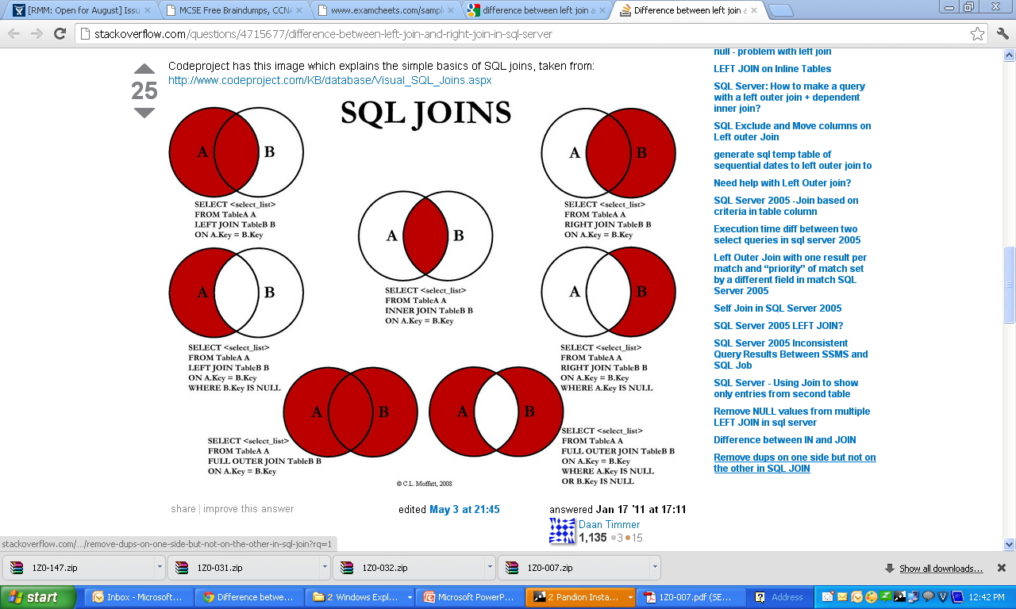

- Index ?

