Name: Srikanth Iyengar
UID: 2020400062
Class: IT
Batch: 7

Aim: To implement computationally Fast Algorithms

Objective:
1. Develop a program to perform FFT on N point signal
2. Calculate FFT of a given DT signal and verify the results using a mathematical formula.
3. Computational efficiency of FFT

Experimetation

Case 1:
A 4 point FFT signal has been chosen, Input signal, x[n] = { 30, 12, 20, 2}
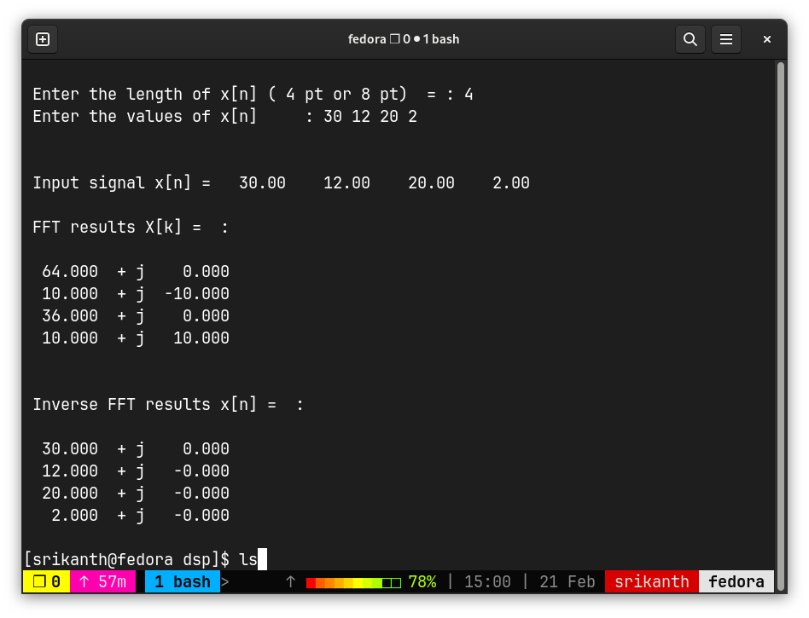
Output: The resultant signal in frequency doman as given by FFT is

Case 2:
A 8 point FFT signal has been chosen, Input signal: {30, 0, 12, 0, 20, 0, 2, 0}

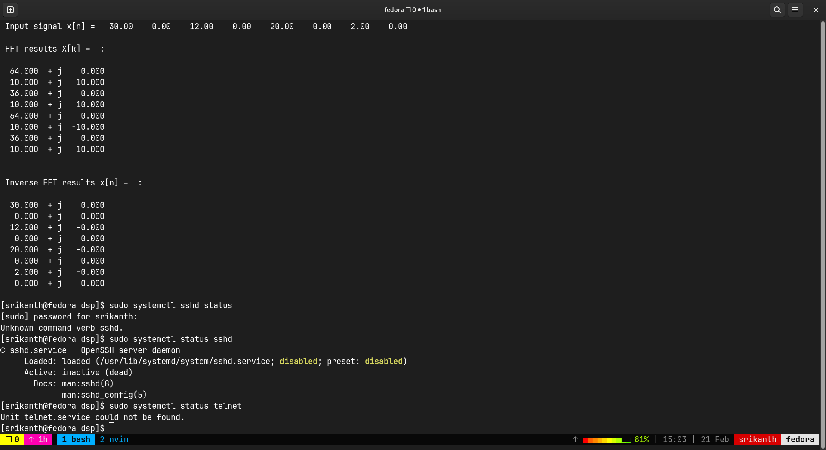
Output:

Analysis:

Conclusion:

1.Computational Efficiency in DFT:
a)Total Real Multiplications = 4N2
b)Total Real Additions = 4N2-2N 35

2.Computational Efficiency in FFT :
a)Total Real Multiplications = 2N Log2N
b)Total Real Additions = 3N Log2N

3.FFT produces fast results due to:
a)Less Computations
b) Parallel implementations

