Name: Srikanth Iyengar
UID: 2020400062
Batch: 7
Branch: IT
Subject: Foundation Of Signal Processing (FOSP)

Aim: The aim of this experiment is to study the magnitude spectrum of the DT signal.

Objective:
- Develop a function to perform DFT of N point signal
Case-1: 4 point DFT has been chosen.
x[n] = {30, 12, 20, 2}

Output:
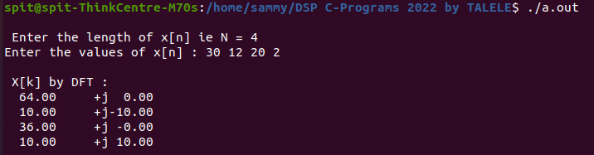
Case-2: 8 point DFT has been chosen.
x[n] = [30, 12, 20, 2, 0, 0, 0, 0]
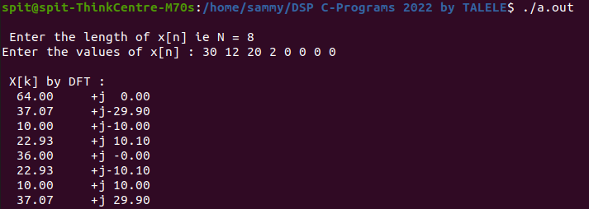

Case-3: 12 point DFT has been chosen for this case.
x[n] = [30, 0, 12, 0, 20, 0, 2, 0]
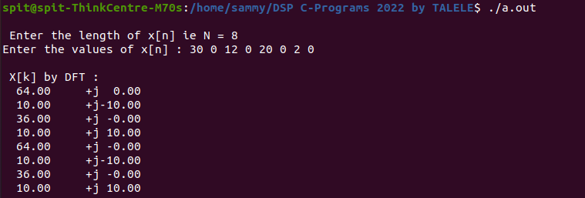
Case-4: Expand the input signal by inserting alternate two zeros
After taking two alternate the effective length of the signals changes to 12.n] = [30, 0, 0, 12, 0, 0, 20, 0, 0, 2, 0, 0]
