Date: 11.4.24   
  
Task 1: Arithmetic Operations  
  
  
using System;

namespace _1_arithmetic_operation

{

internal class Program

{

static void Main(string[] args)

{

Calculate();

}

private static void Calculate()

{

int num1 = Getvalue(1);

int num2 = Getvalue(2);

Performoperation(num1, num2);

}

private static void Performoperation(int a, int b)

{

checked

{

Console.WriteLine($"the sum of {a} and {b} is {a + b}");

Console.WriteLine($"the difference of {a} and {b} is {b - a}");

Console.WriteLine($"the multiply of {a} and {b} is {a * b}");

Console.WriteLine($"the remainder of {a} and {b} is {a % b}");

}

}

private static int Getvalue(int number)

{

int num;

Console.WriteLine($"Enter num {number}:");

while (int.TryParse(Console.ReadLine(), out num) == false)

{

Console.WriteLine("Enter a valid number");

}

return num;

}

}

}  
  
  
**Output**

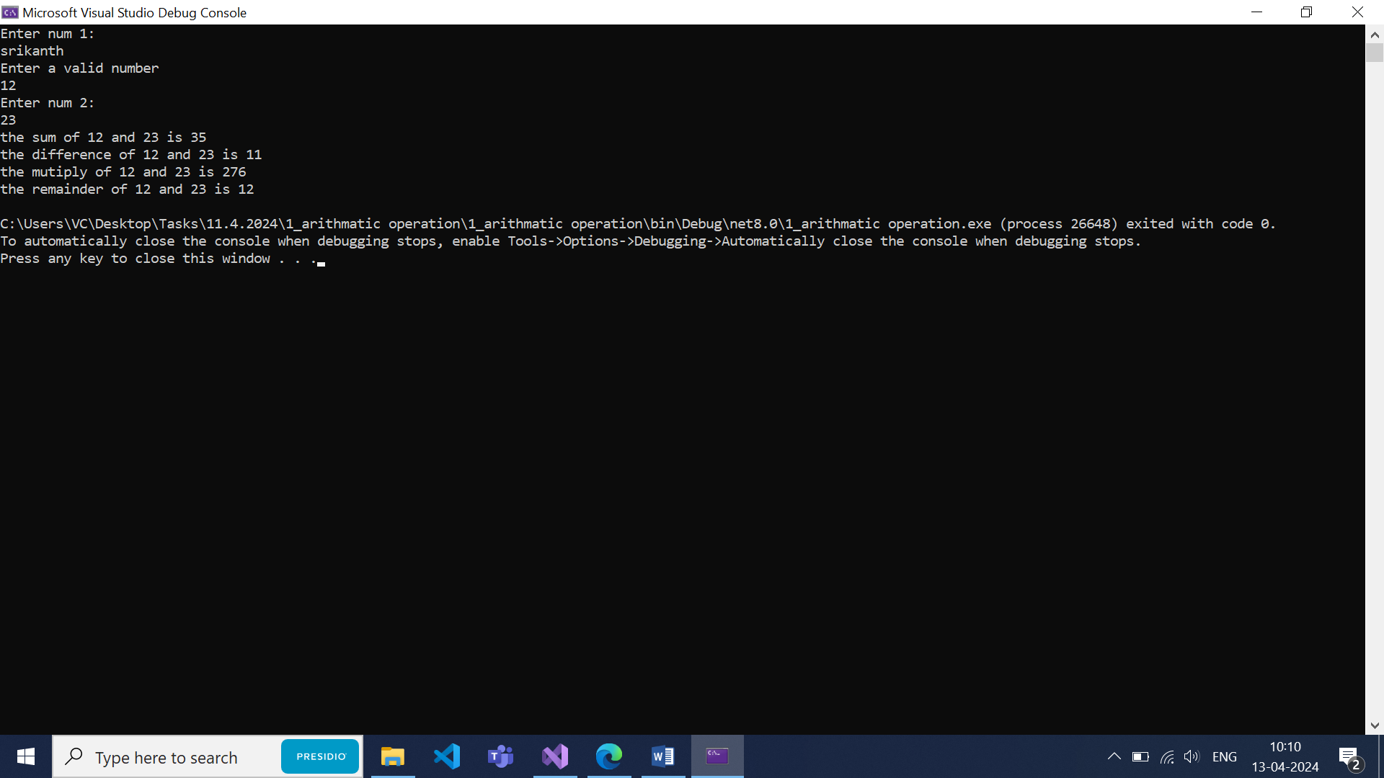

Task 2: Find Greatest of All Numbers  
  
using System;

namespace _2_greatestofallnumber

internal class Program {

static void Main(string[] args)

{

FindGreatestOfAllNumber();

}

private static void FindGreatestOfAllNumber()

{

int greatestNumber = int.MinValue;

int number;

Console.WriteLine("Enter a number: ");

while (int.TryParse(Console.ReadLine(), out number) && number > 0)

{

Console.WriteLine("Enter a number: ");

if (number > greatestNumber) greatestNumber = number;

}

Console.WriteLine($"The greatest number you entered is: {greatestNumber}");

}

}

}

**Output**  
  
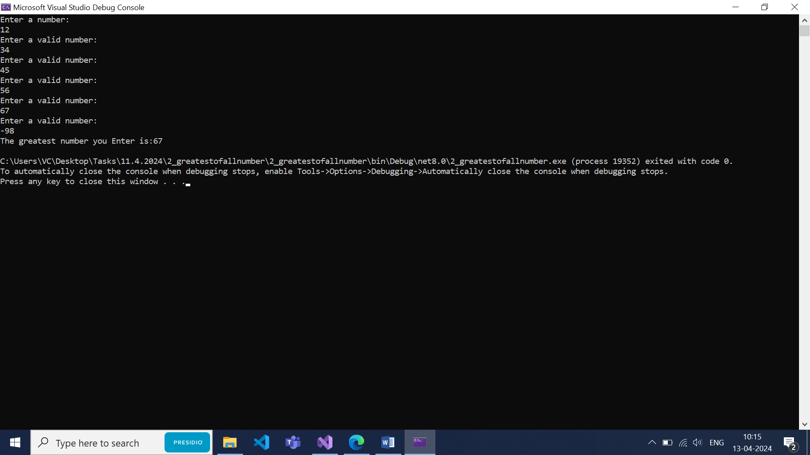

**Task 3: Find average of number divisible by 7**  
  
using System;

namespace _3_average_of_all_divisible_by_7

{

internal class Program

{

static void Main(string[] args)

{

FindAverageOfNumbersDivisibleBySeven();

}

private static void FindAverageOfNumbersDivisibleBySeven()

{

int sum = 0;

int count = 0;

int number = 0;

Console.WriteLine("Enter a number");

while (int.TryParse(Console.ReadLine(), out number) && number > 0)

{

if (number % 7 == 0)

{

count++;

sum += number;

}

Console.WriteLine("Enter a number");

}

if (count > 0)

{

int result = sum / count;

Console.WriteLine($"the Average of number that are divisible by 7 is :{result}");

}

else

{

Console.WriteLine("No numbers divisible by 7 were entered.");

}

}

}

}  
  
**Output**

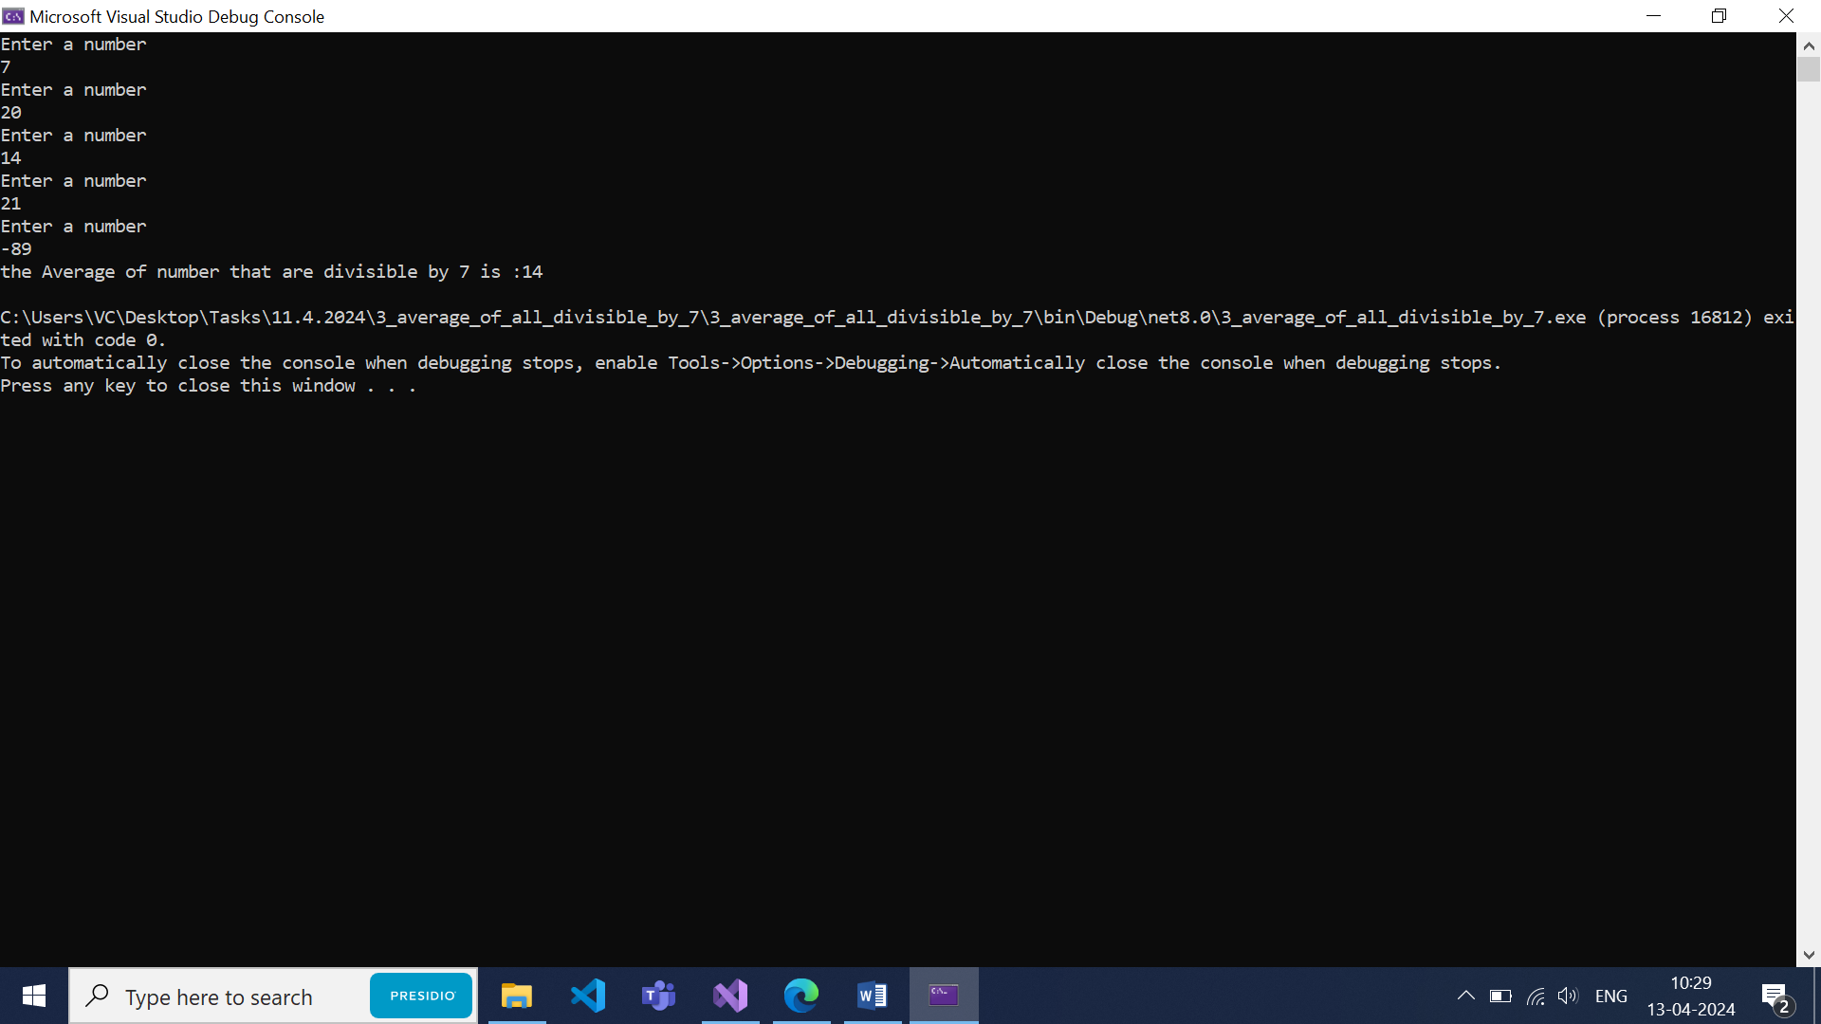

**Task:4 Find length of the user name**namespace _4_lengthof_username

{

internal class Program

{

static void Main(string[] args)

{

Console.Write("Enter your name: ");

string name = Console.ReadLine();

int length = name.Length;

Console.WriteLine($"Your name has {length} characters.");

}

}

}

**Output**

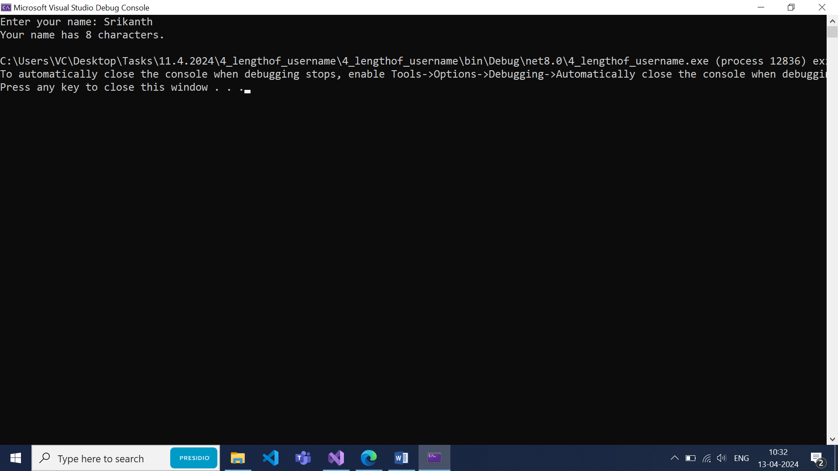

**Task 5: Login form**namespace _5_loginform

{

internal class Program

{

static void Main()

{

string username = "ABC";

string password = "123";

int attempts = 3;

while (attempts > 0)

{

Console.Write("Enter username: ");

string inputUsername = Console.ReadLine();

Console.Write("Enter password: ");

string inputPassword = Console.ReadLine();

if (inputUsername == username && inputPassword == password)

{

Console.WriteLine("Login successful!");

break;

}

else

{

Console.WriteLine("Incorrect username or password. Please try again.");

attempts--;

Console.WriteLine($"You have {attempts} attempts remaining.\n");

}

}

if (attempts == 0)

{

Console.WriteLine("You have exceeded the maximum number of attempts. Please try again later.");

}

}

}

}

**Output**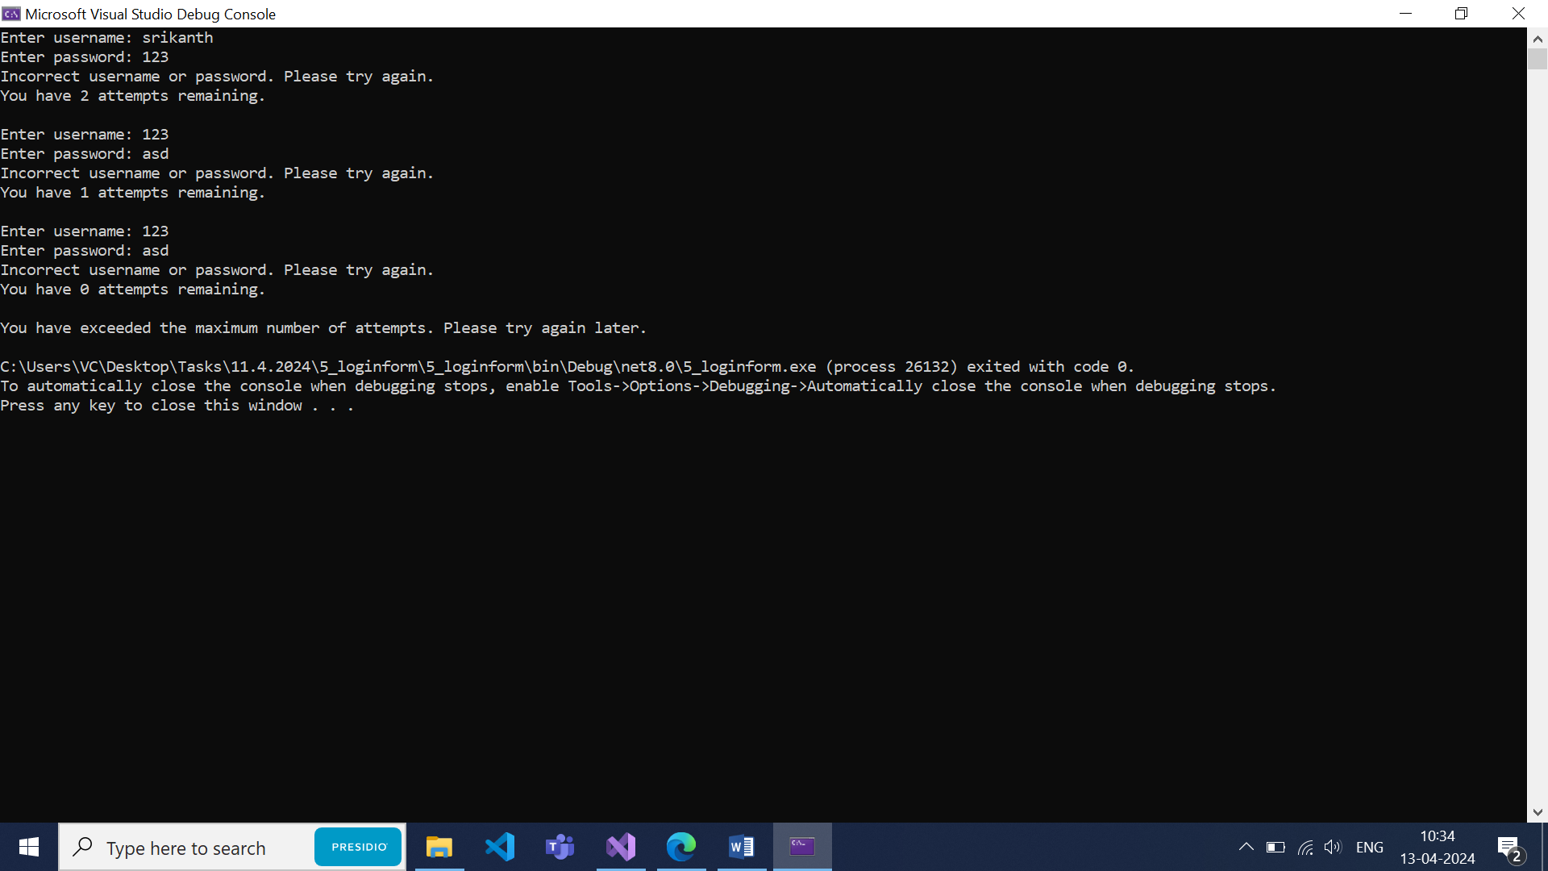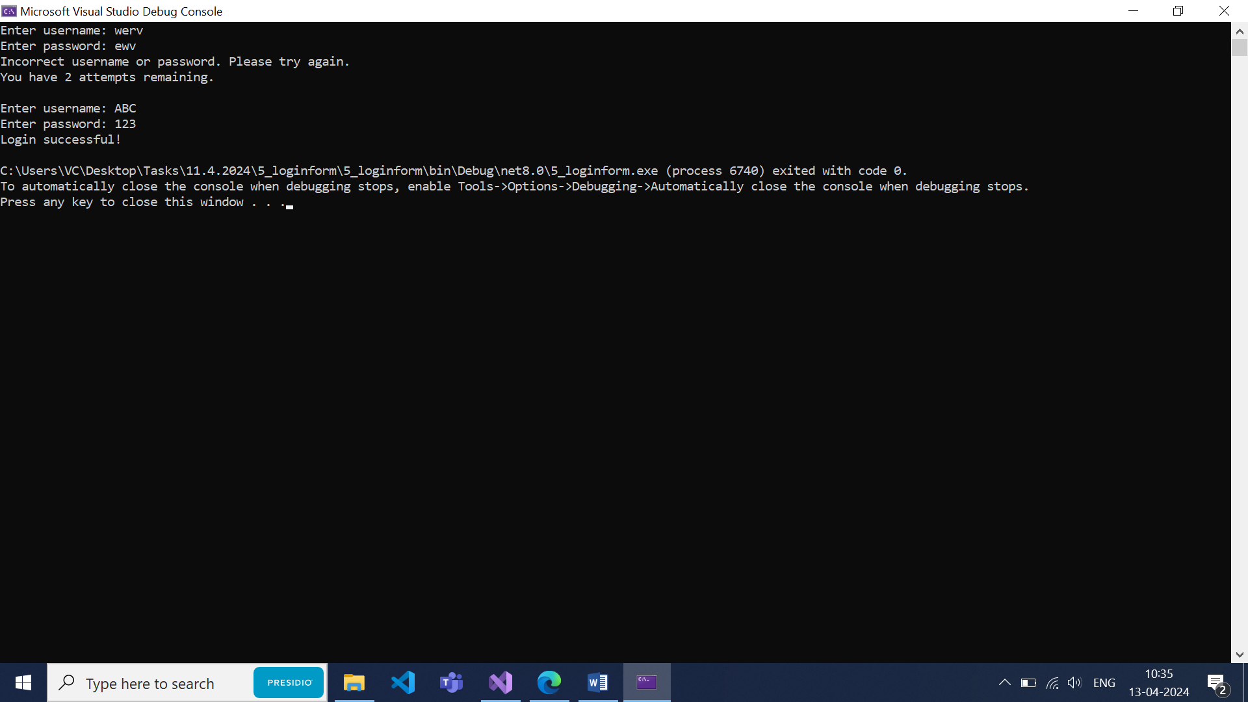

**TASK6: Find vowels**

namespace _5_repeated_vowels

{

internal class Program

{

static void Main(string[] args)

{

Console.WriteLine("Enter a String:");

String str=Console.ReadLine();

int count = 0;

int finalcount_count = int.MaxValue;

String result="";

List<string> minVowelWords = new List<string>();

str = str.ToLower().Trim();

for (int i = 0;i<str.Length;i++)

{

if (str[i] =='a' || str[i] == 'e' || str[i] == 'i' || str[i] == 'o' || str[i] == 'u')

{

count++;

}

if (str[i] == ',' || i==str.Length-1)

{

if (i == str.Length - 1) result += str[i];

if (count < finalcount_count)

{

finalcount_count = count;

minVowelWords.Clear();

minVowelWords.Add(result);

}

else if(count == finalcount_count) minVowelWords.Add(result);

count = 0;

result = "";

continue;

}

result += str[i];

}

Console.WriteLine($"Number of Words: {str.Split(',').Length}");

Console.WriteLine($"Number of vowels: {finalcount_count}");

Console.WriteLine($"Word(s) with the least vowels : {string.Join(" ,", minVowelWords)}");

}

}

}

**Output:**

