SevaOne Postgres Database Reference
Table of Contents

SevaOne Postgres Database Reference
Version: Derived from Flyway migrations in backend/database/migrations/
Audience: Engineers onboarding to SevaOne
Verification: Schema verified against migration SQL files. Live psql was not available in the build environment; re-validate against your deployed database after migrations run.

1. Overview
SevaOne uses one Postgres database split into six schemas. Each schema owns one concern. Application code never issues ad-hoc INSERT/UPDATE/DELETE on tables — all access goes through named sp_* functions in the same schema.
Schema | Owns | Tables
discovery | Department and service catalog | 4
portal | Citizens, operators, handoff tokens | 3
orchestration | Applications, dept sessions, wallet, outbox | 5
status | Application timeline, payment posts | 2
audit | Action log, DB error log | 2
notification | Outbound message queue | 1
Total: 16 tables, plus 1 read-only view (discovery.v_sevaone_service_document_flat).
Conventions (all tables)
- Primary keys are uuid (except audit.db_errors.id which is bigint identity).
- Foreign keys use uuid references, not human-readable codes like revenue or SVC001.
- Timestamps are timestamptz. Booleans are real boolean columns.
- Human-readable codes (department_id, service_id) exist as secondary unique columns for display and integration.

2. System-wide ER diagram
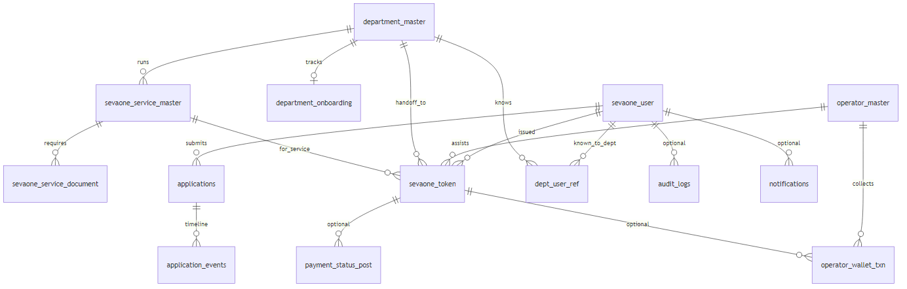
System-wide entity-relationship diagram

3. Cross-schema relationship map

3.1 Citizen → apply → department handoff
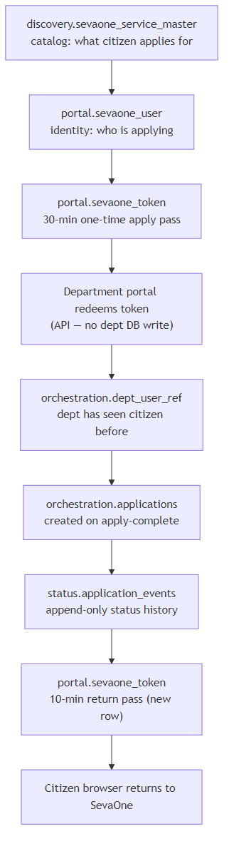
Citizen apply and department handoff flow

3.2 Cardinality summary
From | To | Relationship | FK on delete
department_master | department_master (parent) | N:1 optional | RESTRICT
sevaone_service_master | department_master | N:1 | RESTRICT
sevaone_service_master | department_master (sub-dept) | N:1 optional | SET NULL
sevaone_service_document | sevaone_service_master | N:1 | RESTRICT
department_onboarding | department_master | 1:1 | RESTRICT
sevaone_token | sevaone_user | N:1 | RESTRICT
sevaone_token | operator_master | N:1 optional | RESTRICT
sevaone_token | department_master | N:1 | RESTRICT
sevaone_token | sevaone_service_master | N:1 | RESTRICT
applications | sevaone_user | N:1 | RESTRICT
applications | sevaone_service_master | N:1 | RESTRICT
applications | department_master | N:1 | RESTRICT
application_events | applications | N:1 | CASCADE
dept_user_ref | department + citizen | N:1 each | RESTRICT
operator_wallet_txn | operator, citizen, token | N:1 | RESTRICT / SET NULL
payment_status_post | citizen, dept, scheme, token | N:1 optional | RESTRICT / SET NULL
audit.audit_logs.citizen_id and notification.notifications.citizen_id are logical references only — no FK constraint.

4. Data lifecycle at a glance
Table | Write path today | Notes
discovery.department_master | Seed only | R__seed_lookup.sql — 12 departments
discovery.sevaone_service_master | Seed only | ~40 services in seed script
discovery.sevaone_service_document | None | Table exists; 0 rows
discovery.department_onboarding | Function only, not wired | sp_upsert_department_onboarding unused by app
portal.sevaone_user | Live | Login (OTP/DigiLocker), profile update
portal.operator_master | Seed only | R__seed_operator.sql — test operator
portal.sevaone_token | Live | Apply pass + return pass; redeem sets revoked_at
orchestration.applications | Live | sp_submit_application on dept apply-complete
orchestration.department_sessions | Live | Legacy connector path only
orchestration.dept_user_ref | Live | First successful dept handoff
orchestration.operator_wallet_txn | Live | Operator fee collect/reverse
orchestration.outbox_messages | Live write | No consumer publishes yet
status.application_events | Live | On submit + status updates
status.payment_status_post | Live | Dept payment-status API
audit.audit_logs | Live | Login, token, apply events
audit.db_errors | Live | Written by sp_* exception handlers
notification.notifications | Live write | No delivery worker — channel defaults to log

5. Design conventions

5.1 Migration layout
database/migrations/
V1__schemas.sql # Creates six schemas
tables/<schema>/V{n}__*.sql # One file per table change (versioned, never edited in place)
functions/<schema>/R__sp_*.sql # Repeatable function definitions (re-applied on change)
R__seed_lookup.sql # Departments + services
R__seed_operator.sql # Test operator
views/<schema>/R__*.sql # Views (repeatable)
V__ (versioned): Run once, in numeric order. Each file is immutable — alterations are new V__ files.
R__ (repeatable): Re-run when the file changes. Used for functions, seeds, and views.

5.2 One function per file
Each sp_* routine lives in its own R__sp_<name>.sql. This keeps diffs reviewable and matches the one-table-per-migration discipline.

5.3 Why functions, not raw SQL or EF
- Security: The application DB role can hold EXECUTE on functions only, not INSERT/UPDATE on tables.
- Atomicity: Multi-table writes (e.g. sp_submit_application inserts applications + application_events together) stay in one Postgres transaction.
- Stability: Dapper calls SELECT * FROM schema.sp_foo(@args) — same pattern as inline SQL, no ORM translation.
- Postgres PROCEDURE is not used: Procedures cannot return rowsets to the caller; functions can. See POSTGRES_FUNCTIONS_VS_PROCEDURES.md.

5.4 Error handling
Every sp_* catches exceptions and inserts into audit.db_errors before re-raising. sp_insert_audit_log is the exception — it does not log its own failures to db_errors (would recurse).

6. discovery schema

ER (discovery)
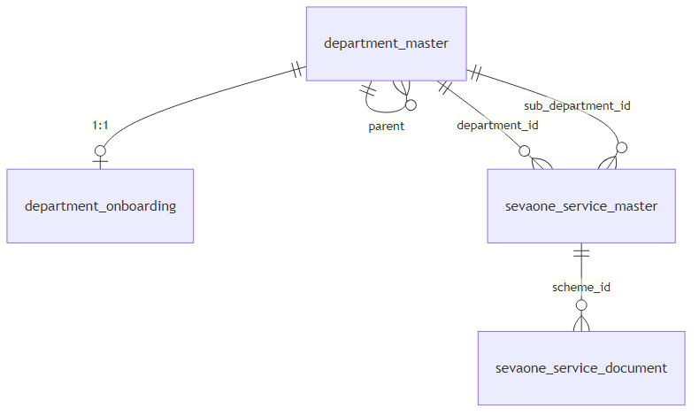
Discovery schema entity-relationship diagram

6.1 department_master
Government departments and internal sub-portals (hierarchy level 1 or 2).
Primary key: id (uuid)
Columns
Column | Type | Null | Default | Notes
id | uuid | NOT NULL | — | PK
department_id | varchar(64) | NOT NULL | — | UNIQUE business code, e.g. revenue
department_name | varchar(200) | NOT NULL | — | English
department_name_kannada | varchar(200) | NULL | —
portal_name | text | NOT NULL | —
portal_name_kannada | text | NULL | —
portal_domain | text | NOT NULL | —
connector_type | text | NOT NULL | — | Connector implementation key
is_integrated | boolean | NOT NULL | — | Real integration vs placeholder
hierarchy_level | smallint | NOT NULL | 1 | 1 = dept, 2 = sub-portal
parent_department_id | uuid | NULL | — | Required when level = 2
is_active | boolean | NOT NULL | TRUE
created_at | timestamptz | NOT NULL | now()
CHECK constraints
- hierarchy_level IN (1, 2)
- Level 1 ⇒ parent_department_id IS NULL; level 2 ⇒ parent_department_id IS NOT NULL
Indexes
- UNIQUE ix_department_master_code on department_id
Functions (read only)
- sp_list_departments, sp_list_departments_with_scheme_count, sp_get_department_by_id, sp_get_department_by_code
- Join helpers in orchestration/discovery cross-reads
Lifecycle: Seeded once. No application write path.

6.2 department_onboarding
Internal onboarding checklist per department (not citizen-facing).
Primary key: id (uuid)
Unique: department_id (1:1 with department_master)
Columns: contact_person_name, designation, contact_number, email, cc_emails, nodal_officer_nomination_requested_at, nodal_officer_name, ai_enabled (default false), onboarding_stage (default NotStarted), created_at, updated_at
CHECK: onboarding_stage IN ('NotStarted','ApiImplemented','Live')
Functions: sp_get_department_onboarding_by_department (SELECT), sp_upsert_department_onboarding (INSERT/UPDATE)
Lifecycle: Function exists; not called from C#. Not seeded.

6.3 sevaone_service_master
Service catalog — one row per apply-able scheme.
Primary key: id (uuid)
Unique: (department_id, service_id)
Key columns: service_id (e.g. SVC001), service_name, category, sakala_days, description, JSON lists (required_documents_json, eligibility_json, aliases_json, steps_json), fees (department_fee, service_charge), deeplinks (deeplink_citizen_url, deeplink_operator_url, homepage_url), Kannada name/description fields, sub_department_id → department_master, is_active
CHECK: mode_of_service NULL or IN ('Online','Offline','Both')
Functions (read): sp_list_schemes, sp_get_scheme_by_id, sp_get_scheme_by_code, sp_get_scheme_by_service_code, sp_list_schemes_with_department, sp_get_scheme_with_department_by_service_code
Lifecycle: Seeded only (~40 services). No runtime admin API.

6.4 sevaone_service_document
Structured required documents per scheme (successor to flat JSON list).
FK: scheme_id → sevaone_service_master.id (RESTRICT)
Columns: document_name, document_name_kannada, document_url, document_type, is_mandatory (default true), is_active, created_at
Index: ix_sevaone_service_document_scheme_id
Functions: sp_get_documents_by_scheme (SELECT) — Live
Lifecycle: No rows, no writes.

6.5 View v_sevaone_service_document_flat
Repeatable view joining documents + schemes + departments for flat reads. No storage of its own.

7. portal schema

ER (portal)
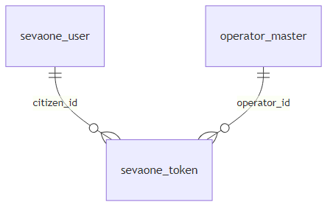
Portal schema entity-relationship diagram

7.1 sevaone_user
One row per citizen.
Primary key: id (uuid)
Identity: sevaone_user_id bigint GENERATED — exposed to departments
Columns (selected)
Column | Type | Constraints
wso2_subject | varchar(200) | NOT NULL, UNIQUE
username, name | varchar(200) | NOT NULL
mobile | varchar(15) | CHECK ^[0-9]{10,15}$; UNIQUE when mobile_verified_at set
mobile_verified_at | timestamptz | NULL until verified
email, address fields | text/varchar | optional
Kannada fields | varchar | optional, from DigiLocker
date_of_birth, gender | date / varchar(20) | gender CHECK: Male/Female/Other/PreferNotToSay
aadhaar_masked, aadhaar_hash | varchar | hash UNIQUE when set
digilocker_id | varchar(64) | UNIQUE when set
photo | bytea | optional, from DigiLocker eAadhaar
profile_completed, profile_finish_pct | boolean / int | pct 0–100
kgid | varchar(50) | UNIQUE when set — gov official, no write path yet
created_at, updated_at | timestamptz | NOT NULL
Functions
Function | Operation
sp_get_citizen_by_id | SELECT
sp_get_citizen_by_wso2_subject | SELECT
sp_get_citizen_by_username | SELECT
sp_get_citizen_by_sevaone_user_id | SELECT
sp_get_citizen_by_mobile | SELECT (verified only)
sp_get_citizen_by_aadhaar_hash | SELECT
sp_insert_citizen | INSERT
sp_update_citizen | UPDATE
sp_delete_citizen | DELETE
Lifecycle: Live — CitizenSessionService on login/register; PortalRepository on profile patch.

7.2 operator_master
Kiosk / assisted-centre operators.
Unique: operator_id (business code)
Columns: operator_type CHECK (G1,K1,B1), operator_name, mobile_no, password_hash, wallet_id, is_active, created_at
Functions: sp_get_operator_by_code, sp_get_operator_by_id, sp_get_operator_credentials — all SELECT, Live
Lifecycle: Seeded (OPR10001). No sp_* write from app.

7.3 sevaone_token
One-time apply passes (30 min) and return passes (10 min).
FKs: citizen_id, department_id, scheme_id; optional operator_id
Columns: token_value, token_hash (UNIQUE), sevaone_user_id (bigint, no FK), assisted_mode, issued_at, expire_at, midnight_valid_until, revoked_at, is_active, return_url
CHECK: assisted mode requires operator_id; expiry ordering
Indexes: token_hash UNIQUE; composites on citizen, department, scheme, expire_at
Functions: sp_insert_token, sp_get_token_by_hash, sp_get_token_by_id, sp_try_redeem_token (sets revoked_at, is_active=false)
Lifecycle: Live — minted on Apply and apply-complete; redeemed atomically.

8. orchestration schema

ER (orchestration)
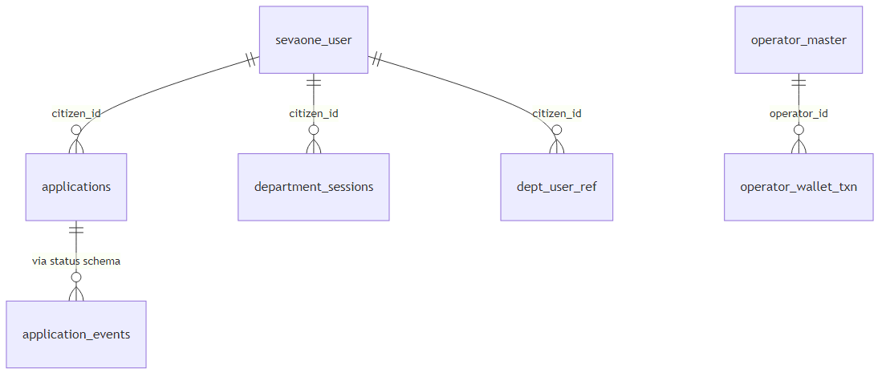
Orchestration schema entity-relationship diagram

8.1 applications
One row per citizen+scheme+department application (deduped).
Unique: seva_reference; (citizen_id, scheme_id, department_id, department_reference)
Columns: department_reference, status (integer enum), submitted_at, sakala_due_at, applicant_name, address, purpose, district, taluk
Functions: sp_submit_application (INSERT + first event), sp_update_application_status, sp_reassign_applications, multiple getters with JOIN to discovery for names
Lifecycle: Live — created on first apply-complete from department.

8.2 department_sessions
Encrypted connector sessions for legacy direct-submission path (not JWS handoff).
Functions: sp_insert_department_session, sp_get_active_department_session, sp_get_active_department_sessions_by_citizen, sp_expire_department_session
Lifecycle: Live for connector integrations only.

8.3 dept_user_ref
Records that a department has previously seen a citizen (UNIQUE (department_id, citizen_id)).
Functions: sp_upsert_dept_user_ref (INSERT ON CONFLICT DO NOTHING)
Lifecycle: Live — written after successful token validation path.

8.4 operator_wallet_txn
Fee collection / reversal at assisted centres.
CHECK: amount > 0
Unique: partial on idempotency_key
Functions: sp_insert_wallet_txn, sp_get_wallet_txn_by_idempotency_key
Lifecycle: Live — operator wallet APIs.

8.5 outbox_messages
Transactional outbox pattern (topic, payload, publish state).
Functions: sp_insert_outbox_message, sp_get_pending_outbox_messages, sp_mark_outbox_published, sp_mark_outbox_failed
Lifecycle: Written on events; no publisher worker consumes pending rows in production yet.

9. status schema

9.1 application_events
Append-only timeline per application.
FK: application_id → applications.id ON DELETE CASCADE
Functions: sp_insert_application_event, sp_get_timeline
Lifecycle: Live — every status change appends a row.

9.2 payment_status_post
Idempotent payment status reports from departments.
Unique: partial on idempotency_key
CHECK: amount IS NULL OR amount >= 0
Functions: sp_insert_payment_status_post, sp_get_payment_status_by_idempotency_key
Lifecycle: Live — dept payment-status endpoint (orphaned from APIM gateway but code exists).

10. audit schema

10.1 audit_logs
Who did what, when (login, token issue/redeem, apply-complete).
No FK on citizen_id (allows operator-only actions).
Indexes: at; (citizen_id, at DESC)
Functions: sp_insert_audit_log, sp_get_audit_logs_by_citizen
Lifecycle: Live throughout auth and dept flows.

10.2 db_errors
Postgres function failures for post-mortem.
PK: id bigint identity
Lifecycle: Written by sp_* exception handlers only — not from C# directly.

11. notification schema

11.1 notifications
Outbound messages queue.
Defaults: channel = 'log' (no real SMS/email worker yet)
Functions: sp_insert_notification, sp_get_pending_notifications, sp_mark_notification_sent
Lifecycle: Inserted on apply/status paths; not delivered by a background worker today.

12. Function catalog (by schema)
Schema | Count | All called from C#?
discovery | 13 | No — onboarding pair unused
portal | 16 | Yes
orchestration | 22 | Yes
status | 4 | Yes
audit | 2 | Yes
notification | 3 | Yes
C# repositories: DiscoveryRepository, PortalRepository, OrchestrationRepository, StatusRepository, AuditRepository, NotificationRepository — each maps 1:1 to sp_* calls in SevaOne.Infrastructure/Repositories/.

13. Seed data reference
R__seed_lookup.sql
- 12 department_master rows (revenue, transport, …)
- ~40 sevaone_service_master rows (SVC001–SVC024, SVC101–SVC116)
- Idempotent: ON CONFLICT DO NOTHING
R__seed_operator.sql
- 1 operator_master row (OPR10001, type K1, PBKDF2 password hash)

14. Related documents
Document | Purpose
DATABASE_SCHEMA.md | Narrative schema guide (citizen-friendly)
POSTGRES_FUNCTIONS_VS_PROCEDURES.md | Why FUNCTION not PROCEDURE
DEPARTMENT_INTEGRATION_GUIDE.md | Dept API (uses sevaone_user_id, tokens)

End of database reference.

