
GOVERNMENT OF KARNATAKA
Directorate of Electronic Delivery of Citizen Services

SevaOne High Level Design
  - Application Architecture
Platform responsibilities and integration design
Document ID SEVAONE HLD 001
Version 1.1
Issue date 21 September 2026
Status For technical review
Prepared for
SevaOne Project Team

Document control
This document defines the SevaOne platform architecture for technical review, implementation planning and department integration. It describes responsibilities, information flows and design requirements at system level.
Document attribute | Value
Document ID | SEVAONE HLD 001
Version and date | 1.1 | 21 September 2026
Status | For technical review
Audience | EDCS reviewers, architects, engineering, operations and department integration teams
Architecture scope | SevaOne citizen portal, assisted services, government administration and supporting AI services

Revision record
Version | Date | Change
1.0 | 20 Sep 2026 | Architecture baseline refreshed against the current repository and issued in the approved document template.
1.1 | 21 Sep 2026 | Added technology baseline, AI hosting, development stack, abuse controls and open decisions; contents aligned with the document set; references moved to the current documents.

Review and approval
Review role | Review state
Architecture and engineering | Pending review
Operations and security | Pending review
EDCS approval authority | Pending approval

Implementation descriptions identify existing responsibilities and flows. Statements labelled design requirement, proposed target or production design define the intended operating contract; they are not deployment certification.

Contents at a glance
Section | Subject
1 | Purpose and scope
2 | System context
3 | Logical components and technology baseline
4 | Request routing and trust boundaries
5 | Identity and access architecture
6 | Application journeys
7 | Integration architecture
8 | Data architecture
9 | AI and language architecture, including hosting
10 | Administration and analytics
11 | Deployment architecture and environments
12 | Security and privacy design
13 | Quality attributes and capacity
14 | Reliability and operations
15 | Design decisions, delivery and open decisions
16 | References and traceability
17 | Terminology and document boundaries

Use Word’s Navigation Pane to jump to the named sections.

1 Purpose and scope

Business purpose
SevaOne provides a common entry point for Karnataka government services. Citizens discover services, receive English or Kannada guidance, authenticate when identity is required, and move to the appropriate department application journey. Operators assist citizens, while authorised government users manage catalogue information and review service activity.

Architecture approach
The core is a modular ASP.NET Core application exposed through browser-facing and department-facing routes. It uses a relational system of record, shared session infrastructure and background processing. AI discovery runs as a separate Python service so model inference and knowledge retrieval can evolve independently of identity and transaction processing.

Included capabilities
Capability | Architectural boundary
Discover and understand | Catalogue browsing, search, AI conversation, language and voice support
Identify and assist | Citizen authentication and profile; operator login and citizen binding
Apply and track | Route classification, department handoff, acknowledgements, status and payment-status capture
Administer and observe | Catalogue publishing, government roles, notices, analytics and operational views

Scope boundaries
Departments retain ownership of service adjudication, statutory decisions and their application portals. Payment settlement, e-sign fulfilment and external identity verification remain provider responsibilities. SevaOne records or coordinates the relevant interactions. The separate Seva-Sindhu-One application, legacy prototypes and demonstration dashboards are outside this baseline.
Detailed DTOs, database column definitions, endpoint inventories, installation commands and machine-level sizing belong in the LLD, API specification, database reference and deployment plan.

2 System context
The platform connects people, identity providers, department systems and AI services. The diagram shows responsibility boundaries; it does not imply that every external interaction uses the same authentication or routing mechanism.
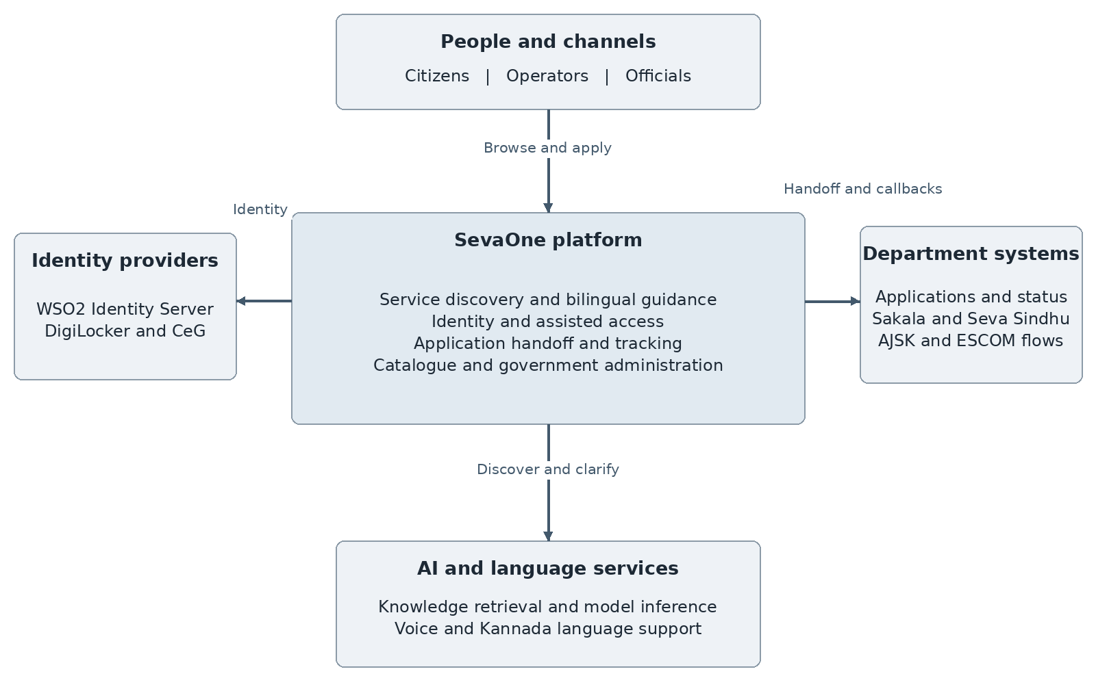
Figure 1 SevaOne system context
Actor or system | Responsibility
Citizen | Discover, authenticate, apply and view outcomes
Operator | Assist an explicitly bound citizen and record assisted activity
Government official | Manage or inspect information within assigned authority
Department system | Process applications and supply acknowledgements or status
Identity and language providers | Provide identity assertions, OTP delivery or language processing

3 Logical component architecture
The BFF is one deployable application containing four .NET projects. These are internal layers, not independently deployed microservices. Domain defines shared models; Infrastructure implements persistence and external clients; Business coordinates use cases; Services hosts HTTP controllers, middleware and workers. [R01]
Component | Primary responsibility
Citizen and operator SPA | React 19, TypeScript, Vite and Tailwind. TanStack Router handles navigation; TanStack Query manages server data and Zustand stores client state. English and Kannada messages are maintained in the application.
Government admin SPA | Separate React application for scoped analytics, catalogue and administrative workflows.
ASP.NET Core BFF | .NET 10 request validation, authentication context, authorisation, catalogue, portal, orchestration, status, audit and administration.
WSO2 Identity Server | Citizen token issuance and introspection; operator, official and department identity integration.
WSO2 API Manager | Published API contexts, gateway policy execution and request stamping on configured routes.
AI and language services | Agentic retrieval, model inference, translation and speech processing; separate administrative assistant and telemetry sidecars.
Persistence and workers | PostgreSQL, Redis, Kafka publishing, notification processing and department status polling.

Technology baseline
Versions are those pinned in the repository and the Compose files at issue date. Production versions are confirmed in the deployment architecture.
Layer | Technology
Citizen and operator SPA | React 19, TypeScript 6, Vite 8, Tailwind CSS 4, TanStack Router and Query, Zustand; Node.js 24.
Government admin SPA | React 19, TypeScript 6, Vite 8, Recharts.
BFF | ASP.NET Core on .NET 10; Dapper and Npgsql; FluentValidation; Serilog; OpenTelemetry.
Relational data | PostgreSQL 18; Flyway versioned and repeatable migrations.
Session, cache and events | Redis 8; Apache Kafka 4.3.
Identity and API management | WSO2 Identity Server 7.3; WSO2 API Manager 4.7 with WSO2 Identity Server as its Key Manager.
Web entry | NGINX 1.27.
AI services | Python FastAPI services; BGE-M3 embeddings; FAISS or Qdrant vector store; OpenAI-compatible model endpoint (vLLM).

Extension points
Department connectors and external-provider interfaces isolate protocol differences. Catalogue metadata selects the apply mechanism for each audience. AI clients, vector-store factories and conversation-store interfaces permit independent provider changes without changing the core application record model.

4 Request routing and trust boundaries
NGINX provides the web entry point and selects an upstream by route family. Gateway transit, application identity and business authorisation are separate decisions. Successful gateway admission alone does not establish a citizen, operator or department identity. [R02 R03]
Route family | Current logical path | Identity or purpose
Citizen catalogue and account routes | NGINX → citizen APIM context → BFF | Public discovery or citizen-cookie identity according to endpoint
Operator routes | NGINX → department APIM context → BFF | Operator session and assisted-citizen context
Department routes | NGINX → department APIM context → BFF | APIM API key, gateway stamp and WSO2 department bearer scope
Other BFF routes | NGINX API fallback → BFF | Endpoint-specific controls, including government administration and ASR
Main citizen chat | Frontend proxy → agentic RAG service on the GPU server | Conversational discovery over /rag-api/chat
External callbacks | Provider or department → designated callback | Callback-specific state, identity and token validation

Browser and service boundaries
Browser code receives display data and navigation results. Identity tokens in HttpOnly cookies are resolved by server middleware. Department handoff payloads are protected for browser transport, while department authentication is performed server to server. Administrative analytics and the government AI assistant retain the caller’s scope.

Production design requirement
External entry points must apply an explicit exposure policy, request limits and transport protection. Application services, identity administration, databases and model inference belong on controlled networks. Anonymous discovery remains a supported product capability, with bounded resource use and no authority to mutate citizen records.

5 Identity and access architecture

Citizen identity
Mobile OTP or DigiLocker and CeG verification establishes a citizen identity. The BFF creates or resolves the portal profile and exchanges a signed assertion for WSO2-backed access and refresh tokens. Access tokens are carried in HttpOnly cookies and validated through a Redis-backed introspection cache. Cached verdicts are bounded to 60 seconds and by remaining token life. WSO2 is the token authority; PostgreSQL owns the SevaOne profile. [R03]
DigiLocker callbacks use one-time login state and a provider transaction lookup. The callback is a browser navigation, so its validation differs from an authenticated JSON request. Profile completion and return navigation are resolved after authentication.

Operator and government identities
Operator and government sessions are stored in Redis and use separate authentication schemes. Operator login supports WSO2-backed identities and the configured legacy credential path. Government login uses WSO2-backed credentials. Operator-assisted journeys carry both the operator identity and the bound citizen context; administrative authority is never inferred from a citizen session.
Identity domain | Authority and application context
Citizen | WSO2 token; SevaOne citizen profile and ownership checks
Operator | Operator session; whitelist, active state and citizen-binding workflow
Government official | Government session; Superadmin, ChiefMinister, Department, DistrictHead or TalukHead scope
Catalogue administrator | Separate catalogue administrative scheme and permitted operations
Department client | API gateway admission plus active bearer token with dept scope; body department must agree

Access design requirements
Enforce ownership and scope on the server for every protected operation. Separate identity verification, profile data and authorisation. Expiry, logout, revocation and operator unbinding must terminate the associated authority without transferring it to another user.

6 Application journeys
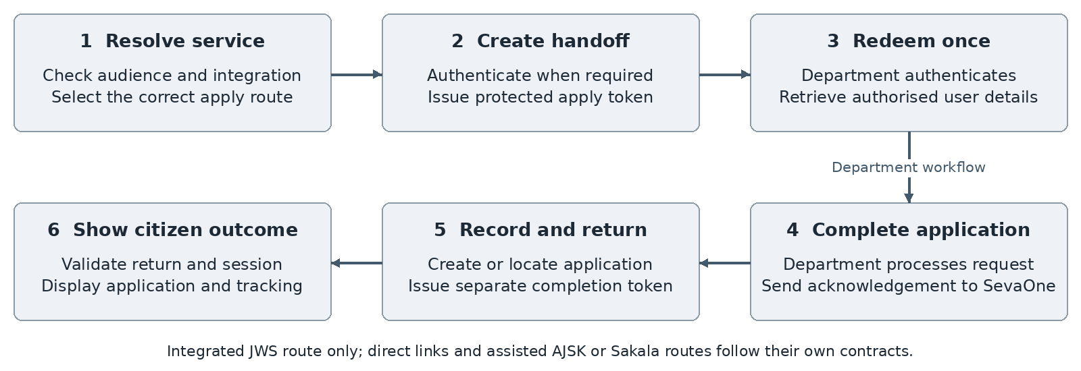
Figure 2 Integrated department handoff and return

Discovery and route selection
A citizen can browse without signing in. ApplyRouteClassifier selects a direct link, an integrated JWS handoff, or an assisted AJSK or Sakala mechanism from department and service metadata. A direct-link fallback can remain anonymous; an identity-bearing handoff requests login first. Operator-assisted access resolves an authenticated operator and a citizen context. [R04]

Protected handoff
For an integrated deep link, SevaOne creates a signed apply token, records its state and wraps it in Data Protection encryption for the redirect. The department relays the opaque token to the user-details endpoint. Validation checks department binding, signature, expiry and atomic one-time redemption. The apply window is 30 minutes.

Acknowledgement and return
The department confirms completion through the acknowledgement operation. SevaOne locates or records the application and creates a separate 10-minute completion token. The browser return validates and redeems that token, then checks the citizen session before navigating to the dashboard. A completion token is not a login credential.

Tracking
Citizen application lists and detail views use ownership checks. Reference-based tracking first checks SevaOne records, then consults Sakala for an external GSC reference. Department status updates and connector polling feed the timeline. An apply click is an engagement event, not proof of an application submission.

7 Integration architecture
Integration | Contract and boundary
DigiLocker and CeG | Start verification, retain one-time callback state, resolve verified attributes and return to the portal.
Mobile Seva | Deliver authentication challenges through the configured OTP sender. OTP delivery is separate from application notifications.
Integrated department | Opaque handoff token; authenticated user-details retrieval, acknowledgement, payment-status and status-update operations.
Sakala and Seva Sindhu | External tracking and assisted token-generation redirects. Service mappings select generic or ESCOM-specific flows.
AJSK | Assisted redirect using the operator identifier and the provider’s URL contract.
Connector-based submission | IDepartmentConnector coordinates session, submission and status calls where a direct integration is configured.
AI providers | Retrieval and model inference for discovery; language gateway for Kannada and speech; no adjudication authority.

Integration rules
An integration is enabled by validated service metadata and an agreed provider contract. Preserve department-scoped service identifiers, separate citizen and operator apply URLs, and record the integration method explicitly. External acknowledgements and references must remain traceable to the relevant citizen, service and department. [R04 R05]
Design requirement: use bounded timeouts, correlation identifiers, replay protection and idempotent callback handling. Retry only operations whose repeat behaviour is defined. A timeout after a remote side effect requires reconciliation before another submission.

Payment and document boundaries
Payment-status callbacks record external outcomes; they do not make SevaOne a settlement system. Document retrieval and e-sign are provider-specific capabilities of a connector. Only the fields required by an authorised department workflow should cross the boundary. Exact schemas, headers and status mappings are maintained in the API and integration specifications.

8 Data architecture
PostgreSQL is the core transactional system of record. The application database is organised into six schemas; WSO2 products use separate databases. Dapper and Npgsql repositories call SQL functions and queries, while Flyway versioned and repeatable migrations manage schema evolution. [R06]
Schema | Main information owned
discovery | Departments, sub-departments, services, document requirements, roles and visibility, staged catalogue imports, change history and apply-click tracking.
portal | Citizen profiles, handoff tokens, operators and whitelist, government administrators, service notices, public notifications and admin import staging.
orchestration | Applications, department sessions, citizen-to-department references, operator wallet transactions and outbox records.
status | Application timeline events and department payment-status records.
audit | Citizen and platform audit records and database error records.
notification | Queued application notification requests and delivery state.

Conceptual relationships
A department owns services and may group them under sub-departments. A citizen may hold many applications; each application links a service and department to SevaOne and external references. Tokens bind a citizen, department and service, with operator context for assisted use. Applications have timeline events. Imports contain staged rows before publication. Catalogue identifiers and display labels have different roles.

Supporting stores
Redis holds short-lived login state, token-introspection verdicts, role-specific sessions and the shared Data Protection key ring. AI conversation state is a separate Redis or development memory concern. Knowledge metadata and vector indexes are derived discovery assets; they do not replace application or identity records.

Data lifecycle requirements
Assign retention, deletion and access rules separately to identity attributes, handoff tokens, application history, audits and AI conversations. Back up durable records and cryptographic key material together with a recoverable version history. Schema migrations and catalogue publishing must be controlled changes.

9 AI and language architecture
The main citizen interface calls the agentic RAG service in apps/Artificial-Intelligence/ai-sevaone. The service maintains conversation context and uses a bounded model tool loop to search, clarify or answer. Its response contains a reply, resolution status, optional resolved service, candidate options and an apply URL. The frontend maps this contract into service cards. [R07]

Knowledge and inference flow
Ingestion reads approved structured and document sources, normalises service records, chunks relevant content and creates embeddings. Retrieval combines the configured vector store with catalogue information and relevance filtering. The supported vector stores are FAISS and Qdrant; the conversation store can use memory or Redis. The model is accessed through an OpenAI-compatible endpoint such as vLLM, independently of the BFF runtime.
AI capability | Distinct role
Citizen agentic RAG | Service discovery and clarification; main /rag-api/chat path
Knowledge ingestion and language | Index refresh from approved sources and Bhashini-based Kannada support, delivered by the agentic RAG service
Speech and Kannada | Browser audio capture, BFF ASR forwarding and Bhashini or configured language gateway
Government AI assistant | Read-only aggregate analytics tools through the BFF using the signed-in government context
AI monitor | Read-only GPU-host telemetry exposed to the BFF for the Superadmin operational view
Earlier AI backend | Retired for now. It is not part of the current runtime and no requirement depends on it.

AI hosting
AI processing runs on the GPU server, not in the Compose stack or on the application hosts. The agentic RAG service is reached directly on its service port. The government AI assistant and the AI monitor bind to the loopback interface of the GPU host and are reached only through protected SSH tunnels; the browser never connects to either. Application services treat all AI endpoints as optional dependencies.

Failure and safety contract
The frontend applies a 35-second chat timeout and can use catalogue search when AI is unavailable. ASR has a separate request budget. Model output is guidance: it cannot create identity, approve eligibility or submit an application. Design requirements include grounded service identifiers, bounded tool execution, safe URL selection, privacy-aware conversation storage and evaluation in both supported languages.
A catalogue publication and an AI knowledge refresh are separate lifecycle events. Maintain a traceable source version and publish searchable knowledge only after content validation.

10 Administration and analytics

Government administration
The separate admin panel uses the BFF for official login, account activation and import, operator management, catalogue maintenance, notices, notifications, scoped dashboards and operational views. Superadmin, statewide, departmental, district and taluk roles are represented explicitly. Business services resolve the permitted data scope from the authenticated official. [R08]

Catalogue governance
Catalogue changes include department and service activation, audience visibility, bilingual descriptions, document requirements, integration mappings and apply URLs. Imports use batch and row staging with an explicit publish or discard operation. Change history supports traceability. Publication must preserve department-scoped identifiers and validated links.

Operational information
The administration surface provides application and activity aggregates and protected health views. The government AI assistant requests read-only analytics through these APIs; it does not bypass scope checks by querying application databases. Knowledge ingestion and GPU telemetry remain distinct from analytics queries.
Information | Interpretation
Apply-click count | Service interest and navigation activity; may include anonymous and assisted users
Application record | Acknowledged or directly recorded application, with a department reference when supplied
Status timeline | Recorded department outcome or connector observation
Payment-status record | Reported external payment state, distinct from financial settlement
AI response | Guidance based on retrieved knowledge, distinct from an official decision

Design requirements
Use consistent metric definitions across the citizen portal, dashboards and AI answers. Apply the same department and geography filters to list, aggregate, export and assistant-tool operations. Administrative publishing must be attributable and auditable.

11 Deployment architecture
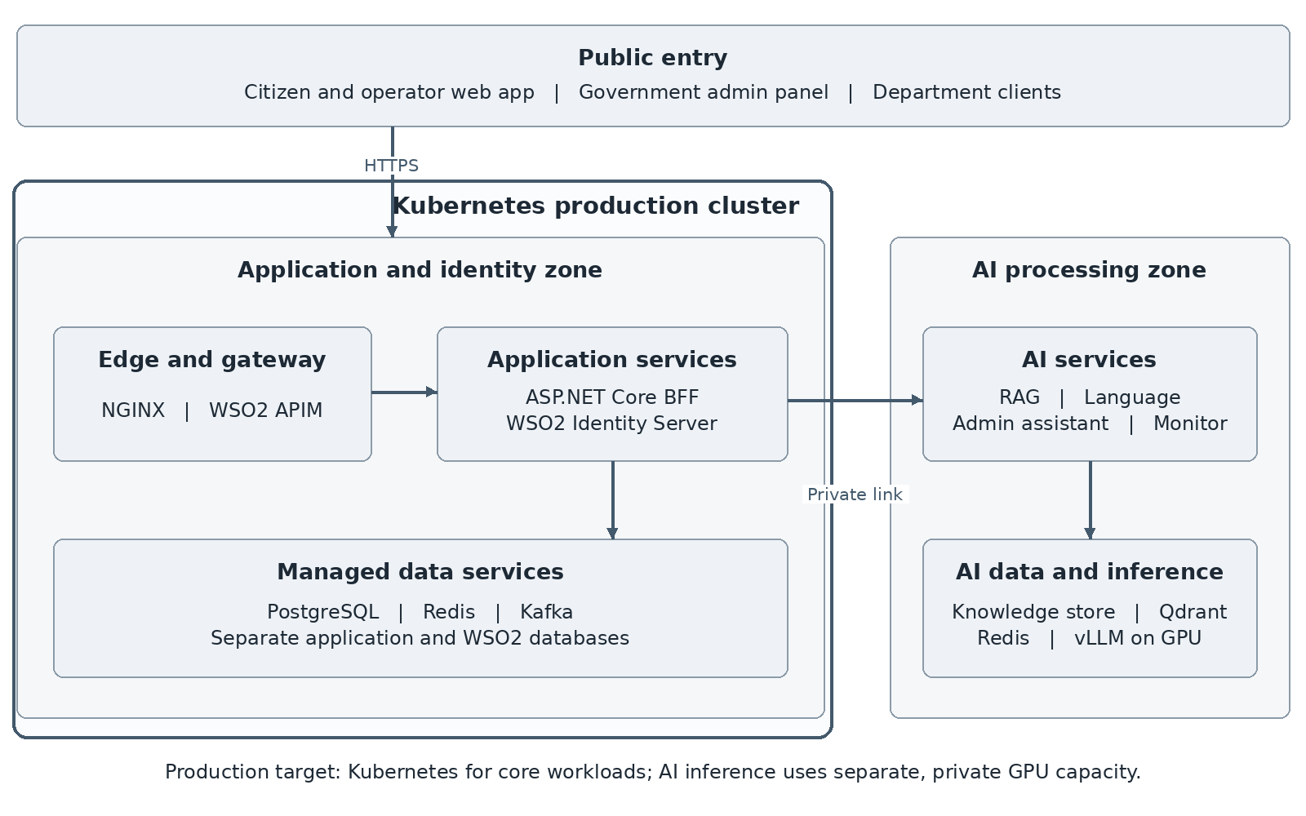
Figure 3 Kubernetes production placement and private AI processing

Kubernetes production target
Kubernetes is the production deployment target. The public load balancer and WAF route traffic through ingress to the frontend, BFF and department gateway; stateless application capacity scales independently. WSO2 and stateful data workloads run on isolated capacity, with operator-managed or approved managed services, persistent storage and tested recovery. Argo CD reconciles reviewed, environment-specific configuration. The Kubernetes deployment plan governs manifests, pools, storage, high availability, sizing and rollout; capacity targets require load validation before acceptance. [R09]

Production placement
Separate application, data, WSO2, control-plane and optional GPU capacity with scheduling constraints and private service paths. Keep stateless web and API capacity independent from model inference; preserve session and key consistency across replicas and assign clear ownership to background workers.

Environment contract
Docker Compose and Dockerfiles under docker-deploy support development and pilot workflows only; they do not define production. Isolate development, integration, acceptance and production; inject secrets and endpoints per environment and version application images, gateway configuration, database migrations and AI knowledge releases together.

Environment composition
Environment | Composition
Development and pilot (Docker Compose) | PostgreSQL, Redis and Kafka; WSO2 Identity Server and API Manager with provisioning; NGINX; BFF; citizen SPA; admin panel.
AI (every environment) | GPU server: agentic RAG service, government AI assistant and AI monitor, as described in section 9.
Not part of the local stack | Legacy prototypes, demonstration dashboards, the earlier AI backend and any AI component.
Production | Kubernetes, as defined in the deployment architecture document.

12 Security and privacy design
Security is organised around identity, gateway admission, authorisation and data minimisation. The following are production design requirements. Their wording defines the intended control model and does not certify a particular running environment.
Control area | Design requirement
Transport and ingress | Use trusted TLS, approved public routes and protected service networks. Apply resource limits by caller and operation.
Abuse controls | Rate-limit OTP start, credential and Apply-tracking operations per caller. Derive the caller from the trusted client address when traffic passes through NGINX or a gateway.
Identity and access | Keep citizen, operator, official and department credentials distinct. Enforce record ownership and administrative scope server-side.
Browser session | Use HttpOnly and Secure cookies with an explicit SameSite policy; validate state-changing requests against cross-site misuse.
Handoff and callbacks | Protect redirect payloads, verify department and service binding, expire tokens and redeem one-time tokens atomically.
Secrets and key material | Provision outside source control, restrict access, rotate with an overlap strategy and back up required decryption keys.
Sensitive information | Minimise identity attributes in APIs, URLs, logs and AI prompts; constrain exports and conversation retention.
Administration | Separate management privileges, capture changes and enforce least privilege for people and service accounts.

Privacy boundaries
Identity-derived attributes and citizen contact preferences have separate provenance. Department access must be linked to an authorised service workflow. AI discovery should operate without unnecessary identity attributes; read-only analytics must preserve the requesting official’s access scope.

Assurance
Security acceptance includes cross-role access tests, replay and expiry tests, session isolation, external-provider trust validation and log inspection. Applicable retention, consent, audit and accessibility obligations are determined by the responsible programme authorities and recorded in the requirements baseline.

13 Quality attributes and capacity
Quality targets must be measurable and agreed before production acceptance. The values below are proposed planning targets, not observed performance or contractual commitments.
Attribute | Proposed acceptance target
Availability | 99.9 percent monthly availability for the core portal and BFF; define exclusions and dependencies in the SLA.
Interactive latency | 95th percentile catalogue and profile responses at or below 2 seconds under the agreed peak workload.
AI response time | 95th percentile useful response at or below 25 seconds; retain a bounded timeout and non-AI discovery path.
Recovery | Core application data RPO at or below 15 minutes and service RTO at or below 4 hours, subject to business approval.
Integrity | Replay-safe tokens and callbacks; no silent loss of acknowledged application or event records.
Accessibility and language | Keyboard-accessible key journeys, readable layouts and equivalent English and Kannada information.

Capacity model
Estimate peak active users, requests per user, login bursts, department callbacks, operator shifts and AI concurrency separately. Calculate data growth from applications, timeline events, audits, attachments or references and retention periods. Measure model throughput and GPU memory for the selected model and context length.
API replica demand is driven by peak request rate, measured service time and a safe utilisation factor. AI demand is driven by concurrent generations and token throughput. Database pools, Redis memory, Kafka retention and external-provider quotas impose independent limits. Validate the full journey with realistic payloads and bilingual queries.

Acceptance workload
Agree normal, peak and burst profiles with EDCS and department owners. Include login storms, slow providers, catalogue refresh, status polling and AI unavailability. Record hardware, configuration, data volume and test results alongside every capacity claim.

14 Reliability and operations

Synchronous and asynchronous work
Synchronous calls handle identity, catalogue lookup and department handoff. Outbox records provide a staging point for Kafka publication; separate background workers dispatch notifications and poll department status. The required event-delivery contract is at least once, with idempotent consumers and explicit reconciliation. Do not assume exactly-once processing across external systems. [R10]
Dependency event | Required operational behaviour
Identity or Redis unavailable | Do not create unverified identities; return a controlled failure for protected actions.
Department timeout | Preserve correlation and reconcile uncertain outcomes before resubmission.
AI or language failure | Keep catalogue discovery available; preserve typed-input alternatives and clear retry behaviour.
Event or notification backlog | Retain pending work, expose age and retry state, and provide controlled replay.
Data or application recovery | Restore compatible data, configuration and keys; verify ownership, token and tracking behaviour.

Observability
The BFF exposes separate liveness and dependency readiness routes and a protected operational health view. Serilog records requests; OpenTelemetry instrumentation covers ASP.NET Core and outgoing HTTP. AI and GPU telemetry form a separate operational domain. Production monitoring must collect and correlate these signals. [R11]
Monitor journey success, latency, authentication failure, provider errors, database and cache saturation, oldest outbox item, notification backlog, AI retrieval quality and GPU saturation. Use correlation IDs rather than raw tokens or identity attributes.

Backup and recovery
Back up PostgreSQL, required Redis persistence and Data Protection keys, identity configuration and signing material, gateway definitions, and AI metadata or index snapshots. Test restoration in isolation and document recovery order: data and keys, identity, gateway and BFF, then AI and asynchronous work. Recovery objectives are approved through the service continuity plan.

15 Design decisions and delivery
Decision | Rationale and consequence
Modular core application | Keep catalogue, identity context and orchestration in one deployable unit while maintaining internal layers and interfaces.
Separate identity and gateway | WSO2 IS owns identity tokens; APIM owns API admission. Business authorisation remains in the BFF.
Metadata-driven apply routes | Permit integrated tokens, direct links and assisted provider flows without representing all departments as equivalent integrations.
Independent AI runtime | Scale inference and retrieval separately; keep transactional decisions outside model output.
Relational ownership with derived indexes | Keep authoritative application records in PostgreSQL; rebuild discovery indexes from governed knowledge sources.
Explicit asynchronous delivery | Use persistent event state and retryable workers; downstream processing must tolerate duplicate delivery.
Gateway-verified trust | The BFF verifies that citizen and department traffic passed through the correct gateway context instead of relying only on network placement.
Identity provider as session authority | WSO2 tokens, cached through Redis introspection, are the citizen session; SevaOne keeps no separate citizen session table.

Delivery sequence
Version and validate the schema, deploy compatible service artefacts, apply gateway definitions, verify identity and provider integration, publish catalogue data, and activate the corresponding AI knowledge version. Keep database changes backward-compatible during rolling releases and retain a documented rollback or roll-forward path.

Architecture acceptance
Review component responsibilities, department contracts, data ownership and role boundaries. Validate citizen login and profile completion, operator binding, every enabled apply mechanism, acknowledgement and return, status tracking, catalogue publication and scoped administration. Test provider failure, replay, concurrent work and recovery as well as the successful journey.

Open architecture decisions
These decisions are recorded in the requirements baseline and the review notes; the architecture holds until they are approved.
Decision | Owner | Reference
Production workload, capacity and availability objective | Product and platform | SRS section 10; deployment architecture section 12
Kubernetes distribution, ownership and GitOps workflow | EDCS platform | Deployment architecture section 15
Recovery objectives per data class | Service and data owner | Deployment architecture section 7
Authenticated route for citizen chat and speech in production | AI owner and platform | SRS section 10; section 9 of this document
Retention and deletion schedules | Privacy and legal | SRS section 7

Governance assumptions
EDCS designates approval and operational owners. Departments supply authoritative service mappings, callback behaviour and credentials. Infrastructure owners confirm hosting, private connectivity, SLOs and recovery arrangements. Catalogue and language owners approve content and refresh frequency. Changes to these assumptions require a reviewed architecture revision.

16 References and traceability
Repository paths below identify the architecture evidence for this baseline. Application code and configuration define implemented behaviour; older design documents provide business context. File contents may evolve after this document’s issue date.
ID | Reference and coverage
R01 | apps/Seva-One/backend/Directory.Build.props; the four SevaOne project files; SevaOne.Services/Program.cs; frontend and admin-panel package.json files. Runtime and component structure.
R02 | docker-deploy/nginx/nginx.conf; frontend/nginx.conf; docker-deploy/wso2-apim/provision.sh. Routing and API contexts.
R03 | Backend Services/Middleware; Business/Portal/Services authentication services; Infrastructure/ExternalAuth/Wso2TokenIntrospectionCache.cs. Identity and sessions.
R04 | Business/Portal/Services/PortalApplyService.cs, ApplyRouteClassifier.cs and PortalDeptFacingService.cs; Services/Controllers/DeptController.cs. Handoff and callbacks.
R05 | Business/SevaSindhu; Infrastructure/Connectors and ExternalAuth; backend/docs/DEPARTMENT_INTEGRATION_GUIDE.md. Provider boundaries.
R06 | backend/database/migrations; Infrastructure/Repositories. Schema and persistence responsibilities.
R07 | frontend/src/aiChat.ts; apps/Artificial-Intelligence/ai-sevaone/app. Chat, knowledge and language.
R08 | Services/Controllers/GovAdminController.cs; Business/Portal/Services/GovDashboardService.cs; apps/Artificial-Intelligence/ai-admin and ai-monitor. Administration.
R09 | docs/deployment/SevaOne_Kubernetes_Deployment_Architecture.docx. Production Kubernetes architecture and validation; docker-deploy Compose assets are development and pilot only.
R10 | Services/BackgroundServices; Infrastructure/Messaging. Event, notification and polling responsibilities.
R11 | Services/Controllers/HealthController.cs; Services/Extensions/TracingExtensions.cs. Operational signals.
R12 | docs/requirements/SevaOne_Software_Requirements_Specification.docx; docs/architecture/SevaOne_Low_Level_Design.docx. Requirements and implementation design.

Backend abbreviations in this table are rooted at apps/Seva-One/backend; Services, Business and Infrastructure mean the corresponding SevaOne project directories.

17 Terminology and document boundaries
Term | Meaning in this design
HLD | High Level Design: system responsibilities, boundaries, flows and quality requirements.
BFF | Backend for Frontend: the ASP.NET Core application serving portal and integration use cases.
APIM and IS | WSO2 API Manager and WSO2 Identity Server.
JWS | JSON Web Signature: signed claims; redirect confidentiality is provided by an additional protection layer.
RAG | Retrieval augmented generation: model guidance grounded in a governed knowledge store.
ASR | Automatic speech recognition for voice input.
GSC | Sakala reference used for external application tracking.
RPO and RTO | Recovery point objective and recovery time objective.
SLO and SLA | Service level objective and service level agreement.
Catalogue publication | Making validated service metadata available to its permitted audiences.
AJSK | Assisted redirect route for operators, using the operator identifier and the provider’s URL contract.
CeG | Centre for e-Governance, the verification partner used with DigiLocker.
ESCOM | Electricity supply company services that use an assisted, token-based redirect.
Handoff token | A short-lived signed value passed to a department. It is not a login credential.
OTP | One-time password sent to a mobile number to verify a citizen or operator.

Companion document responsibilities
Document | Information maintained there
SRS | Business rules, functional acceptance, traceability and approved nonfunctional requirements
LLD and API specification | Component internals, endpoint contracts, DTOs, algorithms and error handling
Database reference | Physical schema, indexes, constraints and migration details
Deployment and operations plan | Environment topology, sizing, configuration, rollout, monitoring and recovery runbooks

This HLD is the system-level baseline for those documents. Detailed changes must preserve its ownership and trust boundaries or be accompanied by an approved design revision.

