
GOVERNMENT OF KARNATAKA
Directorate of Electronic Delivery of Citizen Services

SevaOne Kubernetes Deployment Architecture
  - Production Platform Design
Production Kubernetes topology, state, identity, delivery and capacity validation
Document ID SEVAONE DEPLOY 001
Version 1.1
Issue date 21 September 2026
Status For technical review
Prepared for
SevaOne Project Team

Document control
This document is a SevaOne review baseline prepared from the current repository and project references.
Document attribute | Value
Document ID | SEVAONE DEPLOY 001
Version and date | 1.1 | 21 September 2026
Status | For technical review
Audience | EDCS platform, architecture, engineering, security, database and identity teams
Baseline | Current repository and referenced project documents

Revision record
Version | Date | Change
1.0 | 20 Sep 2026 | Initial review issue in the approved SevaOne template.
1.1 | 21 Sep 2026 | Carried reference sizing, workload resources, capacity target, load and failure validation and the risk register from the earlier plans; added AI hosting.

Review and approval
Review role | Review state
Product owner | Pending review
Engineering and architecture | Pending review
Operations and security | Pending review
EDCS approval authority | Pending approval

Capacity, SLO, provider contract, retention and environment decisions require approval by accountable owners.

Contents at a glance
Section | Subject
1 | Aim and boundary
2 | Principles
3 | Topology
4 | Cluster isolation
5 | Workload placement and reference sizing
6 | Network and TLS
7 | State and recovery
8 | Identity and API management
9 | AI placement
10 | Delivery
11 | Operations
12 | Capacity assumptions and reference target
13 | Security
14 | Rollout, validation, risks and acceptance
15 | References

1 Aim and boundary

Aim
Define the intended production Kubernetes deployment for SevaOne, including workload placement, traffic, durable data, identity, operations, release controls and readiness gates.

Deployment boundary
Kubernetes is the expected production platform. Docker Compose is exclusively for local/developer workflows and is not the production scaling or high-availability design. Actual Kubernetes manifests, policy, environment overlays, pipeline definitions, secret references and runbooks belong in the deployment repository.
The environment matrix distinguishes the intended production platform from the local development stack. This prevents a developer Compose file or single-host estimate from being read as a production availability, scaling or recovery design.
Environment | Purpose | Pattern
Developer/local | Feature work and smoke tests | Docker Compose and non-production credentials; AI runs on the GPU server, not in Compose.
Integration/staging | Provider, migration, security and end-to-end tests | Kubernetes-like controls with test identities.
Production | Citizen service and authorised government/department APIs | Hardened Kubernetes, approved capacity, segmentation and tested recovery.

Reference capacity values are planning estimates, not a load-tested guarantee.

2 Production principles
These principles constrain later topology and sizing decisions. Measurements, reviewed desired state and observable recovery evidence are needed because replica counts or a successful deployment alone do not establish production readiness.
Principle | Design consequence
Stateless app tier | Frontend/BFF can reschedule without losing committed state.
Durable data | Managed services or supported operators for database, cache, broker and object store.
Segmented traffic | Public, app, data, WSO2 and operations paths have explicit policies.
Reviewed desired state | GitOps keeps environment config versioned, auditable and reversible.
Secrets outside Git | Use approved secret manager, rotation and access audit.
Measured scale | Size active requests separately from idle connections.
Failure-aware | Readiness/timeouts/retries prevent optional dependency failure cascades.

Scale from measured workload, not department-specific code branches or hand-edited cluster state.

3 Target topology
The layers show the direction and trust of traffic rather than only listing products. Public users and authenticated department clients enter through different governed paths, while data, management and telemetry remain behind private controls.
Layer | Components | Responsibility
Government edge | LB/WAF, DNS, TLS | Public protection, certificates and connection policy.
Ingress | NGINX ingress or approved equivalent | Host/path route and request limits.
Application | Frontend, BFF and workers | UI, validation, identity-aware APIs and business workflows.
Identity/API | WSO2 IS, Key Manager and APIM | Identity and gateway policies.
Data | PostgreSQL, Redis, Kafka where enabled, object storage | Durable records, short-lived sessions/cache and events.
Operations | Metrics/logs/traces, GitOps and backup | Visibility, reconciliation and recovery.

Traffic
Citizen traffic passes through approved public edge and ingress to frontend/BFF. Department APIs use a separately governed gateway route to APIM/BFF. BFF-to-data, WSO2, AI and department paths are private or allow-listed. Management and telemetry are not exposed through public application routes.
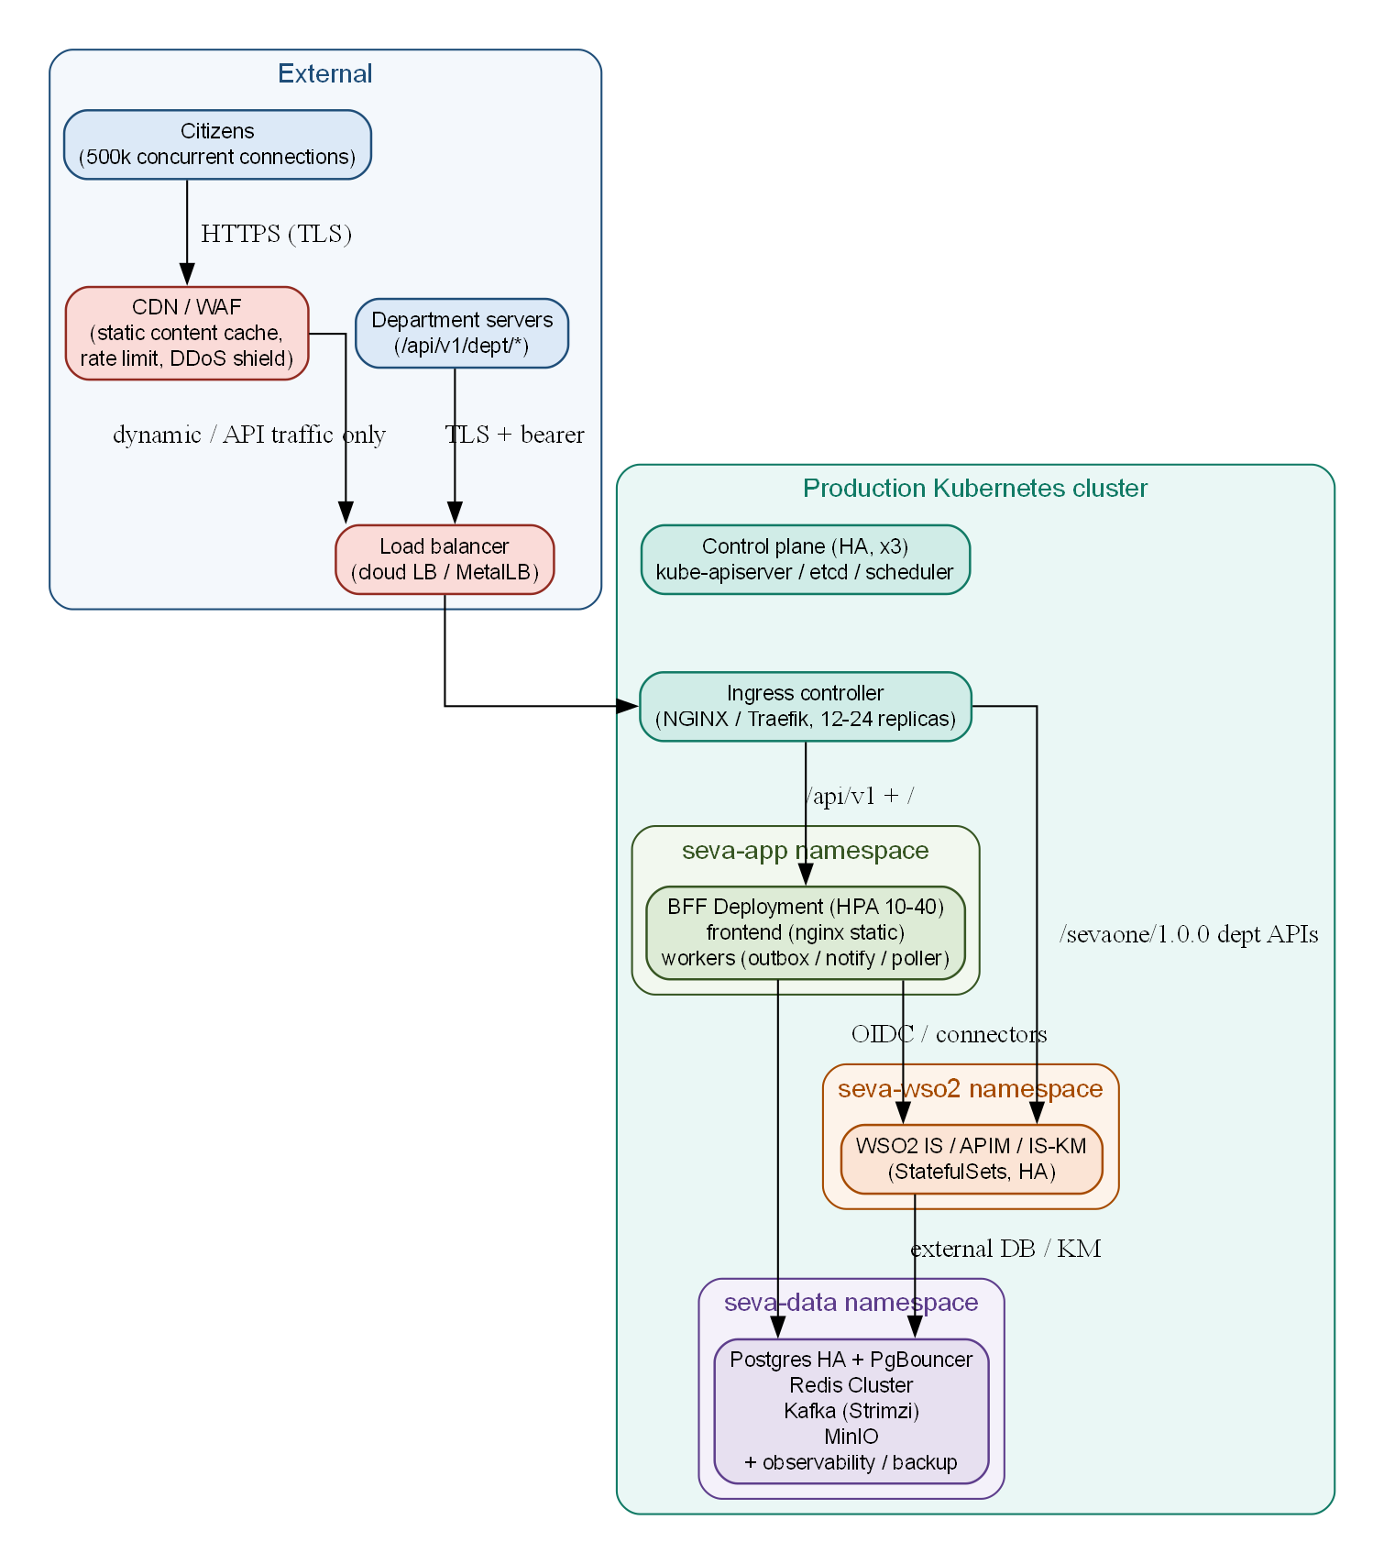
Figure 1 Reference Kubernetes topology and namespaces (reference capacity target)

4 Cluster isolation
Namespace boundaries organize policy and administration, while node placement and failure-domain controls address physical and operational risks. A namespace alone is not a security boundary, and replicas sharing the same zone or storage still share failure modes.
Namespace/pool | Workloads | Isolation intent
seva-app | Frontend, BFF and workers | Application runtime.
seva-platform | Ingress and shared services | Edge routing.
seva-data | PostgreSQL, Redis, Kafka, object store if self-managed | Restricted durable state.
seva-wso2 | Identity, Key Manager and APIM | JVM resources and private management.
observability | Metrics, logs and traces | Restricted operations data.
argocd | GitOps controller | Controlled deployment permissions.

Failure domains
Use separate node pools or scheduling rules for application, data and WSO2. Apply topology spread, anti-affinity and disruption budgets across approved zones. Reserve control-plane capacity. Replicas on one node, zone, storage system or upstream do not establish high availability.

5 Workload placement and scaling
The patterns distinguish fast-scaling stateless services from queues, identity and persistent data. The cited counts are planning references; final replica, request and limit values must follow representative measurements and upstream capacity constraints.
Workload | Starting deployment pattern | Scale signal
Frontend | Deployment; reference starts with 3–5 replicas | Edge load, CPU and readiness.
BFF | Stateless HPA; reference uses 10–40 in its high-load model | CPU/memory, RPS, latency and dependency saturation.
Workers | Separate deployment, at least 2 where HA is needed | Queue age; leader election/partition ownership.
Ingress | Protected pool; reference uses 12–24 for high connection scale | Connections, TLS CPU, file descriptors and errors.
WSO2 | Dedicated JVM pool; product-supported replicas | Heap/GC, login/token rate and gateway health.
Data | Managed or operator-backed, isolated storage | Connections, IOPS, replication lag and recovery.

Replica ranges are proposed planning values, not approved deployment counts. Final requests/limits follow representative performance testing.

Reference sizing
Node pools carried from the earlier deployment plans. This is a starting point for the reference capacity target in section 12 and is validated by the tests in section 14 before production approval.
Node pool | Nodes | vCPU per node | RAM per node | Storage and purpose
Control plane | 3 | 4 | 8 GiB | 100 GB; etcd and API server.
System | 2 | 4 | 8 GiB | 100 GB; CNI, ingress support and exporters.
Application | 8 | 8 | 16 GiB | 100 GB; BFF, frontend, workers and ingress pods. Autoscaled to 12 nodes under load.
Data | 3 | 16 | 64 GiB | 1 TB NVMe or SSD; PostgreSQL, Redis, Kafka and object storage.
WSO2 | 3 | 16 | 64 GiB | 500 GB SSD; Identity Server, Key Manager and APIM.
Total | 19 | 180 | 552 GiB | The earlier plans quote about 200 vCPU and 640 GiB, a rounded envelope that includes headroom.

Workload | Replicas | CPU request / limit | RAM request / limit | Notes
BFF | 10 to 40 (HPA) | 500m / 2000m | 1 GiB / 4 GiB | Stateless; probes and disruption budget.
Frontend | 3 to 5 | 50m / 250m | 64 MiB / 256 MiB | Static SPA served by NGINX.
Workers | 2 | 250m / 1000m | 256 MiB / 1 GiB | Leader election; one active worker.
Ingress controller | 12 to 24 | 1 / 2 vCPU | 2 GiB / 4 GiB | Large worker-connection profile.
PgBouncer | 2 | 250m / 500m | 256 MiB / 512 MiB | Pools connections to PostgreSQL.
PostgreSQL | 1 primary, 2 replicas | 8 / 16 vCPU | 32 GiB / 64 GiB | SSD; tuned shared buffers.
Redis | 3 masters, 3 replicas | 2 / 4 vCPU | 8 GiB / 16 GiB | Cluster mode; persistent configuration.
Kafka | 3 brokers | 2 / 4 vCPU | 8 GiB / 16 GiB | KRaft and SSD.
Object storage | 4 pods, 4 drives | 2 / 4 vCPU | 8 GiB / 16 GiB | Erasure-coded.
WSO2 Identity Server | 2 to 3 | 8 / 16 vCPU | 16 GiB / 32 GiB heap | Sticky sessions; external database.
WSO2 Key Manager | 1 to 2 | 4 / 8 vCPU | 8 GiB / 16 GiB heap | Key Manager for APIM.
WSO2 API Manager | 2 | 8 / 16 vCPU | 16 GiB / 32 GiB heap | Shared database and deployment sync.

A staging cluster that validates the same manifests uses 3 to 5 nodes, 24 to 48 vCPU and 64 to 128 GiB RAM, with reduced replicas and requests.

Why a cluster rather than one large server
Concern | One large server | Cluster of nodes
Availability | Any failure is a total outage. | Loss of one worker, data or WSO2 node is designed to keep service, subject to that component’s HA configuration and tested failover.
Maintenance | Every reboot is downtime. | Nodes are drained and patched one at a time.
Scaling | Everything grows together. | Only the tier that grows is scaled.
Failure isolation | A leak in one component can starve the database. | Dedicated pools keep a noisy component away from the database.

6 Network and TLS
Each route has a defined trust boundary and policy so an open network path is never inferred from service discovery alone. Certificate ownership, renewal and rotation tests keep that trust valid throughout the workload lifecycle.
Path | Policy
Browser → edge | HTTPS only; approved certificate, WAF and edge abuse limits.
Edge → ingress → app | Approved re-encryption, trusted upstreams and bounded request size.
Department → APIM/BFF | Separate API route with department identity and scope.
BFF → WSO2/data/AI | Private service names, trusted TLS and least-privilege egress.
BFF → department | Allow-listed destinations, timeout and correlation; never arbitrary URL execution.
Namespace traffic | Default deny then documented service allow rules.

Record certificate owner, SAN, trust chain, renewal automation and rotation test. Separate public issuer URLs from internal service names where needed.

7 Stateful data and recovery
The recovery matrix identifies the durable systems and the evidence required for each. Business owners must choose recovery objectives; platform teams then prove that backups, logs, keys and configuration can restore a consistent service.
System | Pattern | Recovery requirement
PostgreSQL | Managed HA or supported operator; persistent fast storage | Encrypted isolated backup/WAL; tested failover and PITR restore.
Redis | Managed/operator-backed HA | Define disposable sessions; avoid silent fallback that overloads DB.
Kafka | Managed/operator brokers where enabled | Replication, retention, replay and idempotent consumers.
Object storage | Approved durable service or operator | Versioning/replication and recovery copy.
WSO2 DB | Product-supported persistent databases | Back up identity/API metadata and validate recovery.

Recovery objectives
Business owners set RPO/RTO separately for profiles, applications, audit, configuration and identity. Include data, object stores, WSO2 metadata, cluster configuration and GitOps state. Keep copies outside the primary failure domain; record periodic restore drills.

Redis failure behaviour
Design contract carried from the earlier plan. Confirm it against the implementation (LLD sections 7 and 10) before production acceptance.
Situation | Behaviour
Sessions | Held only in Redis and disposable; a lost session means the citizen signs in again.
Redis unreachable | The BFF treats requests as unauthenticated: protected routes return 401 and sign-in returns 503. There is no fallback to PostgreSQL for session lookups.
Readiness | The BFF readiness probe includes a Redis check, so pods leave the Service while Redis is down and clients get fast 503 responses instead of hanging.
Session reads | A circuit breaker with a short timeout fails fast instead of queueing requests during an outage.
Recovery | The cluster recovers without manual steps; sessions are re-issued at the next sign-in.

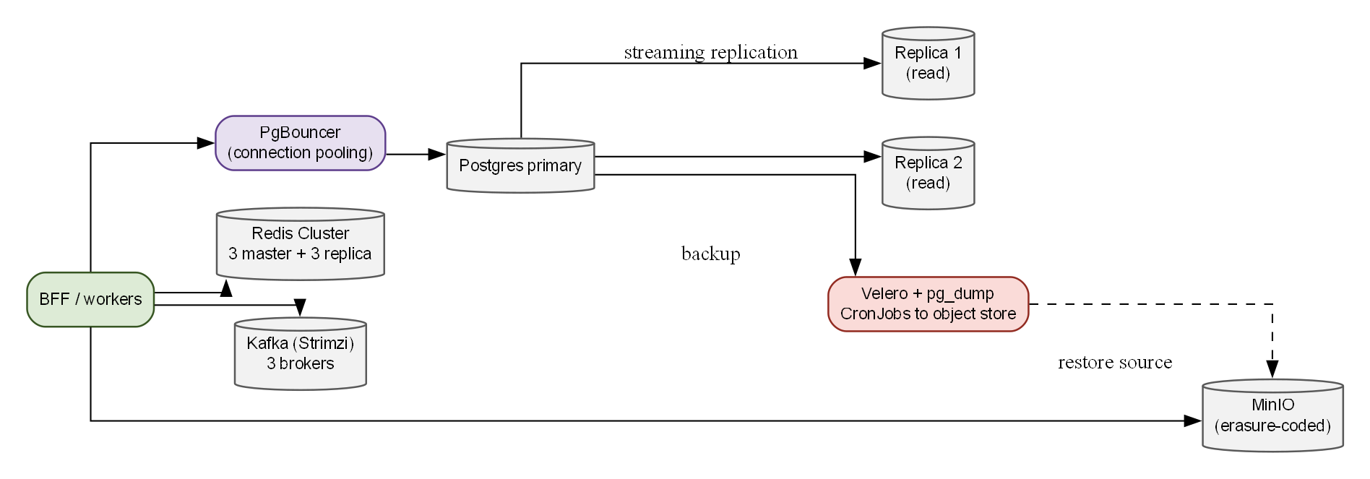
Figure 2 Data tier and backup

8 Identity and API management
WSO2 IS, Key Manager and APIM require product-specific installation, database, certificate and service-endpoint planning. Give them dedicated capacity; keep management consoles private; maintain trusted certificates in both directions; validate internal endpoints separately from browser issuers.
Identity and gateway services have separate product, database and certificate lifecycles. Private management access and post-change smoke tests reduce the chance that a healthy application deployment masks a broken issuer or unpublished API policy.
Concern | Treatment
Issuer | Expose only approved identity endpoints behind controlled DNS/TLS.
Key Manager/APIM | Use supported product topology and persistent external database.
Department APIs | Publish reviewed revision; bind client credential and scope policy.
Rotation | Store secret references in approved manager and test rotation.
Operations | Restrict Carbon/admin ports to audited management network.

After API/Key Manager change, smoke-test the gateway and confirm active published revision.

WSO2 operating rules
Rule | Detail
Build order | Identity Server, then Key Manager, then API Manager. Configuration is baked into the image, so a configuration change is a rebuild and push, not a ConfigMap edit.
deployment.toml | Start from the image default and patch it; a missing super_admin section stops the product starting.
Certificate trust | APIM and the Key Manager trust each other through the default product certificate. If keystores are replaced, import each product’s certificate into the other’s client truststore.
Key Manager registration | Register the Key Manager in APIM once through the Admin Portal. Internal endpoints use Kubernetes service names; display endpoints use the external host.
After API or Key Manager change | Restart the APIM pods where deployment sync is unreliable; the gateway reads the database on boot. Then smoke-test the gateway.
Availability | Keep WSO2 on its own pool with a disruption budget (minimum available 1) and pod anti-affinity, so a single maintenance action cannot remove every identity replica.

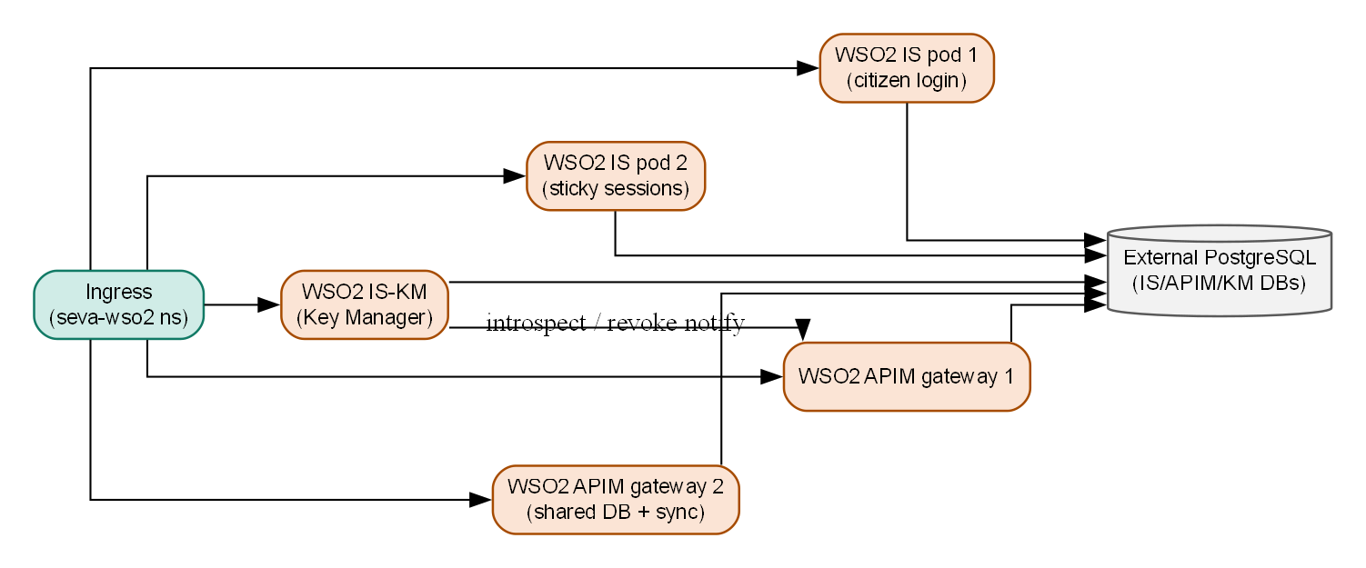
Figure 3 WSO2 identity and API management on Kubernetes

9 AI placement
AI chat, retrieval, embedding, translation and speech may require memory/GPU resources unlike the BFF. Place them in a private pool or approved external inference service with controlled egress and independent scaling.
AI workloads have different compute, data and provider constraints from the BFF, which is why their placement and scaling are treated independently. Private routing and bounded egress protect the application boundary while preserving non-AI journeys during an outage.
Workload | Placement
RAG/chat | Private service reachable only via approved portal proxy path.
Embedding/indexing | Separate job/service over approved catalogue; expose freshness.
Model inference | GPU pool or external provider; isolate credentials and bound calls.
Language/ASR | Private gateway or approved provider with data-retention terms.
AI administration | Separate authenticated admin route and protected telemetry.
Current hosting | GPU server. The RAG service is reached directly; the government assistant and AI monitor bind to loopback and are reached only through SSH tunnels. The earlier AI backend is retired.

Model/vector failures must not disable catalogue/account. Measure latency, queue, provider errors and capacity without unnecessary prompt/identity logging.

10 Delivery and configuration
The release evidence moves from source validation to immutable artifact deployment and runtime verification. Applying compatible database changes before application rollout and keeping secrets outside images make rollback and audit more predictable.
Stage | Release evidence
Test | Unit, integration, contract, migrations, accessibility and security pass.
Build | Immutable images with commit/provenance.
Scan | Dependency/image/secret/config checks meet release gate.
Publish | Approved registry; deploy by digest.
Prepare data | Review Flyway changes and take backup; apply compatible migration.
Reconcile | GitOps applies reviewed environment overlays and policies.
Verify | Health, identity, gateway, department and telemetry smoke tests.
Rollback | Revert desired state and use data-aware recovery procedure.

Keep developer/staging/production settings separate. Certificates, signing keys and provider secrets never belong in repository or image.
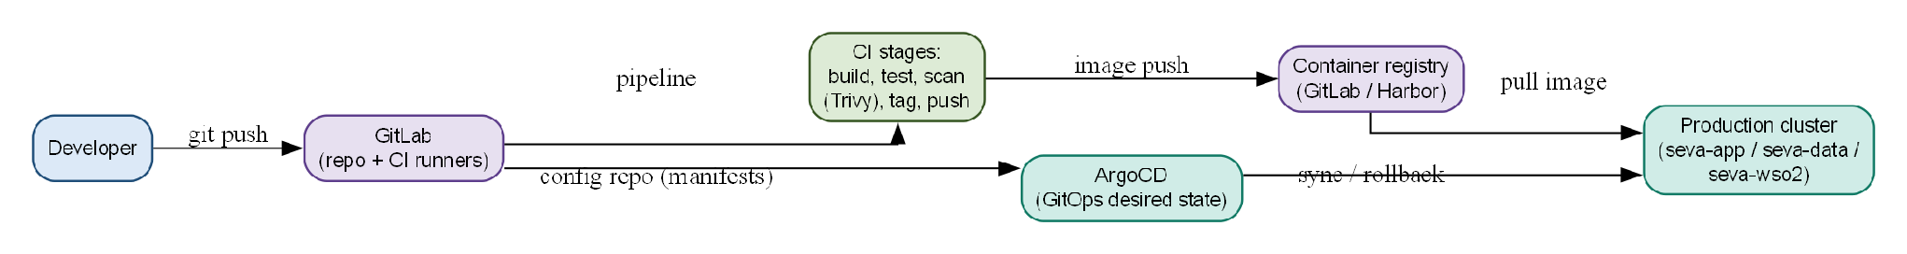
Figure 4 Build, scan, publish and GitOps delivery

11 Operations
The signals translate platform health into user impact and actionable ownership. Liveness detects a stuck process; readiness controls whether it should receive traffic, so optional provider failures should be surfaced without taking every healthy replica out of service.
Signal | Requirement
Metrics | RPS, errors, p95/p99, saturation, queue, database/cache and dependency health.
Logs | Structured, correlated and redacted; audit retained separately.
Traces | Correlation across ingress/BFF/providers without sensitive bodies.
Alerts | User impact, pod readiness, DB lag/saturation, outbox backlog and certificate expiry.
Runbooks | Named owner, trigger, diagnosis, mitigation, rollback and escalation.
Audit | Kubernetes/admin events stored with access and retention controls.

Separate liveness from readiness. Do not mark all replicas unavailable solely due to an optional provider outage.
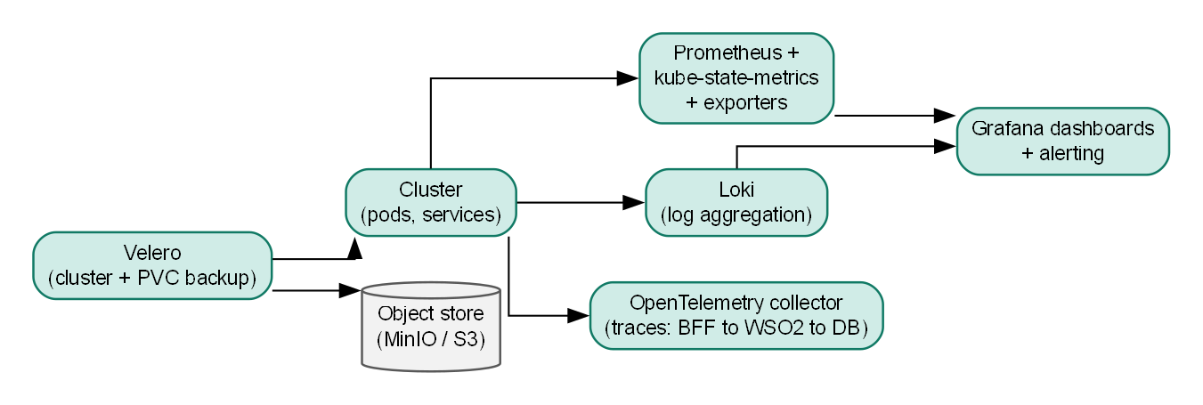
Figure 5 Observability and backup

12 Capacity assumptions
The earlier Kubernetes plans carry a 19-node starting shape (3 control-plane, 2 system, 8 application, 3 data, 3 WSO2) totalling 180 vCPU and 552 GiB RAM, quoted as about 200 vCPU and 640 GiB with headroom. It is planning guidance, not load-tested or a procurement commitment.
The sizing view separates workload dimensions because connection volume, active requests, login bursts, provider latency, AI inference and data growth stress different resources. The node and CPU figures are a planning baseline only and need a production-like workload test before procurement.
Dimension | Measure
Connections | Idle keep-alive/websocket, file descriptors, conntrack and TLS CPU.
Active requests | Mixed RPS, p95/p99, error ratio, DB work and cache hit.
Login bursts | OTP, WSO2 heap/GC, token throughput and SMS latency.
Department | Per-provider latency, timeout, retry and callback bursts.
AI | Concurrent inference, retrieval/model latency, GPU memory and provider limits.
Data | Profiles/apps/audit growth, retention, WAL, backup and restore duration.

The pilot estimate below is a small single-host Compose estimate, not Kubernetes production sizing. Any advertised traffic target needs production-like validation.

Reference capacity target
These figures come from the earlier deployment plan. They are planning targets, not the approved production workload; that decision is open (SRS section 10).
Term | Reference target | Meaning
Concurrent connections | 500,000 | Mostly idle keep-alive connections held at the edge.
Peak request rate | About 50,000 per second | Burst of active requests across the fleet.
Sustained request rate | 10,000 to 20,000 per second | Steady working load.
Peak logins | 500 to 1,000 per second | WSO2 token issuance during morning bursts.
Database writes | 2,000 to 5,000 per second | Applications, events and outbox; capped by business volume.

Level | Derivation | Reference value
Active citizens | Connections minus idle tabs | About 250,000 to 400,000
Page views per second | Active users divided by about 30 seconds think time | About 8,000 to 13,000
HTTP requests per second | Page views times 5 to 15 requests | About 40,000 to 90,000 (design target 50,000)
BFF requests per second | After CDN and cache absorb static and read traffic | About 20,000 to 35,000
Database reads per second | After an 80 percent catalogue cache hit rate | About 4,000 to 7,000
Kafka events per second | Outbox and notifications | About 1,000 to 3,000

Pilot single-host estimate
Engineering-judgment estimates for a small pilot on one Docker Compose host, without load testing. The earlier figure of 17 vCPU and 19 GB also counted department mock services and a local AI backend, which are no longer part of the stack.
Component | vCPU | RAM | Notes
PostgreSQL | 2 | 4 GB | Single instance; use managed or HA PostgreSQL at production scale.
Redis | 1 | 1 GB | Cache and session store.
Kafka | 2 | 2 GB | Single broker for a pilot; three brokers in production.
WSO2 Identity Server | 2 | 2 GB | JVM based; heavier at idle.
WSO2 API Manager | 2 | 2 GB | Gateway plus Publisher and Developer Portal.
BFF | 2 | 1 GB | Scales roughly with concurrent citizen requests.
Frontend and NGINX | 1 | 256 MB | Static assets and reverse proxy.
Host overhead and headroom | 2 | 2 GB | Operating system, Docker and agents.
Total | 14 | about 14 GB | A floor, not a ceiling; WSO2 benefits from more RAM under load.

13 Security and compliance
The controls cover the Kubernetes supply chain, workload identity, network, secrets, data and administrative audit. Final policy settings must be mapped to the applicable government security and privacy standards and verified against the deployed cluster.
Control | Kubernetes expectation
Pod | Restricted standards, non-root, drop capabilities, resource limits.
Identity | Least-privilege service accounts and audited admin access.
Supply chain | Private registry, digest pinning, scans and provenance.
Network | Default deny, private data endpoints, allow-listed egress.
Secrets | Approved secret manager; no manifest/Git/build-arg secrets.
Data | Approved in-transit/at-rest encryption, backup access and retention.
Audit | Kubernetes/admin change records and review evidence.

Map final controls to government security and privacy requirements before production acceptance.

14 Rollout and acceptance
Phased exit evidence makes platform readiness cumulative: application rollout depends on a working cluster, recoverable data and trusted identity paths. Go-live therefore requires measured capacity and operational ownership, not just successful pod startup.
Phase | Exit evidence
Foundation | Cluster/network policy, registry, DNS/TLS, secrets and monitoring.
Data and identity | Recovery, Flyway upgrade, WSO2 topology, trust and identity smoke.
Application | Frontend/BFF/workers, readiness, routes and session tests.
Integration | AI private route, gateway, allow-lists, quotas and callbacks.
Validation | Representative load, failure, restore, security, accessibility and runbook exercise.
Go-live | Approved SLO/capacity, owners, rollback and department sign-off.

Production approval requires measured workload results, secured routes, tested restore, WSO2/gateway evidence, provider contracts and named operational owners—not node count alone.

Load and failure validation
One test cannot prove both connection count and request rate, so each claim has its own test. Connection counts are read from edge telemetry, not from the load generator.
Test | Proves | Pass gate
A Connection capacity | Load balancer and ingress hold the reference connection count. | Target connections established at the load balancer and ingress; error rate below 0.1 percent.
B Throughput ramp | The BFF sustains 10,000 up to 50,000 requests per second in stages. | p95 below 500 ms at the top stage; no saturation.
C Mixed citizen workload | A realistic endpoint mix at target rate. | p95 below 500 ms and p99 below 1,000 ms; each endpoint returns its expected status.
D Login storm | WSO2 handles 500, 750 and 1,000 logins per second. | Identity Server CPU below 70 percent; no login 5xx; OTP delivery within its objective.
E Failure injection | Recovery when one component is lost at a time. | Zero failed requests per kill; PostgreSQL failover under 2 minutes; recovery under 5 minutes.

Failure injection kills 30 percent of BFF pods, one ingress pod, one worker node, one Redis replica, the PostgreSQL primary, a PostgreSQL replica, one WSO2 pod and one Kafka broker, one at a time, under a background mixed workload. Run it quarterly.
Acceptance gates for every test: p95 below 500 ms, p99 below 1,000 ms, error rate below 0.1 percent, CPU below 70 percent, PostgreSQL connections below 80 percent of the pool, and the autoscaler stabilizing within 2 minutes of load onset.

Recovery validation
Capability | Validation
PostgreSQL | Quarterly restore and failover drill against the agreed RPO and RTO.
Object storage | Restore sample objects and verify checksums.
Redis sessions | Simulate loss; confirm safe unauthenticated behaviour and a re-login path.
Kafka | Stop a broker or consumer; verify replay and consumer recovery.
WSO2 | Restore identity and API metadata; run login and gateway smoke tests.
GitOps | Recreate staging from the repository and approved secrets.

Risks and mitigations
Risk | Impact | Mitigation
Capacity assumptions are wrong | Slow or unavailable service. | Staged tests and revised sizing.
Stateful failures correlate on one node | Several dependencies fail together. | Spread replicas; use operators and backups.
Department latency | Apply failures. | Timeouts, typed errors, contract tests and metrics.
WSO2 JVM saturation | Login and token outage. | Dedicated pool, heap and GC monitoring, login-storm tests.
Secret leakage | Security incident. | Secret manager, redaction, scanning and access review.
Bad catalogue import | Wrong service or redirect. | Staging validation, duplicate checks and rollback.
GitOps drift | Unreviewed production state. | Argo reconciliation and restricted direct access.

15 References and decisions
The references distinguish production Kubernetes guidance from local Compose material and point back to the architecture and schema baselines. The open decisions identify the owners whose choices affect topology, recovery and the final service commitment.
Reference | Use
docs/architecture/SevaOne_High_Level_Design.docx | System responsibilities and trust boundary.
docs/architecture/SevaOne_Low_Level_Design.docx | Runtime units, workers and configuration.
docs/requirements/SevaOne_Software_Requirements_Specification.docx | Quality requirements and open decisions this design answers to.
docs/data/SevaOne_Database_Schema_Reference.docx | Database release lifecycle and schema inventory.
docs/suggested/SevaOne_Documentation_Review_Notes.md | Decisions needed to approve production sizing and ownership.
docker-deploy/docker-compose*.yml | Developer and local composition only.
apps/Seva-One/backend/database/migrations | Flyway migrations applied during rollout.

Open decisions
Confirm cluster/distribution owner, failure domains, data service owner, ingress, WSO2 topology, GPU placement, numeric SLO, capacity workload, residency, RPO/RTO and deployment-manifest repository.

